Report of the AE3 of PROGRAMMING

Name: Yangjiangdai Pan

Student ID: 2294163P

Assumptions that I have made to check if it affects the implementation:

ADD:

1. The information is not complete.

There is going to be a warning message and the class will not be added.

1. Repeat class ID.

There is going to be a warning message and the class will not be added.

1. The class list is full.

There is going to be a warning message and the class will not be added.

DELETE:

1. The ID does not exist.

There is going to be a warning message and the class will not be deleted.

1. The other information does not match the ID.

The program will ignore the other information and delete the class with the input ID if it exists.

Deficiencies: My program meets the specification.

Details:

1. Add a class

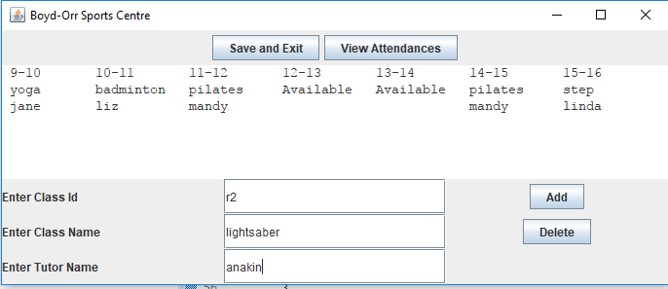

**Figure 1 add a class(before)**

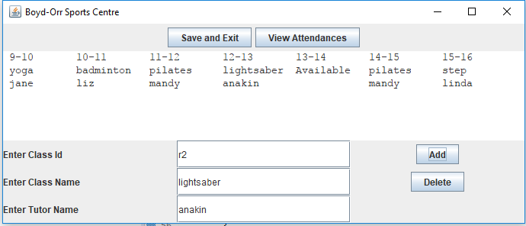

**Figure 2 add a class(after)**

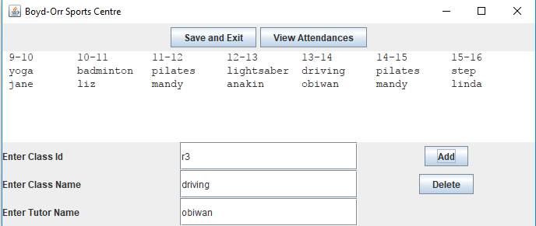

**Figure 3 add an another class**

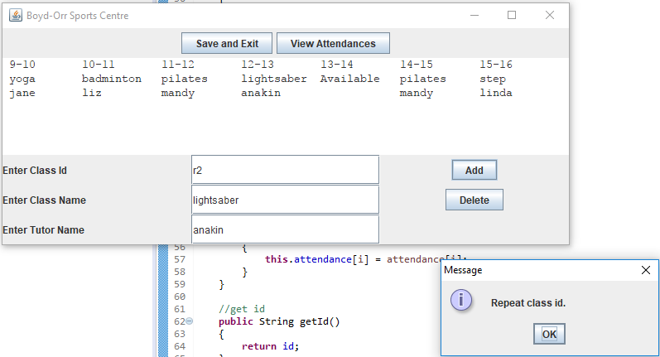

**Figure 4 repeat class id**

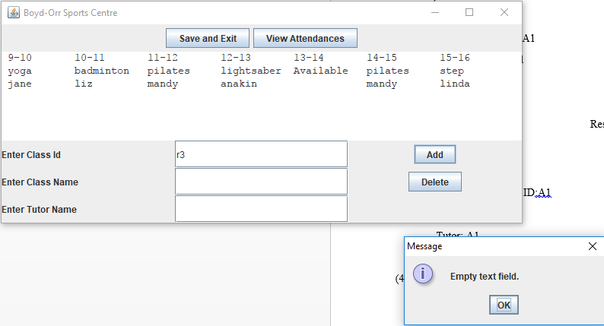

**Figure 5 not complete information**

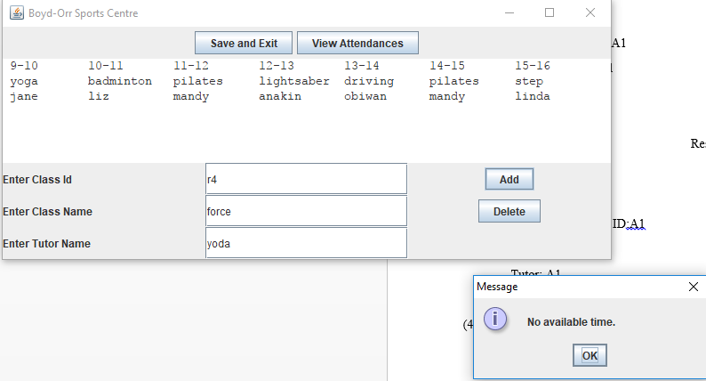

**Figure 6 full class list**

1. Delete a class

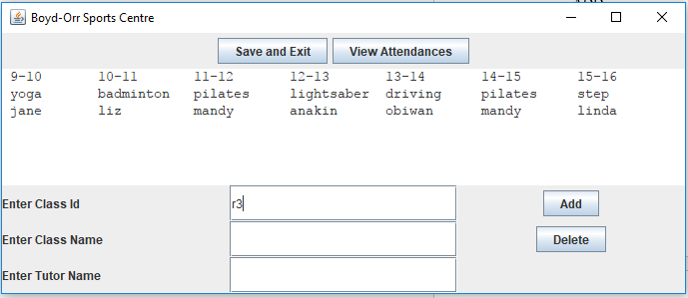

**Figure 7 delete a class(before)**

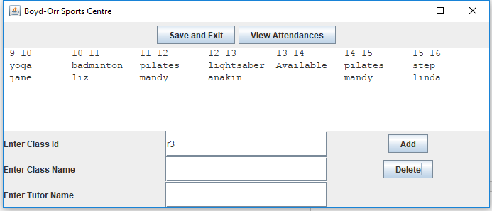

**Figure 8 delete a class(after)**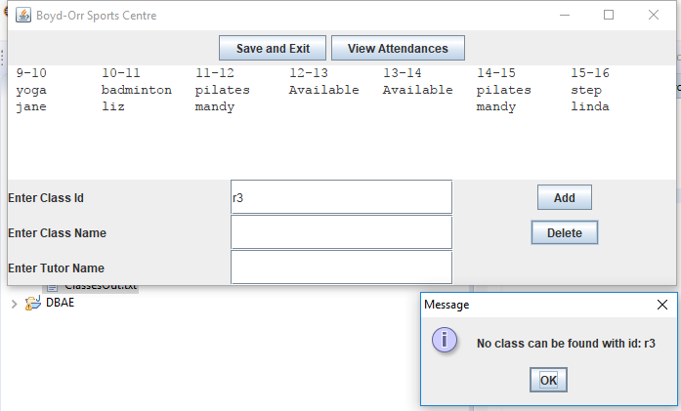

**Figure 9 not exist ID**

1. View attendances

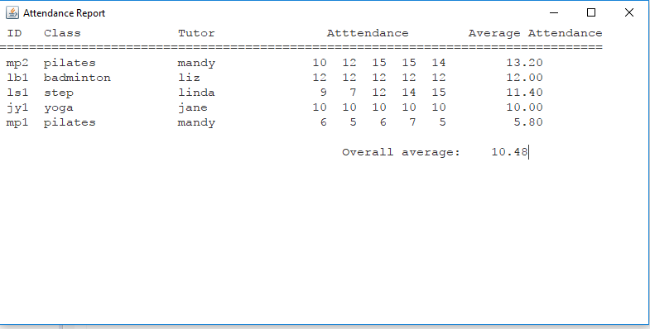

**Figure 10 original**

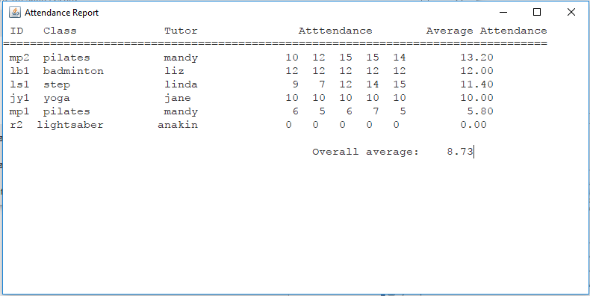

**Figure 11 after input**

1. Save and exit

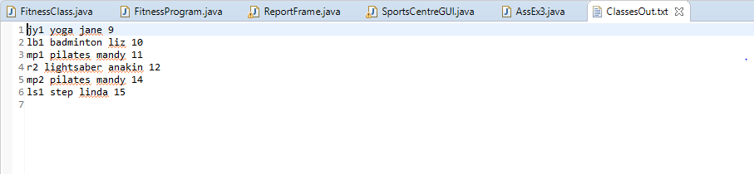

**Figure 12 save and exit**

1. Original GUI

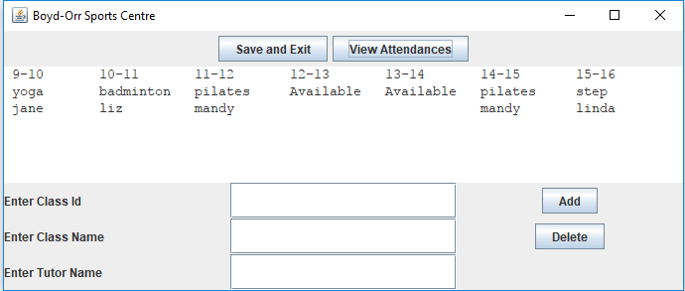

**Figure 13 original GUI**