Lesson 5 – Map Design
  - INFORMATION ON THIS LESSON
- In this lesson we want to create maps of the TUM area. Your job is to design a site map based on the study area. Please choose one of the following map topics:
A site map…
- helpful for people visiting the TUM,
- describing the museum quarter with the sites of the Pinakotheks, or
- showing which cafés can be visited around the TUM.

The map is intended to visualize only the important information for the map user in an aesthetic way. The user (the map reader) should be able to instantly perceive and understand main geographic objects, orientate by landmarks and be able to determine locations by geographical base information and labels. A map can help map users best when distractions are avoided and the important elements immediately catch the eye.

The following chapters will describe your workflow and will give you some information about map layout. Note that some steps may not be necessary for your resulting cartographic map. It is for You to design an individual overview map.

We hope you can incorporate knowledge of spatial analysis and integration, such as:
- Walking Time Analysis (Service Area): Calculate and visualize the ranges reachable within a 5, 10, and 15-minute walk from the main TUM entrance or other locations.
- Public Transport Coverage (Analyze Public Transport Accessibility): Create a buffer (comfortable walking distance) around subway or tram stations surrounding the focus area.
- Noise & Tranquillity Analysis (Buffer Analysis): Create buffers around major busy roads (e.g., Gabelsbergerstraße, Theresienstraße) to represent noise impact zones. Identify and mark which cafés are located outside these "noise buffers," indicating they are relatively quiet, study-friendly spots.
- Optimal Visit Route: Assume a tourist has only half a day and wants to visit the top 3-4 core locations. Use Network Analysis to calculate the shortest walking path connecting these points.
- Transport Competitiveness Map: Divide the area into zones colored by which mode is faster to reach the campus (e.g., "Red Zone" = Take U-Bahn, "Blue Zone" = Take Tram).
- Classic Recommendations & Landmarks(Viewshed): Run a visibility check (Viewshed Analysis) to show the user exactly which Munich landmarks (like the Frauenkirche) they can spot from the terrace.
- Decode the Streets: Use density analysis to differentiate the "Student Vibe" (Amalienstraße/Türkenstraße—cheap eats & copy shops) from the "Gallery District" (Brienner Straße). Or classify the surrounding areas based on their urban atmosphere.

You are encouraged to employ, but are not limited to, the following methods:
- Data Integration: Scrape, download, and integrate relevant data from open sources, government portals, or commercial platforms. (Note: This must be done within legal limits, and you must properly cite all sources and open-source licenses.)
- Custom Graphics: Use graphic design software (e.g., Adobe Illustrator, After Effects) to create your own artistic icons and visual elements.
- 3D Visualization: Design the map in a 2.5D (isometric) or fully 3D format.

  - EDITING PUBLIC TRANSPORT POINTS
The location of bus stops, tram stops and underground stations are important for people visiting places around the TUM. Therefore, we want to adjust our public transport points according to the MVV map (see picture on next page).

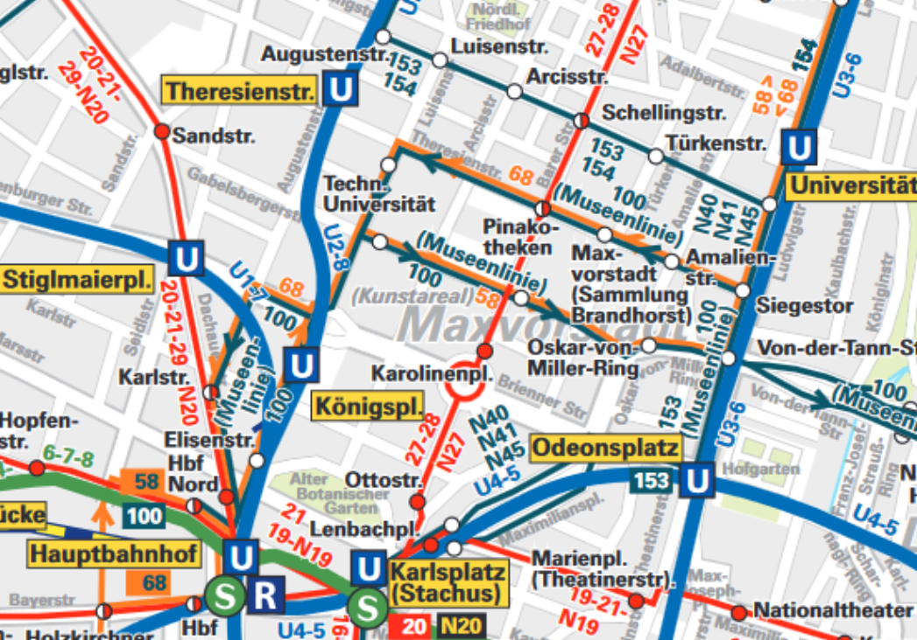
- Add any not digitized tram stops to Your layer tram_stops.

- Check the bus stops on the Schellingstraße. With one symbol for each direction this is a little redundant for cartographic purposes. Delete redundant bus stops so that each stop on the Schellingstraße (of both directions) features one bus symbol only. Modify the position of the bus stops, so that the symbols are moved onto the crossroads. But, prevent spatial conflicts with the tram stops.
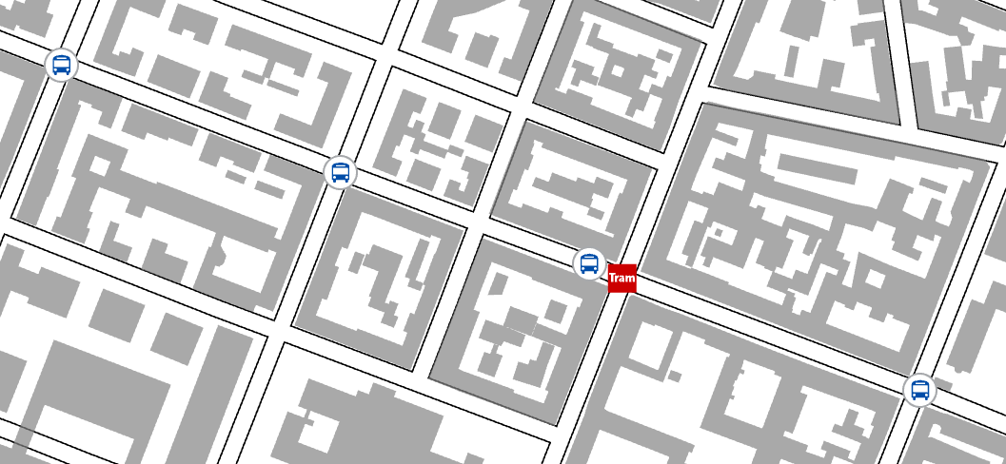

  - LABELLING
In ArcGIS Pro, labelling refers specifically to the process of automatically generating and placing descriptive text for features in maps. A label is a piece of text on the map that is dynamically placed and whose text string is derived from one or more feature attributes. With the use of type design, labels can also categorise objects and establish hierarchies.

Inserting Labels with a Halo
Halos are rendered buffers around each letter.
- Add legible labels to the bus stops using halos.
- In the Contents pane, RIGHT-CLICK on the layer bus_stops, and then CLICK on Label . The attribute field of this layer, name, appears as text string labels on the map. Note, that in some places the standard labelling format is difficult to read, especially when the label´s background is dark or graphically heterogenic. In the next step we will make the labels better readable.
- In the Contents pane, RIGHT-CLICK on the layer bus_stops to CLICK, this time, on Label Properties .
- On the Label Class pane, CLICK on Symbol, CLICK on General and expand the Halo menu. Here, CHOOSE a white colour as Halo symbol, and leave the Halo size on 1 pt. CLICK Apply to execute the settings and to view the results. The labels are now better legible.
- On the General tab, expand the Appearance menu. Here, CHOOSE a font under font name, SET a font size under Size and SET a colour under Color. CLICK Apply to execute the settings and to view the results.

Inserting Labels for a Feature Class
Label classes can be used to restrict labels to certain features or to specify label fields, symbols, scale ranges, label priorities, and sets of label placement options for groups of labels. For example, for a roads layer, you could use a different text size to label road types based on a field classifying roads by importance. I.e. You could also create a query to label only cities with a population greater than 1,000,000.
- Add labels to the museums, while not labelling the other features from this layer.

- In the Contents pane, CLICK to select the layer buildings. On the ribbon CLICK to open the Labeling tab and enable labelling by CLICKING on Label (in the Layer group).
- Under Label Class, CLICK on Label Expression . On the Label Expression tab under Expression You should see a link to the field name. Depending on the analysis from Lesson 4 it might have an alternative name such as feature['building_polygon.name'].
- On the Label Class pane, CLICK on the SQL query tab . and CLICK New expression .In order to address only museum, SELECT to add an expression that states: Where tourism is equal to museum. CLICK Apply. Only the museum buildings should feature labels from the buildings layer.
- On the Label Class pane, CLICK on Symbol, CLICK on General and expand the Appearance menu. Here, CHOOSE a font under font name, SET a font size under Size and SET a colour under Color. The museum labels should be in a different style than the bus stop labels. CLICK Apply to execute the settings and to view the results.

Inserting Street Labels
- Add orientated street labels that are positioned between the road casings.

- In the Contents pane, CLICK to select the layer roads. On the ribbon CLICK to open the Labeling tab and enable labelling by CLICKING on Label (in the Layer group). The attribute field of this layer, name, appears as text string labels on the map. You see that the labels are (as a line feature) automatically orientated to the streets and positioned over the streets. This positioning is to be adapted in the following work steps.
- Under Label Placement, scroll to search, and CLICK on European Streets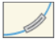. The street labels are now positioned on the streets. This suits the case line design.
- On the Label Class pane, CLICK on Position, and on Conflict resolution . Expand Remove duplicate labels and SELCT the option Remove all from the dropdown arrow. This gets rid of redundant and overcrowded labels.
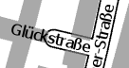
- Some of the street labels overrun the road geometry due to limited space. As these small streets are of lesser importance, overrunning is to be prevented. On the Label Class pane, CLICK on Position > Fitting Strategy . Expand the option Overrun. ENTER 5 Points as Maximum value for overrunning.
- You may have to adjust the label sizes to the road width. CLICK on General and expand the Appearance menu. CHOOSE a font under font name and SET a font size under Size.

Weighting Labels and Features
Label weights and feature weights are used to assign relative importance to labels and features. Use this weight only when there is a conflict, that is, an overlap between a label and a feature. Ultimately, the final positioning of labels on your map is dependent on label and feature weights. In addition, when working with weights, remember that when you allow labels to overlap some features, generally, more labels will be placed on your map because the label engine has more room to place them.
The feature weights are ranked on a scale of 1-1000. A feature weight of 0 indicates that the feature should be treated as available space, while a weight of 1000 indicates that the feature is considered an obstacle and should not be overlapped by labels. The Maplex Label Engine first attempts to place labels in an area of free space. If there is no free space available and a feature must be overlapped, a location with the lowest total feature weight is chosen.
- Currently, some labels overlap with public transport symbols. This makes reading of the two rather difficult. Assign higher weights to the tram_stops and underground_stations layers, so that no street labels occlude tram stop or underground station symbols.
- On the Labeling tab, in the Map group, CLICK More > Weights. The Label Weight Ranking dialog box will open.
- On the Feature Layers tab, CLICK the field Feature Weight next to the underground_stations layer. Change the weight number to 500. Change also the tram_stops weight number to 500.
- CLICK Apply to execute the settings and OK to close the Label Weight Ranking dialog box.
- You should see that there are no remaining conflicts between street labels and tram stop or underground station symbols.

Adding a Layout
To share your work as a printed map, poster, or PDF, you need to make a layout. In ArcGIS Pro, a layout is the composition a map, along with supporting elements, such as a title, a legend, and descriptive text. Some layouts include more than one map. For example, a layout may have a main map and an inset map to show the main map in a larger geographic context.

- Insert a new map layout to Your project. The map should be in A3. You can choose portrait (tall) or landscape (wide) orientation of the A3 page size format. Depending on Your mapping type choice in 5.1, consider which orientation would suit your map best.
The first step in making a page layout is to insert a blank layout.

- On the ribbon, CLICK the Insert tab. In the Project group, CLICK New Layout to show page size and orientation options.
- Under ISO - Portrait or ISO - Landscape, CLICK the A3 page settings of Your choice. A new, blank layout view opens.
- Give the layout a name by RIGHT-CLICKING the layout name in the Contents pane and CLICKING Properties, to open the Layout Properties dialog box. TYPE to enter the name Map Layout under General > Name. CLICK OK to confirm.
- If needed, the page size and orientation can be altered under Page Setup in the Layout Properties dialog box.
- You can also CLICK the Layout tab and use the controls in the Page Setup group to change the page size or orientation after creation.

Adding Guides
Guides are available to help you position and size elements on the page. They are nonprinting lines that help you align elements on the layout.

- Add some helpful guides to the layout.

- RIGHT-CLICK the top ruler on the Layout,
- and CLICK Add Multiple Guides...
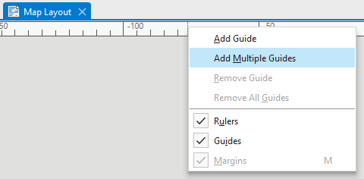

- On the Add Guides dialog box, under Orientation, CLICK Both. CLICK the Placement drop-down menu and CLICK Offset from edge. Replace the value in the Margin box with 25 mm. CLICK OK. Blue-coloured guides are added to the layout at 25 mm from the edge of the page.
- Add a further guide by RIGHT-CLICKING on either the horizontal or vertical ruler and CLICKING on Add Guide. A single guide is added at the position you clicked.
- On the ruler, PLACE the mouse pointer at the location of the guide you just added. A blue triangle indicates that the guide is selected. DRAG the guide for repositioning.
- As you drag the guide, a ScreenTip displays the decimal equivalent of the ruler marks.
- RIGHT-CLICK a blue triangle of a guide and CLICK Remove Guide to delete any guide.

- You can toggle the visibility of Guides and Rulers on the Layout tab in the Show group.

  - INSERTING A MAP FRAME
Map frames are containers for maps on your page. They can point to any map or scene in your project. They can even be empty, which most often occurs when creating templates. It is important to note that the extent of the map inside a map frame is unique and independent of any map view that may be open in the project.
- A map frame can be added to your layout in a variety of shapes. Complete the following steps to add a map frame to your layout.

- On the ribbon, on the Insert tab, in the Map Frames group, CLICK the Map Frame drop-down menu. Under Map, CLICK the thumbnail image of the TUM study area.
- Using your mouse, draw a large rectangle for the map frame on the layout. The Map Frame is added to the layout. It is currently selected, as indicated by selection handles. On the ribbon, the Map Frame contextual tab appears.
- Use the selection handles to resize the map frame. Align its top and bottom edges to the vertical guides. Dragged map elements snap to the guides.
- Resizing the map frame changes the scale and extent of the map, so you may want to make adjustments. To work with the map as a map - rather than as a layout element - you activate the map frame. On the ribbon, CLICK the Layout tab. In the Map group, CLICK Activate . The layout turns gray. On the ribbon, the layout tools are replaced by map tools.
- DRAG and SCROLL to pan and zoom the map to an extent that you like.
- Use the map scale box in the lower left corner of the layout view to set an exact map scale. You can choose a scale from the drop-down list or type a value directly in the scale box.
- On the ribbon, CLICK the Layout tab. In the Map group, CLICK Close Activation to get back to the layout view.

- Once a map has been added to the layout, you can interact with its layers through the layout's Contents pane as you would through the map's Contents pane. There, you have access to a layer's context menu, contextual tabs, and symbology. You also have access to limited navigation controls in the Map group on the Layout tab.

Modifying a Map Frame
After you've inserted a map frame, you can make changes to its appearance and properties. You can change the map a map frame contains; change the shape of the map frame; add an extent indicator; or add a border, background, and shadow.
- Change the name of the map frame (to prevent later confusion), and change the map border style.

- CLICK on the map frame on the layout view to activate it.
- RIGHT-CLICK on the map frame and CLICK Properties . The Map Frame pane opens.
- On the activated Options tab , CLICK on the Name box and ENTER the name Main Frame.
- CLICK on the Display tab . In the Border group, change the Line colour (Symbol) to Gray 50%.
- You can give the map frame a background and a shadow on the Display tab

Adding an Inset Map
- Add a new map tab that contains layers for an inset map and make a rectangle polygon showing the area of concern. Add a new inset map to the map layout and style it with a drop shadow.

- On the ribbon, on the Insert tab, in the Project group, CLICK the New Map dropdown menu and SELECT New Map. A new map is created.
- On the Contents pane of the new map, RIGHT-CLICK on the new map and CLICK Properties . The Map Properties window opens. Under Name, TYPE in Inset Map and confirm by CLICKING OK.
- On the ribbon, on the Map tab, CLICK the Basemap 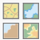 dropdown menu to select an Esri given background map type, i.e. Topographic.
- Create a new layer for a rectangle indicating the study area. Go to the Catalog view and use the tool Create Feature Class to make a new feature class named Inset_Rectangle. (see Lesson 1 for help)
- Back on the Inset Map view, navigate so the Munich area is depicted on the map face.
- Add the Inset_Rectangle layer and the buildings layer to the Inset Map Contents pane. The buildings layer is only for reference.
- Roughly create a new rectangle feature around the study area by using the Rectangle editing tool. CLICK to Save  the editing. (see Lesson 1 for help)
- Now that the rectangle is created, toggle off the visibility of the buildings layer.
- Go to the Symbology of the Inset_Rectangle layer. Assign no fill colour and a strong outline colour. The outline width probably has to be ≥ 3pt for a clear depiction in the inset map. (see Lesson 2 for help)
- CLICK on the Map Layout tab to switch back to the Map Layout view.
- On the ribbon, on the Insert tab, in the Map Frames group, CLICK the Rectangle dropdown menu and SELECT Circle. Then CLICK the Map Frame drop-down menu. This time, CLICK to SELECT the Inset Map thumbnail.
- CLICK on the layout page, HOLD and DRAG using your mouse to draw a circle for the map frame on the layout. The new Inset Map Frame is added to the layout.
- RIGHT-CLICK on the map frame and CLICK Properties . The Map Frame pane opens.
- CLICK on the Display tab . In the Shadow group, change the Symbol colour to a gray value. The inset map gets a drop shadow.
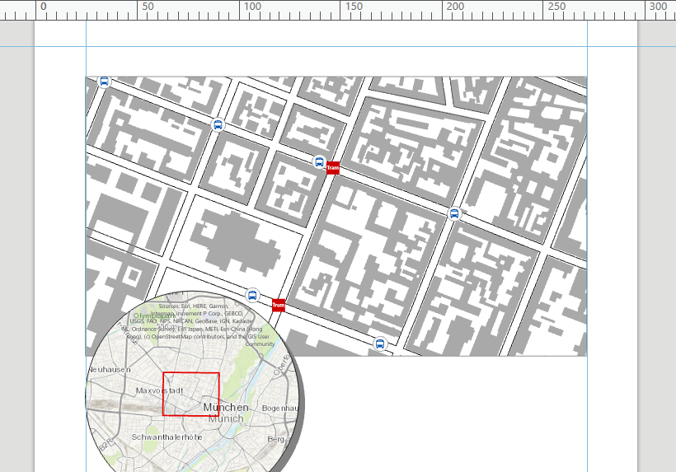

  - ADDING MAP LAYOUT ELEMENTS
In ArcGIS Pro you can add a legend, north arrow, and scale bar to the layout. The legend explains the map's symbology. The north arrow and scale bar provide geographic context.

Adding a North Arrow
A north arrow maintains a connection to a map frame and indicates the orientation of the map inside the frame. When the map rotates, the north arrow element rotates with it.
- Insert a North Arrow, assign it to the main map frame (not the inset map frame) and inspect the direction alterations of different definitions of north.
- On the Insert tab, in the Map Surrounds group, CLICK North Arrow .
- CLICK the top half of the button to insert the current default north arrow. CLICK the bottom half of the button to choose from a gallery of north arrows.
- On the layout, DRAG to position the north arrow.
- RIGHT-CLICK on the north arrow and CLICK Properties to open the North Arrow pane.
- Under Options, North Arrow, SELECT the Main Frame as Map Frame. Now the North Arrow is connected to the Main Frame.
- Control the orientation of the north arrow by choosing an option for Type:
- Map North - The north arrow points to a northbound grid line parallel to the central meridian. This is defined as grid north
- True North - The north arrow angle points to geodetic north (to the north pole) as calculated by the coordinate system of the associated map frame, at the centre of the map.
- Magnetic North - The north arrow angle points to the north magnetic pole, as indicated by the north-seeking needle of a magnetic instrument.
Toggle between Map North and True North and see the inclination for True North. At the central meridian of this UTM stripe grid north and geodetic north would be equal. Though, our study area is located east to the central meridian – that is why the north arrow points slightly to the west, in direction of the north pole.

Adding a Scale Bar
Scale bars provide a visual indication of the size of features, and distance between features, on the map. A scale bar is a line or bar divided into parts. It is labelled with its ground length, usually in multiples of map units, such as tens of kilometres. When a scale bar is added to the layout, it is associated with a map frame and maintains a connection to the map inside the frame. If the map scale changes, the scale bar updates to remain correct. You can modify a scale bar's properties - such as its appearance, size, and position - using the Format tab on the ribbon and the Format Scale Bar pane.

- On the Insert tab, in the Map Surrounds group, click the Scale Bar drop-down menu. CLICK to select a Metric scale bar.
- On the layout, CLICK and DRAG to position and enlarge the scale bar.
- If not already opened, RIGHT-CLICK on the scale bar and CLICK Properties to open the Scale Bar pane.
- Under Options, Scale Bar, SELECT the Main Frame as Map Frame. Now the Scale Bar is connected to the Main Frame.
- Under the Map Units group, SET the Map Units as well as the Label Text to Metres.
- A scale bar should show rounded unit values. CLICK on the Properties tab 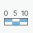. In the Fitting Strategy group, choose Adjust number of divisions. In the Divisions group, ENTER a rounded Division Value i.e. 100.
- On the layout, resize the scale bar by DRAGGING its side edge, so that you receive an appropriate length as well as an appropriate number of divisions.
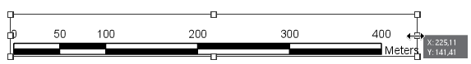
- If required, adjust the number of Subdivisions, under Divisions. DRAG the scale bar to a convenient place on your layout.

Adding a Legend
A legend tells the map reader the meaning of the symbols used to represent features on the map. When a layer is added to a legend, it becomes a legend item with a patch showing an example of the map symbols and explanatory text. Legends can be added to your layout based on a map or a smaller group of the map's layers.
- In the Map Surrounds group, CLICK Legend . Draw a rectangle with the mouse on the layout.
- If not already opened, RIGHT-CLICK on the legend and CLICK Properties to open the Legend pane.
- Under Options, Legend, SELECT the Main Frame as Map Frame. Now the Legend is connected to the Main Frame.
- CLICK on the Display tab to adjust the border around the legend box, the background, or shadow effects.
- CLICK on Legend Arrangement Options . Under, Fitting Strategy SELECT Adjust columns and font size. When You resize the legend using edges of the legend item on the layout, columns and font size will adjust to the geometry of the rectangle.
- Under, Fitting Strategy, you can also define a Minimum font size.
- During the previous lessons lots of layers have been acquired that are not appropriate for the mapping task of this lesson. On the Contents pane, CLICK on the black expand triangle next to Legend. Here You can toggle the visibility of layers on the legend on or off. Try this function by CLICKING to uncheck some layers.
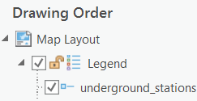
- Note, only layers that are visible in the Map view will be shown on the legend.
- Some layers (that are to be shown in the final map) will not have easily understandable layer names to a user. Rename these layers by CLICKING TWICE on the layer names in the Contents pane, under Main Frame, and TYPING names appropriate for the legend.
- Align the legend to a guide of your layout. CLICK on the legend in the layout, HOVER over the element borders and DRAG to move this map element. It should snap to a guide.

Adding a Picture
You can add pictures to your layout. The insert picture command can be found on the Insert tab in the Graphics group.
- On Moodle, download the file Layout Pictures.zip, unzip it, and save the containing images in a folder with your geodata.
- In the Graphics group, CLICK the Picture button .
- The Insert Picture dialog box appears. Browse to the unzipped folder, choose to CLICK one of the images and CLICK Open.
- On the layout, CLICK and DRAG a rectangle to add the picture.
- After you've added a picture to your layout, you can move it, resize it, change its colour or symbol, and so on, via the Format tab.

Adding a Grid
Grids can be added to a map frame to show coordinates and divide the map frame. There are four types of grids that can be added to a map frame: graticules, measured grids, MGRS grids, and reference girds.
Graticules are lines showing parallels of latitude and meridians of longitude for the earth. They are used to show location in geographic coordinates (degrees of latitude and longitude). A measured grid is a network of evenly spaced horizontal and vertical lines used to identify locations on a map. They are used to show location using projected coordinates.
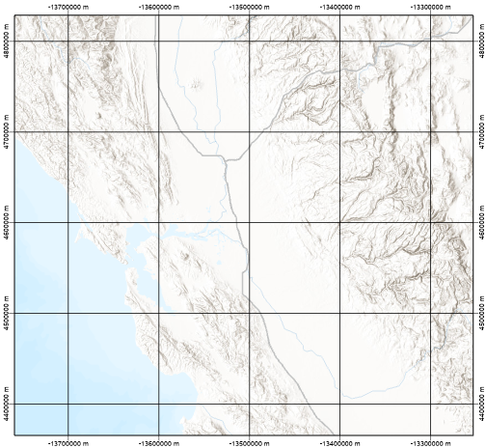
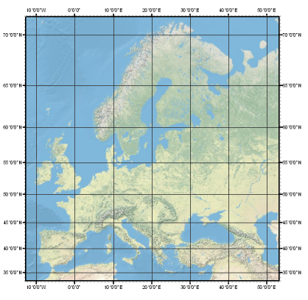
Graticule Measured grid
A Military Grid Reference System (MGRS) grid is a special military style type of measured grid. It is used to show locations in a UTM coordinate system and display MGRS specific information, such as 100,000-meter grid designators. A reference grid is a network of columns and rows used to divide a map into equal-area rectangles. They are used to visually divide the map, independent of the coordinate system, to allow simple location referencing.
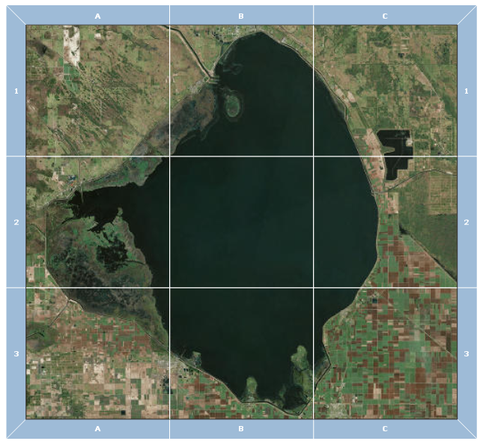
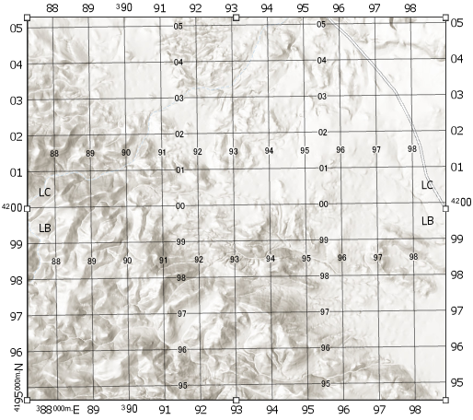
MGRS grid Reference grid
- To add a grid in an active layout view, SELECT the Main Frame in the Contents pane.
- On the Insert tab, in the Map Frames group, CLICK Grid .
- As we have a projected study area, SELECT a Measured Grid from the gallery. The grid is added to the map frame.
- To modify the measured grid, RIGHT-CLICK it in the Contents pane and CLICK Properties to open the Format Map Grid pane.
- CLICK on the options tab . EXPAND the Interval menu and CLICK to uncheck the Automatically adjust check box. This gives us more freedom of grid styling.
- The grid components are managed on the Components tab of the Format Map Grid pane. CLICK on the Components tab .
- The component Labels should be activated. Under Interval, CHANGE the interval to 200 Metres in X and in Y.
- Further reduce the grid, by UNCHECKING North and South under Visible.
- CLICK under Components on Gridlines to adapt the gridlines to the labels. Also here, under Interval, CHANGE the interval to 200 Metres in X and in Y.
- Next CLICK under Components on Ticks. Ticks are the linear marks at the edges of the grid. To make the grid more harmonic, UNCHECK North and South under Visible.

- Measured Grids are essential map elements for topographic maps, for which orienteering in the countryside is one objective. However, for a site map in an urban environment it is probably not needed.

Adding Text
You can add point and paragraph text to your layout. The benefit of paragraph text is that the text wraps inside the given shape.
- Add text elements to create a title as well as map author information using paragraph and point text.

- In the Graphics and Text group on the Insert tab, CLICK on the dropdown menu to extend the options and CLICK on Rectangle .
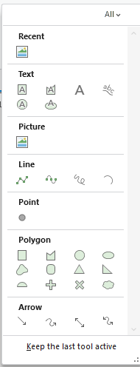
- On the layout, CLICK and DRAG a rectangle to add the text element. The Format Text pane opens.
- DOUBLE-CLICK on the TEXT to activate and TYPE a title for your map.
- On the (Format) Text pane, CLICK on Text Symbol. Then CLICK on General and expand the Appearance menu. Here, CHOOSE a font under font name and SET a colour under Color. CLICK Apply to execute the settings and to view the results.
- On the layout, resize the title by DRAGGING its side edge, so that you receive an appropriate title size for the layout.

- To insert a new text element, CLICK on Rectangle (in the Graphics and Text group on the same dropdown menu)
- On the layout, CLICK and DRAG a rectangle to add the new text element. The Format Text pane opens.
- DOUBLE-CLICK on the TEXT to activate and TYPE your name. This will be the map author information on the map.
- On the Format Text pane, CLICK on Text Symbol and on Properties. CLICK on General and expand the Appearance menu. Here, CHOOSE a font under font name, SET a font size under Size and SET a colour under Color. CLICK Apply to execute the settings and to view the results.
- Move the text elements to favoured places on the map.

  - DESIGNING THE MAP
- After performing all the lesson´s working steps there will be many needed design adaptions for your site map.

- Make sure only required features are visible on the map frame (depending on your map topic /title). Furthermore, set a logical order in the Contents pane, so that major information overlays lesser important information.
- Improve the symbology, so that the features are easily legible and understandable.
- Adjust the labelling of features, so that all important objects are described and all labels are readable. The positioning of labels should enable an uncomplicated assigning to its feature.
- Adjust the sizes and positions of the map layout elements. The overall map appearance should be harmonic.
- Make sure that the crucial information on Your map can be immediately identified by a map reader. I.e. You can ask a fellow student what he thinks of Your map.

  - EXPORTING THE MAP
ArcGIS Pro can export to several industry-standard file formats. However, before exporting the map make sure Your map fulfils the following conditions. Your site map should be:
1. Easy to read,
2. Interesting,
3. Neat and Clear,
4. Suitable for the intended audience, and
5. Simple to understand.
- If no further design adjustments are to be made You are ready for export. Export to PDF in a DIN A3 page size and upload Your result onto Moodle.

- While on Your activated Map Layout tab, go to the Share tab on the ribbon and CLICK on Export Layout (in the Output group). The Export Layout window opens.
- CHOOSE a file name containing your surname.
- Increase the Resolution onto 240 DPI. Leave the Image Quality set on Best.
- CLICK on Export to create your PDF File.
- Open the PDF file and zoom on critical areas of the map to ensure all required elements have been exported to the map and that the graphical quality is fine (for an A3 page size). If not, repeat the Export workflow with adapted settings.
- Upload onto Moodle under Submission: Exercise 5.

- If You are having problems exporting to PDF, you can export and upload the map as an image file.
Contents
Lesson 5 – Map Design 1
5.1 INFORMATION ON THIS LESSON 1
5.2 EDITING PUBLIC TRANSPORT POINTS 1
5.3 LABELLING 3
5.3.1. Inserting Labels with a Halo 3
5.3.2. Inserting Labels for a Feature Class 3
5.3.3. Inserting Street Labels 4
5.3.4. Weighting Labels and Features 5
5.3.5. Adding a Layout 5
5.3.6. Adding Guides 6
5.4 INSERTING A MAP FRAME 7
5.4.1 Modifying a Map Frame 8
5.4.2 Adding an Inset Map 8
5.5 ADDING MAP LAYOUT ELEMENTS 10
5.5.1 Adding a North Arrow 10
5.5.2 Adding a Scale Bar 10
5.5.3 Adding a Legend 11
5.5.4 Adding a Picture 12
5.5.5 Adding a Grid 12
5.5.6 Adding Text 14
5.6 DESIGNING THE MAP 15
5.7 EXPORTING THE MAP 16

