**Satellite Geodesy: Lab3 Report**

Group 6: Zhenyang Hua, Xipeng Li, Yushuo Feng

February 4, 2023

**1.Introduction：**

Lab 3 ask us to conduct an analysis of global gravity variations using GRACE satellite data and HI model data, specifically focusing on mass changes within the Greenland ice sheet. Initially, we will select a time interval during which both types of data are available, to estimate the linear trend and annual amplitude for each grid point. Following this, we will visualize these linear trends and amplitudes, analyzing and interpreting mass changes on a global scale. Moreover, we will verify whether the mass variations derived from GRACE data equal the sum of the variations from HI data and the linear change from the ICE-5G model, discussing our findings through the comparison of global maps. Lastly, focusing on Greenland, calculate and visualize the mass variations from GRACE and HI data using a specified mask, calculate the linear trends and annual amplitudes of these variations, and discuss the similarities and differences observed, as well as the reasons behind them.

**2.Data description  
 ‘GGOS_lab3_data.mat’:  
(1)Time Vectors t_GRACE and t_HI:** These are MATLAB serial date numbers, which represent points in time specifically formatted for MATLAB. They are likely vectors containing timestamps for the GRACE and HI data sets, respectively.

**(2)3D Matrix of Surface Density Variations ewh_GRACE:** This is a three-dimensional matrix where the third dimension corresponds to time. The values represent variations in surface density (given in equivalent water height - EWH) for the GRACE data set, typically in mm EWH or kg/m². This data can be used to analyze changes in mass, such as ice melt or water accumulation, over time.

**(3)3D Matrix of the HI Model Data ewh_HI:** Similar to ewh_GRACE, this three-dimensional matrix contains data for the HI (Hydrology and Ice) model, detailing the variations in surface density over time, also in mm EWH or kg/m².

**(4)2D Matrix of the Gravity Trend from the GIA Model ewh_ICE5G:** This two-dimensional matrix provides the gravity trend data from the GIA (Glacial Isostatic Adjustment) model called ICE-5G. The values are given in terms of equivalent water heights per year (mm EWH/year or kg/m²/year). This data reflects the long-term changes in the Earth's gravity field due to past ice mass changes and is used to adjust the current observations for these historical effects.

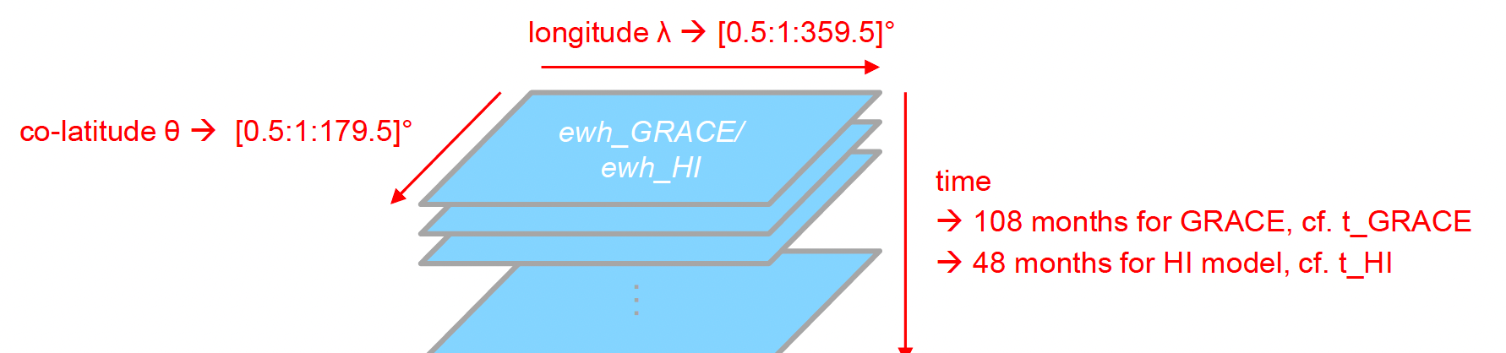

**(5)Regional Mask for Greenland greenlandmask:** This is a binary matrix (containing ones and zeros) that serves as a mask to isolate the Greenland region from the rest of the data. A value of 1 corresponds to Greenland, and a value of 0 corresponds to other regions.

Overall, these data sets provide the necessary inputs to analyze temporal changes in Earth's gravity field, attributed to variations in mass distribution primarily due to hydrological and cryospheric changes, and to validate models against the observed data.

**3.Methodology:**

**3.1 Derive integrated mass variations over Greenland for each month of GRACE and HI data：**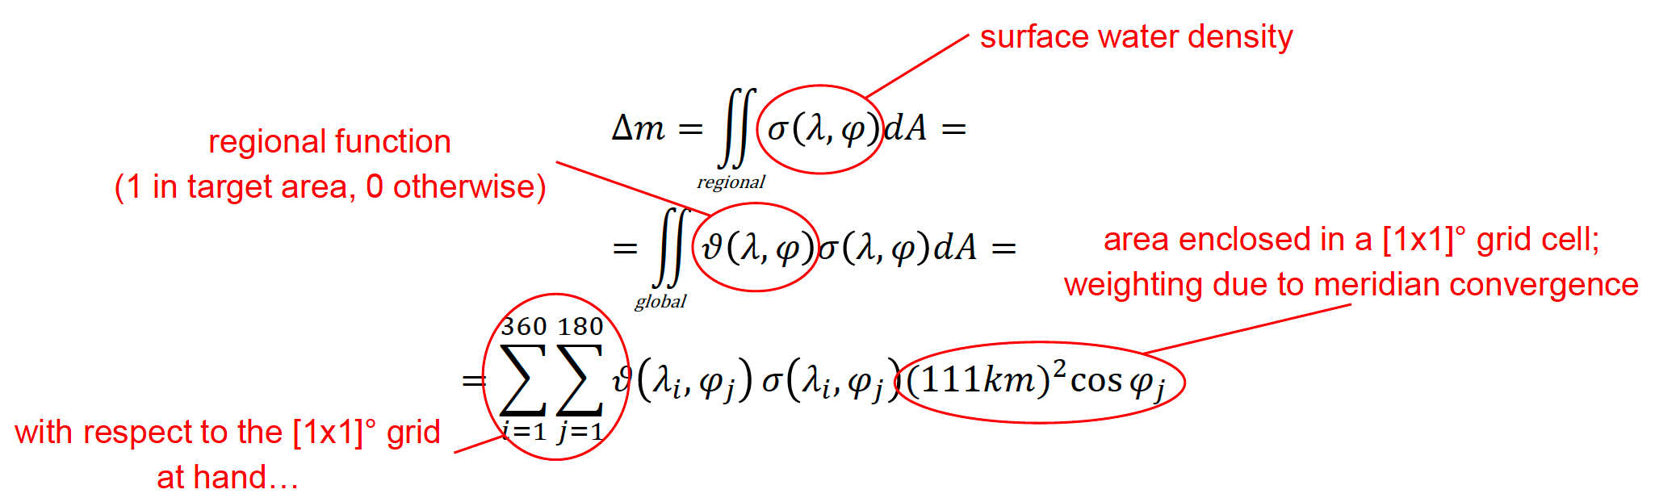

The formula is describing how to calculate the integrated mass variations over Greenland using the GRACE and HI data:  
(1)Δm is the change in mass that will be calculating.

(2)σ(λ, φ)dA is the surface density (σ) at a given latitude (φ) and longitude (λ) multiplied by the area element (dA). This represents the contribution of a small area element to the total mass change.

(3)The integral (∬...dA) is the mathematical operation that sums up the contributions from all area elements to get the total mass change over the region.

(4)The regional function ϑ(λ, φ) is 1 inside the target area (Greenland) and 0 elsewhere. It's used to select only those contributions that are within Greenland.

(5)The expression (111km)^2 cos(φj) accounts for the actual area of each [1x1]° grid cell, considering that the area of a grid cell decreases with the cosine of the latitude due to the convergence of meridians towards the poles.

In summary,this translates the integral into a discrete summation over the grid cells of the [1x1]° grid that covers Greenland. Sum over all longitudes (i from 1 to 360) and latitudes (j from 1 to 180), but only include the cells within Greenland as defined by the regional function ϑ. The surface density σ at each grid cell is multiplied by the area of that cell, taking into account the cosine latitude correction for meridian convergence.

**3.2 Account for the effect of GIA in case of GRACE**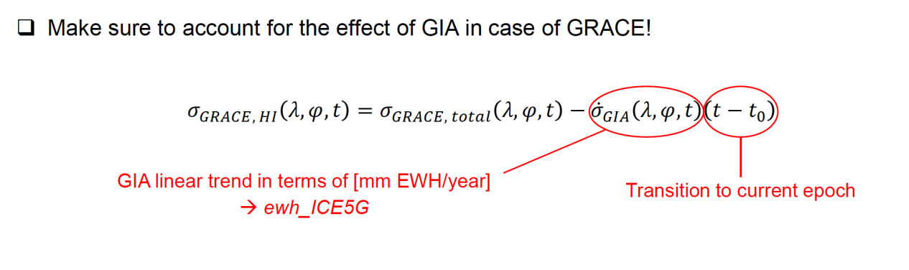

The formula describes how to remove the contribution of GIA from the total surface water density observed by GRACE to obtain the surface water density that reflects purely hydrological and glaciological effects, such as changes in mass due to melting ice or precipitation.

(1)σ_GRACE,HI(λ, φ, t) represents the surface water density observed by GRACE data at a specific time (t) and location (defined by longitude λ and latitude φ), adjusted to reflect actual hydrological and glaciological changes.

(2)σ_GRACE,total(λ, φ, t) is the total surface water density as shown by GRACE data, which includes the effects of hydrological and glaciological changes as well as GIA.

(3)σ̇_GIA(λ, φ, t) is the rate of change in surface water density predicted by the GIA model, usually expressed in equivalent water height per year (mm EWH/year). This represents the annual contribution of GIA to the surface water density, which is a linear trend.

(4)(t - t₀) represents the time difference from a reference time (t₀) to the current time (t). This time difference is used to transition the linear trend predicted by the GIA model to the current epoch.

(5)ewh_ICE5G is likely a variable containing GIA model data, which represents the rate of change in water density due to GIA.

In summary, to obtain the GRACE hydrological and glaciological surface water density changes that do not include the impact of GIA, we need to subtract the surface water density change predicted by the GIA model from the total surface water density data provided by GRACE, multiplied by the time difference.

**4.Results and Analysis:  
4.1.1:**Based on monthly GRACE (Gravity Recovery and Climate Experiment) solutions and Hydrological Isostasy (HI) data, we will performs an analysis of global gravity variations .However, as we know, the dataset includes 108 months of GRACE data and 48 months of HI data. So, for GRACE data, we selected the interval from the start index 1 to the end index 44.For HI data, the interval is from the start index 3 to the end index 48. At the mean time, we converted the time points t_GRACE and t_HI from days to years by dividing by 365 to work with them in a yearly context.

Following with this, we initialized a parameters matrix para_GRACE and para_HI for both GRACE and HI datasets, respectively, with dimensions (180, 360, 4), assuming a global grid of 180 latitudes by 360 longitudes and 4 parameters to estimate for each grid point (intercept, linear trend, and coefficients for the cosine and sine terms of the annual signal). Then loop through all latitudes and longitudes, For each latitude and longitude, you form a design matrix A including a constant term (for intercept), a linear term (for trend), and sinusoidal terms (for capturing the annual cycle). After that, solve the least squares problem to estimate the parameters for each grid point, which are stored in para_GRACE and para_HI. Finally, calculate the linear term and annual signal for every grid point.

4.1.2: