Reasoning/Thesis
We are looking into this in Maryland to have a relationship to look into in highly populated states to see what some of the contributing factors to violent and property crime may be so that there may be work to combat this.

Data From:

Violent Crime & Property Crime by County: 1975 to Present
Maryland Statistical Analysis Center (MSAC), within the Governor's Office of Crime Control and Prevention (GOCCP). MSAC, in turn, receives these data from the Maryland State Police's annual Uniform Crime Reports

Median Household Income in Maryland and Jurisdictions, 2013-2023
Source from the U.S. Census Bureau, Small Area Income and Poverty Estimates, November 2023.

Maryland Per Capita Personal Income (Current Dollars): 2013-2023
Maryland Per Capita Personal Income (Current Dollars) from 2013-2023. Source U.S. Bureau of Economic Analysis (BEA), December 2023

Preliminary Research on Cities/Counties of Interest From:

H1= There is a direct relationship between the proportion of income/population to the violent and property crime in counties in Maryland.

H2=The relationship between proportion of income/population to the violent and property crime in counties in Maryland is coincidental.

Area of Research
Relationship between the proportion of INC/POP to Crime.Look if the trend line for individual counties follow the trend of the state.
Opposite trend - When one goes up the other goes down

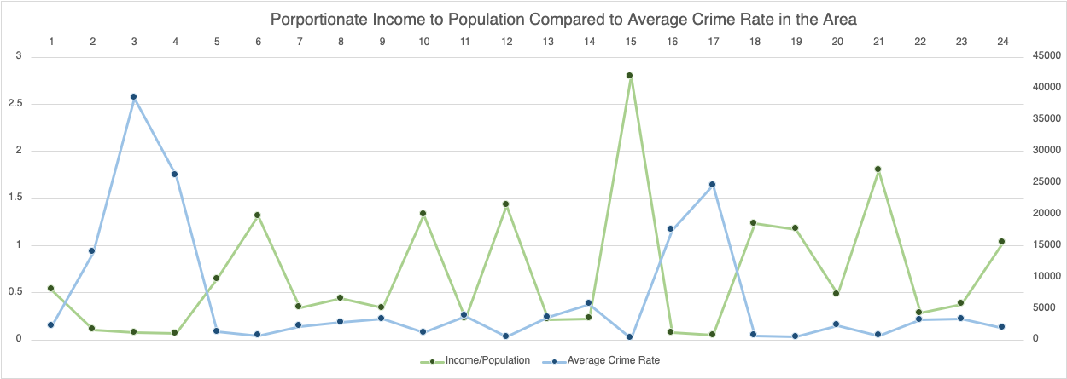

Using the highlighted cases, we looked at the change over time to see if the trend appeared there as well. The trend looks to appear in the highlighted cases as well, additionally, there seems to be a downward trend of crime in the time period

Cities/Counties of Interest

Baltimore City
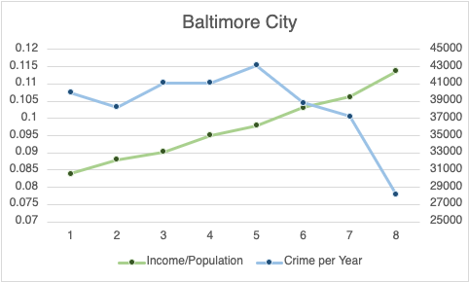

Caroline County
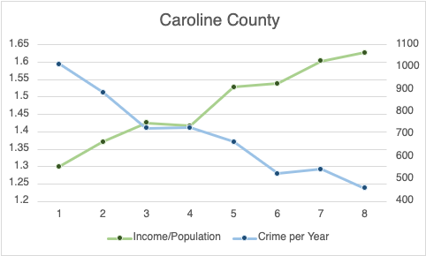

Garrett County
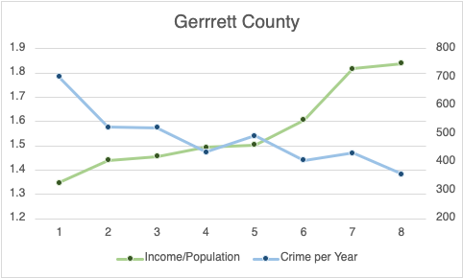

Kent County
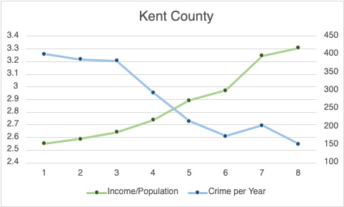

Prince George County
