Migrating SME On-Premises Services to Cloud Platform as a Service – From Analysis to Deployment

Lewis Fulljames

FUL16630227

A thesis submitted in partial fulfilment of the degree of BSc(Hons) Computer Science

School of Computer Science

University of Lincoln

2019

Contents

Abstract 3

Introduction 4

Why was the project done? 4

Literature Review 5

Pros/Cons of moving to the cloud 5

Benefits of Cloud Computing 5

Drawbacks of Cloud Computing 6

Cloud Models 6

Infrastructure-as-a-Service: IaaS 6

Platform-as-a-Service: PaaS 8

Software-as-a-Service: SaaS 9

Cloud Migration Planning 10

Methodology 13

Project Management 13

Software Development 14

Toolsets and Machine Environments 14

Design, Development and Evaluation 15

Requirements elicitation, collection and analysis 15

Risk Analysis Diagram 16

Cost Analysis Diagram 18

Diagrams ….. 18

Design ….. 18

Implementation ….. 18

Evaluation ….. 18

Bibliography 20

# Abstract

This project investigates how an SME migrates its on-premise resources to a suitable cloud vendor with minimal configurations and downtime. There is a need for this investigation as cloud adoption by enterprises within the UK have been steadily increasing over the previous five years and are predicted to increase further as cloud services improve and expand. In 2014 UK 24% of enterprises adopted the cloud, which grew to 35% in 2016 and in 2018 has risen to 42% (Eurostat Press Office, 2018; Eurostat, 2017; Eurostat Press Office, 2014).

The report presents documentation for the risk assessment and cost analysis of cloud providers, as well as migration diagrams showing the transition of on-premise resource to a cloud environment. As well as adequate testing of the deployed resources, a literature review is provided to investigate the pros and cons of cloud migration, critical analysis of popular cloud models, as well as precautions that need to be implemented to avoid downtime and minimal configuration. The deployment and migration was achieved with the use of YAML and JINJA files. The resources were deployed onto Google Cloud, due to the University’s education partnership with Google.

# Introduction

## Why was the project done?

The aim of this project is to migrate Beacon Inc’s internal resources to the cloud with the appropriate planning and documentation

To achieve this aim a literature review was produced which uncovered the pros and cons of cloud computing from both a business and technical standpoint, critical analysis of popular cloud models, as well as precautions that need to be implemented to avoid downtime and minimal configuration. As well as a cost and risk analysis of multiple cloud vendors with cloud infrastructure diagrams displaying how the cloud resources are connected in the cloud environment.

Beacon Inc. is a small-medium sized enterprise (SME) which offers hardware and software systems for proximity-based ibeacons in the retail and marketing sector. This project investigates the best practices of migrating on-premise services of an SME to a cloud environment. Ensuring minimal downtime and configuration, by migrating resources quickly and securely ensuring that data is not lost. Public cloud adoption in enterprises has increased from 24% to 42% in 2018 and has become a top priority for 38% in 2018 (Eurostat Press Office, 2018; RightScale, 2018; Eurostat Press Office, 2014). These figures indicate a shift through all business landscapes towards cloud-hosted resources. Beacon Inc. an SME which is looking to take advantage of cloud computing by migrating their on-premise services to a bespoke cloud infrastructure to support their long-term growth predictions. Consequently, businesses like Beacon Inc. need to not only be aware of both the benefits and drawbacks of cloud migration but also understand the different methods and planning involved in ensuring a successful migration with little or no downtime.

Utilising cloud technology for an SME like Beacon Inc. will support and ensure the success of their long-term growth due to cloud technology being scalable (Zolkos, 2017) to the business’s demands. In addition to the cloud’s ability for scalable resources as a result of increase or decrease in demand, so is the billing (Lanich, 2017) as Beacon Inc. will only need to pay the resources that they are utilising. As Beacon Inc. have predicted for long-term growth, their user base will grow alongside it as more users come into contact with the beacons. This increase in demand will place pressure to always have their resources online and available, migrating internal resources to the cloud ensures a higher level of redundancy, as cloud vendors adopt geo-replication (Rouse, 2011) so there will always be an available resource as there will be backups of your cloud resources around the world ready for deployment if one goes down thanks to duplication to a point of N+1 (Hinchey, 2018).

Cloud computing is bringing a host of benefits to businesses that adopt it, from reducing costs to increasing security and performance of infrastructure, increasing business productivity, profitability and competitiveness (Business Queensland, 2017) (Microsoft Azure, n.d.). As well as benefits, cloud computing raises some concerns over data ownership and privacy with the cloud vendors that resources are hosted with (Business Queensland, 2017) (Donahue, 2014). This project will look into these benefits and drawbacks in more depth to fully understand what sacrifices a business needs to make in order to gain from the benefits cloud brings to a business. Understanding the most optimal way to migrate businesses with internal resources to a cloud vendor with minimal downtime is vital to the businesses success and the continuation of businesses adoption of cloud technology. Additionally, understanding the benefits and drawbacks of different cloud models such as Infrastructure as a service (IaaS), Platform as a service (PaaS) and Software as a service (SaaS) can bring to a business.

# Literature Review

In this literature review, I will discuss the benefits and drawbacks of migrating to a cloud environment from a business/technical perspective. Additionally, I will present and critique the main cloud models, and data security and privacy implications of cloud computing. This discussion will allow the identification of cloud migration best practices that ensure minimal downtime and configuration.

## Pros/Cons of moving to the cloud

Cloud computing has several characteristics, defined by Bahga & Madisetti (2014, 172), Krutz & Vines (2010, 9-11), Sitaram & Manjunath (2011, 9), Tan & Smoot (2011, 8), Yang & Huang (2013, 10-14) and Hill, et al. (2013, 9). Among these, we pay particular attention to the following in this project:

* *On-demand self-service*, to allow end users to access the resource without human interaction;
* *Broad network access* to allow multiple internet connected devices access globally (Bahga & Madisetti, 2014, 36);
* *Rapid elasticity* and *location-independent resource pooling*, to enable high *reliability* and *availability* of the resource;
* *Utility billing* to reduce the organisation's expenditure as they would only need to pay for what they use (Bahga & Madisetti, 2014, 36).

### Benefits of Cloud Computing

Cloud computing offers numerous benefits, such as wide *accessibility*, increased *reliability*, *flexibility*, *availability*, *cost reduction*and resource *scalability* (Altorbaq, et al., 2017; Velte, et al., 2010, 29-31; Hill, et al., 2013, 9; Yang & Huang, 2013, 10-14; Sitaram & Manjunath, 2011, 9) and Khajeh-Hosseini, et al. (2010). Resource scalability prevents over- or under-provisioning of resources by dynamically allocating resources in the cloud environment responding to demand. Hill, et al. (2013, 55) expand on cost savings by highlighting that cloud computing applies utility billing which means the organisation only pays for what they use. Additionally, costs due to maintaining the data centre are reduced, since energy and floor space is no longer required. In addition, staff have more time to focus on more progressive tasks instead of data centre maintenance, saving further costs and increasing productivity (Tan & Smoot, 2011, 290; Velte, et al., 2010, 31). Moreover, Hill, et al. (2013, 58) expand on the previous benefits with easier management of resources due to their centralisation in the cloud.

Cloud computing can bring many benefits from a business perspective. For example, the ability to offer new products and services to end users, and the reduction of repetitive maintenance and configuration tasks involved with on-premise resources (Khajeh-Hosseini, et al., 2010). Khajeh-Hosseini, et al. (2010) also states that with the adoption of modern technology, staff members can advance their skill set, resulting in an increase of satisfaction within the workforce. Sitaram & Manjunath (2011, 9) also expand on some of the business benefits such as no longer needing a high initial investment for resources.

### Drawbacks of Cloud Computing

Negative effects of cloud computing can occur when organisations do not adequately upgrade their current network infrastructure for the expected increase in demand (Yang & Huang, 2013, 14). Yang & Huang (2013, 14) state that resources may not be accessible if the network is inadequate, due to bottlenecks, etc. (Hill, et al., 2013, 18). Additionally Yang & Huang (2013, 15) and Sitaram & Manjunath (2010, 13) express the loss of control an organisation has over its deployed resources compared to on-premise resources (Altorbaq, et al., 2017; Velte, et al., 2010, 31; Khajeh-Hosseini, et al., 2010). Yang & Huang (2013, 15) state that the loss of control leads to increased complexity with overall security and concerns over data privacy, as resources reside in different countries, which enforce different laws on data handling, etc. (Altorbaq, et al., 2017; Hill, et al., 2013, 16). Hill, et al. (2013, 16, 17) raise concerns over supplying the cloud vendor with more control over resources as it can lead to a variety of drawbacks. Such as vendor lock-in, and the risk of losing information and resources if the cloud vendor goes bankrupt. Furthermore Khajeh-Hosseini, et al. (2010) state that as the cloud vendor has more control, it now acts as the organisations IT support for the services it hosts. Potentially resulting in departmental downsizing and deterioration of customer support quality. Krutz & Vines (2010, 58) state that some of the benefits that cloud computing offer come at a cost. For example, easier management of resources creates security concerns as resources are all in one location.

Cloud resources have many of the vulnerabilities that on-premise resources encounter. Such as VM’s connected to all other VM’s within the same virtual network, if a single VM is compromised, other VM’s become significantly vulnerable (Tan & Smoot, 2011, 269). Moreover, network traffic that is not passed through a security device is unmonitored making attacks easier (Tan & Smoot, 2011, 269). This vulnerability can be resolved with encryption and the development of encryption key management (Hill, et al., 2013, 229). Hill, et al. (2013, 233) highlight security risks such as not knowing how a cloud vendor manages your data, or if your data is actually deleted. Standardisations and certifications such as COBIT, Cloud Security Alliance (CSA) and ISO/IEC 27001:2005, are a widely accepted way to understand a cloud vendor (Hill, et al., 2013, 235; Sitaram & Manjunath, 2010, 316). Hill, et al. (2013, 26) also states that although there are security vulnerabilities with cloud computing generally cloud computing is more secure the on-premise data centres.

## Cloud Models

### Infrastructure-as-a-Service: IaaS

Infrastructure-as-a-Service (IaaS) is a cloud model which rents computing and storage resources to an organisation (Sitaram & Manjunath, 2010, 15). These resources are virtualized and allow the organisation to modify and place their own software onto these virtualized servers (Bahga & Madisetti, 2014, 36; Hill, et al., 2013, 10; Velte, et al., 2010, 15, 69). Krutz & Vines (2010, 37) describe IaaS as the most extensible cloud model, and that it is often used together with other cloud models. Krutz & Vines (2010, 41) also define the abilities of IaaS such as “provision processing, storage, networks, and other fundamental computing resources where the customer is able to deploy and run arbitrary software, which can include operating systems and applications.”.

Kozlovszky, et al. (2013), Lee, et al. (2011) and Velte, et al. (2010, 16) state the benefits that IaaS can bring to an organisation such as flexibility, scalability, adaptability, resilience, reduced costs, and global accessibility, allowing a resource to be accessed by multiple people at the same time (Tan & Smoot, 2011, 290). However, Kozlovszky, et al. (2013) state that the benefits also cause IaaS to become more complex. This requires more highly skilled staff members to set up and maintain a successful IaaS cloud environment. Although Krutz & Vines (2010, 41) state that IaaS can grant access to a higher level of IT talent and technology solutions.

Furthermore, Velte, et al. (2010, 69-70) and Yang & Huang (2013, 21) state that Amazons Elastic Compute Cloud (EC2) is a popular IaaS solution which utilises the previous benefits of IaaS (Hill, et al., 2013, 106-109). EC2 grants “quick scaling capacity, both up and down”, as well as a pay-as-you-go payment plan which allows for “cost savings without giving up speed, reliability, flexibility, and performance” (Bahga & Madisetti, 2014, 193; Velte, et al., 2010, 69-70).

Xu & Yang (2011) define IaaS as “dynamically scalable” where “virtualised resources are provided as services over the internet”. This definition backs up benefits claimed by Krutz & Vines (2010), Velte, et al. (2010), and Lee, et al. (2011) who describe IaaS as being a scalable solution, which is accessed over the internet. Xu & Yang (2011) expand on scalability later in the paper, highlighting that IaaS enables on-demand provisioning of resources, which allows organisations to meet demands.

Kozlovszky, et al. (2013) and Lee, et al. (2011) expand on the drawbacks of IaaS, such as vendor lock-in, reliability, security, and regulatory compliance for data locality. These drawbacks can be resolved with SLA’s (Service Level Agreements) to agree on a level of performance, availability, jurisdiction and security from the cloud vendor (Velte, et al., 2010, 16; Hill, et al., 2013, 38-39; Sitaram & Manjunath, 2010, 325). Furthermore, existing in-house portals and tools will need to be redeveloped or redesigned to work with cloud infrastructure which will require extra investment (Kozlovszky, et al., 2013; Lee, et al., 2011). Hill, et al. (2013, 18) state that dynamic scalability has the potential to scale uncontrollably resulting in high costs. To prevent this server sprawling a max limit of scalability is set.

Xu & Yang (2011) focus on open source cloud platforms such as Eucalyptus, OpenNebula, oVirt, etc. Xu & Yang (2011) expand on the pros and cons of open source cloud platforms, and how they can be used to develop cloud management tools. Xu & Yang (2011) discuss the use of a cloud management platform known as Papaya, which is based on Eucalyptus, Libvirt and VMM, and is commonly used for management and monitoring of cloud resources. When IaaS resources are based on Eucalyptus Xu & Yang (2011) state that it can increase the security of resources as it implements the WS-Security standard with an asymmetric RAS key pair. Resolving one of the drawbacks previously mentioned.

Velte, et al. (2010, 15-16, 69-70) focus on the benefits of IaaS and what needs to be taken into consideration before IaaS adoption. Velte, et al. (2010, 15-16, 69-70) and Krutz & Vines (2010) do not discuss any drawbacks an organisation like Beacon Inc. may need to plan for unlike Lee, et al., (2011) and Kozlovszky, et al. (2013) both of whom discuss the weaknesses of the IaaS cloud model. Kozlovszky, et al. (2013), Lee, et al. (2011), and Velte, et al. (2010, 15-16, 69-70) all agree that IaaS is a flexible and scalable solution that results in a cost saving compared to hosting applications on-premises. Kozlovszky, et al. (2013) highlight IaaS’s role in modern-day cloud computing as well as the main business areas that have adopted it.

Krutz & Vines (2010) tend not to focus on the drawbacks of any cloud model, instead chooses to focus on how each cloud model can be applied to an organisation, and what benefits the organisation can expect to gain. Krutz & Vines, (2010) back up many of the claims made by Velte, et al. (2010). For example, Velte, et al. (2010) claims that the level of control over resources decreases as you move from IaaS to PaaS to SaaS, this is backed up by Krutz & Vines (2010). Krutz & Vines (2010), also back up the claim that the organisation has more control with what they place upon their resources in the cloud, such as operating systems and applications. EC2 or Amazon SimpleDB are popular IaaS solutions that have a variety of uses, such as IoT systems, this could be a form of IaaS implementation Beacon Inc. could utilise (Velte, et al. 2010; Krutz & Vines, 2010; Bahga & Madisetti, 2014, 193-194).

Xu & Yang (2011) provide a deeper explanation of how IaaS functions, and what open source cloud platforms are required for management platforms to operate and what they can bring to an organisations cloud deployment. Xu & Yang (2011) do not describe the general drawbacks of an IaaS cloud model, but instead describes the drawbacks of the core individual open source cloud management platforms such as Eucalyptus, etc. Unlike Krutz & Vines (2010), Velte, et al. (2010), and Lee, et al. (2011) who choose to focus their attention on the larger scope of the IaaS cloud model.

Lee, et al. (2011) and Kozlovszky, et al. (2013) discuss the advantages that IaaS can bring to an organisation as well as the drawbacks that need to be considered before migrating. Lee, et al. (2011) highlights a number of areas that need to be considered such as vendor lock-in, reliability, data locality, etc., which can be used with the method proposed by Kozlovszky, et al. (2013) to evaluate cloud vendors. Lee, et al. (2011) discusses areas, such as in-house portals and tools, lock-ins, etc. that would need to be addressed before the adoption of the IaaS cloud model. Whereas Kozlovszky, et al. (2013) focuses its attention on methods to evaluate a cloud provider.

### Platform-as-a-Service: PaaS

Krutz & Vines (2010, 40) describe the core characteristics of PaaS, which is to “deploy onto the cloud infrastructure customer-created or acquired applications created using programming languages or tools supported by the provider”. As well as that the “customer does not manage or control the underlying cloud infrastructure” (Sitaram & Manjunath, 2010, 16, 73). This is reiterated by Velte, et al. (2010, 14, 72, 75) who highlight that the cloud provider supplies the required resources that the organisation use to host and develop their software applications and services (Bahga & Madisetti, 2014, 36; Hill, et al., 2013, 10). In addition to the previous point Krutz & Vines (2010, 39-40) state that software development tools do not need to be installed locally, due to being provided through a web browser. Which enables the application development environment to be highly accessible. Krutz & Vines (2010) also describe PaaS as a cloud model between IaaS and SaaS as the security managed by the cloud vendor and extensibility are equal.

Both Velte, et al. (2010, 14) and Krutz & Vines (2010, 40) highlight the vast amount of services PaaS offers. For example, PaaS services can include virtual application environments and distribution channels, as well as application standards and toolkits. In addition to hosting, web service integration, security, automatic scalability, etc. (Velte, et al., 2010, 14; Sitaram & Manjunath, 2010, 73); Hill, et al., 2013, 18). These are all desirable for Beacon Inc. as they can support Beacon Inc’s long-term growth plans. As a result of these services, PaaS acts as an end-to-end application solution, which supports all stages of the software development life cycle model (SDLC) (Krutz & Vines, 2010, 39-40; Sitaram & Manjunath, 2010, 73; Hill, et al., 2013, 14). Bahga & Madisetti (2014, 176) give an example of PaaS, known as Xively that would be beneficial to Beacon Inc. Xively manages the backend data collection of IoT devices which can be used for creating solutions for IoT applications.

Velte, et al. (2010, 14) also, highlight the ability for organisations such as Beacon Inc. to develop and utilise mashups, which allows the construction of multiple web services (Sitaram & Manjunath, 2010, 136). This is achieved as PaaS supports web development interfaces such as REST (Representational State Transfer) and SOAP (Simple Object Access Portal). This can also be beneficial to Beacon Inc. as it allows the combination of the desired features held in different web development interfaces to be combined into one application.

Furthermore, Velte, et al. (2010, 15) describe the primary reasons for PaaS adoption. These include the ability for developers from different locations to work as a unified team, merge web services from multiple sources, and cost reduction from built-in cloud infrastructure services and the abstraction of higher level programming.

Additionally, Krutz & Vines (2010, 39-40) emphasise some of the benefits PaaS can offer. These include accelerated development and deployment, as a PaaS solution provides both the computing platform and solution stack (Hill, et al., 2013, 99). Krutz & Vines (2010, 39) also state that PaaS can offer developers a lower cost of entry, as also described by Velte, et al. (2010).

Drawbacks of the PaaS cloud model include a lack of interoperability, increasing the chances of vendor lock-in Velte, et al. (2010, 14; Kolb, et al., 2015; Hill, et al., 2013, 14). Velte, et al. (2010, 14) expand on the previous drawback further and highlights that if the organisation still wants to move away from the cloud vendor they would need to pay a “high fee”. Additionally, Velte, et al. (2010, 15) warn that if the cloud vendor goes out of business you could lose your data that was stored in the cloud.

Krutz & Vines (2010, 40) state that a PaaS application should include application usage monitoring, as well as security, privacy, and reliability, dynamic multi-tenancy, and allow integration with other resources hosted within the cloud environment (Sitaram & Manjunath, 2010, 74). Krutz & Vines (2010, 40) also, suggest that a true PaaS solution should be browser based.

Unfortunately, Krutz & Vines (2010) do not directly talk about the drawbacks of PaaS. Instead, Krutz & Vines (2010) focus their attention on benefits, best practices and applications of PaaS. This gives insight into how PaaS could be utilised for a company like Beacon Inc. when compared to how PaaS was evaluated by Velte, et al. (2010). Many of the points raised by Krutz & Vines (2010), such as lower costs, the ability to use toolkits and merge web services from multiple sources, supporting every stage of the SDLC, etc., are reiterated by Velte, et al. (2010).

### Software-as-a-Service: SaaS

Velte, et al. (2010, 11) describe SaaS as a cloud vendor hosted application that is distributed to end users through the internet. The end users only use the application, they cannot modify it, unlike IaaS and PaaS (Bahga & Madisetti, 2014, 36; Hill, et al., 2013, 15). Velte, et al. (2010, 11) also state that SaaS does not require any integration with other systems, and the provider does all of the software patching, updating and infrastructure maintenance (Bahga & Madisetti, 2014, 37; Hill, et al., 2013, 11). Krutz & Vines (2010, 37) describe SaaS as having low extensibility along with the cloud vendor managing all security. Krutz & Vines (2010, 6) define SaaS as a “software distribution and deployment model” which can be run locally or in the cloud.

Velte, et al. (2010, 174) state that there are two forms of SaaS. The line of business services, which is aimed at enterprises and companies, examples include supply-chain management and similar business tools. The second form of SaaS is customer-oriented services, for example, webmail services, customer banking, etc. Velte, et al. (2010, 12) states that SaaS could be utilised for customers who need powerful software but don’t have the resources or time for development. For example, customer resource management (CRM), Web analytics or web content management, etc. (Hill, et al., 2013, 15).

A core benefit of SaaS includes protecting the intellectual property of the software engineer (Velte, et al., 2010, 12; Krutz & Vines, 2010, 38; Hill, et al., 2013, 97). This is done as software is hosted in the cloud and licenced directly to an organisation, a group of users or an individual user. As well as the organisation receiving maintenance support and patch updates (Sitaram & Manjunath, 2010, 153). Velte, et al. (2010, 12) also discusses how SaaS utilises “mashups” or “plugins” when used as a component of another application, this promotes SaaS as a flexible solution.

Moreover, Velte, et al. (2010, 6, 13, 175, 79) and Krutz & Vines (2010,38) outline SaaS software as a cheaper alternative to traditional software. As well as shortening the adoption time of software in an organisation. This is due to not needing resources to manage internally hosted applications and custom development lifecycles not being needed.

Velte, et al. (2010, 79-80) state that cost savings come from reduced dependency on internal IT staff and the cloud provider is now acting as the IT department (for the apps they are hosting). As well as savings with hardware and/or software. Additionally, Velte, et al. (2010, 13) also mention the low learning curve for utilising SaaS, due to its internet-based nature (Hill, et al., 2013, 15). Furthermore, Velte, et al. (2010, 11) state that SaaS applications are easier to customise when compared to traditional software which required “tinkering with the code”. Finally, SaaS applications can offer simplified security, by utilising Secure Socket Layer (SSL) to encrypt connections between the client and cloud, instead of complex back-end configurations such as VPN’s.

Both Krutz & Vines (2010, 38) and Velte, et al. (2010, 12) emphasize that SaaS resolves difficulties that organisations encounter with traditional software. For example compatibility with hardware, operating systems, and other software. As SaaS offers a wide application distribution due to being accessed through the internet (Bahga & Madisetti, 2014, 37; Yang & Huang, 2013, 21; Hill, et al., 2013, 11).

Many of the benefits and descriptors Krutz & Vines (2010) use to describe SaaS are reiterated in the previous literature. Such as reduced costs, automatic scalability and accessibility with internet connectivity (Velte, et al., 2010; Hill, et al., 2013, 11). Additionally, Velte, et al. (2010) and Krutz & Vines (2010) both agree that SaaS lowers the maintenance required by the developers as this is now managed by the cloud vendor. Krutz & Vines (2010, 6) further explain SaaS supports the ability to collaborate with team members who are separated geographically, as just an internet connection is required to utilise SaaS applications.

Velte, et al. (2010, 11) and Hill, et al. (2013, 11) highlight drawbacks of SaaS, such as having no control over the direction of development. This may cause the customer to change applications, as with every update the application becomes less and less useful. Furthermore, Velte, et al. (2010, 12, 175) report that the change in how an organisation may pay for its software, could bring additional complexity and planning to the organisations budget. In addition to the previous drawback, a pay-as-you-go subscription model can be hard to predict over long periods.

Velte, et al. (2010, 77) also, describe a popular variation of SaaS known as Software Plus Service (S+S). S+S runs some software locally and some on the cloud infrastructure. Velte, et al. (2010, 77) highlight some of the benefits S+S can bring to an organisation which include gaining the flexibility that cloud computing provides, as well as the privacy of on-site data storage.

## Cloud Migration Planning

Velte, et al. (2010) expand on the different approaches available for a company like Beacon Inc. in addition to the considerations and planning that needs to happen before a cloud migration. Unlike Kozlovszky, et al. (2013) and Lee, et al. (2011), Velte, et al. (2010) do not explain thoroughly the downsides that each cloud model could bring to an organisation. Instead, they focus on the benefits and numerous applications of each cloud model and make clear that as you move from IaaS, to PaaS and to the SaaS cloud model you give more control over to the cloud provider.

Krutz & Vines (2010) discuss the primary cloud models, IaaS, PaaS and SaaS. Krutz & Vines (2010) put emphasis on the PaaS and SaaS cloud models, with in-depth reviews and applications for both cloud models.

Below is a table showing the traits of each cloud model, derived from the previous literature. This table can be used to select the right cloud model for particular cloud migration. For the cloud migration of Beacon Inc., both IaaS and PaaS will be utilised. IaaS will be used for data storage and web servers due to higher control over infrastructure, security and extensibility. PaaS has characteristics suited for the use of computation, backups, big data, due to accelerated development and deployment and having low complexity for integration. Furthermore, a migration to a SaaS solution for services such as email or office applications would be recommended to reduce costs and introduce more collaboration within the organisation.

|  |  |  |  |
| --- | --- | --- | --- |
| Feature | IaaS | PaaS | SaaS |
| Scalability | ✔ | ✔ | ✔ |
| Availability | ✔ | ✔ | ✔ |
| Control over security | High | Medium | Low |
| Extensibility | High | Medium | Low |
| Flexible | ✔ | ✔ | ✔ |
| Adaptability | ✔ | ✔ | ✖ |
| Resource Pooling | ✔ | ✔ | ✖ |
| High accessibility | ✔ | ✔ | ✔ |
| Utility Billing | ✔ | ✔ | ✔ |
| Control over the underlying infrastructure  security | ✔ | ✖ | ✖ |
| Accelerated development | ✖ | ✔ | ✖ |
| Accelerated deployment | ✖ | ✔ | ✖ |
| Chances of vendor lock-in | Medium | Medium – High | High |
| Complexity | High | Medium | Low |
| Learning curve | High | Medium | Low |
| Control over development | ✔ | ✔ | ✖ |

To avoid the disadvantages previously listed Velte, et al. (2010, 16) highlight what organisations need to consider before cloud migration. For example, greater control over your infrastructure requires cloud networking hardware such as load balancers, firewalls, etc. Internet connectivity is another consideration that needs to be made as network demand will increase dramatically. Management of defunct hardware due to migration to the cloud. Finally, utility billing is a major change in how the organisation will pay for its infrastructure and is not always easy to predict long term.

Cloud providers can be evaluated with criteria such as security which is split into sub-sections such as “IT Human resources”, “Risk management”, etc. This criterion must be objective, measurable, and relevant to the user/organisation (Kozlovszky, et al., 2013). A common migration method for understanding the current and intended infrastructure are question catalogues (Pahl & Xiong, 2013). Sitaram & Manjunath (2010, 398) suggest cloud benchmarks to measure the cloud performance. For example, the Transaction Processing Performance Council-C (TPC-C) benchmark for capacity planning or the Yahoo Cloud Serving Benchmark (YCSB) for benchmarking storage.

Processes are in place for organisations to understand the risks they face when moving to the cloud. Sitaram & Manjunath (2010, 312-313) suggest a six-step process to manage migration risks these include:

*1. Information resource categorisation*, which categorises each resource by how much impact it has on the business if it fails (criticality), and the sensitivity of the data it contains (sensitivity)

*2. Select security controls*, for example, whitelisting IP addresses

*3. Risk Assessment*, ensuring previous security controls are adequate

*4. Security controls implementation*

*5. Operational Monitoring*, security controls are monitored for effectiveness

*6. Periodic Review*, are the implemented security controls still effective?

Kozlovszky, et al. (2013) also, talk about organisations and groups that are “actively pursuing cloud ecosystem evaluation” from a security and data control point of view, these include CSA, the European Network and Information Security Agency (ENISA), the Cloud Computing Interoperability Group, and the Jericho Forum.

The General Data Protection Regulation (GDPR) is a regulation that organisations need to adhere to when storing and processing data. GDPR states that organisations need to give customers the right to access, delete and modify personal data (Altorbaq, et al., 2017). Furthermore, Altorbaq, et al. (2017) state that the location of cloud resources needs to also be taken into consideration when adhering to GDPR (Sitaram & Manjunath, 2010, 321).

# Methodology

## Project Management

Project management was used throughout the planning, designing, development and testing of the artefact as well as the creation of this report.

The reason I chose the waterfall model was that the deployment of resources to a cloud vendor could not be completed until adequate research has been concluded. Clear documentation and diagrams are one of the waterfalls main strengths, so was well suited to this project. Developing a knowledge of the needs and desires of Beacon Inc. prevents unexpected costs from unrequired resources and/or services being deployed. With this knowledge, a targeted solution can be developed allowing them to achieve their long term business goals. This continues into the testing phase as this cannot be completed until the deployment phase is complete, and if the development phase needed to be returned to all the testing would need to be redone. This linear pattern is common across the whole project and was predicted before development had begun.

This is why I decided to choose the waterfall model, as the first two stages of the waterfall model are a dedication to requirement gathering and system design, which allows me to develop a solution with all the required information to succeed. The result of requirement gathering was a cost analysis of four of the largest cloud providers (Google Cloud, Amazon Web Services, Microsoft Azure, and IBM Cloud) (Dignan, 2018). The cost analysis also allowed for a further understanding of the individual resources and what they can offer Beacon Inc. In addition to the cost analysis a risk analysis was developed showing the standards, certifications and regulations each cloud vendor adheres to. Where in the world they apply and what resources they exclude from the standard, certification or regulation. Finally, two infrastructure diagrams were produced as part of the system design phase. One showing Beacon Inc.’s current internal infrastructure and another showing how the cloud resources would be deployed and configured in the cloud. Once this planning phase was complete I could move onto the next step which was the implementation and integration steps where I developed the deployment scripts, as we now know what resources to deploy and which cloud vendor we will be deploying to. I used Jinja and YAML to develop my deployment scripts, as well as the Google cloud GUI to deploy PaaS resources such as Cloud IoT Core.

The final stages of the waterfall model involved testing the deployment scripts. I experimented with a number of API testing suites these include Postman, SOAPUI, and Katalon Studio (Aldaine, 2018). I decided to use Postman due to its simple UI and its ease to design test cases and visualising data with informative graphs. Postman was then used to test various sized Bitnami LAMP stack VM’s (1 CPU, 2 CPU’s, 4 CPU’s, 8 CPU’s) with a number of endpoints, to the VM’s which performed best for Beacon Inc’s needs.

The waterfall model is less popular today due to the rising popularity of agile methodologies, due to software being too susceptible to change causing the need for software to be more flexible. This is one of the downsides of the waterfall model, its inability to respond to change, when a change occurs steps will need to be redone from the beginning, adding time and cost to the overall project.

Methods of project management that I utilised for the completion of this project was weekly meetings with my supervisor, Gantt chart, and a scrum board. Weekly meetings with my supervisor allowed me to both gain knowledge of how best to progress with my next aim or objective, or refine my current work. This proved to be a valuable tool in managing my time with my project. A Gantt chart was developed at the start of the project, as a way to plan my time until the deadline of the project. This fitted in very well with the use of the waterfall model as there was a clear deadline for each stage. I felt that the Gantt chart was successful in keeping me on track with achieving my aims and objectives. Finally, another tool that was utilised within the completion of my project was the scrum board this had a very similar role to the Gantt chart but allowed me to keep track of what I am currently working on in a more granular way, and where each feature is in terms of planning, development, or testing. My supervisor was also a member of the scrum board so my progress could be seen and discussed within my supervisor meetings.

## Software Development

?????

## Toolsets and Machine Environments

For the development of the deployment scripts, Google Cloud shell was used. Google cloud shell allows me to organise and store my code files as well as develop my YAML and jinja deployment files. Google Cloud Shell is accessed through a web browser, instead of being installed locally onto my PC. This allows the software and tools to be UpToDate and allows me to develop on different devices seamlessly. The Google Cloud Shell also allows me to deploy the deployment script to the cloud environment, modify the deployed resources and also delete them from the cloud environment. This is why I chose to develop my deployment files within Google Cloud Shell instead of the locally installed Google Cloud SDK. In addition to utilising the Google Cloud Shell, I also utilised the Cloud Console app by Google, which was used to delete test deployments when I was away from my PC. This was achievable as I could connect to the Cloud Shell from within the app. In addition to connecting to the Cloud Shell, I could also see the status of deployed resources and errors that have occurred.

For the testing of the deployed Bitnami LAMP stack, with the migrated database and installed SLIM framework. I first experimented with three popular API testing suites, Postman, SoapUI, and Katalon studio. I used the free version of SoapUI which gave me access the tools required to test my VM’S. I found SoapUI easy to develop test cases and run tests on my VM’s. Unfortunately, the UI was overwhelming with the number of options and features available which made it hard to get the full potential out of the software. I was also unsuccessful in producing a graphical visualisation of the test results, because of the previous issue. Katalon studio is a free API testing suite, which has a variety of features to test web UI and API’s as well as mobile applications. I found it easy to organise my API tests with object repositories, test suites, reports, etc. and easy to produce graphs of the test results with the use of Katalon analytics. Katalon studio also supported the use of exploratory and automated testing, which would be useful for Beacon Inc. in the long and short term future. Finally, I used the free version of Postman. Postman has an easy to use UI, and I found it easy to produce my desired test conditions. Producing informative graphs from the testing results was easy with the use of the monitoring tool. Postman also supports exploratory testing through basic requests and automated testing through the monitoring tool. Postman was the API testing tool that I chose to fully test a variety of different sized VM’s due to its ease of use, and a wide array of features.

For the development of the cost and risk analysis, Microsoft Excel was used. I decided that Microsoft Excel was the best tool to use for the creation of the cost analysis as I could use a formula to keep a tally of the current cost of a cloud solution. For the risk analysis Excel was used due to presenting the different standards and cloud vendor information clearly. Compared to other similar software such as Google sheets, Excel does not bring any additional functionality, but to more accessible to a greater number of users. For example, if a non-google user wanted to edit the cost analysis they would need to sign in with a google account within fourteen days, otherwise there access would be revoked.

For the development of the internal and cloud infrastructure diagrams, Microsoft PowerPoint was the primary development tool alongside Google Slides. Microsoft PowerPoint was used as the primary development tool for the diagrams as I had better usability when designing detailed diagrams. As well as the accessibility discussed previously. I utilised the Microsoft PowerPoint google cloud asset library and the google slides version of the Google cloud asset library. I chose to use both as I discovered that not all of the solution icons were available within the PowerPoint version when compared to the google slides version which had a wider variety of icons available.

For project management I originally used Workstreams to develop and utilise a SCRUM board, but once I started to develop the SCRUM board it was inflexible, as you could only have three bins, “Planned”, “In Progress”, and “Completed”, this proved to be less than optimal as I required a testing phase and backlog, which is why I decided to use Trello instead. Trello allowed me to use multiple bins and had a cleaner UI so it was easier to understand my current situation.

Trello allowed me to set deadlines for tasks, add bins, and colour code tasks into groups. Additionally, Trello allowed me to add members to the board, therefore my supervisor was added so that we could discuss progress within our weekly meetings.

Link to Trello board: <https://trello.com/b/Npk66MBv>

In the development of this project, I also implemented version control software, with the use of GitHub. GitHub was used so that I can roll back to an older version if unfixable errors occur. GitHub fits well with my use of the waterfall model, as I can branch off and develop and test each unit separately and then combine them (pull request) when all units are complete. A unit would usually consist and a type of resource deployment, for example, the VM deployments, or storage deployment. I could also flag errors, suggested improvements, etc. within GitHub so that I can resolve or develop new ideas later. Ensuring that the deployment of resources is robust.

OneDrive was used throughout my project as a form of documentation sharing with my supervisor and backing up core files. OneDrive was used over other cloud storage providers as my University Office 365 account can link to other members of the University, making it easier to share documents within.

# Design, Development and Evaluation

## Requirements elicitation, collection and analysis

There was a high amount of resource gathering at the start of my project, due to the the type of project I am undertaking and the methodology I am following. The first form of requirement gathering I undertook was Understanding what resources Beacon Inc current have. This was an important starting point to understand what is currently required for the business to function. This was achieve with face to face meetings with Beacon Inc where it was also made clear what resources they desire to be deployed within their cloud environment. These resources included two apache web servers and SQL server, VPN capability, container storage, and Identity Access Management (IAM). Within these face to face meetings I also gained insight into how much traffic they were expecting and what data is expected to be migrated into the cloud. This helped me plan the specification of resources and better plan the cost of the cloud migration. The previous literature review was helpful in ensuring I avoided common drawbacks of cloud computing such as uptime and security. This lead me to develop a cost and risk analysis of the top four cloud vendors, so an easy comparison could be made between them. Gathering data for the risk analysis was mainly done by looking at the certifications, standards, and regulations that the cloud vendor adheres to. This is widely accepted as the best way to measure the security of a cloud vendor, as the organisations conducting the standards are given the required access to conduct their investigation. The information required to develop the risk analysis was through a variety of mediums. Mainly through cloud vendor documentation as this ensures that the information is up to date and accurate. I also utilised the cloud providers support chat and email communications, as a form of gathering reliable, up to date information about the cloud vendors.

### Risk Analysis Diagram

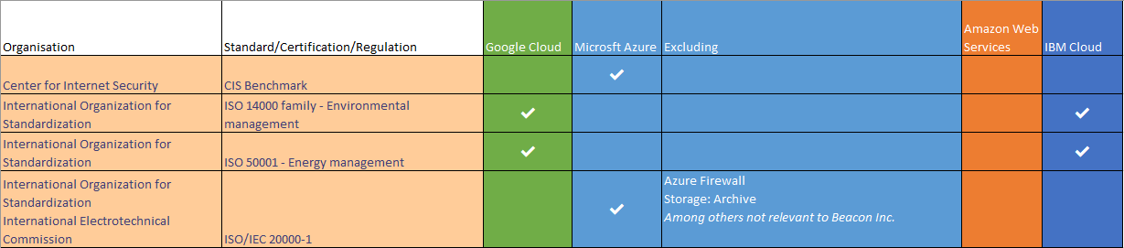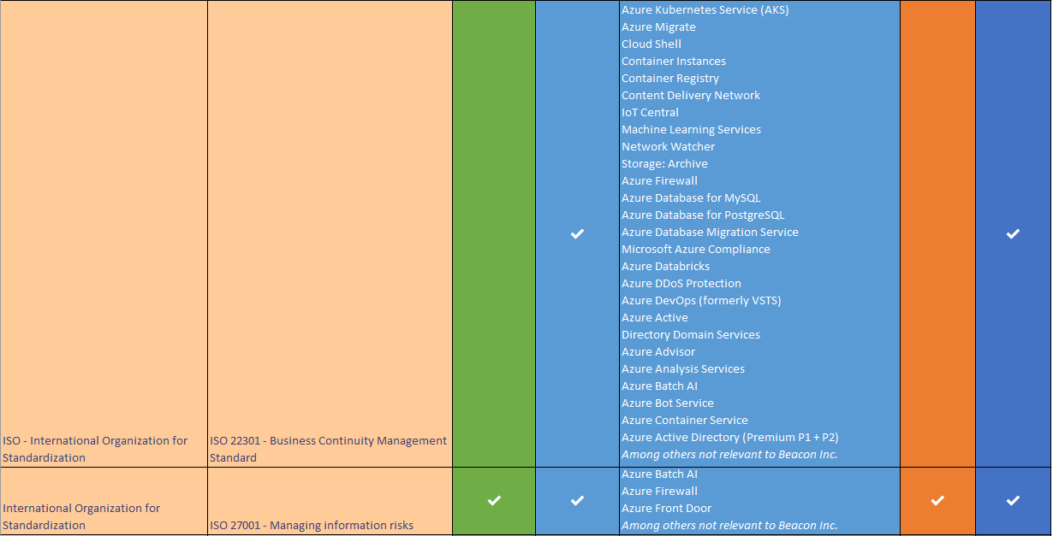

Table 1 Risk Analysis

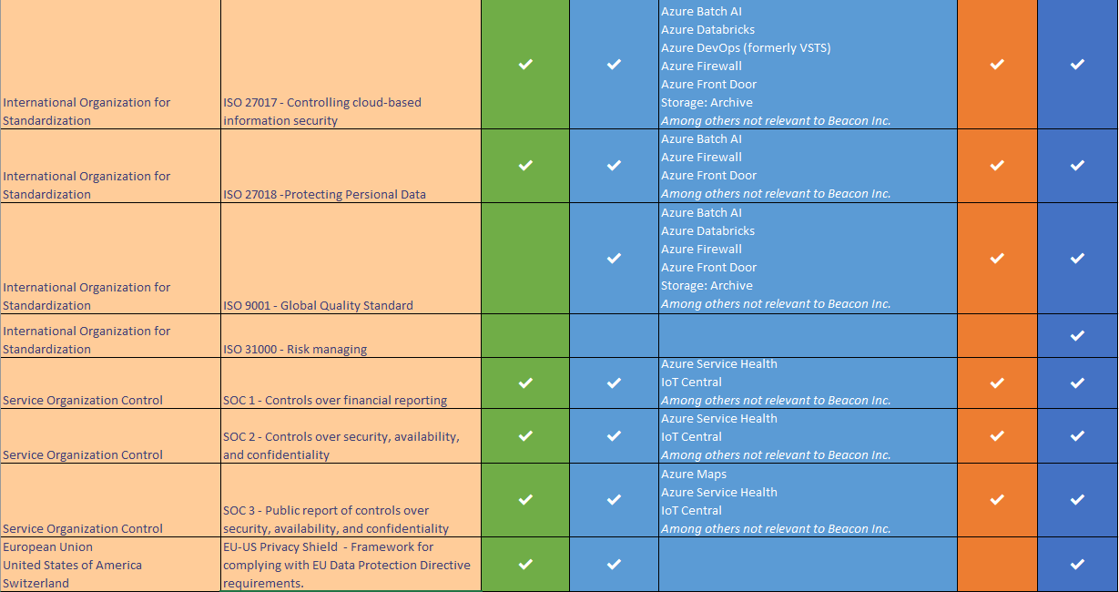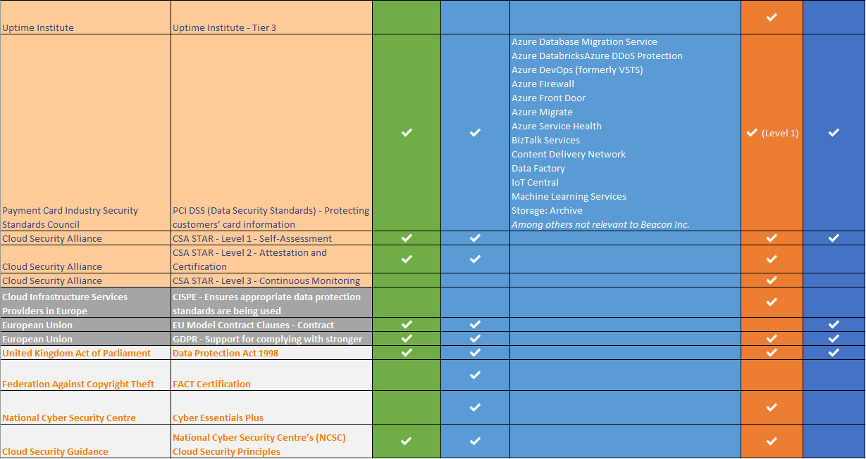

Table 1 Risk Analysis

The above risk analysis (Table 1) displays the various regulations, certifications, and standards the four chosen cloud vendors adhere to. The regulations, certifications, and standards are organised into five groups based on jurisdiction, globally (Peach), European Union (Dark grey), and the United Kingdom (Light grey). Microsoft Azure was open about the resources that the certifications do not cover, this number was surprisingly high for standards such as ISO 22301. Overall the cloud vendor with the most relevant standards, certifications and regulation adherence was Microsoft Azure (20) followed by Amazon Web Services (17) and IBM Cloud (17) and in last place was Google Cloud (16). Google cloud misses out with core standardisations such as ISO 9001 which is alarming to many business as this globally recognised quality standard, and is common amongst many cloud providers.

The cost analysis information was sourced from cloud vendor supplied documentation and cost calculators, and in some cases deploying the resources, as this would warn the user of the cost just before the resource is deployed, if no documentation can be found elsewhere. Vast research was put into selecting the correct resources for Beacon Inc, which derived from face to face meeting with Beacon Inc, and researching the documentation within the cloud vendors websites.

### 

### Cost Analysis Diagram

### 

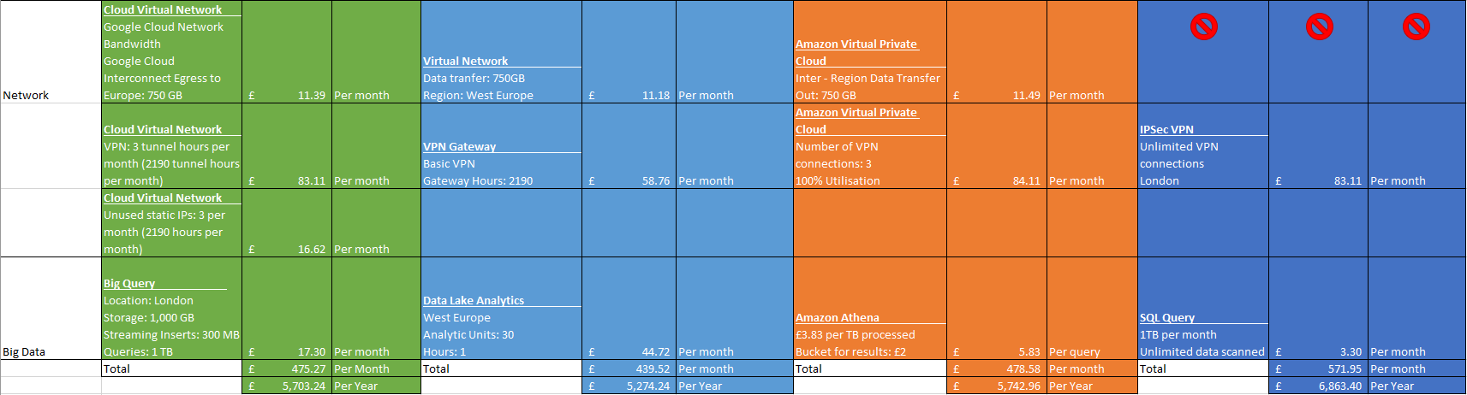

Table 2 Cost Analysis

## Diagrams …..

## Design …..

## Implementation …..

## Evaluation …..

# Bibliography

Aldaine, A., 2018. *Top 10 API Testing Tools (Details & Updates Done for You!).* [Online]   
Available at: https://medium.com/@alicealdaine/top-10-api-testing-tools-rest-soap-services-5395cb03cfa9  
[Accessed 1 April 2019].

Altorbaq , A., Blix , F. & Sörman , S., 2017. *Data subject rights in the cloud: A grounded study on data protection assurance in the light of GDPR.* [Online]   
Available at: https://ieeexplore.ieee.org/document/8356406/authors#authors  
[Accessed 18 October 2018].

Bahga, A. & Madisetti, V., 2014. *Internet of things: A Hands-On Approach.* s.l.:Ashdeep Bahga & Vijay Madisetti.

Business Queensland, 2017. *Benefits of cloud computing.* [Online]   
Available at: https://www.business.qld.gov.au/running-business/it/cloud-computing/benefits  
[Accessed 15 October 2018].

Business Queensland, 2017. *Risks of cloud computing.* [Online]   
Available at: https://www.business.qld.gov.au/running-business/it/cloud-computing/risks  
[Accessed 15 October 2018].

Dignan, L., 2018. *Top cloud providers 2018: How AWS, Microsoft, Google, IBM, Oracle, Alibaba stack up.* [Online]   
Available at: https://www.zdnet.com/article/top-cloud-providers-2018-how-aws-microsoft-google-ibm-oracle-alibaba-stack-up/  
[Accessed 14 February 2019].

Donahue, S., 2014. *What is Cloud Computing, and What’s the Big Deal?.* [Online]   
Available at: http://www.paitgroup.com/cloud-computing-whats-big-deal/  
[Accessed 15 October 2018].

Eurostat Press Office , 2014. *ICT usage in enterprises in 2014.* [Online]   
Available at: https://ec.europa.eu/eurostat/documents/2995521/6208098/4-09122014-AP-EN.pdf/627ddf4f-730a-46ca-856b-32532d8325c5  
[Accessed 19 February 2019].

Eurostat Press Office, 2018. *ICT usage in enterprises in 2018.* [Online]   
Available at: https://ec.europa.eu/eurostat/documents/2995521/9447642/9-13122018-BP-EN.pdf/731844ac-86ad-4095-b188-e03f9f713235  
[Accessed 19 February 2019].

Eurostat, 2017. *Cloud computing use in EU enterprises.* [Online]   
Available at: https://ec.europa.eu/eurostat/en/web/products-eurostat-news/-/DDN-20170330-1  
[Accessed 19 February 19].

Hill, R., Hirsch, L., Lake, P. & Moshiri, S., 2013. *Guide to cloud computing principles and practice.* 1 ed. London: Springer-Verlag London.

Hinchey, T., 2018. *9 reasons cloud computing is a big deal.* [Online]   
Available at: https://dvsadigital.blog.gov.uk/2018/01/24/9-reasons-cloud-computing-is-a-big-deal/  
[Accessed 15 October 2018].

Khajeh-Hosseini, A., Greenwood, D. & Sommerville, I., 2010. *Cloud Migration: A Case Study of Migrating an Enterprise IT System to IaaS.* [Online]   
Available at: https://ieeexplore.ieee.org/document/5557962/authors#authors  
[Accessed 17 October 2018].

Khajeh-Hosseini, A., Greenwood, D. & Sommerville, I., 2010. *Cloud Migration: A Case Study of Migrating an Enterprise IT System to IaaS.* [Online]   
Available at: https://arxiv.org/ftp/arxiv/papers/1002/1002.3492.pdf  
[Accessed 17 October 2018].

Kolb, S., Lenhard, . J. & Wirtz, G., 2015. *Application Migration Effort in the Cloud - The Case of Cloud Platforms.* [Online]   
Available at: https://ieeexplore.ieee.org/document/7214026  
[Accessed 12 1 2019].

Kozlovszky, M., Törőcsik, M., Schubert, T. & Póserné, V., 2013. *IaaS type Cloud infrastructure assessment and monitoring.* [Online]   
Available at: https://ieeexplore.ieee.org/document/6596261/authors#authors  
[Accessed 17 December 2018].

Krutz, R. L. & Vines, R. D., 2010. *Cloud Security: A Comprehensive Guide to Secure Cloud Computing.* Indianapolis, Ind.: Wiley.

Lanich, Z., 2017. *The Benefits Of Moving To The Cloud.* [Online]   
Available at: https://www.forbes.com/sites/forbestechcouncil/2017/05/19/the-benefits-of-moving-to-the-cloud/#52d6b6e24733  
[Accessed 15 October 2018].

Lee, B. S., Yan, S., Ma, D. & Zhao, G., 2011. *Aggregating IaaS Service.* [Online]   
Available at: https://ieeexplore.ieee.org/document/5958104/authors#authors  
[Accessed 17 December 2018].

Microsoft Azure, n.d. *What is cloud computing?.* [Online]   
Available at: https://azure.microsoft.com/en-gb/overview/what-is-cloud-computing/  
[Accessed 15 October 2018].

Pahl, C. & Xiong , H., 2013. *Migration to PaaS clouds - Migration process and architectural concerns.* [Online]   
Available at: https://ieeexplore.ieee.org/document/6632740  
[Accessed 12 1 2019].

RightScale, 2018. *RightScale 2018 State of the Cloud Report.* [Online]   
Available at: https://assets.rightscale.com/uploads/pdfs/RightScale-2018-State-of-the-Cloud-Report.pdf  
[Accessed 15 October 2018].

Rouse, M., 2011. *geo-replication.* [Online]   
Available at: https://searchwindowsserver.techtarget.com/definition/geo-replication  
[Accessed 15 October 2018].

Sitaram, D. & Manjunath, G., 2011. *Moving to the Cloud: Developing Apps in the New World of Cloud Computing.* 1 ed. Waltham: Syngress.

Tan, N. & Smoot, S., 2011. *Private Cloud Computing: Consolidation, Virtualization, and Service-Oriented Infrastructure.* Waltham, MA: Morgan Kaufmann.

Velte, A. T., Velte, T. J. & Elsenpeter, R., 2010. *Cloud Computing A Practical Approach.* 1st ed. New York: McGraw-Hill.

Xu, L. & Yang, J., 2011. *A management platform for Eucalyptus-based IaaS.* [Online]   
Available at: https://ieeexplore.ieee.org/document/6045059/authors#authors  
[Accessed 18 December 2018].

Yang, C. & Huang, Q., 2013. *Spatial Cloud Computing: A Practical Approach.* Boca Raton, Florida: CRC Press.

Zolkos, G., 2017. *5 biggest benefits of moving to the cloud.* [Online]   
Available at: https://www.bizjournals.com/bizjournals/how-to/technology/2017/12/5-biggest-benefits-of-moving-to-the-cloud.html  
[Accessed 15 October 2018].