Lab 1 Report
- www.telstra.com.au has the IP address 129.94.242.2.
The advantages of having multiple IP addresses is they are different addresses to multiple servers. These servers can serve as a backup for the website
The name of 127.0.0.1 is localhost – this refers to the computer making the request also called the loopback.

Website | Ping | Web Browser | Why?
www.google.co.uk | Yes | Yes
www.utoronto.ca | Yes | Yes
www.cloudflare.com | Yes | Yes
ec.ho | No | No | Invalid addresss
west.cn | Yes | Yes
defence.gov.au | No | Yes | Disabled ICMP
yes.no | Yes | Yes
one.one.one.one | Yes | Yes
theguardian.com | Yes | Yes
xn--i-7iq.ws | Yes | Yes

- There are 17 routers between tum.de and my computer
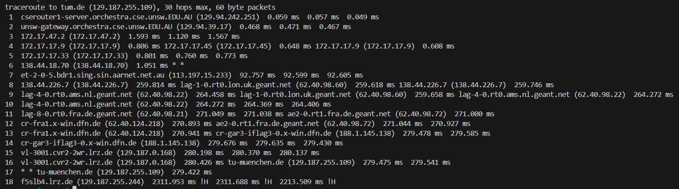
The first router out of Australia is number 7, the address has sing which stands for Singapore and the time taken to receive the ping is around 92ms compared to the 1ms for the previous servers indicative that this server is substantially further than server 6.
Server 8 is the first server to be found in the UK – this is because the ping for this server is approximately the same as lag-1-0.rt0.lon.uk.geant.net which is in London as the lon.uk reveals. This server 138.44.18.70 is part of the APNIC which connects Australia to the rest of the world.
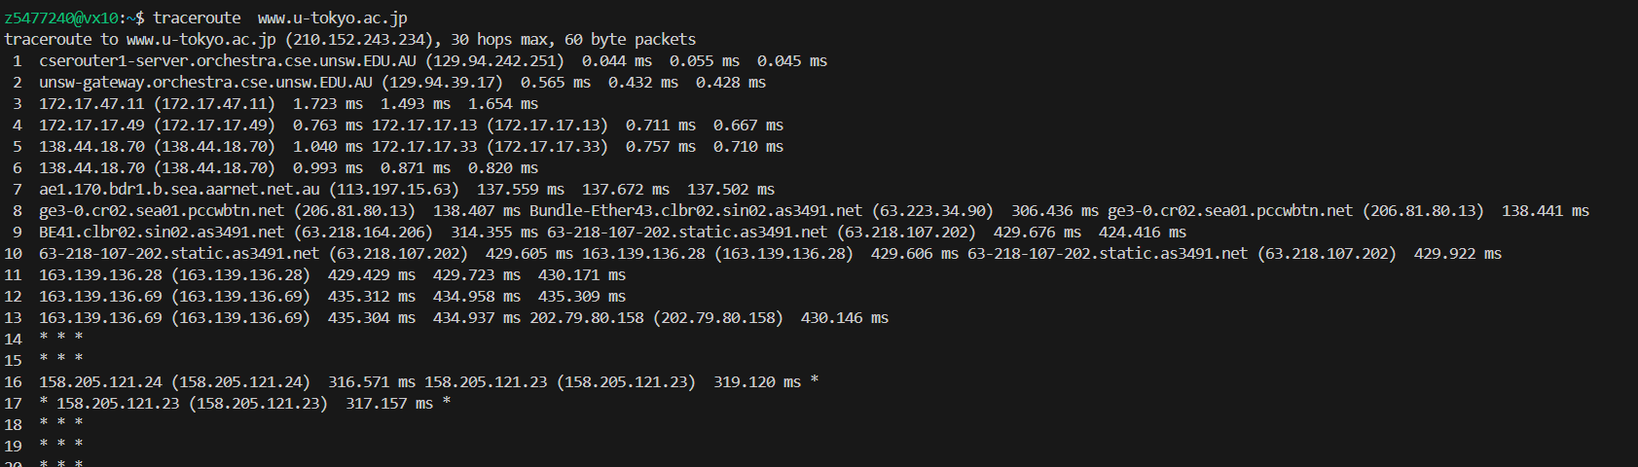
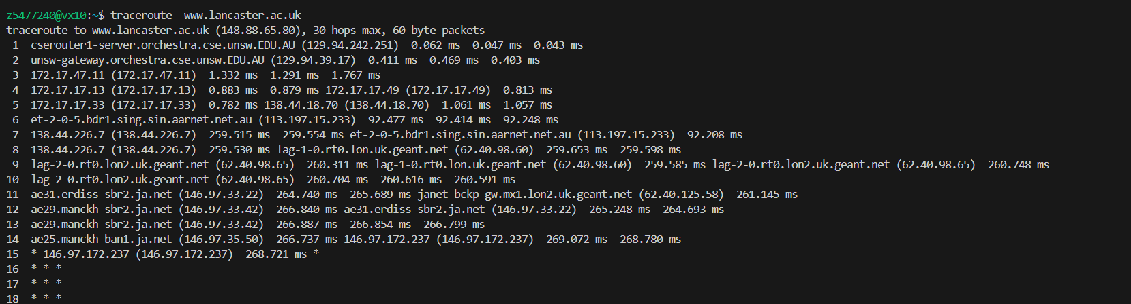The traceroute to Lancaster Uni differs from UCLA and Tokyo University at server 4, while Tokyo University differs from UCLA at server 5. Server 4 starts with 172, which means that it is a private server, servers 5 are different AARNET routers.
The number of hops is not proportional to the distance between servers – the distance between Sydney and Tokyo is about 8 000km, Sydney and Lancaster is about 17 000km and 12 000km however the hops between Tokyo and Lancaster Universities were both 15 hops while UCLA was 13 hops
The IP addresses of as13030.net/traceroute.php is 213.144.137.198 and the address of lg.nexlinx.net.pk is 202.59.80.52.
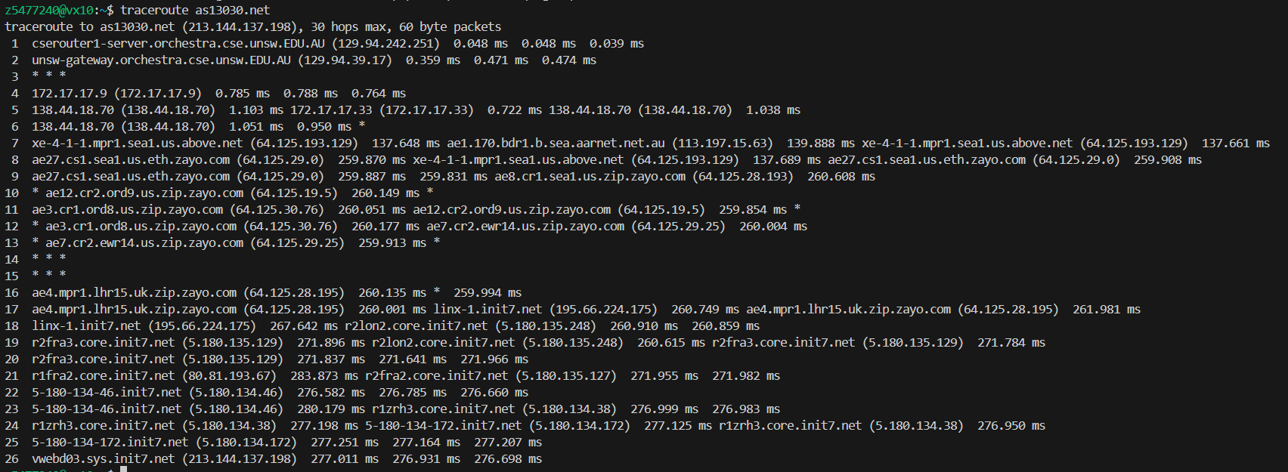
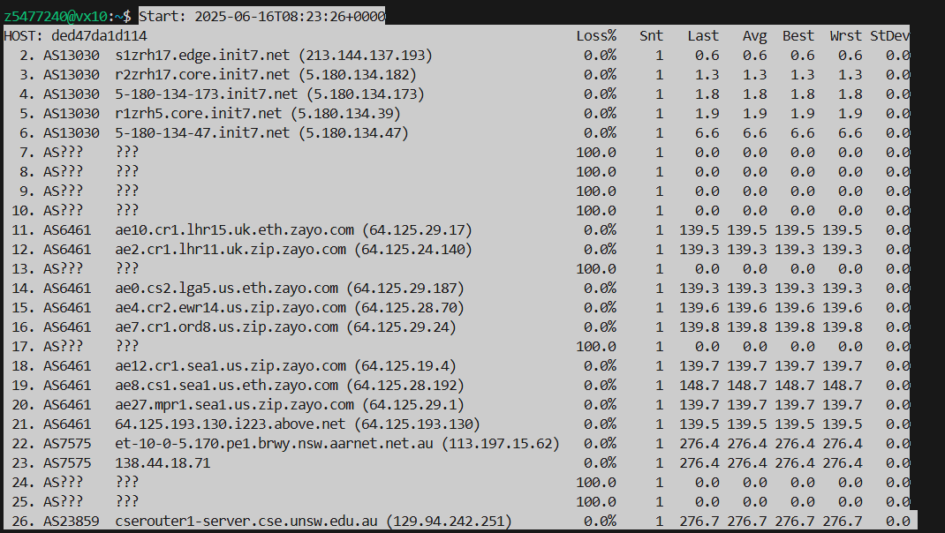
The common routers other than the end routers are for as13030.net:
- 138.44.18.70/71 (AARNET)
- 64.125.x.x (AboveNet/Zayo in Seattle, Chicago and UK)
- 5.180.x.x (init7 routers in Europe.)
The general hop path is the same however, the exact path is not. The IP address are roughly the same though the numbers at the end tend to be more subject to change due to network traffic or policies which force the packets to be sent via different routers.
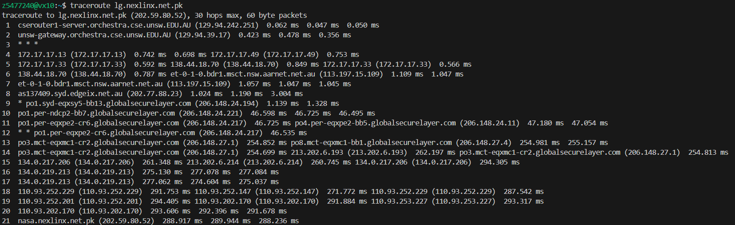
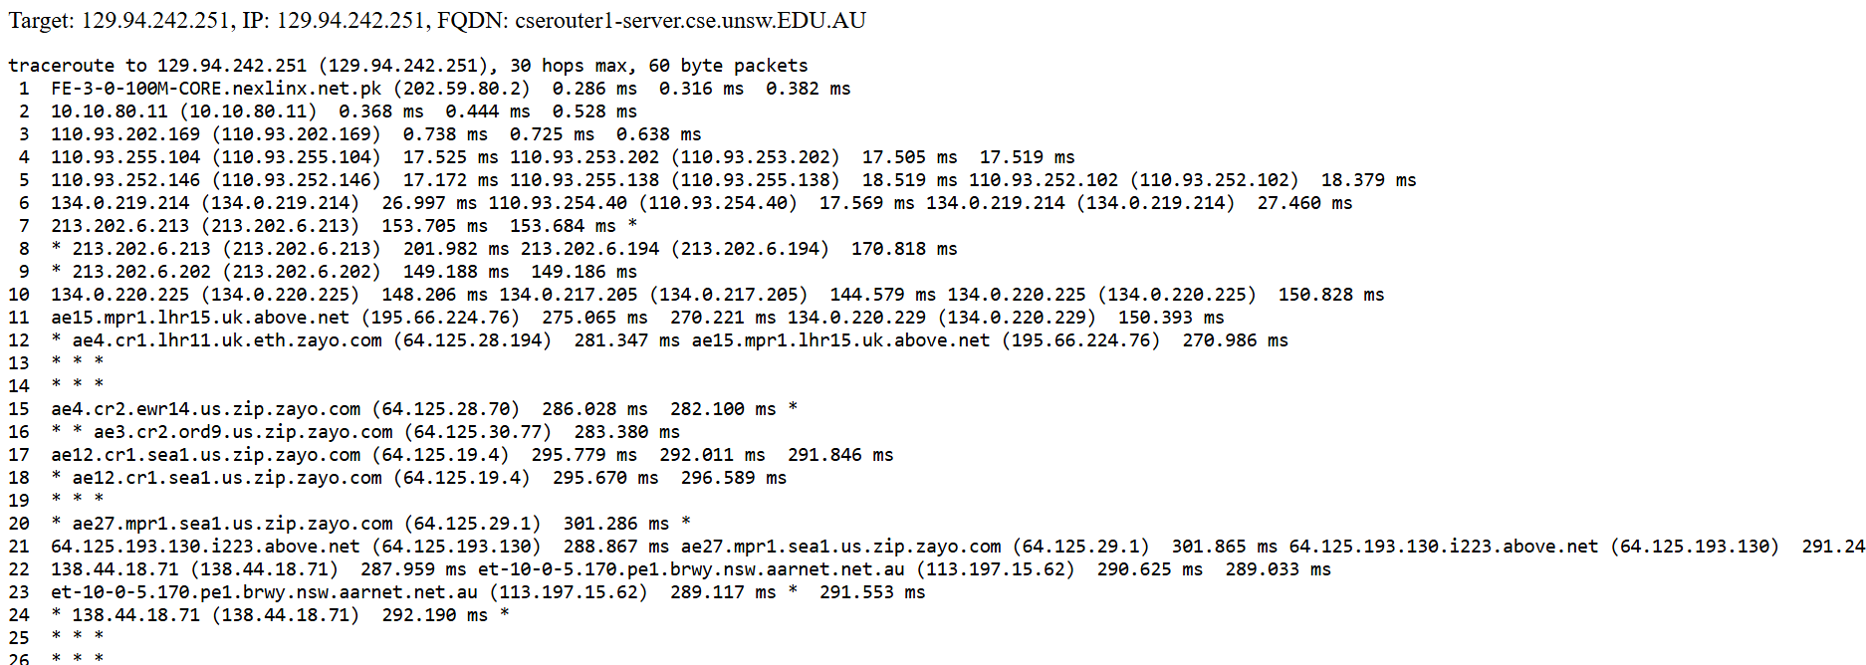
For lg.nexlinx.net.pk, both the traceroute and the reverse traceroutes pass through 110.93.x.x (Transworld associates), 202.59.80.x (They Call Me Joe Pty Ltd), 213.202.x.x (Zain Omantel International) 134.0.x.x RIPE Network Coordination Centre, 138.44.x.x (AARNET), 113.197.x.x (AARNET).
They differ with the traceroute using as137409.syd.edgeix.net.au and Global Security routers while the reverse uses ae15.mpr1.lhr15.uk.above.net and goes through the Zayo routers.
Similar to the previous website, due to network policy constraints, the two traceroutes do not go through the same paths.
- Shortest time taken to:
- University of Queensland (794km) – 2.65ms
- University of Lancaster (16 986km) - 56.62ms
- University of Philippines Diliman (6 271km) – 20.10ms
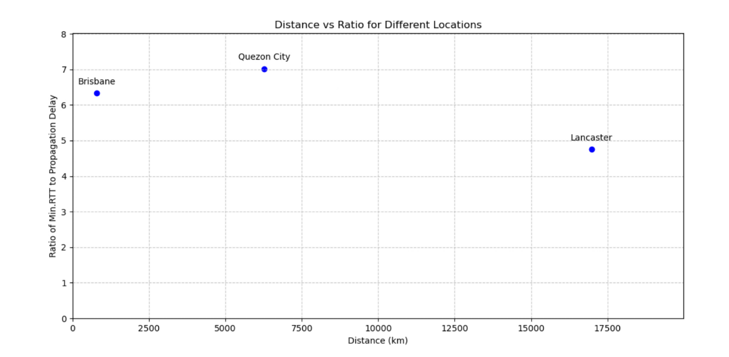
Each time the packets are transferred they are processed with statistical multiplexing and so are stored in a queue. These queuing delays can increase how fast packets are sent and since they apply to each router, even a 1ms delay on each router can add up quickly. Another reason is the nodal processing, for a packet to be sent it needs to arrive to a router completely and have it’s checksum calculated which takes time. Since this also applies each time the packet is sent from a router it also adds up.
The delay varies since the different methods of delay will affect the transmission differently. Propagation delays will generally affect each packet proportionally to the distance travelled since they are related to how fast the packet is transmitted (unless the route which the packet takes is very inefficient), while processing delays, transmission delays, and queueing delays can vary depending on the routers that the transmission takes. For example, as seen from part 2, the number of hops is not necessarily proportional to the distance travelled and hence the processing and queueing delays between each university can vary. Therefore, the delays vary but not necessarily linearly with distance.

The delays that depend on packet size are transmission and processing delays. Transmission delays are a result of packets being sent at a fixed bits per second rate and so the larger the packet, the more bits need to be send and so it is more delayed. Processing delays are affected by packet size, since the larger the packet, the router will need to process more of the packet when calculating the check sum.

