Proxy Report
I used python to create my proxy server. With the server I have attached proxy.py, a server directory (which simulates a remotely hosted server), a cache directory which includes cache.py that manages the cached data and client.py which contains sample client requests. Client.py uses the telnet library to test the proxy server I also used helpers.py to hold constants and helper functions.
The proxy server will listen for any client wanting to connect to it. Once a connection occurs, the proxy server will create a thread to process the request from the client. This enables concurrent clients to make requests to the proxy simultaneously.
If the request is a GET or a HEAD request, it will ask the cache whether the file exists in the cache already. If not, the proxy makes a request to the main server and receives the intended file and serving this file to the client. In the case of a successful GET request, the proxy server will attempt to cache the file. The cache will check whether the file is too big to be cached and if there is enough space. If the file is too large to be cached, it will not cache the file however if it can be cached but there is not enough space in the cache, cache.py will find the oldest file and delete it before checking again if there is enough space. It will continue deleting files until the new file can be cached. In the case of a POST request, the proxy will connect with the server and forward the POST request. In the case of any errors, the proxy will send errors such as 404 in the case of a file not found in the GET or HEAD requests or 400 in the case of malformed requests.
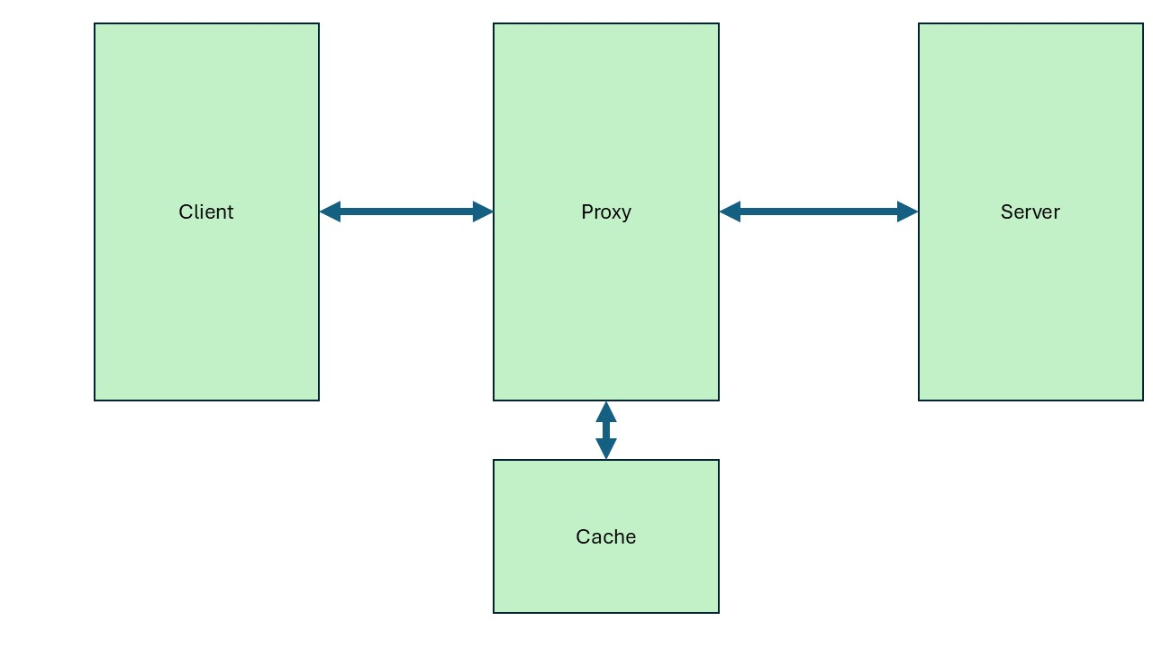
I decided to use a cache class to handle cache related behaviour – this allows the proxy and cache to be more independent of each other and closer to a real proxy and cache server. The cache uses a file directory to keep all of the cached files and copies and deletes files when necessary. The cache also checks whether a file can be cached, that is if it is too big to be cached.

The proxy can parse much of the request, however due to time constraints I was not able to completely implement the parsing. It splits the headers and body using b”\r\n\r\n” since the header and body are split with two \r\n. It then splits the header by spaces with the first line being the request line, the line which is used to log. The request line is then split into the method, URL and the HTTP version. As this proxy is not persistent, HTTP version is not utilised. The headers are then split into keys and values e.g. content length: <length> is split into the key “content length” (in lower case) and the value <length >. This is to fulfil the fields in the header e.g. field-name: field-value. Since this proxy is fairly rudimentary these fields are not used. The URL is checked to see if it starts with http:// and the remainder is split into the host_port and url. If the url contains a ‘/’ this means that there is a path and the path is stripped. If there is not, this means that the path must be /index.html.
If a port is given e.g. there is a :<port number>, the proxy parses this else, the proxy will keep the host as is and assume the port number is 80. The host and port number has not been implemented besides in the logging systems and as such does not do anything.
The proxy sends responses and requests using the HTML format. When sending, it first encodes the data as bytes which allows the socket to correctly send this. As such the length of the body is given in bytes rather than characters.
There are numerous limitations to the proxy server. It does not correctly handle client requests – the port number is not assigned when requested, and the header flags are not recognised. The proxy does not maintain a persistent connection and also does not handle the CONNECT method. The logging system is quite basic and will handle most errors, when unexpected errors occur this can cause the sockets to close ungracefully blocking the port until they are timed out. While threads have been introduced, they are not necessarily correctly implemented nor tested – the cache is not thread safe yet and as such multiple get responses could cause a permission error as two threads try to communicate with the cache.

Sources:
HTTP: Hypertext Transfer Protocol | MDN
socket — Low-level networking interface — Python 3.13.5 documentation
I used these to understand how to use the functions and what the HTTP protocol looks like.

