**Set up github and git**

**Working all commands.**

1)Open <https://github.com/>

2) Signup for new user

3) Enter your user name and pwd

4)Better give your user name as your email

Ex:manojpadhisp@gmail.com

User name: manojpadhisp

Pwd:………U r user pwd.

5) Then go the signinas option on right hand side above bar

Then go the setting

Then click into the organization

Next click free user. If you want to pay then take other option.

For individual better choose free option.

6) Click new organization on right hand side panel.

7) organization account name

Give any name as you like. Mine is (FullstackDevManojPadhi)

8) Give email id again

9) Click personal button

10) Then click Next button

11) Click Complete set up

Then set up [Repositories](https://github.com/orgs/FullstackDevManojPadhi/repositories):

1)Click [Repositories](https://github.com/orgs/FullstackDevManojPadhi/repositories) button left side tool bar of github.

2)Click a Create a new Repository

3) Put Repository name.

I gave “FullstackDev” my Repository name. You can put any name as per your wish..

4)Click Public

5)Add a README file option.

6) Click Create repository

Done my set up github.

My repository name is “FullstackDev’

Branch name is “main”

Set up git base: Which is git.

1) [Git - Downloads from (git-scm.com)](https://git-scm.com/download) link

2)Click for Window/linux/mac which one you need.

3) After download install the exe file on your local box.

4)Then go the start ->Click Git bash

Then git will start

Cd c:

Cd GitPlay

It will go the GitPlay folder.

Or

Go to your any folder

Mine is : C:\GitPlay -> Right clink on empty folder >Click Gitbash

Question 1) What is Git and github?

**Git:** Git is a distributed version control system for tracking changes in source code during software development. It is designed for coordinating work among programmers, but it can be used to track changes in any set of files. Its goals include speed, data integrity, and support for distributed, non-linear workflows.

**GitHub:** GitHub is a web-based Git repository hosting service, which offers all of the distributed revision control and source code management (SCM) functionality of Git as well as adding its own features.

Playing with Git: There is two way we can play with git.

1) Existing repository

2) Create a new repository

First, I will go with existing repository:

Step:

1. Go the repository and bring the code/repository to my local machine.

<https://github.com/FullstackDevManojPadhi/FullstackDev>

2)Go the code and copy the https link

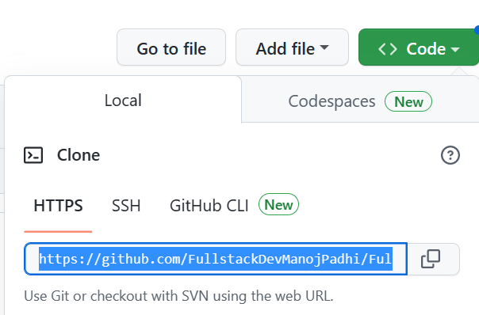

1. Then go the git bash in your local box and clone it.
2. 

4) Clone command will download my github repository to my local folder.

Now we will play with git command:

Example: git <action> <attributes>

git clone httpslink

My folder structure like this:

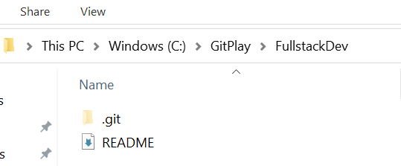

Once repository download, you can go and check the repository folder.

Here we can see one folder.

1).git

Everyone should be this folder. it is hidden so if any not able to see show hidden file and folder option need to give check .

Below graph I will explain one by one :

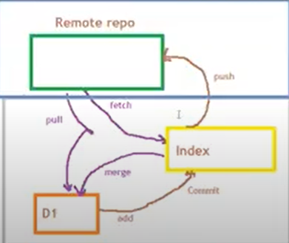

2nd: How to push the one file into the github.

1) Create a new file inside the C:\GitPlay\FullstackDev repository folder

test.cpp file need to push in to my repository.

Check the status

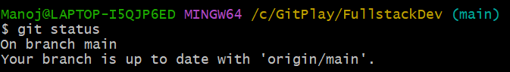

Use any command: if you know the file name give file name or enter *

If we enter * means one or more file will add.

Use only below one command:

$git add test.cpp

$git add *

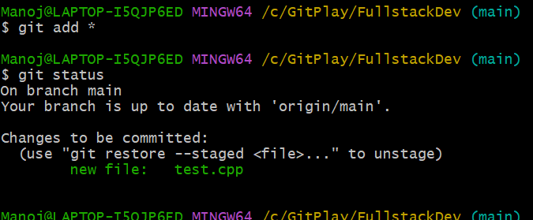

Next, commit:

Git commit –m “any description”

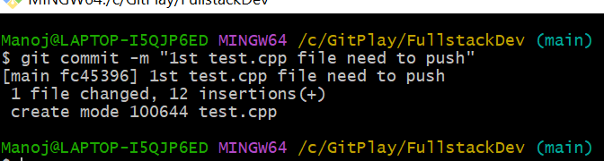

Next push: Before push 1st time, need to give the userid/pwd or token id of github.

I created the token id. once you will create the token life time it will use .

$git push

Here will ask for user id/pwd or token.

Need to create the token and enter the token.

Then go the github panel->Setting

Left panel go the ->Developer setting and click it.

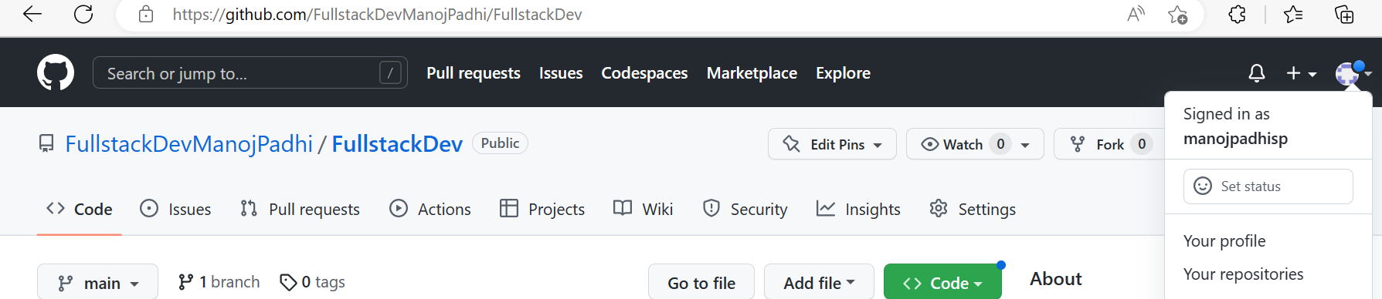

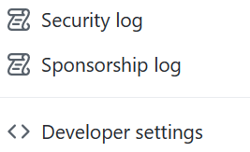

**->Go the Tokens classic**

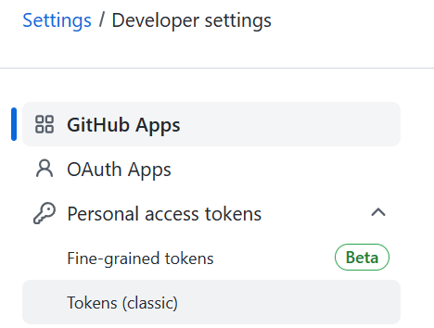

**->Click the Generate new token.**



**->Next, put the No expiration and click all check box. Then click Generate Token.**

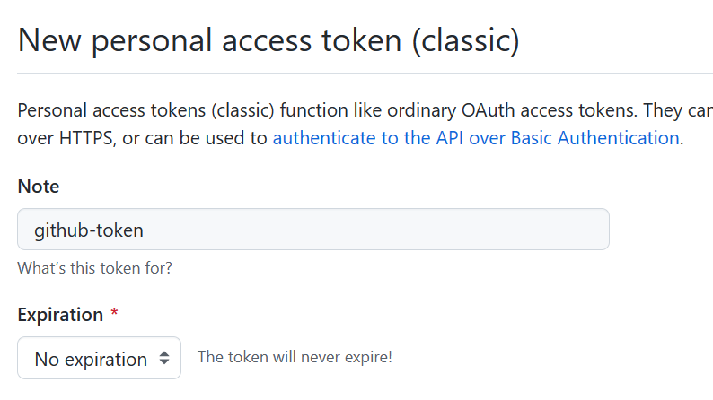

1) After enter the token it will push the test.cpp file in my repository.

2) Now successfully push the test.cpp file.

3) How can I check file is pushed or not?

4) Go the organisation and click FullstackDev

[FullstackDevManojPadhi/FullstackDev (github.com)](https://github.com/FullstackDevManojPadhi/FullstackDev)

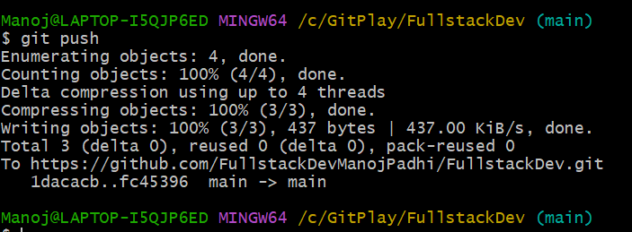

///////////////////////////////////////////////////////////////////////////////////////////

Till now we learn below steps.

1)Repository creation

2)git command how it is work

3) token creation

4) add, commit and push command uses

///////////////////////////////////////////////////////////////////////////////////////////

Next pull and fetch commands.

1)pull command git the all new change files.

Let us say my “FullstackDev” local repository having two files.

Other developer/QA/BA/Tester added one more new file test2nd.cpp file. However, my local machine having two files now but repository having three files.So I need to bring back to my local machine 3rd file that is test2nd.cpp file.

My local box: Here README and test having 2 files.

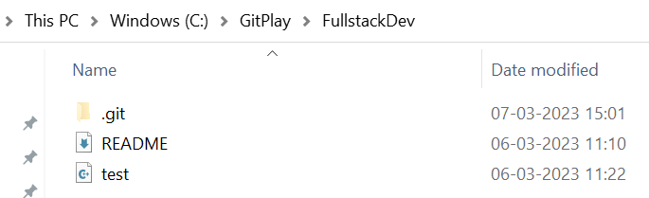

Use pull command and see the local folder:

$git pull

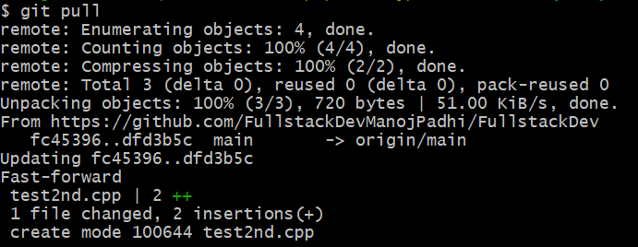

After pull test2nd.cpp file download into my local folder. Which is fast-forward.

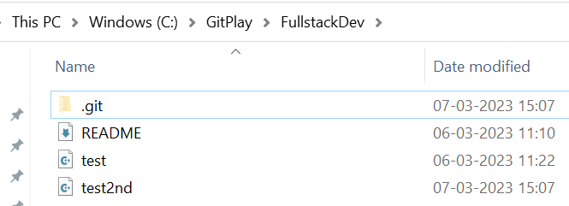

Next go the **FullstackDev repository .**

1)Click the test2nd.cpp file and edit the file.

2) After edit add some more lines on this file and commit inside the github .

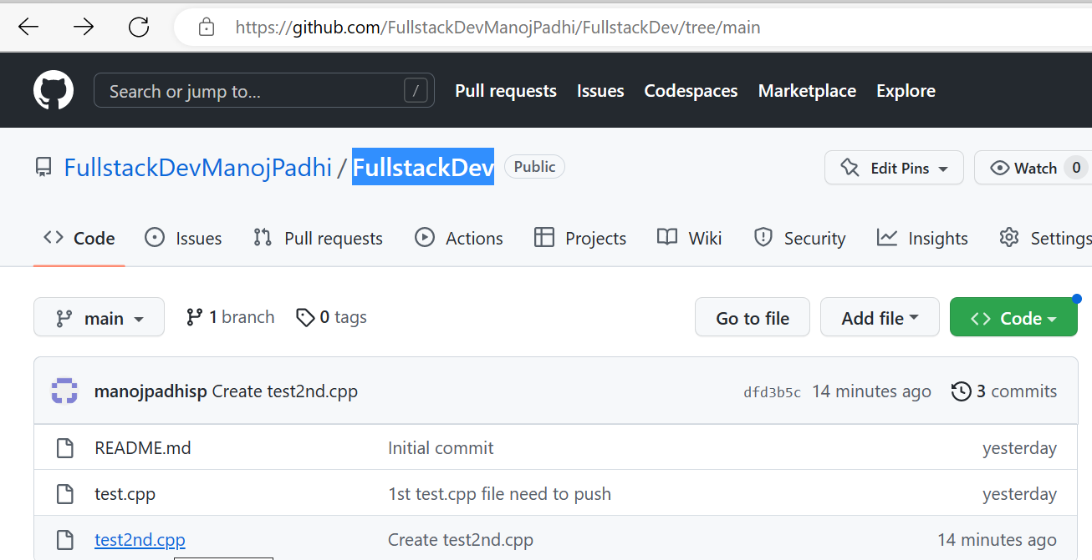

Use fetch command:

Before fetch, please look into the file.I have opened the test2nd.cpp file in my local box.

Here we can see only 2 lines.

However, github I have already updated two more extra line still not updated on my local repository.

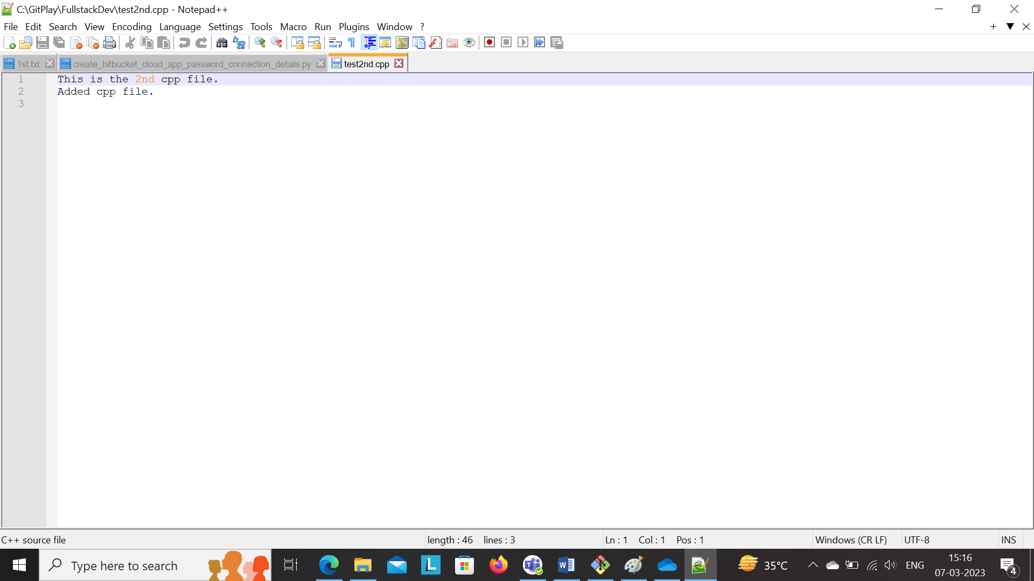

$git fetch

After fetch please look into the test2nd.cpp file.

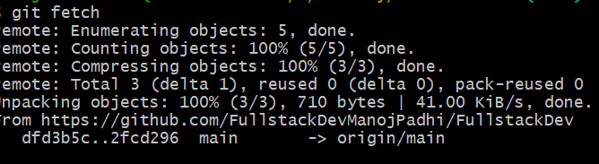

After fetch also same two line codes.



After fetch also still 2 line codes so still file not merged due to fetch command.

$git merge

After git merge extra 2 more line we will see clearly.

So fetch command not able to merge the codes .

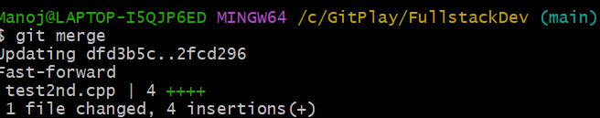

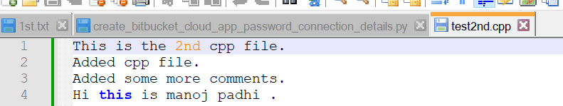

$git pull ---- pull + merge the files

$git fetch only pull the files not merged the files.

******************************************************************************

3rd)More pull command.

Let us say you open test2nd.cpp file and added fifth line locally.

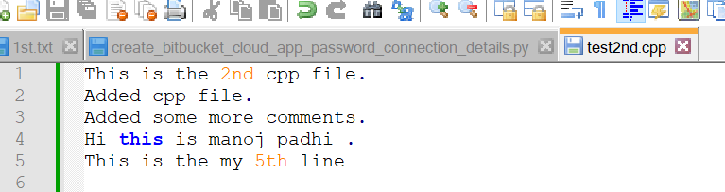

In mean time github also some body updated same file and committed.

Here Siva added 5th line extra stuff and committed on github.

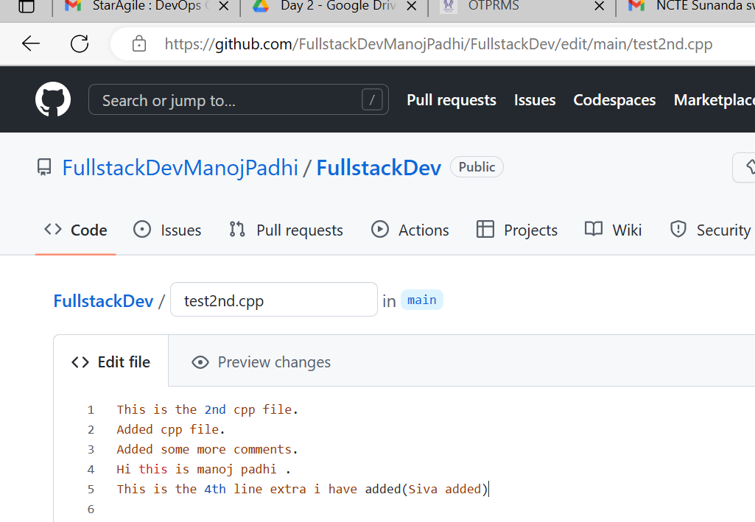

Here after git pull getting error. Bcz locally also we updated same file. So we need to commit 1st then it will work fine.

$git pull

Need to add and commit then use the pull command.

After pull also will get the conflict file. Need to solve the conflict file.

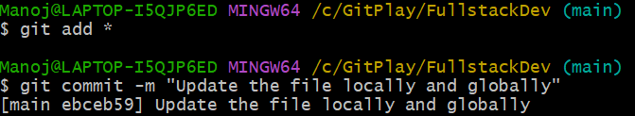

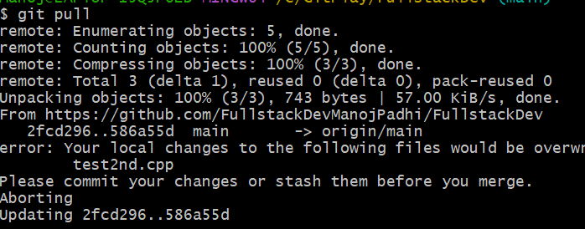

Need to open the test2nd.cpp file.

Remove which line of code we don’t need or keep it remove below HEAD and symbol stuff.

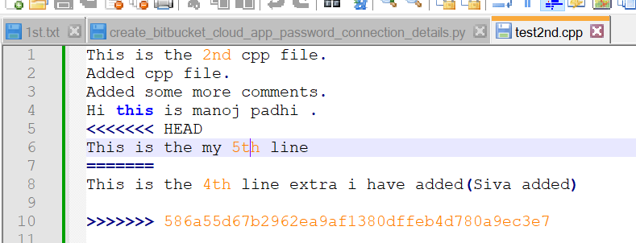

Remove and save locally:

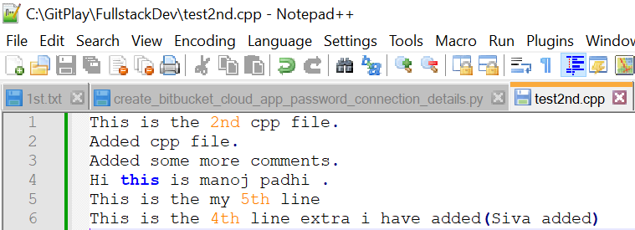

Then use add and commit command to save on github.

$git add *

$git commit –m “last changes of this file”

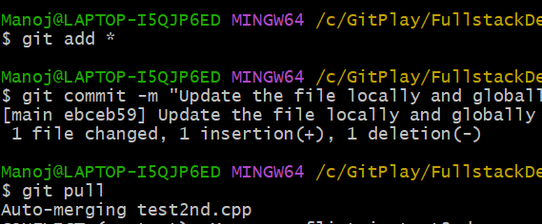

What is Branch in git?

**Git Branch**

A branch is a version of the repository that diverges from the main working project. It is a feature available in most modern version control systems. A Git project can have more than one branch. These branches are a pointer to a snapshot of your changes. When you want to add a new feature or fix a bug, you spawn a new branch to summarize your changes.

$git branch feature/developer

How to see the all branches:

$git branch

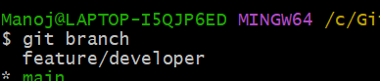

Right now, I am in main branch but I want to shift to developer branch. How to shift main branch to developer branch.

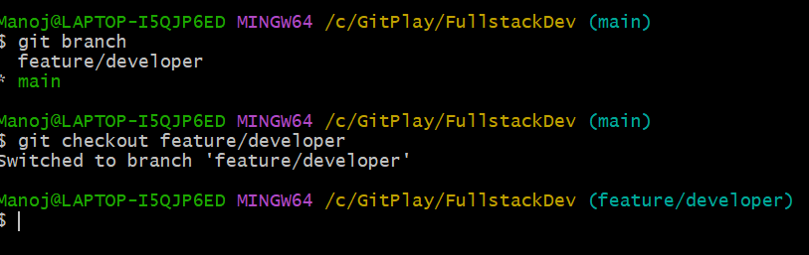

Q) How to merge one branch to other branch.

I have created one new file (test3rd.cpp) on developer branch and commit on developer branch.

This file not in my main branch. test3rd.cpp file on developer branch now. So need to merge the file from developer branch to main branch.

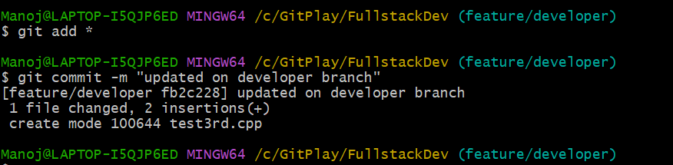

Merge from one branch to other.

1)My file merged in developer branch.

2)Need to merge test3rd.cpp file on main branch.

3)Go to the main branch 1st

$git checkout main

4)git merge feature/developer

Here file will merge into main branch.

Main point: Those branch we need to merge same branch we need to stay .

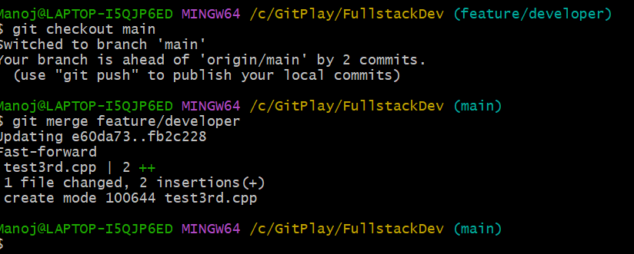

Merge from one branch to other using commit id.

Left case: First one have 4 commit id.

2nd one have 3 commit id.

So 2nd one only one commit id we are missing. Therefore, we need to merge only one commit id of 1st one.

Right case:1st one and 2nd one 3 commit id is same.

But 1st and 2nd one more extra commit id both the case.

So how we will merge the commit id from one branch to other.

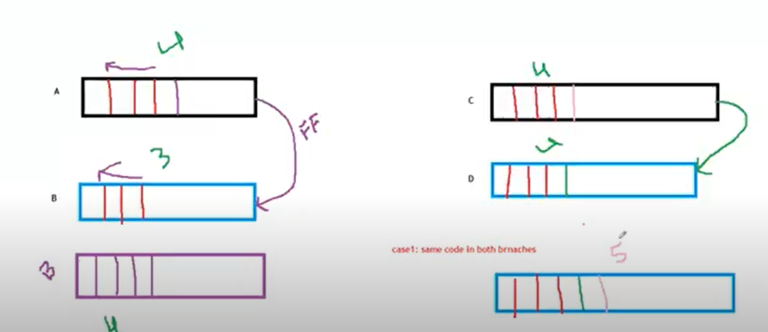

1st:How to see the commit id.

$git log

$git log –oneline

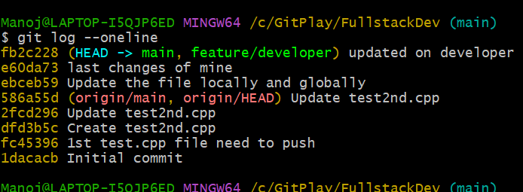

1) Go to the developer branch.

2) Create a file test4thfeature.cpp

3) Added the file.

4) Commit file.

Manoj@LAPTOP-I5QJP6ED MINGW64 /c/GitPlay/FullstackDev (main)

$ git checkout feature/developer

Switched to branch 'feature/developer'

Manoj@LAPTOP-I5QJP6ED MINGW64 /c/GitPlay/FullstackDev (feature/developer)

$ git add *

Manoj@LAPTOP-I5QJP6ED MINGW64 /c/GitPlay/FullstackDev (feature/developer)

$ git commit -m "feature branch added"

[feature/developer 6f3899b] feature branch added

1 file changed, 1 insertion(+)

create mode 100644 test4thfeature.cpp

Manoj@LAPTOP-I5QJP6ED MINGW64 /c/GitPlay/FullstackDev (feature/developer)

$

Next, go the main branch.

Merge from feature branch to main branch.

$ git checkout main

Switched to branch 'main'

Your branch is ahead of 'origin/main' by 3 commits.

(use "git push" to publish your local commits)

Manoj@LAPTOP-I5QJP6ED MINGW64 /c/GitPlay/FullstackDev (main)

$ git merge feature/developer

Updating fb2c228..6f3899b

Fast-forward

test4thfeature.cpp | 1 +

1 file changed, 1 insertion(+)

create mode 100644 test4thfeature.cpp

Manoj@LAPTOP-I5QJP6ED MINGW64 /c/GitPlay/FullstackDev (main)

Q)I want to push the files into developer branch.

After pushing getting error. Because still developer branch not created on github repository.

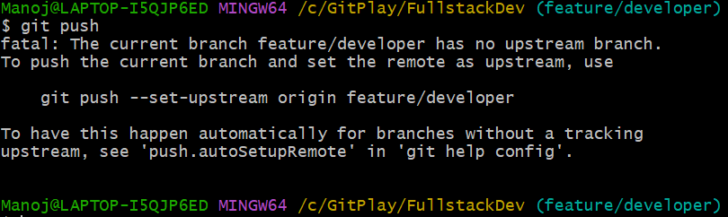

Now added all files on github from local box.

$git push origin feature/developer

$ git push origin feature/developer

Total 0 (delta 0), reused 0 (delta 0), pack-reused 0

remote:

remote: Create a pull request for 'feature/developer' on GitHub by visiting:

remote: https://github.com/FullstackDevManojPadhi/FullstackDev/pull/new/feature/developer

remote:

To https://github.com/FullstackDevManojPadhi/FullstackDev.git

* [new branch] feature/developer -> feature/developer

Manoj@LAPTOP-I5QJP6ED MINGW64 /c/GitPlay/FullstackDev (feature/developer)

# Q) How Git Stash command is working.

# 1) I have updated test4thfeature.cpp file in github and commit on github .

# 

# 2) Added 2/3 line my local box test4thfeature.cpp file also.

# 

# Using pull command try to bring the file but it is getting error. Because my github already commit somethings, also my local also updated 2/3 lines more in same file. So it is getting erros.

# 

# Try to save on feature branch using stash command.

$ git stash

Saved working directory and index state WIP on feature/developer: 6f3899b feature branch added

Manoj@LAPTOP-I5QJP6ED MINGW64 /c/GitPlay/FullstackDev (feature/developer)

$

# Then try to pull again. Here we are not getting any errors due to stash command .

$ git pull origin feature/developer

From https://github.com/FullstackDevManojPadhi/FullstackDev

* branch feature/developer -> FETCH_HEAD

Updating 6f3899b..4e3bf20

Fast-forward

test4thfeature.cpp | 7 ++++++-

1 file changed, 6 insertions(+), 1 deletion(-)

# $git stash –help (This one for help command)

# Using git stash list command will bring the github changes. Not my local changes.

# $git stash list

# 

# Now my local box getting the latest changes of my github.

# Not able to see the my local changes because of stash .

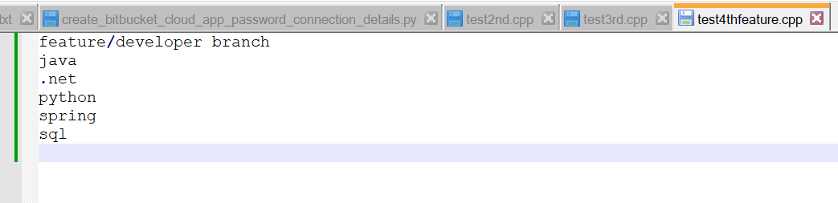

Using pop command try to merge the local changes.

Open the test4thfeature.cpp file.

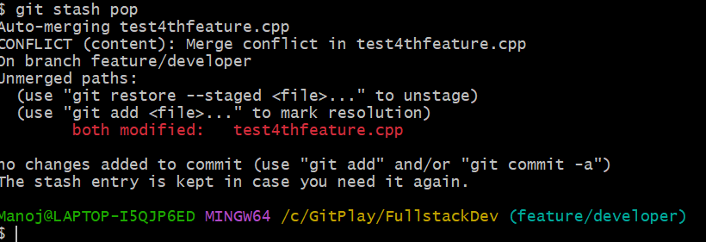

Due to pop command getting conflict. Need to solve the conflict.

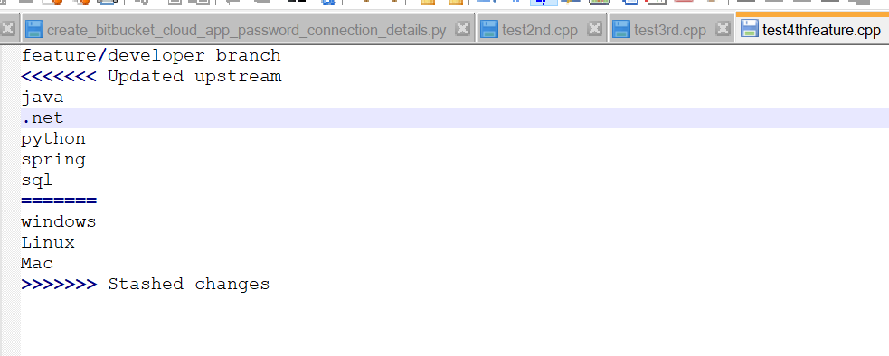

After the merge need to drop my local. Otherwise it will save on locally.

$ git stash drop

Dropped refs/stash@{0} (9e749c86e92b6e0e3ff6a695366b33ab4cace9d5)

********************************************************************************