https://www.coinspot.com.au/markets

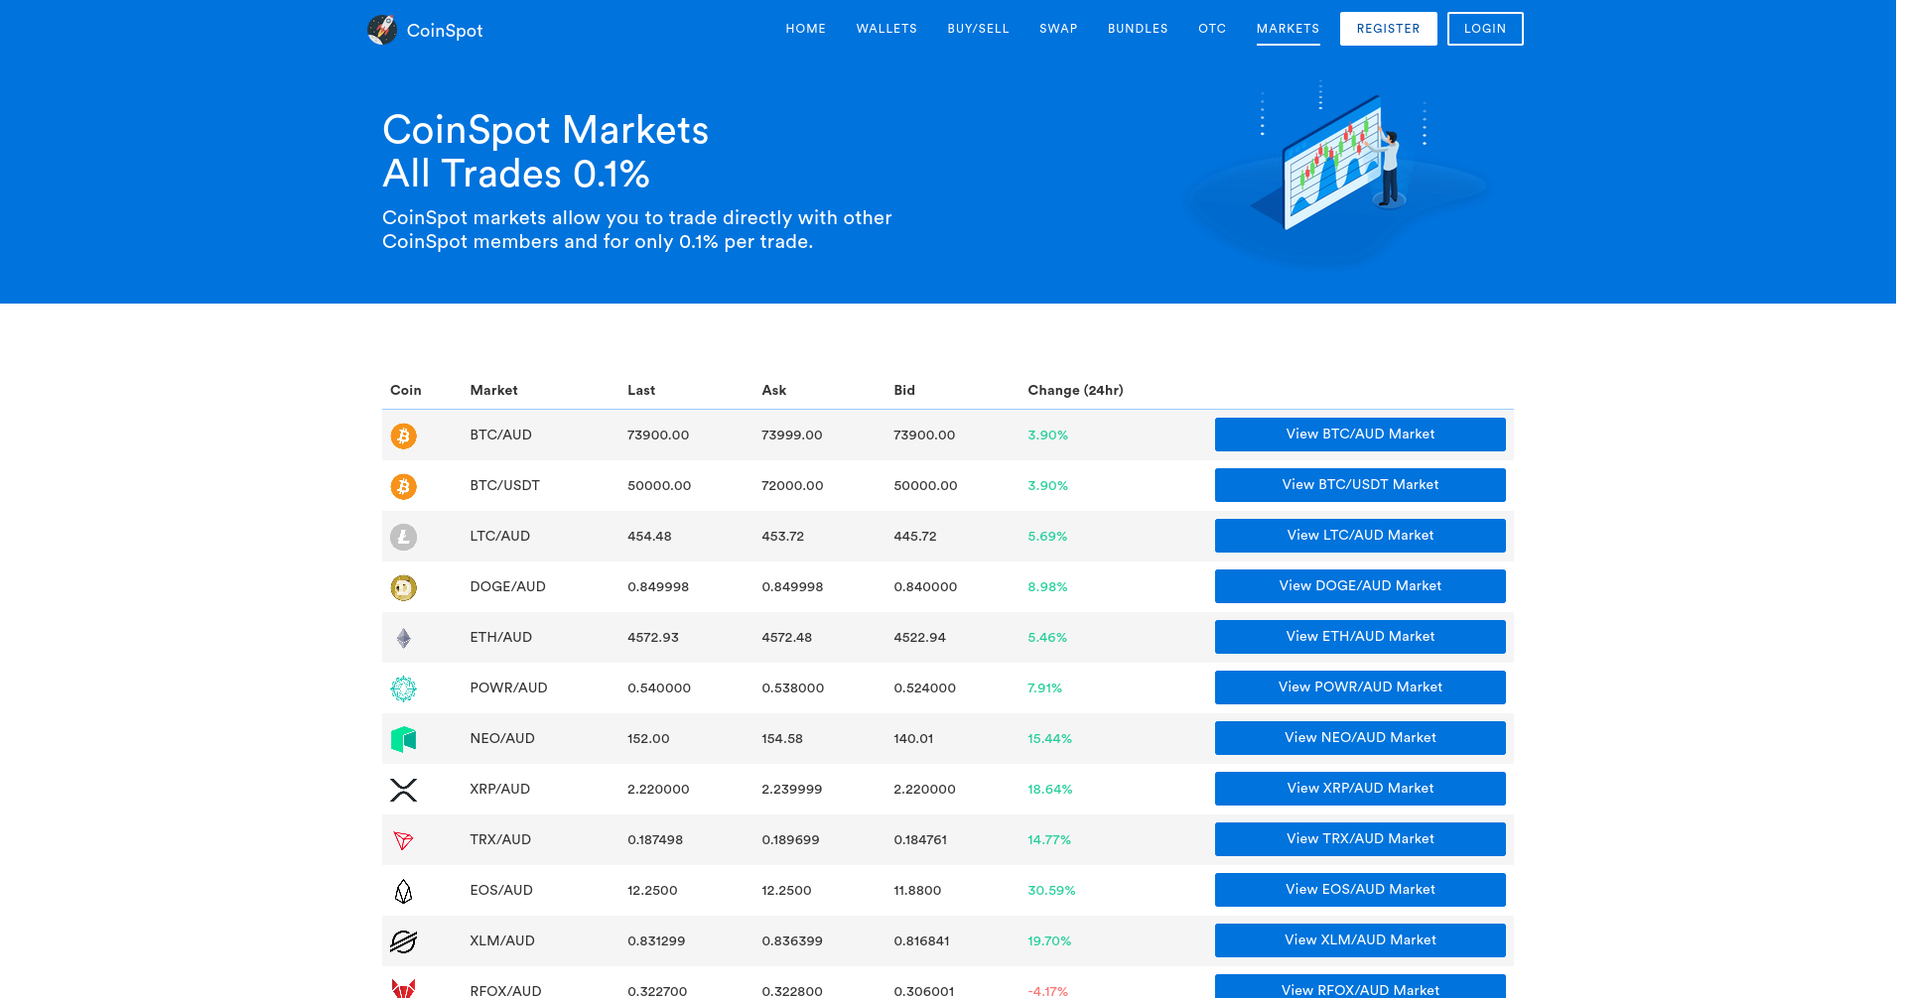

# nikto

- Nikto v2.1.5/2.1.5

https://www.coinspot.com.au/.svn

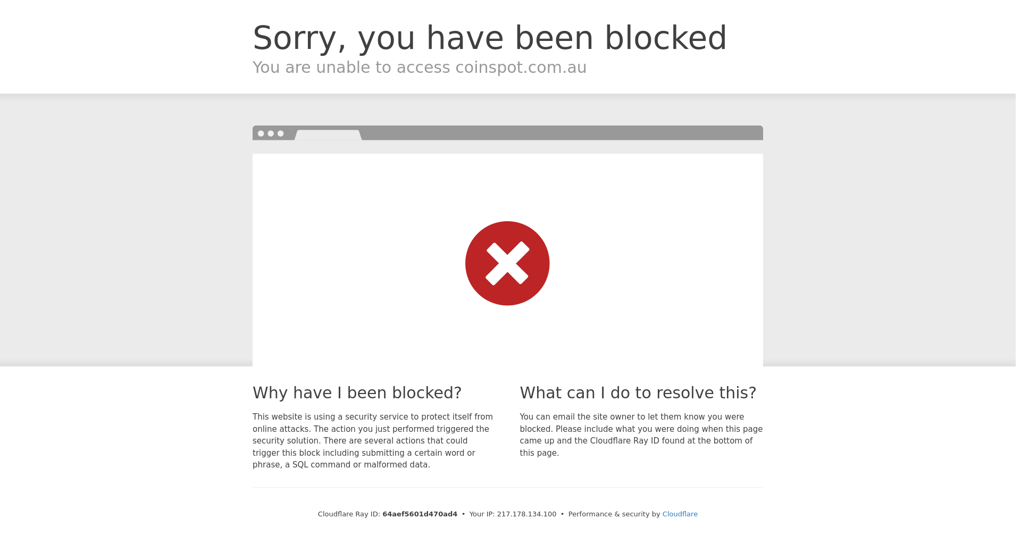

# nikto

- Nikto v2.1.5/2.1.5

https://www.coinspot.com.au/api

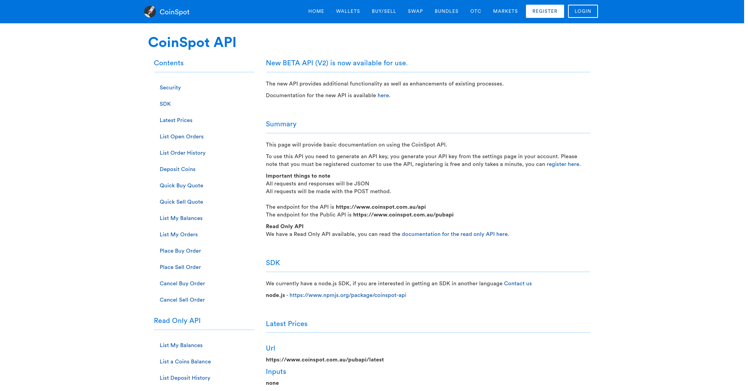

# nikto

- Nikto v2.1.5/2.1.5

https://www.coinspot.com.au/.htpasswd

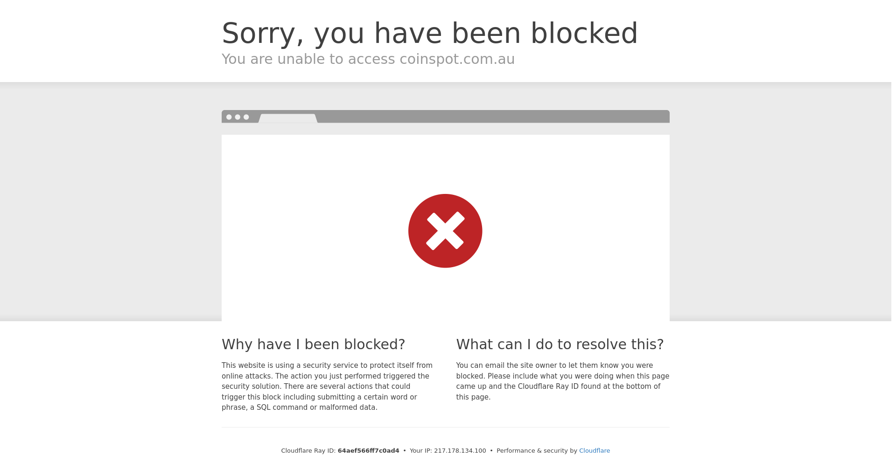

# nikto

- Nikto v2.1.5/2.1.5

https://www.coinspot.com.au/Login

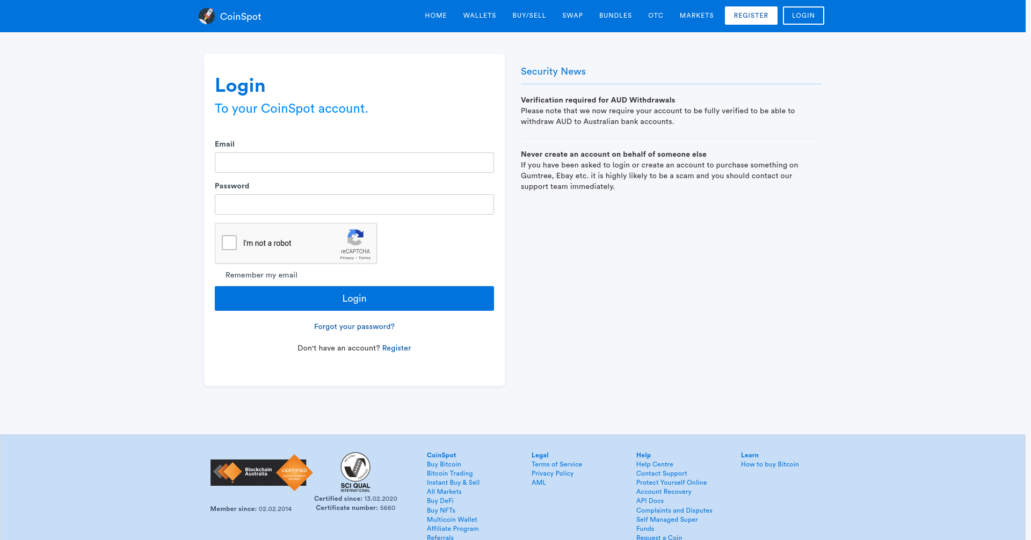

# nikto

- Nikto v2.1.5/2.1.5

https://www.coinspot.com.au/error_log

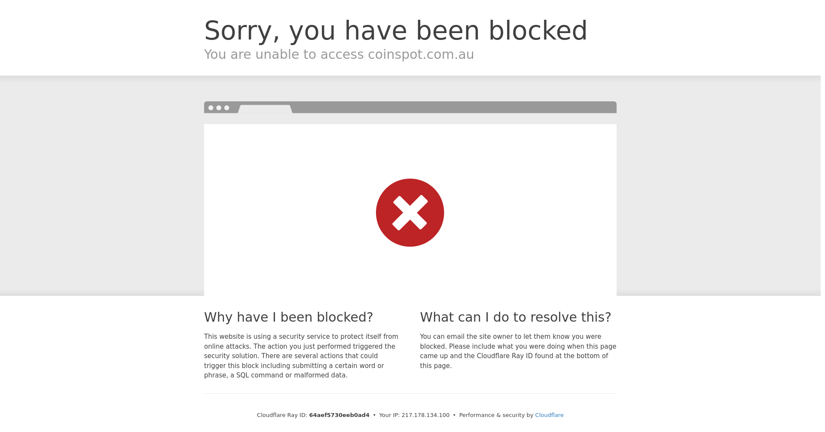

# nikto

- Nikto v2.1.5/2.1.5

https://www.coinspot.com.au/blog

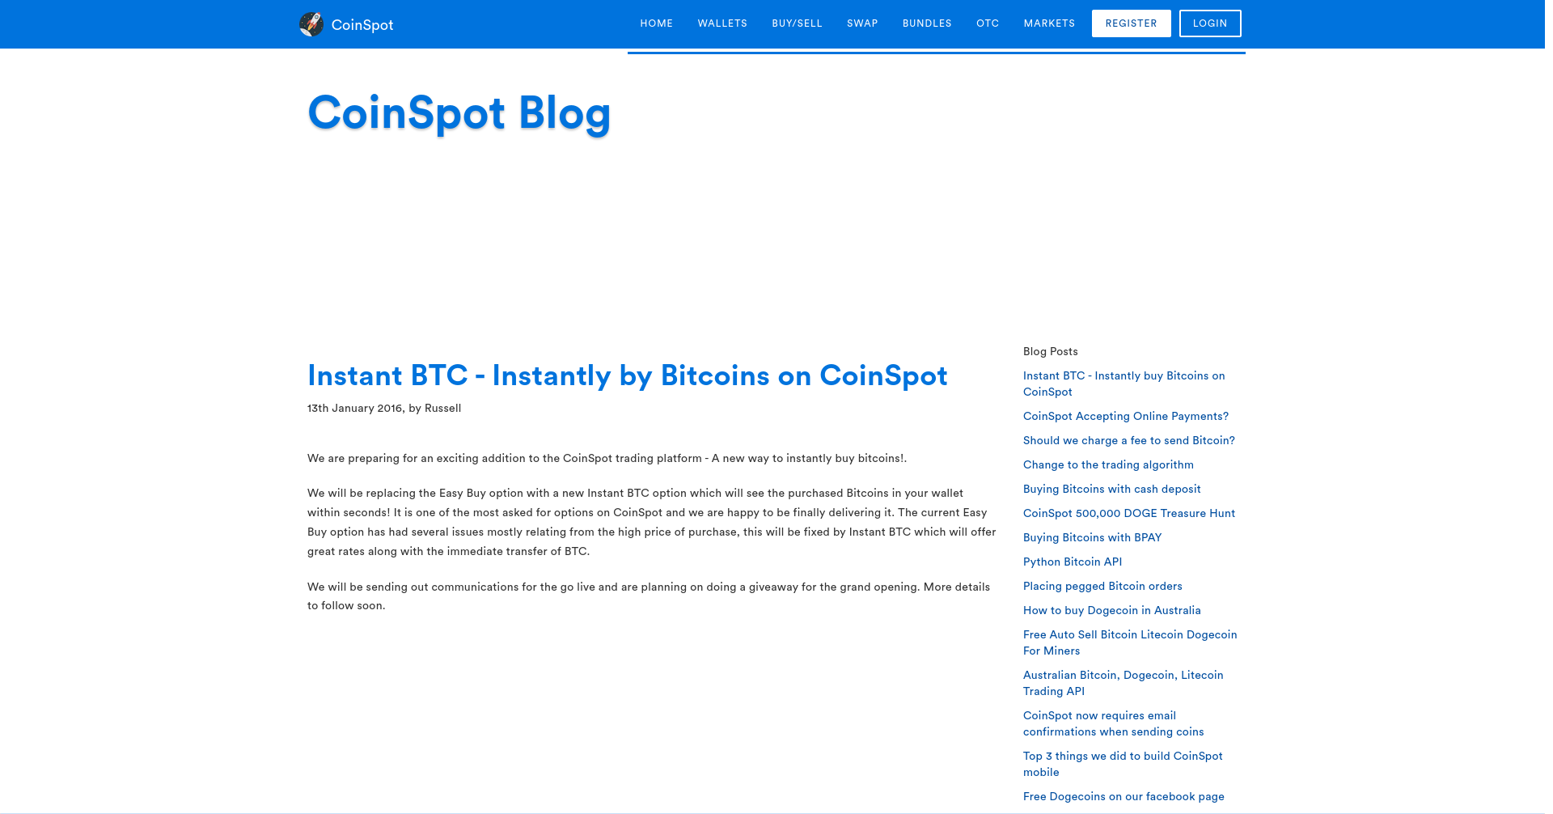

# nikto

- Nikto v2.1.5/2.1.5

https://www.coinspot.com.au/forgotpassword

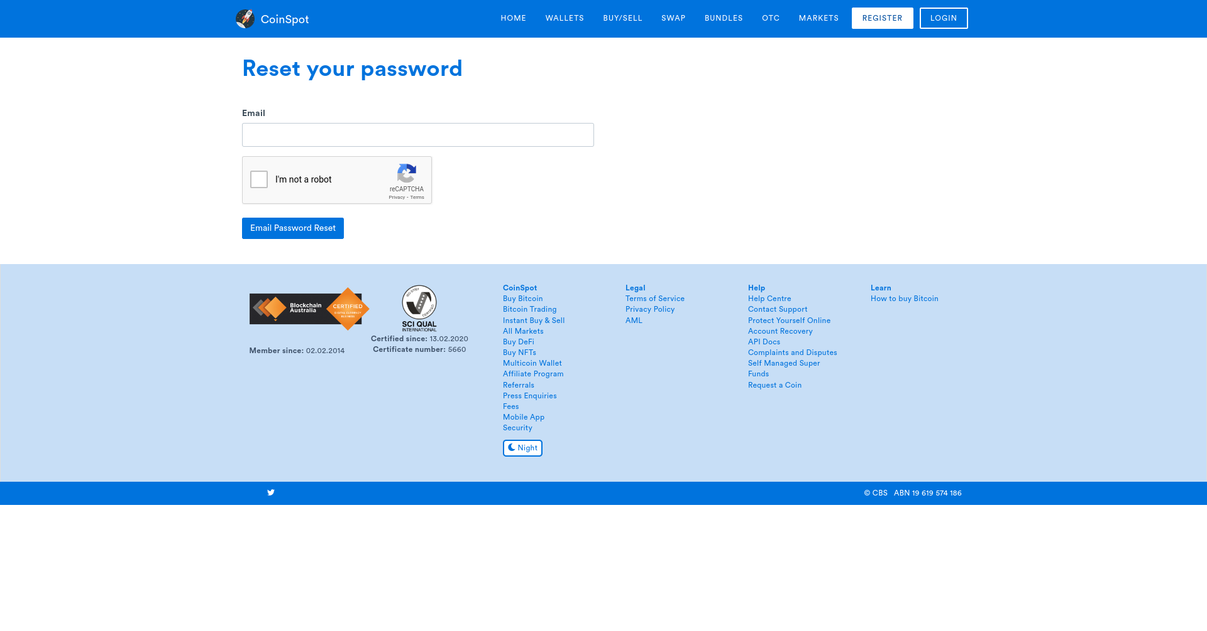

# nikto

- Nikto v2.1.5/2.1.5

https://www.coinspot.com.au/status

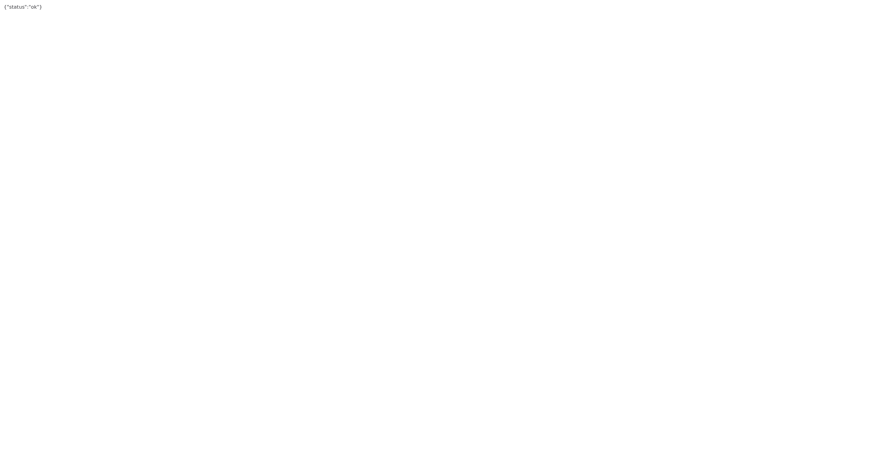

# nikto

- Nikto v2.1.5/2.1.5

https://www.coinspot.com.au/.bashrc

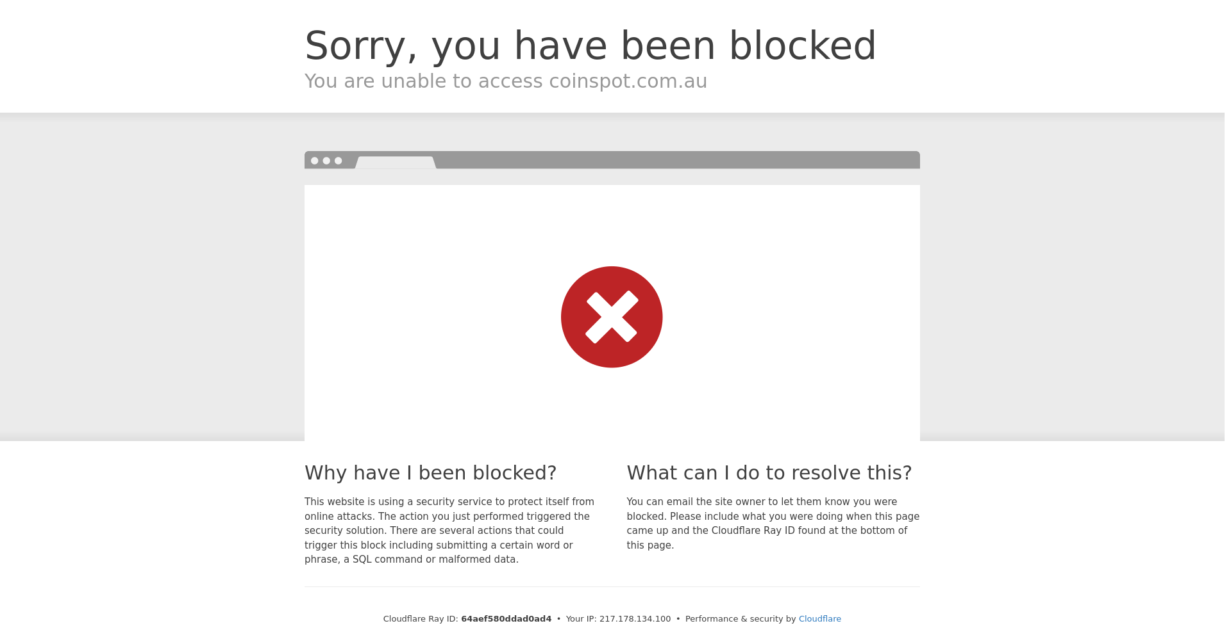

# nikto

- Nikto v2.1.5/2.1.5

https://www.coinspot.com.au/affiliate

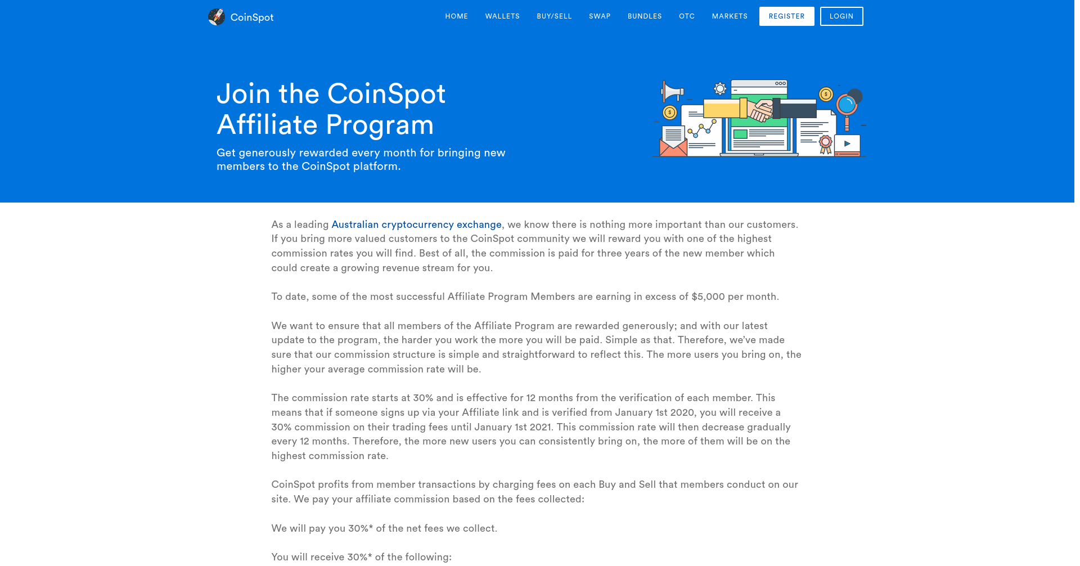

# nikto

- Nikto v2.1.5/2.1.5

https://www.coinspot.com.au/.passwd

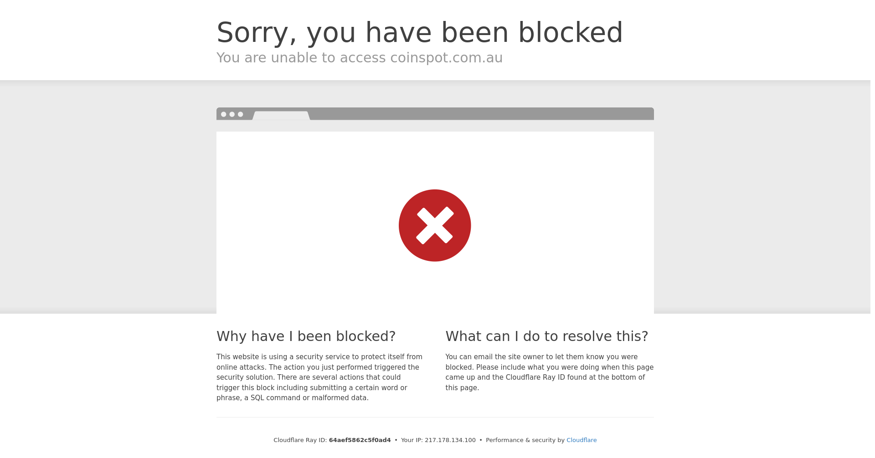

# nikto

- Nikto v2.1.5/2.1.5

https://www.coinspot.com.au/.bash_history

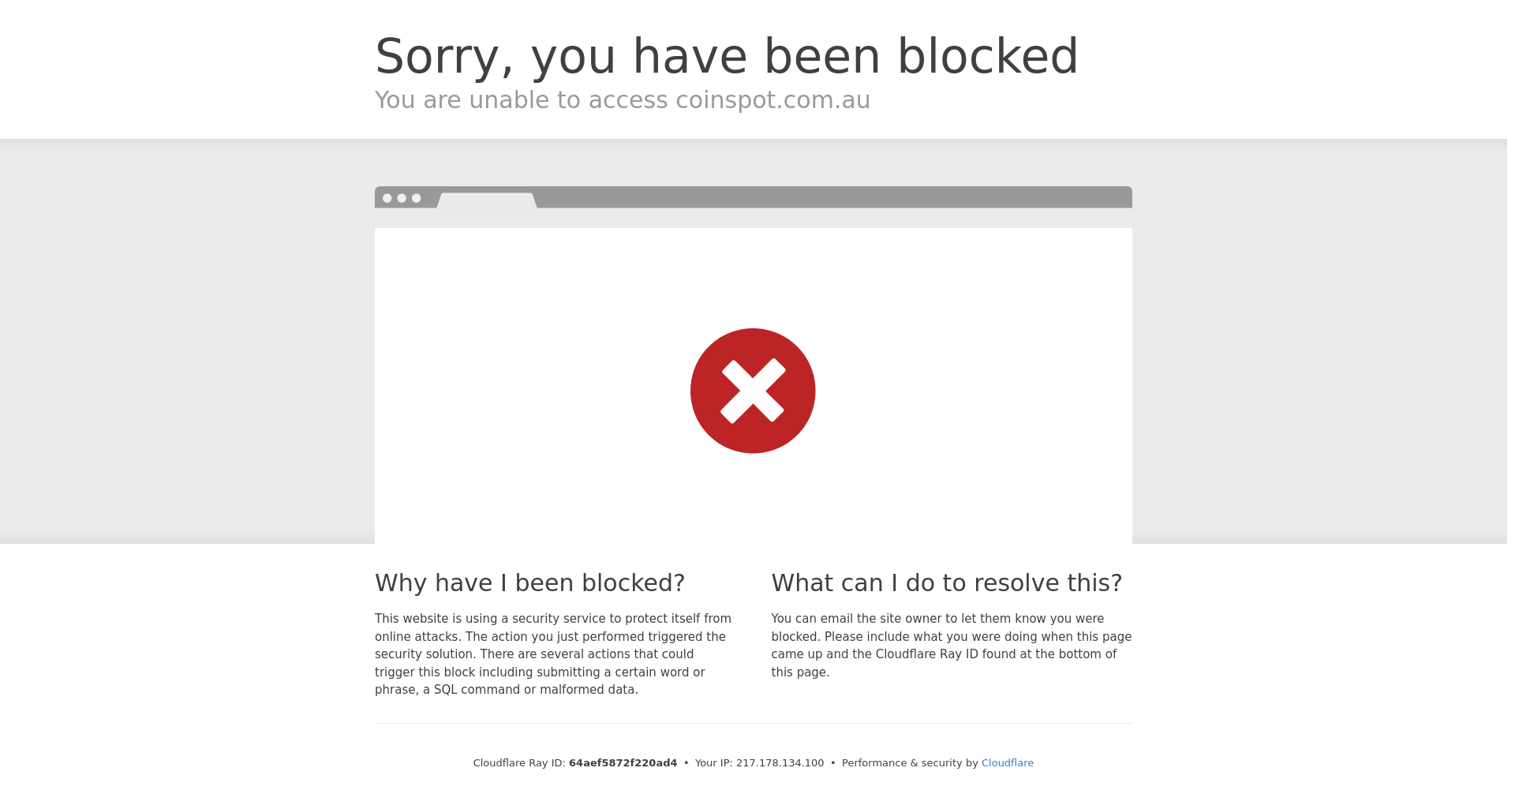

# nikto

- Nikto v2.1.5/2.1.5

https://www.coinspot.com.au/.cvs

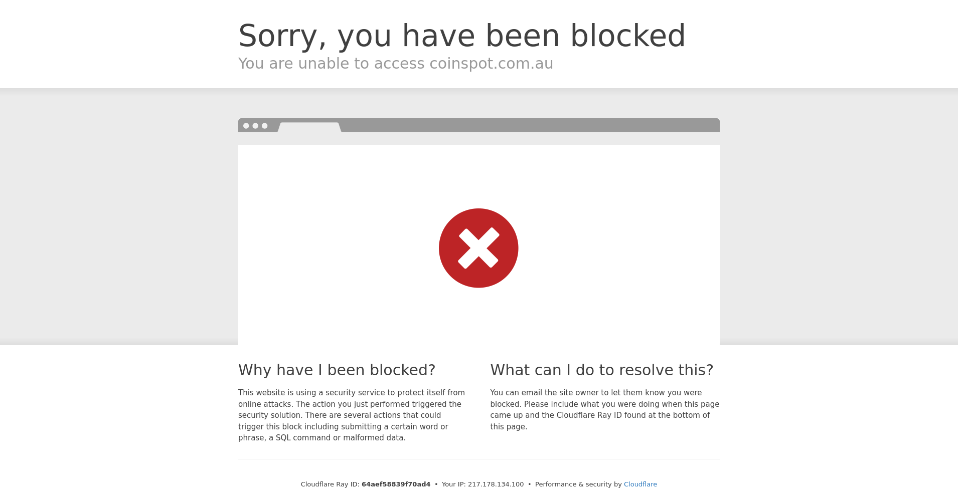

# nikto

- Nikto v2.1.5/2.1.5

https://www.coinspot.com.au/authorized_keys

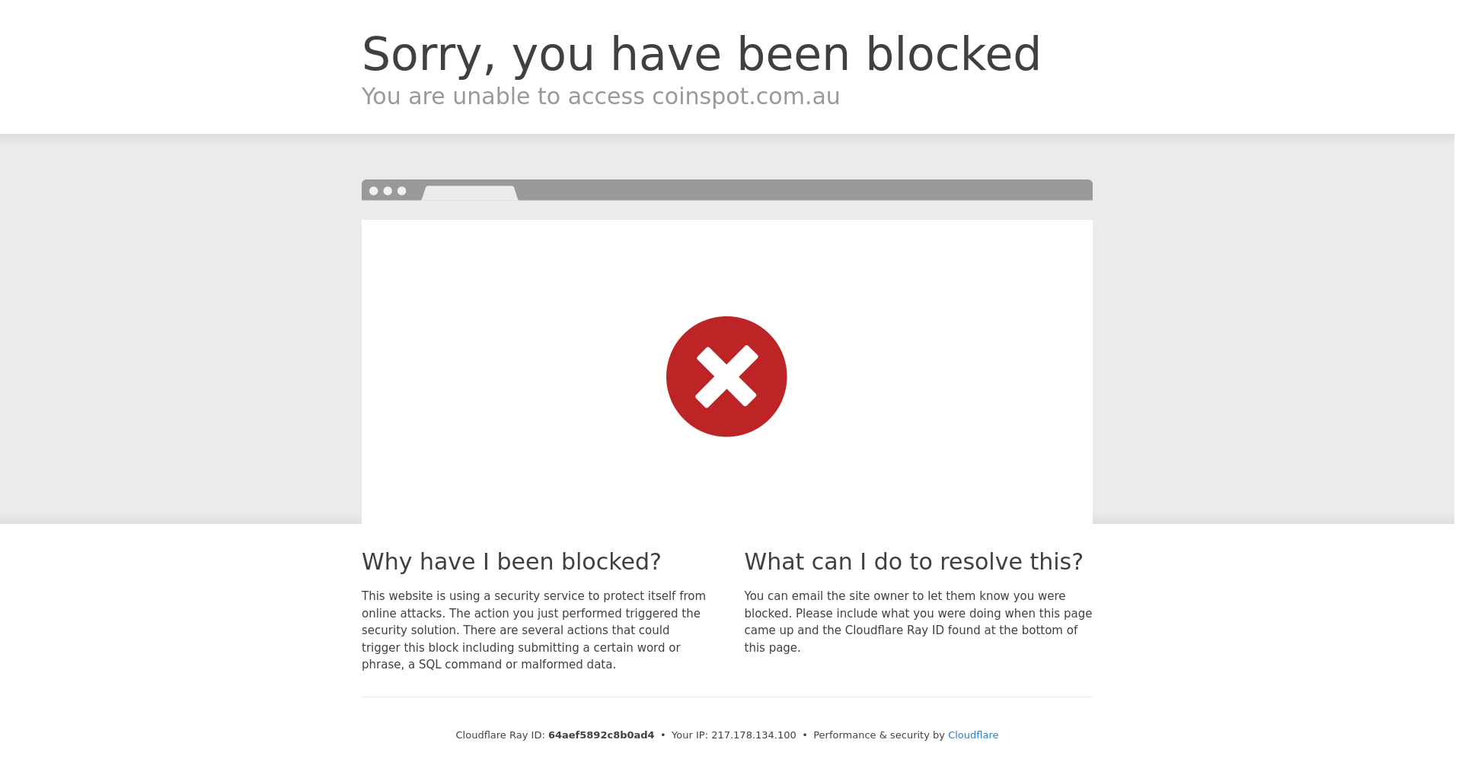

# nikto

- Nikto v2.1.5/2.1.5

https://www.coinspot.com.au/.ssh

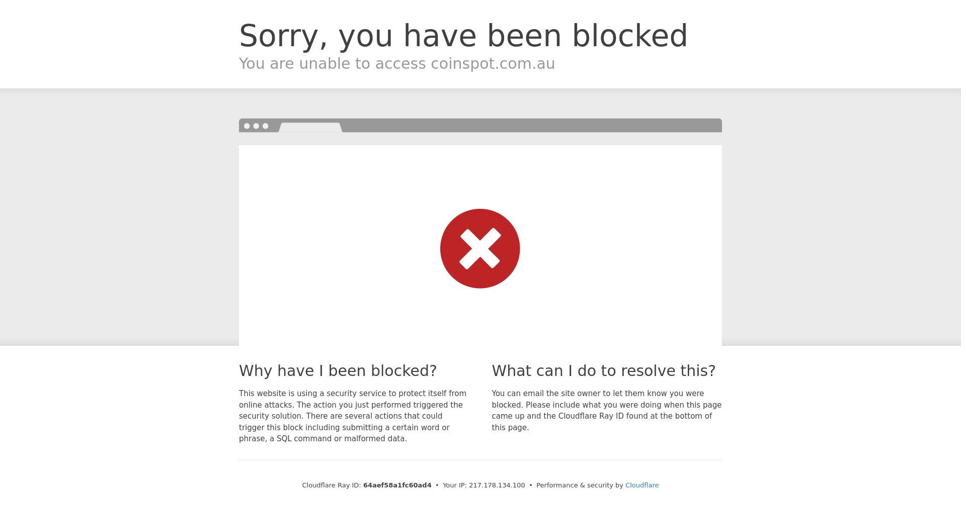

# nikto

- Nikto v2.1.5/2.1.5

https://www.coinspot.com.au/.mysql_history

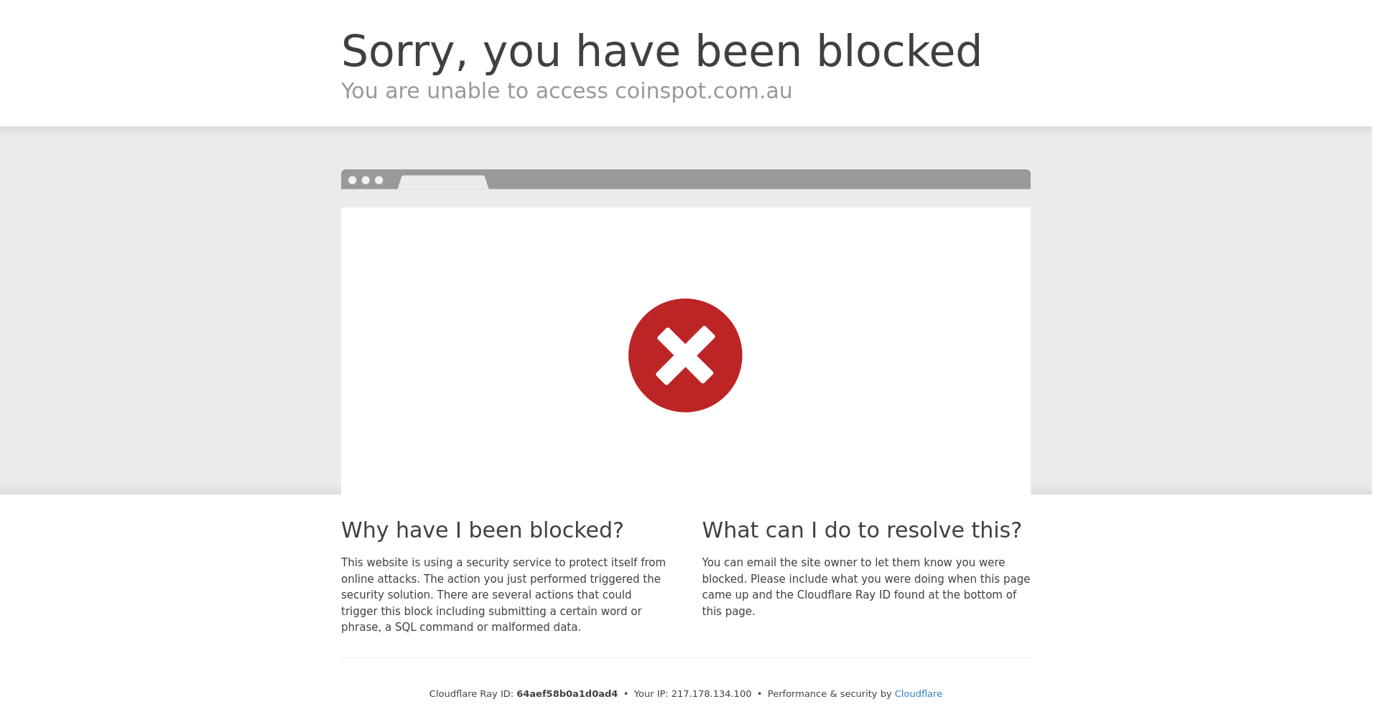

# nikto

- Nikto v2.1.5/2.1.5

https://www.coinspot.com.au/access_log

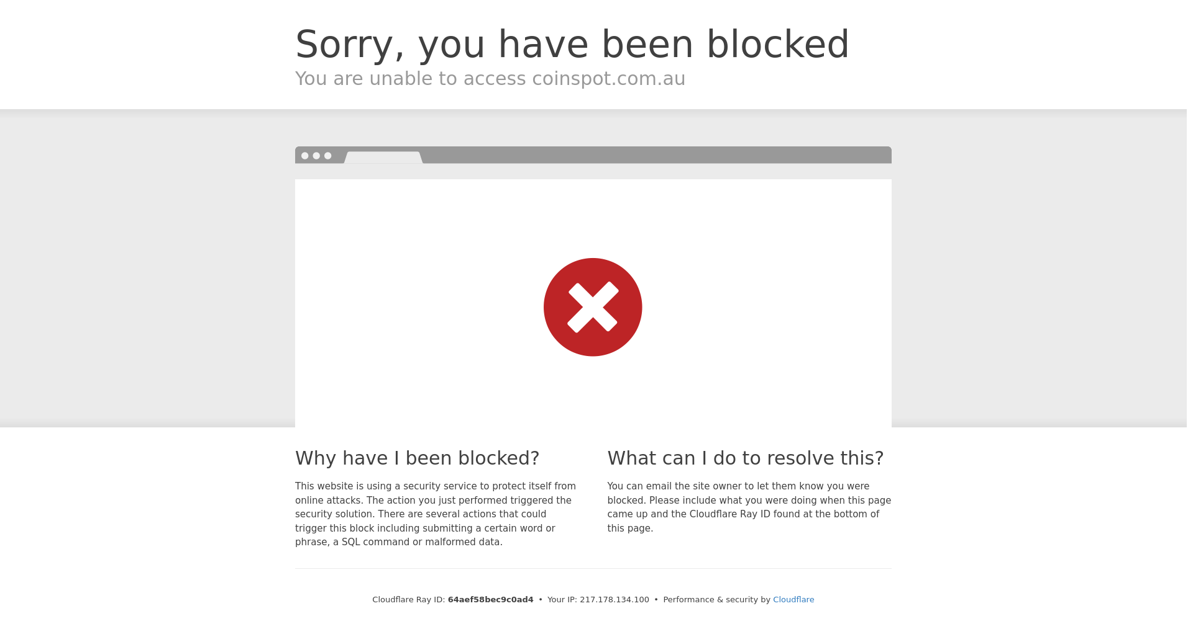

# nikto

- Nikto v2.1.5/2.1.5

https://www.coinspot.com.au/Blog



# nikto

- Nikto v2.1.5/2.1.5

https://www.coinspot.com.au/privacy

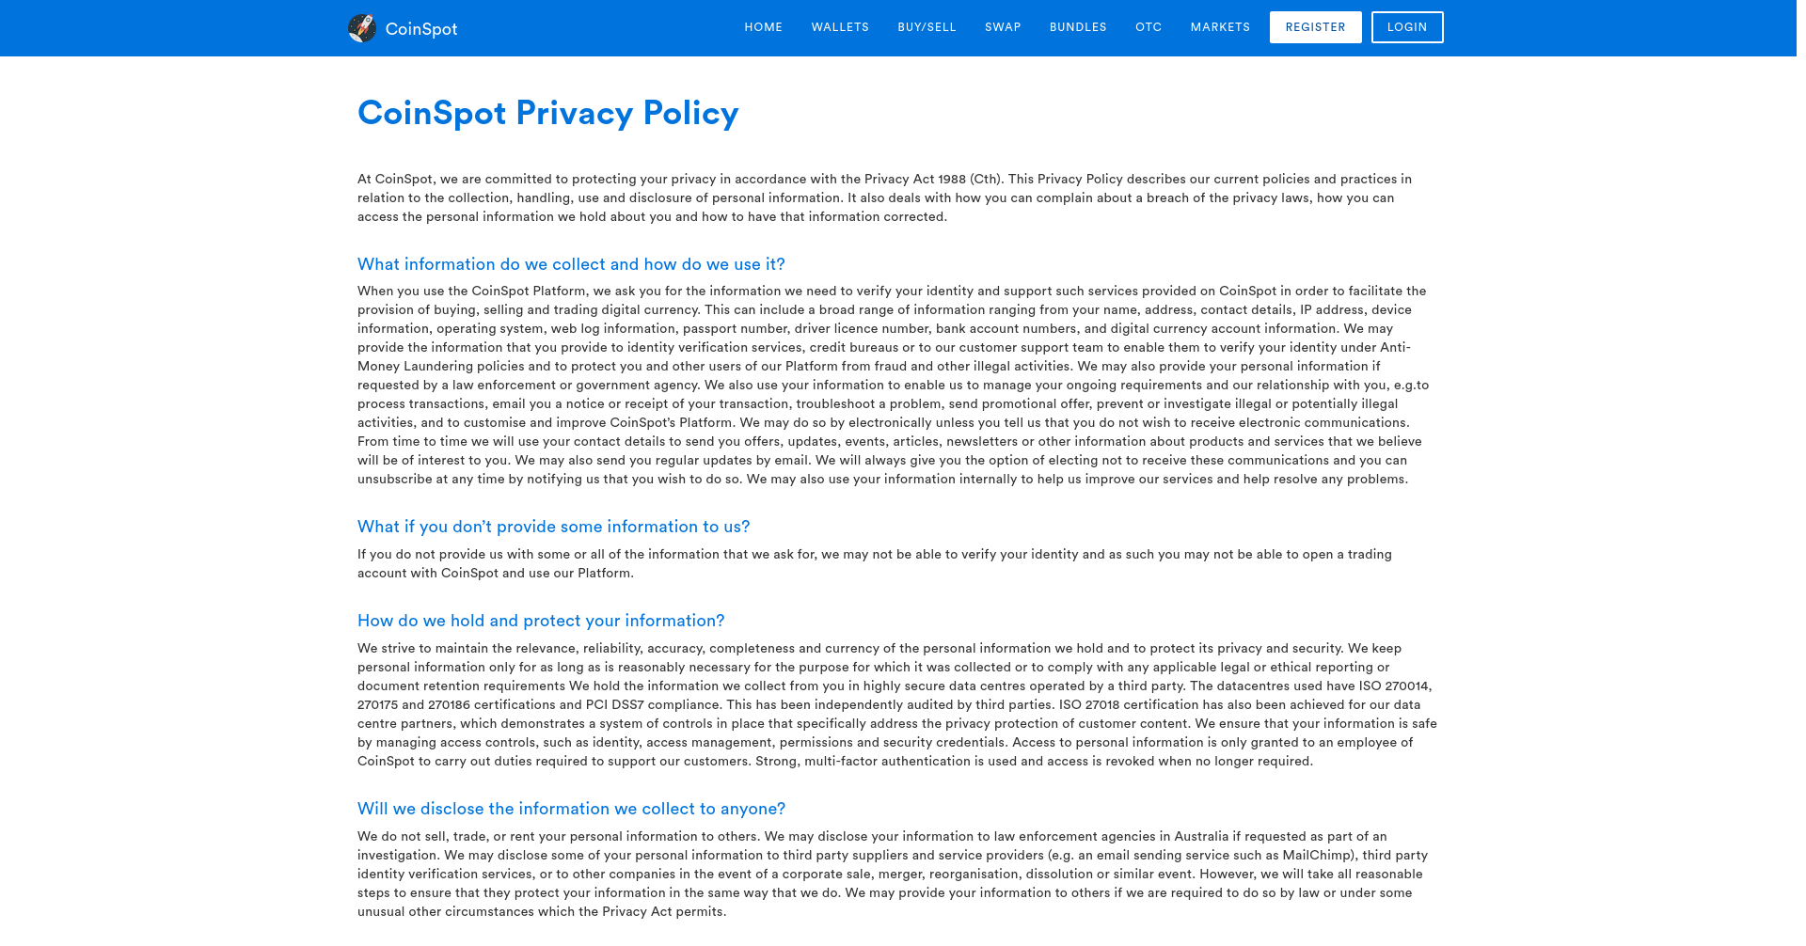

# nikto

- Nikto v2.1.5/2.1.5

https://www.coinspot.com.au/register

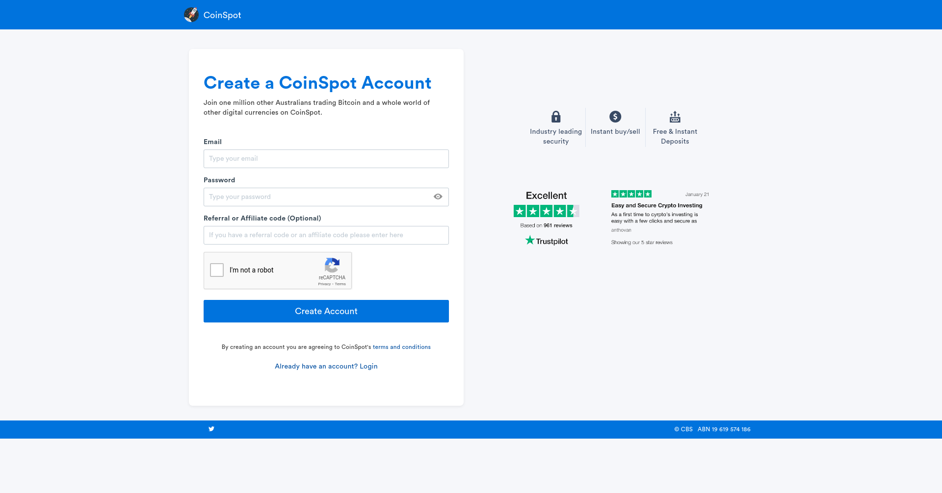

# nikto

- Nikto v2.1.5/2.1.5

https://www.coinspot.com.au/mobile

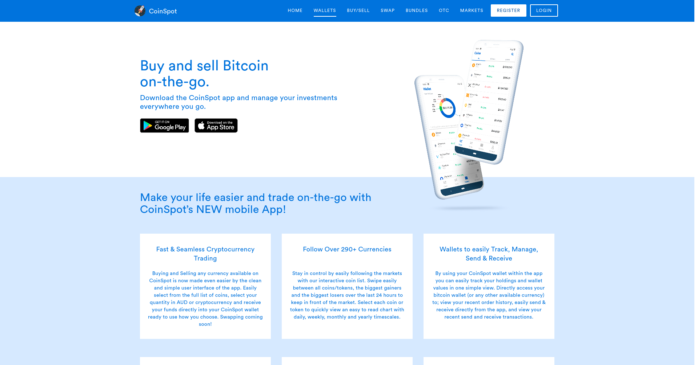

# nikto

- Nikto v2.1.5/2.1.5

https://www.coinspot.com.au/Security

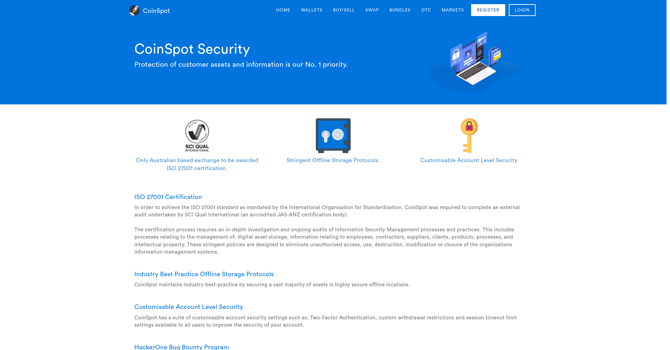

# nikto

- Nikto v2.1.5/2.1.5

https://www.coinspot.com.au/Support

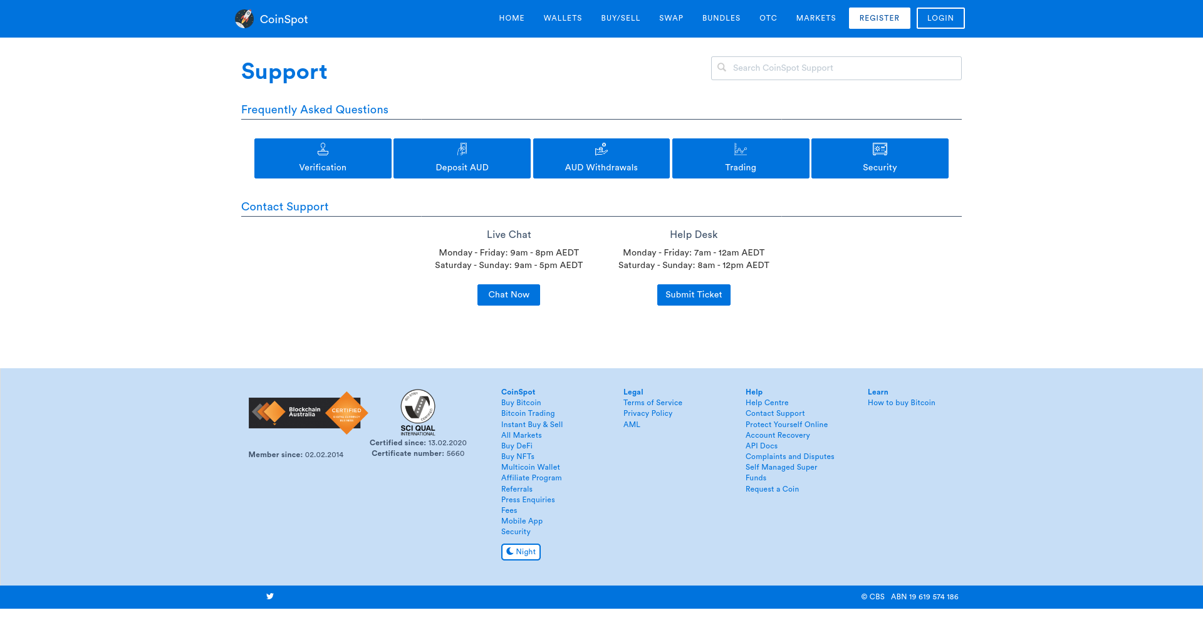

# nikto

- Nikto v2.1.5/2.1.5

https://www.coinspot.com.au/support



# nikto

- Nikto v2.1.5/2.1.5

https://www.coinspot.com.au/Contact

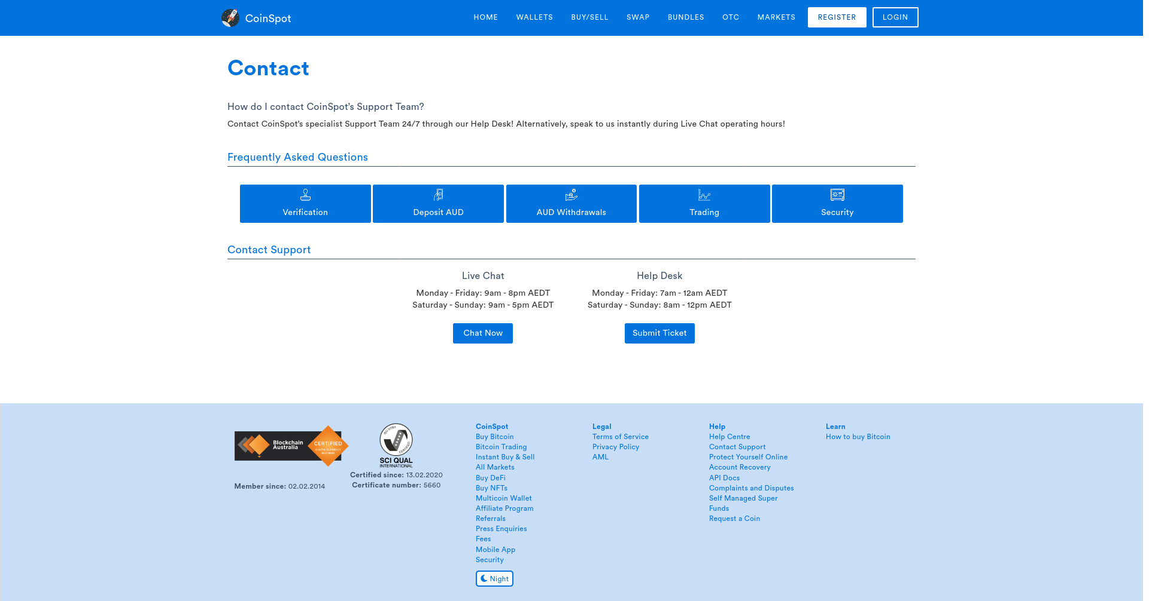

# nikto

- Nikto v2.1.5/2.1.5

https://www.coinspot.com.au/login



# nikto

- Nikto v2.1.5/2.1.5

https://www.coinspot.com.au/.htaccess

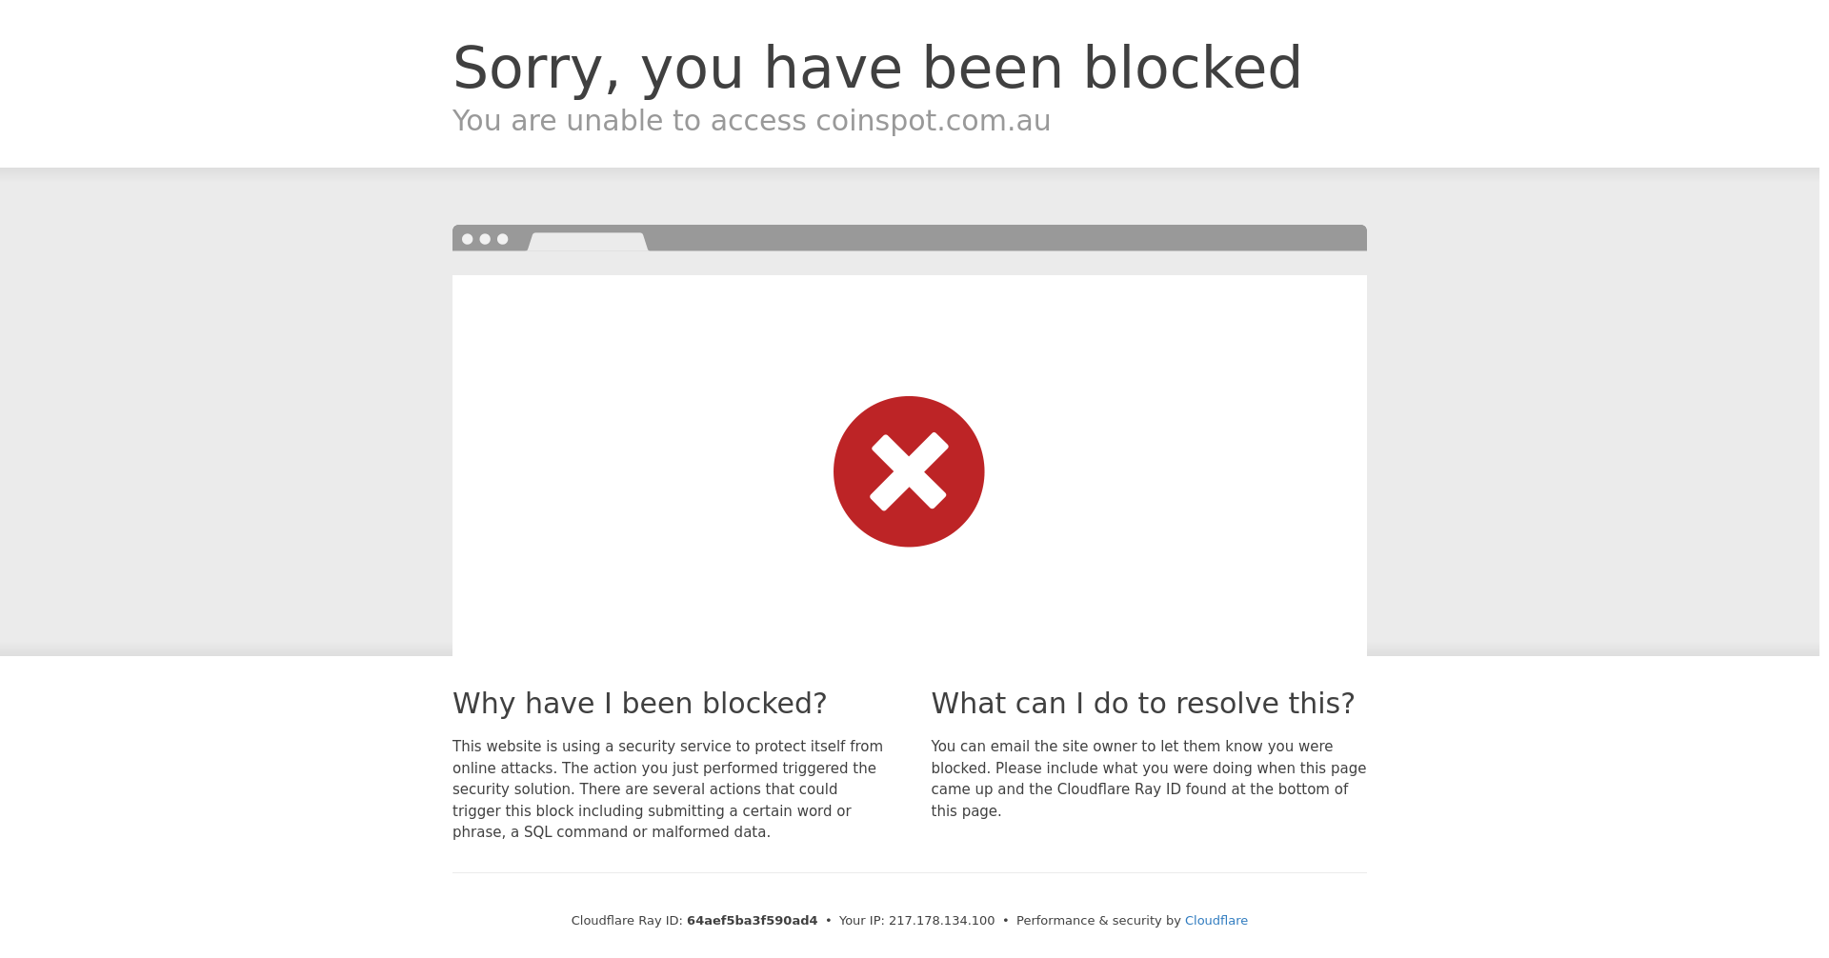

# nikto

- Nikto v2.1.5/2.1.5

https://www.coinspot.com.au/terms

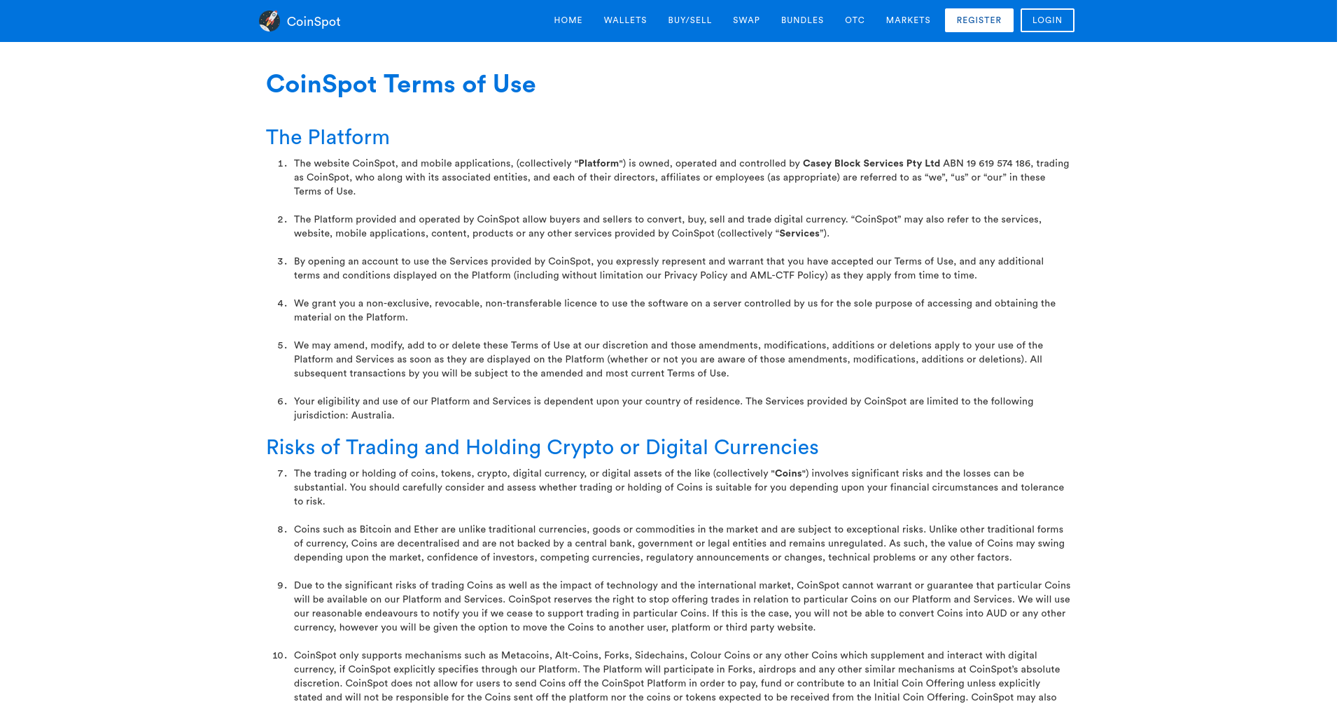

# nikto

- Nikto v2.1.5/2.1.5

https://www.coinspot.com.au/contact



# nikto

- Nikto v2.1.5/2.1.5

https://www.coinspot.com.au/Press

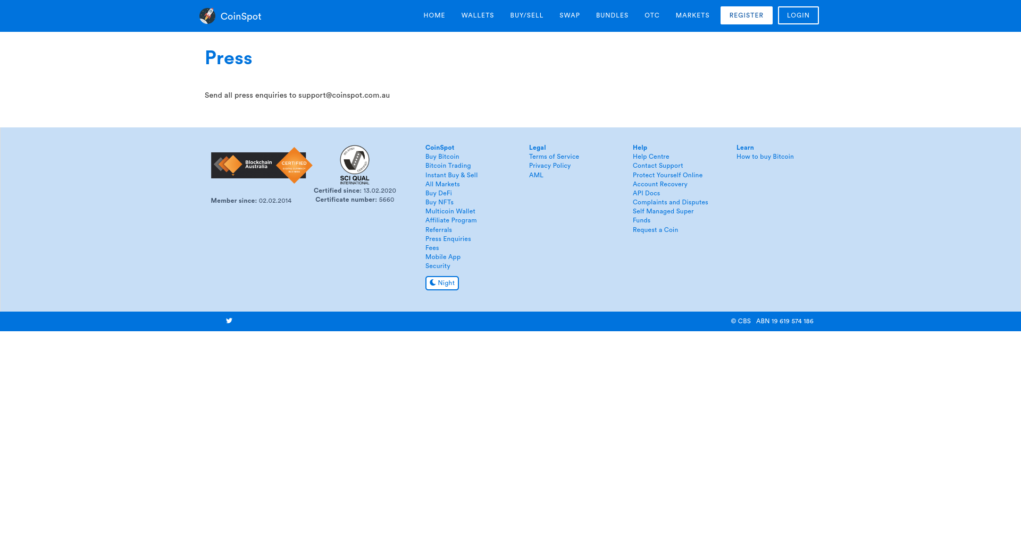

# nikto

- Nikto v2.1.5/2.1.5

https://www.coinspot.com.au/Privacy



# nikto

- Nikto v2.1.5/2.1.5

https://www.coinspot.com.au/press



# nikto

- Nikto v2.1.5/2.1.5

https://www.coinspot.com.au/.profile

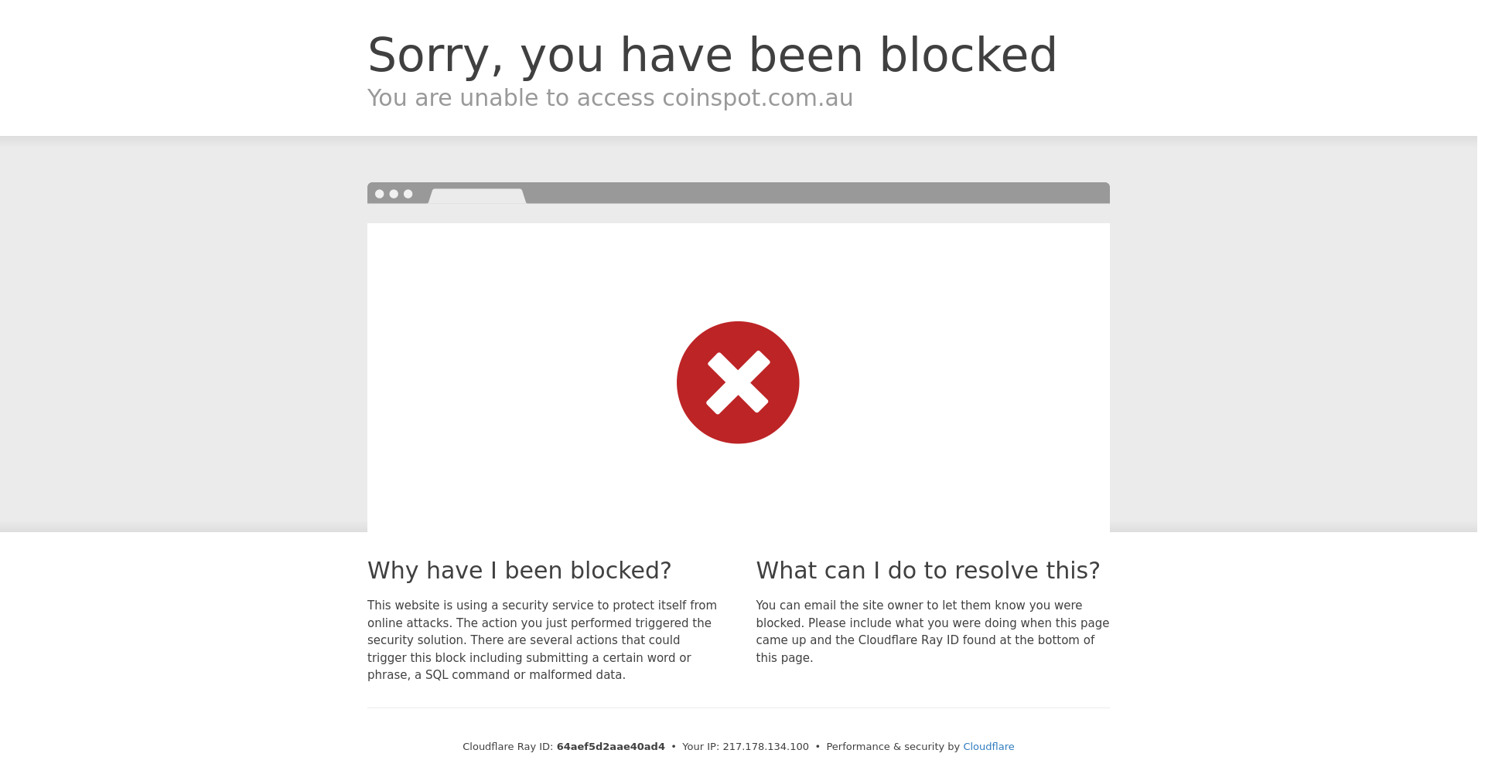

# nikto

- Nikto v2.1.5/2.1.5

https://www.coinspot.com.au/prices

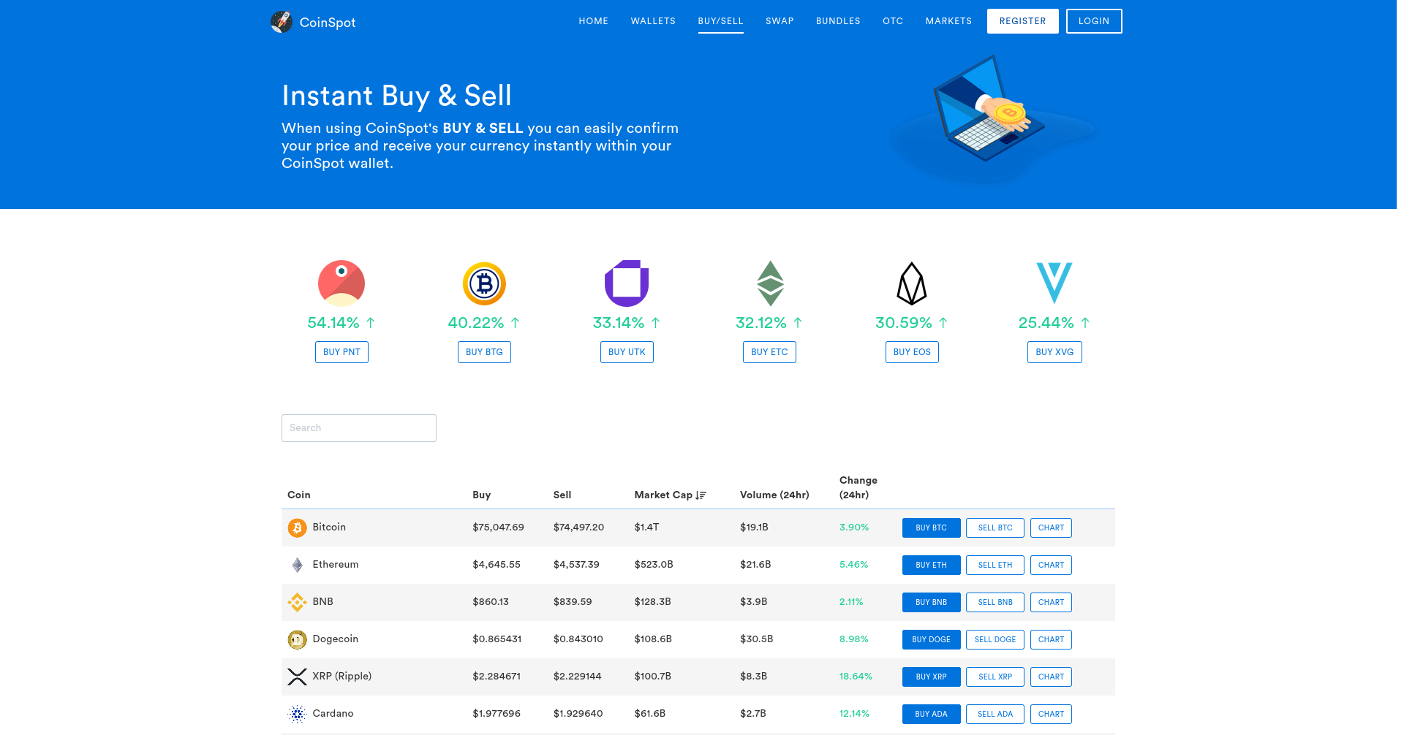

# nikto

- Nikto v2.1.5/2.1.5

https://www.coinspot.com.au/security



# nikto

- Nikto v2.1.5/2.1.5

https://www.coinspot.com.au/id_rsa

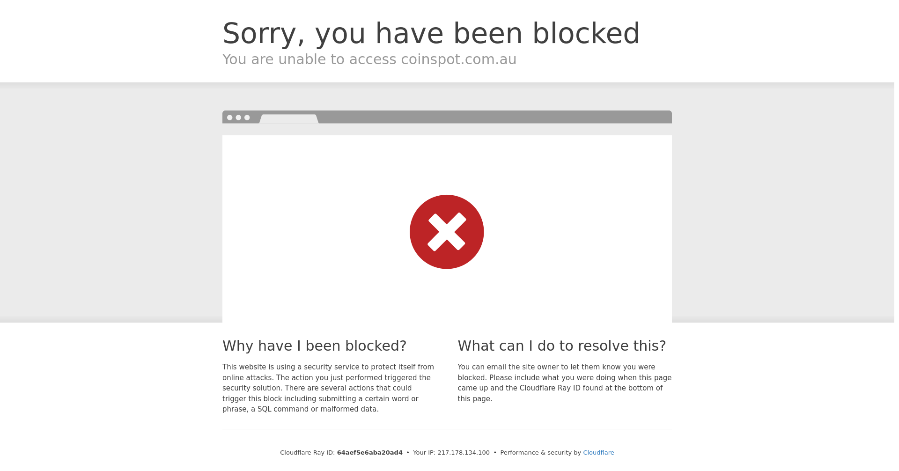

# nikto

- Nikto v2.1.5/2.1.5

https://www.coinspot.com.au/public

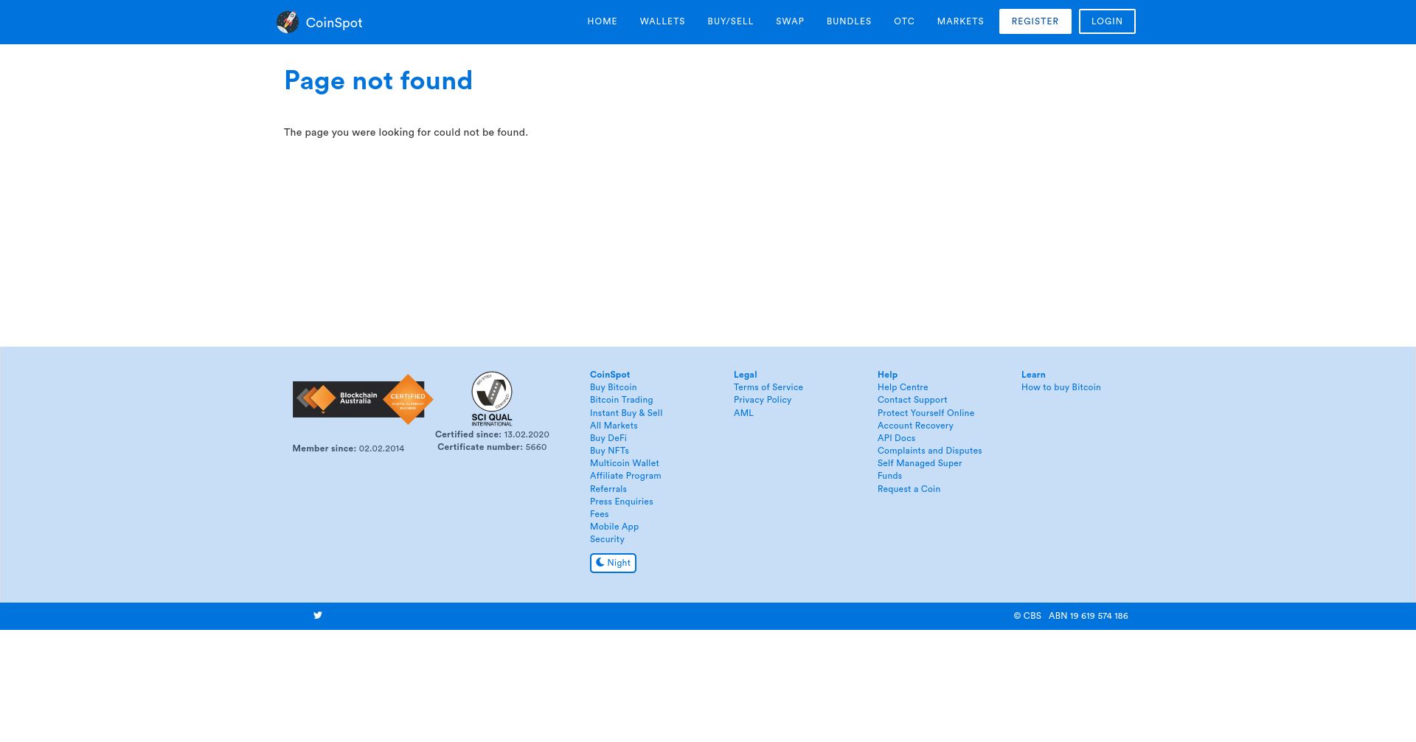

# nikto

- Nikto v2.1.5/2.1.5

https://www.coinspot.com.au/phpinfo.php

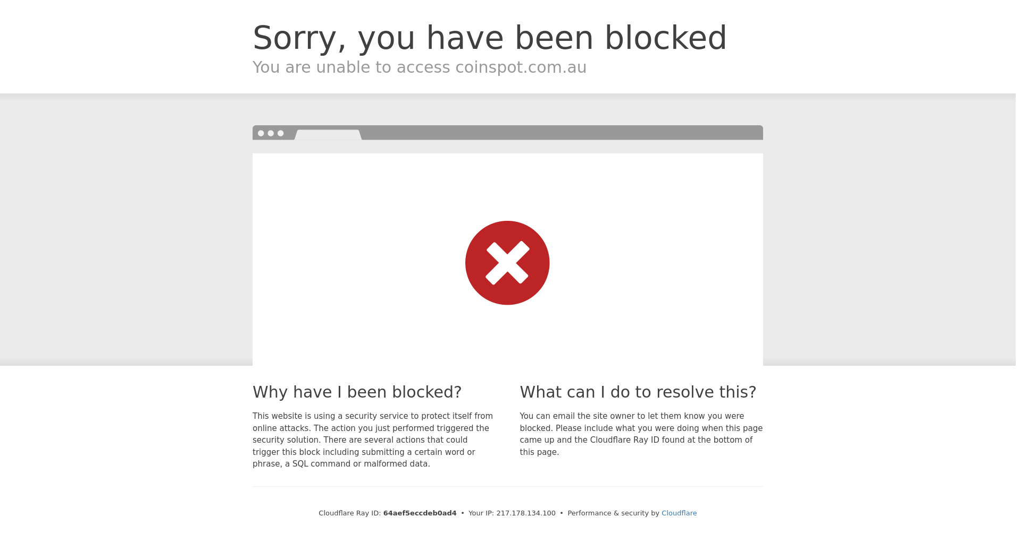

# nikto

- Nikto v2.1.5/2.1.5

https://www.coinspot.com.au/logout

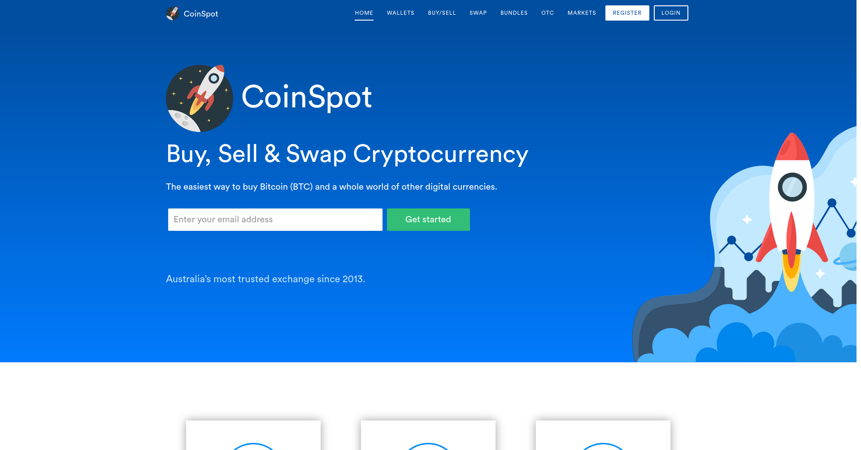

# nikto

- Nikto v2.1.5/2.1.5

https://www.coinspot.com.au/.history

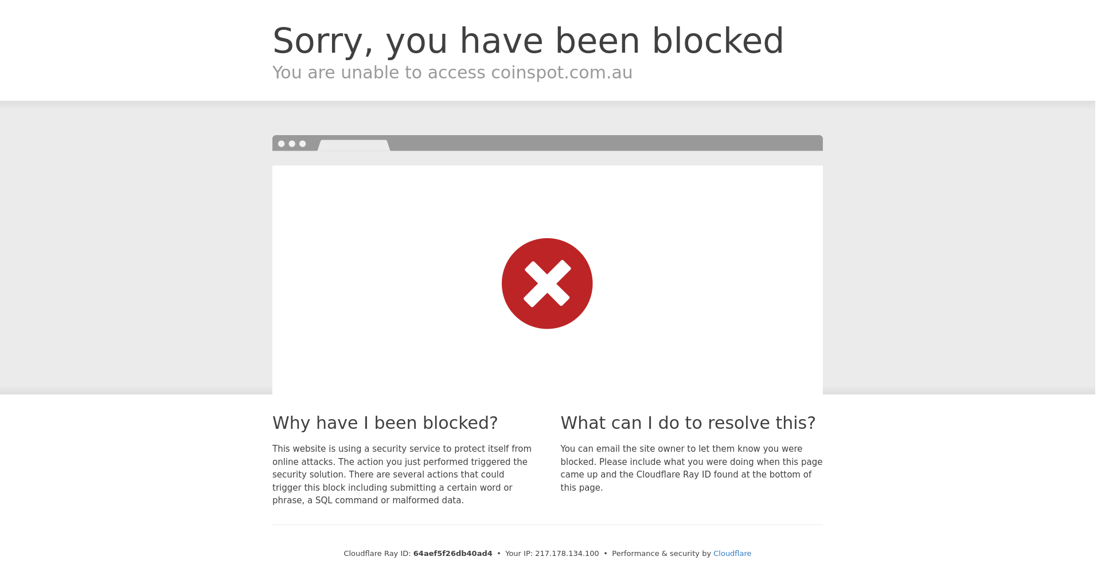

# nikto

- Nikto v2.1.5/2.1.5