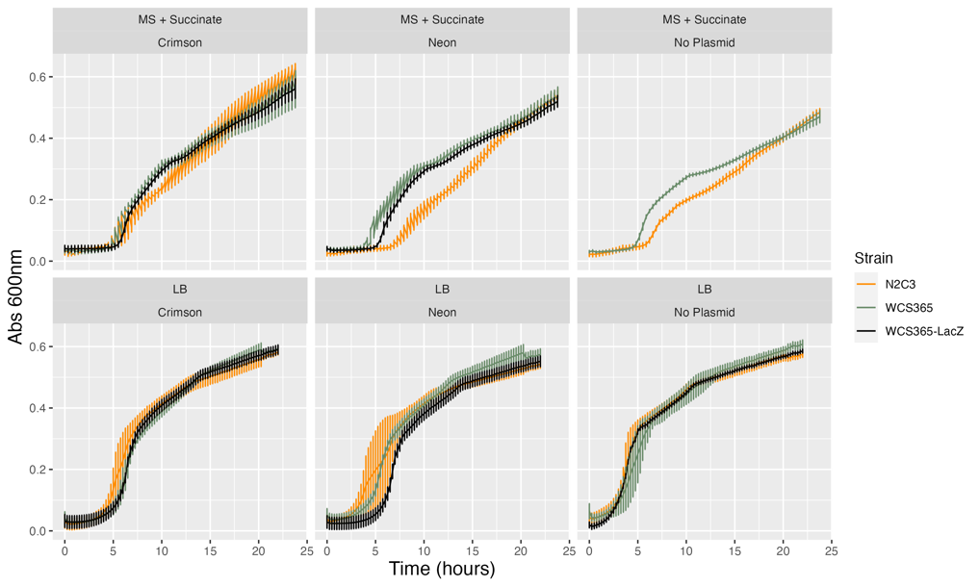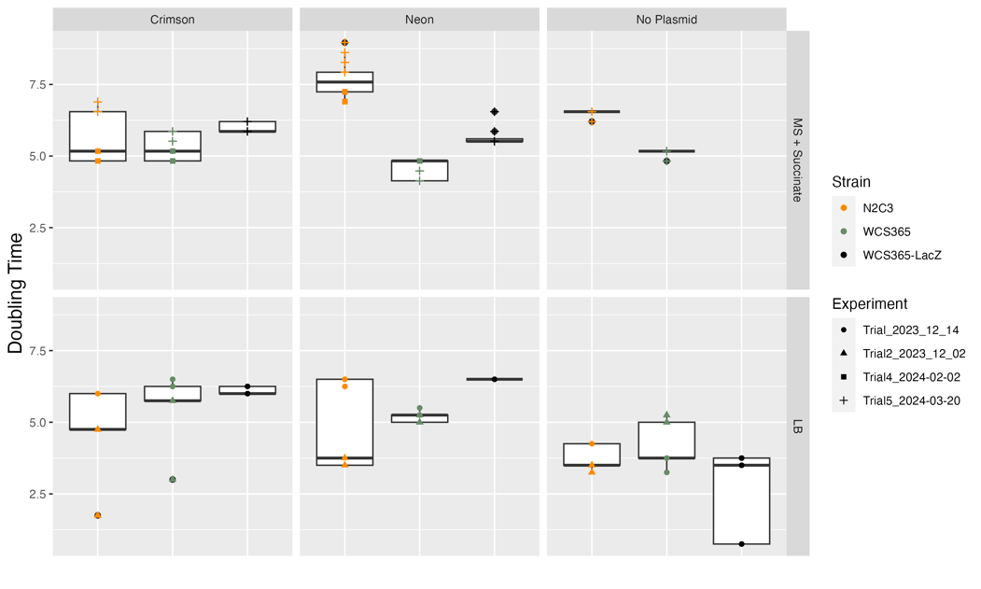

a.

b.

Figure S10. Slight growth burden for N2C3 in minimal media. (a) Growth curves of all strains used in experiments. (b) Doubling time summary from growth curves. WCS365 and N2C3 do not differ in growth rate or carrying capacity in LB media, with our without plasmids or lacZ insertion. There is a slight growth disadvantage to N2C3 in minimal media (1/2MS1/2MES+30mM Succinate) compared to WCS365. The difference is most prominent when N2C3 is carrying the Neon plasmid (pSW002-Pc-mNeonGreen).