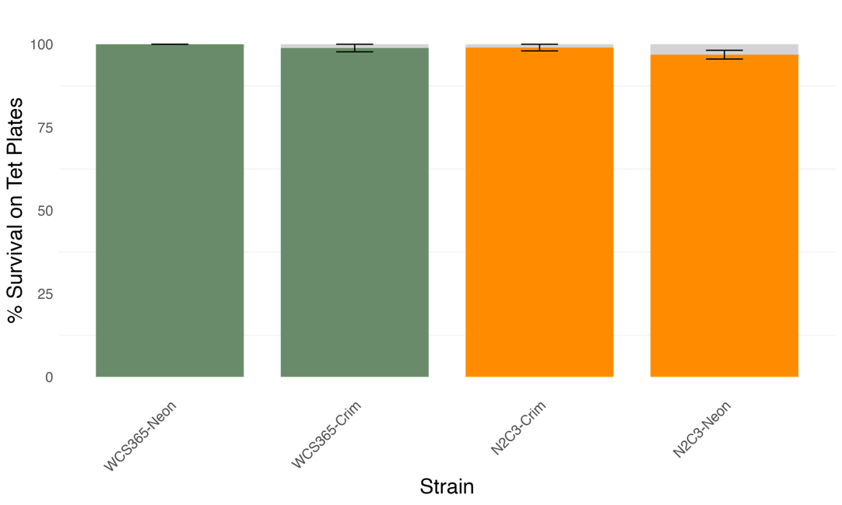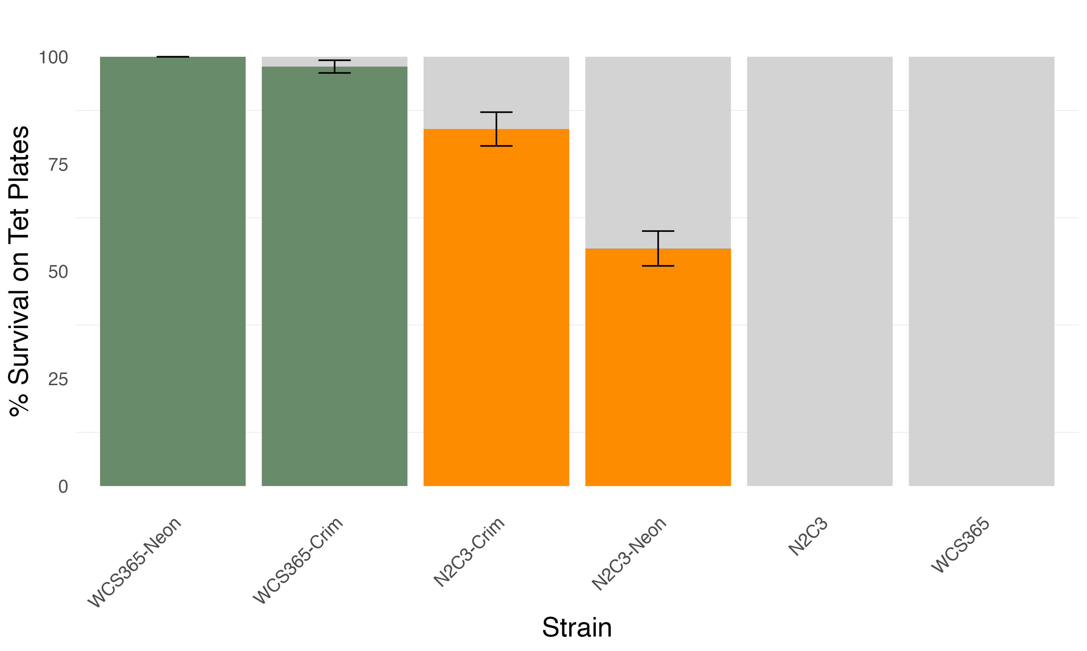

**A**

**B**

Figure SXX. Fluorescent plasmids are maintained *in planta* and plasmid loss is greatest for N2C3 carrying the Neon plasmid. WCS365 and N2C3 with Crimson (pSW002-Pc-E2-Crimson) or Neon (pSW002-Pc-mNeonGreen) plasmid were inoculated on plants and grown hydroponically for seven days. Plasmid loss was measured based on the ability for bacteria to maintain tetracycline resistance. Grey bars represent total colonies tested for tetracycline resistance. Filled bars are the percentage of colonies that survived on tetracycline plates. **(A)** Plasmid maintenance at T0: at the time of inoculation most bacteria are carrying the plasmid. Results are for one experiment. **(B)** Plasmid maintenance after 7 days on plants. WCS365 had very little plasmid loss (100% of Neon and 97-100% of Crim carrying colonies tested maintained the plasmid) while N2C3 performed better when carrying the Crimson plasmid (45%-63% of Neon and 73-89% of Crim carrying colonies tested maintained the plasmid). N2C3 and WCS365 without a plasmid are unable to survive on tetracycline. Results are a combination of multiple plants over two replicate experiments done on different weeks.