**Introduction**

Olist is a platform that connect small and medium business with the marketplaces in Brazil (Extra, Shoptime, Walmart, Submarino, .etc) and help the merchants to sell at these marketplaces. Unlike in some countries, the fast-growing e-commerce sector in Brazil are dominated by a number of large-size marketplaces rather than by a single marketplace. Therefore, a merchant has incentive to operate in multiple marketplaces to maximize their revenue. With the limitation in human resources as the main pain points, the merchant would want to use Olist to manage the sales in different marketplaces and streamline the stock management and the order fulfilment process.

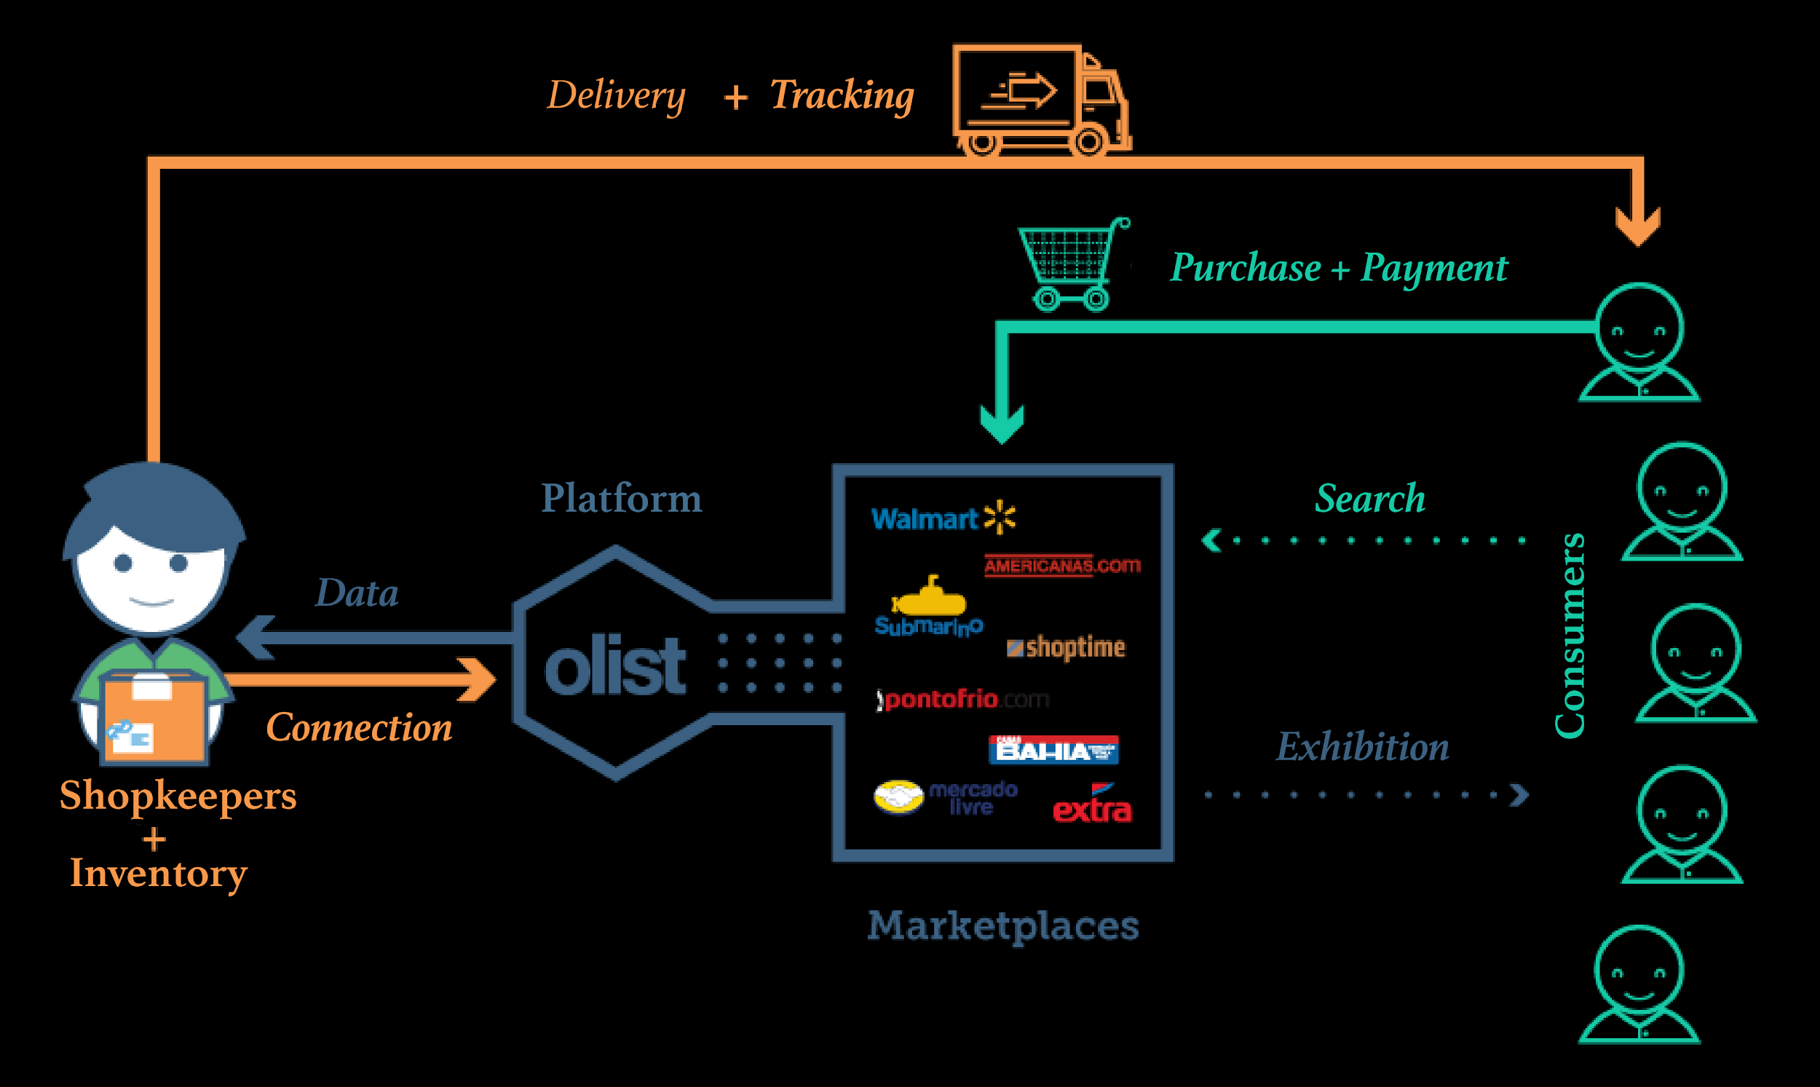

*Figure 1: Olist’s business model*

With this B2B2C model, Olist's marketing team have 2 main objectives:

* From seller side, they want to increase the number of merchants using Olist platform.
* From buyer side, they want to maximize the e-commerce sales on these marketplaces.

The scope of this analysis focus more on the B2B side of Olist. With a given dataset, I will conduct the exploratory data analysis that can bring some helpful insights to Olist's B2B marketing team.

Marketing & Sales process for B2B:

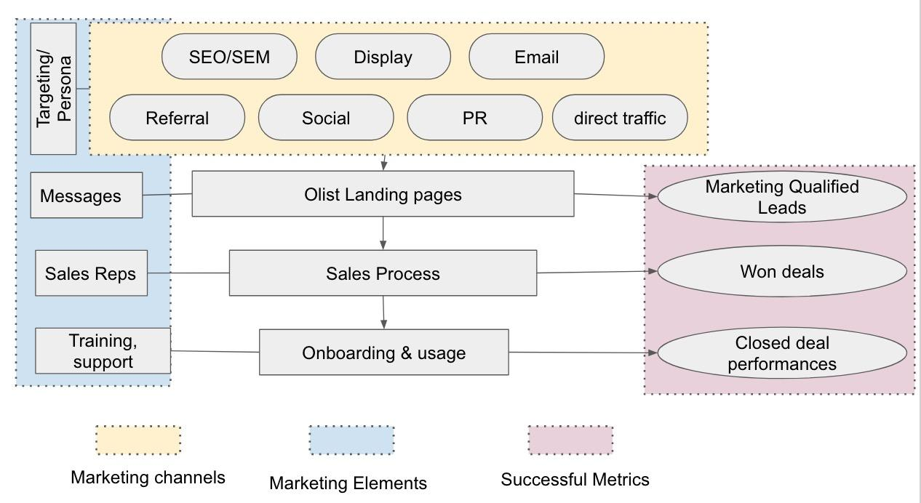

Figure 0: B2B Marketing funnel

**Data characteristics**

The datasets were obtained from Kaggle.

* First dataset contains 8000 data points about the MQL (marketing qualified leads), its first contact date, the landing page that captured the leads, and the lead origin (the channel that bring the leads to the landing pages). It has 4 variables with 8000 data points

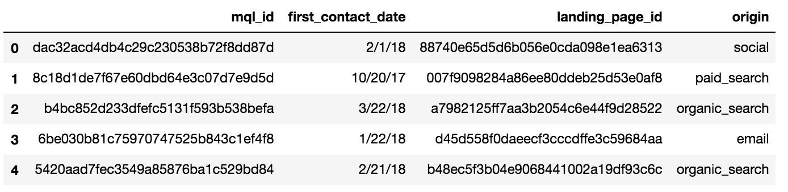

* Second dataset contains 842 observations. Each observation is a won deal of Olist which consists of the mql_id of the merchant, seller_id (used in Olist platform), sdr_id (the sales development rep that was in charge of the sales process) won_date, its business segment, lead_type, lead_behaviour_profile, business_type, declared_monthly_revenue,... (It has 10 variables)

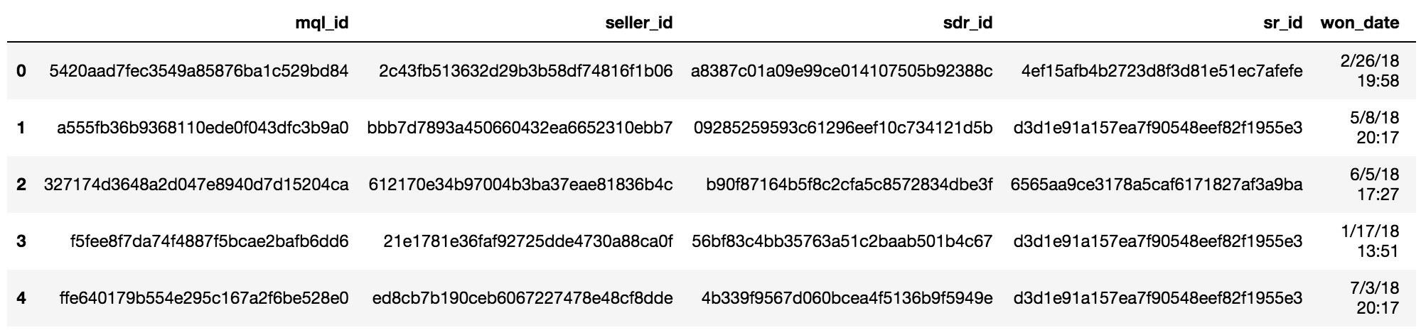

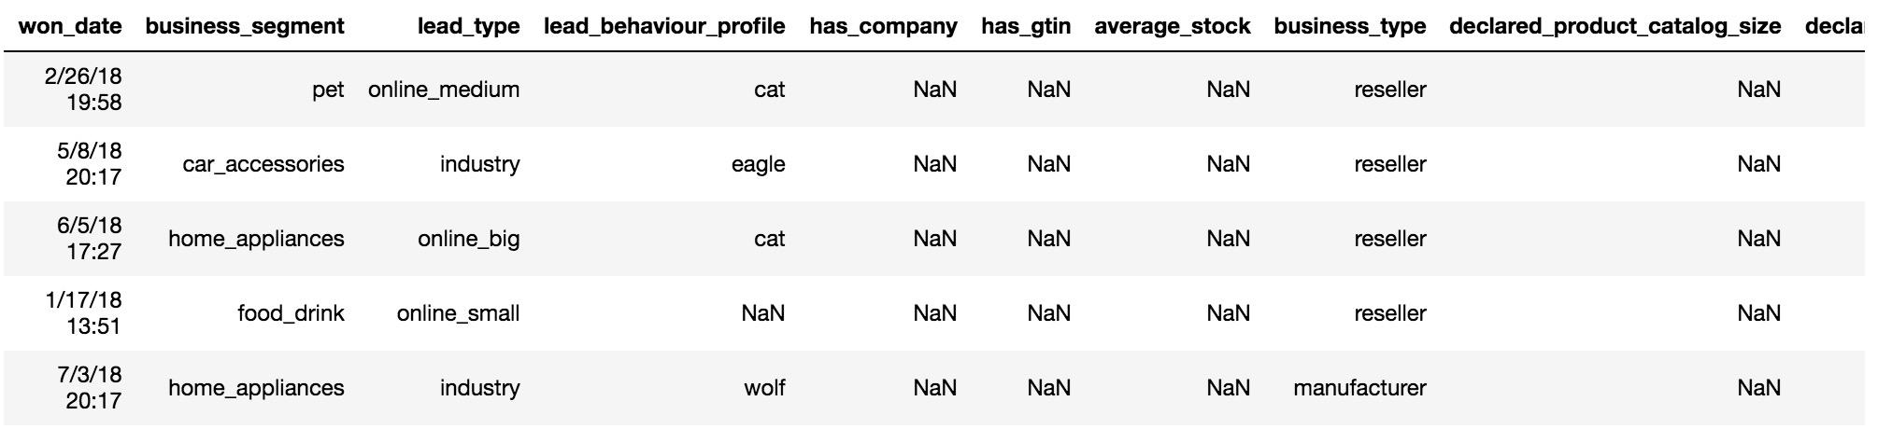

* Third dataset: Via Kaggle, Olist also donated their dataset about the demand side. We will use this to inform Olist marketers about the performance of the sellers, thus help them to improve the B2B marketing process.

**Exploratory Data Analysis**

**The number of MQL:** The MQL data is provided from 07/2017 to 06/2018, while the won MQL data is provided from 01/2018 to 12/2018. In 2017, MQLs that Olist marketing team generated is around 400 mqls/month. In 2018, they boost the number to 1000-1400 leads per month. Regarding the won MQL, its peak was at 05/2018 with 200 won opportunities.

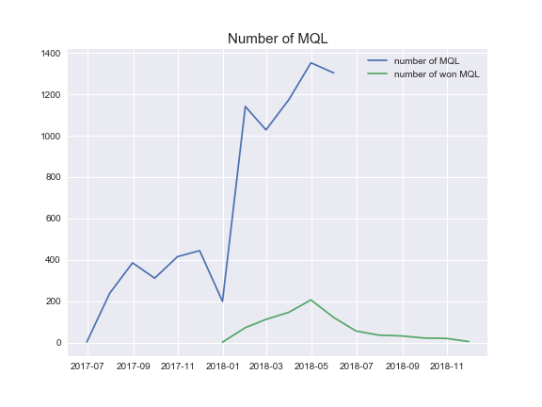

Figure 1:

**Channels:** The majority of MQLs come from organic_search channel, followed by direct traffic and social . Other, other_publicities, referral and display are the sources that bring the least MQLs to Olist. The organic_search MQL is significantly increased in 2018-02 and declined after that. This can be the result of a big event/PR campaign.

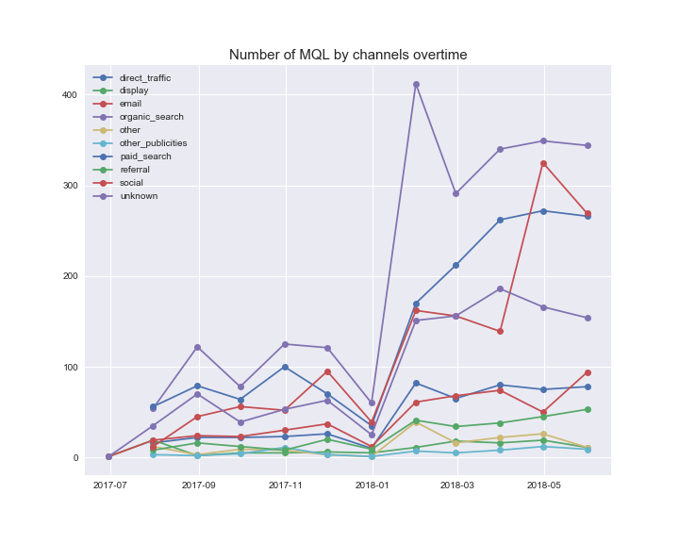

Figure 2:

The conversion rates for these channels are varied. Organic_search, paid_search and direct traffic are the sources that enjoy the highest conversion rates (12.5%, 11.5% and 11% respectively). Email, other_publicities and social have lowest conversion rates (3%, 5%, 5.5% respectively). This means that SEO and Google Adwords are the most effective marketing campaigns for Olist. This result seems to be relevant with a couple of surveys illustrating the most effective marketing channel for B2B companies.

<https://www.bizible.com/blog/b2b-industry-analysis-best-marketing-channels>

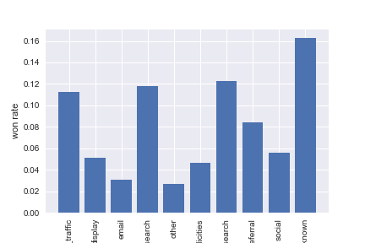

Figure 3:

**Landing page**

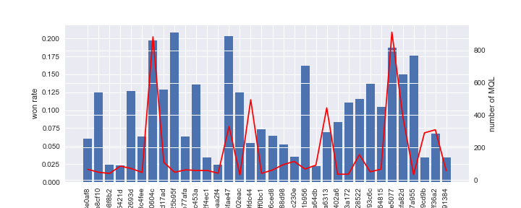

figure 4:

Olist used 495 landing pages to capture MQLs. Even though sales team is responsible for converting an MQL into a won opportunity, marketing team can affect this likelihood from the top of the funnel by providing relevant messagings and benefits on the landing pages. From figure 4 above, there are 2 landing pages that have very high number of MQLs (~800 MQLs) as well as very high won rate (~20%), meaning that 20% of the MQLs captured from these landing pages become Olist's sellers.

Learning from these landing pages can help Olist to replicate the success to other landing pages.

**Targeting**

**Business Segment**

Targeting is very important in B2B marketing. There're segments that will be very interested in Olist and vice versa. The following graph show that by using the sales cycle (how long the sales process is) as the indication:

Figure 5:

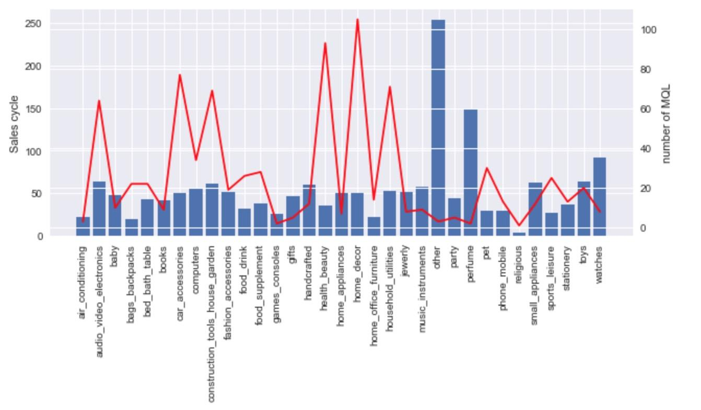

Business segments such as Home_decor, health_beauty, household_utilities, construction tool for house and garden, car accessories and electronics are the majorities of the sellers with the sales cycle typically around 50 days. Somes segments that have long sales cycle than others are perfume and watches. However, since these 2 segments only have small number of MQLs (7 & 10) so Olist should probably wait for more MQLs to have a more accurate observation.

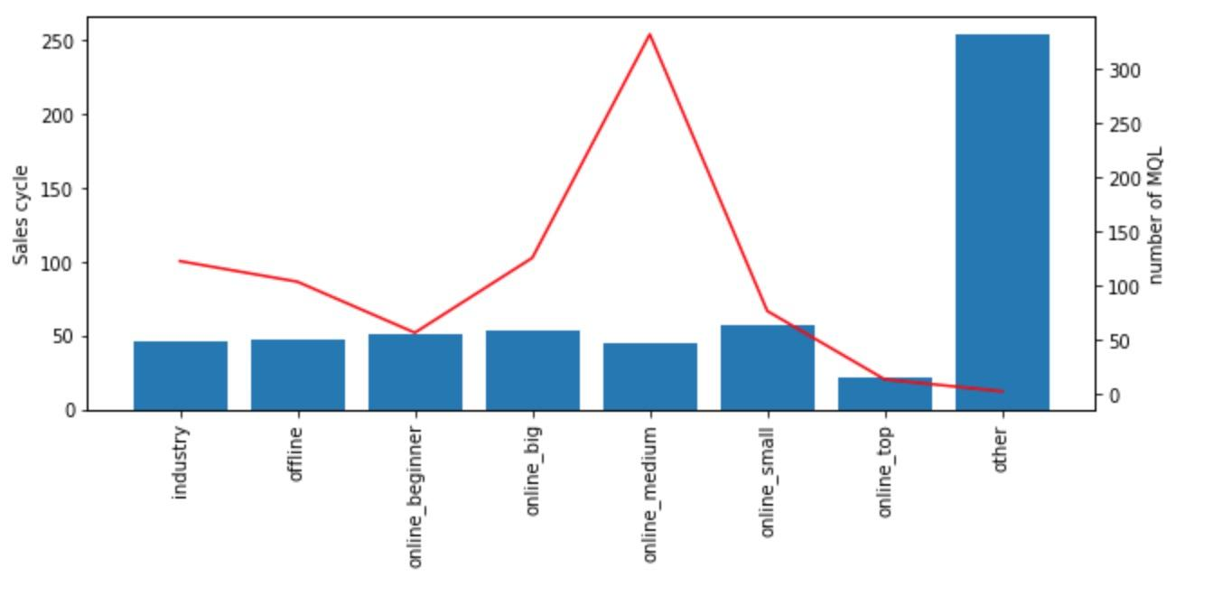

Figure 6:

Regarding the Lead_type variable, Online_medium is the most popular type among Olist MQLs. There is no significant difference between sales cycle of these business types.

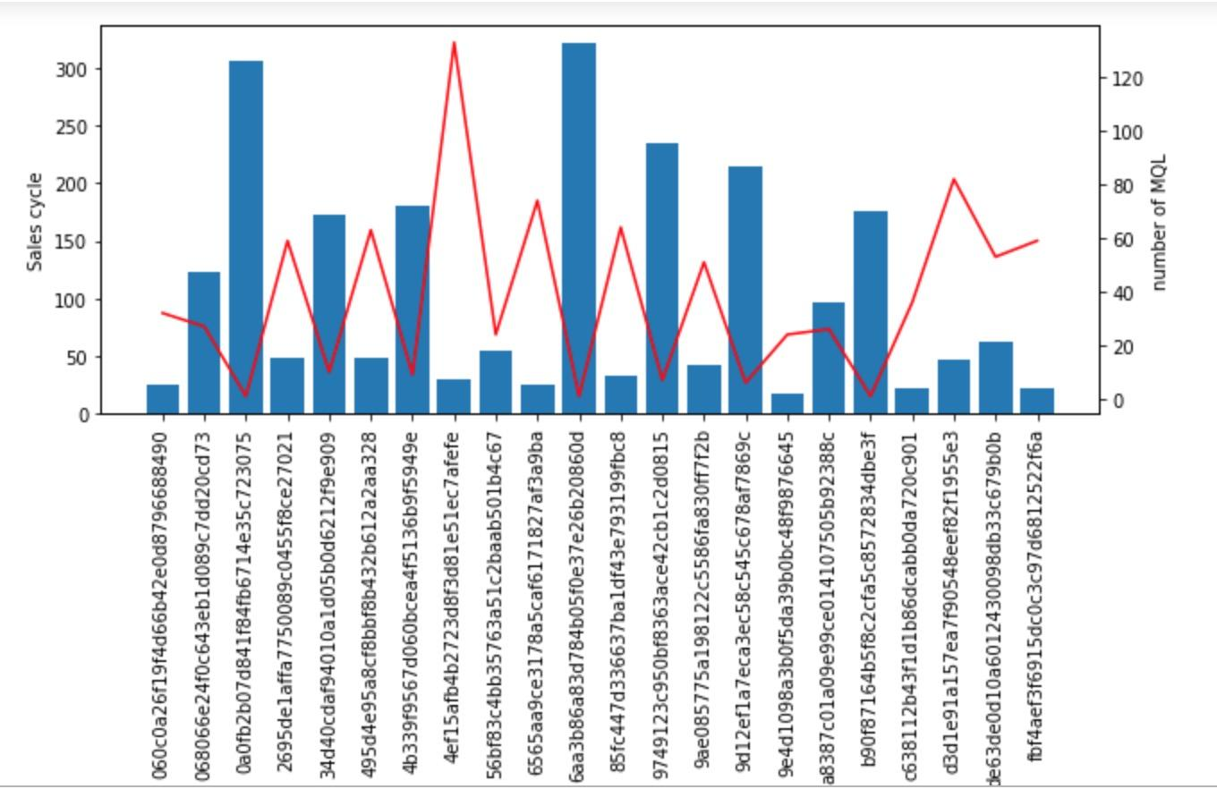

Figure 7:

Olist can also base on the sales cycle to evaluate the performance of a Sales Rep. From Figure 7, It seems that the more number of leads a SR has, the shorter the sales cycle. This can be explained that an experienced sales rep (more MQLs) will perform better (shorter sales length) than a new sales rep.

**Lead Behavior**

The table below is the description of each behavior profile, based on DiSC, a behavior assessment tool developed from DiSC theory of psychologist William Moulton Marston.

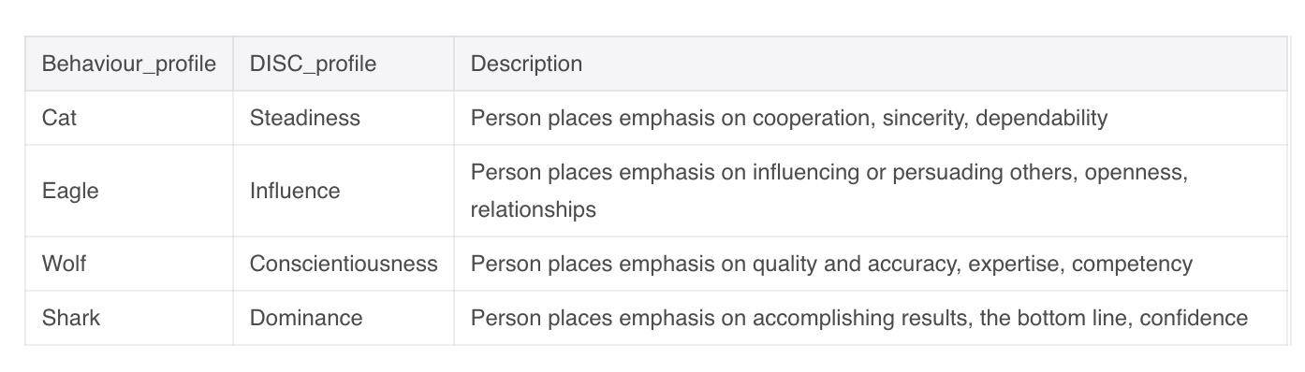

48.3% of lead behaviour profiles is cat - steadiness, meaning that this person places emphasis on cooperation, sincerity and dependability. Understand the characteristics of the leads can help Olist team to create relevant personas, making it easier for them to craft contents, messagings and stories to the targeted audience.

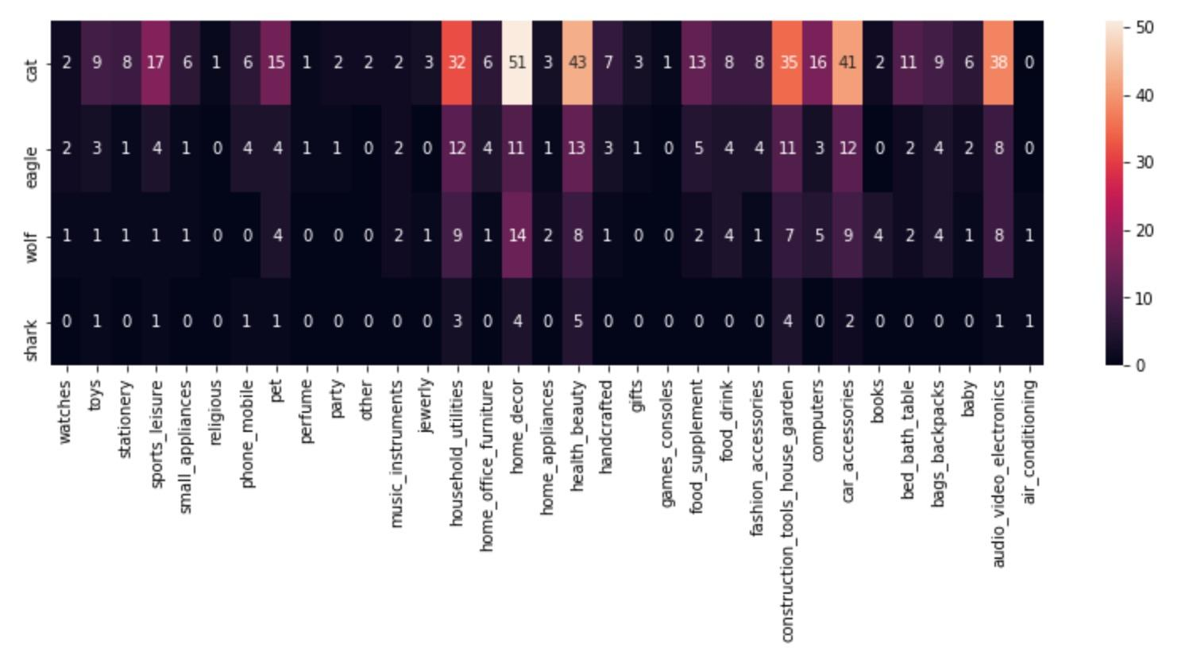

figure 8:

Steadiness type:

<https://www.discprofile.com/what-is-disc/overview/steadiness/>

**Business Type**

There are 2 business types: reseller and manufacturer. Reseller accounts for 69.7% of total MQLs. Therefore, there is no surprise when reseller appear the most among the business segments. However, in home_decor segment, 56% are manufacturers.

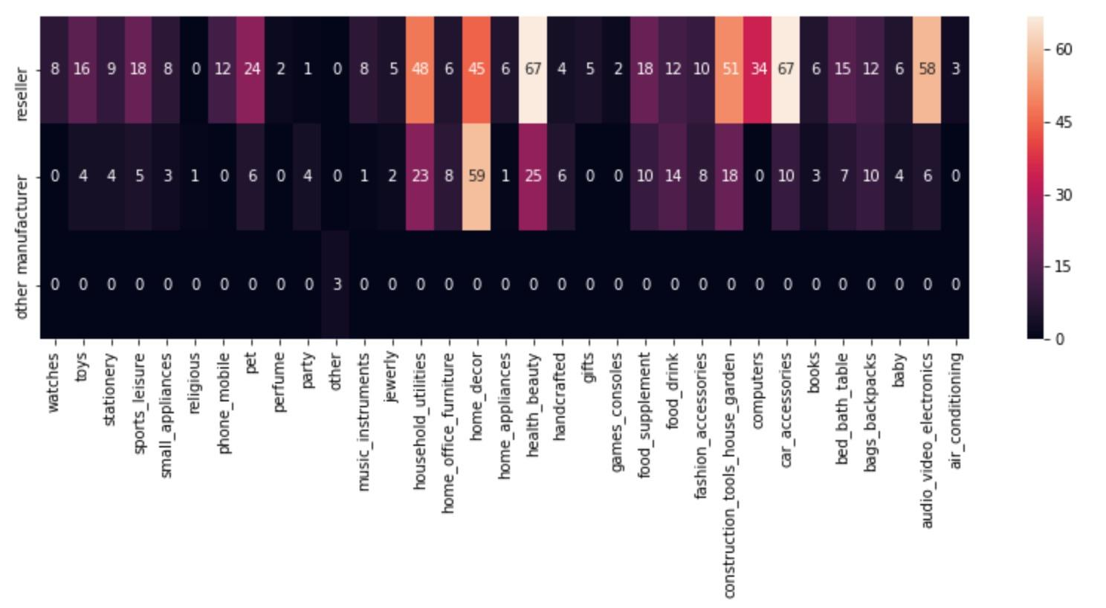

figure 9:

**Close deal performance**

**Time for first orders**

Most sellers have to wait less than 50 days to have the first order from Olist since the day they agree to join Olist platform (figure 10).

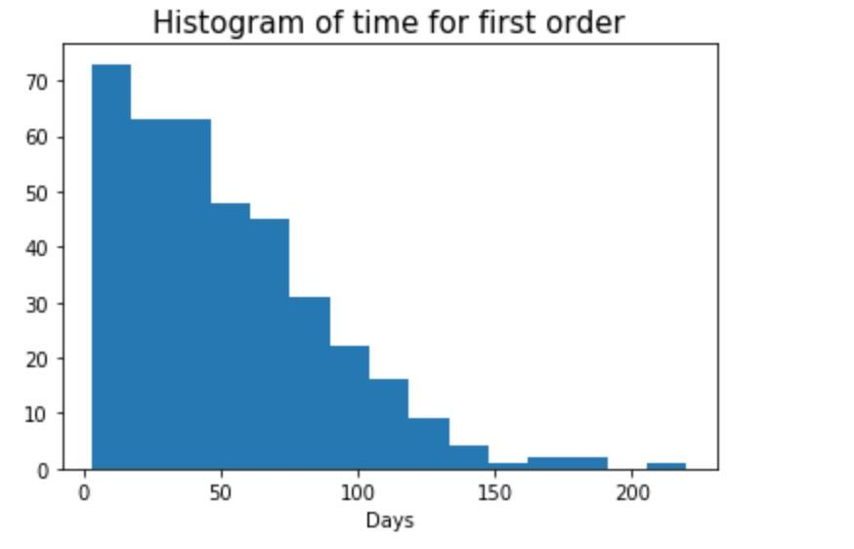

figure 10:

Main business segments such as heath_beauty, home_decor, household_utilities, audio_video_electronics,...typically wait 50-60 days to have the first order since won date. We also see some other segments such as food_drink, handcrafted and fashion_accessories have significantly longer time before its first order.

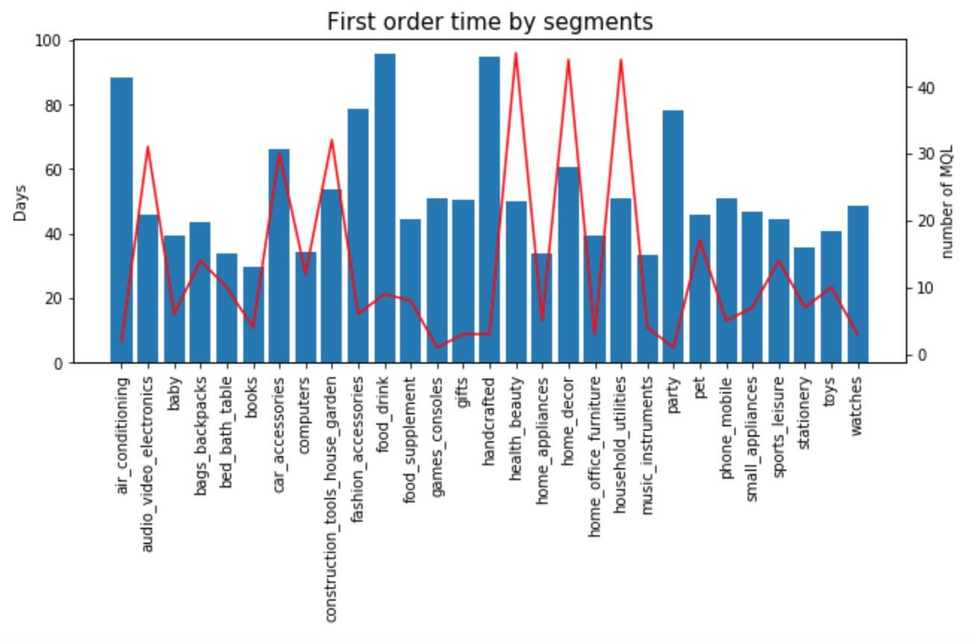

figure 11:

**Sales per segments:**

Figure 12 is the top 10 product categories that have highest sales from Olist. Since health_beauty, computer_accessories, furniture_devor, housewares, auto and garden_tools are also the main business segments among MQLs, the sales values from these segments also on top. The only thing that surprise me is Watches. Though only have small number of sellers from Watches segment, revenues from watches is really high in comparison with other segments.

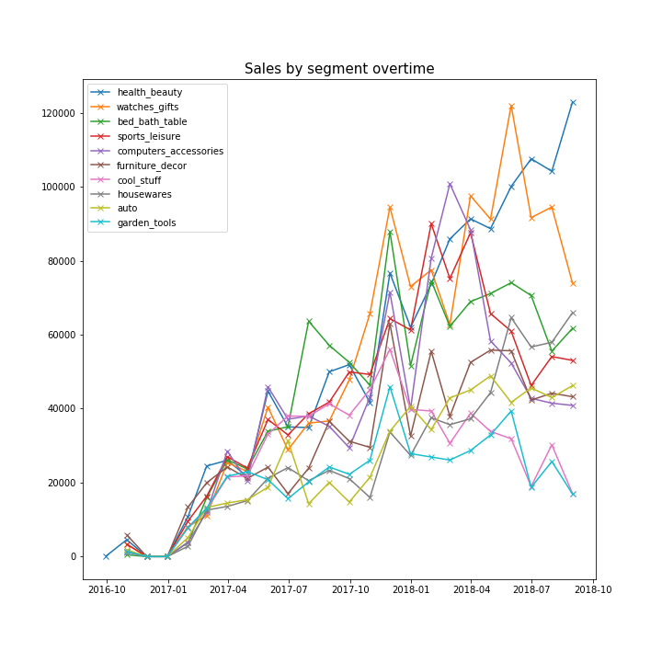

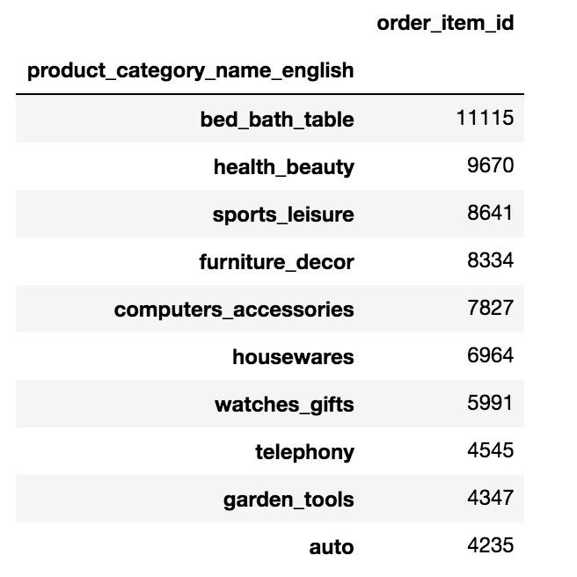

Top10 from the sales unit witness no big difference.

**Conclusion & Recommendation**

We look at Olist seller side marketing from different angles: channels, messages (landing pages), targeting (business segment, lead behavior, business type,..), sales process (sales cycle, sales rep), closed deal performance to indicate the platform usage. Each angle can add value to how the team can optimize the marketing campaigns.

Here are some detail recommendation:

* Continue to work on SEO/Events to increase organic traffic
* Learn from successful landing pages → hypothesis for A/B testing -> replicate the successes
* Sport leisure and watches can be developed more because we have high revenue from them
* Leads are steadiness type → build persona around these type of people and build messaging/content around them
* Investigate in Home_decor segment why it attract a lot of manufacturers? Can it be replicated in others segments?