**LABORATORY 3 SESSION 1**

Tareador executed without flags.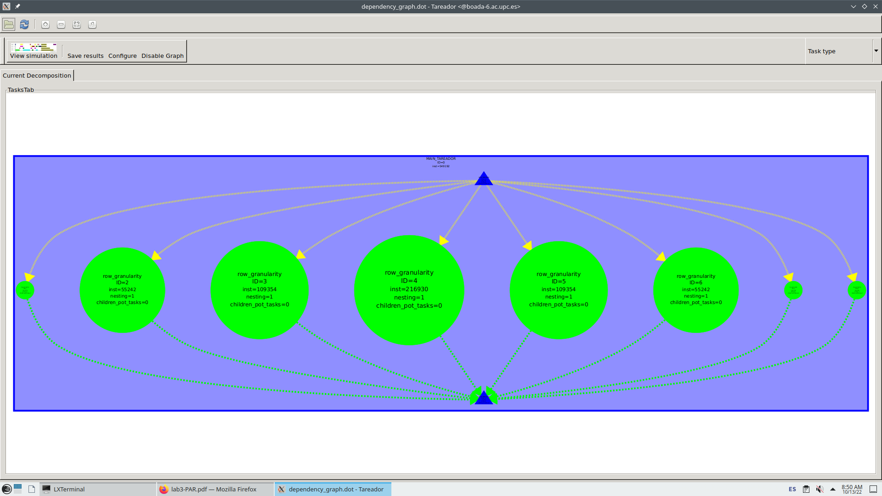

We can see that:

* There are 8 tasks because the matrix has 8 rows.
* Code is highly parallelizable as the tasks are all in the same level.
* There exists a huge imbalance between the different tasks, that’s because of the different convergence times of each row of points, being the central ones the heaviest ones. This matches with our display with (incloure mandelbrot photo)

Tareador executed with flag -h:

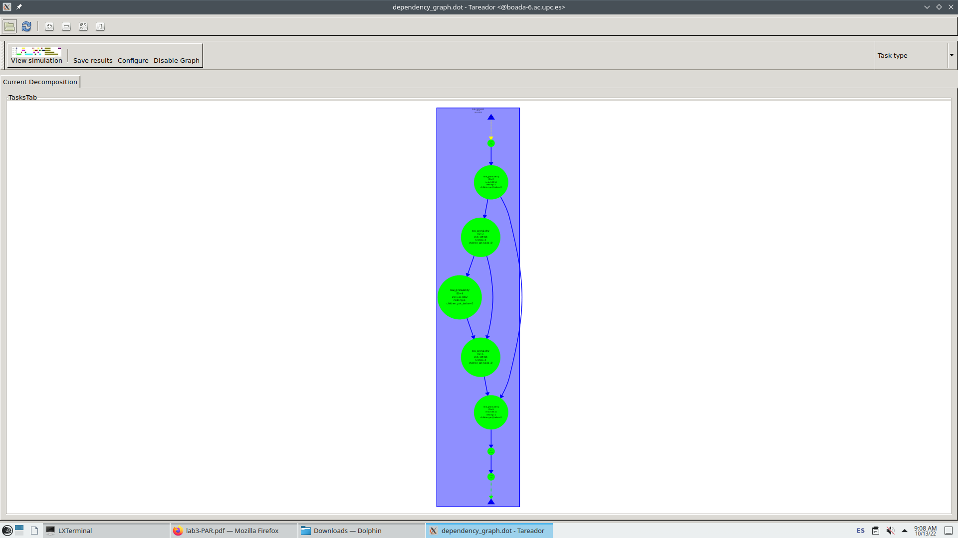

Clearly indicate the most important

characteristics for the graphs that you obtained. Explain which section of the code is causing the

serialisation of tasks when using the -d and the -h options and how this section of code should be

protected when parallelising with OpenMP . Reason when each strategy/granularity should be used.

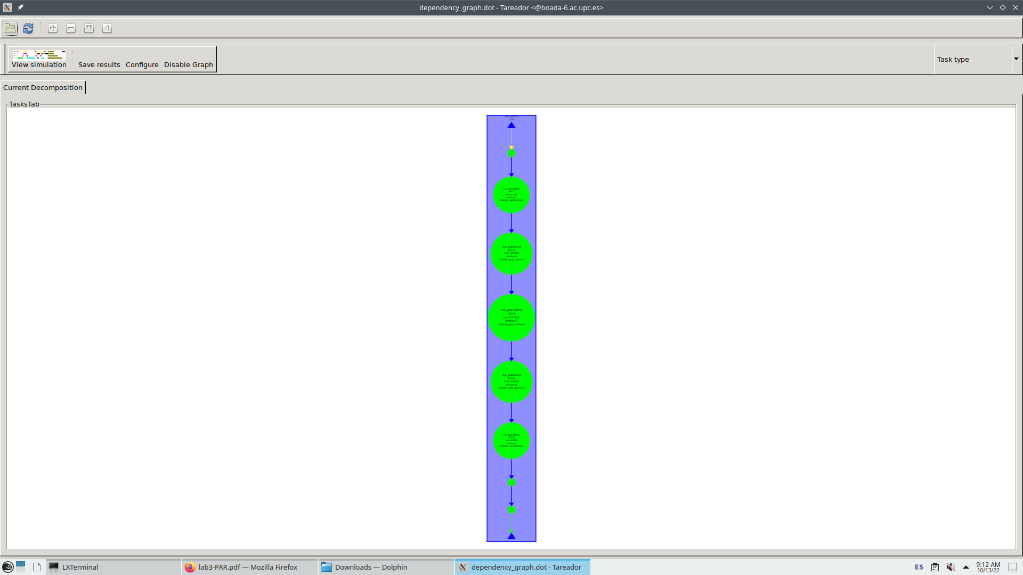

mirar edges desde tareador i analitzar codi de cada una de les tres versions per a determinar que causa que en la -d i menys -h sigui serial.