- Create a new Stack Project (call it YourNameStrings)
- Build, install and run the default project, then change to implement the following :
  - Read in two strings
  - Print out the first string in reverse (and in uppercase)
  - Print out “these strings are anagrams of each other” if the inputted strings are anagrams of each other
- You should use a Folder StringUtilities with two module(files) one is GenUtils and the other is Anagram in the library
- The GenUtils module should contain (at least) the following function:
- strToUpper which takes a string and returns the uppercase version of the string (using the toUpper function from Data.Char)
- The Anagram module should contain the following function:
- isAnagram which takes in two strings and returns true if the two strings are anagrams of each other. (an anagram a word, phrase, or name formed by rearranging the letters of another, such as spar formed from rasp),
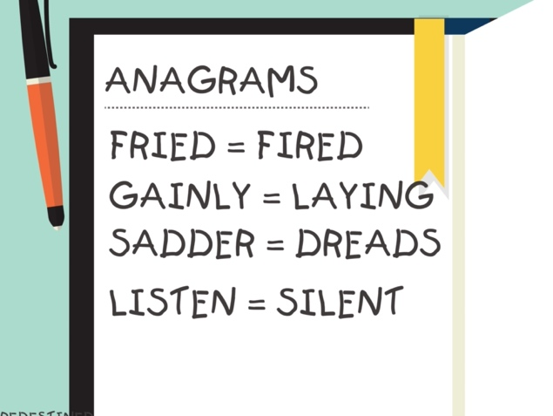
(Hint: If you sort two strings that are anagrams of each other, the sorted strings will be equal. You need Data.List to use the sort function).
Ensure that the package runs, and that if conforms to spec.

Save this project, zip it and upload it (70 Marks)

