- Create a new Stack project (call it YourNameQuestion2)
- Build, install and run the default project, then change to implement the following :
  - Read in a String(this is the string to be encoded) and a number (this is the number of characters that you should shift the characters by).
  - Print out the first five characters of the inputted string.
  - Using Caesar’s Cipher (as seen in class) apply this encoding technique to the inputted string.
- You should use a Folder StringUtilities with two module(files) one is GenUtils and the other is Anagram in the library
- The GenUtils module should contain (at least) the following function:
- firstThree which takes a string and returns the first three characters
- The Anagram module should contain the following function:
- isAnagram which takes in two strings and returns true if the two strings are anagrams of each other. (an anagram a word, phrase, or name formed by rearranging the letters of another, such as spar formed from rasp),

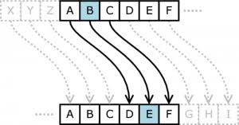

(Hint: If you sort two strings that are anagrams of each other, the sorted strings will be equal. You need Data.List to use the sort function).
Ensure that you

Save this project, zip it and upload it (70 Marks)

