GridView

內容

GridView 1

介紹 2

實作 3

建立GridView 3

資料鏈結 4

千分號 & 靠右對齊 5

分頁 6

1.設定屬性 6

2.建立事件 7

# 介紹

使用方便

快速把撈取資料,在畫面上以表格呈現

效率上比使用ReportView好

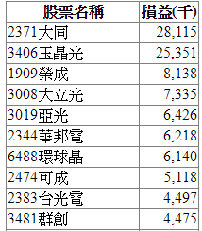

# 實作

## 1.建立GridView

設計工具(aspx)

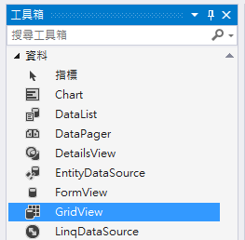

<asp:GridView ID="GridView1" runat="server" OnRowDataBound="GridView1_RowDataBound" >

</asp:GridView>

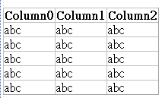

## 2.資料鏈結

程式碼(aspx.cs)

DataSet myds = getDateSet(sDate, eDate, sUnit,aaa);

GridView1.DataSource = myds;

GridView1.DataBind();

private DataSet getDateSet(string sDate, string eDate, string sUnit,string p)

{

SqlConnection sqlConn = new SqlConnection(control.ConnStr);

SqlCommand sqlCmd = new SqlCommand(getCmd(p), sqlConn);

sqlCmd.Parameters.Add(new SqlParameter("@sDate", sDate));

sqlCmd.Parameters.Add(new SqlParameter("@eDate", eDate));

sqlCmd.Parameters.Add(new SqlParameter("@Unit", sUnit));

SqlDataAdapter myda = new SqlDataAdapter(sqlCmd);// + Convert.ToInt32(Request.QueryString["id"]), myConn);

sqlCmd.CommandTimeout = 6000;

DataSet myds = new DataSet();

sqlConn.Open();

myda.Fill(myds);

sqlConn.Close();

return myds;

}

## 千分號 & 靠右對齊

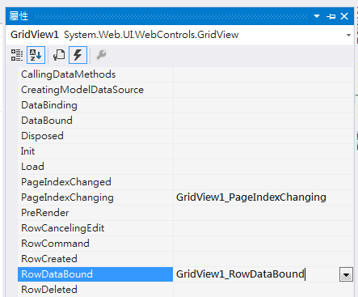

程式碼

protected void GridView1_RowDataBound(object sender, GridViewRowEventArgs e)

{

string sShowField, sMessage;

DataRowView oDataRow;

if (e.Row.RowIndex != -1)

{

oDataRow = (DataRowView)(e.Row.DataItem);

sShowField = oDataRow["損益"].ToString();

sMessage = func.千分位(sShowField, 0);

e.Row.Cells[1].Text = sMessage;//X oDataRow["當沖買進成交金額"] = sMessage;

e.Row.Cells[1].HorizontalAlign = HorizontalAlign.Right;//靠右

}

}

注意 :

拿值可以這樣拿oDataRow["當沖買進成交金額"]

但給值不能這樣給 oDataRow["當沖買進成交金額"] = sMessage;

給值要這樣寫e.Row.Cells[1].Text = sMessage;

# 分頁

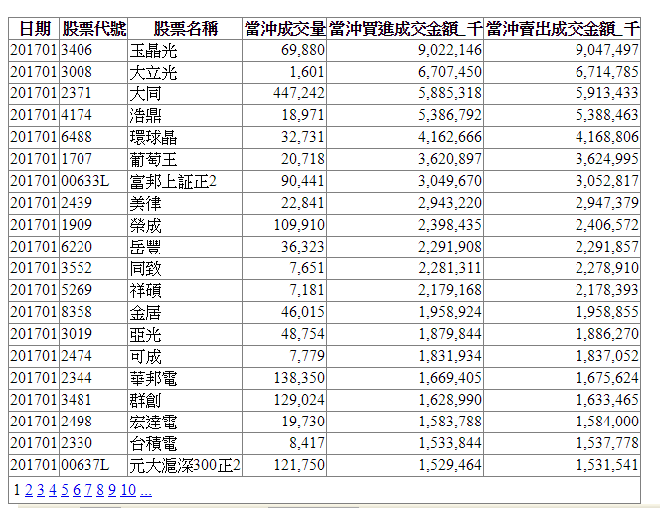

## 1.設定屬性

**設計工具**

GridView.AllowPaging = True

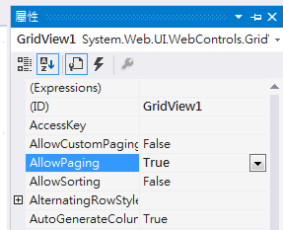

## 2.建立事件

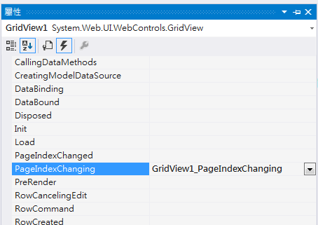

**程式碼**

protected void GridView1_PageIndexChanging(object sender, GridViewPageEventArgs e)

{

GridView1.PageIndex = e.NewPageIndex;

myds = getDateSet();

GridView1.DataSource = myds;

GridView1.DataBind();

}