# 顯示流水號

SELECT

ordr.CardCode AS 客戶代碼,

ordr.docentry

, row_number() over ( order by ordr.CardCode) RowID

from ordr

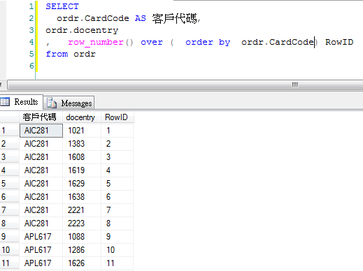

# 分群組顯示流水號

SELECT ordr.cardcode

,ordr.docentry

, row_number() over (PARTITION BY ordr.CardCode order by ordr.docentry) RowByCardCode

from ordr

order by ordr.CardCode

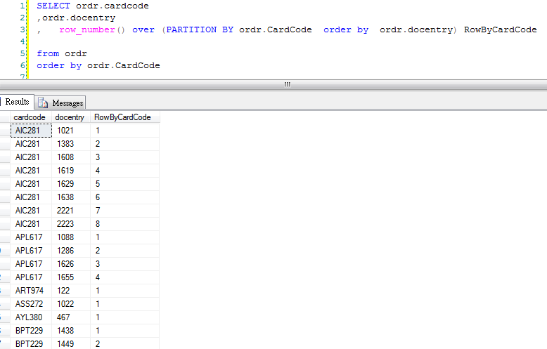

# 用群組流水號,控制是否重覆顯示cardcode

SELECT

CASE

row_number() over (PARTITION BY ordr.CardCode order by ordr.DocEntry)

WHEN 1 THEN ordr.CardCode

else ''

END AS 客戶代碼,

ordr.docentry

, row_number() over (PARTITION BY ordr.CardCode order by ordr.docentry) RowByCardCode

, row_number() over ( order by ordr.CardCode) RowID

from ordr

order by ordr.CardCode

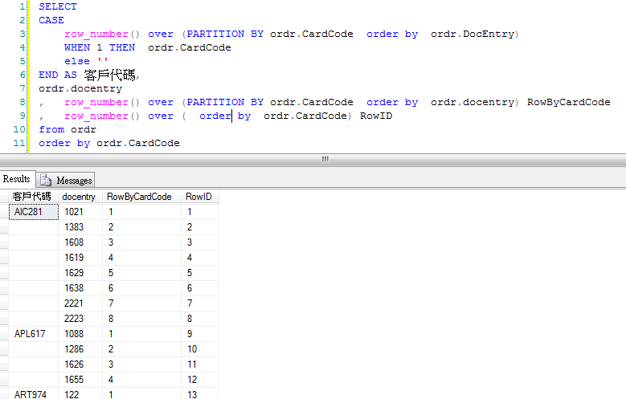

<file:///D:/cadmen/99-note/DB/SQLServer/%E8%AA%9E%E6%B3%95/%E7%82%BA%E6%9F%A5%E8%A9%A2%E7%9A%84%E7%B5%90%E6%9E%9C%E5%8A%A0%E4%B8%8A%E5%BA%8F%E8%99%9F(ROW_NUMBER,RANK,OVER).htm>

# 相同的資料相同排名113355589

2.RANK

依照排序的欄位，相同的資料相同排名，下一個不同會【跳脫】

|  |  |
| --- | --- |
| 1 | SELECT |
| 2 | RANK() OVER(ORDER BY CustomerID) AS ROWID | |

|  |  |
| --- | --- |
| 3 | ,* |
| 4 | FROM Orders | |

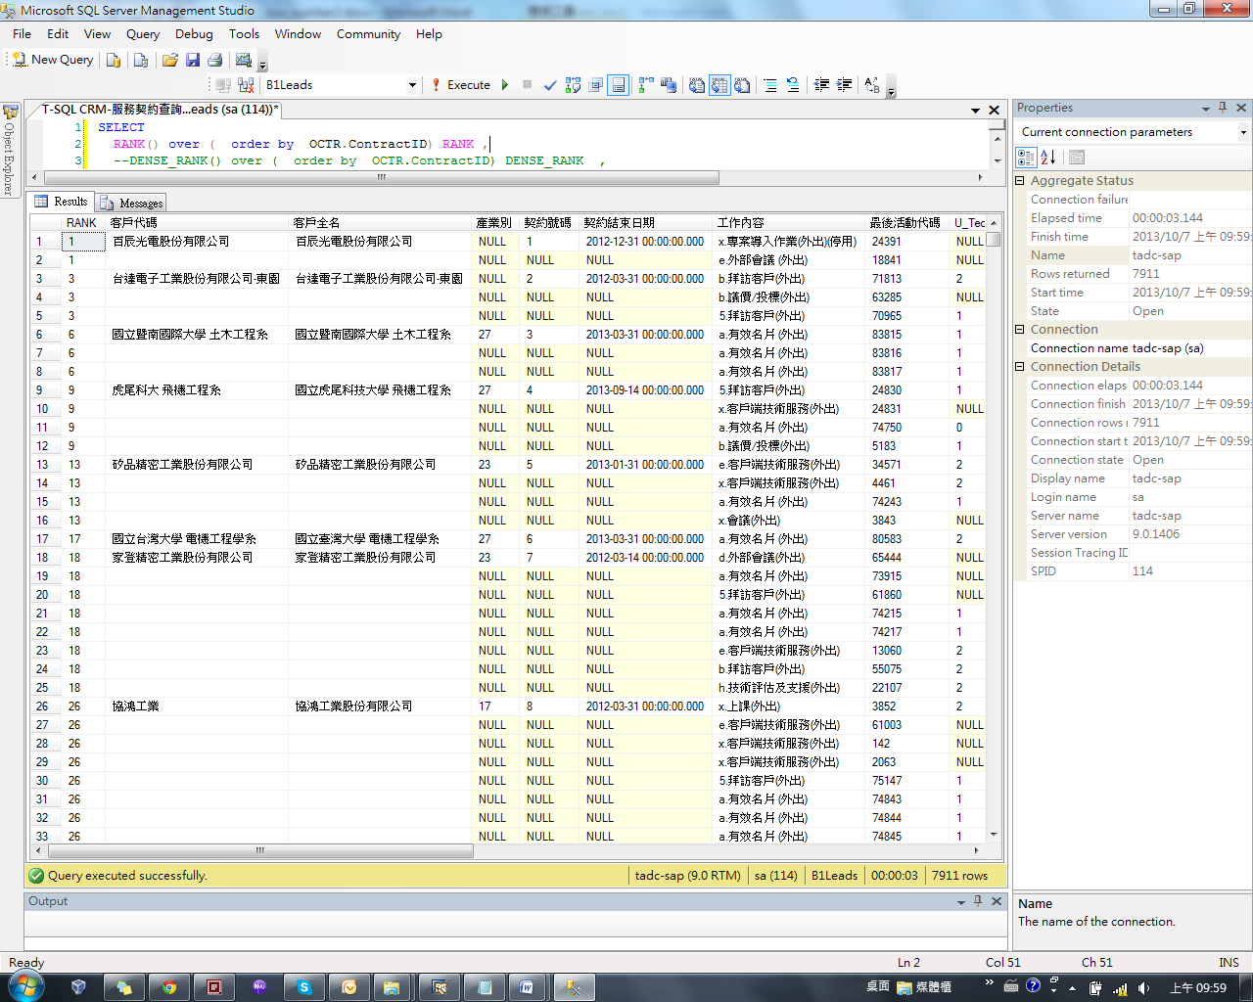

# 相同的資料相同排名1122333456

3.DENSE_RANK

依照排序的欄位，相同的資料相同排名，下一個不同會【不跳脫】

|  |  |
| --- | --- |
| 1 | SELECT |
| 2 | --ROW_NUMBER() OVER(ORDER BY CustomerID) AS ROWID | |

|  |  |
| --- | --- |
| 3 | --RANK() OVER(ORDER BY CustomerID) AS ROWID |
| 4 | DENSE_RANK() OVER(ORDER BY CustomerID) AS ROWID | |

|  |  |
| --- | --- |
| 5 | ,* |
| 6 | FROM Orders | |

