# 拆多個語法

## SQL

declare @cmd nvarchar(30) ='20131103;20131201;3';

declare @strsql as varchar(8000) =''

select @strsql='select

('''+replace(@cmd,';',''') select (''')+''')'

select @strsql

exec (@strsql)

## result

select ('20131103') select ('20131201') select ('3')

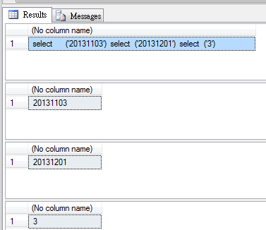

# 多列

declare @cmd nvarchar(30) ='20131103;20131201;3';

declare @strsql as varchar(8000) =''

select @strsql='select '''+replace(@cmd,';',''' as mychar , ''')+''''

select @strsql

exec(@strsql)

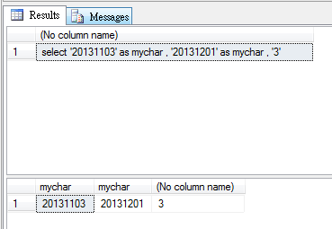

## 放到table

declare @temp table (SDate datetime,EDate datetime,RowID int)

declare @cmd nvarchar(30)='20131103;20131201;3';

declare @strsql as varchar(8000)

='select '''+replace(@cmd,';',''' as mychar , ''')+''''

select @strsql

insert into @temp exec(@strsql)

select * from @temp

select @SDate =SDate,@EDate= EDate,@RowID = RowID from @temp

select @Sdate,@EDate,@RowID

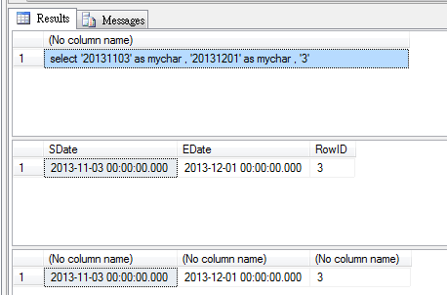

# 多行

## SQL

declare @cmd nvarchar(30) ='20131103;20131201;3';

declare @strsql as varchar(8000) =''

select @strsql='select '''+replace(@cmd,';',''' as mychar union all select ''')+''''

select @strsql

exec(@strsql)

## result

select '20131103' as mychar union all select '20131201' as mychar union all select '3'

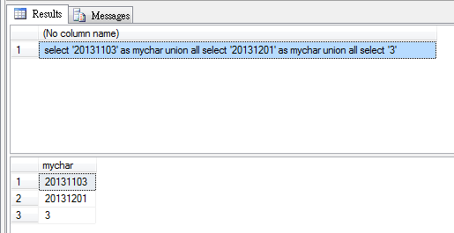

# 放到#table

## SQL

drop table #temp

create table #temp(aaa varchar(20))

declare @cmd nvarchar(30)

set @cmd='20131103;20131201;3';

declare @strsql as varchar(8000) =''

select @strsql='insert into #temp values

('''+replace(@cmd,';',''') insert into #temp values (''')+''')'

select @strsql

exec (@strsql)

select * from #temp

## Result

insert into #temp values ('20131103') insert into #temp values ('20131201') insert into #temp values ('3')

