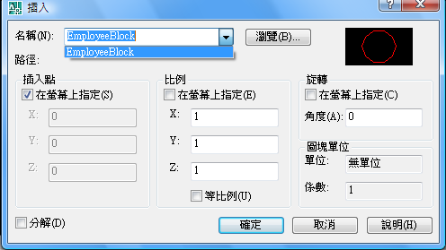
若EmployeeBlock只存在這,不存在於畫面中.該EmployeeBlock存於:BlockTable/EmployeeBlock

由瀏覽選circle.dwg,按下確定後,circle存在於:BlockTable/circle
也存在於BlockTable/ModuleSpace/
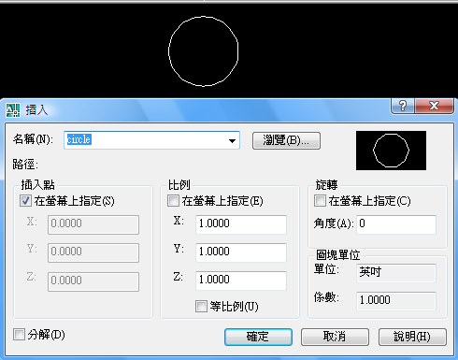
怎麼讀BF呢?
用以下,取到的是0,覺得很奇怪.難道它不是GetBlockReferenceIds取出來的不是BF?
[CommandMethod("ReadEntityInModuleSpace")]
public void ReadEntityInModuleSpace()
{
Database db = HostApplicationServices.WorkingDatabase;
Editor ed = Autodesk.AutoCAD.ApplicationServices.Application.DocumentManager.MdiActiveDocument.Editor;

// The try/finally idiom is another approach for using, commiting
// and disposing of transactions. This technique is demonstrated once here.
// However, the 'Using' approach will be used from here on.

Transaction trans = db.TransactionManager.StartTransaction();
try
{
BlockTable bt = (BlockTable)(trans.GetObject(db.BlockTableId, OpenMode.ForRead));
BlockTableRecord btr = (BlockTableRecord)trans.GetObject(bt[BlockTableRecord.ModelSpace], OpenMode.ForRead);
ObjectIdCollection bfs = btr.GetBlockReferenceIds(true, true);//沒有讀到東西
//ObjectIdCollection bfs = btr.GetBlockReferenceIds(false, true);//沒有讀到東西
//ObjectIdCollection bfs = btr.GetBlockReferenceIds(false, false);//沒有讀到東西
//ObjectIdCollection bfs = btr.GetBlockReferenceIds(true, false);//沒有讀到東西
foreach (ObjectId id in bfs)
{
Entity ent = (Entity)trans.GetObject(id, OpenMode.ForRead, false);
ed.WriteMessage(ent.BlockId + "/" + ent.BlockName + ",");
}
/* while (bBTE.MoveNext())
{
//bBTR = (BlockTableRecord)bBTE.Current.GetObject(OpenMode.ForRead);
bBTE.Current
BlockReference bf = (BlockReference)trans.GetObject(, OpenMode.ForRead);

//BlockReference bf = (BlockReference)bBTE.Current;
ed.WriteMessage(bf.Name.ToString());
}*/
}
catch (System.Exception ex)
{
ed.WriteMessage(ex.Message.ToString());
}
finally
{
trans.Dispose();
}
}

