ShowModalDialog
System.Windows.Forms.DialogResult
ShowModalDialog(
System.Windows.Forms.IWin32Window owner,
System.Windows.Forms.Form formToShow,
System.Boolean persistSizeAndPosition)

ShowModalDialog(null, null, false)沒有放form,放null就會發生以下錯誤訊息.
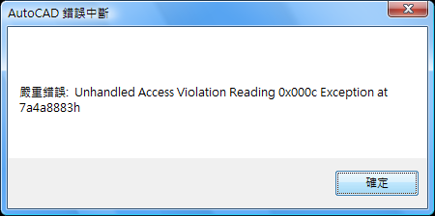
開啟專案,就會跳這個畫面
