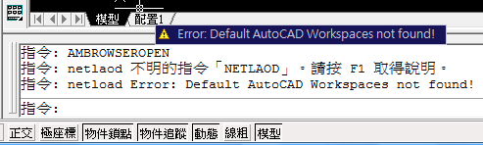
[CommandMethod("addtoolbar")]
public void addToolbar()
{
Toolbar newTb = new Toolbar("New Toolbar",cs.MenuGroup);
newTb.ToolbarOrient = ToolbarOrient.floating;
newTb.ToolbarVisible = ToolbarVisible.show;

ToolbarControl tbCtrl = new ToolbarControl(ControlType.NamedViewControl,newTb,-1);

ToolbarButton tbBtn = new ToolbarButton(newTb,-1);
tbBtn.Name = "PolyLine";
tbBtn.MacroID = "ID_Pline";

ToolbarFlyout tbFlyout = new ToolbarFlyout(newTb,-1);
tbFlyout.ToolbarReference = "DRAW";

foreach( Workspace wk in cs.Workspaces)
{
WorkspaceToolbar wkTb = new WorkspaceToolbar(wk,newTb);
wk.WorkspaceToolbars.Add(wkTb);
wkTb.Display = 1;
}
}
以上執行都沒有東西,於是加了: cs.SaveAs("d:\\Casys_toolbar.cui");就有檔案了.
指令: cuiload
無法載入自訂檔: D:\Casys_toolbar.cui
該自訂群組名稱已經存在。
=>可是找不到啊.

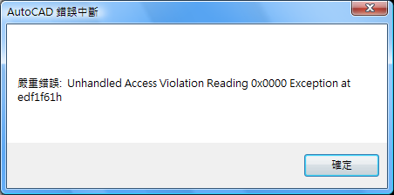
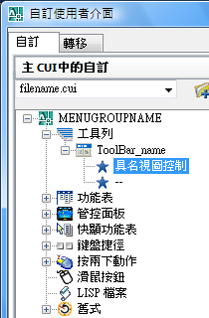

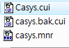
ToolbarButton tbBtn = new ToolbarButton(newTb, -1);
//'tbBtn.MenuMacroReference' 擲回型別'System.ArgumentNullException' 的例外狀況
//但卻沒有產生exception

using Autodesk.AutoCAD.ApplicationServices;
using Autodesk.AutoCAD.DatabaseServices;
using Autodesk.AutoCAD.EditorInput;
using Autodesk.AutoCAD.Runtime;
using Autodesk.AutoCAD.Geometry;
using Autodesk.AutoCAD.Customization;
using System;
using System.Collections.Specialized;

namespace PartialCUI
{
public class Commands
{
// cs - main AutoCAD CUI file
[CommandMethod("addtoolbar")]
public void addToolbar()//新增cui,裡面是工具列自訂.
{
try
{
CustomizationSection pcs = new CustomizationSection();
pcs.MenuGroupName = "MenuGroupName";
Toolbar newTb = new Toolbar("ToolBar_name", pcs.MenuGroup);
ToolbarButton tbBtn = new ToolbarButton(newTb, -1);
//'tbBtn.MenuMacroReference' 擲回型別'System.ArgumentNullException' 的例外狀況
//但卻沒有產生exception
tbBtn.Name = "PolyLine";
pcs.SaveAs("d:\\fileName.cui");
}
catch (System.Exception ex)
{
Application.DocumentManager.MdiActiveDocument.Editor.WriteMessage("\nERR: " + ex.Message.ToString());
}
}
}
}

