目錄
新增cui檔
CustomizationSection.MenuGroupName沒命名
CustomizationSection.MenuGroupName有命名
有ToolBar但沒有item
工具列裡有一個視圖控制(ToolbarControl)
工具列裡新增一個btn,按下btn就會呼叫指令.
Cuiload
載入cui

目錄

新增cui檔

CustomizationSection.MenuGroupName沒命名
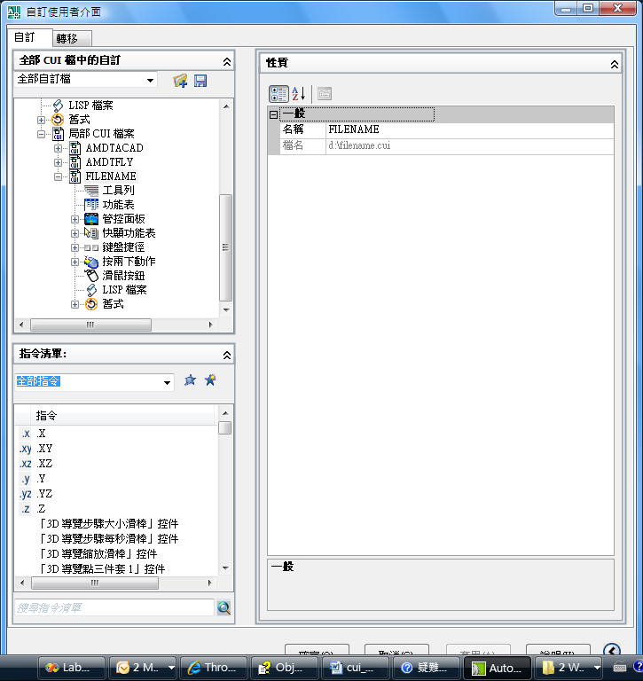
using Autodesk.AutoCAD.ApplicationServices;
using Autodesk.AutoCAD.DatabaseServices;
using Autodesk.AutoCAD.EditorInput;
using Autodesk.AutoCAD.Runtime;
using Autodesk.AutoCAD.Geometry;
using Autodesk.AutoCAD.Customization;
using System;
using System.Collections.Specialized;

namespace PartialCUI
{
public class Commands
{
// cs - main AutoCAD CUI file
[CommandMethod("addtoolbar")]
public void addToolbar()//新增cui,裡面是工具列自訂.
{
try
{
CustomizationSection pcs = new CustomizationSection();
pcs.SaveAs("d:\\fileName.cui");
}
catch (System.Exception ex)
{
Application.DocumentManager.MdiActiveDocument.Editor.WriteMessage("\nERR: " + ex.Message.ToString());
}
}
}
}

CustomizationSection.MenuGroupName有命名
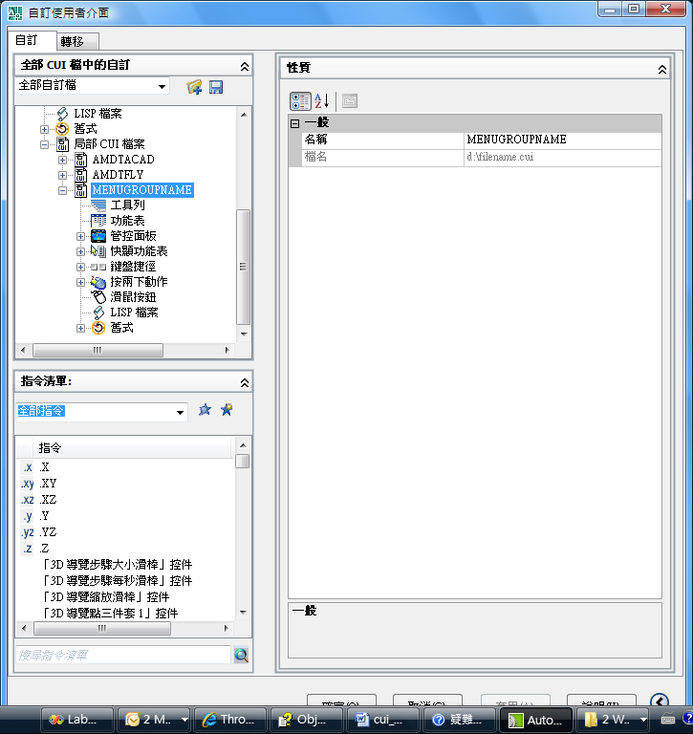
using Autodesk.AutoCAD.ApplicationServices;
using Autodesk.AutoCAD.DatabaseServices;
using Autodesk.AutoCAD.EditorInput;
using Autodesk.AutoCAD.Runtime;
using Autodesk.AutoCAD.Geometry;
using Autodesk.AutoCAD.Customization;
using System;
using System.Collections.Specialized;

namespace PartialCUI
{
public class Commands
{
// cs - main AutoCAD CUI file
[CommandMethod("addtoolbar")]
public void addToolbar()//新增cui,裡面是工具列自訂.
{
try
{
CustomizationSection pcs = new CustomizationSection();
pcs.MenuGroupName = "MenuGroupName";
pcs.SaveAs("d:\\fileName.cui");
}
catch (System.Exception ex)
{
Application.DocumentManager.MdiActiveDocument.Editor.WriteMessage("\nERR: " + ex.Message.ToString());
}
}
}
}

有ToolBar但沒有item
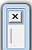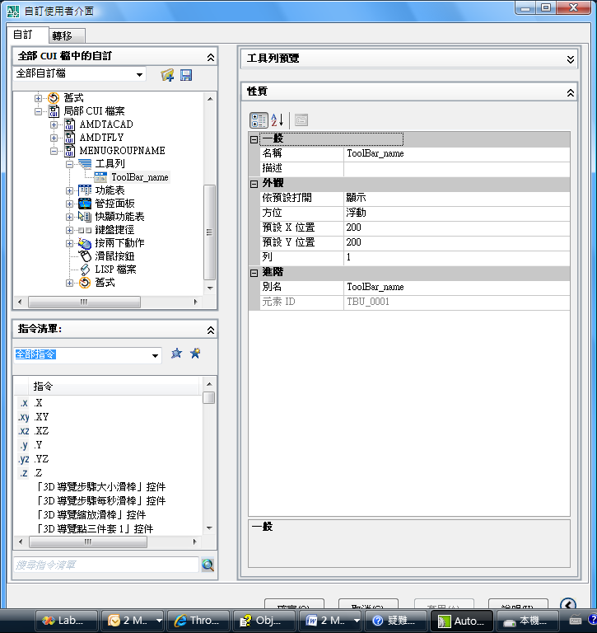
using Autodesk.AutoCAD.ApplicationServices;
using Autodesk.AutoCAD.DatabaseServices;
using Autodesk.AutoCAD.EditorInput;
using Autodesk.AutoCAD.Runtime;
using Autodesk.AutoCAD.Geometry;
using Autodesk.AutoCAD.Customization;
using System;
using System.Collections.Specialized;

namespace PartialCUI
{
public class Commands
{
// cs - main AutoCAD CUI file
[CommandMethod("addtoolbar")]
public void addToolbar()//新增cui,裡面是工具列自訂.
{
try
{
CustomizationSection pcs = new CustomizationSection();
pcs.MenuGroupName = "MenuGroupName";
Toolbar newTb = new Toolbar("ToolBar_name", pcs.MenuGroup);
pcs.SaveAs("d:\\fileName.cui");
}
catch (System.Exception ex)
{
Application.DocumentManager.MdiActiveDocument.Editor.WriteMessage("\nERR: " + ex.Message.ToString());
}
}
}
}

工具列裡有一個視圖控制(ToolbarControl)
ToolbarControl tbCtrl = new ToolbarControl(ControlType.NamedViewControl, newTb, -1);
這行就是具名視圖控制.有了它,就會產生.
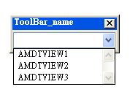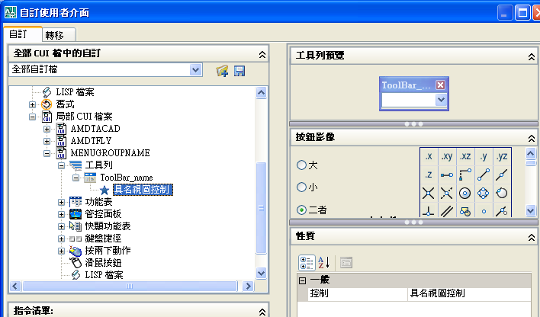
using Autodesk.AutoCAD.ApplicationServices;
using Autodesk.AutoCAD.DatabaseServices;
using Autodesk.AutoCAD.EditorInput;
using Autodesk.AutoCAD.Runtime;
using Autodesk.AutoCAD.Geometry;
using Autodesk.AutoCAD.Customization;
using System;
using System.Collections.Specialized;

namespace PartialCUI
{
public class Commands
{
// cs - main AutoCAD CUI file
[CommandMethod("addtoolbar")]
public void addToolbar()//新增cui,裡面是工具列自訂.
{
try
{

CustomizationSection pcs = new CustomizationSection();
pcs.MenuGroupName = "MenuGroupName";

Toolbar newTb = new Toolbar("ToolBar_name", pcs.MenuGroup);
//newTb.ElementID = "aaa";//不給會有預設TBU_0001

//預設就是如此,所以可以不用設.
//newTb.ToolbarOrient = ToolbarOrient.floating;
//newTb.ToolbarVisible = ToolbarVisible.show;
ToolbarControl tbCtrl = new ToolbarControl(ControlType.NamedViewControl, newTb, -1);

pcs.SaveAs("d:\\fileName.cui");
LoadMyCui("d:/fileName.cui");
}

catch (System.Exception ex)
{
Application.DocumentManager.MdiActiveDocument.Editor.WriteMessage("\nERR: " + ex.Message.ToString());
}
}
private void LoadMyCui(string cuiFile)//"d:/Casys.cui";
{
Document doc = Application.DocumentManager.MdiActiveDocument;

//這些不知道做什麼的
object oldCmdEcho = Application.GetSystemVariable("CMDECHO");
object oldFileDia = Application.GetSystemVariable("FILEDIA");

Application.SetSystemVariable("CMDECHO", 0);//這個不知道做什麼的,李先生說這是設定editor不要做回應的
Application.SetSystemVariable("FILEDIA", 0);//這個不知道做什麼的,李先生說這是設定不要跳出對話框的

doc.SendStringToExecute("_.cuiload " + cuiFile + " ", false, false, false);//執行cuiload 檔案路徑+檔案名稱=>載入自訂功能表.
doc.SendStringToExecute("(setvar \"FILEDIA\" " + oldFileDia.ToString() + ")(princ) ", false, false, false);//這個不知道是做什麼的.
doc.SendStringToExecute("(setvar \"CMDECHO\" " + oldCmdEcho.ToString() + ")(princ) ", false, false, false);//這個不知道是什麼的.
}
[CommandMethod("vv")]
private void m1()
{
Application.DocumentManager.MdiActiveDocument.Editor.WriteMessage("\nvv_m1");
}

}
}

工具列裡新增一個btn,按下btn就會呼叫指令.
1.若沒有定義圖檔,預設如下圖. 雖然有預設但影像屬性仍為空白.
MenuMacro mm1 = new MenuMacro(mg, "Cmd 1", "^C^CCmd1", "ID_MyCmd1");
^C^C對應到我們輸入的指令.而後面的tag,則是給toolbar.MacroID ="ID_MyCmd1";
我們輸入的指令稱為巨集.macroID翻譯為元素ID
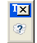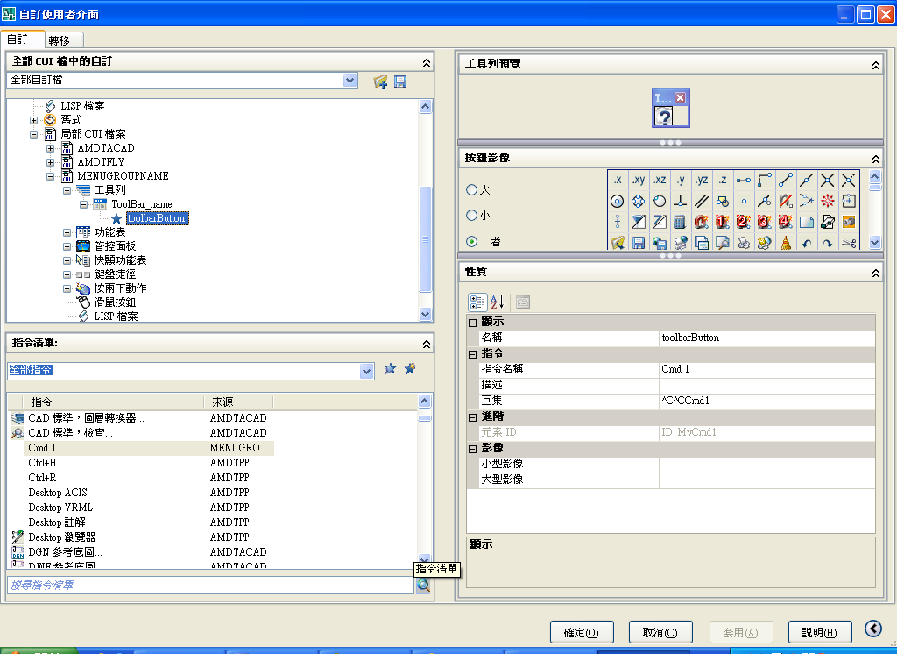
CustomizationSection pcs = new CustomizationSection();
pcs.MenuGroupName = "MenuGroupName";
MacroGroup mg = new MacroGroup("Casys", pcs.MenuGroup);
MenuMacro mm1 = new MenuMacro(mg, "Cmd 1", "^C^CCmd1", "ID_MyCmd1");
Toolbar newTb = new Toolbar("ToolBar_name", pcs.MenuGroup); //命名,放在pcs.MenuGroup下.
ToolbarButton tbBtn = new ToolbarButton("vv", "toolbarButton", newTb, -1);//命名,放在toolbar下.
tbBtn.MacroID = "ID_MyCmd1";//連接到ID_MyCmd1這個命令.
using Autodesk.AutoCAD.ApplicationServices;
using Autodesk.AutoCAD.DatabaseServices;
using Autodesk.AutoCAD.EditorInput;
using Autodesk.AutoCAD.Runtime;
using Autodesk.AutoCAD.Geometry;
using Autodesk.AutoCAD.Customization;
using System;
using System.Collections.Specialized;

namespace PartialCUI
{
public class Commands
{
// cs - main AutoCAD CUI file
[CommandMethod("addtoolbar")]
public void addToolbar()//新增cui,裡面是工具列自訂.
{
try
{

CustomizationSection pcs = new CustomizationSection();
pcs.MenuGroupName = "MenuGroupName";//必需要有,要不會:'pcs.MenuGroupName' 擲回型別'System.NullReferenceException' 的例外狀況;;{"並未將物件參考設定為物件的執行個體"}
// Let's add a menu group, with two commands
MacroGroup mg = new MacroGroup("Casys", pcs.MenuGroup);
MenuMacro mm1 = new MenuMacro(mg, "Cmd 1", "^C^CCmd1", "ID_MyCmd1");
Toolbar newTb = new Toolbar("ToolBar_name", pcs.MenuGroup);
//newTb.ElementID = "aaa";//不給會有預設TBU_0001
ToolbarButton tbBtn = new ToolbarButton("vv", "toolbarButton", newTb, -1);
tbBtn.MacroID = "ID_MyCmd1";

//ToolbarButton tbBtn = new ToolbarButton(newTb, -1);
//'tbBtn.MenuMacroReference' 擲回型別'System.ArgumentNullException' 的例外狀況
//但卻沒有產生exception,改成ToolbarButton tbBtn = new ToolbarButton("vv","name_toolbar",newTb, -1);就new成功了.

pcs.SaveAs("d:\\fileName.cui");
LoadMyCui("d:/fileName.cui");
}

catch (System.Exception ex)
{
Application.DocumentManager.MdiActiveDocument.Editor.WriteMessage("\nERR: " + ex.Message.ToString());
}
}
private void LoadMyCui(string cuiFile)//"d:/Casys.cui";
{
Document doc = Application.DocumentManager.MdiActiveDocument;

//這些不知道做什麼的
object oldCmdEcho = Application.GetSystemVariable("CMDECHO");
object oldFileDia = Application.GetSystemVariable("FILEDIA");

Application.SetSystemVariable("CMDECHO", 0);//這個不知道做什麼的,李先生說這是設定editor不要做回應的
Application.SetSystemVariable("FILEDIA", 0);//這個不知道做什麼的,李先生說這是設定不要跳出對話框的

doc.SendStringToExecute("_.cuiload " + cuiFile + " ", false, false, false);//執行cuiload 檔案路徑+檔案名稱=>載入自訂功能表.

doc.SendStringToExecute("(setvar \"FILEDIA\" " + oldFileDia.ToString() + ")(princ) ", false, false, false);//這個不知道是做什麼的.
doc.SendStringToExecute("(setvar \"CMDECHO\" " + oldCmdEcho.ToString() + ")(princ) ", false, false, false);//這個不知道是什麼的.
}
[CommandMethod("Cmd1")]
public void Cm1()
{
Editor ed = Application.DocumentManager.MdiActiveDocument.Editor;
ed.WriteMessage("12345");
}

}
}

Cuiload

載入cui
private void LoadMyCui(string cuiFile)// "d:/Casys.cui";
{
Document doc = Application.DocumentManager.MdiActiveDocument;

//這些不知道做什麼的
object oldCmdEcho = Application.GetSystemVariable("CMDECHO");
object oldFileDia = Application.GetSystemVariable("FILEDIA");

Application.SetSystemVariable("CMDECHO", 0);//這個不知道做什麼的,李先生說這是設定editor不要做回應的
Application.SetSystemVariable("FILEDIA", 0);//這個不知道做什麼的,李先生說這是設定不要跳出對話框的

doc.SendStringToExecute("_.cuiload " + cuiFile + " ", false, false, false);//執行cuiload 檔案路徑+檔案名稱=>載入自訂功能表.

doc.SendStringToExecute("(setvar \"FILEDIA\" " + oldFileDia.ToString() + ")(princ) ", false, false, false);//這個不知道是做什麼的.
doc.SendStringToExecute("(setvar \"CMDECHO\" " + oldCmdEcho.ToString() + ")(princ) ", false, false, false);//這個不知道是什麼的.
}

