範例二:
What is editor.editor提供以下方法讓使用者使用.(and more.explore Autodesk.AutoCAD.EditorInput.Editor Methods)
=>其實就是個處理器.把丟進來的東西做處理,然後再處理後的成品傳出去.
=>提供多種處理方式.
What is ed.GetPoint(PromptPointOptions);=>其實就是個處理器.把丟進來的東西做處理,然後再處理後的成品傳出去.
What is ed.GetDistance(PromptDistanceOptions); =>其實就是個處理器.把丟進來的東西做處理,然後再處理後的成品傳出去.
What is ed.WriteMessage("Hello");=>其實就是個處理器.把丟進來的東西做處理,然後再處理後的成品傳出去.
What is PromptPointOptions=>其實只是個容器
What is PromptPointResult=>其實只是個容器
What is PromptDistanceOptions=>其實只是個容器

What is editor
Editor ed = Application.DocumentManager.MdiActiveDocument.Editor;
Editor就是下面這個
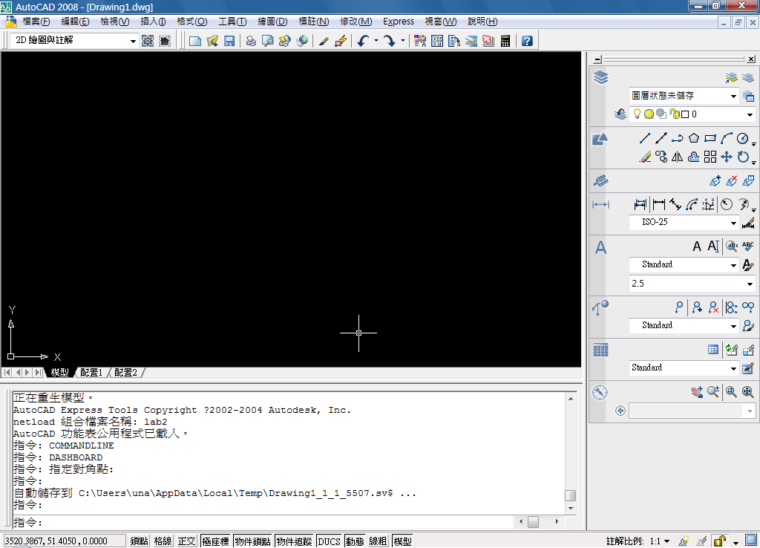
Editor的方法
PromptPointResult = ed.GetPoint(PromptPointOptions);
這個方法會把prPointOptions物件裡的值給輸出到CMD,
然後會使用PromptPointResult把使用者輸入的值接收.然後回傳PromptPointResult.
PromptDoubleResult = ed.GetDistance(PromptDistanceOptions);
這個方法會把PromptDistanceOptions物件裡的值給輸出到CMD,
然後做計算,計算出的值,給PromptDoubleResult.然後回傳PromptDoubleResult.
ed.WriteMessage("Hello");
如果只是單純的要在CMD上寫東西,沒有要接收回傳值的話,使用ed.WriteMessage("Hello");就可以了
What is PromptPointOptions
PromptPointOptions(System.String message) :顯示在CMD的文字
有一個屬性UseBasePoint.Type是BOOL,解釋如下: Gets or sets whether the base point is to be used.但不懂它指的是什麼
What is PromptDistanceOptions
PromptDistanceOptions(System.String message) 顯示在CMD的文字
有5個屬性:
BasePoint Type是Autodesk.AutoCAD.Geometry.Point3d: Gets or sets the base point to be used by the prompt.
使用者可輸入點
DefaultValue Type是System.Double: The default value to be used when the user presses ENTER without any other input.
使用者如果按下ENTER卻沒有輸入值時,所給的預設值.
Only2d Type是System.Boolean: Gets or sets whether the distance returned should be measured as a 2D projection to the UCS.
無論距離有沒有被傳回,應該量2D設計to the UCS.不知這是什麼.
UseBasePoint Type是System.Boolean: Gets or sets whether the base point is to be used. 不知這是什麼.
UseDashedLine Type是System.Boolean: Gets or sets whether a dashed "rubber band" line is to be drawn between the base point and the cursor's current location while prompting.
What is PromptPointResult
有一個屬性叫做Status是存取使用者按下的鍵是ENTER還是ESC還是產生錯誤. None/ Other/ Modeless/ OK/ Cancel/ Keyword/ Error(奇怪這個屬性,手冊上沒提到)
有一個屬性VALUE,Type是Autodesk.AutoCAD.Geometry.Point3d是存放使用者輸入的值.

[CommandMethod("selectPoint")]
static public void selectpoint() // This method can have any name
{
Editor ed = Application.DocumentManager.MdiActiveDocument.Editor;
try
{
// Put your command code here
PromptPointOptions prPointOptions = new PromptPointOptions("Select a point");
PromptPointResult prPointRes;
prPointRes = ed.GetPoint(prPointOptions);
if (prPointRes.Status != PromptStatus.OK)
{
ed.WriteMessage("Error\n");
}
else
{
ed.WriteMessage("You selected point " + prPointRes.Value.ToString());
}
}
catch(System.Exception ex)
{
ed.WriteMessage("Error Getting Distance" + ex.Message);
}
}

// Define Command "getdistance"
[CommandMethod("getdistance")]
static public void getdistance()// This method can have any name
{
Editor ed = Application.DocumentManager.MdiActiveDocument.Editor;
try
{

PromptDistanceOptions prDistOptions = new PromptDistanceOptions("Find distance, select first point:");
PromptDoubleResult prDistRes;
prDistRes = ed.GetDistance(prDistOptions);
if (prDistRes.Status != PromptStatus.OK)
{
ed.WriteMessage("Error\n");
}
else
{
ed.WriteMessage("The distance is: " + prDistRes.Value.ToString());
}
}
catch(System.Exception ex)
{
ed.WriteMessage("Error Getting Distance" + ex.Message);
}
}

