**#FunTimesWithTheTA   
Piezo Pulse Sensor - a Pressure-Based Heart Rate Monitor**

by Orlando S. Hoilett

**Introduction**

In this installment of #FunTimesWithTheTA we will build The Piezo Pulse Sensor. The piezo pulse sensor is a pressure-based heart rate monitor. The piezo pulse sensor uses piezo elements to transduce changes in blood volume in your in your finger, due to the pulsatile activity of the heart, to a voltage that can be detected with an amplifier. By observing the signal, we can plot the resulting waveform and calculate heart rate.

**Learning Objectives**

1. Apply the Piezo-Electric Effect to measure heart rate
2. Understand the use of buffer amplifiers
3. Utilize bypass capacitors to remove noise
4. Investigate ability of filters to selectively attenuate either high frequency components (Low Pass) or low frequency components (High Pass) of signals
5. Create a circuit for measuring heart rate

**ABET Outcomes**

“an ability to function effectively on a team whose members together provide leadership, create a collaborative and inclusive environment, establish goals, plan tasks, and meet objectives” (Outcome 5)

“an ability to develop and conduct appropriate experimentation, analyze and interpret data, and use engineering judgment to draw conclusions” (Outcome 6)

“an ability to acquire and apply new knowledge as needed, using appropriate learning strategies.” (Outcome 7)

http://www.abet.org/accreditation/accreditation-criteria/criteria-for-accrediting-

engineering-programs-2018-2019/



*Figure 1: Circuit diagram of Pulse Piezo showing the piezo element, the buffer amplifier, and the active bandpass filter to amplify the signal.*

**Table of Contents**

|  |  |
| --- | --- |
| **Section** | **Page** |
| Introduction | **1** |
| Objectives | **1** |
| Piezo Pulse Sensor Schematic | **2** |
| Key Terms and Definitions | **4** |
| Part #1: Transducer: The Piezo Element | **6** |
| Part #2: Active Bandpass Filter | **7** |
| Part #3: Bypass Filters | **9** |
| Revision History | **10** |

**Key Terms and Definitions**

***Piezo Elements***

A piece of quartz that produces a voltage when deformed

***Piezo Electric Effect***

An effect in which deforming a solid cause it to produce a voltage (in this case the piezo quartz is the solid and your pulse is the force)

***Load (Loading)***

The components of the circuit that use power (adding circuitry that will draw additional power from the rest of the circuit)

***DC Signals***

A voltage signal that does not vary with time

***AC signals***

A voltage signal that varies with time

***Noise***

Any unwanted signal (generally interfering with the signal you’re trying to measure)

***Bypass Capacitors***

Capacitors that are connected to voltage sources for the purpose of removing noise

***Buffer amplifier***

An op amp being used to isolate one portion of the circuit from another (as the op-amp draws no current)

***Operational Amplifier or Op Amp***

A type of circuit component that can perform mathematical operations on electrical signals such as multiplication, division, logarithm, etc.

***Cut-off frequency***

The frequency at which a filter begins to attenuate signals. Typically defined as the frequency at which the output of the filter is 70.7% of the input signal.

***Attenuation***

A decrease in signal amplitude.

***Gain***

An increase in signal amplitude.

***High-pass Filter***

A type of filter that causes signals with a higher frequency than the specified cut-off frequency to pass with minimal to no attenuation or change in amplitude, but that attenuates signals with frequencies lower than the cut-off frequency.

***Low-pass Filter***

A type of filter that causes signals with a lower frequency than the specified cut-off frequency to pass with minimal to no attenuation or change in amplitude, but that attenuates signals with frequencies higher than the cut-off frequency.

***Band-pass Filter***

A type of filter than causes signals lower than a given frequency and higher than a given frequency to become attenuated while only passing signals within a given “band” of frequencies. A bandpass filter is a simple combination of a low and a high-pass filter.

***Passband***

The passband refers to the range of frequencies that are not attenuated by a given filter

***Stopband***

The stop band refers to the range of frequencies that are completely attenuated by a given filter.

**Part #1: Transducer: The Piezo Element**

Piezo element operates on a principle known as the piezo electric effect. The piezo element is made of small quartz crystals that produce a voltage when deformed. When the heart pumps blood through the body, the volume of blood in the vessels changes periodically with the heartbeat. At our fingers, the changing blood volume causes a small pressure that can be sensed by a pressure sensor external to our fingers (in this case the piezo element). The piezo element then produces a time varying voltage, with that voltage change being a direct result of the pulsatile activity of the heart. By plotting the response of the piezo element, we can detect heartbeats.

*Figure 2: Piezo Element and Buffer Amplifier*

In parallel with the piezo, we place a 1 MegaOhm resistor that limits the current being sourced from the piezo element. The voltage produced by the piezo element is used as the voltage for the non-inverting input of an op-amp. The op-amp in this configuration is called a buffer amplifier. The buffer amplifier allows us to measure the voltage output of the piezo element with minimal distortion of the signal and pass that signal to subsequent stage without loading the two stages. Recall that the output voltage of the buffer amplifier is given by the equation:

(1)

***Testing***

1. Power the op amps with +/- 7 V from the benchtop power supply
2. Please set the current limit of your benchtop power supply to 50mA.
3. Please see Part #3: Bypass Capacitors
4. Gently tap the piezo element. You should see a small signal appear at the output of the buffer amplifier.

***Try It!***

1. Play one of your favorite songs on your phone
2. Hold the phone’s speaker up against the piezo element

You should be able to see the audio signals at the output of the buffer amplifier. This may or may not work wonderfully depending on the sound pressure level of your phone’s speakers.

**Part #2: Active Bandpass Filter**



A band-pass filter is a useful filter configuration that allows us to combine the effects of low-pass and high-pass filters resulting in only a “band” of frequencies in the passband. We will use a bandpass filter to block DC signals to ensure that only the AC portion of our signal is being amplified and for filtering high frequency noise such as 60 Hz. The band-pass filter has two cut-off frequencies set by the low-pass and high-pass filter. Recall that the cut-off frequency of low-pass and high-pass filters are determined by the following equation:

*Figure 3: Two active filters, an active bandpass filter and an active low-pass filter to provide gain and decrease noise.*

(2)

The low-pass filter determines the higher cut-off frequency (use C1 and R2). The high-pass filter determines the lower cut-off frequency (use C2 and R3). The cut-off frequencies are set to 0.5 Hz and 3.4 Hz.

The gain in the passband is determined by equation 3

(or in this case) (3)

(4)

The passband gain should be about 23dB.

***Testing***

1. Power the op amps with +/- 7 V from the benchtop power supply
2. Please set the current limit of your benchtop power supply to 50mA.
3. Please see Part #3: Bypass Capacitors
4. In High-Z mode, create a 1 Hz, 20 mVpp sine wave from your function generator.
5. Input the sine wave into your bandpass filter.
6. You should have an output signal of about 300mVpp.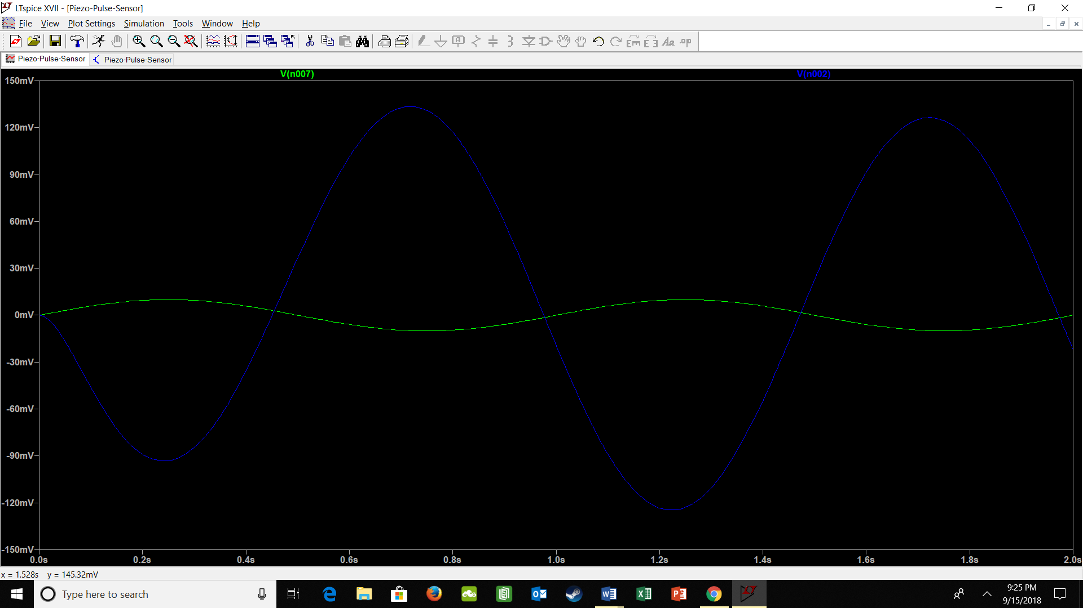

Figure 4 Simulated Output of the Bandpass Filter

1. Change the frequency of your input sine wave to 60Hz.
2. In High-Z mode, change the signal amplitude 1Vpp
3. You should have an output signal of about 830mVpp.

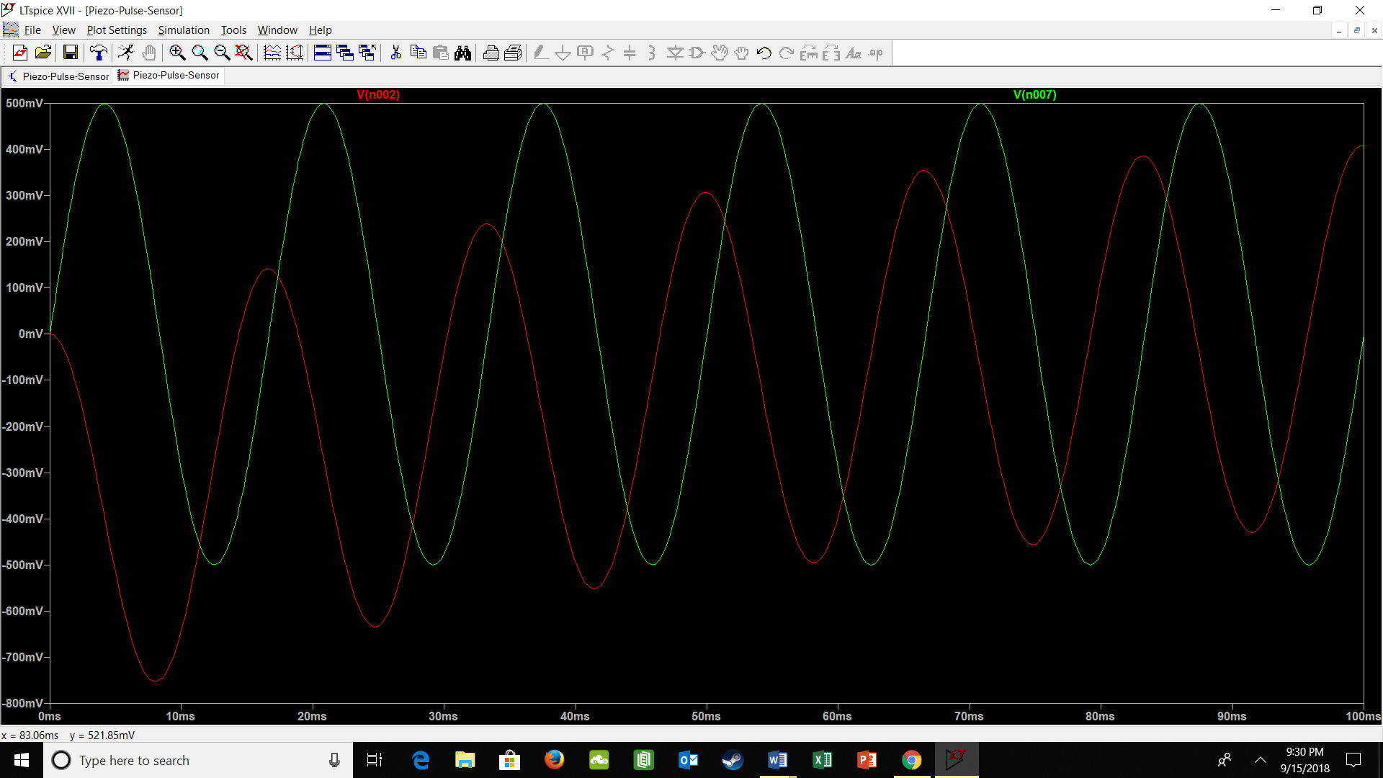

Figure 5 Simulated Output of the Bandpass FIilter

Note: Notice the attenuation of the 60Hz wave compared to the 1Hz wave

**Part #3: Bypass Capacitors**

****Image that instead of providing a constant DC supply, our batteries or benchtop power supply actually have a small AC noise on top of the DC voltage. Imagine that sometimes, this AC noise can become rather large. If this AC noise is too large and drops below the operating voltage of our op amps, the circuit can momentarily turn off. As you imagine, this could potentially be pretty bad. It would be really awkward if you were using your cellphone and all of a sudden, it would suddenly turn off. This is the unfortunate reality of real voltage sources. Real voltages sources cannot provide a truly steady voltage level, but droop and spike with changes in load (the circuit the DC supply is powering). We can minimize the effects of these momentary changes in power supply voltages with capacitors. Recall that capacitors resist changes in voltage. Also recall that capacitors actually store charge. If we connect a capacitor directly across the terminals of the battery, the capacitor will charge up to the voltage level of the battery. Since capacitors resist changes in voltage, the capacitor reduces AC noise on our DC voltage that is caused by changing load and by normal operation of our circuit. In this configuration, capacitors are referred to as bypass capacitors. It is important to use bypass capacitors for each one of your op amps and to place these capacitors as close as possible to the power supply pin of your op amp. Bypass capacitors should be used on both supplies (the positive and negative supply) of your op amp.

*Figure 6: Bypass capacitors placed as close as possible to the power supply pin of each op amp in the circuit. These bypass capacitors help reduce power supply noise as well as keep the operation of the circuit stable.*

Please see the following video to see the effect of using a bypass capacitor in a practical circuit. <https://youtu.be/fr-S1TsHXvk>

**Revision History**

|  |  |  |
| --- | --- | --- |
| **Revision Code** | **Revision**  **Date** | **Description** |
| A | 11/16/2017 | * Initial document for 2017 #FunTimesWithTheTA |
| A.2 | 8/3/2018 | * Minor edits (typos mostly) for 2018 #FunTimesWithTheTA |
| A.3 | 9/15/2018 | * Final edits for 2018 #FunTimesWithTheTA * Added Key Terms and Definitions * Reworded some text and added clarifying text * Added objectives |