**#FunTimesWithTheTA Build Session  
PulseFit – a “Do-It-Yourself” Heartbeat Sensor with Auto-Adjusting Threshold**

Adapted from: <http://www.instructables.com/id/Heart-Sensor-With-AutoAdjusted-Threshold-and-Heart/> by Orlando S. Hoilett

**Introduction**

Photoplethysmography is the study of the change of volume in an organ using light. Photoplethysmography has famously been applied to measuring the volume of blood in someone’s finger as a method of calculating heart rate. In this technique, the finger is illuminated by a light-emitting diode (LED) (often red, IR, or green) and a photodetector measures the amount of light that passes through the finger. The intensity of light varies with varying blood volume of the finger, which coincidentally corresponds to different phases of the cardiac cycle. The pulse waveform has a very characteristic waveform (Figure 1). It has a fast rise, which corresponds to the systolic phase (ventricles pumping blood to the rest of the body) and a slow drop-off (diastole). Additionally, there is a secondary peak called the dicrotic notch, which corresponds to the closure of the aortic valve, which sends a secondary pressure wave throughout the body. From studying pulse waveform, we can calculate heart rate as well as determine other biometric quantities.

In this installment of #FunTimesWithTheTA we will build PulseFit a “Do-It-Yourelf” Heartbeat Sensor with Auto-Adjusting Threshold.

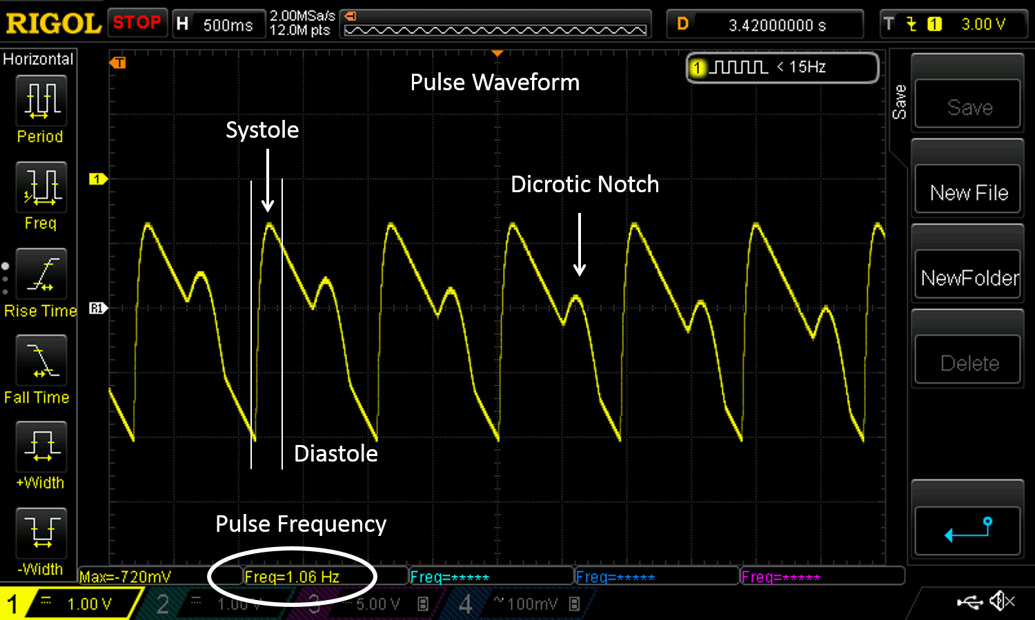

*Figure 1: Example output of PulseFit highlighting the cardiac phases.*

**Objectives**

* Understand the basics of filters, different filter types, cut-off frequency
* Understand the operation of photodiodes in detecting light
* Understand the application of time constant to different circuit configurations including peak detectors
* Understand the various phases of the cardiac cycle as depicted in a photoplethysmograph (Figure 1)
* Have some fun!!

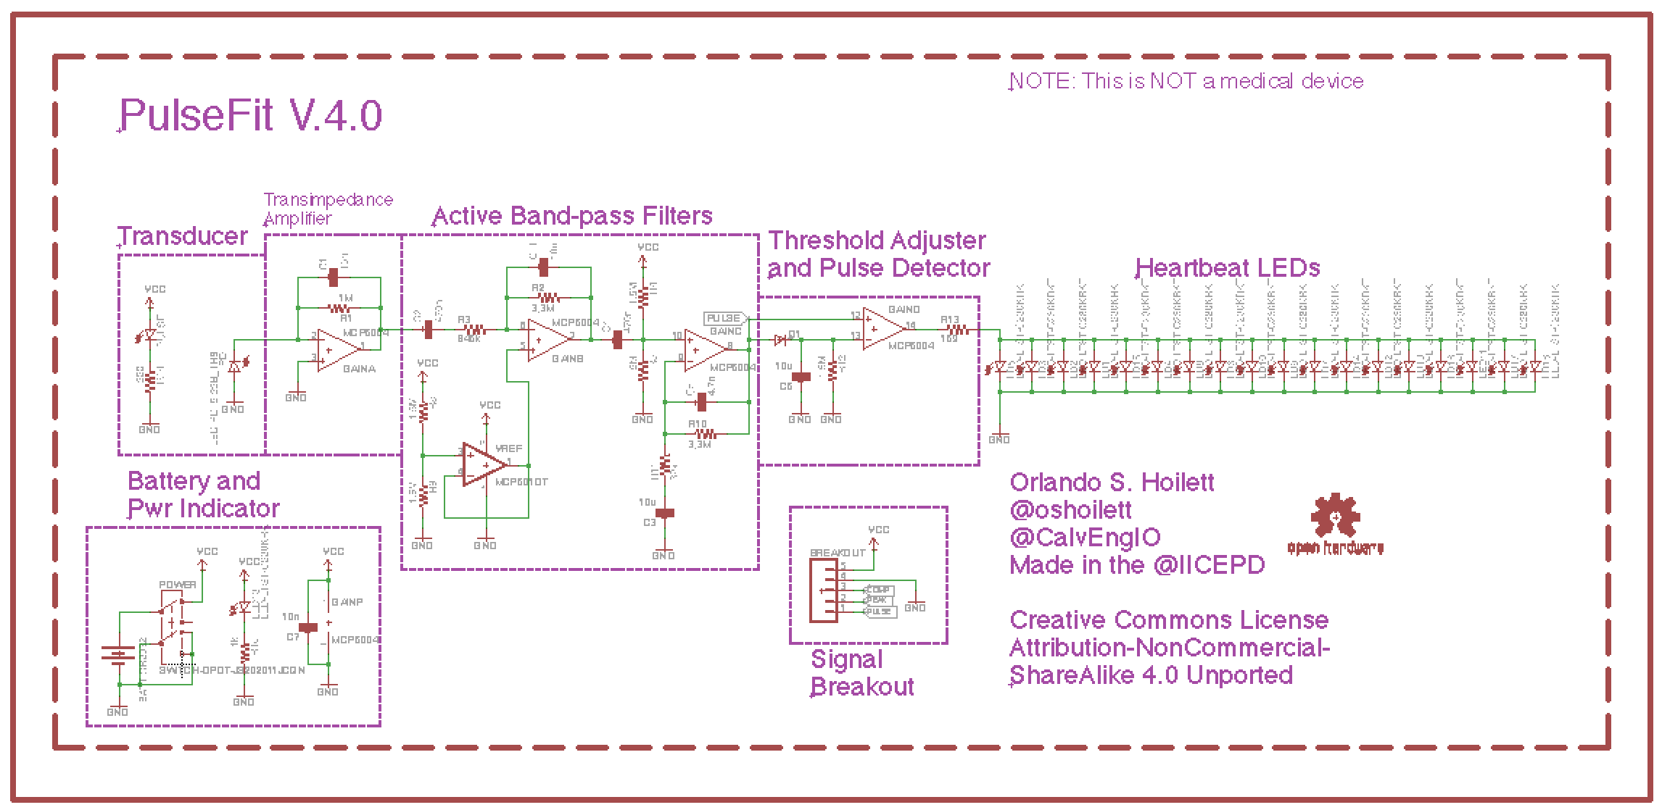

*Figure 2: Circuit diagram of PulseFit.*

**Part #1: Transducer: The Light-Emitting Diode and the Photodiode**

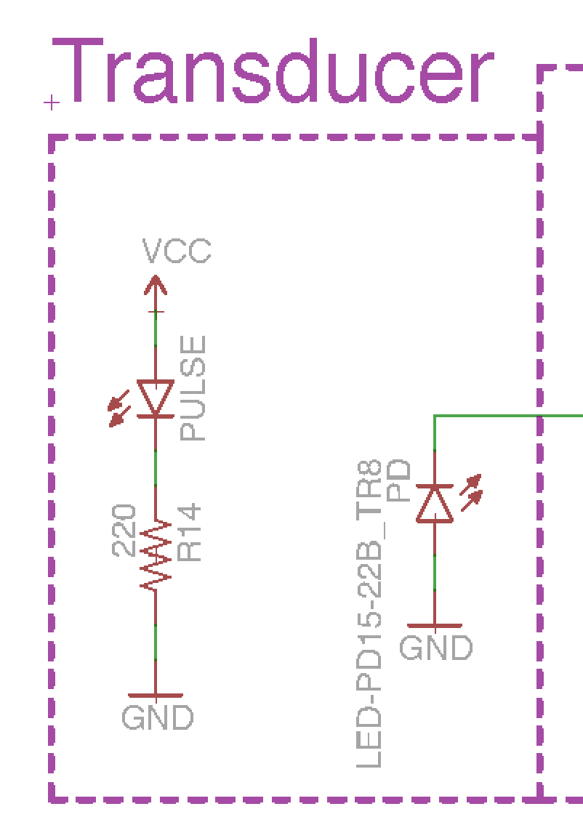

*Figure 3: LED and Photodiode.*

***Infrared Light-Emitting Diode (IR LED)***

IR LEDs, as the name suggests, are specific types of LEDs that emit infrared light. For pulse sensing, IR LEDs are often employed due to the well-characterized absorbance of IR light by hemoglobin, the protein the blood that carries oxygen. The absorbance of IR light by hemoglobin is an important consideration for other techniques such as pulse oximetry, which is the characterization of blood oxygenation. In the case of detecting a heartbeat, the amount of blood in finger will vary with each phase of the cardiac cycle changing how much of the IR light is being absorbed by the finger. Please remember to respect the polarity of the LED. The anode is positive while the cathode is negative.

***Photodiode***

Photodiodes are handy circuit components that convert light energy into electrical current. Photodiodes allow us to measure the amount of light that passes through the finger in order to determine the amount of light absorbed by the finger.

Photodiodes come in many varieties. The ones that we will be using have special optical filters built in that block ambient daylight. This allows our photodiode to be very robust against background light. The photodiode will still respond to strong sunlight, however, but room lighting should not affect it significantly.

***Testing:***

1. Power the LED with +10 V.
2. Test if the LED is on, by looking at the LED with the front or back camera of an Android phone or the front camera of an iPhone.

**Part #2: Transimpedance Amplifier (TIA)**

**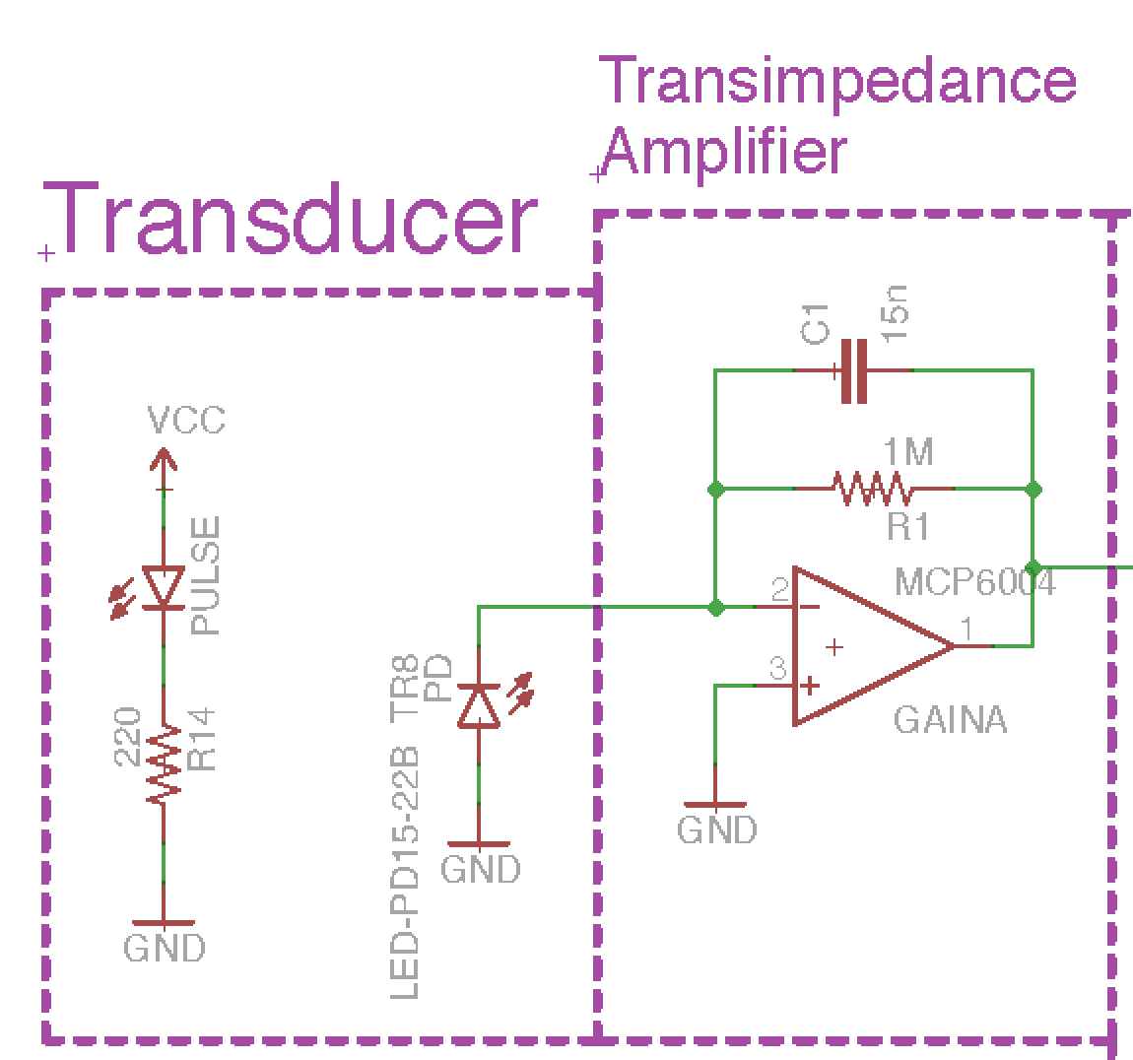***Figure 4: Transimpedance Amplifier (TIA) or “current-to-voltage” converter. The photodiode is in zero bias state. When light hits the photodiode, it produces a current that is converted to a voltage using the TIA.*

A transimpedance amplifier (TIA) is a “current-to-voltage” converter that converts the current produced by the photodiode, to a voltage that can be read at the output of the amplifier. This occurs because of Kirchoff’s Current Law. The current produced by the photodiode flows away from the inverting pin of the op amp to ground. KCL says that whatever current flows out of the node, must also flow into the node. As such, we get an equal and opposite current through RF and CF. Ohm’s Law says that V = I*ZF (where ZF is the equivalent impedance of RF and CF) which results in a voltage at the output of the amplifier that is proportional to the photocurrent. CF and RF create a low-pass filter with a cut-off frequency defined by

$f_{c}=1/{2πR_{F}C_{F}}$ (2)

RF is typically very large, which means that our TIA has a very high gain. High gain in an amplifier can often cause unstable behavior known as “oscillations” which are often high frequency. CF helps dampen high frequency oscillations by creating a low-pass filter with RF. In the case of our TIA, CF also helps filter 60 Hz noise.

Additionally, the gain of our TIA is defined by the following equation (if we ignore the effect of CF outside of our passband)

$V_{out}=-I_{P}*R_{F}$ (3)

Using equation 3, we can easily calculate the output voltage of our amplifier given a certain photocurrent and feedback resistance.

***Testing:***

1. Power the TIA with +/- 10 V from the benchtop power supply
2. Use your oscilloscope to view the output of the TIA.
3. Repeatedly block and un-block the photodiode, preventing the IR light from hitting the photodiode, by placing an opaque object between the two components. You should see a changing output similar to a square wave. The difference may only be a few tens of milliVolts.

***Part #3: Active Band-pass Filter***

***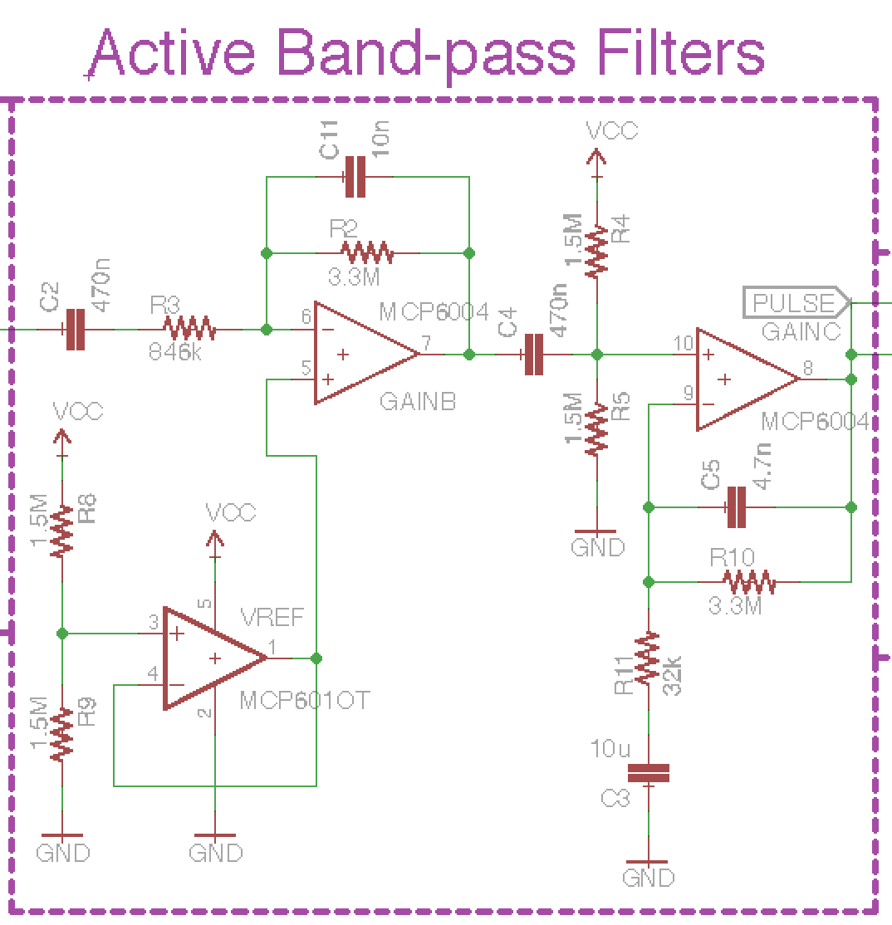****Figure 5: Two active band-pass filters to provide gain and decrease noise.*

A band-pass filter is a useful filter configuration that allows us to combine the effects of low-pass and high-pass filters resulting in only a “band” of frequencies in the passband. We will use a band-pass filter to block DC signals, to ensure that only the AC portion of our signal is being amplified, while at the same time filtering high frequency noise such as 60 Hz. The band-pass filter has two cut-off frequencies set by the low-pass and high-pass filter. Recall from equation 1 that the cut-off frequency the low-pass and high-pass filters are determined by

$f_{c}=1/{2πR_{F}C_{F}}$ (2)

The low-pass filter determines the higher cut-off frequency. The high-pass filter determines the lower cut-off frequency.

Notice the difference in the configurations of the band-pass filter. One filter is set in non-inverting configuration, the other is set in inverting configuration. This is done simply to invert our signal so that we have a positive increase in voltage during the systolic phase. Please note, this would correspond with more absorbance of light by our finger and decreased photocurrent (lower signal). We simply invert the signal to get the opposite relationship for convenience sake.

***Testing***

1. Power the op amps with +/- 10 V from the benchtop power supply
2. Create a 1 Hz, 10 mVpp sine wave from your function generator.
3. Input the sine wave into your band-pass filter.
4. You should have an output signal of about 4 Vpp.

**Part #4: Auto-Threshold Adjuster and Output Indicator**

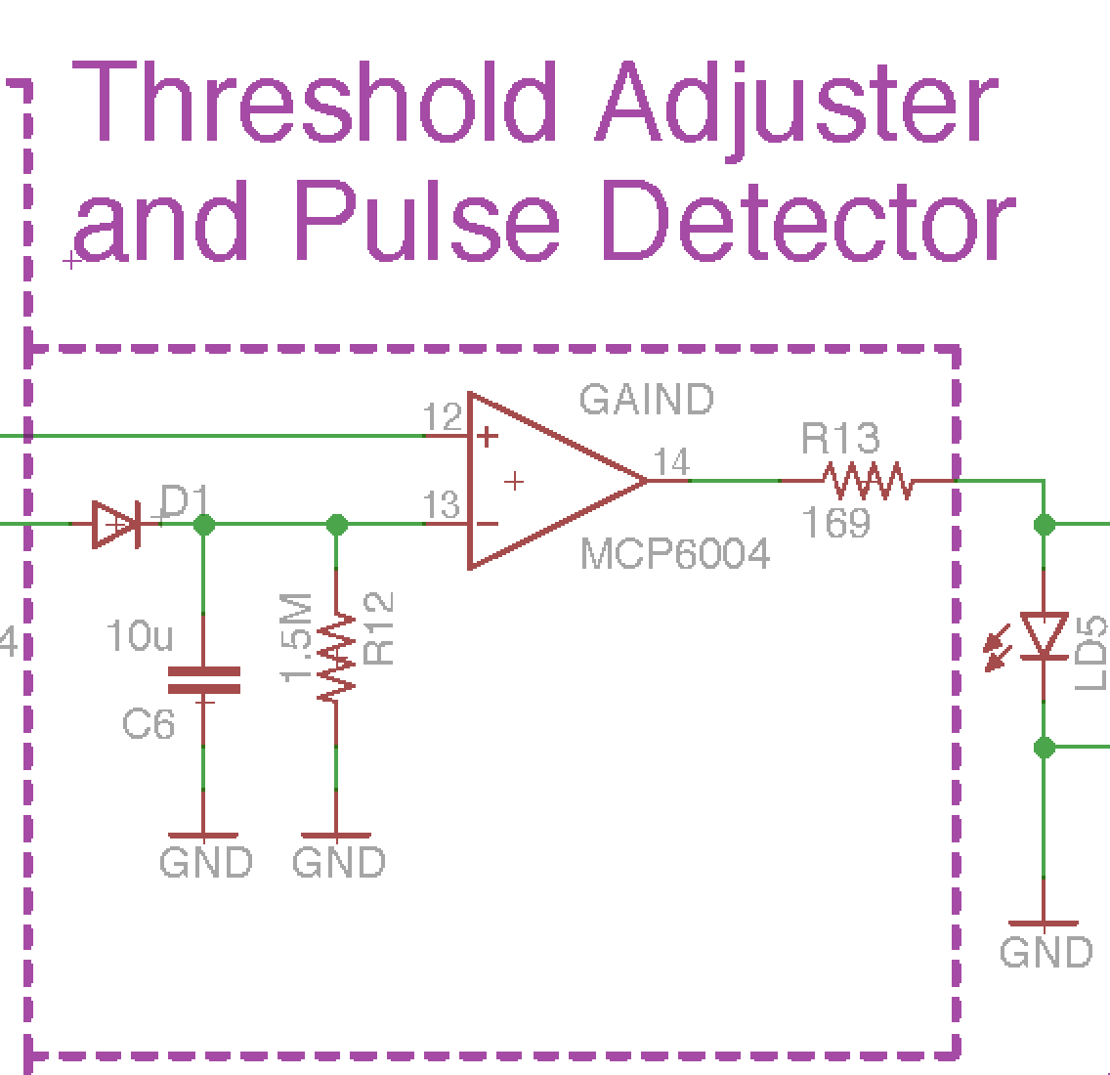

*Figure 6: Peak detector and comparator circuit. The peak detector auto-adjusts a threshold or the pulse output and the comparator lights up an LED when a heartbeat comes through.*

***Peak Detector Circuit***

The peak detector circuit, as the name suggests, finds the peak voltage of the input signal. It accomplishes this primarily with the diode and capacitor. A capacitor stores charge. If we were to connect a capacitor to a 9V battery, then remove the 9V battery, the voltage across the capacitor would remain 9V even with the battery removed. The peak detector utilizes this ability of the capacitor.

A diode is a device that blocks the flow of current in the reverse direction. This prevents the capacitor from discharging meaning the capacitor would hold the 9V charge indefinitely. We do not want the capacitor to hold charge indefinitely, so we place a resistor in parallel with the capacitor. The resistor discharges the capacitor at a rate equal to the RC time constant (τ) of the resistor-capacitor circuit where,

$τ=R×C$ (4)

We set our RC time constant so that the capacitor holds the charge long enough to set a relatively level threshold with only small change in voltage before our next pulse.

***Comparator and LED indicator***

A comparator compares the voltage between an op amp’s two inputs (inverting and non-inverting). The output of the comparator is determined by the following equation

$V_{out}=A_{OL}\left(V_{+}-V_{-}\right), with V^{-}≤Vout ≤V^{+}$ (5)

Where AOL is the open loop gain of the amplifier, which we will assume to be infinity, V+ is the voltage at the non-inverting pin, and V- is the voltage at the inverting pin. Do not confuse V+ and V-, which are the supply voltages of the op amp and V+ and V-, which are the voltages at the non-inverting and inverting input respectively. In short, if the voltage at V+ is higher than V-, the output of the amplifier will hit the positive rail (V+). If the voltage at V- is higher than V-, the output of the amplifier will hit the negative rail (V-).

We connected the pulse output to the non-inverting pin of the comparator and the peak detector to the inverting pin. If the pulse output voltage exceeds the voltage of the peak detector, the output of the comparator is positive which lights our LEDs indicating a heartbeat (systole). If the pulse output does not exceed the voltage of the peak detector, the LEDs do not light indicating diastole.

***Testing***

1. Power the op amps with +/- 10 V from the benchtop power supply
2. Output a 1 Hz, 3 Vpp sine waveform from the function generator and place it at the inputs labeled “PULSE” and “PEAK.” The LED should pulse momentarily every one second.
3. When combined with the other parts, you should obtain waveforms similar to those depicted below.