Main Manuscript for
The hidden cost of a single index: dimension-explicit functional vulnerability across the global avifauna
Aurèle Toussaint
Centre de Recherche sur la Biodiversité et l’Environnement (CRBE), Université de Toulouse, CNRS, IRD, Toulouse INP, 118 route de Narbonne, 31062 Toulouse, France
Correspondence: aurele.toussaint@cnrs.fr
ORCID: 0000-0002-5738-4637
Author Contributions: AT conceived the study, analysis the data and write the manuscript
Competing Interest Statement: The author declares no competing interests.
Classification: Biological Sciences/Ecology
Keywords: Trait-based approach, functional biogeography, trait-space, threatened species, birds

This PDF file includes:
Main Text
Figures 1 to 4
Abstract
Biodiversity crisis is eroding not only species but also the ecological functions they perform. Yet, while functional approaches dominate biodiversity assessments, they collapse traits into an aggregated functional space, whatever the number and the type of traits. Here I quantified the global functional diversity of birds, simulated the consequences of projected extinctions, and identified priority species and regions for conservation, by explicitly disentangling three ecological dimensions: locomotion, diet, and reproduction. Across 8,413 species, the loss of 5% of species under realistic 100-year IUCN trajectories produced a 1.1–1.4% global contraction of functional richness, and the loss of all currently threatened species (12% of the avifauna) further eroded functional richness by 2.2–4.0%, depending on the dimension considered, with the locomotion dimension showing the steepest absolute losses. Functional consequences were markedly heterogeneous in space: cell-level contractions reached -20% of functional richness under the IUCN All-Threatened scenario, with the steepest losses concentrated in the Saharo-Sahelian belt and montane Eurasia for the diet dimension, and on insular faunas for the reproduction dimension. Top priority species (Functionally Unique, Specialized and Endangered) differed substantially among the three-trait space. Only 1 species of the top 25 was shared across all spaces, with vultures and large raptors dominating diet rankings, ground-cuckoos and large condors dominating locomotion rankings, and megapodes, bearded vultures and albatrosses dominating reproduction rankings. These results demonstrated that aggregating traits into a single functional diversity index biased conservation priority. Conservation planning that ignores this heterogeneity risks protecting ecosystems against the wrong kinds of functional collapse.
Significance Statement
Functional diversity, the spread of ecological roles a community supports, has become a central tool for prioritizing species conservation. Standard practice combines all roles into a single composite index, implicitly treating them as interchangeable. Using the world's birds as a test case, I show this assumption is wrong in a quantifiable and consequential way. When avian function is separated into its three principal axes, how species move, what they eat, and how they reproduce, each axis identifies a different geography of vulnerability and a nearly disjoint set of priority species. Only one of twenty-five top-priority species is shared across all three. Aggregating ecological roles into a single number hides which ecosystem processes are actually at risk and misallocates conservation effort.

Main Text
Introduction

Birds occupy a key ecological role in the functioning of terrestrial ecosystems across the world (1, 2). As pollinators, seed dispersers, scavengers, predators and ecosystem engineers, they contribute to processes that operate from the scale of individual interactions to the global cycling of nutrients (3–5). This multifaceted ecological role can be revealed through suites of traits that ecological theory treats as distinct axes of organismal strategy (6, 7). For instance, locomotion can be estimated though body size, wing geometry, and limb proportions, and constrains where and how species move, forage, and disperse (8). Trophic ecology by beak morphology, foraging substrate, and dietary composition, and constrains which resources a species exploits and on which other species it depends (9). Reproduction by life-history traits — clutch size, incubation duration, generation length, longevity — and constrains how populations recover from perturbation (7). These three types of functional traits correspond to partially independent ecological strategies — flight mechanics versus trophic acquisition versus demographic pace — and the mismatch among them produces the canonical avian trade-offs (e.g., between dispersal ability and reproductive output, between body size and clutch size, between trophic specialization and habitat breadth). Thus, there is no a priori reason to expect that a species ranked as functionally distinct along one of these ecological strategies will be extreme along the others, or that regional pools rich in one form of functional diversity will be rich in the others.
Yet, despite the amount of work quantifying the functional erosion following the extinction of threatened species in birds (e.g., 2, 7, 10, 11), our quantitative understanding of how avian extinctions will reshape global ecosystem functioning remains limited to some specific aspects of their ecological role. For instance, Ali et al. (2022)(2), drawing on the AVONET morphological database (12), projected the loss of all threatened species would erode a disproportionate fraction of avian morphological diversity, particularly because threatened species occupy peripheral regions of the morphospace. Their morphospace, however, is dominated by traits associated with locomotion and trophic acquisition while silent on other traits such as demographic strategy. Thus, species that are unremarkable in beak and wing geometry but extreme in life-history pace — long-lived, slow-reproducing island endemics, for instance — could be missed as priority in such way. Conversely, Carmona et al. (2021) (7) and Toussaint et al. (2021) (10) used life-history and habitat traits to quantify functional erosion across the entire vertebrate tree of life and identified birds as a class in which threatened species concentrate idiosyncratic combinations of demographic and habitat-use strategies. Their scheme hence captures the demographic axis that Ali et al. (2022) (2) miss, but at the cost of resolving fine-grained variation in beak and wing morphology, which determines trophic and locomotor function. Even though each study is internally consistent, they describe partially non-overlapping facets of avian functional diversity (13) and could identify different species and different regions as conservation priorities. Such mismatch could strongly affect the conservation efficiency deserving the inclusion of functional traits as key tools to preserve ecosystem functioning and services. Reconciling them requires asking the question they cannot ask alone: do the three ecological dimensions — locomotion, diet, reproduction — converge on the same vulnerable species and the same vulnerable regions, or do they diverge?
The ecological stakes of this question are substantial. If extinction risk concentrates on trophic specialists such as vultures, large frugivores or hornbills without preferentially targeting taxa that are extreme in dispersal or in life history, then the loss of avian biodiversity will translate primarily into the collapse of trophic functions: scavenging, seed dispersal of large-fruited plants, top-down control of vertebrate prey. If, by contrast, extinction risk concentrates on slow-reproducing island endemics, the dominant signal will be demographic, and the affected functions will be those most sensitive to colonization lags and predator-prey re-equilibration. If extinction risk is concentrated in flightless or weakly volant taxa, locomotor functions and the seed-dispersal and pollination services that depend on them will be disproportionately affected. These three scenarios imply qualitatively different consequences for ecosystem functioning — and qualitatively different conservation responses — even when the number of species lost is the same. Yet to date, no global assessment of avian functional diversity has tested whether locomotion, diet, and reproduction identify the same species and the same regions as functionally vulnerable, or whether each dimension point out distinct geography of risk that an aggregated analysis would average away.
Here, I quantified the loss of functional diversity for the entire global avifauna by explicitly decomposing bird’s functional traits into three ecological dimensions: locomotion (i.e., morphological traits), diet, and reproduction (i.e., life history traits). For that, I assembled a global trait dataset for 8,413 bird species by harmonizing AVONET, EltonTraits, and the AMNIOTE database, and project each species into the three trait spaces. I then asked three questions. First, how do realistic and worst-case extinction scenarios reshape the functional richness of each dimension at the global and local scale, and is the loss of threatened species greater than expected by chance? Second, are the same regions identified as functionally vulnerable across the three dimensions, or do dimensions produce divergent geographies of risk? Third, do the top-priority species — those that combine functional uniqueness, specialization, and elevated extinction risk — overlap among dimensions, or does each ecological dimension identify a unique set of conservation flagships? Together, these analyses provided the first dimension-explicit, global biogeography of avian functional vulnerability.

Results

Across the 8,413 species included in the analysis, the three trait spaces capture markedly different aspects of avian ecology (Fig. 1, SI Appendix, Table S5). The locomotion space, built from eight AVONET morphological traits associated with locomotion (i.e., tarsus length, wing length, Kipp’s distance, secondary index, hand wing index, tail length, adult body mass and adult body length, SI Appendix, Table S1, Table S4), segregated species along a primary axis of body size and wing geometry, with ratites (e.g., Struthio camelus, Rhea spp., Dromaius novaehollandiae) and penguins (Aptenodytes spp.) at one extreme and small aerial insectivores at the other. The diet space, derived from ten EltonTraits proportional foraging variables, depicted axes of trophic specialization: obligate scavengers (Old and New World vultures), apex raptors and large piscivores occupied peripheral positions, while generalist omnivores clustered near the centroid. The reproduction space, built from six AMNIOTE life-history traits (i.e., clutch size, number of clutches per year, incubation time, longevity, fledging age, and egg mass), separated fast-living passerines from slow-living, long-lived seabirds and flightless taxa with extreme parental investment.
The magnitude of congruence between the three-trait spaces varied markedly. Locomotion and reproduction showed strong correlation (Procrustes r = 0.755, SI Appendix, Table S5), reflecting their dependence on body size and overall pace-of-life on the first trait space axis, whereas locomotion–diet (r = 0.370) and diet–reproduction (r = 0.366) were only weakly congruent. This dimensional independence propagated to species-level functional uniqueness (FUn): pairwise Spearman correlations between dimension-specific FUn scores were also weak (ρ = 0.16 for locomotion versus diet, ρ = 0.32 for reproduction versus diet, ρ = 0.32 for locomotion versus reproduction), confirming that a species functionally unique along one trait space was not necessarily unique along the others.
Under the realistic 100-year IUCN scenario, in which each species’ probability of extinction over the next century was derived from its current Red List category, the global avifauna was projected to lose, on average, 5% of its species. The associated contraction of trait spaces (measured as the loss in functional richness, FRic), however, varied among dimensions: 1.4% in locomotion space, 1.1% in diet space, and 1.3% in reproduction space (Fig. 2). Despite their low values of functional losses, all were significantly greater than expected under a random loss of species.
The IUCN All-Threatened (IUCN AT) scenario, which assumed the extinction of all currently Vulnerable, Endangered, and Critically Endangered species, magnified these contrasts. Under this scenario, 12% of species were expected to be lost, but the loss in FRic reached 2.2% in diet space, 3.3% in reproduction space, and 4.0% in locomotion space (Fig. 2). All three losses exceeded random expectations (P < 0.001), with the locomotion dimension showing the steepest absolute contraction. Mean functional uniqueness (FUn), quantifying how isolated remaining species become in trait space, increased by 4.0% (locomotion), 10.8% (diet), and 4.1% (reproduction); these increases exceeded random expectations under the null model (P = 1 for all trait spaces), indicating that the magnitude of the FUn shift induced by the loss of threatened species was comparable to that produced by an equivalent random loss. The dimensional asymmetry in FUn change, with diet showing a more than two-fold increase relative to the other two dimensions, was therefore more related to the structural arrangement of diet specialists in trait space rather than as evidence of selectivity in extinction risk in this metric.
Decomposing the IUCN AT scenario at the cell level on a global Discrete Global Grid System (DGGS) revealed that the spatial distribution of the trait space vulnerability was dimension-dependent (Fig. 3, SI Appendix, Fig. S4). Cell-level FRic loss ranged from negligible to nearly 20%, and the spatial distribution of these losses differed markedly among dimensions. The diet dimension exhibited the most spatially structured pattern, with deeper losses concentrated along the Saharo-Sahelian belt, the Mediterranean basin, and montane Eurasia — regions where threatened large frugivores, hornbills, and the global stronghold of Old-World vultures are concentrated. The locomotion dimension showed comparatively diffuse losses across continental but pronounced contractions on insular ecosystems where flightless or weakly volant endemic species dominate. The reproduction dimension showed the strongest insular signal, with the steepest contractions on island groups in the Indo-Pacific and in Madagascar, reflecting the disproportionate concentration of slow-life-history island taxa such as megapodes, mesites, and large procellariforms at high extinction risk. Crucially, cells that suffered the greatest loss in FRic in one dimension were not those most vulnerable in others, and areas of maximal species richness in the Neotropics and Indo-Malayan tropics showed comparatively modest FRic losses across all three dimensions despite hosting most threatened species. This can be explained by the fact that the high local species richness buffered species losses against erosion of the trait spaces. Trait-by-trait GLMM analyses of extinction selectivity (SI Appendix, Fig. S1) confirmed this divergence: extinction risk was preferentially associated with large body mass, increased wing length and tarsus length in the locomotion dimension; with obligate scavenging (Diet.Scav) and consumption of plant material other than fruit/seed (Diet.PlantO) in the diet dimension; and with low clutch size, increased incubation duration, and increased adult longevity in the reproduction dimension. These three trait syndromes overlapped only partially, and the species pools they identified as most exposed differ substantially.
Applied independently to each of the three trait spaces, the FUSE index (Functionally Unique, Specialized, and Endangered) identified sharply distinct sets of priority species (Fig. 4a–c). The locomotion FUSE ranking was dominated by morphologically distinctive species whose body traits were functionally isolated within the surviving avifauna such as the Sumatran ground-cuckoo (Carpococcyx renauldi), the Philippine eagle (Pithecophaga jefferyi), the California condor (Gymnogyps californianus), the helmeted hornbill (Rhinoplax vigil), the African penguin (Spheniscus demersus), and large albatrosses (Diomedea sanfordi, D. antipodensis). The diet FUSE ranking was dominated by trophic specialists and large frugivore-granivores with no functional replacement in their respective ecosystems: the blue-throated macaw (Ara rubrogenys), the kokako (Callaeas cinereus), the helmeted hornbill (Rhinoplax vigil), Baer’s pochard (Aythya baeri), the purple-naped lory (Lorius domicella), and threatened cracids (Crax globulosa, C. alberti). The reproduction FUSE ranking was dominated by species combining extreme slow life history with imminent extinction risk: the maleo (Macrocephalon maleo), the bearded vulture (Gypaetus barbatus), the California condor again, the Tristan and Amsterdam albatrosses (Diomedea dabbenena, D. amsterdamensis), the Philippine eagle, and the Bengal florican (Houbaropsis bengalensis).
The resulting overlap among the top 25 FUSE species across dimensions was then highly limited (Fig. 4d) since only 1 species — the helmeted hornbill (Rhinoplax vigil) — appeared in all three rankings and pairwise overlaps were also small (10 species shared between locomotion and reproduction, 1 between locomotion and diet, 0 between diet and reproduction). The remaining 52 species of the three top 25 lists were identified by a single dimension. This dimension-specific signal extended to broader thresholds: at the top-5% threshold, only 1.2% of priority species under FUS and 24% under FUSE were jointly highlighted across all three dimensions (SI Appendix, Fig. S5). A direct comparison with an aggregated FUSE space (i.e., considering all traits in a single trait space, SI Appendix, Fig. S3) showed that 12 of the 25 top-priority species under either approach were unique to that approach — the aggregated approach being dominated by morphologically extreme but functionally redundant species (e.g., large albatrosses, ratite-like taxa) and the disaggregated approach by species exhibiting moderate extremeness across multiple ecological dimensions. The conservation flagships identified by an aggregated FUSE analysis would therefore systematically displace from priority lists species that were functionally unique in only one dimension.

Discussion

Disentangling the functional consequences of bird extinctions into three ecologically explicit dimensions revealed a structured pattern of vulnerability that was invisible to aggregated analyses. Globally, the projected contraction of functional richness under realistic 100-years IUCN scenario was small in absolute terms (1.1–1.4% across dimensions over 100 years) but already significantly exceeded random expectations and accelerated two- to three-fold under the worst-case scenario (IUCN AT scenario, 2.2–4.0%). Far more than these global means, however, cell-level losses can reach −20% of local FRic in regions where threatened species were concentrated, and the surrounding species pool was small (Fig. 3, SI Appendix, Fig. S4). At the global scale, the locomotion dimension showed the largest absolute contraction of functional richness, the diet dimension showed the smallest, but the diet dimension produced by far the steepest increase in mean functional uniqueness (+10.8% under IUCN AT, against +4.0–4.1% for the other two dimensions). This contrast indicated that diet specialists, although they collectively occupied a smaller fraction of the global trait volume, were arranged so peripherally in trait space that their loss isolated the surviving species more strongly than the loss of locomotor or reproductive specialists. The locomotion dimension, by contrast, retained substantial redundancy because the loss of individual flightless or large-bodied taxa rarely removed whole regions of the morphospace. Reproduction occupied an intermediate position, with vulnerability concentrated on slow-life-history island endemics whose loss represented the erasure of demographic strategies rather than morphological or trophic ones. These results both extended and refined previous patterns on the loss of morphological and life-history traits. In addition, the present analysis added a layer of resolution by showing that the spatial distribution of vulnerability shifted substantially depending on the ecological dimension considered (Fig. 3, SI Appendix, Fig. S4), and each dimension carried a distinct ecological pattern with distinct consequences for ecosystem functioning.
The diet dimension showed the most spatially structured pattern. Cell-level losses were the more important along arid and montane belts of the Old World — the Saharo-Sahelian zone, the Mediterranean basin, and montane Eurasia — where the global stronghold of obligate scavengers (Gyps, Trigonoceps, Neophron, Gypaetus) is concentrated (14, 15). A second, geographically distinct hotspot of dietary-functional loss tracked the humid tropical forests of Indo-Malaya and the Afrotropics, where the global diversity of large frugivorous hornbills is concentrated (16). The functions at stake in these regions are not interchangeable with those provided by other birds: vertebrate carrion processing, in particular, has no functional analogue in the surviving avifauna because no other guild combines the digestive specialization, foraging breadth, and aggregation behavior required to consume large carcasses at the rates observed in extant vulture assemblages (17). The collapse of this guild has already documented cascading consequences — outbreaks of mammalian mesoscavengers (18, 19), increased disease transmission (18, 20), and disruption of nutrient redistribution (21) — that rare or threatened raptors and corvids are demonstrably unable to compensate for (20). The same logic applied, with different mechanisms, to the loss of large frugivorous hornbills: their long-distance dispersal of large-fruited tree species (16, 22) cannot be substituted by smaller frugivores, whose gape and gut anatomy cap effective dispersal at roughly 12 mm seed width (23). The downstream consequences operate at decadal-to-centennial timescales: dispersal limitation propagates through tree recruitment into aboveground biomass, with projected losses of 2.5–5.8% on average — and up to 26–38% in heavily defaunated communities — translating into substantial erosion of tropical forest carbon storage (24). That the analysis performed in this study isolated these losses within the diet dimension, rather than averaging them with locomotor or reproductive variation.
The locomotion dimension showed the inverse signature: continental losses were diffuse while insular losses were sharp and localized. This reflected a fundamental property of avian morphospace, namely that flightlessness and morphologically peripheral marine specialization cluster in evolutionarily isolated lineages on insular and high-latitude distributions (25–27). The disproportionate concentration of functional diversity in island avifauna is unlikely to be compensated by colonization or biotic invasion (28). The consequences of these losses were also functionally specific: when flightless ground-feeding birds — ratite-grade taxa such as moas and elephant birds, large flightless rails, and flightless waterfowl — disappear from an island system, what is lost is not only their identity as species but the suite of ground-level browsing and folivory (29, 30), small-seed and fungal-spore dispersal (30), and ecosystem-engineering activities (trampling, bioturbation, soil nutrient redistribution) that no flighted endemic can functionally replicate (29, 31, 32) — a non-substitutability now documented empirically at the global scale (28). Similarly, the loss of penguins and large albatrosses removes the dominant marine-to-terrestrial nutrient pump on subantarctic islands, with cascading consequences for soil chemistry and primary productivity that have been documented to persist for centuries after colony abandonment (33, 34). Aggregated functional analyses tended to recover these signals only when they happen to dominate the global morphospace and would otherwise dilute them in the much larger pool of continental morphological variation.
The reproduction dimension showed the strongest insular concentration of vulnerability and carried the most mechanistically distinct ecological pattern. Slow-life-history endemics such as large procellariforms, kiwis, kakapo, and flightless rails accumulated on islands precisely because the absence of native mammalian predators relaxed selection for fast reproductive strategies, permitting life-history syndromes (delayed maturity, single-egg clutches, prolonged parental investment) that have since proved fatally maladaptive in the face of introduced mammalian predation (35–37). The same trait combinations now make these species uniquely vulnerable to introduced predators and habitat loss, and uniquely slow to recover demographically. The consequences for ecosystem functioning unfolded not through immediate trophic disruption but through long-lag erosion of two interdependent processes. First, slow-reproducing endemics anchored long-term mutualisms with island plants — pollination, seed dispersal, and ocean-to-land nutrient subsidies whose loss propagated through generations of plant recruitment before becoming detectable(38, 39). Second, by stabilizing these mutualistic networks across environmentally variable years through an insurance-like portfolio effect (40), they conditioned the trajectory of post-disturbance recovery, which has not been restored by subsequent biotic invasions (41). The introduction of arctic foxes onto Aleutian seabird islands provides the empirical demonstration of this cascade: the resulting collapse of ocean-derived nutrient inputs transformed productive grasslands into nutrient-depleted dwarf-shrub tundra (42). Their loss is therefore poorly captured by short-term measures of ecosystem function and largely invisible to morphology-only analyses (2); only an explicit life-history dimension was able to highlight it.
The fact that these three signatures were spatially and taxonomically partially decoupled — visible at the cell level (Fig. 3, SI Appendix, Fig. S4) and at the continent level (Fig. 4e), where locomotion FUSE peaked in Antarctica (penguins, albatrosses), diet FUSE in Africa (vulture-driven), and reproduction FUSE in Europe (driven by long-lived raptors and seabirds) — had direct consequences for both ecological inference and conservation strategy. From an ecological standpoint, it implied that the aggregate statement "bird extinctions cause disproportionate loss of functional diversity" (2, 7), although correct at the global level, concealed three distinct mechanisms that target three different sets of ecosystem processes. Trophic, locomotor, and demographic functions were not interchangeable currencies, and a region depleted in one dimension was not compensated by retention of the others (Fig. 3, Fig. 4). The geographies of threatened uniqueness diverged sharply across dimensions: trophic vulnerability concentrated along arid Old-World belts; locomotor vulnerability in subantarctic and Pacific oceanic archipelagos; and reproductive vulnerability in tropical insular systems (Fig. 4a–c). From a conservation standpoint, this means that prioritization schemes built on a single aggregated functional-vulnerability index (7, 43) systematically misallocate effort: applying the aggregated FUSE framework displaced 12 of 25 (48%) of the top-priority species relative to the dimension-explicit pipeline, with only 1 species shared across all three-dimensional rankings (SI Appendix, Fig. S3). This magnitude of misallocation aligns with the broader spatial mismatch documented between taxonomic, phylogenetic, and functional diversity facets (7), and extends it to a finer-grained level — within the functional facet itself. Disentangling functional space into ecologically meaningful dimensions therefore did more than improve resolution, it contributed to explicit the link between trait-based approach and the ecological processes (44, 45). This can also be a condition for using functional diversity to forecast ecosystem function rather than merely to describe it.
For conservation planning, lists of priority species derived from a single, aggregated FUSE under-represented species that are functionally irreplaceable along only one dimension (SI Appendix, Fig. S3). Yet single-dimension irreplaceability was ecologically meaningful. For instance, a region that retained its full locomotor diversity but loss all its obligate scavengers cannot fully maintain its ecosystem function. Recent global biodiversity policy frameworks, including the Kunming-Montréal Global Biodiversity Framework, increasingly called for the protection of ecological processes and not only of species or area-based targets; dimension-explicit functional assessments hence provided a tractable way to make those targets quantitative. The species identified here as top-priority within each dimension — large condors, hornbills and ground-cuckoos for locomotor functions, parrots, hornbills and trophic specialists for diet functions, megapodes, bearded vultures and albatrosses for reproductive functions — should be read not as a refinement of the aggregated FUSE list but as three complementary lists that together constituted a more honest accounting of avian functional irreplaceability.
The three trait spaces analyzed here — locomotion, diet, reproduction — were an analytical choice rather than a complete enumeration of avian ecological strategy; thermoregulation, sociality, and migratory behavior could also be added as further dimensions. Future work should then extend this dimension-explicit framework to other ecological dimension, integrate climate-change-driven range shifts. Such framework should also be generalized to other vertebrate classes such as mammals or fishes, where comparable global trait and threat datasets are becoming available.

Materials and Methods

Trait dataset and species coverage
I assembled a global avian trait dataset by harmonizing three complementary sources: AVONET (12) for morphological traits, EltonTraits 1.0 (46) for diet variables, and the AMNIOTE database (47) for life-history traits. The BirdLife binomials reported in AVONET (sheet AVONET1_BirdLife, column Species1) were retained as the master taxonomic key because they correspond to the taxonomy used by the IUCN Red List, while EltonTraits and AMNIOTE entries were joined through the standardized binomials of the traitdata R package. Four species of Apterygidae (kiwis) were excluded prior to merging in line with (48). IUCN Red List categories were retrieved in April 2026 from the IUCN Red List API v4 (rredlist package, version >= 1.0.0) by directly querying every binomial; the most recent assessment was retained for each species. Data Deficient, Not Evaluated, Extinct, Extinct in the Wild and Regionally Extinct entries were removed from analyses. After taxonomic reconciliation, the working dataset comprised 8,413 bird species.
Continuous morphological and life-history traits were log-transformed and z-standardized. Missing values were imputed with the random-forest method missForest (49), informed by the standardized continuous traits, the fuzzy-coded diet variables, and the first ten phylogenetic eigenvectors of a global bird megaphylogeny (50). Phylogenetic eigenvectors were obtained from the square root of the cophenetic distance matrix and projected through metric multidimensional scaling (stats::cmdscale, k = 10). The diet variables of EltonTraits were converted to a fuzzy-coded representation with ade4::prep.fuzzy prior to functional-space construction. A sensitivity analysis confirmed that imputation produced negligible changes in trait-space configuration (SI Appendix, Supporting Information Text, Tables S2-S3, Figures S6-S7, S9-S10).
Functional trait spaces
I built three independent trait probability density (TPD) spaces (51) -- locomotion, diet, and reproduction -- and, for the comparison reported in SI Appendix, Fig. S3, an aggregated reference space pooling all three trait blocks. For each space, an inter-trait Gower distance was computed with ade4::dist.ktab under the scaledBYrange option, declaring quantitative blocks (Q: 8 morphological traits for locomotion; 6 life-history traits for reproduction) and the diet block as fuzzy (F: 10 EltonTraits proportions). Principal coordinates analysis (ape::pcoa) was applied to each distance matrix and the first two PCoA axes were retained for downstream analyses, in agreement with the parallel analysis stop rule (paran) and with the Pimiento et al. (43) protocol. Within each two-dimensional PCoA space, every species was represented by a multivariate Gaussian kernel centered on its coordinates, with a diagonal bandwidth set to the square root of the unconstrained plug-in selector ks::Hpi.diag (52); kernels were integrated over a 100 x 100 regular grid (gridSize = 100) at the alpha = 0.95 quantile using TPD::TPDsMean, yielding 10,000 cells per space following method of (7). An aggregated space was built from a single dist.ktab on the union of the three trait blocks under the same scaledBYrange standardization.
Functional metrics
Within each two-dimensional PCoA space I computed three species-level metrics following the formulation of Pimiento et al. (43). Functional uniqueness (FUn) was defined as the mean Euclidean distance from a species to its k = 5 nearest neighbors, evaluated through a kd-tree query (RANN::nn2) for scalability. Functional specialization (FSp) was defined as the Euclidean distance from a species to the centroid of the global trait space. FUn and FSp were rescaled to [0, 1] and multiplied by four. The species-level FUSE score was then computed as FUSE = ln(1 + (FUn × GE)) + ln(1 + (FSp × GE)), where GE is the ordinal IUCN category score, mapped as a probability of extinction LC = 0.0009, NT = 0.0071, VU = 0.10, EN = 0.667, CR = 0.999. All metrics were derived independently within each of the three trait spaces; no metric was averaged across spaces. Robustness to k was verified by recomputing FUn and FUSE for k in {1, 3, 5, 10}: pairwise Spearman correlations of species-level FUn across k exceeded 0.71 within every dimension (SI Appendix, Fig. S2).
Congruence between trait spaces
The independence of the three configurations was assessed with two complementary approaches. First, pairwise and three-way congruence between the multivariate configurations was tested with Procrustes analysis on the first two PCoA axes (vegan::protest, symmetric superimposition, 999 permutations) (25, 26). Second, pairwise Spearman correlations of species-level FUn quantified concordance at the level of individual species. Significance was evaluated both unstratified and after restricting permutations within taxonomic order to control for non-independence among related species.
Extinction scenarios and null model
Two extinction scenarios were simulated, following the framework of Pimiento et al. (13). The 100-year IUCN scenario assigns each species an independent Bernoulli draw with a 100-year extinction probability derived from its current IUCN category (LC = 0.0009, NT = 0.0071, VU = 0.10, EN = 0.667, CR = 0.999), using the conversion of (53, 54). The IUCN AT (All-Threatened) scenario assumes the deterministic extinction of every Vulnerable, Endangered and Critically Endangered species. For each scenario, I recomputed FRic - the proportion of trait-space cells with non-null kernel support that remained occupied by the surviving assemblage - and the mean FUn of survivors, and expressed both as proportional changes relative to the contemporary global values. The 100-year IUCN scenario was iterated 1,000 times; the IUCN AT scenario is deterministic. To test whether observed losses exceeded random expectations, every iteration was paired with a randomisation that permuted the identity of extinct species while preserving the number of extinctions. Empirical and null distributions were compared through the standardised effect size, SES = (mean_obs - mean_null) / sd_null, with a one-sided permutation p-value computed under the +1/+1 convention (27) so that p = 0 is structurally avoided and the test remains valid for deterministic scenarios. Random-number streams were generated independently per worker through future.apply::future_sapply with future.seed = TRUE.
Biogeographic decomposition
Species ranges were obtained from the BirdLife International Birds-of-the-World shapefiles, retaining geometries coded as Extant (1), Probably Extant (2) or Possibly Extant (3) for the breeding distribution. Range polygons were rasterized at 0.5 degrees resolution (rasterSp::rasterizeRange) and intersected with a global Discrete Global Grid System of hexagonal ISEA cells at resolution 7 (dggridR; cell area approximately 35,000 km2); each species was then assigned to every cell overlapped by its range. For every cell hosting at least eight species and for each of the three trait spaces, the 100-year IUCN (200 stochastic iterations per cell, to balance precision and computational cost) and IUCN AT (deterministic) scenarios were re-applied to the cell-specific species pool, and percentage changes in species richness, FRic and FUn were stored. Community-level FUSE scores were computed per cell as the arithmetic mean of the top 10% of species-level FUS or FUSE scores in the cell, following Pimiento et al. (13). For the continent-level summary (Fig. 4e), DGGS centroids were intersected with Natural Earth country polygons (rnaturalearth, small-scale dataset) in WGS84 prior to any reprojection.
Trait-extinction associations
To identify which trait modalities are preferentially associated with extinction risk, two complementary generalized linear mixed models (GLMMs) were fitted independently within each of the three trait spaces (SI Appendix, Fig. S1). A binomial GLMM (lme4::glmer; bobyqa optimiser, maxfun = 2 x 10^5) related threatened status (1 = VU/EN/CR, 0 = LC/NT) to the underlying continuous traits, with taxonomic order as a random intercept. A beta GLMM (glmmTMB::glmmTMB with beta_family) related the 100-year extinction probability -- pre-transformed into the open interval (0, 1) -- to the same predictors. Continuous predictors (morphological and life-history traits) were log10-transformed (positive values only) and z-standardized so that coefficients are directly comparable in magnitude across traits and dimensions; the diet proportions, which contain structural zeros and are bounded in [0, 1], were left untransformed. Coefficients with 95% Wald confidence intervals excluding zero were considered significant. The conservation-relevant difference between the disaggregated and the conventional aggregated approach was further quantified by comparing the top-25 FUSE rankings derived from the three independent spaces with those obtained from the aggregated trait space (SI Appendix, Fig. S3).
All analyses were carried out in R 4.4.

Acknowledgments
I thank the genotoul bioinformatics platform Toulouse Occitanie (Bioinfo Genotoul, https://doi.org/10.15454/1.5572369328961167E12) for providing computing resources.

References

1. C. Martínez-Núñez, R. Martínez-Prentice, V. García-Navas, Protected area coverage of vulnerable regions to conserve functional diversity of birds. Conservation Biology 37 (2023). https://doi.org/10.1111/cobi.14131.
2. J. R. Ali, B. W. Blonder, A. L. Pigot, J. A. Tobias, C. R. Jarome Ali, Bird extinctions threaten to cause disproportionate reductions of functional diversity and uniqueness. (2022). https://doi.org/10.1111/1365-2435.14201.
3. R. S. C. Cooke, F. Eigenbrod, A. E. Bates, Ecological distinctiveness of birds and mammals at the global scale. Glob. Ecol. Conserv. 22, e00970 (2020).
4. C. J. Whelan, Ç. H. Şekercioğlu, D. G. Wenny, Why birds matter: from economic ornithology to ecosystem services. J. Ornithol. 156, 227–238 (2015).
5. N. L. Michel, C. J. Whelan, G. M. Verutes, Ecosystem services provided by Neotropical birds. 122, 1–21 (2020).
6. M. Schleuning, D. García, J. A. Tobias, Animal functional traits: Towards a trait‐based ecology for whole ecosystems. Funct. Ecol. 37, 4–12 (2023).
7. C. P. Carmona, et al., Erosion of global functional diversity across the tree of life. Sci. Adv. 7, eabf2675 (2021).
8. J. A. Tobias, J. Ottenburghs, A. L. Pigot, Avian Diversity: Speciation, Macroevolution, and Ecological Function. Annu. Rev. Ecol. Evol. Syst. 51, 533–560 (2020).
9. J. Y. Barnagaud, et al., Ecological traits influence the phylogenetic structure of bird species co-occurrences worldwide. Ecol. Lett. 17, 811–820 (2014).
10. A. Toussaint, et al., Extinction of threatened vertebrates will lead to idiosyncratic changes in functional diversity across the world. Nat. Commun. 12, 1–12 (2021).
11. J.-Y. Barnagaud, et al., Biogeographical, environmental and anthropogenic determinants of global patterns in bird taxonomic and trait turnover. Global Ecology and Biogeography 26, 1190–1200 (2017).
12. J. A. Tobias, et al., AVONET: morphological, ecological and geographical data for all birds. Ecol. Lett. 25, 581–597 (2022).
13. C. Pimiento, et al., Functional diversity of marine megafauna in the Anthropocene. Sci. Adv. 6, eaay7650 (2020).
14. E. R. Buechley, Ç. H. Şekercioğlu, The avian scavenger crisis: Looming extinctions, trophic cascades, and loss of critical ecosystem functions. Biol. Conserv. 198, 220–228 (2016).
15. D. Ogada, et al., Another Continental Vulture Crisis: Africa’s Vultures Collapsing toward Extinction. Conserv. Lett. 9, 89–97 (2016).
16. S. Kitamura, Frugivory and seed dispersal by hornbills (Bucerotidae) in tropical forests. Acta Oecologica 37, 531–541 (2011).
17. E. Sebastián-González, et al., Functional traits driving species role in the structure of terrestrial vertebrate scavenger networks. Ecology 102 (2021).
18. D. L. Ogada, M. E. Torchin, M. F. Kinnaird, V. O. Ezenwa, Effects of Vulture Declines on Facultative Scavengers and Potential Implications for Mammalian Disease Transmission. Conservation Biology 26, 453–460 (2012).
19. A. Markandya, et al., Counting the cost of vulture decline—An appraisal of the human health and other benefits of vultures in India. Ecological Economics 67, 194–204 (2008).
20. E. G. Frank, et al., The Social Costs of Keystone Species Collapse: Evidence From The Decline of Vultures in India The Social Costs of Keystone Species Collapse: Evidence From The Decline of Vultures in India *. (2024).
21. T. L. DeVault, O. E. Rhodes, J. A. Shivik DeVault, T. L. DeVault, O. E. Rhodes, MINI-REVIEW Scavenging by vertebrates: behavioral, ecological, and evolutionary perspectives on an important energy transfer pathway in terrestrial ecosystems. (2003).
22. R. Naniwadekar, A. Rathore, U. Shukla, S. Chaplod, A. Datta, How far do Asian forest hornbills disperse seeds? Acta Oecologica 101, 103482 (2019).
23. C. Bello, et al., Defaunation affects carbon storage in tropical forests. Sci. Adv. 1 (2015).
24. C. A. Peres, T. Emilio, J. Schietti, S. J. M. Desmoulière, T. Levi, Dispersal limitation induces long-term biomass collapse in overhunted Amazonian forests. Proc. Natl. Acad. Sci. U. S. A. 113, 892–897 (2016).
25. N. A. Wright, D. W. Steadman, C. C. Witt, Predictable evolution toward flightlessness in volant island birds. Proc. Natl. Acad. Sci. U. S. A. 113, 4765–4770 (2016).
26. F. Sayol, M. J. Steinbauer, T. M. Blackburn, A. Antonelli, S. Faurby, Anthropogenic extinctions conceal widespread evolution of flightlessness in birds. Sci. Adv. 6 (2020).
27. A. L. Pigot, et al., Macroevolutionary convergence connects morphological form to ecological function in birds. Nat. Ecol. Evol. In press (2019).
28. F. Sayol, et al., Loss of functional diversity through anthropogenic extinctions of island birds is not offset by biotic invasions. Sci. Adv. 7, 5790 (2021).
29. J. R. Wood, et al., Resolving lost herbivore community structure using coprolites of four sympatric moa species (Aves: Dinornithiformes). Proceedings of the National Academy of Sciences 110, 16910–16915 (2013).
30. A. P. Boast, et al., Coprolites reveal ecological interactions lost with the extinction of New Zealand birds. Proceedings of the National Academy of Sciences 115, 1546–1551 (2018).
31. D. M. Hansen, M. Galetti, The Forgotten Megafauna. Science (1979). 324, 42–43 (2009).
32. D. M. Hansen, C. J. Donlan, C. J. Griffiths, K. J. Campbell, Ecological history and latent conservation potential: large and giant tortoises as a model for taxon substitutions. Ecography 33, 272–284 (2010).
33. X. L. Otero, et al., Seabird colonies as important global drivers in the nitrogen and phosphorus cycles. https://doi.org/10.1038/s41467-017-02446-8.
34. M. L. Grant, S. M. Reichman, A. L. Bond, J. L. Lavers, Seabirds Enhance Primary Producer and Consumer Isotope Signals on a Sub-Tropical Island. Ecol. Evol. 15 (2025).
35. T. M. Blackburn, P. Cassey, R. P. Duncan, K. L. Evans, K. J. Gaston, Avian extinction and mammalian introductions on oceanic islands. Science (1979). 305, 1955–1958 (2004).
36. G. H. Adler, R. Levins, The Island Syndrome in Rodent Populations. Q. Rev. Biol. 69, 473–490 (1994).
37. R. Covas, Evolution of reproductive life histories in island birds worldwide. Proceedings of the Royal Society B: Biological Sciences 279, 1531–1537 (2012).
38. S. H. Anderson, D. Kelly, J. J. Ladley, S. Molloy, J. Terry, Cascading effects of bird functional extinction reduce pollination and plant density. Science (1979). 331, 1068–1071 (2011).
39. C. E. Aslan, E. S. Zavaleta, B. Tershy, D. Croll, Mutualism Disruption Threatens Global Plant Biodiversity: A Systematic Review. https://doi.org/10.1371/journal.pone.0066993.
40. S. Yachi, M. Loreau, Biodiversity and ecosystem productivity in a fluctuating environment: The insurance hypothesis. Proc. Natl. Acad. Sci. U. S. A. 96, 1463–1468 (1999).
41. F. Sayol, et al., Loss of functional diversity through anthropogenic extinctions of island birds is not offset by biotic invasions. Sci. Adv. 7, 5790 (2021).
42. D. A. Croll, J. L. Maron, J. A. Estes, E. M. Danner, G. V. Byrd, Introduced predators transform subarctic islands from grassland to tundra. Science (1979). 307, 1959–1961 (2005).
43. B. McGill, B. Enquist, E. Weiher, M. Westoby, Rebuilding community ecology from functional traits. Trends Ecol. Evol. 21, 178–185 (2006).
44. C. Violle, et al., Let the concept of trait be functional! Oikos 116, 882–892 (2007).

Figures

Figure 1. Trait spaces for 8,413 bird species across the three ecological dimensions. Trait probability density (TPD) spaces are represented for locomotion (left, AVONET morphological traits), reproduction (center, AMNIOTE life-history traits), and diet (right, EltonTraits foraging traits). Representative species are labelled at the periphery of each space. See SI Appendix, Table S1 for trait names and Table S4 for PCoA loadings.

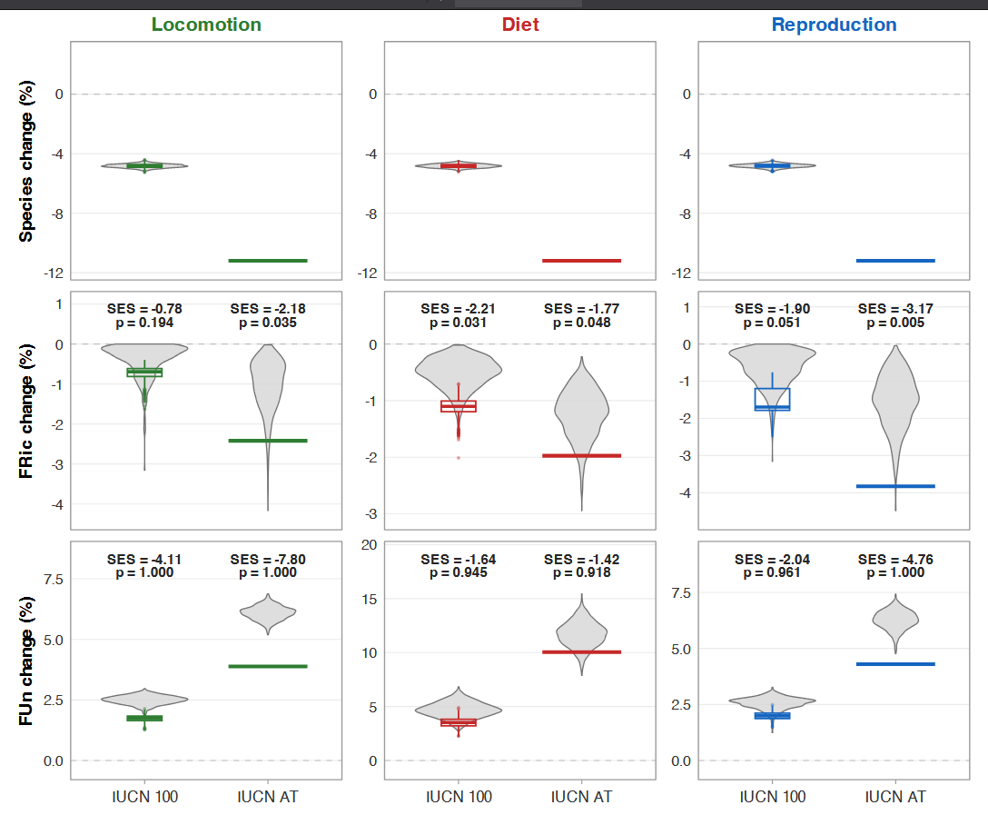
Figure 2. Forecasted losses of bird’s fauna across the three ecological dimensions. Proportional changes in (top row) species richness, (middle row) functional richness (FRic, % of the trait volume occupied), and (bottom row) functional uniqueness (FUn, mean distance to five nearest neighbors) under two extinction scenarios — IUCN 100 (probabilities derived from current Red List status, 100-year horizon) and IUCN AT (deterministic extinction of all currently threatened species) — applied separately to the locomotion (left column), diet (center column), and reproduction (right column) TPD spaces. Colored boxplots show empirical values across 1,000 stochastic draws of the IUCN 100 scenario or the deterministic IUCN AT outcome (horizontal segments); grey violins show the corresponding null distributions from 1,000 randomized extinction draws of the same number of species. P-values from one-sided Wilcoxon tests against the null are reported above each panel: P < 0.001 for all FRic comparisons (empirical losses systematically exceed random expectations), and P = 1.000 for all FUn comparisons (empirical FUn changes do not exceed random expectations).

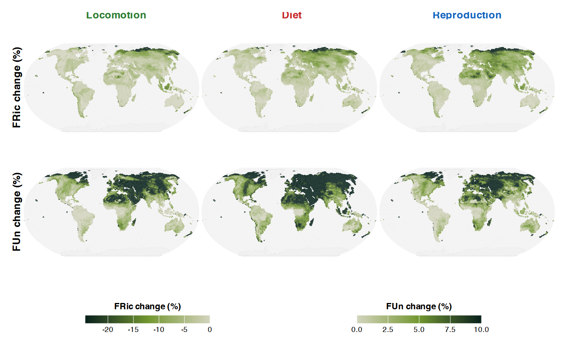
Figure 3. Spatial distribution of functional vulnerability across the three ecological dimensions. Cell-level percent change in functional richness (FRic, top row) and functional uniqueness (FUn, bottom row) under the IUCN All-Threatened scenario, computed independently for each ecological dimension. Each cell is a hexagon of a global Discrete Global Grid System (DGGS, resolution 7) and is shaded by the percent change of the corresponding metric induced by the deterministic loss of all currently Vulnerable, Endangered, and Critically Endangered species. Negative values denote a contraction of FRic or an increase of mean FUn (loss of redundancy). Maps are projected in Robinson’s equal-area projection. Common color scale is used within each row to facilitate comparison between dimensions.

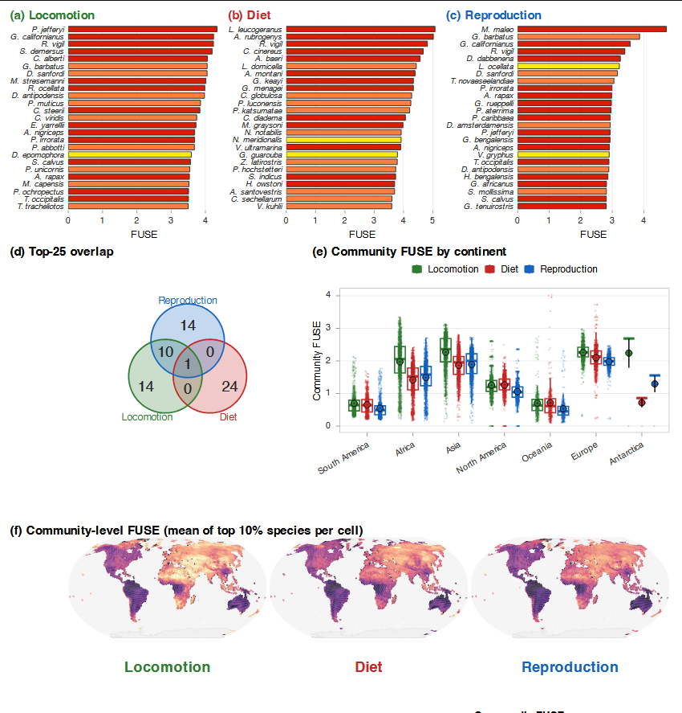
Figure 4. Top-priority bird species (FUSE) across the three ecological dimensions. (a–c) The 25 highest-ranking species under the FUSE index applied separately to the locomotion (a), diet (b), and reproduction (c) trait spaces. Bar lengths represent FUSE scores; bar colors denote IUCN Red List category (LC to CR), and species names are abbreviated as G. species. (d) Three-set Venn diagram of the overlap among the top-25 FUSE species across the three dimensions. (e) Distribution of community-level FUSE values per continent, computed as the mean of the top 10% of species per cell, shown for each ecological dimension. (f) Global maps of community-level FUSE per Discrete Global Grid cell, with a common color scale across dimensions for cross-dimensional comparison.

