Supporting Information for

The hidden cost of a single index: dimension-explicit functional vulnerability across the global avifauna
Aurèle Toussaint
Centre de Recherche sur la Biodiversité et l’Environnement (CRBE), Université de Toulouse, CNRS, IRD, Toulouse INP, 118 route de Narbonne, 31062 Toulouse, France
Correspondence: aurele.toussaint@cnrs.fr
ORCID: 0000-0002-5738-4637

This PDF file includes:

Supporting Information Text
Figures S1 to S10
Tables S1 to S5
References

Supporting Information Text

Missing trait values imputation

Missing values (23% of all trait entries; Table S1) were imputed with a machine-learning algorithm implemented in the missForest R package (1) with the default settings: ntree = 100, mtry = floor(√p), where p is the number of predictors, and convergence was assessed with the standard stopping rule based on stabilization of the out-of-bag (OOB) error across iterations. These settings are widely used and perform reliably for ecological trait datasets (1).
Imputation relied on morphological, diet, and reproduction traits, together with phylogenetic information, following (2). I used the global bird phylogeny of (3), which includes 9,993 species and was accessed through the megatrees package (4); a single consensus tree was derived from 100 trees. To capture phylogenetic signal, I extracted the first 10 phylogenetic eigenvectors from a PCA of the square-rooted cophenetic distance matrix (5). Including phylogeny in this way improves estimation of species positions in trait space because it captures the shared structure of evolutionary history and trait variation (6).
I then performed sensitivity analyses to test whether combining multiple trait types improved imputation. First, I varied the number of phylogenetic eigenvectors included in the imputation (0, 5, 10, 50, and 100). For each setting, I ran 100 independent imputations and summarized the mean and confidence interval of the imputed values. For each species–trait combination with missing data, I calculated the inter-imputation NRMSE, defined as the standard deviation of imputed values across the 100 runs divided by the observed trait range on the log₁₀ scale (Table S2). I also used Procrustes tests to assess whether the number of eigenvectors affected the structure of the reproduction trait space. These analyses showed that changing the number of phylogenetic eigenvectors had little effect on trait-space structure.
I next compared two imputation schemes: one based only on reproduction traits and phylogenetic eigenvectors, and another using all trait types jointly (morphological, life-history, and diet traits). The cumulative variance explained by the first two PCoA axes of the reproduction trait space differed by less than 0.31 percentage points between the two schemes, indicating that ordination structure was largely insensitive to the predictor set. Species positions in reproduction trait space were also highly congruent across schemes (Procrustes r = 0.99, P < 0.001), confirming that predictor choice had negligible effects on the functional space used in downstream analyses. I therefore retained all available trait types as predictors in the final imputation.

Trait spaces

Trait spaces were constructed following (2). Quantitative traits were log-transformed and scaled so that all variables contributed equally. Because some traits were not quantitative (for example, diet traits were coded as fuzzy variables), I used a mixed-variable distance coefficient that extends Gower’s distance to multiple data types. Specifically, I used ktab.list.df() from the ade4 package, which accommodates heterogeneous variables within a common framework. Traits were organized into three blocks—morphology, life history, and diet—allowing us to combine ecological dimensions that differed in both variable number and coding scheme. This approach also ensures equal block weighting: each block contributes equally to the total distance regardless of how many traits it contains, effectively weighting each trait by 1 divided by the number of traits in its block.
I then performed a PCoA on the resulting distance matrix and retained the first two axes, which explained the largest share of variance and are the most commonly interpreted dimensions (Table S4). Using the same ordination framework for all datasets ensured that the resulting functional spaces were directly comparable in downstream analyses. For fully quantitative trait sets, using PCoA instead of PCA did not alter species positions in functional space (Procrustes test = 1, P < 0.001).
A beak trait space was also constructed independently of the locomotion space using three linear beak measurements—culmen length, beak width, and beak depth—following the ecomorphological framework of (7) who identified these traits as major predictors of avian trophic niche. This space was built with the same workflow as the others: a Gower distance matrix followed by PCoA. The first three axes were retained. Axis 1 explained 86.95% of the variance, consistent with a size-dominated gradient, whereas axes 2 and 3 explained 10.72% and 2.33%, respectively, and captured residual variation in beak shape independent of size. The strong congruence between beak-space and diet-space distinctiveness (Procrustes r = 0.92, P < 0.001, Fig. S6) shows that linear beak measurements recover part of the dietary signal.
I also tested whether adding body mass to the reproduction and diet spaces, as is often done in the literature, altered their structure. Results showed that including body mass had little effect on either space (Procrustes test > 0.9, P < 0.001, Fig. S7).

Confirmatory Factor Analysis (CFA) of Trait Structure

To test whether the traits used in this study formed coherent functional modules, I performed a confirmatory factor analysis (CFA). I hypothesized that traits clustered into three latent factors representing locomotion, life history, and diet. All traits were log-transformed before analysis to reduce variance heterogeneity. I then compared this modular CFA model with an alternative model in which all traits loaded onto a single latent factor. Model fit was assessed using chi-squared difference tests, AIC/BIC, and RMSEA.
I also examined how the number of retained dimensions influenced the structure of each trait space. For reproduction and locomotion traits, the first two axes already accounted for more than 70% of the variance, so additional dimensions were unnecessary (Table S4). By contrast, diet traits and the aggregated space required four axes to exceed 70% cumulative variance explained. Although retaining additional axes substantially increased computational time and complicated interpretation, this result indicates that functional biogeographic patterns in those spaces could also be explored in four dimensions, as previously done for diet traits (9).

Trait spaces comparison

I compared trait spaces using Procrustes tests to determine whether species occupied similar positions across them. This allowed us to evaluate how strongly the overall structure of functional space depended on the type of traits considered (Table S5).
For locomotion and reproduction, no single trait dominated species discrimination, indicating that functionally unique species in these spaces are characterized by distinctive combinations of traits rather than by a single extreme feature (Fig. S8). In contrast, diet space was more strongly structured by specific feeding categories; for example, insectivory contributed disproportionately to functional distinctiveness. This pattern suggests that locomotion and reproduction spaces are relatively robust to trait choice, partly because body size captures much of the underlying variance, whereas diet space may be more sensitive to the composition of the trait set.

Sensitivity analysis of PCoA robustness

I quantified how sensitive trait-based principal coordinates analyses (PCoA) were to the number of traits used to construct each space. I evaluated the three single-function spaces—locomotion, reproduction, and diet—as well as the aggregated space. Robustness was assessed by subsampling traits, recomputing the PCoA, and comparing each subsampled ordination with the reference ordination built from the full trait set for that space (Fig. S9).
Diet variables represent fuzzy membership in food categories (0–1). Because these memberships sum to 100% within each species, diet spaces may be more sensitive than locomotion or reproduction spaces to changes in trait composition: modifying the set of dietary categories redistributes variance across all remaining categories and can therefore alter the geometry of the space. To avoid this issue, I row-normalized diet vectors to sum to 1 whenever diet information was available. Rows composed entirely of zeros were corrected by adding a small constant (1e-6) uniformly and renormalizing. This ensured that distances were always defined while having negligible influence on relative positions.
For each space, I computed trait distances with ade4::dist.ktab applied to a ktab object. Locomotion and reproduction blocks were treated as quantitative (Q), diet as fuzzy (F), and the aggregated space used the block types c(“Q”, “Q”, “F”). Within dist.ktab, I used the option scaledBYrange to standardize variables within each block by their observed range, thereby preventing high-variance traits from dominating the analysis. PCoA was then performed with classical metric scaling (stats::cmdscale), retaining the first K axes (default K = 8) for downstream comparisons. Restricting the analysis to K axes stabilized comparisons, reduced noise from poorly resolved higher-order dimensions, and limited memory use.
For each trait space, I first computed a reference PCoA using the complete trait set after the preprocessing steps described above. This reference ordination served as the baseline against which all subsampled ordinations were compared (Fig. S9).
For each trait space, I varied the number of traits n from a minimum threshold (default = 3) to the maximum available in that space. For each value of n, I generated R random subsamples (default R = 20–50) without replacement. In locomotion, reproduction, and diet spaces, n traits were drawn uniformly within the focal block. In the aggregated space, I constrained each draw to include at least one trait from each block: one locomotion trait, one reproduction trait, and one diet trait were first selected, and if n was greater than 3, the remaining n − 3 traits were sampled uniformly from the remaining pool across all blocks.
For each subsample, I recomputed the distance matrix and PCoA using the same settings as for the reference ordination, including the same value of K.
I quantified the robustness of subsampled ordinations relative to the reference using two complementary metrics:
- Procrustes agreement (vegan::protest): we aligned the K-dimensional subsampled scores to the reference scores and recorded the Procrustes correlation‐like statistic, reported by protest as t0 (hereafter proc_stat; larger is better; 1 indicates identical configurations up to rigid similarity transforms).
- Mantel correlation (vegan::mantel): Pearson correlation between the reference and subsampled distance matrices (mantel_r). This captures stability at the distance level (independent of ordination).
To reduce computation time for large species sets, I used point estimates only (permutations = 0). If inferential P-values are needed, the same workflow can be rerun with permutations (for example, 999), at the cost of longer runtimes.
For each space and each value of n, I summarized the distribution of proc_stat (and optionally mantel_r) across replicates with boxplots. I also added a horizontal reference line at proc_stat = 0.8 as a heuristic robustness threshold. Values remaining above 0.8 across a broad range of trait counts indicate that the PCoA structure is highly robust to trait subsampling.
To assess the contribution of each trait to functional structure, I calculated species-level functional uniqueness in the full multidimensional space built from all traits. Functional uniqueness measures how isolated a species is in trait space relative to all others (10). I then recalculated uniqueness after removing each focal trait in turn from the aggregated space. Comparing uniqueness values between the full and reduced spaces allowed to quantify how much each trait contributed to species distinctiveness. An increase in functional uniqueness when a trait was included indicates that it adds complementary ecological information and expands the occupied trait space toward rarer trait combinations. By contrast, traits whose inclusion caused little or no change likely captured information already represented by other variables (Fig. S8).
For each space, I assembled species × trait matrices from the imputed dataset (see main Methods). Locomotion and life-history traits were treated as quantitative variables (Q), diet as fuzzy membership variables (F) after row normalization and correction of all-zero rows, and the aggregated space as the concatenation of the three blocks with types c(“Q”, “Q”, “F”). Functional dissimilarities among species were computed with ade4::dist.ktab using the scaledBYrange option to standardize ranges within blocks. For computational stability, diagonal entries of the distance matrix were set to NA before row-wise means were calculated.

Functionally distinct species

I define functional distinctiveness as a composite property combining two aspects: global isolation from the overall species pool and local isolation from the nearest ecological analogues. To capture these two components, I calculated functional uniqueness (FUn), defined as the mean pairwise functional distance between a focal species and all others in the dataset (11), and functional specialization (FSp), defined as the distance to the nearest functional neighbor. These metrics are complementary: FUn reflects large-scale functional rarity, whereas FSp captures fine-scale ecological isolation. Considering both therefore provides a more complete description of species positions in trait space than either metric alone.
Functionally distinct species were identified independently within each space. I then compared these sets across spaces to assess consistency. Specifically, I quantified the degree of concordance in species identified as functionally distinct across different trait spaces. I computed the Jaccard similarity index between each pair of trait spaces based on the sets of functionally distinct species. This index provides a measure of overlap relative to the union of distinct species in both trait spaces. I classified each functionally distinct species according to whether it was identified as distinct in only one trait space (exclusive) or in two (or more) trait spaces (shared). The proportion of exclusive functionally distinct species provides a measure of how much the identification of functional distinctiveness depends on the choice of trait space.

Figures

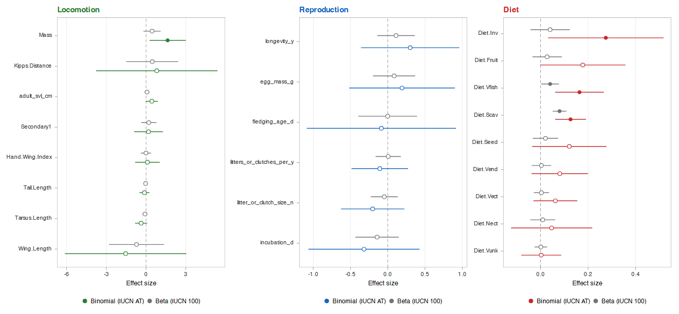

Fig. S1. Trait selectivity of bird extinctions across ecological dimensions. Standardized coefficients (with 95% Wald confidence intervals) from binomial GLMM (response: threatened status, VU+EN+CR vs LC+NT) and beta GLMM (response: 100-year extinction probability) fitted independently within each ecological dimension, with taxonomic order as random effect. Continuous traits are log-transformed and z-standardized so that coefficients are directly comparable in magnitude. Filled symbols denote coefficients whose 95% CI excludes zero. AVONET morphological traits (locomotion, top-left), AMNIOTE life-history traits (reproduction, top-right), and EltonTraits foraging proportions (diet, bottom).

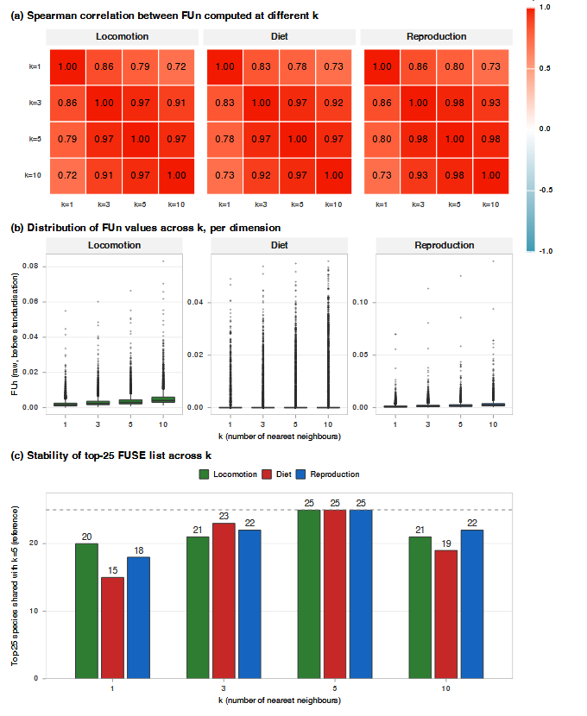

Fig. S2. Sensitivity of functional uniqueness (FUn) and FUSE rankings to the choice of k (number of nearest neighbors), the only free parameter of the FUn metric. (a) Pairwise Spearman correlations of species-level FUn computed at k = 1, 3, 5, 10 within each ecological dimension. All correlations exceed 0.71, with adjacent k values correlating at ρ ≥ 0.86. (b) Distribution of raw FUn values per k and per dimension, illustrating the expected scale shift but stable distributional shape. (c) Number of species shared between the top-25 FUSE list at the reference k = 5 (Pimiento et al. 2020) and the top-25 list at each alternative k, per dimension; values range from 15 to 25 of 25 species, indicating that FUSE rankings are robust to k.

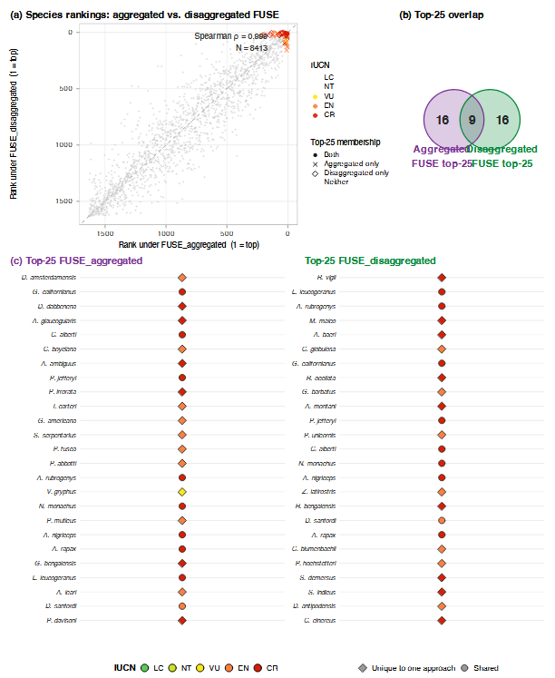

Fig. S3. Comparison of FUSE rankings derived from the disaggregated three-dimension framework used in the main text versus the conventional aggregated approach (single multidimensional space built from the same three trait blocks via the ade4 dist.ktab + PCoA pipeline with scaledBYrange option). (a) Scatter of species ranks under the two approaches; the diagonal is the 1:1 line. Points are colored by IUCN status; species in the top-25 of either approach are marked. Spearman ρ = 0.999 across all 8,413 ranked species. (b) Two-set Venn diagram showing that 12 of the 25 top-priority species under either approach are unique to that approach (13 shared, 12 aggregated-only, 13 disaggregated-only). (c) Top-25 species lists side-by-side, with circles indicating species present in both lists and diamonds indicating species nominated by only one approach.

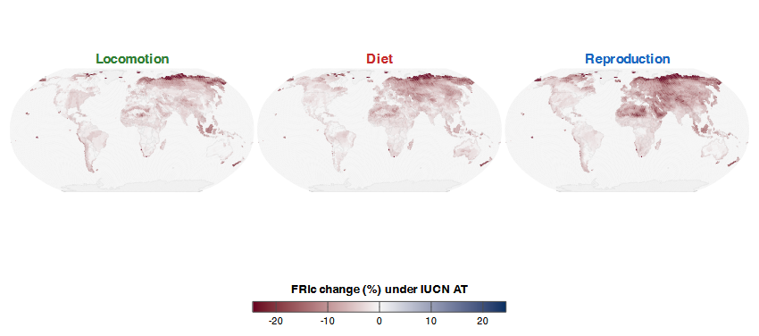

Fig. S4. Cell-level percent change in functional richness under the IUCN All-Threatened scenario (analogue of Pimiento et al. 2020, Fig. 4), computed independently for each ecological dimension. Common color scale across the three panels facilitates direct comparison of the amplitude of losses between dimensions.

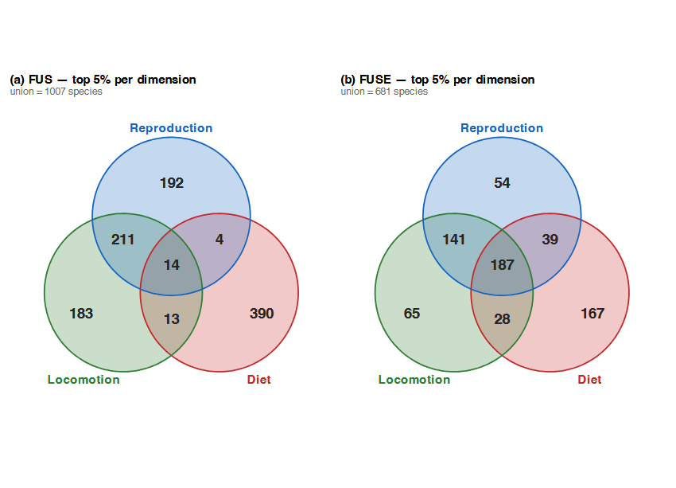
Fig. S5. Three-set Venn diagrams of the overlap among the top 5% of bird species ranked by Functional Uniqueness–Specialization (FUS, panel a) and threat-weighted FUSE (panel b), across the three ecological trait spaces. FUS captures intrinsic functional distinctiveness; FUSE additionally weights by IUCN-derived extinction probability.

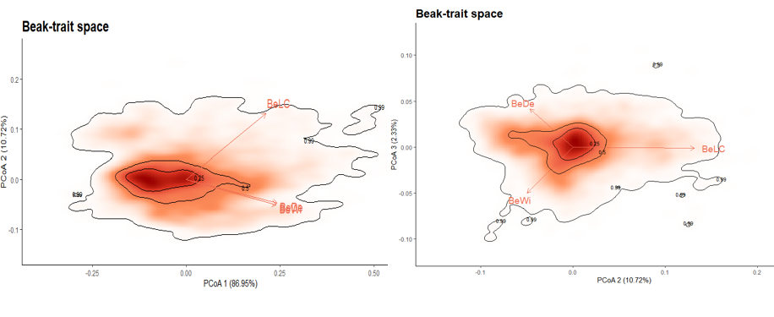
Fig. S6. Beak-trait space. We considered three traits related to beak shape and size (beak length culmen, beak width, beak depth). The method to build the trait space is similar than other for other trait spaces as explained in the MS. We performed Gower’s distance matrix, and keep the two first PCoA axes.

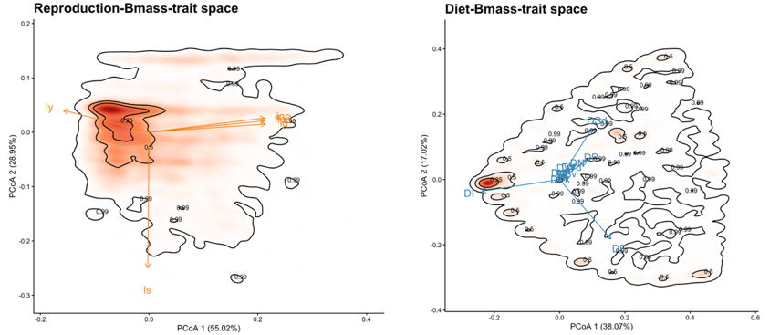
Fig. S7. Reproduction and diet-trait spaces. We represent two alternatives of reproduction and diet trait-space using all traits related to each function and body mass. The Reproduction-Bmass trait space is similar to the one published in Carmona et al. 2021.

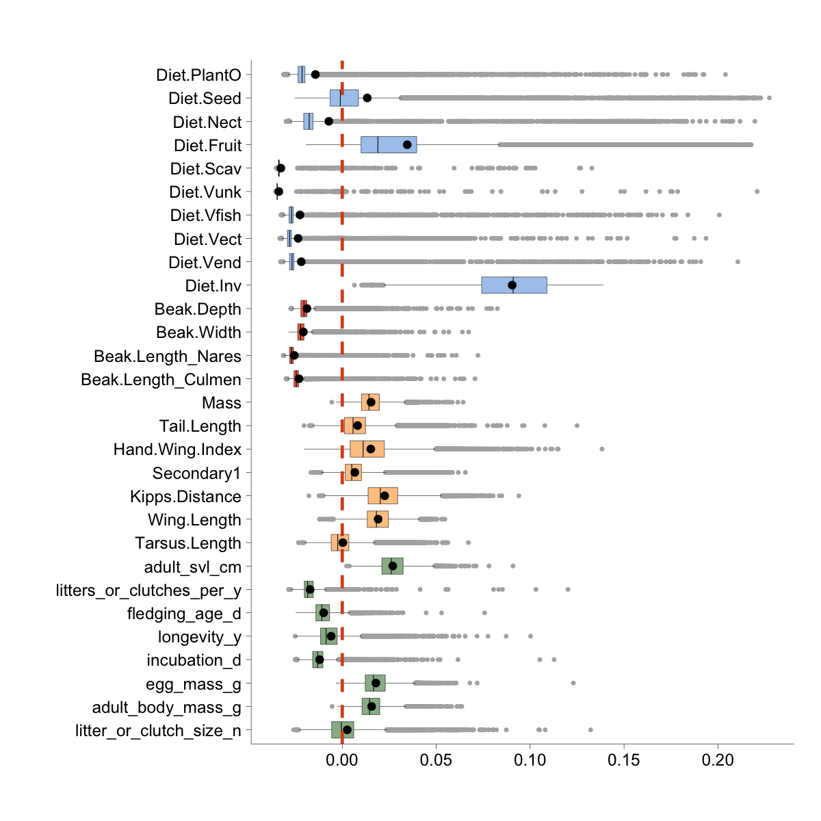
Fig. S8. Trait contribution to species functional distinctiveness. Each boxplot shows the distribution of changes in functional distinctiveness after removing a given trait from the combined trait space (i.e., LMD-trait space). Values represent the difference in distinctiveness between the combined trait space and a reduced trait space excluding the focal trait. Positive values indicate that the inclusion of the trait increases species distinctiveness—suggesting that the trait contributes unique ecological information to the trait space. Traits whose exclusion causes little or no change in distinctiveness are likely redundant with other traits. Colored boxes indicate trait categories: diet (blue), Locomotion (orange), and Reproduction (green). The red dashed line denotes zero change, highlighting traits with net positive or negative contributions to the representation of functional uniqueness in the trait space.

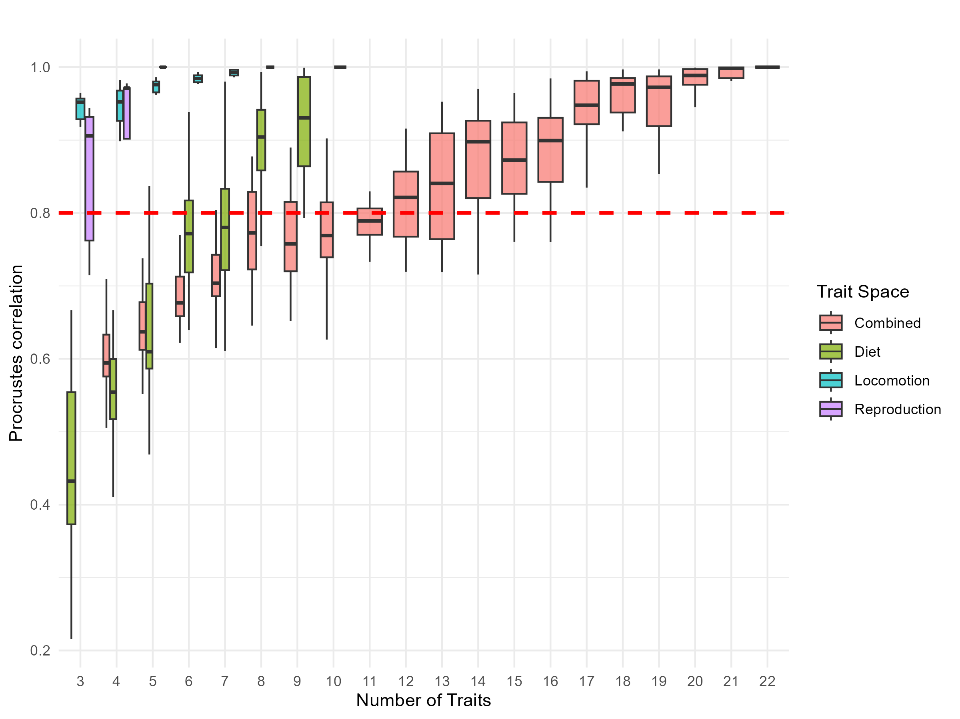
Fig. S9. Robustness of PCoA to the number of traits across four trait spaces. Boxplots show the distribution of Procrustes correlation coefficients (proc_stat) obtained by resampling different numbers of traits within each functional trait space: Locomotion (Locomotion), Reproduction (Reproduction), diet (Diet), and their combination (Combined). The dashed red line indicates a correlation threshold of 0.8, considered as high congruence. Higher values indicate that the reduced trait set captures the structure of the full space more reliably.

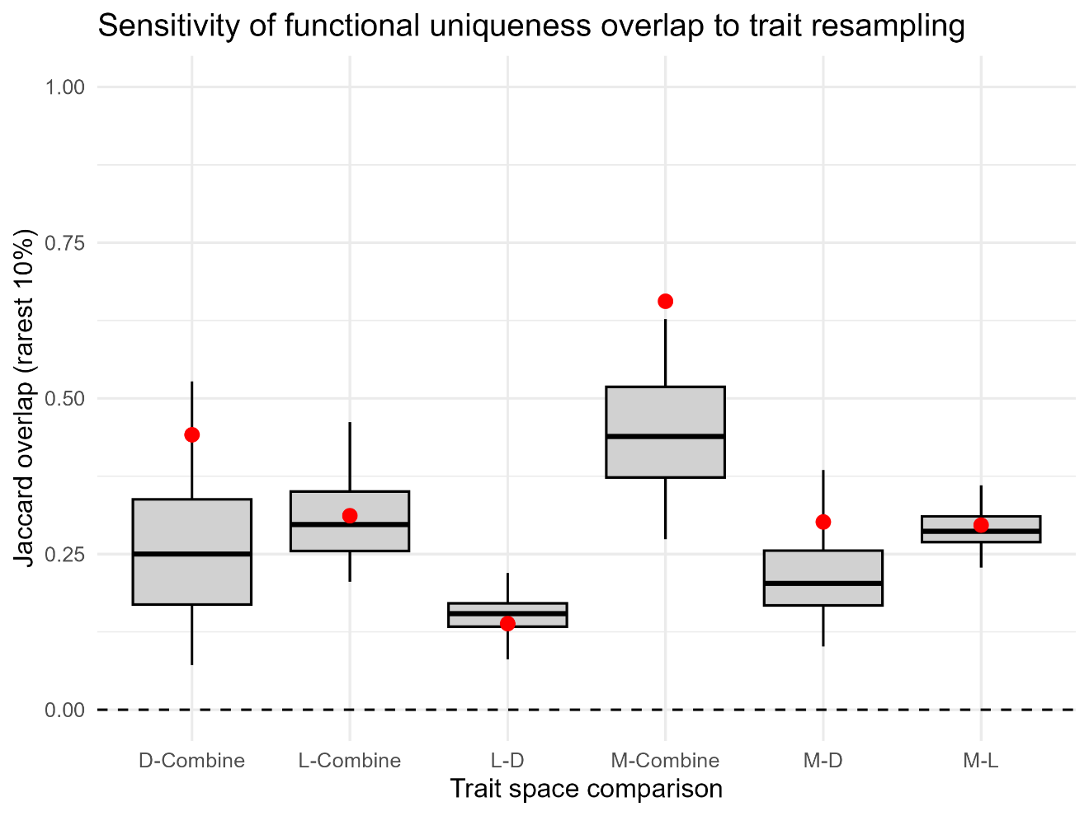
Fig. S10. Sensitivity of functional uniqueness overlap across trait spaces. For each pair of trait spaces (M = Locomotion/Locomotion; L = Life-history/Reproduction; D = Diet; Aggregated = MLD), boxplots show the distribution of Jaccard overlaps between the observed sets of the rarest 10% species obtained by resampling traits within each space. Red dots indicate the observed overlap using the full trait sets. The dashed line at 0 provides a visual reference. Overlaps substantially above the resampling distribution indicate that agreement between spaces is not simply driven by the number or identity of resampled traits but reflects consistent detection of functionally rare species across spaces.

Table S1. Names and completeness of bird traits by type
Trait Type | Original Name | Short Name | Data Completeness
Morphological (M) | Tarsus.Length | trl | 8413/8413 (100%)
Morphological (M) | Wing.Length | wl | 8413/8413 (100%)
Morphological (M) | Kipps.Distance | kd | 8413/8413 (100%)
Morphological (M) | Secondary1 | s1 | 8413/8413 (100%)
Morphological (M) | Hand-Wing.Index | hwl | 8413/8413 (100%)
Morphological (M) | Tail.Length | tll | 8413/8413 (100%)
Morphological (M) | Mass | bmA | 8413/8413 (100%)
Morphological (M) | adult_svl_cm | svl | 1359/8413 (16.15%)
Life-history (L) | litter_or_clutch_size_n | ls | 5506/8413 (65.45%)
Life-history (L) | egg_mass_g | em | 3887/8413 (46.2%)
Life-history (L) | incubation_d | inc | 1835/8413 (21.81%)
Life-history (L) | longevity_y | lg | 1331/8413 (15.82%)
Life-history (L) | fledging_age_d | fled | 1509/8413 (17.94%)
Life-history (L) | litters_or_clutches_per_y | ly | 1429/8413 (16.99%)
Diet (D) | Diet.Inv | DI | 8413/8413 (100%)
Diet (D) | Diet.Vend | DVd | 8413/8413 (100%)
Diet (D) | Diet.Vect | DVt | 8413/8413 (100%)
Diet (D) | Diet.Vfish | DVf | 8413/8413 (100%)
Diet (D) | Diet.Vunk | DVk | 8413/8413 (100%)
Diet (D) | Diet.Scav | DSv | 8413/8413 (100%)
Diet (D) | Diet.Fruit | DF | 8413/8413 (100%)
Diet (D) | Diet.Nect | DN | 8413/8413 (100%)
Diet (D) | Diet.Seed | DSd | 8413/8413 (100%)
Diet (D) | Diet.PlantO | DP | 8413/8413 (100%)
Beak-Diet (BD) | Beak.Length_Culmen | BeLC | 8413/8413 (100%)
Beak-Diet (BD) | Beak.Length_Nares | BeLN | 8413/8413 (100%)
Beak-Diet (BD) | Beak.Width | BeWi | 8413/8413 (100%)
Beak-Diet (BD) | Beak.Depth | BeDe | 8413/8413 (100%)

Table S2. Imputation variability across 100 independent missForest runs (NRMSE = SD of imputed values / range of observed values, log₁₀ scale).
K | trait | Mean | SD
0 | adult_svl_cm | 0.162 | 0.012
0 | fledging_age_d | 0.130 | 0.016
0 | incubation_d | 0.139 | 0.021
0 | litter_or_clutch_size_n | 0.199 | 0.015
0 | litters_or_clutches_per_y | 0.117 | 0.020
0 | longevity_y | 0.200 | 0.018
5 | adult_svl_cm | 0.104 | 0.010
5 | fledging_age_d | 0.076 | 0.009
5 | incubation_d | 0.079 | 0.011
5 | litter_or_clutch_size_n | 0.101 | 0.008
5 | litters_or_clutches_per_y | 0.103 | 0.016
5 | longevity_y | 0.166 | 0.011
10 | adult_svl_cm | 0.101 | 0.009
10 | fledging_age_d | 0.075 | 0.009
10 | incubation_d | 0.077 | 0.011
10 | litter_or_clutch_size_n | 0.104 | 0.009
10 | litters_or_clutches_per_y | 0.107 | 0.015
10 | longevity_y | 0.161 | 0.009
50 | adult_svl_cm | 0.102 | 0.010
50 | fledging_age_d | 0.076 | 0.007
50 | incubation_d | 0.076 | 0.010
50 | litter_or_clutch_size_n | 0.101 | 0.010
50 | litters_or_clutches_per_y | 0.108 | 0.018
50 | longevity_y | 0.159 | 0.013
100 | adult_svl_cm | 0.106 | 0.010
100 | fledging_age_d | 0.081 | 0.009
100 | incubation_d | 0.079 | 0.015
100 | litter_or_clutch_size_n | 0.103 | 0.010
100 | litters_or_clutches_per_y | 0.105 | 0.015
100 | longevity_y | 0.163 | 0.016
The NRMSE are expressed in percentage of the range of observed values. Mean, Median, and SD of NRMSE are presented. n_missing = number of species with missing values for each trait.

Table S3. Imputation variability across 100 independent missForest runs (NRMSE = SD of imputed values / range of observed values, log₁₀ scale).
Trait | Mean | SD | n_missing
adult_svl_cm | 0.980 | 0.271 | 5994
fledging_age_d | 0.479 | 0.290 | 5838
incubation_d | 0.424 | 0.259 | 5524
litter_or_clutch_size_n | 1.085 | 0.691 | 2093
litters_or_clutches_per_y | 0.697 | 0.272 | 5921
longevity_y | 1.181 | 0.306 | 6000
The NRMSE are expressed in percentage of the range of observed values. Mean, and SD of NRMSE are presented. n_missing = number of species with missing values for each trait.

Table S4. Principal component analysis (PCoA) of trait data for the different trait spaces.

 | Aggregated |  | Locomotion |  | Reproduction |  | Diet
 | PC1 | PC2 | PC1 | PC2 | PC1 | PC2 | PC1 | PC2
Variance | 41.788 | 18.047 | 76.231 | 17.7 | 41.616 | 18.863 | 64.278 | 21.325
Cumulative | 41.788 | 59.835 | 76.231 | 93.931 | 41.616 | 60.479 | 64.278 | 85.603
trl | 0.724 | -0.401 | 0.771 | 0.485
wl | 0.965 | -0.195 | 0.991 | -0.03
kd | 0.833 | -0.011 | 0.842 | -0.536
s1 | 0.881 | -0.275 | 0.914 | 0.347
hwl | 0.436 | 0.185 | 0.426 | -0.901
tll | 0.767 | -0.178 | 0.808 | 0.208
bmA | 0.955 | -0.182 | 0.962 | 0.155
svl | 0.958 | -0.198 | 0.975 | 0.14
ls | 0.014 | -0.008 |  |  | -0.032 | 0.997
em | 0.931 | -0.269 |  |  | 0.976 | 0.058
inc | 0.777 | -0.213 |  |  | 0.883 | -0.09
lg | 0.803 | 0.017 |  |  | 0.807 | -0.094
fled | 0.767 | -0.063 |  |  | 0.828 | -0.042
ly | -0.533 | 0.415 |  |  | -0.642 | -0.135
DI | -0.537 | -0.789 |  |  |  |  | -0.946 | -0.162
DVd | 0.342 | -0.087 |  |  |  |  | 0.092 | 0.129
DVt | 0.276 | -0.19 |  |  |  |  | -0.028 | 0.068
DVf | 0.334 | -0.143 |  |  |  |  | 0.018 | 0.116
DVk | 0.083 | -0.041 |  |  |  |  | 0.003 | 0.01
DSv | 0.227 | -0.055 |  |  |  |  | 0.052 | 0.06
DF | 0.235 | 0.588 |  |  |  |  | 0.667 | -0.697
DN | -0.189 | 0.419 |  |  |  |  | 0.213 | 0.154
DSd | 0.048 | 0.417 |  |  |  |  | 0.397 | 0.657
DP | 0.321 | 0.161 |  |  |  |  | 0.297 | 0.271
Acronyms of the traits are shown in the Table S1

Table S5. Procrustes tests between the three trait spaces and the aggregated trait space.

Type | Procrustes tests
Aggregated vs. locomotion | 0.783 **
Aggregated vs. reproduction | 0.731 **
Aggregated vs. diet | 0.762 **
Locomotion vs. reproduction | 0.755 **
Locomotion vs. diet | 0.370 **
Reproduction vs. diet | 0.366 **

Table S6. Jaccard dissimilarity index

References
1. D. J. Stekhoven, P. Buhlmann, MissForest--non-parametric missing value imputation for mixed-type data. Bioinformatics 28, 112–118 (2012).
2. C. P. Carmo, et al., Erosion of global functiol diversity across the tree of life. Sci. Adv. 7, eabf2675 (2021).
3. W. Jetz, G. H. Thomas, J. B. Joy, K. Hartmann, A. O. Mooers, The global diversity of birds in space and time. ture 491, 444–448 (2012).
4. D. Li, rtrees: an R package to assemble phylogenetic trees from megatrees. Ecography 2023, e06643 (2023).
5. C. Penone, et al., Imputation of missing data in life‐history trait datasets: which approach performs the best? Methods Ecol. Evol. 5, 961–970 (2014).
6. K. Stewart, et al., Functiol diversity metrics can perform well with highly incomplete data sets. Methods Ecol. Evol. 14, 2856–2872 (2023).
7. F. Sayol, B. R. Reijenga, J. A. Tobias, A. L. Pigot, Ecophysical constraints on avian adaptation and diversification. Current Biology 35, 1326-1336.e6 (2025).
8. J. A. Tobias, et al., AVONET: morphological, ecological and geographical data for all birds. Ecol. Lett. 25, 581–597 (2022).
9. J.-Y. Bargaud, et al., Ecological traits influence the phylogenetic structure of bird species co-occurrences worldwide. Ecol. Lett. 17, 811–20 (2014).
10. C. Violle, et al., Functiol Rarity: The Ecology of Outliers. Trends Ecol. Evol. 32, 356–367 (2017).
11. C. P. Carmo, F. Bello, N. W. H. Mason, J. Lepš, Trait probability density (TPD): measuring functiol diversity across scales based on TPD with R. Ecology 100, e02876 (2019).

