**MNIST Digits Classification with PyTorch**

**Introduction**

In this homework, I compare the MLP and CNN models with and without Batch Normalization.

**Hyperparameter Selection**

In theory, to select the right hyperparameters, a full exhaustive search that iterates through every combination should be done with a **validation dataset**. However, this is done mainly on an ad hoc basis, where the parameters work well enough in combination.

*Table1: Hyperparameters used for all models*

|  |  |
| --- | --- |
| Loss | CrossEntropy |
| Learning rate | 0.01 |
| Batch size | 100 |
| Weight decay | 0 |
| Momentum | 0.9 |
| Max epoch | 50 |

**Results Summary**

*Table2: Network details*

|  |  |  |  |  |
| --- | --- | --- | --- | --- |
| Models | CNN with BN | CNN without BN | MLP with BN | MLP without BN |
| Architecture | Conv-BN-ReLU-AvgPool-Conv-BN-ReLU-AvgPool-Reshape-Linear | Conv-ReLU-AvgPool-Conv-ReLU-AvgPool-Reshape-Linear | Linear-BN-ReLU-Linear-BN-ReLU-Linear | Linear-ReLU-Linear-ReLU-Linear |
| >98% test acc | 9 epochs | 10 epochs | 3 epochs | 5 epochs |
| Time per epoch | 15s | 13s | 13s | 13s |
| Time to reach  >98% test acc | ~130s | ~130s | ~40s | ~65s |
| Training loss | 10-2 | 10-2 | 10-3 | 10-3 |
| Test loss | 10-3 | 10-3 | 10-3 | 10-3 |
| Training acc | 98.50% | 98.87% | 100% | 100% |
| Test acc | 98.51% | 98.46% | 98.30% | 98.27% |

**Comments and Discussion**

Training time & Convergence:

CNN and MLP take about the same time per epoch. MLP converges (defined as >% test acc) quicker. Adding BatchNormalization layers does not affect run time appreciably.

No. of Parameters:

MLP has more parameters, CNN does parameter sharing and tying. BatchNormalization does not affect no. of parameters.

Accuracy:

CNN achieves slightly better acc. BatchNormalization does not affect this.

Overfitting:

Overfitting plagues MLP but not so much for CNN. BatchNormalization does not affect this.

Effects of BN:

The use of Batch Normalization is to be more **robust** to bad parameter initialization. Here, we don’t see much difference with or without BN. We would perhaps see the effects of BN if initialization is badly done.

**Plots**

The loss (training & test) and accuracy (training & test) of each setup are plotted.

CNN with BN loss CNN without BN loss

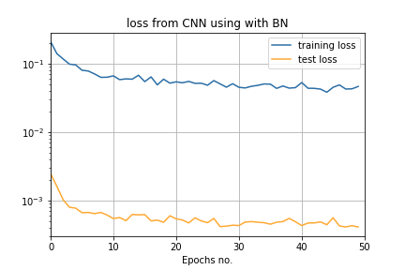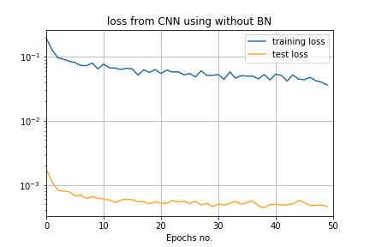

CNN with BN acc CNN without BN acc

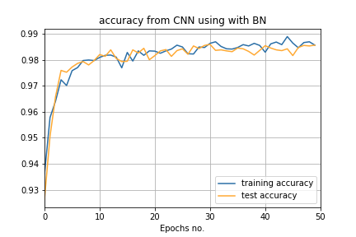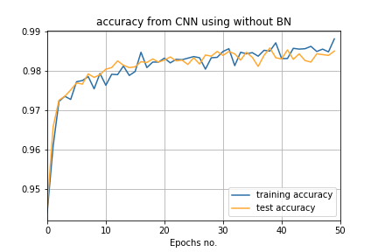

MLP with BN loss MLP without BN loss

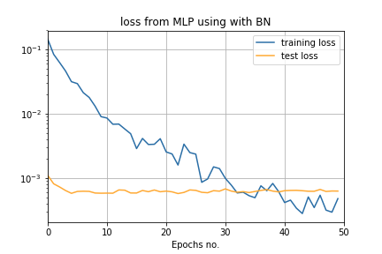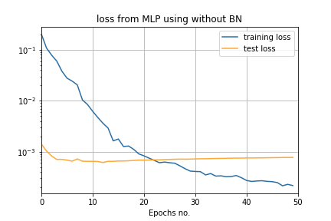

MLP with BN acc MLP without BN acc

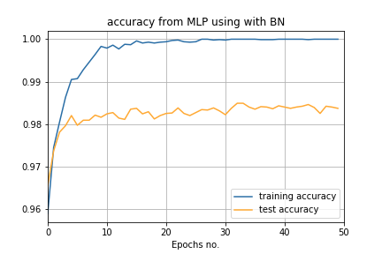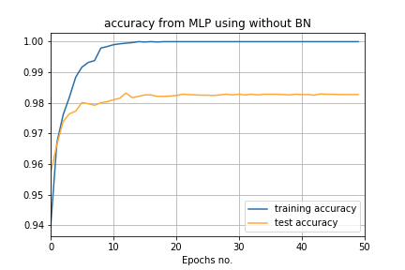

**Reference:**

* [Deep Learning](http://www.deeplearningbook.org/)

* [CS231n](http://cs231n.github.io/neural-networks-2/)

* [Ioffe, S., Szegedy, C. (2015). Batch Normalization: Accelerating Deep Network Training by Reducing Internal Covariate Shift] (https://arxiv.org/abs/1502.03167)