**Variational Auto-Encoders**

**Introduction**

In this homework, I use 2 VAEs to model a generative process on MNIST dataset.

**VAE_basic**

The basic model uses Bernoulli likelihood function.

Each training epoch takes an average of ~60s.

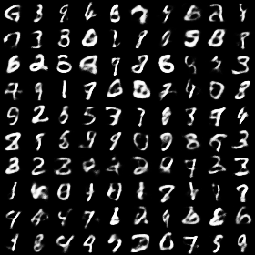

*Figure1: Output of VAE_basic after epoch10*

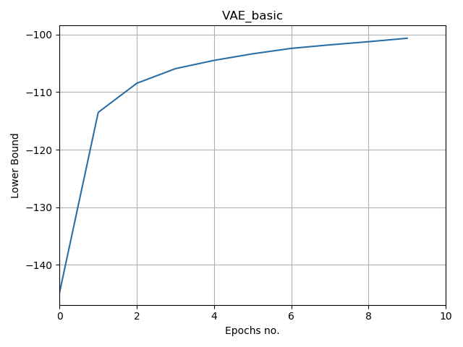

*Figure2: Lower bound of VAE_basic after epoch10*

**VAE_gaussian**

This model uses Gaussian likelihood function.

Each training epoch takes an average of ~75s.

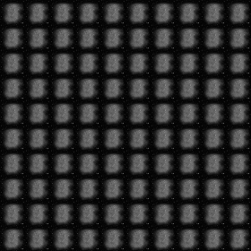

*Figure3: Output of VAE_gaussian after epoch10*

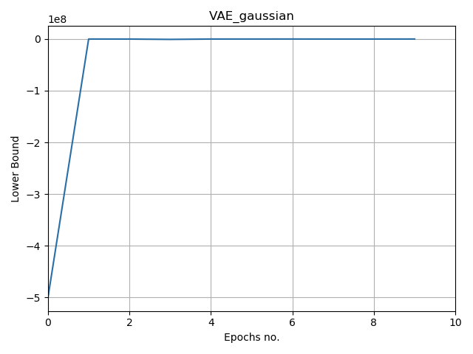

*Figure4: Lower bound of VAE_ gaussian after epoch10*

**Comments and Discussion**

For *VAE_gaussian*, the lower bound is in the order of -105 after 10 epochs. This is much larger than that of *VAE_basic*, which was in the order of -102. This means that *VAE_gaussian* is learning the correct distribution.

A possible reason is that *VAE_gaussian* takes longer to learn and we have not run enough epochs. Another possible reason is implementation error.