IC Engagement
How the Investment Committee's matters, meetings, votes, conditions, minutes and correspondence work inside CEF-PIP.
PREPARED FOR  Executive review | COVERS  /engagement and its sub-pages | SCREENS CAPTURED FROM  cef-pip-dev (staging) | LAST VERIFIED  7 September 2026

1. What it is
IC Engagement is the Investment Committee's single working home inside CEF-PIP — the one place every new investment, disbursement approval, portfolio problem, exit and policy decision gets raised, discussed, voted on and recorded, alongside the meeting it was decided in and the paperwork behind it.
Before this module, that trail lived across email threads, a shared SharePoint folder and someone's private notes. IC Engagement doesn't replace SharePoint as the document store — every document here is still a link into the fund's existing data room — but it gives the decision itself a permanent, auditable record: who raised it, who voted which way, whether quorum was met, what conditions followed, and what the locked minutes said.

2. Who can open it
Four roles land inside IC Engagement automatically: Management, Executive, IT Admin, and Board Committee Member.
Anyone else — an analyst supporting the committee, for instance — needs to be individually flagged for IC access without changing their day-to-day role. Board Committee Member is the one role built exclusively for this module: it has no access to the main Portfolio dashboard at all, so an external board member's account can't wander into operational data it has no business seeing.
Worth knowing: a Board Committee Member only ever sees documents CEF staff have promoted to Approved or Executed. Anything still in draft or under review is invisible to them — the platform enforces this on the server, not just by hiding a button.

3. The front door
Opening /engagement lands on a single triage screen: four headline numbers, then what needs attention today. Nothing here needs a click to reveal itself — it's a status check before you go anywhere else.
- Open / Under-Review Matters, Upcoming Meetings, Overdue Conditions, My Open Conditions — four counters, each one click from its own list.
- Matters needing attention and the two condition lists link straight into the record behind it.
- Five tiles — Matter Register, Meetings, Committee Roster, Secretariat, Email are the doors into everything covered below.
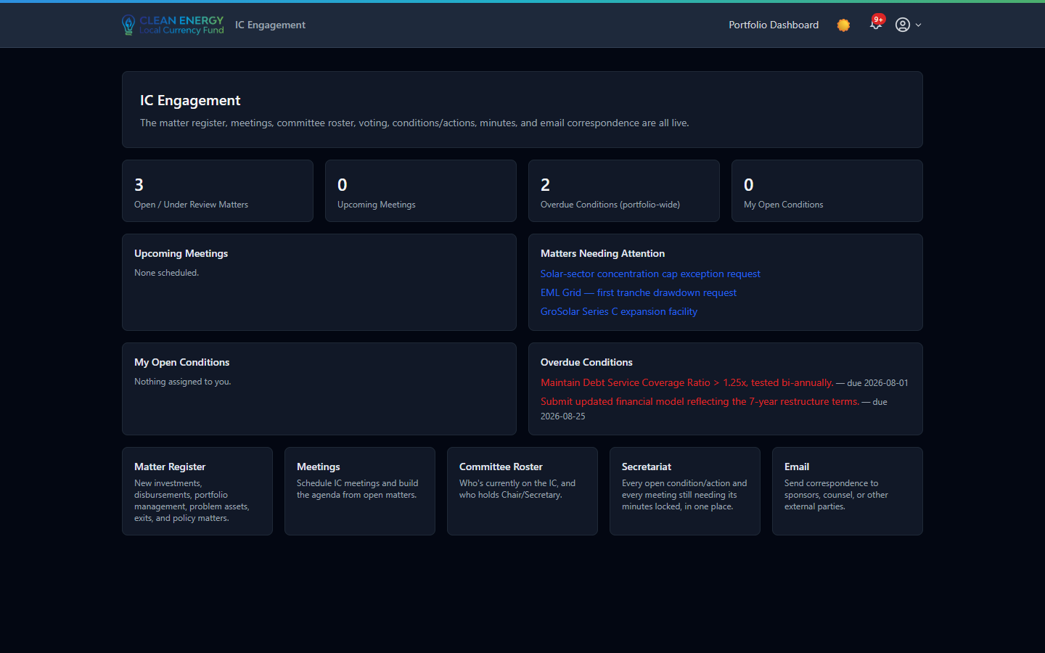
The landing dashboard — logged in as management@fundco.ng, dev environment.

4. Matter Register
/engagement/matters
Every matter the IC has ever touched, in one filterable list — new investments, disbursements, portfolio management, problem assets, exits and policy changes each get their own category. A colored status badge (Open, Under Review, Scheduled, Decided, Closed, Withdrawn) shows where each one stands at a glance, and New Matter opens an inline form to raise the next one — category, decision type, title, the AssetCo it concerns, and a description.
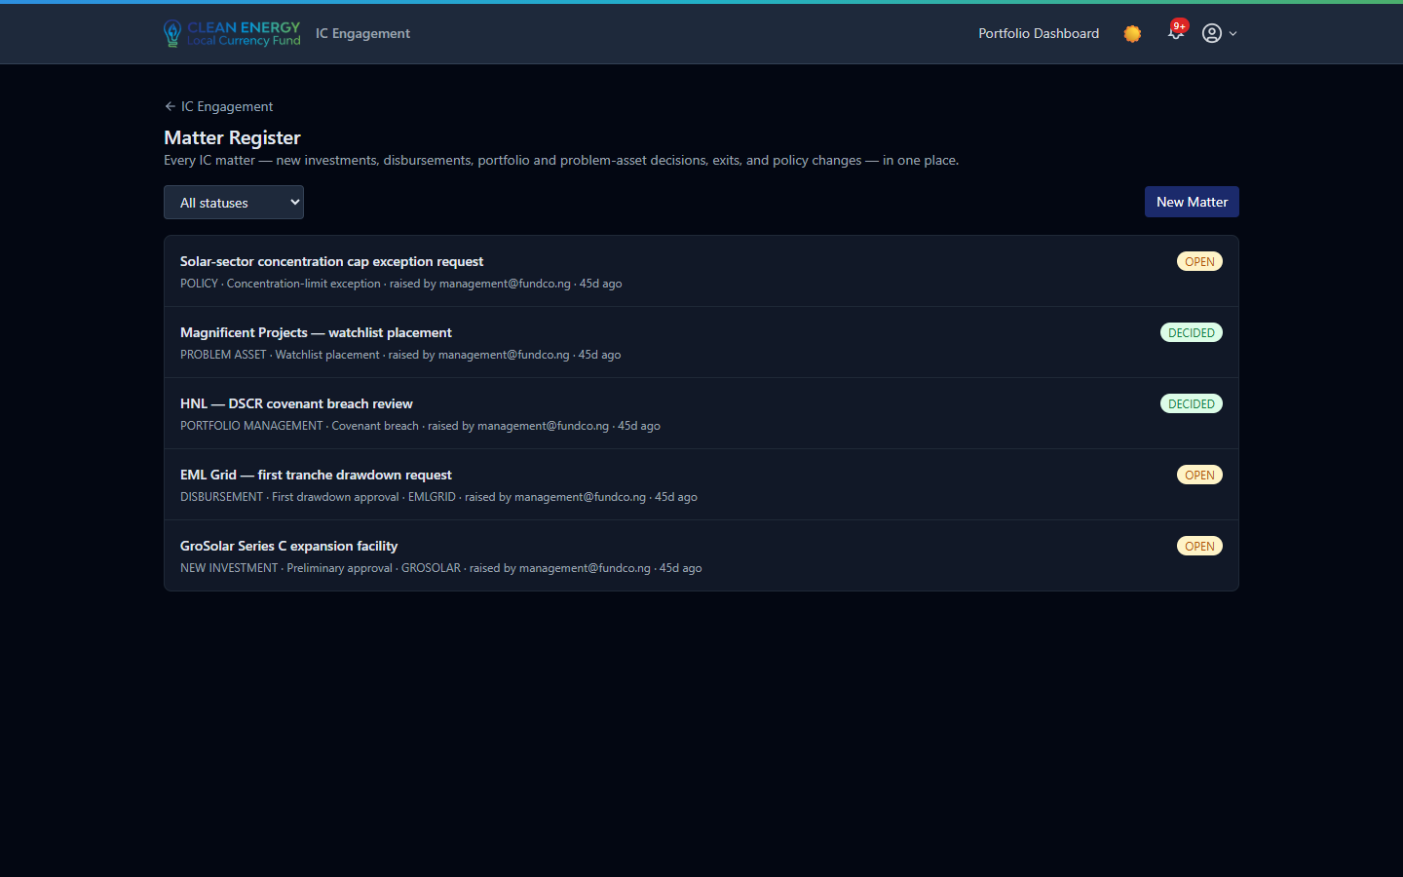
Five live matters in the dev environment — two already Decided, three still Open.

5. Inside a matter
Click through and everything about that one matter sits on a single page, stacked in the order the committee actually works through it:
- Status, Delegated Authority & Trustee No-Objection — the matter's own status plus two independent trackers recording where an external sign-off stands (Not Required → Pending → Granted / Received).
- Conditions & Actions — covenants, drawdown conditions and management actions that follow a decision, each with an owner, a due date and a status running from Open through to Satisfied, Waived or Breached.
- Documents — reference links into the fund's SharePoint data room (title, classification, URL — no files are ever uploaded into CEF-PIP itself), each carrying its own approval status and an “I've uploaded this and it's shared” confirmation, separate from just editing the record.
- Questions & Comments — a running pre-meeting thread; posting one notifies the matter's owner and deal lead directly, so debate can start before anyone's in the room.
- Compose Email — correspondence scoped to this matter, sent through the fund's own domain.
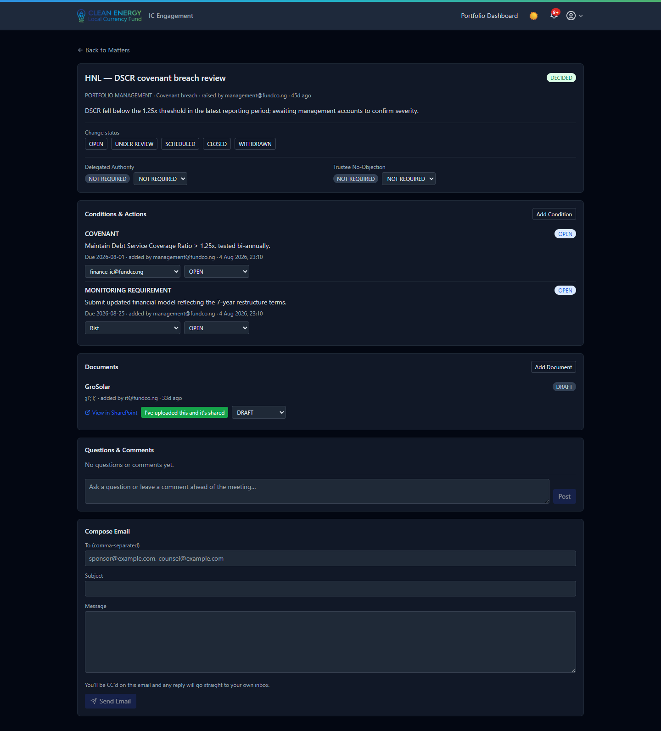
A Decided matter carrying two open conditions and one document awaiting further review.

6. Meetings, votes & minutes
/engagement/meetings
Scheduling a meeting pre-fills the recurring Teams link and lets any open matter be added to the agenda. Expanding an agenda item reveals the vote itself: live tally, quorum, and — once recorded — the outcome.
- Quorum is computed live from the active roster (a majority, minus anyone recused) and shown before a vote is even cast.
- Members vote Approve / Reject / Abstain, or declare a conflict — which recuses them immediately and withdraws any vote they'd already cast.
- The Chair, Secretary, or a management-level user records the final decision (Approved, Approved with Conditions, Deferred, Declined, Noted, and seven other outcomes) — once recorded, it's final, and the matter's own status updates automatically.
- Minutes live at the foot of every meeting: drafted, sent for review, then locked — a one-way action with no unlock, anywhere.
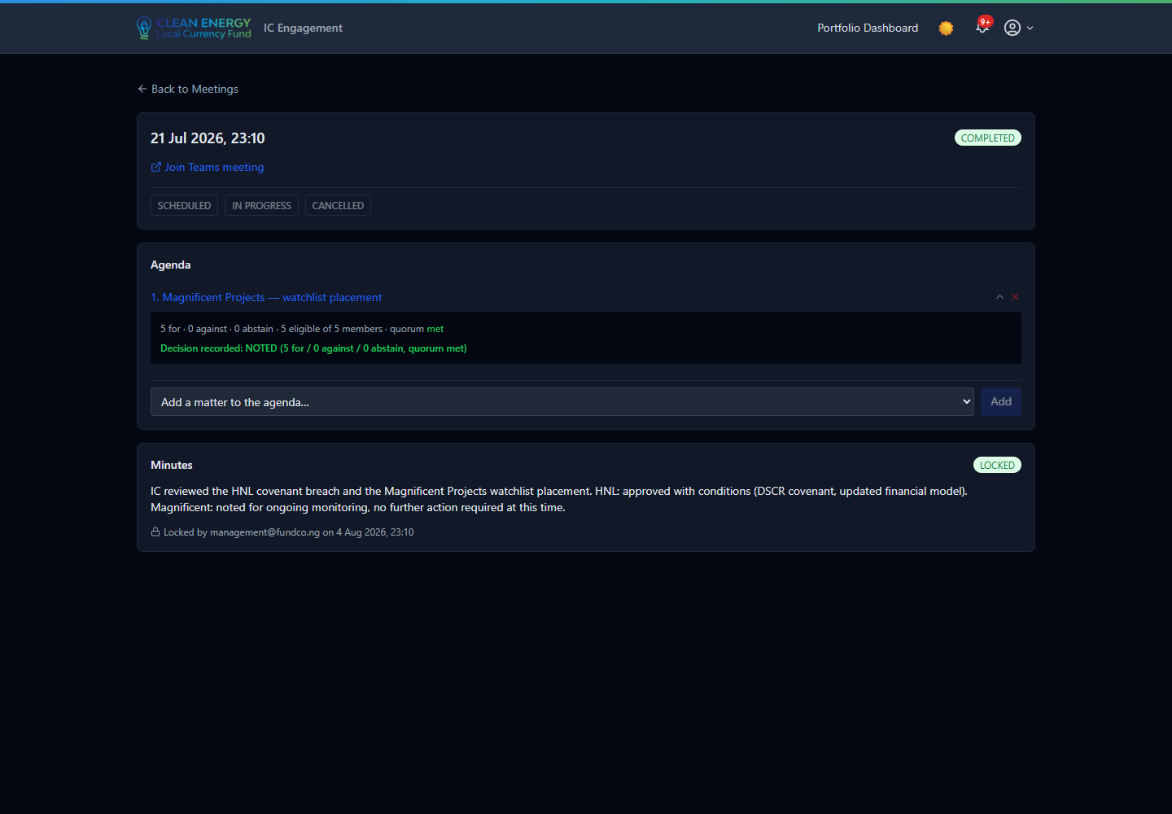
A completed meeting: 5 for / 0 against, quorum met, decision recorded as Noted — and minutes already locked.

7. Committee Roster
/engagement/committee
Who currently sits on the IC, who chairs it, and who acts as secretary. Membership isn't fixed by a contract term in the system — management, executive, IT admin, or the sitting secretary can add, remove, or re-flag Chair/Secretary at any time.
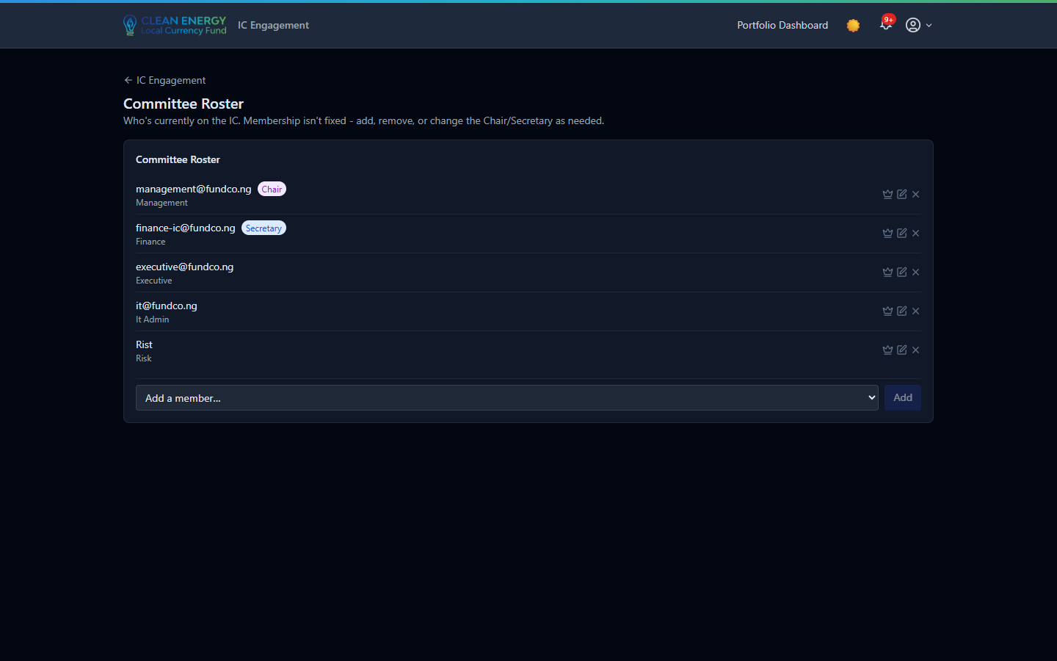
A five-person roster with Chair and Secretary flagged.

8. Secretariat view
/engagement/secretariat
Built for whoever runs meeting logistics day to day: an amber banner surfaces any completed meeting still waiting on locked minutes, every open condition across the entire register (not just one person's), and a side-by-side view of every meeting's status against its minutes' status — so a finished meeting with still-draft minutes doesn't quietly slip through.
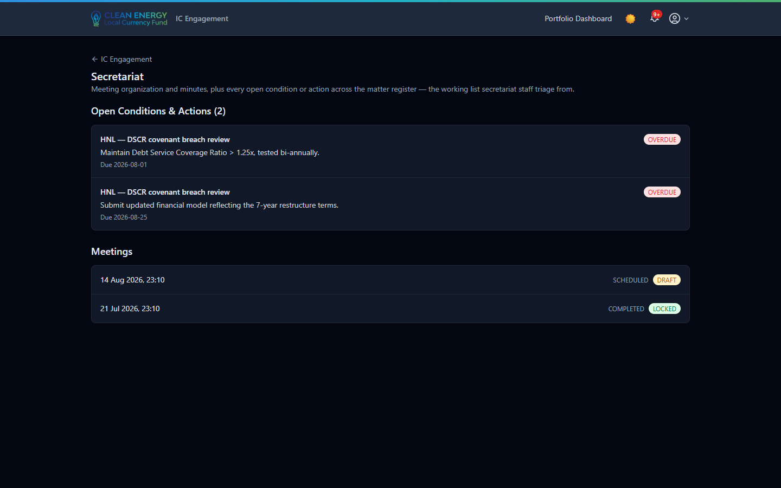
Two overdue conditions flagged in red; the upcoming meeting's minutes still show Draft.

9. Governance safeguards
The features above exist to run meetings; these are the rules underneath them that make the record defensible — each one enforced by the server, not just hidden in the interface.
Document approval gate  Board members see only Approved/Executed documents — draft material isn't just hidden, it 404s if requested directly. | Conflict = automatic recusal  Declaring a conflict withdraws any vote already cast and blocks that member from voting again on the same matter.
One decision per matter  Recording a decision is final for that matter/meeting pair — the matter's status flips to Decided or Withdrawn automatically. | Minutes lock one way  There's no unlock action anywhere in the system — once locked, the edit controls are removed from the page entirely.
Reply-to follows the sender  Every email sent through the portal auto-CCs the sender and sets them as reply-to, so replies never land in a shared inbox. | Role confinement, both ways  Board members are boxed into /engagement only; everyone else keeps their normal Portfolio dashboard access alongside it.

Separately, /dashboard/approvals is a CEF Series change-approval workflow for Finance/Risk submissions — a related audit-trail feature, but not part of IC Engagement and not covered here.

IC Engagement — CEF-PIP · Screens captured live from the dev/staging environment, 7 September 2026

