Name: Hanna Kibret

Id: Atr/9509/10

Section: 2

Practical 2:

These are the screenshots of the steps I followed to write the head.h file and the test.c files respectively.







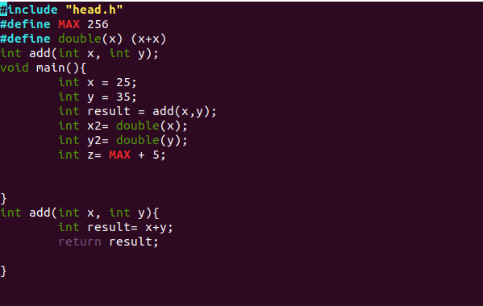

Exercise 1: The pre-processor replaces the header files like the stdio.h and head.h with their contents in the test.i file the head.h file for example includes extern int x = 25; statement and this statement is now included in our test.i file as shown below. The pre-processor also removes comments if there are any.

To get the pre-processed file we run the following command in the terminal:



The type of file generated is a file with .i extension and it looks something like this:

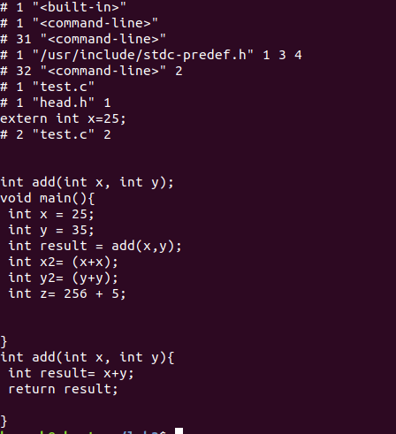

Exercise 2: The compiler compiler converts the file with the .i extenson into assembly code. It produces a file with .s extension. The output of the compiler displays a warning message as shown in the figure below:

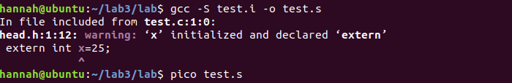

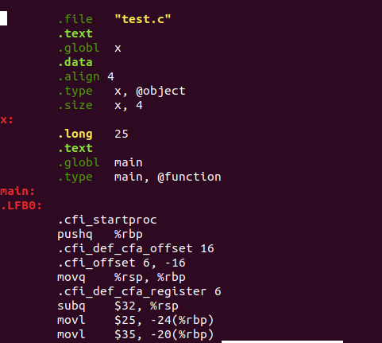

Exercise 3: The assembler converts the file it received from the compiler to an object code which is a code the machine can understand using this command:



The generated file is a file with .o extension which is written in object code the machine can understand and this will be linked in the next step.

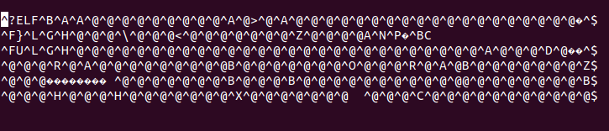

Exercise 4: The linker links code for functions like printf() from wherever they are defined in to our final executable file, which is using that function. In other words it searches for machine language definition of functions and fetches it from the standard C library. The output of this is an executable file.



The final folder content looks like this:



Practical 3:

These are the screenshots of the steps I followed to write the head.h, main.c and swap.c files.







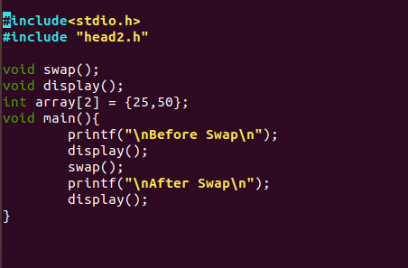



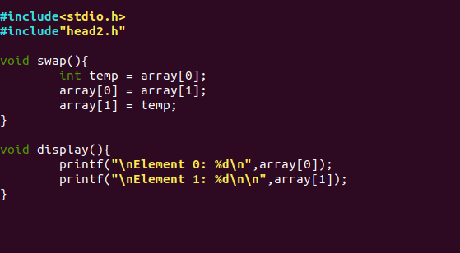

1. I wasn’t able to run the program because the main.c file refers to methods swap() and display() and these methods are not defined in the main.c file so the main file has no way of knowing about these methods and what they do. The swap.c file doesn’t have a main method which is an entry point of all c programs so the gcc compiler displays the “undefined reference to main” error, in the swap method we referred to an array which we haven’t initialized in the swap.c file so the compiler displays the ’”undefined reference to array” error as sown in the figure below.

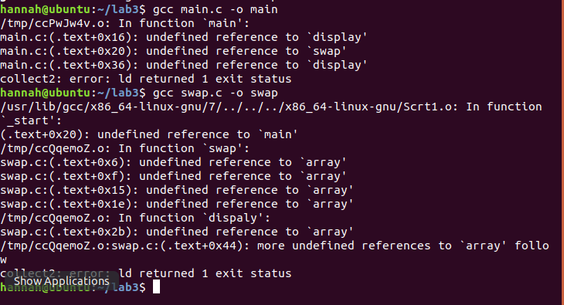

1. I think the problem occurred in the linker phase because the definition of the swap and display methods found in the swap.c file wasn’t linked to the main.c file.
2. There weren’t any problems.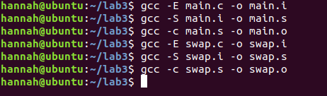
3. Yes, the problem was resolved and the program is running correctly.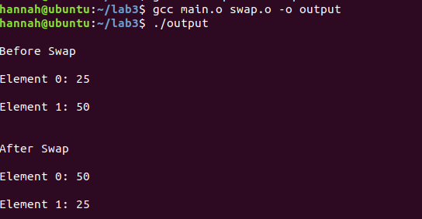

Exercises: Writing different C programs.

Exercise 1:



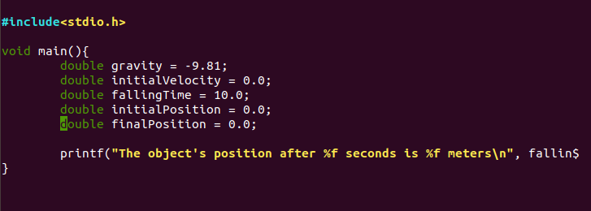

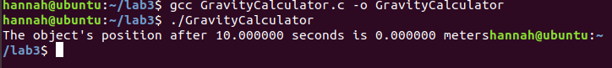

Exercise 2:

After modifying the final position according to the equation provided the output looks like this:

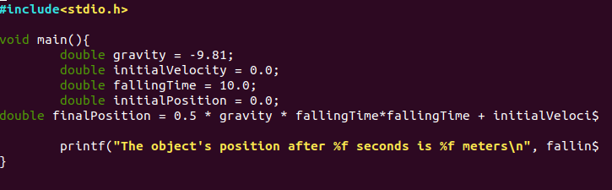



Exercise 3: The output is shows as the figure below:

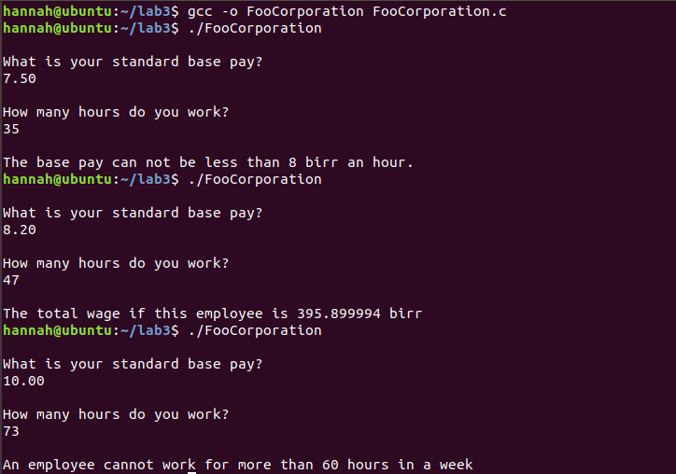

This output was achieved by following these commands and writing the following code.



