Product Design
Team : SSAD15
Project: Location Based Advertisement
Team Members:Aakash,Kritika,Arushi

Design Model
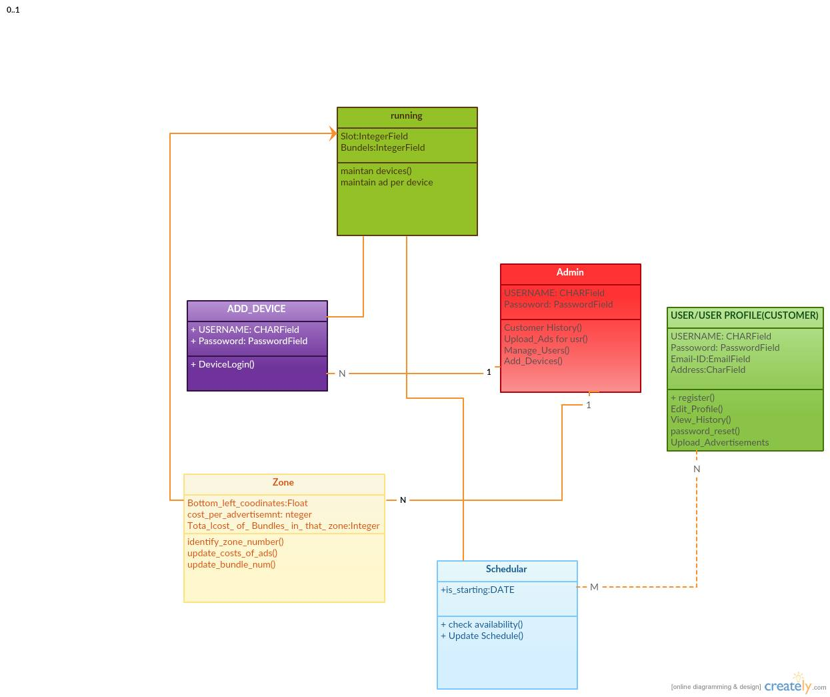

Zone | - It maintains all the information about a zone , that includes :  Bottom left coordinates of the zone,  Cost per Advertisement per bundle per slot in that zone,  Total number of bundles in that zone  - Methods Include :  - Identify the zone number corresponding  - Update the cost per advertisement per bundle per slot for a particular zone  - Update the total number of bundles in a zone
Scheduler | - Stores the advertisement scheduled for a given week,given zone starting in given slot number and repeating a fixed number of times.  - Methods Includes :  - Check availability of the request (bundle,slot in a zone) by a user  - Update the schedule bookings for upcoming weeks
Current_Running | - Stores all the data required for the current week for running of advertisements.  - Methods includes :  - Maintain the number of devices allocated in zone per slot  - Maintains the number of devices allocated to a single advertisement per slot per zone.  - Decide the next advertisement to be displayed per zone per slot.
User | - Stores all the information about a particular user.  - Methods include :  - Edit Profile  - View History  - Upload Advertisement  - Password reset
Admin | - Stores the profile of the admin  - Methods include :  - View combined history of all users  - Upload advertisement on users behalf  - Manage Users  - Add devices
Device | - Has the information about a logged in device .  - Methods include :  - Get Advertisement
.

Sequence Diagram(s)

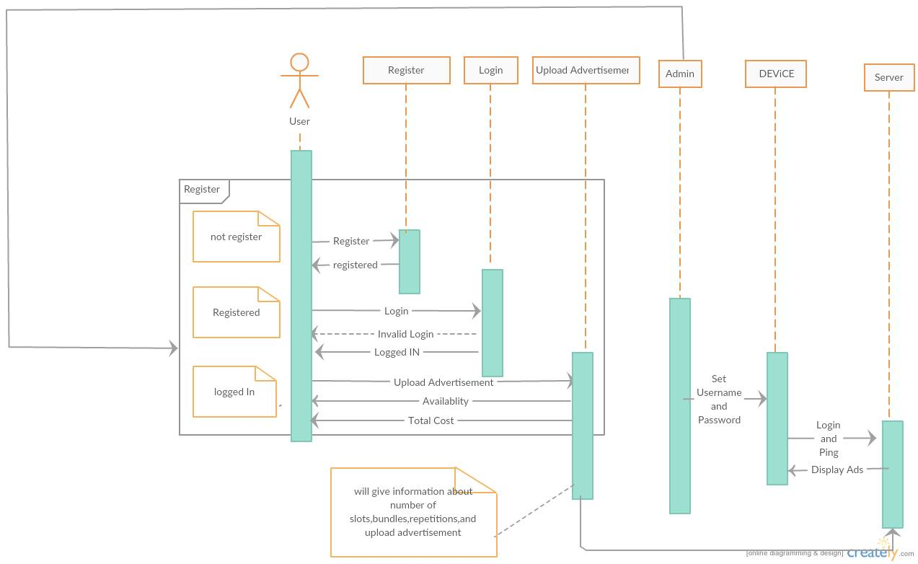

Design Rationale
First after Registering User will be automatically logged-in but due to security issues we removed that design and is asked for logged in.
Changed The Design of SIGN-UP for User-Convinience.

