Software Requirements Specification (SRS) Doc

Location Based Advertising

Team no. 24:

Kritika Agrawal, Aakash Mittal , Arushi Singhal

Brief problem statement

We have to create a platform on which users can advertise their product based on location. User will buy slots based on time and location for his advertisement and upload advertisement . On server side , a sequence of advertisements will be created for display at a particular time , location and bundle of devices. Device will ping its location to the server and corresponding advertisements will be displayed. The advertisements will be beamed on the screens with GPS module attached (For e.g. Android TV, Tab), fitted inside the vehicles (for e.g. RTC buses).

System requirements

OSM API

MVC framework (Django)

Users profile

Administrator: Well acquainted with the use of computer.

Local business owner: Not expected to know much about computers. Should atleast know how to open a website.

Feature requirements (described using use cases)

No. | User Case Name | Description | Release
1. | Division of region | Overall area where advertisements can be displayed will | R1
 | into zones | be divided into square zones and user will be identified on
 |  | the basis of the zone he is located in.
2. | Updating | Number of bundles,slots available,price etc. will be | R2
 | information about | updated by the administrator.
 | each zone
3. | Selecting a zone | User will select the business point. The required zones | R1
3. |  | that map with the target area will be selected
 |  | automatically.
4. | Selection of | User will select Number of bundles he wants to advertise | R2
 | bundles | his product on.
5. | Selection of slots | User will select number of slots he wants for his | R1
 |  | advertisement . One slot will be of 30 s. If his
 |  | advertisement is of 45s (for eg.) then he has to buy two
 |  | slots.
6. | Selection of | User will select the time period ,in terms of number of | R2
 | number of weeks | weeks , for which he wants to advertise. Week will be on
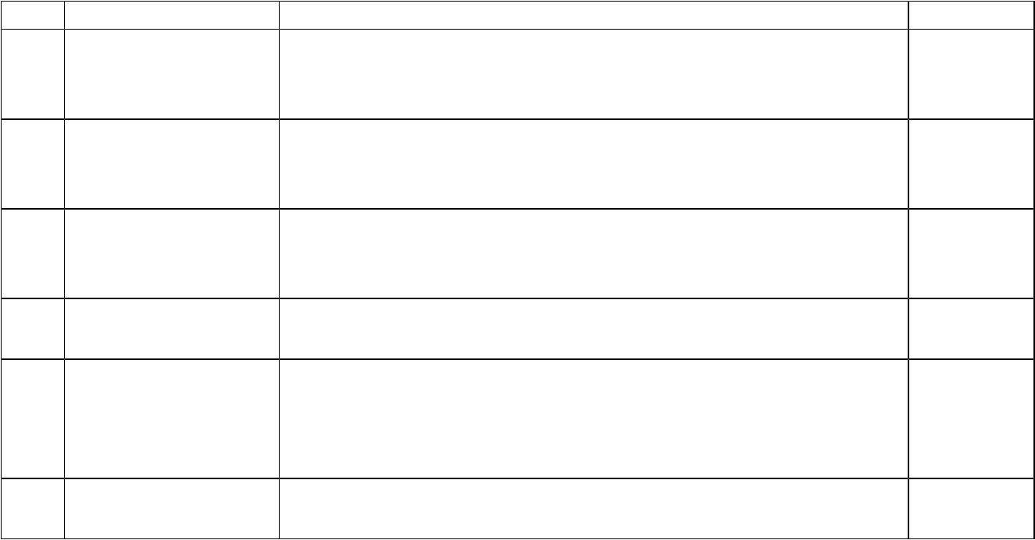
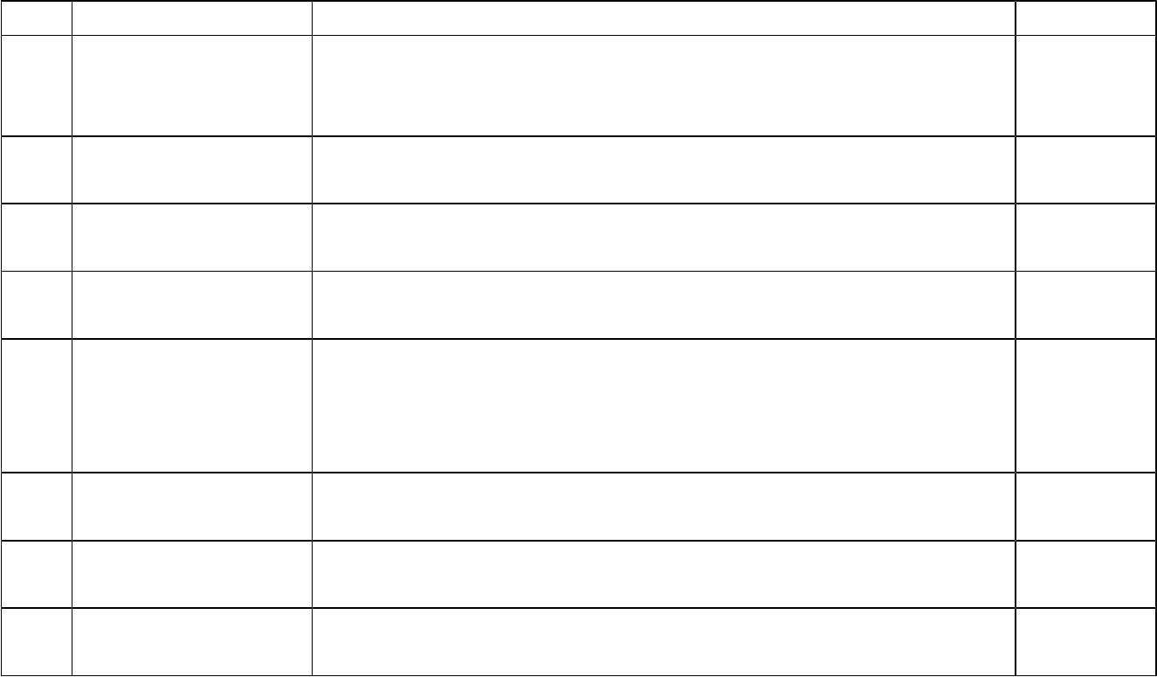 |  | Monday-sunday basis.
7. | Check | Checking if the number of slots,bundles and time period | R2
 | Availability and | for which user is demanding is available or not for the
 | Confirm | selected zone.
8. | Calculate Cost & | Calculating amount he has to pay for his selection, | R2
 | confirmation | confirm and update record.
9. | Upload | User will upload his advertisement He will also enter the | R1
 | Advertisement | exact duration of his advertisement.
10. | Login | Anyone using the web application has to login .System | R1
 |  | will check if the user is administrator or user.
11. | Login to display | Device first needs to login at the time of initialization of | R1
 |  | device (one time step) .
 |  | Latter the advertisements will be displayed on the device
 |  | based on its pinged location.
12. | Display | Advertisements corresponding to the location of the | R1
 | Advertisements | device which has pinged and time , will start playing.
13. | User History | When user is logged in , he can check his previous | R2
 |  | activities.
14. | Managing Users | Administrator can regulate users .He will have the power | R2
 |  | to add or delete them or any content uploaded by them.

Use case diagram
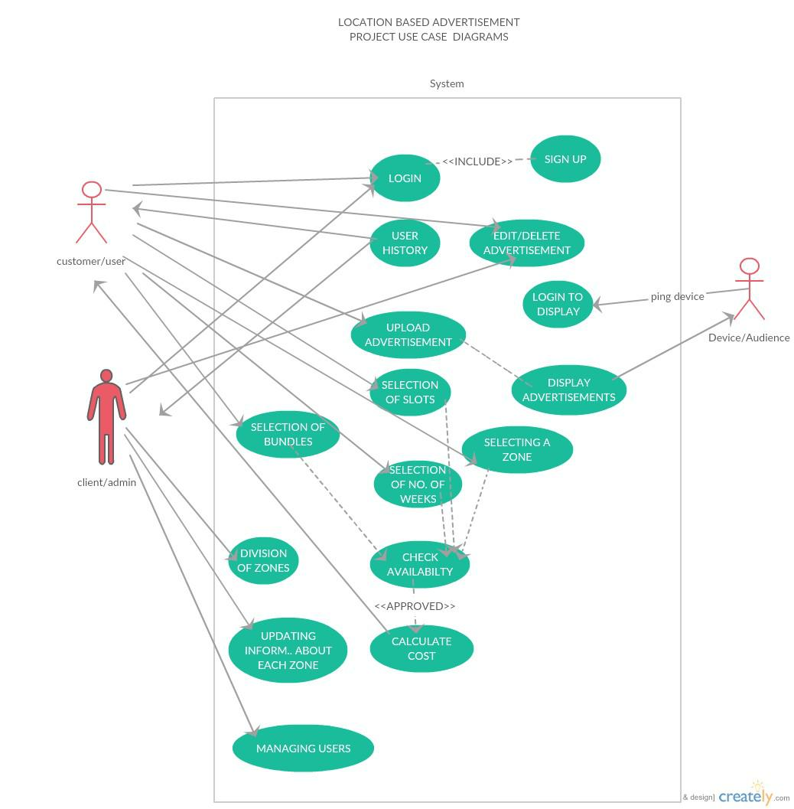
DETAILED USE CASES

- Division of Zones

Use case number: | 1
Use case name: | Division of zones
Overview: | Overall area where advertisements will be done have to be divided
 | into square zones . The areas where the users advertisement will
 | be displayed will be decided based on the zones that map with the
 | target zone - square centered at the users business point and
 | having side length 5km . Each zone have to demarcated and
 | assigned a number.
Type: | Primary
Actors: | It is for one -time use for the initialization of the product.
Preconditions : | Database structure have been decided.
Main flow : | I. Demarcation of the rectangular area that contains all the
 | possible area where the we will have to ever advertise.
 | II. Gets its endpoints (their longitude and latitude) .
 | III. Divide the above rectangle into squares each of side
 | 1Km ,assign each square a number and store its end
 | points corresponding to it in a database.
Post-condition: | The zones have been initialized .
Cross-reference: | None

- Update Information about each zone

Use case number: | 2
Use case name: | Update information about each zone
Overview: | Give the administrator to update/change the number of
 | bundles,price per zone . It enables the admin to exercise more
 | control and increase his business profit .
Type: | Secondary
Actors: | Administrator
Preconditions : | • Division of zones

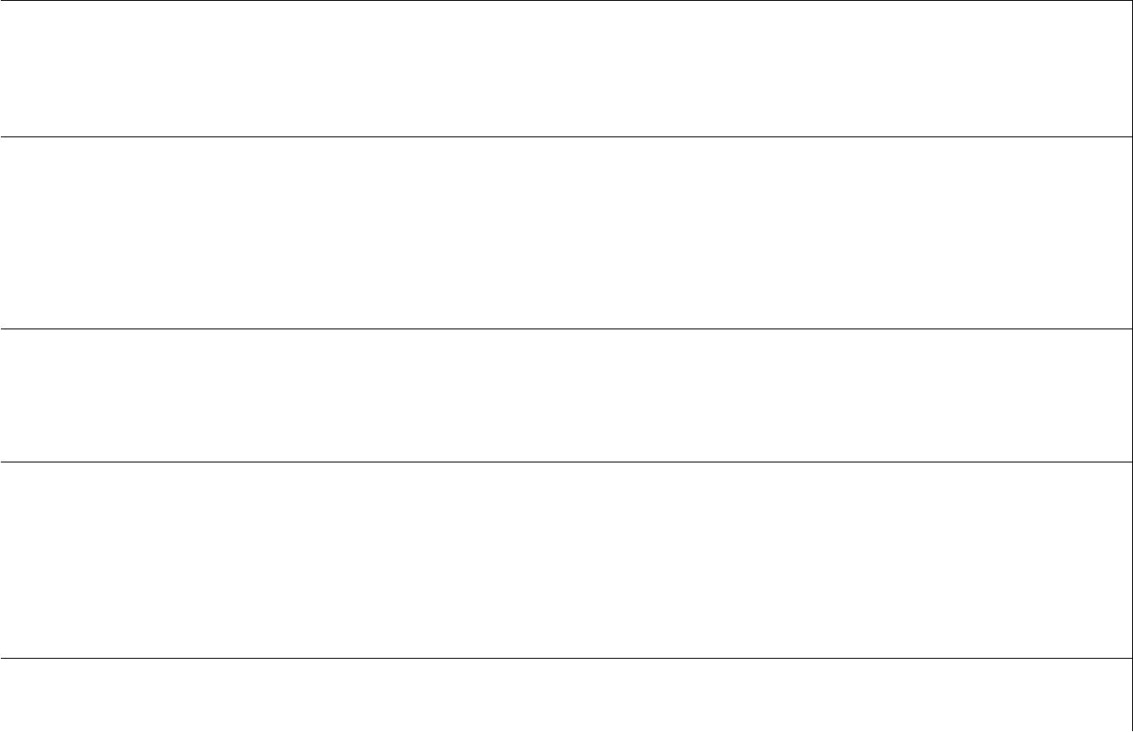
- The administrator have been authorized .

Main flow : I. The administrator the chooses the zone .

II. He is the asked for the updated values.

III. The changes are made in the database.

Alternate Flow : 3) If unable to make changes to the database , display error

and the values remain as the original one .

Post-condition: • The values have been updated.

- The new values will be used for calculation of

prices,booking of bundles from the week after the changes have been made.

Cross-reference: Division of zones

● Selecting a zone

Use case number: | 3
Use case name: | Selecting a zone
Overview: | User will select its business point . The zone that overlap with
 | target area will be selected automatically.
Type: | Essential
Actors: | user
Precondition: | Login and uploaded advertisement
Main flow : | 1.user select the business point and the required zones are
 | selected automatically ,
 | 2. According the zone cost will be decided.
 | 3.Followed by selection of slots and bundles.
Post-condition: | true
Cross-reference: | Validate login

- Selecting bundles

Use case number: | 4
Use case name: | Selecting bundles
Overview: | User will select Number of bundles he wants to advertise
 | his product on.
Type: | Essential
Actors: | User
Precondition: | Login and upload advertisement.
Main flow : | 1.user select the number of bundles
 | 2.number of bundles for each zone is pre-decided.
 | 3. cost may vary for bundles in different zone
Alternate flow: | If that much bundle is not available then customer has to reduce
 | number of bundles.
Alternate flow: | Total cost also depends on the number of bundles.
Post-condition: | true
Cross-reference: | Validate login

- Selecting a slot

Use case number: | 5
Use case name: | Selecting a slot
Overview: | User will select number of slots he wants for his
 | advertisement . One slot will be of 30 s. If his
 | advertisement is of 45s (for eg.) then he has to buy two

 | slots
Type: | Essential
Actors: | user
Precondition: | Login and upload advertisement
Main flow : | 1.user select the number of slots.
 | 2. according to the number of slots final cost will be decided.
Alternate flow: | If that much slot is not available then customer has to reduce the
 | number of slots.
Alternate flow: | Timing for each slot is fix so if customer advertisement increase
 | the time of one slot then he has buy two or more slots
 | depending upon the time of each slot and advertisement time.
Alternate flow: | The customer can't increase or decrease the number of slots
 | after submitting the advertisement for display.
Post-condition: | true
Cross-reference: | Validate login

- Selecting of number of weeks

Use case number: | 6
Use case name: | Selecting of number of weeks
Overview: | User will select the time period ,in terms of number of
 | weeks , for which he wants to advertise. Week will be on
 | Monday to Sunday basis.
Type: | Essential
Actors: | user
Precondition: | Login and upload advertisement
Main flow : | 1.user will select the number of weeks

 | 2. according to the number of weeks cost will be decided.
Alternate flow: | 1.Each week starts on Monday and will end on Sunday.
Alternate flow: | User can't edit number of weeks after submission and same
 | advertisement will be shown for that number of weeks
Post-condition: | true
Cross-reference: | Validate login

- Check Availability

Use case number: | 7
Use case name: | Check availability
Overview: | When the user tries to book slots with a given number of bundles
 | and for a given week , check if the same are available for each
 | zone that lies into the target zone .
Type: | Secondary
Actors: | User
Preconditions : | • | Division of zones
 | • | Update information about each zone
 | • | Selection of bundle
 | • | Selection of slot
 | • | Selection of week
 | • | Selection of zone
Main flow : | I. | For each zone in the selected zone calculate the number
 |  | of bundle(may be decimal) that will be alloted to the user
 |  | for this zone .
 | II. | Check availability.
 | III. If the required parameters are available go ahead and ask
 |  | for confirmation and then book .
Alternate Flow : | 3) If for some zone the required parameters are not available ,
 | calculate the available parameters for the rest of the zones and


show the user the actual parameters he could be given against the required one and bill the user accordingly.

Post-condition: | • Ask for confirmation and then go ahead with booking .
Cross-reference: | Calculation of cost and booking .

- Calculate Cost and confirmation

Use case number: | 8
Use case name | Calculate Cost and confirmation
Overview: | Based on the zones selected and those available of them
 | calculate the cost the user will be billed of,ask for confirmation and
 | update record.
Type: | Secondary
Actors: | End User
Preconditions : | • Check availability
Main flow : | I. Based on the chosen and those available of them
 | calculate the cost the user will be billed of .
 | II. Ask for confirmation .
 | III. Redirect him to the payment portal and wait for
 | confirmation.
 | IV. Once confirmed update the database .
Alternate Flow : | 3) If the payment turns unsuccessful redirect him back to
 | booking page .
Post-condition: | • The slot with set number of bundles and time-period have
 | been booked .
Cross-reference: | Check Availability , Databases

- Upload advertisements

Use case number: | 9
Use case name: | Upload advertisements

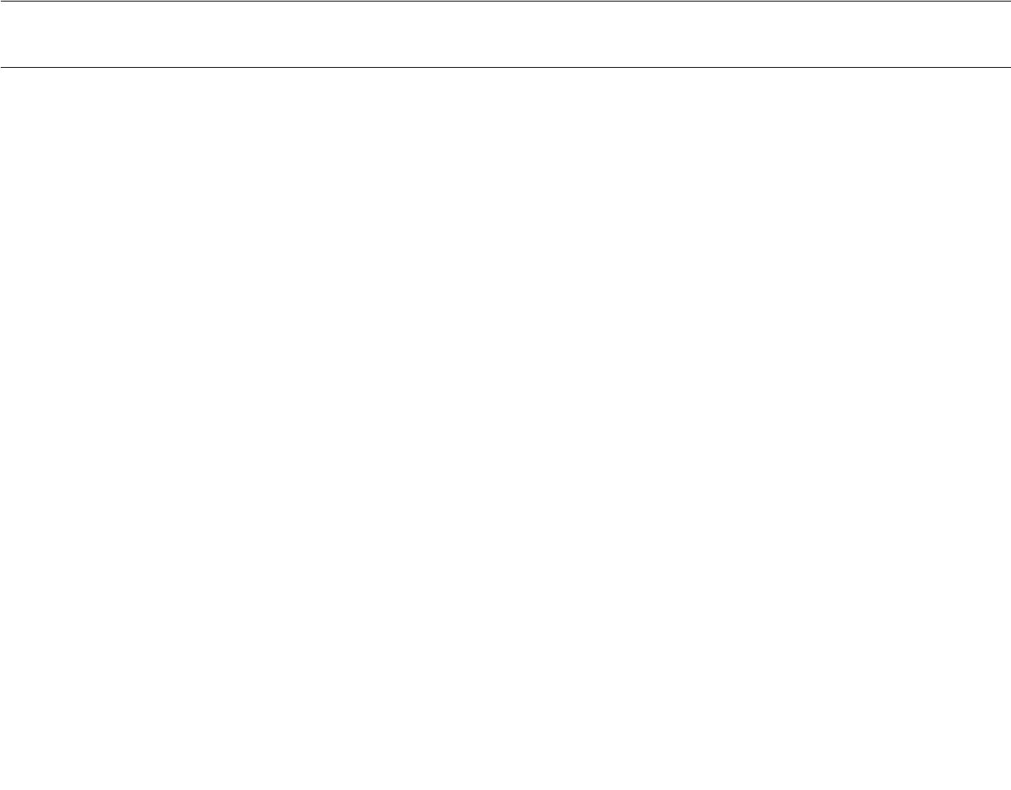
Overview: • User will upload his advertisement

 | • He will also | enter | the exact | duration | of | his
 | advertisement.
Type: | Essential
Actors: | user
Precondition: | User has logged in
Main flow : | User will upload the advertisement along with the time |  |  |  | of the
 | advertisement.
Alternate flow: | If the time of the advertisement exceeds the time decided for one
 | slot then either user has to increase the number of slots as the
 | Time for each slot is | fix | or else the | advertisement |  | will
 | automatically cut.
Post-condition: | true
Cross-reference: | Validate login

• login

Use case number: | 10
Use case name: | login
Overview: | Anyone using the web application has to login. System will check
 | if the user is administrator or user.
Type: | Essential
Actors: | User/administrator
Precondition: | Sign up
Main flow : | 1. user will login with email-id and password'
 | 2. system will check if that id already exist and if not then it will
 | ask for correct id and password.

 | 3. system will detect if it's a user or admin and accordingly
 | power will be given.
Alternate flow: | If the login is not validate then the message will be prompt.
Alternate flow: | If that id is not found then the user will be asked to to do sign up
 | first.
Post-condition: | true
Cross-reference: | Validate login

- Login to display

Use case number: | 11
Use case name: | Login to display
Overview: | Device first needs to login at the time of initialization of device
 | (one time step) .
 | Latter the advertisements will be displayed on the device based
 | on its pinged location.
Actors: | Device/end-user
Precondition: | Sign up
Main flow : | I. .To initialize device , its required to login once.
 | II. In the subsequent time ,no re login will be required
 | unless the device is being initialized again.
Alternate flow: | If not validate ask to re-enter the id and password again
Alternate flow: | If that id is not found then the user will be asked to to do sign up
 | first.
Post-condition: | true
Cross-reference: | Validate login

- Display advertisements

Use case number: 12

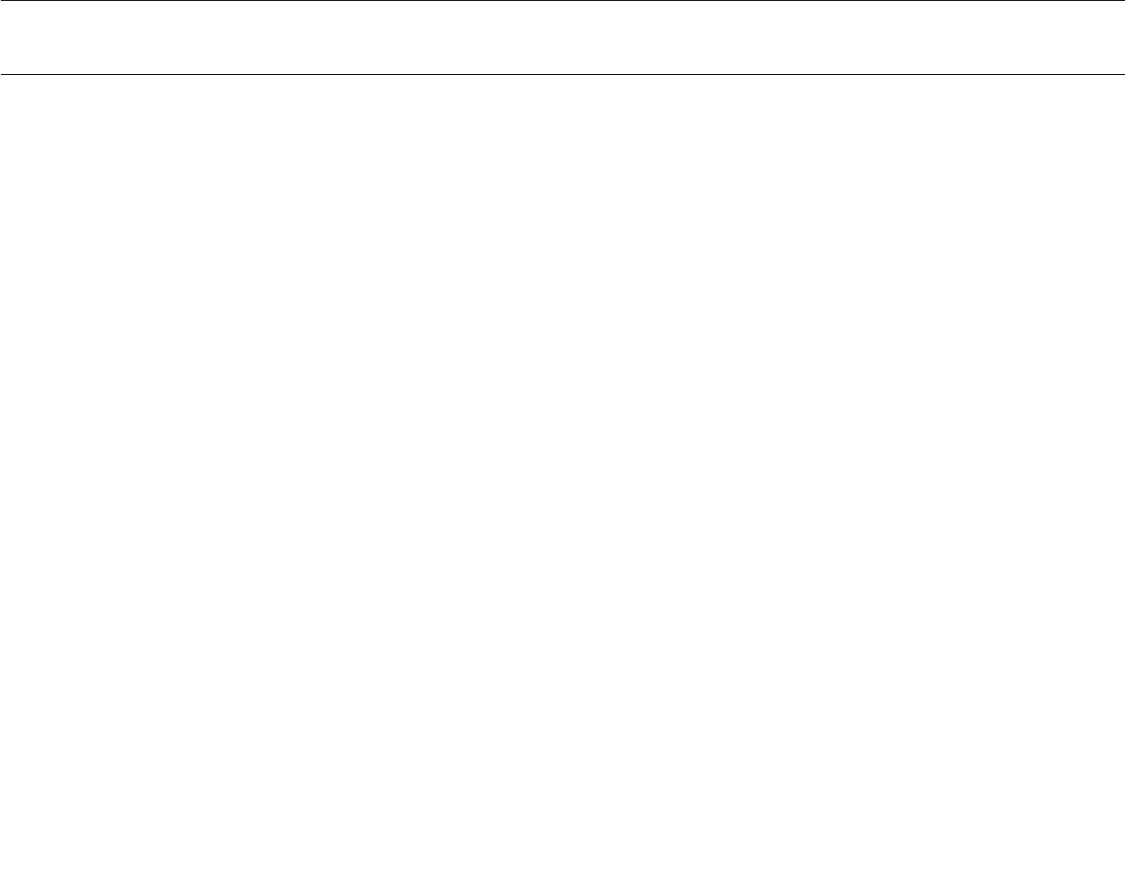  Use case name: | Display Advertisement
Overview: | Advertisements corresponding to the location of the
 | device which has pinged and time will start playing.
Actors: | user
Precondition: | Log in
Main flow : | 1.user will first log-in
 | 2.device location will be pinged to the server and accordingly
 | advertisement will be shown.
 | 3. each device has unique id.
Alternate flow: | If the id and password is not validate then msg will be displayed.
Post-condition: | true
Cross-reference: | Validate login

- Managing User

Use case number: | 15
Use case name: | Managing User
Overview: | Administrator can regulate users. He will have the power
 | to add or delete them or any content uploaded by them.
Actors: | Administrator
Precondition: | Administrator has to log In
Main flow : | 1. Administrator can add and delete the advertisement uploaded
 | by the user.
 | 2. can see user info and has excess to all the functionalities
 | which the user has
Post-condition: | true

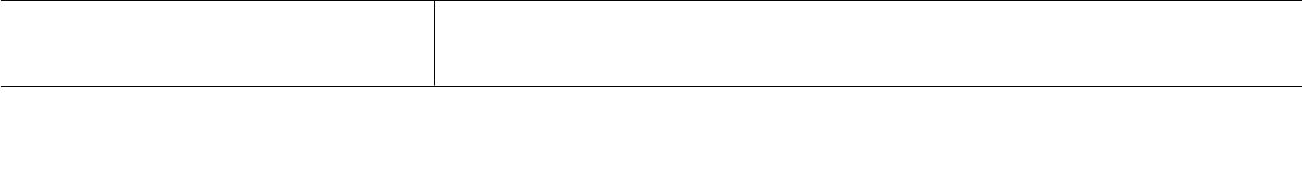
Cross-reference: Validate login

- User History
Use case number: | 13
.Use case name: | User History
Overview: | When user is logged in , he can check his previous activities.
Actores | Customer/Admin
Precondtion | Logged-In
Main-Flow: | 1)User/Admin will logged In  2)will click on history  3)If admin then can see all users history.
Post-Condition: | True

