**E-mail to be sent when new SELLER requests to join site**

Dear “First Name”,

Congratulations! You’re one step closer to securing the funding you need to fuel the growth of your business.

A member of the team is currently reviewing your application and will be in contact with you as soon as possible with your outcome or with a request for further details.

If you have any queries before then or would just like to chat, please feel free to get in touch.

We look forward to starting this journey with you to maximise the potential of your business.

Kindest regards,

Aamar Aslam

CEO & Founder,

Funding Invoice,

A.Aslam@fundinginvoice.co.uk

**E-mail to be sent when new SELLER is approved by admin**

Dear “First Name”,

Great news – Your application to join the Funding Invoice family has been approved!

We’ll give you a call at your earliest convenience for a quick chat and to go over a few details.

We look forward to working with you to achieve your business goals.

Warm regards,

Aamar Aslam

CEO & Founder

Funding Invoice

A.Aslam@fundinginvoice.co.uk

**E-mail to be sent when new INVESTOR requests to join site**

Dear *First Name*,

Congratulations! You’re one step closer to adding to our innovative investment product to your portfolio.

We will be in contact within 1 hour during our usual business hours with further details.

Thank you for choosing Funding Invoice.

We look forward to helping you realise high returns on your investments into some of the UK’s most exciting businesses.

Warmest regards,

Aamar Aslam

CEO & Founder

Funding Invoice

A.Aslam@fundinginvoice.co.uk

**E-mail to be sent when new INVESTOR is approved by admin**

Hi *First Name*!

Congratulations – you have been approved to join the Funding Invoice community and are now ready to start investing!

Please feel free to contact us with any queries!

Warmest regards,

The Funding Invoice Team

**E-mail to be sent when invoice is uploaded**

Dear *First Name*,

Your invoice has been accepted and is now available to be purchased by our professional investors.

We will be in contact as soon as your invoice has been purchased in full!

Warm regards,

The Funding Invoice Team

**E-mail to be sent when Investor wins auction**

Dear *First Name*,

You’ve won an auction! The details of the invoice which you have purchased are as follows:

*Debtor Name*, *Invoice Value*, *Invoice Due Date*,*Winning Bid*. Please log in to see further details.

Warm regards,

The Funding Invoice Team

**E-mail which I mentioned earlier which can be downloaded by seller on 2nd page of invoice upload: the following bit“**We can also verify your invoice by you bcc'ing us in an e-mail sent to your debtor and ensuring that they "reply all" so that the response is also sent to us. A draft e-mail that you could use is available to download below.”

The downloadable file should be a word doc with the following:

**I WILL PROVIDE THIS FOR YOU TOMORROW, ASHOK.**

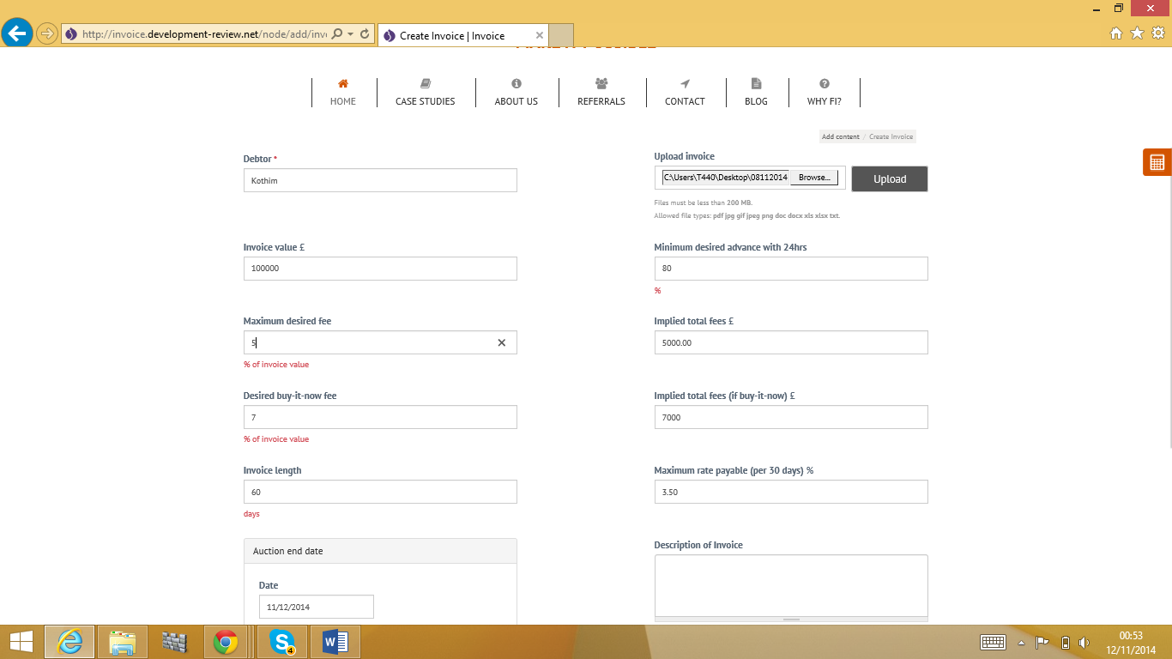**Screenshots detailing calculations for invoice upload**

Please make this so it shows as “7000.00” like the field above

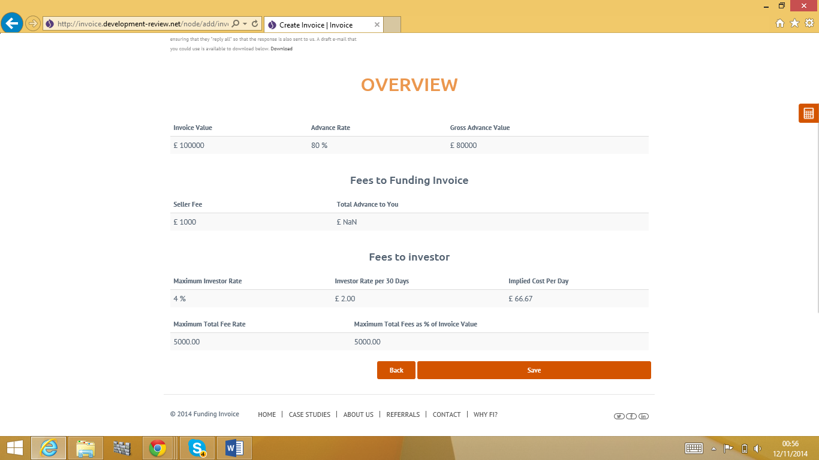

Take number from the left and divide by invoice length and multiply by 30.

In this case: (6%/60)*30 =3%

Desired buy-it-now fee – 1%. My fault! 6% in this case.

Capital I, please.

Seller fee = correct.

Total Advance to You should be equal to the following:

**Gross Advance Value** – **Seller Fee**

Correct row.

(This number / Invoice Length)

In this case 7000/60 = £116.67

**For clarity I will re-paste a fresh image of the above to continue annotations**



Delete the red bit

This*Invoice Value.

In this case 7%*Invoice Value = 7,000

Same as “Buy-it-now fee” in this case 7%

Number is a percentage.

Write “Total Fees” here as a heading like this

Move this field below