Rapid Order Entry Manual

To enter Kanata Prizes or WFC bonuses use the Rapid Order Entry Screen of the Fulfillment system.

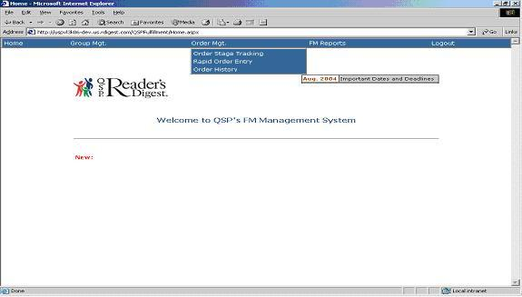
Under the Order Mgt Tab
Click on Rapid Order Entry
Search for your accounts by entering one of the following: Group ID, Group Name or Campaign ID. You can also search by City, Province, and Postal code. Then, click on “Search”.

See below

Note the FM ID and Name will default to your Name and ID.

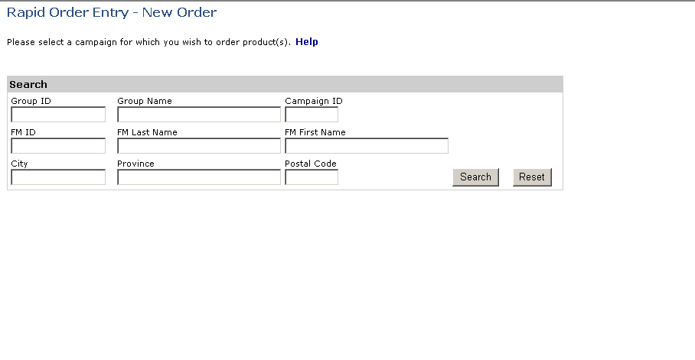
Enter 1 of these ID’s, and then click on

The campaign information will display below.
Chose Current Campaign and click “Select”

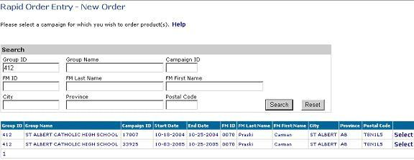

Example: Group ID was entered and it populated the Campaigns for that Group ID. Choose the current CA and click on

Verify you have the proper Campaign. If it’s incorrect click “Back”.
You must also choose a catalogue at this point.

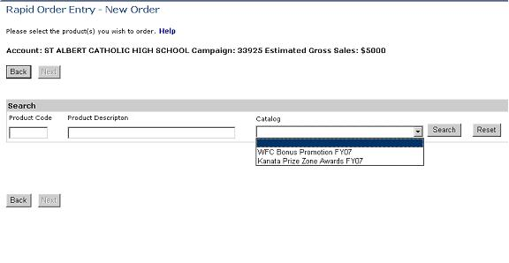
If you selected the wrong Campaign Click on which will bring you to the previous screen.
Choose a Catalogue
You can only order from 1 Catalogue at a time.
Campaign info and
Estimated Gross Sales

Displays all available Items to order, from the Catalogue selected.

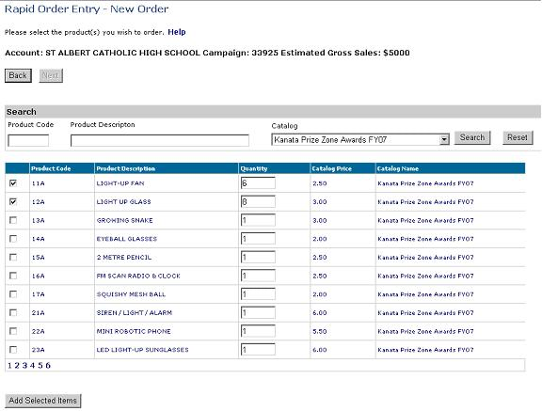
Quantity defaults to 1. You’re able to change the Quantity.
To search for a specific item enter the Product Code then click on Search

In addition to searching for a specific item, you can also select from the populated list. Add a check mark on the items you want to order then click on “Add Selected Items”

All the items are listed on different pages. You must add a check mark on the Items you want to order and click “Add Selected Items” before you select another page.

Once you clicked on Add Selected Items your Items will populate at the bottom.
You can remove items from the list by adding a check mark next to the item, then click on “Remove from the list”. You can clear all the Selected Items by clicking on “Clear All”. Once you have entered all the items you want to order click “Next”.

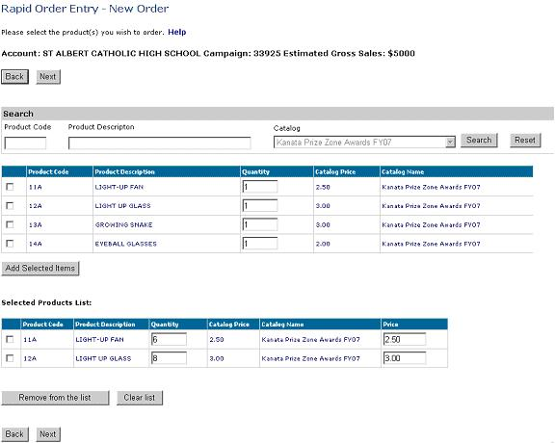
You can still change the quantity at this stage.
To remove items add check a mark and click on
Will clear all selected Products.

Click on when you are finished adding items.

On this page you must choose where the Items are going to be shipped, Delivery date, Billing address and Order Qualifier. Once complete you have the option to “Save” or “Submit to Warehouse”.
Select where you want the items to be shipped. If you select “other” you must fill in the shipping information.
Select Delivery Date
Enter Order Qualifier.
“Kanata” or “Kanata Problem Solver”. You can’t do a Problem Solver and a Regular order at the same time; they must be done in separate orders.
If you select “Save” the order will go in Order History and you’ll still be able to modify the order before you close it.
Select if you want it billed to the FM or the School.
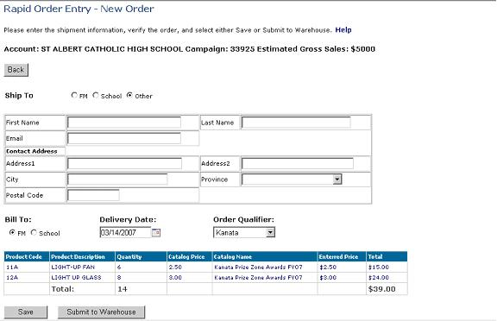
If you press, “Submit to warehouse” you’re no longer able to modify the order.

After you Press “Save” or “Submit to Warehouse” it will bring you back to the first screen where the school’s information was entered, and there will be a message at the bottom of the Page showing you the order ID # for your Order.

Example of a Saved Order

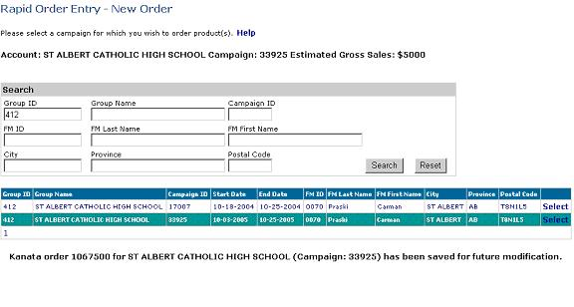
Displays the Order ID.

Shows that the order is saved (not submitted).

Example of an Order Submitted to the Warehouse

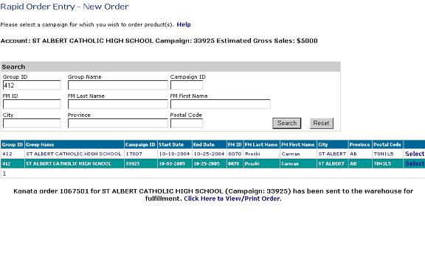
Displays the Order Id
You are able to view/Print your order
Shows that the order is submitted.

Order History is used to Modify, Close, Cancel or Print a Kanata Prize or WFC bonus Order.

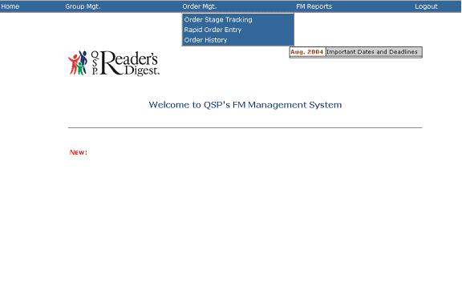
Under Order Mgt,
click on ‘Order History’

To Search for your account(s) you must fill in one of these Id’s, preferably the Order ID.
Make sure the Date Range is correct.
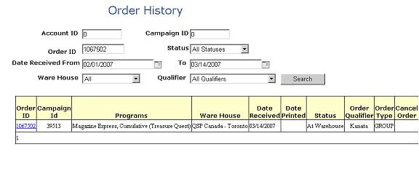
Type the Order Id #, then click on Search.

After you clicked on Search the order will appear below. Click on the Order ID link to modify the order (if it was ‘Saved’), or to view/print the order (if it was ‘Submitted’).

This is an example of an Order submitted to the warehouse. (Order History Screen)
To cancel the order, click on the link, which will open your Email client and let you send an email to have the order cancelled.
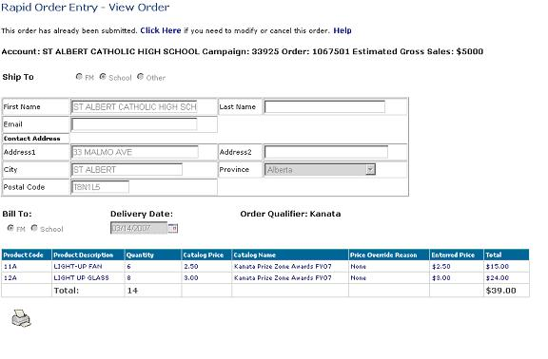

To Print details on the order Click on . Set your printer to ‘Landscape’ view so that the entire order fits on the page.

This is an example of a Saved order. (Order History Screen)

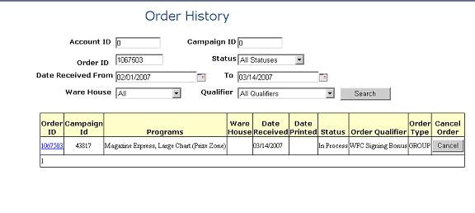
Same searching capabilities as described on Page 11.
Click on the link to modify the order.
Click Cancel if you want to cancel the order.

To modify a saved Order

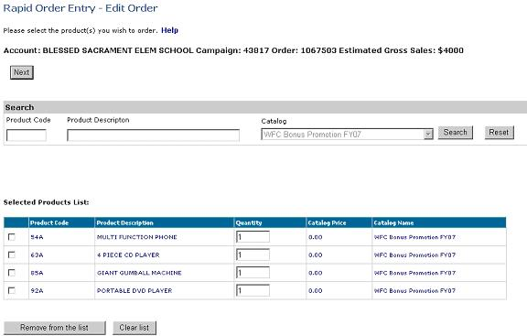
Click on Search to show the items available in the Catalogue.
You can only change the catalogue if you first clear the list of items that you have already selected.

From this point you are able to modify the order in exactly the same way as you had originally created it. Click here for more information.

