Changing diel growth symmetries and light-capture in PhycoCyanin and PhycoErythrin-rich picocyanobacteria across photic regimes and growth phases

Sylwia Śliwińska-Wilczewska1,2, Marta Konik3,4, Mireille Savoie1, Naaman Omar1, and Douglas A. Campbell1,✉

1 Department of Biology, Mount Allison University, 53 York St., Sackville NB, Canada, E4L 1C9  
2 Institute of Oceanography, University of Gdansk, 46 Pilsudskiego St, P81-378, Gdynia, Poland  
3 Department of Geography, University of Victoria, Victoria, BC V8P 5C2, Canada  
4 Institute of Oceanology, Polish Academy of Sciences, 81-712 Sopot, Poland

✉ Correspondence: [Douglas A. Campbell <[dcampbel@mta.ca](mailto:dcampbel@mta.ca)>](mailto:dcampbel@mta.ca)

# Supplementary material

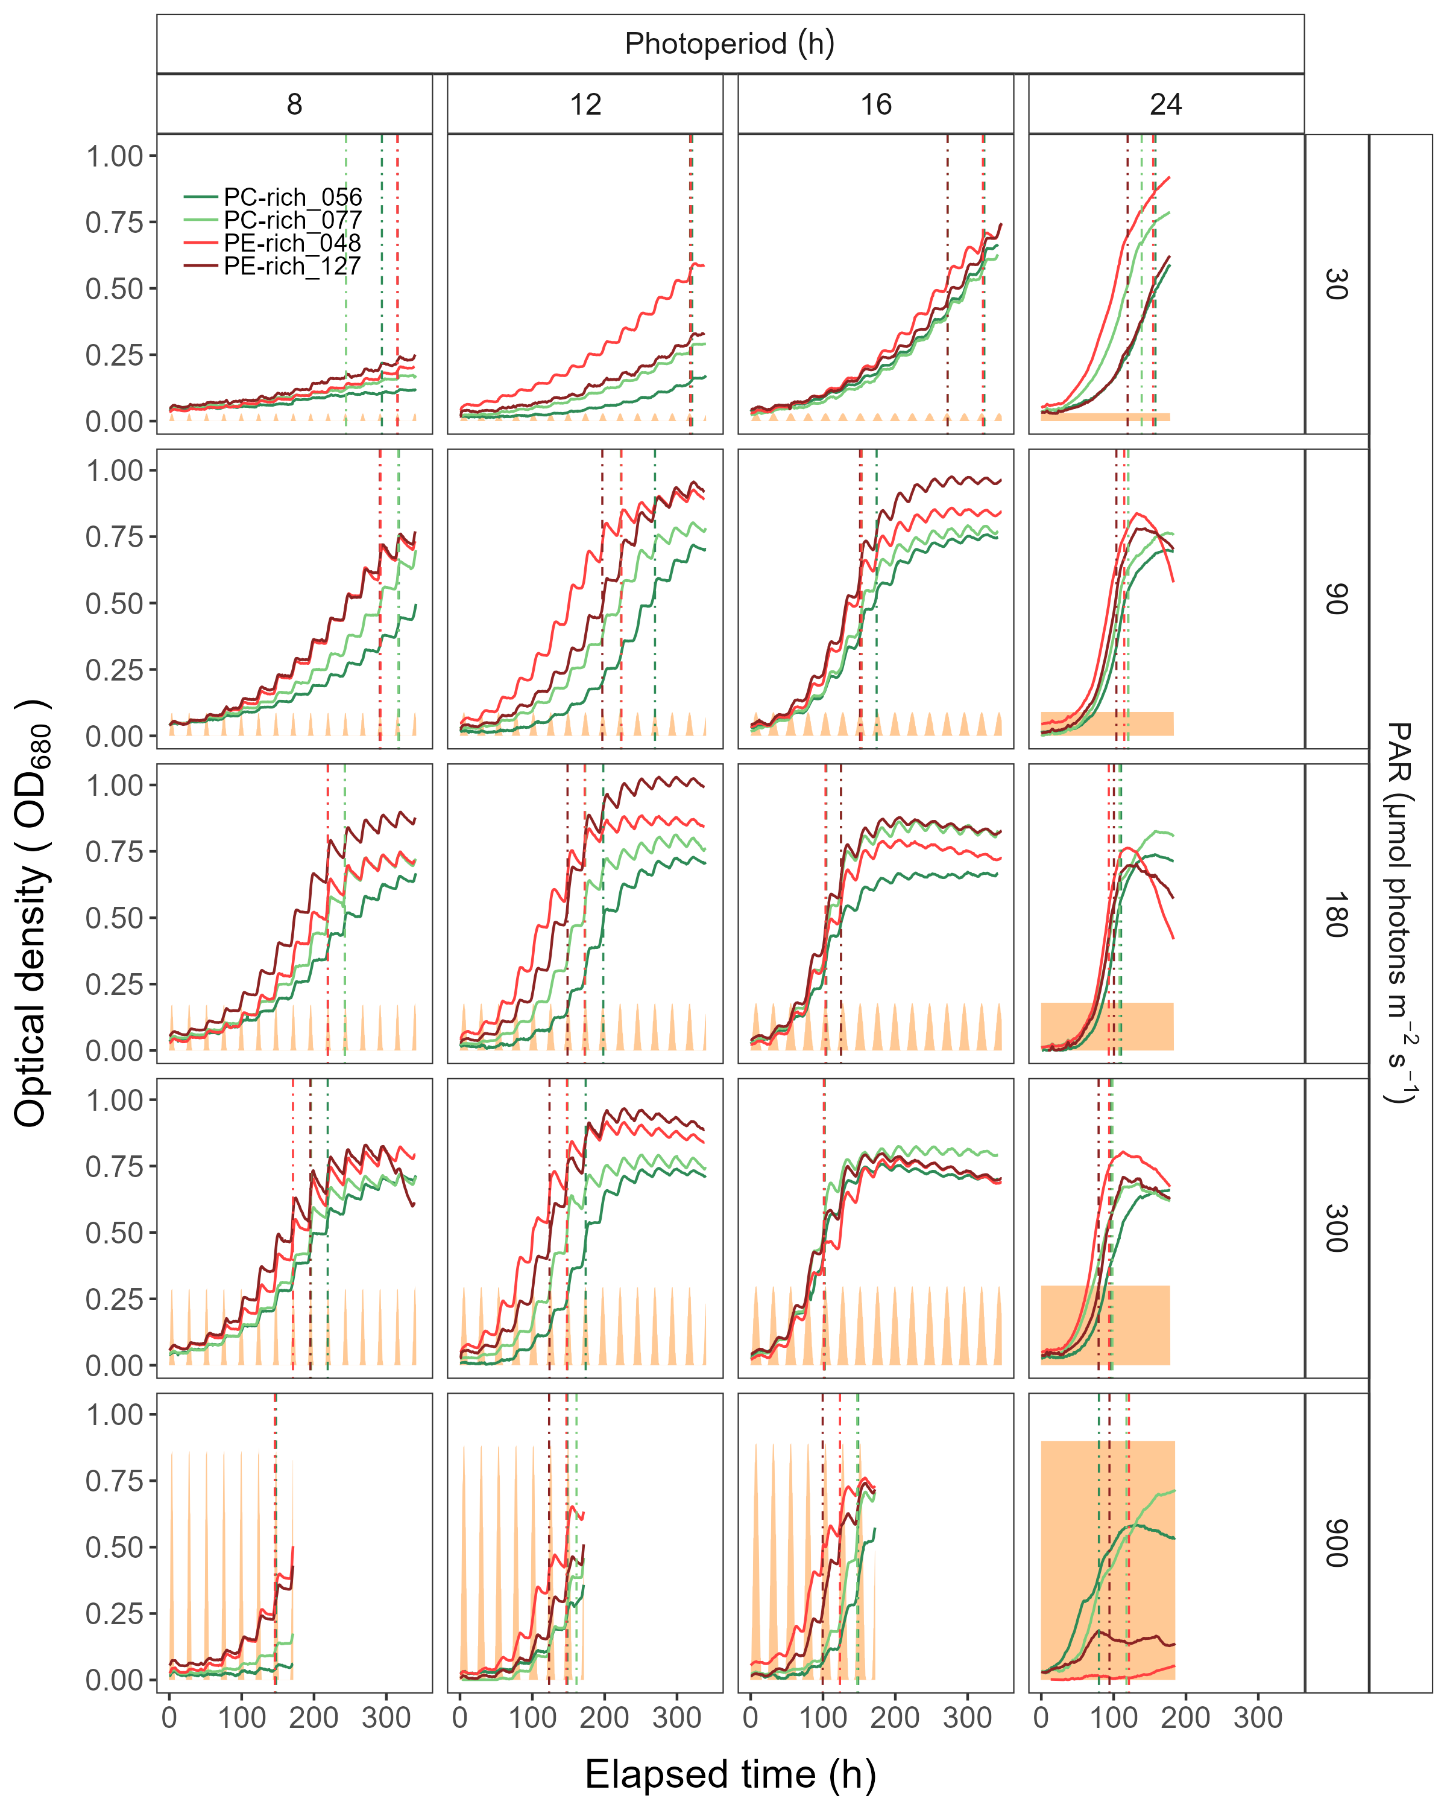

(#fig:SFig_GrowthCurve)Example of representative growth curves (tracked as OD680) of two PhycoCyanin(PC)-rich cultures (light green line; 056, dark green line; 077) and two PhycoErythrin(PE)-rich cultures (light red line; 048, dark red line; 127) (Culture Collection of Baltic Algae) of *Synechococcus* sp. grown at 30, 90, 180, 300, or 900 peak diel PAR µmol photons m−2s−1; and photoperiods of 8, 12, 16, or 24 h. The vertical lines represent the time when the cultures reached their maximum absolute hourly growth (tMaxAG), taken as an index of transition from exponential to pre-stationary growth phases. The orange area represents the photoperiods, with peak PAR x 1/1000 to scale to the Y axis.

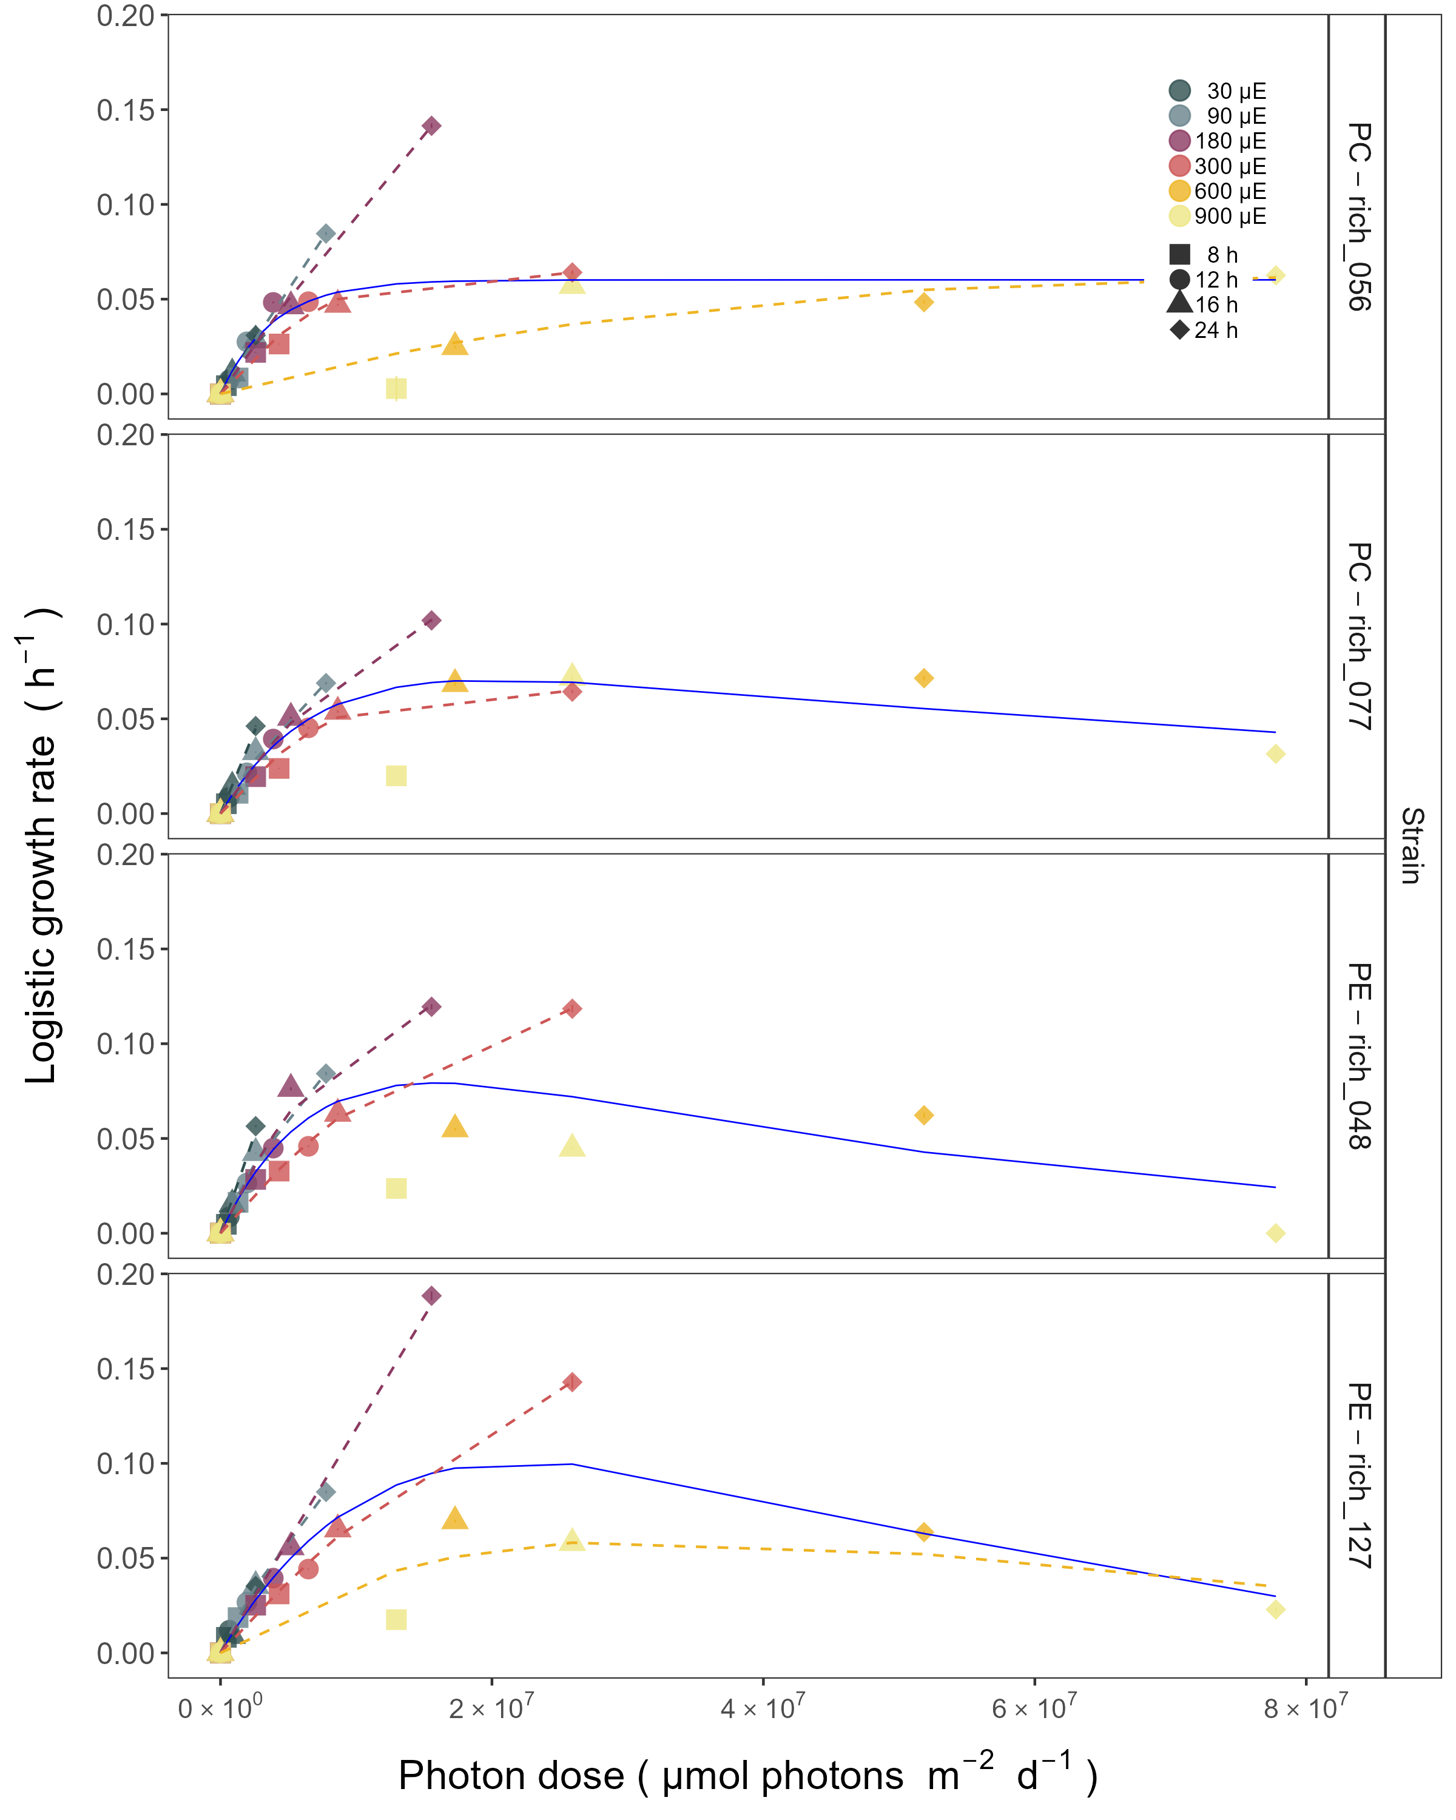

(#fig:SFig_GrowthRate)Chlorophyll specific exponential growth rates, estimated from logistic fits of chlorophyll proxy OD680-OD720 vs. elapsed time, for two PhycoCyanin(PC)-rich cultures (056, 077) and two PhycoErythrin(PE)-rich cultures (048, 127) (Culture Collection of Baltic Algae) of *Synechococcus* sp. grown at 30, 90, 180, 300, 600, or 900 peak diel PAR µmol photons m−2s−1; and photoperiods of 8, 12, 16, or 24 h. Growth rates (+/- SE from logistic model; SE falls within symbol sizes) are plotted vs. cumulative diel µmol photons m−2d−1, and pool fit with curve (Harrison and Platt, 1986) was shown as solid blue line. Separate lines (dashed) fit for growth under 30 (dark gray), 90 (light gray), 180 (purple), 300 (red), 600 together with 900 (orange) peak diel PAR µmol photons m−2s−1 when they were significantly different (ANOVA, *p* < 0.05) from the pool fit.

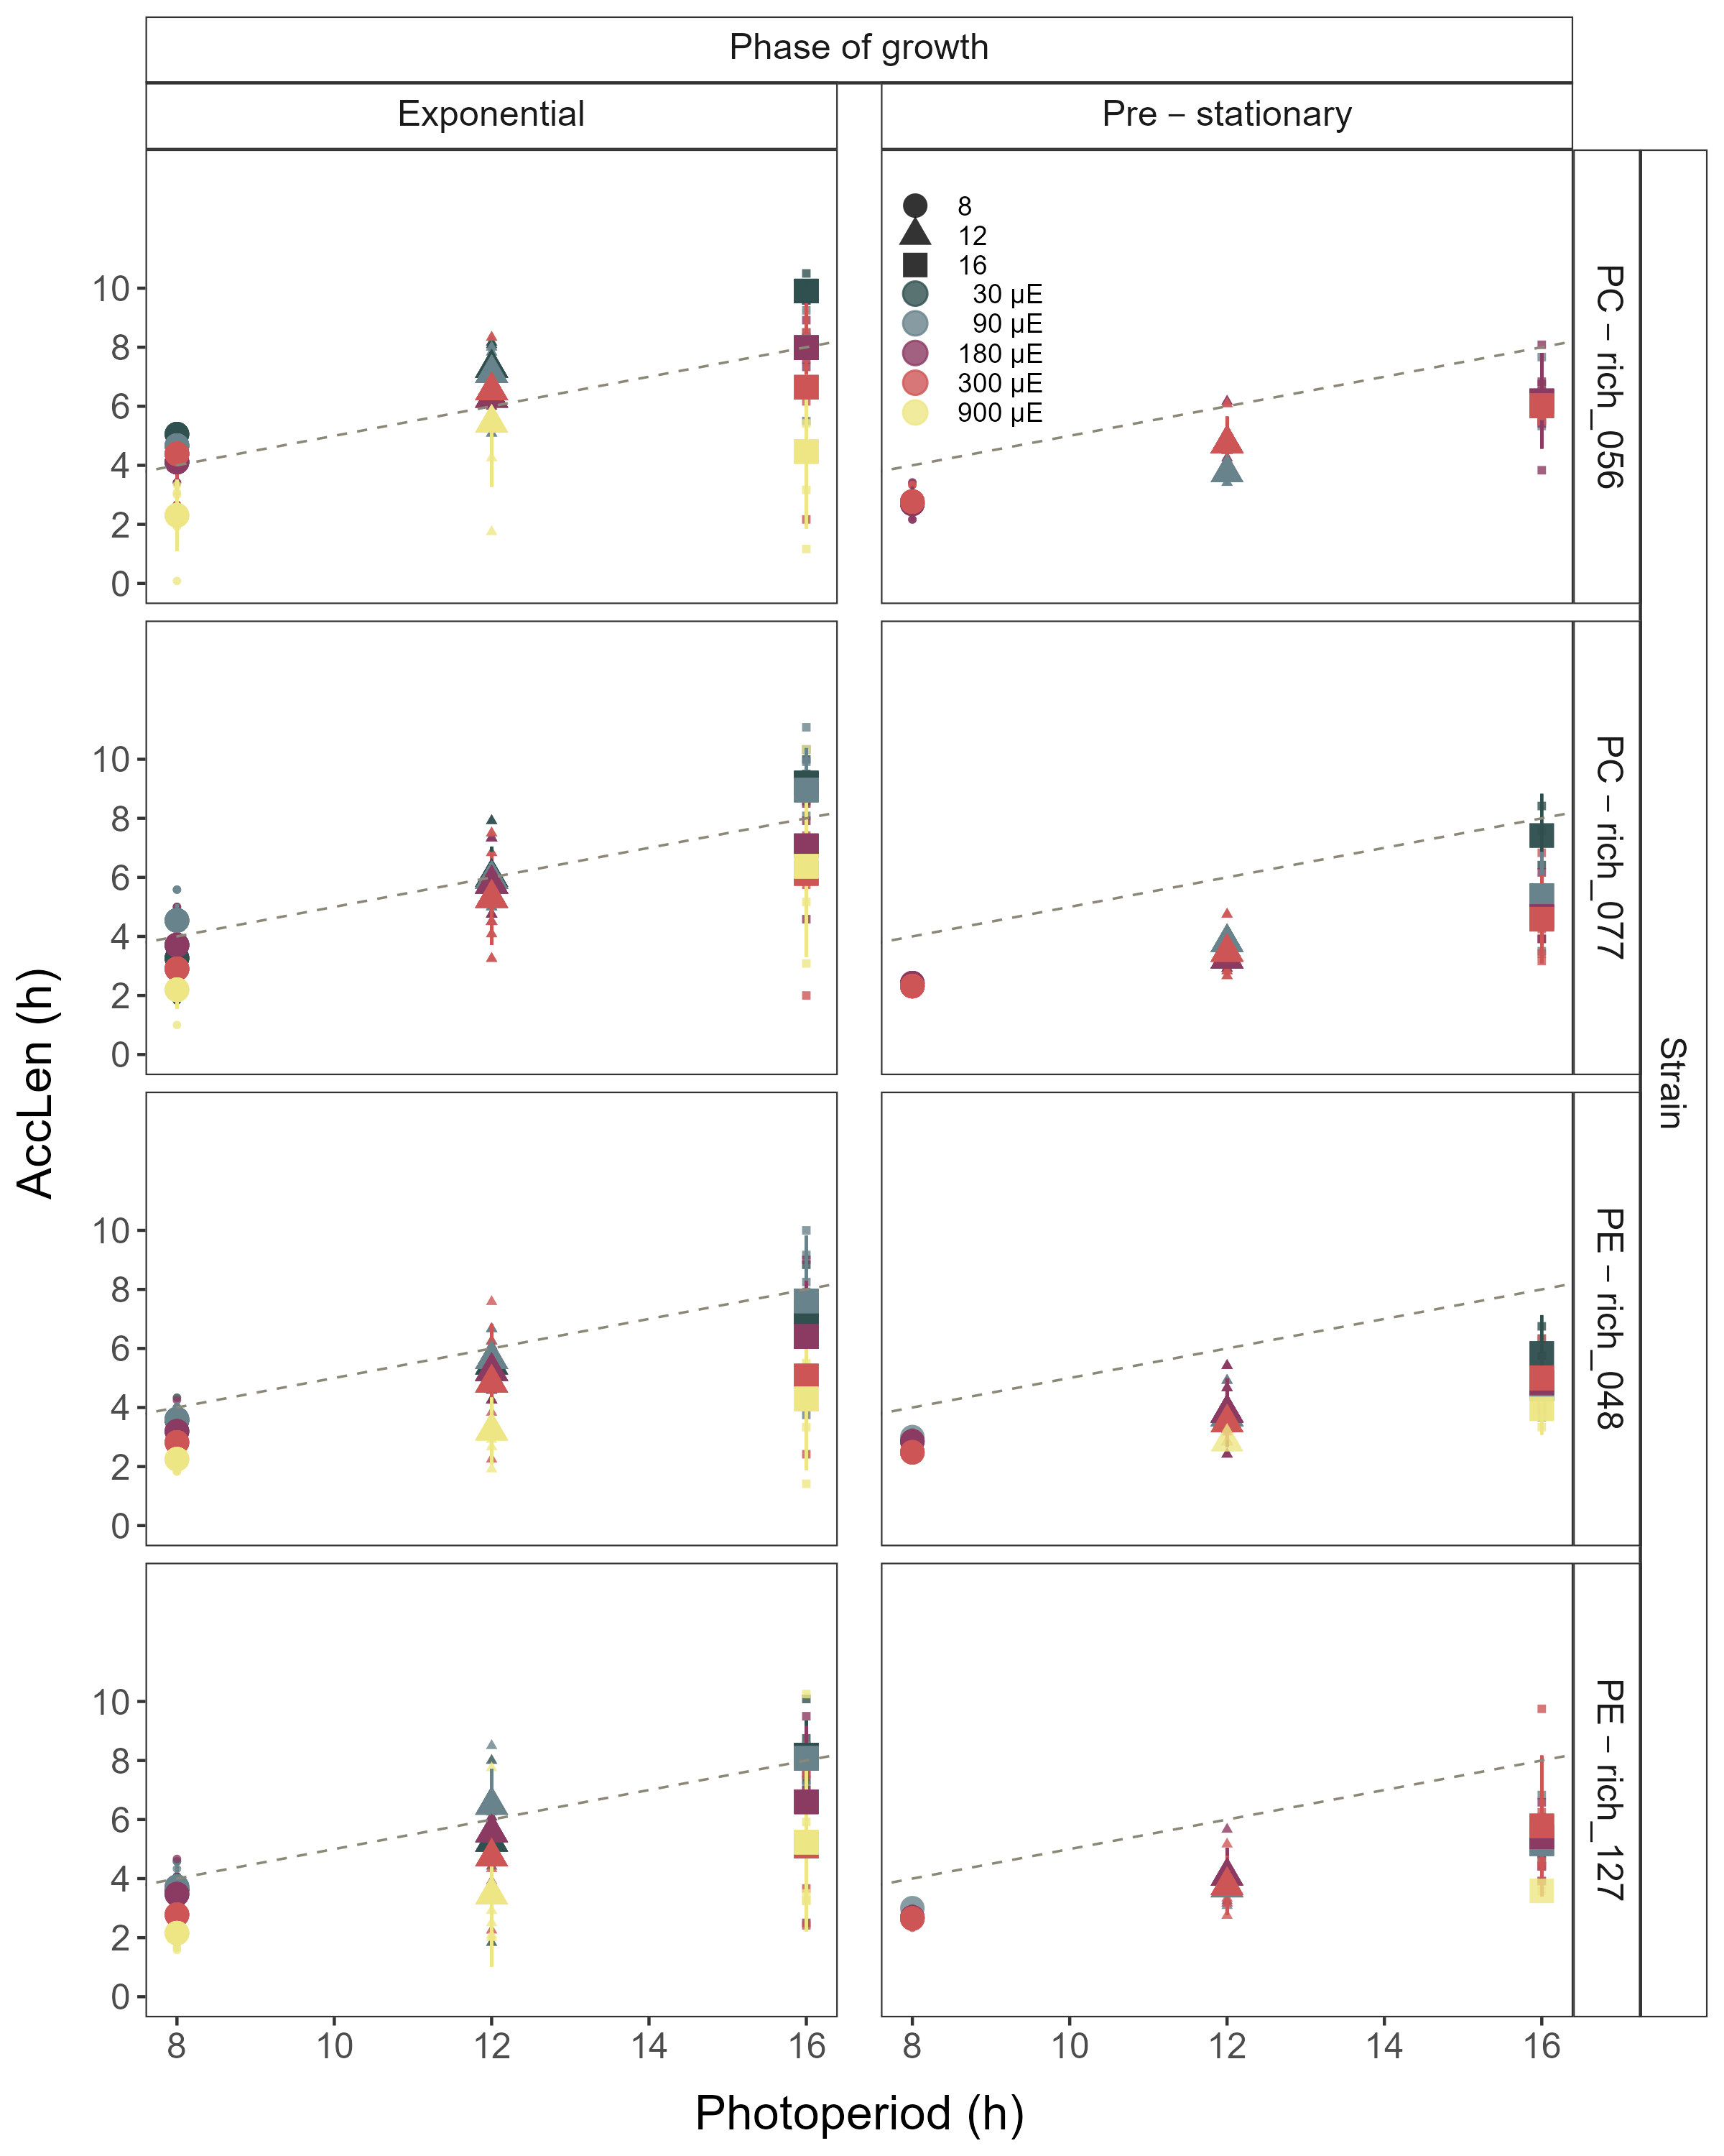

(#fig:SFig_AccLen)Hours of photoperiod to reach maximum hourly growth increment (AccLen), for two PhycoCyanin(PC)-rich cultures (056, 077) and two PhycoErythrin(PE)-rich cultures (048, 127) (Culture Collection of Baltic Algae) of *Synechococcus* sp. grown at 30, 90, 180, 300, or 900 peak diel PAR µmol photons m−2s−1; and photoperiods of 8, 12, or 16 h. Figure represent all data (small symbols) and means (big symbols) for n = 0-5 days from exponential phase, prior to reaching maximum absolute hourly growth; or from pre-stationary growth phase, after reaching maximum absolute hourly growth. The diagonal dashed lines indicate the time (h) to reach the maximum light during the day.

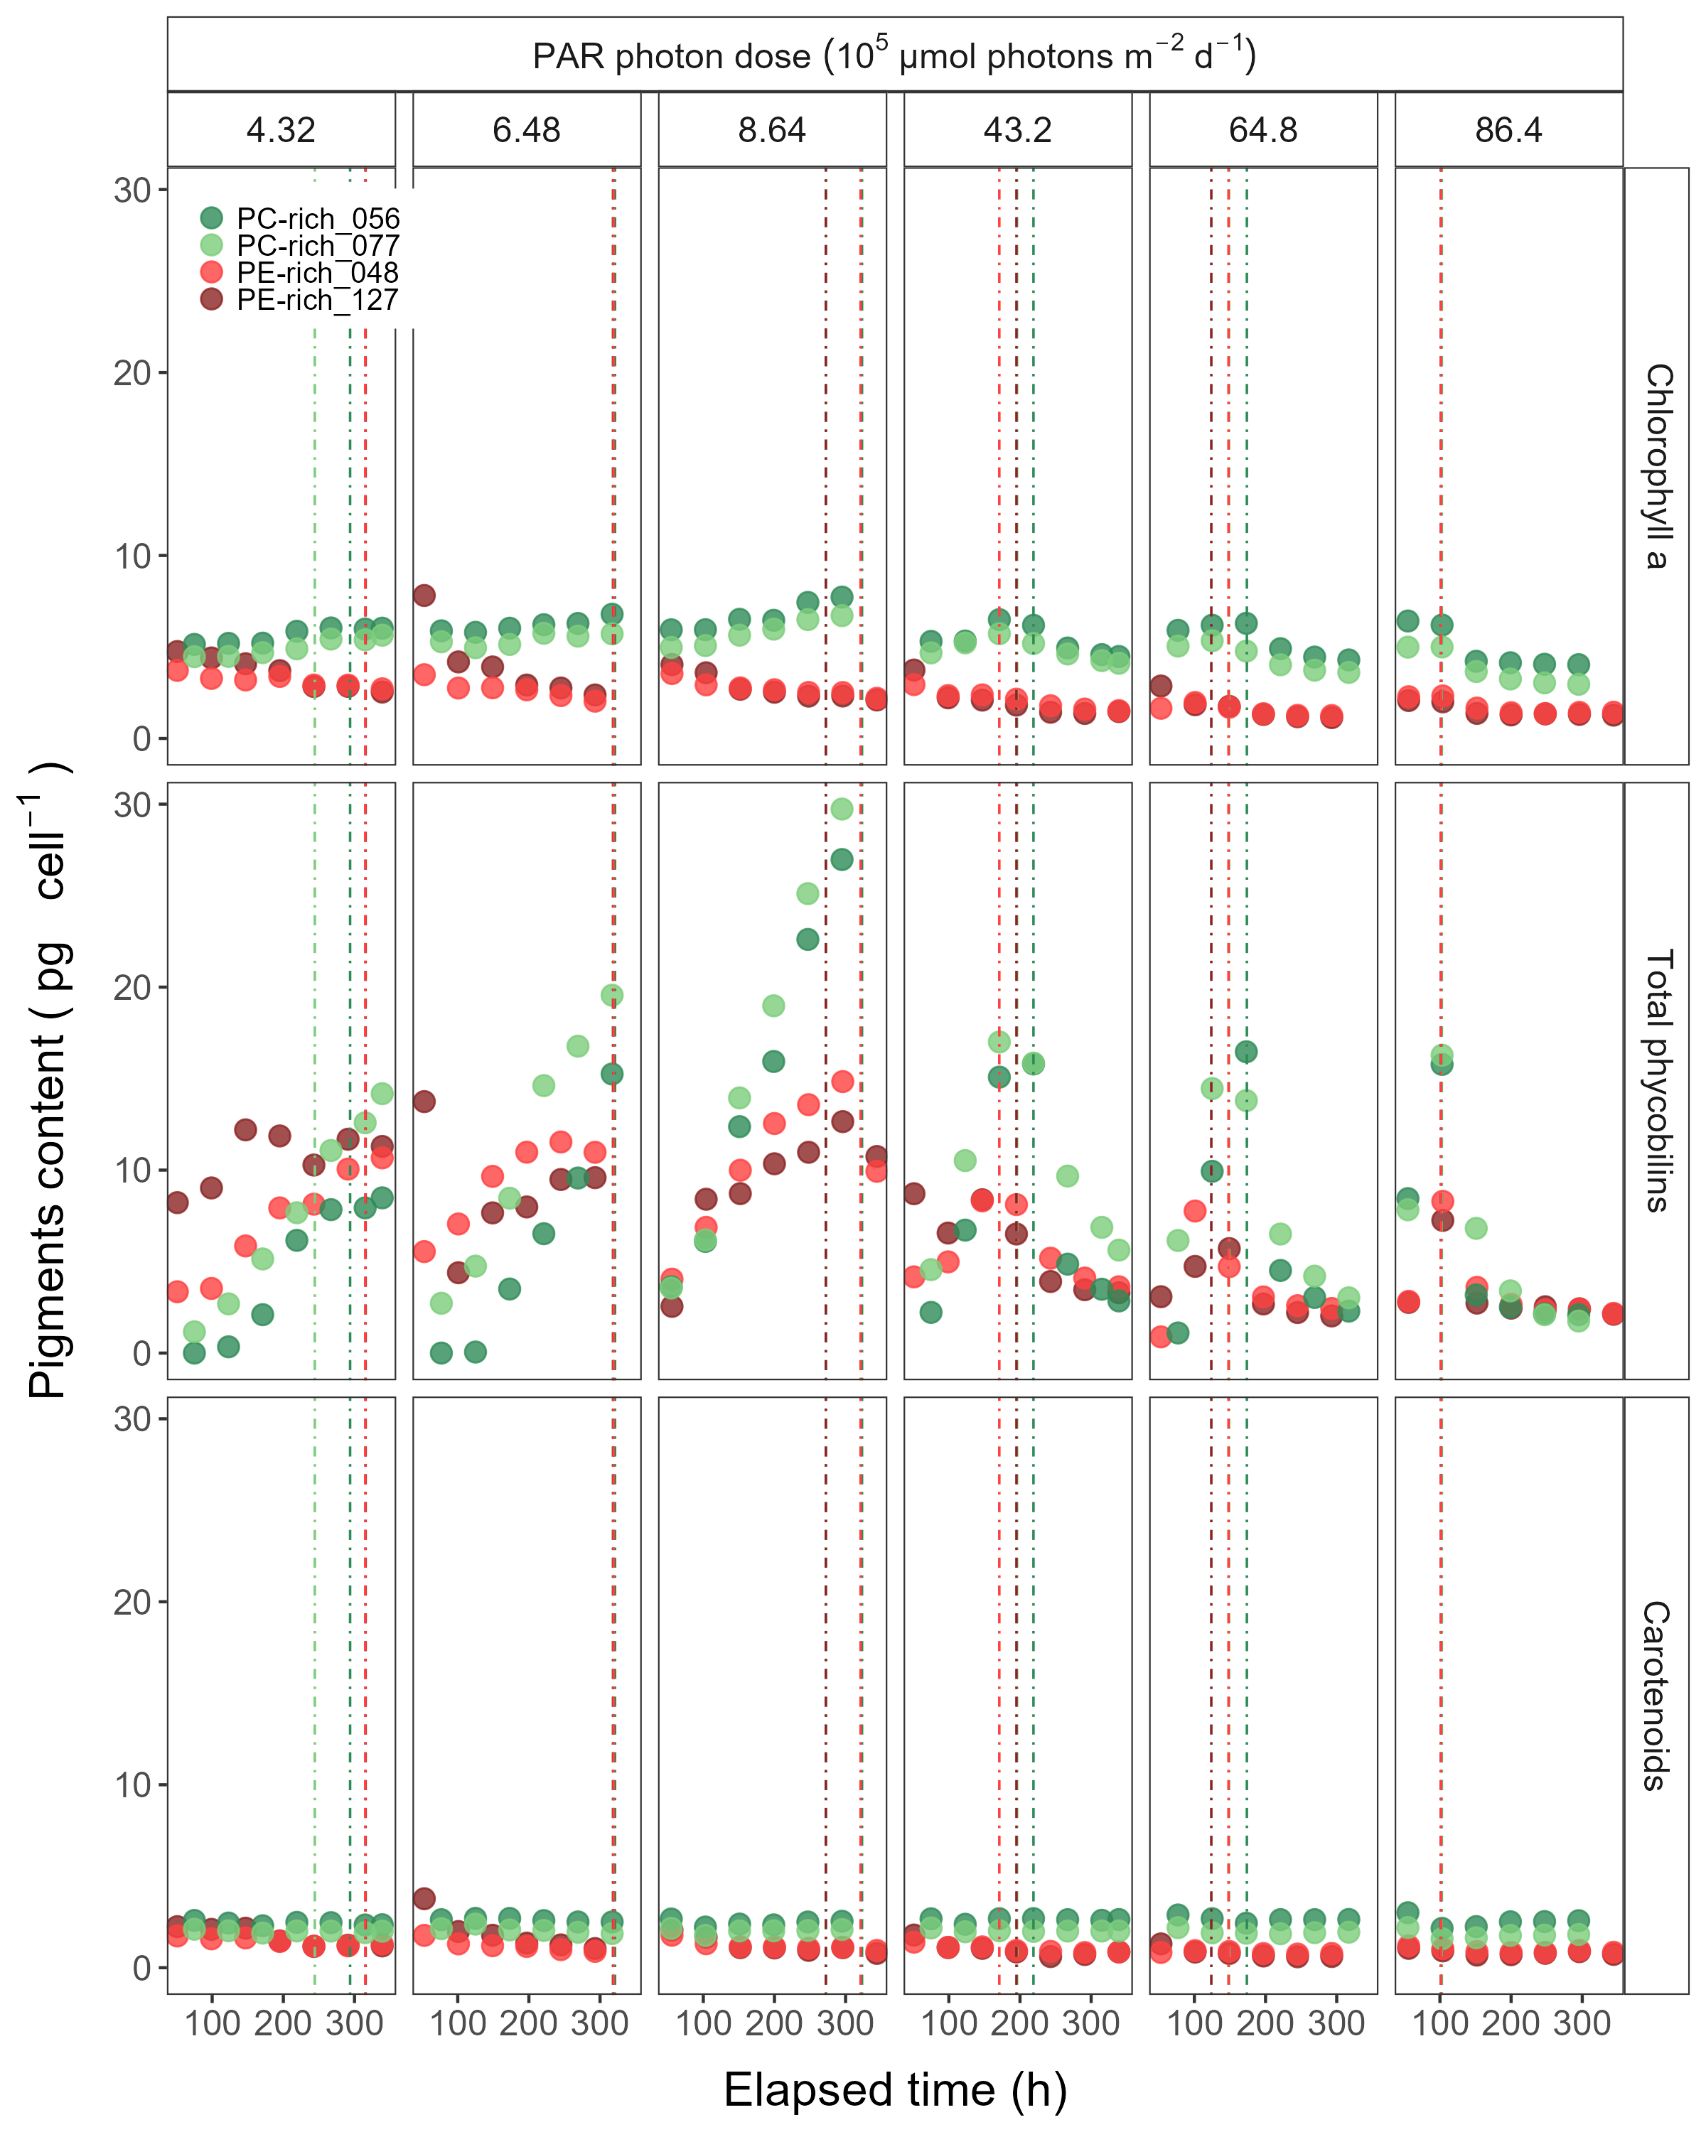

(#fig:SFig_Pigments)Changes of cell-specific pigment content of two PhycoCyanin(PC)-rich cultures (Culture Collection of Baltic Algae; 056, 077) and two PhycoErythrin(PE)-rich cultures (Culture Collection of Baltic Algae; 048, 127) of *Synechococcus* sp. at selected cumulative diel µmol photons m−2d−1 over time (h). The vertical lines represent the time when the strains reached their maximum absolute hourly growth (tMaxAG).

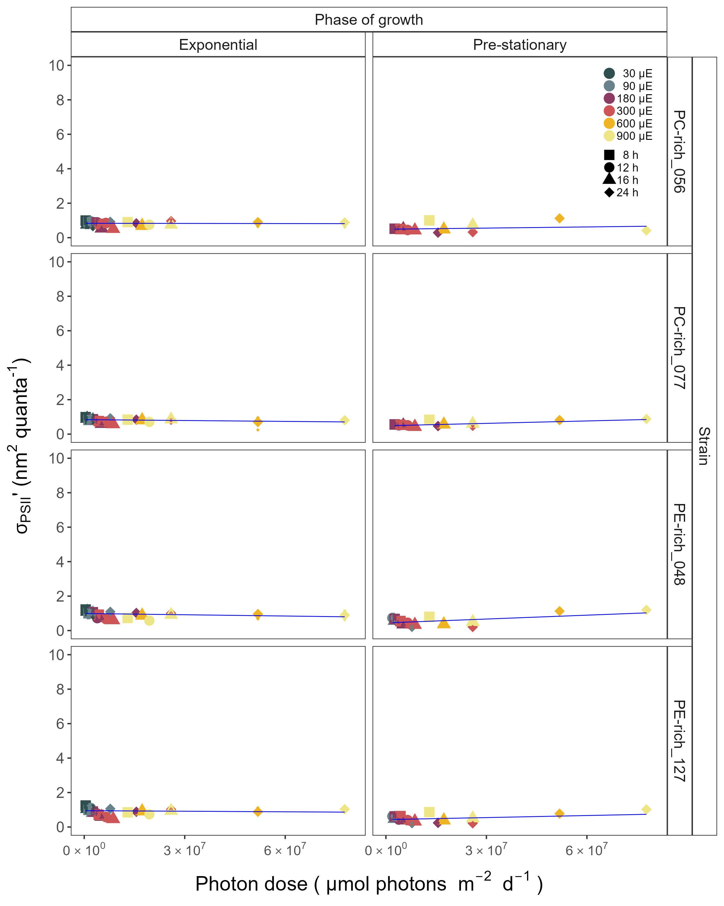

(#fig:SFig_Sigma445)Effective absorption cross section of PSII (σPSII’; nm2 quanta-1) measured under diel peak PAR growth light under Ex445 nm (blue) excitation in two PhycoCyanin(PC)-rich cultures (056, 077) and two PhycoErythrin(PE)-rich cultures (048, 127) (Culture Collection of Baltic Algae) of *Synechococcus* sp. grown at 30, 90, 180, 300, 600, or 900 peak diel PAR µmol photons m−2s−1; and photoperiods of 8, 12, or 16 h. n = 3, +/- SD. Line shows single phase exponential decay fit.