**2. Materials & Methods**

**2.1. Study Organisms & Culturing**

Seven phytoplankton species were studied, including polar and temperate strains of diatoms and green algae. *F. cylindrus*, a psychrophilic pennate diatom measuring 15-55 µm, thrives in the high salinity and subzero temperatures of Arctic and Antarctic sea-ice systems [1,2]. Forming large blooms in the bottom layer of sea ice and across the wider sea ice zone, *F. cylindrus* acts as a keystone and indicator species for polar ecosystems [1,3]. Conversely, *T. pseudonana* is a small (2.5-15 μm) centric diatom found worldwide in diverse freshwater, coastal, brackish, and marine habitats[4]. *T. pseudonana* can tolerate a wide range of salinities (0.5%–37%) and temperatures (4–25°C), contributing to its frequent use as a model diatom species [4].

*Chlamydomonas ICEMDV* and *Chlamydomonas priscuii* are halotolerant algae isolated from the perennially ice-covered hypersaline Lake Bonney, in McMurdo Dry Valleys, Antarctica[5,6]. With large (15 to 20 μm) biflagellate cells, *C. ICEMDV* dominates the shallow photic zone, where it experiences higher irradiance, extreme nutrient limitation, and lower salinity [5,7]. The smaller *C. priscuii* dominates the deep photic zone, characterized by permanent low temperatures, low irradiance, and high salinity[8,9]. The final psychrophile species is *Chlamydomonas malina,* amarine microalga isolated from the Arctic Ocean's Beaufort Sea, measuring around 10 μm in length and 5 μm in width, and growing optimally at 4°C [10,11]. *C. reinhardtii* is a model green alga approximately 10 μm in size and found in soil and aquatic environments with an optimal temperature range of 20-32°C [12,13]. *C. vulgaris*, ranging from 2 μm to 10 μm in size, is primarily found in freshwater environments and grows optimally at 27°C [14,15].

*Culturing Protocols*

The seven species, and respective culturing conditions are summarized in Table 1. Cultures of *T. pseudonana* and *C. vulgaris* were prepared by Naaman Omar (Mount Allison University); *Chlamydomonas* cultures were prepared by MacKenzie Poirier (Cvetskova Lab, University of Ottawa); and *F. cylindrus* cultures were prepared by Sébastien Guérin (Takuvik International Research Laboratory, Université Laval).

'Dilution' is not a meaningful column for the materials & methods. If you want to include it you need a footnote explaining what it means.

Table 1: Culturing conditions for experimental phytoplankton strains

|  |  |  |  |  |  |  |
| --- | --- | --- | --- | --- | --- | --- |
| Culture ID | Strain | Dilution | Par (µmol photons m-2s-1) | Photoperiod | Growth  Temp (°C) | Media |
| NaOm1305 | *T. pseudonana* | 1 | 50 | 12 | 22 | F2 |
| NaOm1663 | *T. pseudonana* | 1 | 50 | 12 | 22 | F2 |
| NaOm1671 | *C. vulgaris* | 1 | 50 | 12 | 22 | F2 |
| NaOm2987 | *C. vulgaris* | 1 | 50 | 12 | 22 | BG11 |
| NaOm2988 | *T. pseudonana* | 1 | 50 | 12 | 22 | F2 |
| NaOm2990 | *C. vulgaris* | 1 | 70 | 12 | 22 | BG11 |
| NaOm2991 | *T. pseudonana* | 1 | 70 | 12 | 22 | F2 |
| NaOm2992 | *T. pseudonana* | 1 | 70 | 12 | 22 | F2 |
| SeGu1001 | *F. cylindrus* | 1 | 10 | 24 | 0 | F2 |
| SeGu1006 | *F. cylindrus* | 1 | 10 | 24 | 6 | F2 |
| MaPo1001 | *C. priscuii* | 0.2 | 10 | 24 | 4 | BBM |
| MaPo1002 | *C. ICEMDV* | 0.2 | 10 | 24 | 4 | BBM |
| MaPo1003 | *C. malina* | 0.2 | 10 | 24 | 4 | BBM |
| MaPo1004 | *C. priscuii* | 1 | 10 | 24 | 4 | BBM |
| MaPo1005 | *C. reinhardtii* | 1 | 10 | 24 | 24 | BBM |
| MaPo1006 | *C. reinhardtii* | 1 | 10 | 24 | 24 | BBM |

**2.2. Single Turnover Variable Chlorophyll Fluorescence**

A single turnover variable chlorophyll fluorescence (St-ChlF) approach was employed to evaluate the progressive desynchronization of the S-State cycle across the range of phytoplankton species and growth temperatures.

A sample of XX mL of each culture was taken for a chlorophyll assay XXXXX. Then, samples of YY mL of culture were loaded into a temperature-controlled cuvette (PolyScience) placed within the measurement chamber of a Soliense LIFT-REM fluorometer (Version LIFT-REM 1.0, Soliense Inc). The apparatus was covered to block out incident light and cells were acclimated to the dark for a minimum of 30 seconds. In a dark regulated state, non-photochemical quenching processes are relaxed, and electrons have been passed downstream from all PSII centres, leaving all PSII reaction centres open for photochemistry upon receipt of an incident photon. Therefore, when if PSII receives a photon, the maximum proportion of energy will be partitioned to photochemistry, corresponding to minimum ChlF (Fo) [16].

The sample is then exposed to a series of 32 short, high-intensity, evenly-spaced flashes of 445 nm light. Depending upon the spacing between sequential flashes each series occupied XX to YY s. Flash series were applied with different spacings, and at different temperatures, with the culture sample replaced for each new measurement temperature.

Each flash consists of a rapid series of 50-70 sub-saturating flashlets delivered every ZZ microsecond [16], over ~ AA µs. These flashlets induce the absorption of light by PSII, which then extracts electrons from H2O, and passes the electrons downstream to QA-, transiently reducing the pool of electron acceptors and effectively closing PSII for photochemistry[18] over a period of ~1000 µs. Closing the photochemistry pathway redirects a greater proportion of additional incoming light energy to ChlF, resulting in maximum ChlF (Fm). This induction is known as the saturation phase (Figure 1), where the fluorescence yield increases from a minimum (Fo) to a maximum (Fm) [17]. For each flash, the ChlF minima and maxima are extracted using a fitting model (LIFT software version 22.11.11, Soliense Inc; Kolber1998. CITATION). Fo and Fm can then be used to derive the maximum quantum yield of photochemistry in PSII, a secondary ChlF parameter calculated as follows [16]:

${{\text{F}}_{\text{v}}}/{{\text{F}}_{\text{m}}}\text{=}\frac{{\text{F}}_{\text{m}}\text{-}{\text{F}}_{\text{o}}}{{\text{F}}_{\text{m}}}$**(Equation 1)**

The maximum quantum yield represents the efficiency with which an open PSII can convert absorbed light energy into chemical energy.

Figure 1: Sample chlorophyll fluorescence induction curve

Each flash is short enough, and bright enough, that it delivers, on average, one photon to each PSII, initiating a transition between S-states for each PSII. Thus, as sequential flashes are applied to the culture, each individual PSII is driven through the four S-states [18]. In an idealized culture, the population of PSII will cycle synchronously, reflected by an ongoing oscillation in chlorophyll fluorescence with a period of four (Figure 3) [19]. However, a recombination reaction, represent a loss of a charge separation, will cause a missed step in the S-state cycling of an individual PSII. As more recombination events occur, desynchronization of S-state cycling among the population of PSII will scramble the periodic changes in ChlF, dampening the observed oscillation of the population level fluorescence. [19]. Prolonged synchronous cycling thus reflects fewer wasteful recombination reactions at the level of each PSII and thus, more efficient photosynthetic energy conversion.

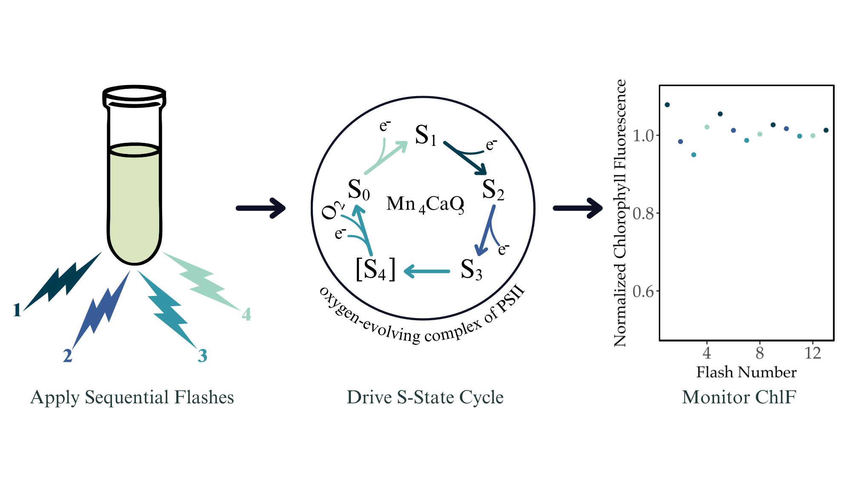Figure 3: Repeated single-turnover excitation of variable chlorophyll fluorescence for monitoring the S-state cycling in PSII during photosynthesis

*Measurement Conditions*

By evaluating the S-State cycling of polar and temperate taxa of diatoms and green algae under a range of measurement light and temperature conditions (Table 2), we can determine if polar taxa have evolved to increase photosynthetic energy conversion efficiency by minimizing inefficient recombination reactions. Measurement temperatures ranged from 0 to 28°C, depending on the taxa (Table 2).

Altering the spacing between sequential flashes can simulate varying light conditions. At higher light levels, more photons arrive per unit of time, corresponding to shorter spacing between saturating flashes in our measurement protocol (Figure 3). Cultures were evaluated at flash spacings of 1, 2, 4, 8, and 16 seconds. Corresponding steady-state light levels were calculated for each unique measurement condition as follows:

$\text{Light}\left(\text{μmol γ}{\text{m}}^{\text{-2}}{\text{s}}^{\text{-1}}\right)\text{=}\frac{\text{1}}{\text{flash spacing (s)}}\text{×}\frac{\text{1}}{{\text{σ}}_{\text{PSII}}\text{(}{\text{Å}}^{\text{2}}{\text{γ}}^{\text{-1}}\text{)}}\text{×}\frac{\text{1}{\text{m}}^{\text{2}}}{\text{1E20}{\text{Å}}^{\text{2}}}\text{×}\frac{\text{1 μmol}}{\text{6.02 2E17 γ}}$**(Equation 2)**

This calculation requires the effective absorption cross-section of photosystem II (σPSII), a parameter estimated from the ChlF induction curve during the saturation phase (Kolber 1998 citation). This parameter represents the probability of light capture by the PSII antenna bed associated with the dark-adapted PSII [16,20]. The conversion of flash spacing to light levels yielded similar ranges of effective measurement light levels for each strain (Table 2). For comparison, full sunlight at the sea surface is ~ 2000 µmol photons m-2s-1 so our measurement light ranges ~ 5 orders of magnitude lower than full sunlight, and ~ 3 orders of magnitude below the ~ 20 µmol photons m-2s-1 threshold, used to define the conventional bottom of the photic zone supporting photosynthetic productivity in the oceans.

Table 2: Measurement conditions by strain

|  |  |  |  |
| --- | --- | --- | --- |
| Strain | Flash Spacings (s) | Steady Light Level Equivalent Range  (µmol photons m-2s-1) | Measurement Temperatures (°C) |
| *F. cylindrus* | 1, 2, 4, 8, 16 | 0.02981 - 0.65678 | 0, 2, 6, 10 |
| *T. pseudonana* | 1, 2, 4, 8, 16 | 0.02428 - 0.53428 | 10, 14, 18, 20, 22, 24, 28 |
| *C. ICEMDV* | 1, 2, 4, 8, 16 | 0.04252 - 0.73733 | 4, 8, 12 |
| *C. priscuii* | 1, 2, 4, 8, 16 | 0.04289 - 0.77084 | 4, 8, 12 |
| *C. malina* | 1, 2, 4, 8, 16 | 0.03705 - 0.65817 | 4, 8, 12 |
| *C. reinhardtii* | 1, 2, 4, 8, 16 | 0.04670 - 0.84377 | 12, 16, 20, 24 |
| *C. vulgaris* | 1, 2, 4, 8, 16 | 0.05102 - 0.89781 | 10, 14, 18, 22, 26 |

**2.3. Analytical Methods**

Data was processed using R version 4.3.2 along with RStudio version 2023.12.0+369 using the x86_64-apple-darwin20 (64-bit) platform and running under macOS Sonoma 14.3.1. Fluorescence data files generated by LIFT software were imported and tidied using the tidyverse, lubridate, and googlesheets4 packages. The tidyverse, doBy, and WaveletComp packages were used for wavelet analyses. Lastly, the mgcv and mgcViz packages were used for generalized additive modelling, while the ggplot2, metR, and viridis packages were used for data visualization.

*Wavelet Transformations*

The fluorescence data yields a time series of Fv/Fm over 32 flashes, for each flash spacing, and each measurement temperature. The fluorescence time series were analyzed for each combination of strain, growth conditions, measurement temperature, and flash spacing, using wavelet transformations CITATION, as exemplified in Figure 4. Unlike traditional methods, wavelet analysis does not assume that the statistical properties of a time series are constant. Instead, wavelet transformations locally decompose the signal across different time scales and estimate spectral characteristics as a function of time [21]. By examining the frequency and wavelet power spectra, we can uncover the dominant patterns in the data [22].

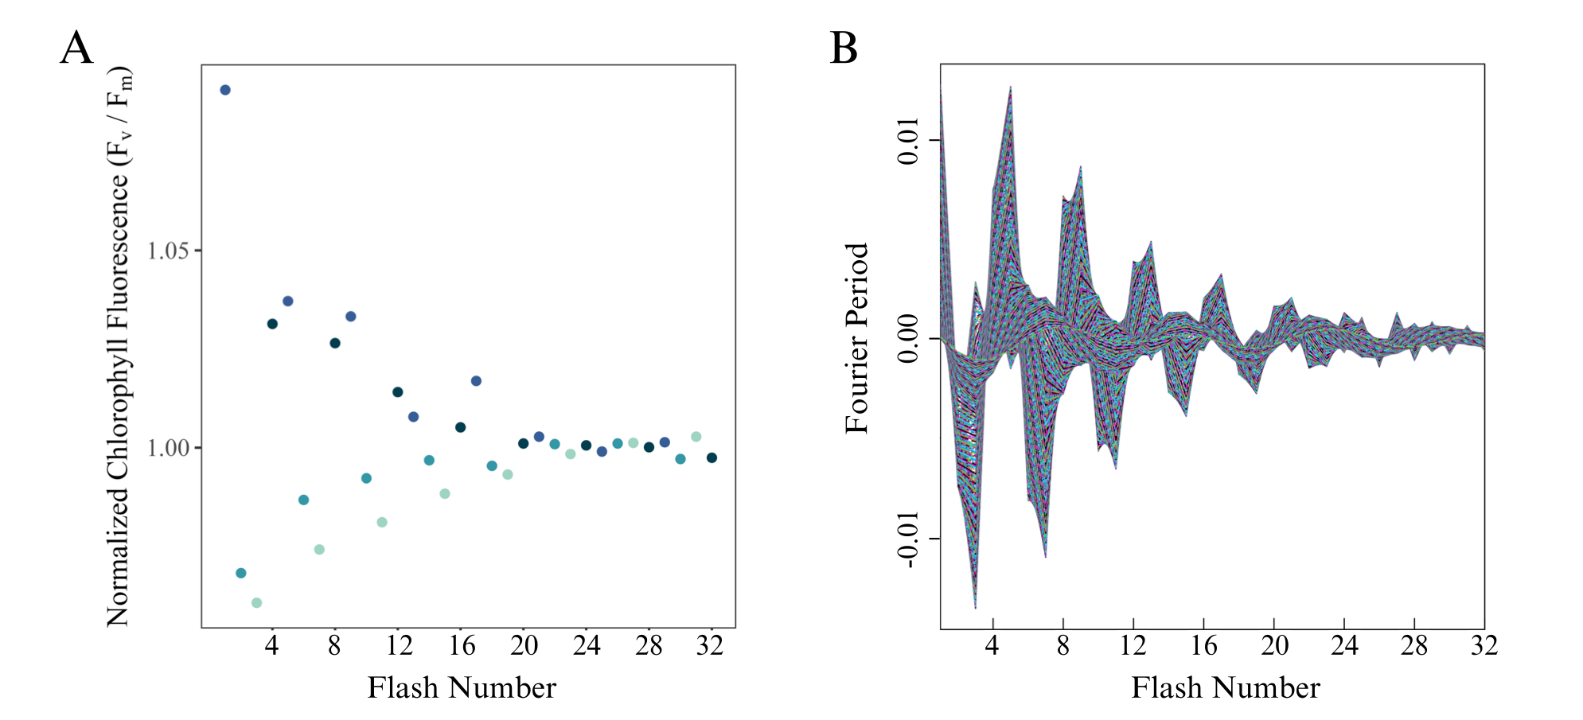

Figure 4: Representative wavelet transformation of *Chlamydomonas priscuii* fluorescence over 32 consecutive flashes, measured at 4°C and 1-second flash spacing, equivalent to a photon delivery rate to PSII achieved under approximately steady-state light level of 0.708 µmol photons m-2s-1.

The core of the wavelet transformation involves computing the wavelet power spectrum of the standardized time series using the Morlet wavelet [23]. Further, the statistical significance of the periodic components in the time series was calculated using a simulation algorithm. Surrogate time series are generated based on a white noise model, consisting of uncorrelated random values with constant mean and variance. Comparing the wavelet of the original data with the white noise model, p-values are calculated to determine whether the observed periodic components are statistically significant [23].

The statistical significance of the wavelet power at a periodicity of four indicates whether the culture is exhibiting the periodic oscillations in chlorophyll fluorescence that indicate synchronous S-state cycling across the PSII population. For wavelets exhibiting S-state cycling, we generated a reconstruction limited to areas with a statistically significant signal, as depicted in Figure 5. Damping of the reconstructed wavelet represents the significance of the signal dropping below the threshold of p=0.05. The damping index then represents the number of flashes applied before this damping occurs, indicating how many successive photons are received by the PSII population before recombination reactions desynchronize the S-state cycle towards randomness across the population.

Figure 5: Sample plot illustrating the wavelet reconstructions at ⍺ = 0.05 of *Chlamydomonas priscuii* fluorescence over 32 consecutive single turnover flashes across a range of measurement temperatures and flash spacings, with their equivalent steady-state light levels.

*Generalized Additive Modelling*

The observed patterns in S-state cycling across conditions within taxa were then modelled using the nonparametric method of generalized additive modelling (GAM). GAMs fit a model to predict the damping index based on a tensor product smooth of the two predictors, temperature and light level. The response variable is linked to the independent variables using a smoothing function, where many localized polynomials are joined to form a piecewise function called a spline [24]. For each strain, two separate GAM models were fit to the data using the restricted maximum likelihood method. The first examines the response of S-state damping to light level and deviation from growth temperature according to the following equation, where n is the number of distinct levels of temperature deviation evaluated for that strain:

$\text{DampingIndex}\text{\sim }\text{te}\text{(}\text{TempDiff}\text{,}\text{LightLevel}\text{, k=}\text{n, method= REML}$**(Equation 3)**

The second examines the response of S-state damping to light level and measurement temperature according to the following equation, where n is the number of distinct levels of temperature measured for that strain:

$\text{DampingIndex}\text{\sim }\text{te}\text{(}\text{Measurement}\text{Temp}\text{,}\text{LightLevel}\text{, k= n, method= REML}$**(Equation 4)**

Models were validated by verifying the choice of basis dimensions (k) and evaluating the residual plots [25]. Based on the fitted models, the damping index can then be predicted for other combinations of temperature and light [26] These predictions were then visually represented with a contour plot.

References

1. Otte A, Winder JC, Deng L, Schmutz J, Jenkins J, Grigoriev IV, et al. The diatom Fragilariopsis cylindrus: A model alga to understand cold-adapted life. Journal of Phycology. 2023;59: 301–306. doi:10.1111/jpy.13325

2. Cefarelli AO, Ferrario ME, Almandoz GO, Atencio AG, Akselman R, Vernet M. Diversity of the diatom genus Fragilariopsis in the Argentine Sea and Antarctic waters: morphology, distribution and abundance. Polar Biology. 2010;33. doi:10.1007/s00300-010-0794-z

3. Kang S-H, Fryxell GA. Fragilariopsis cylindrus (Grunow) Krieger: The most abundant diatom in water column assemblages of Antarctic marginal ice-edge zones. Polar Biol. 1992;12: 609–627. doi:10.1007/BF00236984

4. Poulsen N, Kröger N. Thalassiosira pseudonana (Cyclotella nana) (Hustedt) Hasle et Heimdal (Bacillariophyceae): A genetically tractable model organism for studying diatom biology, including biological silica formation. Journal of Phycology. 2023;59: 809–817. doi:10.1111/jpy.13362

5. Cook G, Teufel A, Kalra I, Li W, Wang X, Priscu J, et al. The Antarctic psychrophiles Chlamydomonas spp. UWO241 and ICE-MDV exhibit differential restructuring of photosystem I in response to iron. Photosynth Res. 2019;141: 209–228. doi:10.1007/s11120-019-00621-0

6. Stahl-Rommel S, Kalra I, D’Silva S, Hahn MM, Popson D, Cvetkovska M, et al. Cyclic electron flow (CEF) and ascorbate pathway activity provide constitutive photoprotection for the photopsychrophile, Chlamydomonas sp. UWO 241 (renamed Chlamydomonas priscuii). Photosynth Res. 2022;151: 235–250. doi:10.1007/s11120-021-00877-5

7. Li W, Podar M, Morgan-Kiss RM. Ultrastructural and Single-Cell-Level Characterization Reveals Metabolic Versatility in a Microbial Eukaryote Community from an Ice-Covered Antarctic Lake. Applied and Environmental Microbiology. 2016;82: 3659–3670. doi:10.1128/AEM.00478-16

8. Cvetkovska M, Vakulenko G, Smith DR, Zhang X, Hüner NPA. Temperature stress in psychrophilic green microalgae: Minireview. Physiologia Plantarum. 2022;174: e13811. doi:10.1111/ppl.13811

9. Hüner NPA, Szyszka-Mroz B, Ivanov AG, Kata V, Lye H, Smith DR. Photosynthetic adaptation and multicellularity in the Antarctic psychrophile, Chlamydomonas priscuii. Algal Research. 2023;74: 103220. doi:10.1016/j.algal.2023.103220

10. Balzano S, Gourvil P, Siano R, Chanoine M, Marie D, Lessard S, et al. Diversity of cultured photosynthetic flagellates in the northeast Pacific and Arctic Oceans in summer. Biogeosciences. 2012;9: 4553–4571. doi:10.5194/bg-9-4553-2012

11. Morales-Sánchez D, Schulze PSC, Kiron V, Wijffels RH. Temperature-Dependent Lipid Accumulation in the Polar Marine Microalga Chlamydomonas malina RCC2488. Frontiers in Plant Science. 2020;11. doi:10.3389/fpls.2020.619064

12. Sasso S, Stibor H, Mittag M, Grossman AR. From molecular manipulation of domesticated Chlamydomonas reinhardtii to survival in nature. King SR, Rodgers PA, editors. eLife. 2018;7: e39233. doi:10.7554/eLife.39233

13. Xie B, Bishop S, Stessman D, Wright D, Spalding MH, Halverson LJ. Chlamydomonas reinhardtii thermal tolerance enhancement mediated by a mutualistic interaction with vitamin B12-producing bacteria. The ISME Journal. 2013;7: 1544–1555. doi:10.1038/ismej.2013.43

14. Wiel JBV, D. Mikulicz J, R. Boysen M, Hashemi N, Kalgren P, M. Nauman L, et al. Characterization of Chlorella vulgaris and Chlorella protothecoides using multi-pixel photon counters in a 3D focusing optofluidic system. RSC Advances. 2017;7: 4402–4408. doi:10.1039/C6RA25837A

15. Leyva LA, Bashan Y, Mendoza A, de-Bashan LE. Accumulation fatty acids of in Chlorella vulgaris under heterotrophic conditions in relation to activity of acetyl-CoA carboxylase, temperature, and co-immobilization with Azospirillum brasilense. Naturwissenschaften. 2014;101: 819–830. doi:10.1007/s00114-014-1223-x

16. Schuback N, Tortell PD, Berman-Frank I, Campbell DA, Ciotti A, Courtecuisse E, et al. Single-Turnover Variable Chlorophyll Fluorescence as a Tool for Assessing Phytoplankton Photosynthesis and Primary Productivity: Opportunities, Caveats and Recommendations. Frontiers in Marine Science. 2021;8. doi:10.3389/fmars.2021.690607

17. Berman-Frank I, Campbell D, Ciotti A, Erickson Z, Fujiki T, Halsey K, et al. Application of Single Turnover Active Chlorophyll Fluorescence for Phytoplankton Productivity Measurements. Version 2.0. Scientific Committee on Oceanic Research (SCOR) Working Group 156; 2023 Jun. doi:10.25607/OBP-1084

18. Dau H, Haumann M. Time-resolved X-ray spectroscopy leads to an extension of the classical S-state cycle model of photosynthetic oxygen evolution. Photosynth Res. 2007;92: 327–343. doi:10.1007/s11120-007-9141-9

19. de Wijn R, van Gorkom HJ. S-state dependence of the miss probability in Photosystem II. Photosynthesis Research. 2002;72: 217–222. doi:10.1023/A:1016128632704

20. Xu K, Jiang H, Juneau P, Qiu B. Comparative studies on the photosynthetic responses of three freshwater phytoplankton species to temperature and light regimes. J Appl Phycol. 2012;24: 1113–1122. doi:10.1007/s10811-011-9741-9

21. Cazelles B, Chavez M, Berteaux D, Ménard F, Vik JO, Jenouvrier S, et al. Wavelet analysis of ecological time series. Oecologia. 2008;156: 287–304. doi:10.1007/s00442-008-0993-2

22. Theis FJ, Meyer-Bäse A. Spectral Transformations. 1st ed. Biomedical Signal Analysis : Contemporary Methods and Applications. 1st ed. MIT Press; 2010. p. 42.

23. Roesch A, Schmidbauer H. WaveletComp: Computational wavelet analysis. 2018. Available: https://CRAN.R-project.org/package=WaveletComp

24. Pinilla J, Negrín M. Non-Parametric Generalized Additive Models as a Tool for Evaluating Policy Interventions. Mathematics. 2021;9: 299. doi:10.3390/math9040299

25. Daniel Schoenig, Laurie Maynard, Marie-Hélène Brice, Kevin Cazelles, Pedro Henrique P. Braga, Esteban Gongora, et al. Workshop 8: Generalized additive models in R. Québec Centre for Biodiversity Science; 2023. Available: https://r.qcbs.ca/workshop08/pres-en/workshop08-pres-en.html#36

26. Wood SN. Generalized Additive Models: an introduction with R. 2nd ed. New York: Chapman and Hall/CRC; 2017.

27. Loader C. Local regression and likelihood. New York: Springer; 1999.

28. Breiman L, Friedman JH. Predicting Multivariate Responses in Multiple Linear Regression. Journal of the Royal Statistical Society: Series B (Methodological). 1997;59: 3–54. doi:10.1111/1467-9868.00054

Loess fits a smooth curve by generating local regression models at each data point, estimating the response variable by calculating a weighted average of nearby data points based on their distance from the point of interest [27]. These local regression models are then combined to produce a smooth curve representing the overall relationship between the damping index and the predictors of temperature and light level. Based on the fitted model, the damping index can then be predicted for other combinations of temperature and light [28]. These predictions were then visually represented with a contour plot.