**Results**

**3.1. Single Turnover Variable Chlorophyll Fluorescence**

Exposing phytoplankton cultures to a series of 32 successive flashes produced oscillations in the maximum quantum yield of photochemistry in PSII, as estimated through the secondary chlorophyll fluorescence parameter FV/FM. As shown in Figure 1 for the polar alga *C. priscuii,* the raw time series of FV/FM over successive flashes reveals consistent variations in fluorescence yield as the predominant s-state transitions occur across the PSII within the population. Moreover, the amplitude of the ChlF oscillations declines over time and with decreasing light levels.

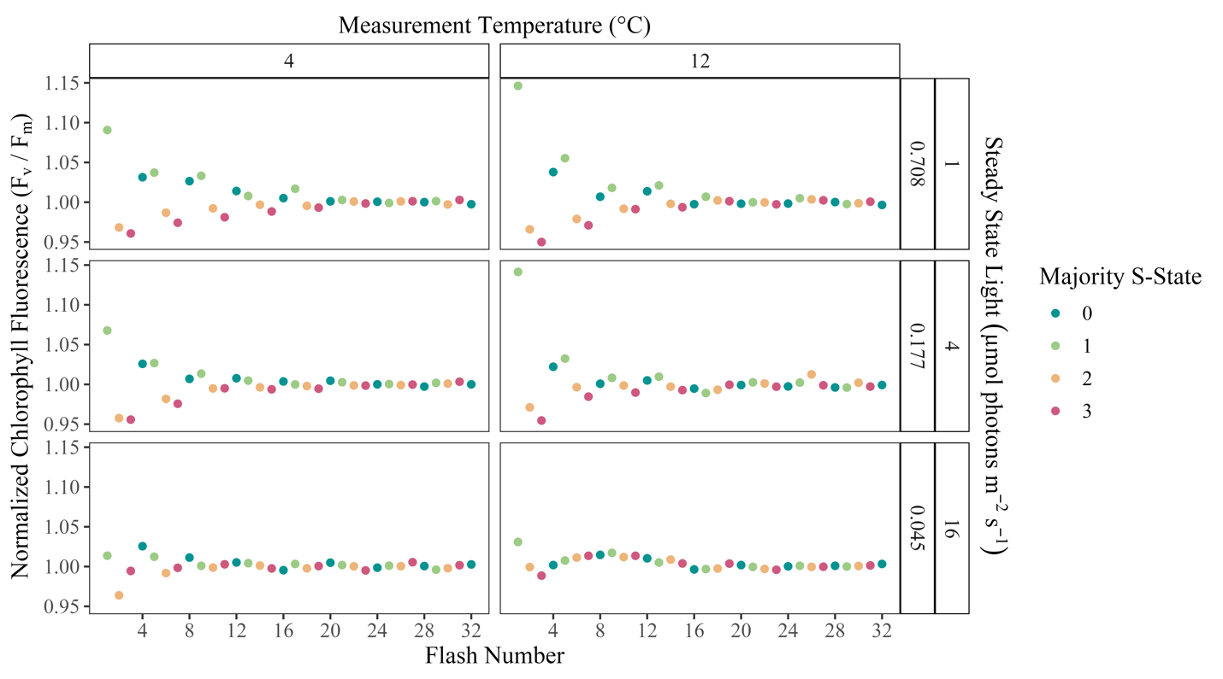

**Figure 1:** Oscillations in the maximum quantum yield of the photochemistry in *Chlamydomonas priscuii* cultures over a series of 32 flashes, as measured through the secondary chlorophyll fluorescence parameter FV/FM. Representative conditions include cultures at 4 and 12 °C, under steady-state light levels of 0.088 – 0.708 µmol photons m-2s-1, analogous to flash spacings of 8 – 1 seconds.

**3.2. Wavelet Analysis**

Wavelet transformations were computed for the fluorescence time series of each unique combination of measurement temperature, steady-state light level, and strain. Assessing the wavelet power of a 4-step periodicity across conditions, key trends emerge. As exemplified by the polar alga *C. priscuii* (Figure 2A), the average wavelet power declines with increasing temperature and decreasing light. While this trend remains in the temperate taxa (Figure 2B), the wavelet power is consistently lower, suggesting weaker 4-step periodicity in temperate taxa.

**A**

**B**

**Figure 2:** Sample plot of wavelet power by period of oscillations in the maximum quantum yield of photochemistry in A. *Chlamydomonas priscuii* and B. *Chlamydomonas reinhardtii* cultures across a range of measurement temperatures and steady-state light levels, with their equivalent flash spacings.

Polar taxa exhibited significant 4-step oscillations in Fv/Fm across a broader range of conditions than their temperate counterparts (Figure 3). The temperate diatom *T. pseudonana* showed significant s-state cycling across 20.57 % of measured conditions, compared to 85% in its polar counterpart, *F. cylindrus*. Similarly, the temperate green algae *C. vulgaris* and *C. reinhardtii* displayed significant cycling across 32% and 40 % of conditions. Meanwhile, significant cycling occurred in 60, 73, and 80% of measurement conditions for the polar algae *C. ICEMDV*, *C. malina*, and *C. priscuii*.

**Figure 3:** Statistical significance of 4-step oscillations in the maximum quantum yield of PSII photochemistry across polar and temperate phytoplankton taxa, as measured through variable chlorophyll fluorescence.

**3.3. Generalized Additive Modelling**

*By Deviation from Growth Temperature*

Predictions from generalized additive modelling were generated for the damping of S-state-induced chlorophyll fluorescence oscillations as predicted by the tensor product smooth of the deviation from growth temperature (°C) and the steady-state light level (µmol photons m-2s-1; Table 1).

Table 1: Summary statistics by phytoplankton strain of GAM models using the restricted maximum likelihood method to model the response of the damping of S-state-induced chlorophyll fluorescence oscillations to the predictors of deviation from growth temperature (°C) and the steady-state light level (µmol photons m-2s-1).

|  |  |  |  |  |  |
| --- | --- | --- | --- | --- | --- |
| Strain | Significance of smooth term | | | Adjusted R2 | Deviance Explained |
| EDF | F-ratio | P-value |
| *F. cylindrus* | 7.23 | 6.82 | 2.8e-05 | 0.584 | 66.1% |
| *T. pseudonana* | 6.08 | 9.01 | 5.38e-06 | 0.674 | 73.2% |
| *C. ICEMDV* | 4.51 | 6.59 | 0.00687 | 0.687 | 78.8% |
| *C. priscuii* | 4.31 | 2.17 | 0.115 | 0.389 | 57.7% |
| *C. malina* | 4.34 | 2.56 | 0.0843 | 0.423 | 60.2% |
| *C. reinhardtii* | 6.05 | 9.49 | 0.000274 | 0.786 | 85.4% |
| *C. vulgaris* | 5.39 | 13.83 | 4.08e-06 | 0.772 | 82.3% |

The smoothing term was significant for the polar diatom *F. cylindrus* (F = 6.835, p = 2.8e-05), explaining 66.1% (adjusted R2 = 0.584) of the deviance in the damping index. Similarly, the model of the temperate diatom, *T. pseudonana*, produced a significant smoothing term (F = 9.01, p = 5.38e-06), which accounted for 73.2% of the deviance in the damping index (adjusted R2 = 0.674). These models were used to predict the number of consecutive flashes before the damping of ChlF oscillations for each strain at each combination of temperature deviation and light level (Figure 4).

Both diatom taxa exhibited the longest predicted periodic oscillations in ChlF at higher light levels and lower temperatures. Notably, the polar *F. cylindrus* sustained cycling longer than its temperate counterpart, *T. pseudonana*, under comparable conditions. This disparity was particularly prevalent above the growth temperature and under low steady-state light (Figure 4). At these conditions, *T. pseudonana* cultures did not exhibit the significant 4-step oscillation in ChlF indicative of S-state cycling.

**Figure 4**: GAM model predictions of the consecutive flashes before the damping of S-state-induced chlorophyll fluorescence oscillations as predicted by the deviation from growth temperature (°C) and the steady-state light level (µmol photons m-2s-1) experienced by polar and temperate diatoms.

The GAM output varied more between algal strains (Table 1). The smoothing term was significant for the temperate strains *C. reinhardtii* (F = 9.49, p = 0.000274) and *C. vulgaris* (F = 13.83, p = 4.08e-06), predicting 85.4% (adjusted R2 = 0.786) and 82.3% (adjusted R2 = 0.772) of the deviance in the damping index, respectively. However, while the smoothing term was significant (F = 6.59, p = 0.00687), predicting 78.8% (adjusted R2 = 0.687) of the deviance for the polar *C. ICEMDV*, it was not significant for the other two polar taxa. For *C. priscuii*, the statistical evaluation of the smoothing term produced an F value of 2.17 and a corresponding p-value of 0.115, explaining only 57.7% (adjusted R2 = 0.389) of the deviance in the response variable. Similarly, the non-significant smoothing term for *C. malina* (F = 2.56, p = 0.0843) only explained 60.2% of the deviance in the damping index (adjusted R2 = 0.423).

Overall, model predictions for algal strains exhibited a similar pattern to the diatoms, with the longest predicted periodic oscillations in ChlF at higher light levels and lower temperatures (Figure 5). The trends shown by the three strains of polar algae are remarkably consistent, displaying virtually identical patterns and differing by only 1-2 flashes before S-state damping under identical conditions (Figure 5). Further, much like the temperate diatoms, the temperate algae *C. reinhardtii* and *C. vulgaris* did not exhibit significant periodic oscillations in ChlF around their growth temperature under low steady-state light (Figure 5).

**Figure 5**: GAM model predictions of the consecutive flashes before the damping of S-state-induced chlorophyll fluorescence oscillations as predicted by the deviation from growth temperature (°C) and the steady-state light level (µmol photons m-2s-1) experienced by polar and temperate green algae.

*By Measurement Temperature*

Table 2: Summary statistics by phytoplankton strain of GAM models using the restricted maximum likelihood method to model the response of the damping of S-state-induced chlorophyll fluorescence oscillations to the predictors of measurement temperature (°C) and the steady-state light level (µmol photons m-2s-1).

|  |  |  |  |  |  |
| --- | --- | --- | --- | --- | --- |
| Strain | Significance of smooth term | | | Adjusted R2 | Deviance Explained |
| EDF | F-ratio | P-value |
| *F. cylindrus* (grown at 0°C) | 6.06 | 4.46 | 0.00827 | 0.609 | 73.4% |
| *F. cylindrus* (grown at 6°C) | 5.49 | 3.42 | 0.0279 | 0.509 | 65.1% |
| *T. pseudonana* | 6.08 | 9.01 | 5.38e-06 | 0.674 | 73.2% |
| *C. ICEMDV* | 4.51 | 6.59 | 0.00687 | 0.687 | 78.8% |
| *C. priscuii* | 4.31 | 2.17 | 0.115 | 0.389 | 57.7% |
| *C. malina* | 4.34 | 2.56 | 0.0843 | 0.423 | 60.2% |
| *C. reinhardtii* | 6.05 | 9.49 | 0.000274 | 0.786 | 85.4% |
| *C. vulgaris* | 5.39 | 13.83 | 4.08e-06 | 0.772 | 82.3% |

**Figure 6**: GAM model predictions of the consecutive flashes before the damping of S-state-induced chlorophyll fluorescence oscillations as predicted by the measurement temperature (°C) and the steady-state light level (µmol photons m-2s-1) experienced by polar and temperate diatoms. White dashed lines represent the growth temperatures of the individual cultures.

**Figure 7**: GAM model predictions of the consecutive flashes before the damping of S-state-induced chlorophyll fluorescence oscillations as predicted by the measurement temperature (°C) and the steady-state light level (µmol photons m-2s-1) experienced by polar and temperate green algae. White dashed lines represent the growth temperatures of the individual cultures.