**PLEASE DO NOT EDIT**

ANY FURTHER CHANGES SHOULD BE MADE TO THESIS_FORMATTED

**Results**

**3.1. Single Turnover Variable Chlorophyll Fluorescence**

Exposing phytoplankton cultures to a series of 32 successive flashes produced oscillations in the maximum quantum yield of photochemistry in PSII, as estimated through the secondary chlorophyll fluorescence parameter FV/FM. Initially, the majority of the dark-adapted population of PSII is at S1, with a smaller fraction at S0 [1,2]. As shown in Figure 1 for the polar alga *C. priscuii,* the time series of FV/FM over successive flashes reveals consistent variations in fluorescence yield as the predominant s-states follow each other across the PSII within the population. However, the amplitude of the ChlF oscillations declines progressively over time, and with wider spacing of sequential flashes, equivalent to decreasing light levels.

**Figure 1:** Oscillations in the maximum quantum yield of the photochemistry in *Chlamydomonas priscuii* cultures over a series of 32 flashes, as measured through the secondary chlorophyll fluorescence parameter FV/FM. Representative conditions include cultures measured at 4 or 12 °C, with flash spacings of 8 – 1 seconds, equivalent to effective light levels of 0.088 – 0.708 µmol photons m-2s-1.

**3.2. Wavelet Analysis**

Wavelet transformations were computed for the fluorescence time series of each unique combination of measurement temperature, flash spacing (equivalent to effective light level), and strain. Assessing the wavelet power of a 4-step periodicity across conditions, key trends emerge. As exemplified by the polar alga *C. priscuii* (Figure 2

A), the average wavelet power declines with increasing flash spacings (equivalent to decreasing effective light levels) and measurement temperatures. While this trend remains in the temperate taxa (Figure 2B), the wavelet power is consistently lower, suggesting a weaker 4-step periodicity of ChlF in temperate taxa.

**A**

**B**

**Figure 2:** Sample plot of wavelet power by period of oscillations in the maximum quantum yield of photochemistry in A. Polar *Chlamydomonas priscuii* and B. Temperate *Chlamydomonas reinhardtii* cultures across a range of measurement temperatures and flash spacings, with the equivalent effective light levels.

Polar taxa maintained significant 4-step oscillations in Fv/Fm,and thus stronger synchronization of PSII S-State cycling across a broader range of measurement conditions, than did their temperate counterparts (Figure 3). The temperate diatom *T. pseudonana* showed significant 4-step ChlF oscillations across 20.57 % of measured conditions, compared to 85% of measured conditions in its polar counterpart, *F. cylindrus*. Similarly, significant 4-step ChlF oscillations occurred across 32% and 40 % of measurement conditions for the temperate green algae *C. vulgaris* and *C. reinhardtii,* and60, 73, and 80% of measurement conditions for the polar algae *C. ICEMDV*, *C. malina*, and *C. priscuii*.

**Figure 3:** Statistical significance of 4-step oscillations in the maximum quantum yield of PSII photochemistry across polar and temperate phytoplankton taxa, as measured through variable chlorophyll fluorescence.

**3.3. Generalized Additive Modelling by Deviation from Growth Temperature**

Predictions from generalized additive modelling were generated for the damping of S-state-induced chlorophyll fluorescence oscillations, as predicted by the tensor product smooth of the deviation from growth temperature during measurements (°C) and the effective light level (µmol photons m-2s-1; Table 1) for each strain.

**Table 1:** Summary statistics by phytoplankton strain of GAM models using the restricted maximum likelihood method to model the response of the damping of S-state-induced chlorophyll fluorescence oscillations to the predictors of deviation from growth temperature (°C) and the effective light level (µmol photons m-2s-1).

|  |  |  |  |  |  |
| --- | --- | --- | --- | --- | --- |
| Strain | Significance of smooth term | | | Adjusted R2 | Deviance Explained |
| EDF | F-ratio | P-value |
| *F. cylindrus* | 7.23 | 6.82 | 2.8e-05 | 0.584 | 66.1% |
| *T. pseudonana* | 6.08 | 9.01 | 5.38e-06 | 0.674 | 73.2% |
| *C. ICEMDV* | 4.51 | 6.59 | 0.00687 | 0.687 | 78.8% |
| *C. priscuii* | 4.31 | 2.17 | 0.115 | 0.389 | 57.7% |
| *C. malina* | 4.34 | 2.56 | 0.0843 | 0.423 | 60.2% |
| *C. reinhardtii* | 6.05 | 9.49 | 0.000274 | 0.786 | 85.4% |
| *C. vulgaris* | 5.39 | 13.83 | 4.08e-06 | 0.772 | 82.3% |

The smoothing term was significant for the polar diatom *F. cylindrus* (F = 6.835, p = 2.8e-05), explaining 66.1% (adjusted R2 = 0.584) of the deviance in the damping index. Similarly, the model of the temperate diatom, *T. pseudonana*, produced a significant smoothing term (F = 9.01, p = 5.38e-06), which accounted for 73.2% of the deviance in the damping index (adjusted R2 = 0.674). These models were used to predict the number of consecutive flashes before the damping of ChlF oscillations for each strain at each combination of deviation from growth temperature during measurements (°C) and effective light level (µmol photons m-2s-1; Figure 4).

Both diatom taxa exhibited the longest predicted periodic oscillations in ChlF at higher effective light levels and lower temperatures. Notably, the polar *F. cylindrus* sustained cycling longer than its temperate counterpart, *T. pseudonana*, under comparable conditions. This disparity was particularly prevalent above the growth temperature and when longer spacing between flashes produced lower effective light levels (Figure 4). Under these conditions, *T. pseudonana* cultures did not retain the significant 4-step oscillation in ChlF indicative of synchronized S-state cycling.

**Figure 4**: GAM model predictions of the consecutive flashes before the damping of S-state-induced chlorophyll fluorescence oscillations as predicted by the deviation from growth temperature (°C) during measurements and the effective light level (µmol photons m-2s-1, with equivalent flash spacings in seconds) experienced by polar and temperate diatoms. White dashed lines represent the growth temperatures.

The GAM outputs varied more among algal strains (Table 1). The smoothing term was significant for the temperate strains *C. reinhardtii* (F = 9.49, p = 0.000274) and *C. vulgaris* (F = 13.83, p = 4.08e-06), predicting 85.4% (adjusted R2 = 0.786) and 82.3% (adjusted R2 = 0.772) of the deviance in the damping index, respectively. However, while the smoothing term was significant (F = 6.59, p = 0.00687), predicting 78.8% (adjusted R2 = 0.687) of the deviance for the polar *C. ICEMDV*, it was not significant for the other two polar taxa. For *C. priscuii*, the statistical evaluation of the smoothing term produced an F value of 2.17 and a corresponding p-value of 0.115, explaining only 57.7% (adjusted R2 = 0.389) of the deviance in the response variable. Similarly, the non-significant smoothing term for *C. malina* (F = 2.56, p = 0.0843) only explained 60.2% of the deviance in the damping index (adjusted R2 = 0.423).

Overall, model predictions for algal strains exhibited a similar pattern to the diatoms, with the longest predicted oscillations in ChlF at measurement conditions with higher effective light levels (shorter spacing between flashes) and lower measurement temperatures relative to growth temperature (Figure 5). The trends shown by the three strains of polar algae are remarkably consistent, displaying virtually identical patterns and differing by only 1-2 flashes before signal damping, under identical conditions (Figure 5). Further, much like the temperate diatoms, the temperate algae *C. reinhardtii* and *C. vulgaris* did not exhibit significant periodic oscillations in ChlF at measurement temperatures near or above their growth temperature and under the low light conditions produced by longer flash spacings (Figure 5).

**Figure 5**: GAM model predictions of the consecutive flashes before the damping of S-state-induced chlorophyll fluorescence oscillations as predicted by the deviation from growth temperature (°C) during measurements and the effective light level (µmol photons m-2s-1, with equivalent flash spacings in seconds) experienced by polar and temperate green algae. Dashed lines represent the growth temperatures.

**3.3. Generalized Additive Modelling By Measurement Temperature**

To facilitate comparison across actual measurement temperatures, additional generalized additive models were fit to the data. For *T. pseudonana, C. ICEMDV, C. priscuii, C. malina, C. reinhardtii,* and *C. vulgaris,* replicate cultures of the strain were grown at the same temperatures. Therefore, the GAMs generated for these strains encompass a different temperature range but are represented by the same summary statistics (Table 2). Conversely, the polar diatom *F. cylindrus* was cultured at both 0 and 6°C. Thus, separate models were fit for each *F. cylindrus* culture to account for possible physiological differences resulting from the distinct growth conditions.

The smoothing term was significant for both *F. cylindrus* cultures (0°C F = 4.46, p = 0.00827; 6°C F = 3.42, p = 0.0279). However, while the model accounted for 73.4% of the deviance in the damping response of *F. cylindrus* grown at 0°C (adjusted R2 = 0.609), it only accounted for 65.1% (adjusted R2 = 0.509) in *F. cylindrus* grown at 6°C (Table 2).

Table 2: Summary statistics by phytoplankton strain of GAM models using the restricted maximum likelihood method to model the response of the damping of S-state-induced chlorophyll fluorescence oscillations to the predictors of measurement temperature (°C) and the effective light level (µmol photons m-2s-1).

|  |  |  |  |  |  |
| --- | --- | --- | --- | --- | --- |
| Strain | Significance of smooth term | | | Adjusted R2 | Deviance Explained |
| EDF | F-ratio | P-value |
| *F. cylindrus* (grown at 0°C) | 6.06 | 4.46 | 0.00827 | 0.609 | 73.4% |
| *F. cylindrus* (grown at 6°C) | 5.49 | 3.42 | 0.0279 | 0.509 | 65.1% |
| *T. pseudonana* | 6.08 | 9.01 | 5.38e-06 | 0.674 | 73.2% |
| *C. ICEMDV* | 4.51 | 6.59 | 0.00687 | 0.687 | 78.8% |
| *C. priscuii* | 4.31 | 2.17 | 0.115 | 0.389 | 57.7% |
| *C. malina* | 4.34 | 2.56 | 0.0843 | 0.423 | 60.2% |
| *C. reinhardtii* | 6.05 | 9.49 | 0.000274 | 0.786 | 85.4% |
| *C. vulgaris* | 5.39 | 13.83 | 4.08e-06 | 0.772 | 82.3% |

Although measured at the same range of temperatures, the two *F. cylindrus* cultures from different growth temperatures exhibited different trends in ChlF oscillations. First, the culture grown at 0°C exhibited the significant 4-step oscillation in ChlF indicative of synchronized S-state cycling across only 75% of the measured conditions, compared to 95% of the measurement conditions for the culture grown at 6°C (Figure 6). Further, at comparable measurement temperatures under wide flash spacing, equivalent to low light, the culture grown at 6°C maintained significant cycling for longer (Figure 7). At flash spacings equivalent to light levels above 0.2 µmol photons m-2s-1, cultures from both 0 and 6°C growth temperatures exhibited similar, stable damping indices (Figure 7).

**Figure 6:** Statistical significance of 4-step oscillations in the maximum quantum yield of PSII photochemistry across measurement conditions in the polar diatom *F. cylindrus*, as measured through variable chlorophyll fluorescence.

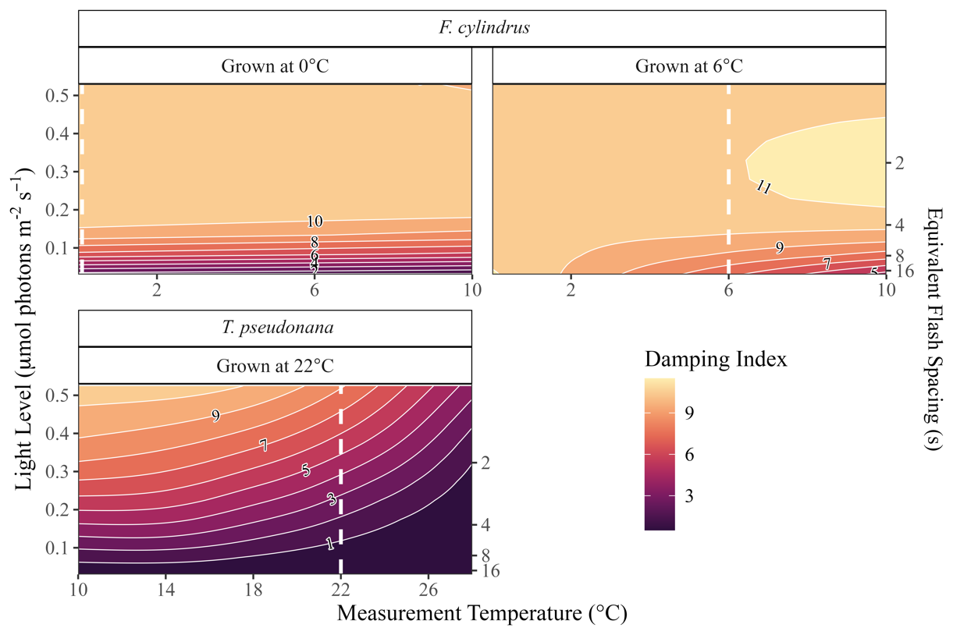

**Figure 7**: GAM model predictions of the consecutive flashes before the damping of S-state-induced chlorophyll fluorescence oscillations as predicted by the measurement temperature (°C) and effective light level (µmol photons m-2s-1; with equivalent flash spacings in seconds) experienced by polar and temperate diatoms. White dashed lines represent the growth temperatures of the individual cultures.

At a measurement temperature of 10°C, the model predicts that the duration of ChlF oscillations (Damping Index) for *F. cylindrus* will sharply increase with effective light before plateauing at approximately 0.2 µmol photons m-2s-1, the light level produced by a 4-second interval between flashes (Figure 8). At light levels below 0.5 µmol photons m-2 s-1, this corresponds to *F. cylindrus* exhibiting more sustained ChlF oscillations than does *T. pseudonana* also measured at 10°C. However, at this common measurement temperature and the higher effective light levels produced by shorter flash spacings, *T. pseudonana* sustains ChlF oscillations for durations comparable to its polar counterpart *F. cylindrus* (Figure 8).

**Figure 8:** GAM model predictions of the consecutive flashes before the damping of S-state-induced chlorophyll fluorescence oscillations in polar and temperate diatom cultures over a range of effective light levels (µmol photons m-2s-1) at a common measurement temperature of 10°C. The effective light levels for the model training data were calculated based on the spacing (seconds) between sequential flashes delivered to the culture.

For the green algae, the models using measurement temperature as a predictor depicted the same trends between and within strains as the models using the deviation from growth temperature as a predictor (Figure 9).

**Figure 9**: GAM model predictions of the consecutive flashes before the damping of S-state-induced chlorophyll fluorescence oscillations as predicted by the measurement temperature (°C) and the effective light level (µmol photons m-2s-1; with equivalent flash spacings in seconds) experienced by polar and temperate green algae. White dashed lines represent the growth temperatures of the individual strains.

However, the model predictions at a shared measurement temperature of 12°C demonstrate limited variation among taxa (Figure 10). For all strains, the duration of significant ChlF oscillations increased with the higher effective light levels corresponding to shorter intervals between sequential flashes. Two polar strains, *C. priscuii* and *C. malina*, and the temperate *C. reinhardtii* showed near-identical trajectories. While the temperate *C. vulgaris* exhibits less sustained ChlF oscillations at low effective light levels, it achieves similar durations to the *Chlamydomonas* strains by flash spacings of 2 seconds, equivalent to an effective light level of approximately 0.3 µmol photons m-2s-1. Unexpectedly, the polar alga *C. ICEMDV* consistently exhibits the shortest duration of ChlF oscillations, indicative of the least sustained S-State cycling across all measurement conditions (Figure 10).

**Figure 10:** GAM model predictions of the consecutive flashes before the damping of S-state-induced chlorophyll fluorescence oscillations in polar and temperate green algae strains over a range of effective light levels (µmol photons m-2s-1) at a common measurement temperature of 12°C. The effective light levels for the model training data were calculated based on the spacing (seconds) between sequential flashes delivered to the culture.

References

1. de Wijn R, van Gorkom HJ. S-state dependence of the miss probability in Photosystem II. Photosynthesis Research. 2002;72: 217–222. doi:10.1023/A:1016128632704

2. Gates C, Ananyev G, Dismukes GC. Realtime kinetics of the light driven steps of photosynthetic water oxidation in living organisms by “stroboscopic” fluorometry. Biochimica et Biophysica Acta (BBA) - Bioenergetics. 2020;1861: 148212. doi:10.1016/j.bbabio.2020.148212