PHOTOSYNTHETIC ADAPTATIONS OF POLAR PHYTOPLANKTON

TO EXTREME LOW LIGHT

BY

NATASHA MADELEINE RYAN

A thesis submitted to the

Department of Biology

Mount Allison University

in partial fulfillment of the requirements for the

Bachelor of Science degree with Honours in Biology

April 19, 2024

Table of Contents

List of Figures and Tables 2

Acknowledgements 3

Abstract 4

Introduction 1

Polar Phytoplankton 1

Arctic Blooms 2

Cold Adaptations 3

Energetic Principles of Photosynthesis 5

Recombination 6

S-State Cycling 8

Study Aims 9

Materials & Methods 10

Study Strains 10

Culturing Protocols 10

Single Turnover Variable Chlorophyll Fluorescence 12

Measurement Conditions 15

Analytical Methods 17

Wavelet Transformations 17

Generalized Additive Modelling 19

Results 21

Single Turnover Variable Chlorophyll Fluorescence 21

Wavelet Analysis 22

Generalized Additive Modelling by Deviation from Growth Temperature 24

Generalized Additive Modelling By Measurement Temperature 28

Discussion 34

Modelling and Operational Limitations 34

Consistent Responses to Measurement Conditions 35

Comparisons Among Strains 36

Ecological Implications & Future Directions 37

References 39

Appendix 45

# List of Figures and Tables

# Acknowledgements

* Dr. Campbell
* Lab members
* Funding (NSERC?)
* Takuvik people
* UOttawa people
* Honours cohort, family, & friends

# Abstract

Polar phytoplankton are vital for global aquatic ecosystems, driving primary production, biogeochemical cycling, carbon sequestration, biodiversity, and climate regulation. The slow but significant productivity of polar phytoplankton at exceptionally low light suggests possible adaptations for low-light photosynthesis. We hypothesized that maintaining photosynthesis under extremely low light involves suppressing energetically wasteful charge recombinations in Photosystem II. These recombinations desynchronize the four-step cycle of Photosystem II oxygen evolution. Therefore, we used single turnover variable chlorophyll fluorescence to detect changes in recombination in polar diatoms and green algae in response to temperature and photon delivery frequency. Prolonged synchronous cycling indicates fewer wasteful recombination reactions and, thus, more efficient photosynthetic energy conversion under low light. Within taxa, we observed that higher photon delivery rates and colder temperatures result in less recombination. Further, polar taxa synchronized cycles for longer durations than temperate taxa under comparable conditions. Our findings support our hypothesis that diverse polar phytoplankton have evolved capacities to sustain photosynthesis under extreme low light. This research challenges the conventional understanding of the limits on photosynthesis under light limitation, helping unravel polar ecosystem dynamics and predict ecosystem responses to climate change.

# Introduction

## Polar Phytoplankton

Phytoplankton are photosynthetic microorganisms with diverse evolutionary histories and ecologies [1]. Inhabiting aquatic environments, phytoplankton can be found in oceans, lakes, rivers, streams, estuaries, and wetlands across the biosphere.

Photolithotrophic growth, a defining characteristic of phytoplankton, fuels the production of biomass by harnessing light energy to oxidize inorganic compounds containing carbon, nitrogen, phosphorus, sulfur, and other essential micronutrients [2]. With photons as the sole energy input, phytoplankton growth is constrained to the photic zone, the region of water receiving sufficient light for photosynthesis. Photosynthetically active radiation (PAR) decreases with depth as the light passing through the water column is scattered and absorbed [3]. Eventually, light attenuates to a level defined as the bottom limit of the photic zone, operationally established at 1% of surface irradiance, equivalent to 2-20 µmol photons m-2 s-1 [2].

Light availability is further constrained in polar regions, presenting unique challenges for phytoplankton growth [4,5]. The radiation that penetrates through the ice is influenced by solar angle, sea ice thickness, and snow depth [6]. The solar elevation angle changes because of the obliquity, or tilt, of the Earth as it orbits the sun, resulting in the polar night and midnight sun, depending upon latitude and season. The thickness of the ice and snowpack further constrains light, with reflective and relatively opaque ice and snow cover limiting the light that penetrates these environments [4]. Snow, in particular, shows high light attenuation properties, further lowering the already limited light energy [5].

Despite these constraints, certain psychrophile phytoplankton demonstrate slow but significant productivity under the ice in the winter through photosynthesis at extremely low light levels [4,5]. Across the Arctic, phytoplankton have been reported beneath the sea ice from Resolute Bay to the North of Svalbard, Baffin Bay, and the Greenland, Barents, Laptev, and Chukchi Seas [7]. In 1995, the lower limit of the photic zone was reconsidered as benthic microalgae in the Antarctic were reported photosynthetically active at light levels less than 1 µmol photons m-2 s-1 [8]. Moreover, more recent studies have documented winter phytoplankton growth below >1m of snow and 1 m of sea ice, corresponding to PAR below 0.15 µmol photons m-2 s-1 [5]. This represents photosynthesis occurring at light levels 1-2 orders of magnitude below the historical lower limit for the photic zone.

Slow but significant growth during winter under the ice underscores the ability of psychrophilic phytoplankton to maintain intact photosystems throughout the polar night [4]. Further, it offers support for a theoretical minimum light level for phytoplankton growth of 0.01 µmol photons m-2 s-1 [2]. Such low-light phytoplankton photosynthesis and growth may serve to mitigate cell mortality in the extended darkness of winter, establishing a seeding population for the spring bloom [4].

### Arctic Blooms

As the ice begins to retreat in the spring, phytoplankton blooms start to appear in the Arctic Ocean. Spring blooms are a major source of annual net primary production in this region, representing the most significant event for carbon export to higher trophic levels or biological sequestration in the deep ocean [7]. However, the ice-free period is also characterized by the stratification of surface water, which limits the inorganic nutrient supply [6]. Nutrient limitation imposes an upper limit on the size and duration of polar spring blooms, resulting in a short productive period [6]. Regardless, spring phytoplankton blooms in the Arctic play key global biogeochemical roles in primary production and carbon cycling.

Polar regions play a pivotal role in carbon cycling, representing almost half of the global CO2 sequestration through microbial photosynthesis [9]. As part of this carbon cycle, phytoplankton form the biological carbon pump, mediating the drawdown of atmospheric carbon to the ocean's interior [1]. The increased solubility of CO2 at low water temperatures leads to substantial carbon sequestration through deep water formation at the poles, establishing a crucial carbon export pathway from surface waters to the deep ocean [5,7]. Further, substantial CO2 sequestration arises from high river inputs and the resistance of the terrestrially derived dissolved organic matter entering the Arctic basin to degradation [10].

Phytoplankton are highly productive relative to their biomass, owing to their rapid proliferation and photosynthetic activity in all cells, which distinguishes them from terrestrial plants [1]. This productivity supports rapid consumption by higher trophic levels, creating a prolific food source for ice-associated zooplankton and amphipods. Therefore, the timing of spring blooms is crucial in shaping food availability and the hatching success of associated zooplankton [5]. As the base of polar food webs, changing phytoplankton dynamics can have repercussions across all trophic levels.

The dynamics of polar phytoplankton blooms are currently undergoing substantial changes in both total annual productivity and seasonal peaks, primarily driven by climate change [7,11]. In the Arctic, the pace of warming is accelerating, resulting in multifaceted alterations within the marine ecosystem. The warming-induced reduction in sea ice extent and thickness has increased light availability, extending the potential phytoplankton growing season and expanding their potential open-water habitats [7]. Simultaneously, escalating freshwater inputs from melting contribute to an increase in vertical stratification, influencing nutrient availability. However, these effects are counterbalanced by heightened storm frequency and increased wind speeds, fostering vertical nutrient mixing [7]. Further, ocean acidification results in reduced calcification, while increased water temperatures boost metabolic activity for some species while posing challenges for obligate cold extremophiles [7,12].

These climate-driven modifications extend across the atmosphere, cryosphere, and ocean and greatly alter marine ecological dynamics, including productivity, interspecific interactions, population mixing, and pathogen and disease transmission [7]. Comprehending the adaptations and ecophysiology of psychrophilic phytoplankton becomes imperative in anticipating the consequences of these rapid global changes.

### Cold Adaptations

Numerous adaptations enable some psychrophile phytoplankton to survive in extreme polar environments. Microbes inhabiting sea ice must contend with solar, osmotic, oxidative and nutrient stress [10]. Further, as poikilotherms, they must overcome the severe inhibiting effects of a cold, low-energy environment. Cold temperatures place severe physiochemical constraints on the cellular functions of psychrophile phytoplankton, exerting a negative influence on water viscosity, solute diffusion rates, membrane fluidity, enzyme kinetics and macromolecule interactions [10].

As a result of their extreme environments, some psychrophilic phytoplankton exhibit high genetic divergence from closely related temperate species. A study of the polar diatom *F. cylindrus* found that approximately 25% of its genome consists of loci with highly divergent alleles from their mesophilic relatives [13]. Genes related to catalytic activity, transport, metabolic processes and those integral to membranes were shown to be significantly enriched compared to temperate species, consistent with known microbial adaptations to cold temperatures [13].

To combat the harsh cold, some psychrophiles produce new compounds or alter existing ones. Cryospheric enzyme flexibility is promoted by changes in protein structure, including amino acid substitutions, H-bonds, and salt bridges [10]. Further, synthesizing cold shock proteins minimizes cold protein denaturation while promoting replication, transcription, and translation under low-temperature conditions [10]. Psychrophile phytoplankton also possess anti-freeze proteins (AFPs), encoded by numerous genes identified through metagenomic analyses [14]. AFPs are released into the extracellular space, where they act on ice through an adsorption-inhibition mechanism, effectively inhibiting ice recrystallization. As temperatures dip below freezing, AFPs attach to the ice crystal, forcing the ice front to grow between them. This induces a surface curvature of the crystal that shifts the equilibrium vapour pressure, lowering the local freezing point and limiting local ice growth [14].

Beyond novel compounds, polar microbes alter their cell membranes and solutes. First, they utilize cellular-compatible solutes, including sugars, polyols, amino acids, betaine, and DMSP, which reduce intracellular freezing points and maintain enzyme hydration spheres, stabilizing catalytic activity [10]. Additionally, they exhibit high levels of polyunsaturated fatty acids (PUFAs) in their lipid membranes, including cell membrane phospholipids and chloroplast membrane galactolipids [10,12]. The unsaturated bonds contribute to a looser packing of lipids, maintaining membrane fluidity at cold temperatures.

Moreover, many psychrophilic species coordinate multiple metabolic routes to achieve photostasis, a delicate balance between energy input and utilization [12]. During dark periods, they employ the Entner-Doudoroff pathway (EDP). While the EDP provides less energy per molecule of glucose than glycolytic metabolism, it requires fewer resources for enzyme synthesis, representing a strategic trade-off [15]. Using this alternate metabolism may help the phytoplankton to retain the functionality of their photosynthetic apparatus during prolonged dark periods, allowing them to quickly recover upon re-illumination [12].

Much is known about these diverse physiochemical adaptations for surviving cold temperatures and low light. However, possible bioenergetic adaptations in the photosynthetic apparatus of psychrophilic phytoplankton remain understudied.

## Energetic Principles of Photosynthesis

Oxygenic photosynthesis is the metabolic process by which light energy, water, and carbon dioxide are converted to oxygen and carbohydrates. Photosynthesis in eukaryotic phytoplankton occurs in specialized organelles called chloroplasts, which, depending upon taxa, are bounded by a two-to-four-membrane envelope and filled with a granular matrix called the stroma [3]. The stroma comprises a concentrated solution of proteins, including the enzymes used in carbon dioxide fixation. Within the stroma are thylakoids, membranes containing pigments and electron carriers. The thylakoid membrane is composed of a polar lipid bilayer, and embedded in it is photosystem II (PSII), a multi-subunit protein complex (Figure 1) [3].

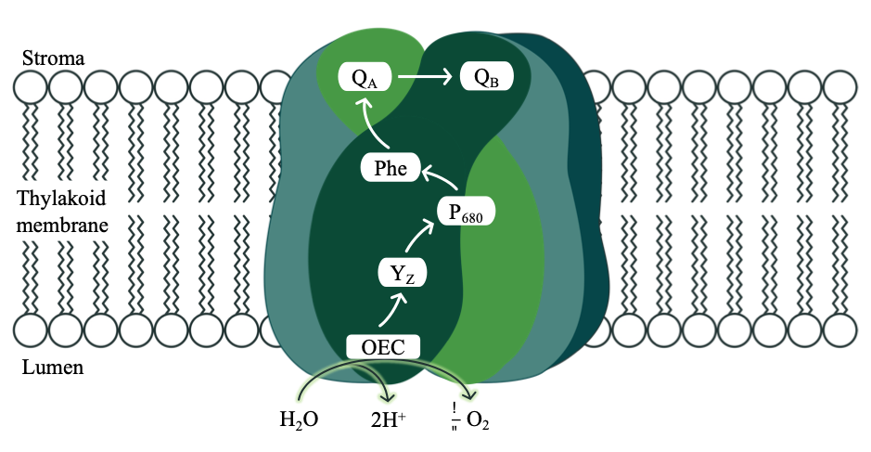

**Figure 1:** Electron flow through the photosystem II protein complex within the thylakoid membrane of chloroplasts.

PSII consists of 17 transmembrane protein subunits, three membrane-extrinsic protein subunits, and more than 40 cofactors, including the Mn cluster, chlorophylls, carotenoids, plastoquinones, and Fe2+. Ca2+, and Cl- ions [16,17]. During photosynthesis, PSII catalyzes light-induced charge separation and water oxidation, transferring electrons from a donor to acceptor molecules and producing molecular oxygen [16].

In PSII, photons are captured by light-harvesting chlorophyll molecules, composed of a central magnesium atom surrounded by cyclic tetrapyrrole [3]. Absorption of a photon by a chlorophyll molecule initiates a transition from the ground state to an electrically excited state. The excitation energy is distributed variably among three pathways: photochemistry, dissipation as heat (non-photochemical quenching, NPQ), and re-emission as fluorescence (ChlF) [18]. Energy directed towards photochemistry by antenna pigments first undergoes rounds of inductive resonance transfer among multiple pigments before eventually reaching the reaction center of PSII, where actual photochemistry occurs [3]. The reaction center, P680, is composed of a Chl a heterodimer PD1 and PD2 [17,19].

When P680 is raised to its excited state, P680+, it transfers an electron to an initial acceptor molecule and then withdraws an electron from a donor molecule [3]. On the acceptor side, P680+ first passes an electron to pheophytin (Phe). The electron from reduced Phe is transferred to plastoquinone A (QA), followed by transfer to plastoquinone B (QB) [17]. Once QB is fully reduced by receiving two electrons, the reduced QB is released, carrying the electrons into the mobile plastoquinone pool in the lipid phase of the thylakoid membrane [3]. On the donor side, P680+ returns to its ground state P680 by taking an electron from a tyrosine residue D1-Tyr-161 (Yz). Yz, in turn, extracts an electron from the manganese cluster in PSII [20].

### Recombination

During photosynthesis, electron transfers occur at both the donor and acceptor sides of Photosystem II (PSII), stabilizing separated charges [17]. However, these reactions remain reversible, occasionally resulting in the backflow of electrons through the pathway, referred to as recombination reactions [21]. Recombination plays a pivotal role in photodamage and photoprotection, harming PSII but proving essential for survival under excess light conditions [22].

At elevated light levels, the prior reduction of downstream electron acceptors blocks electron transfer from P680+. Under such conditions, the primary radical pair [P680+Phe-] will recombine, generating the excited triplet chlorophyll 3P680+ (Figure 2) [23]. Chlorophyll triplets react with ground-state molecular oxygen to produce singlet oxygen (1O2), a highly damaging, photoinhibitory reactive oxygen species [22].

Conversely, non-radiative charge recombination acts as a mechanism of photoprotection [17]. These pathways enable direct recombination from the singlet P680+Phe- or P680+QA- state and are governed by the redox potential of the QA and Phe electron acceptors [24]. Direct recombination helps prevent the accumulation of excess energy and competes with triplet chlorophyll formation in the PSII reaction center, thereby reducing the formation of harmful ROS [21].

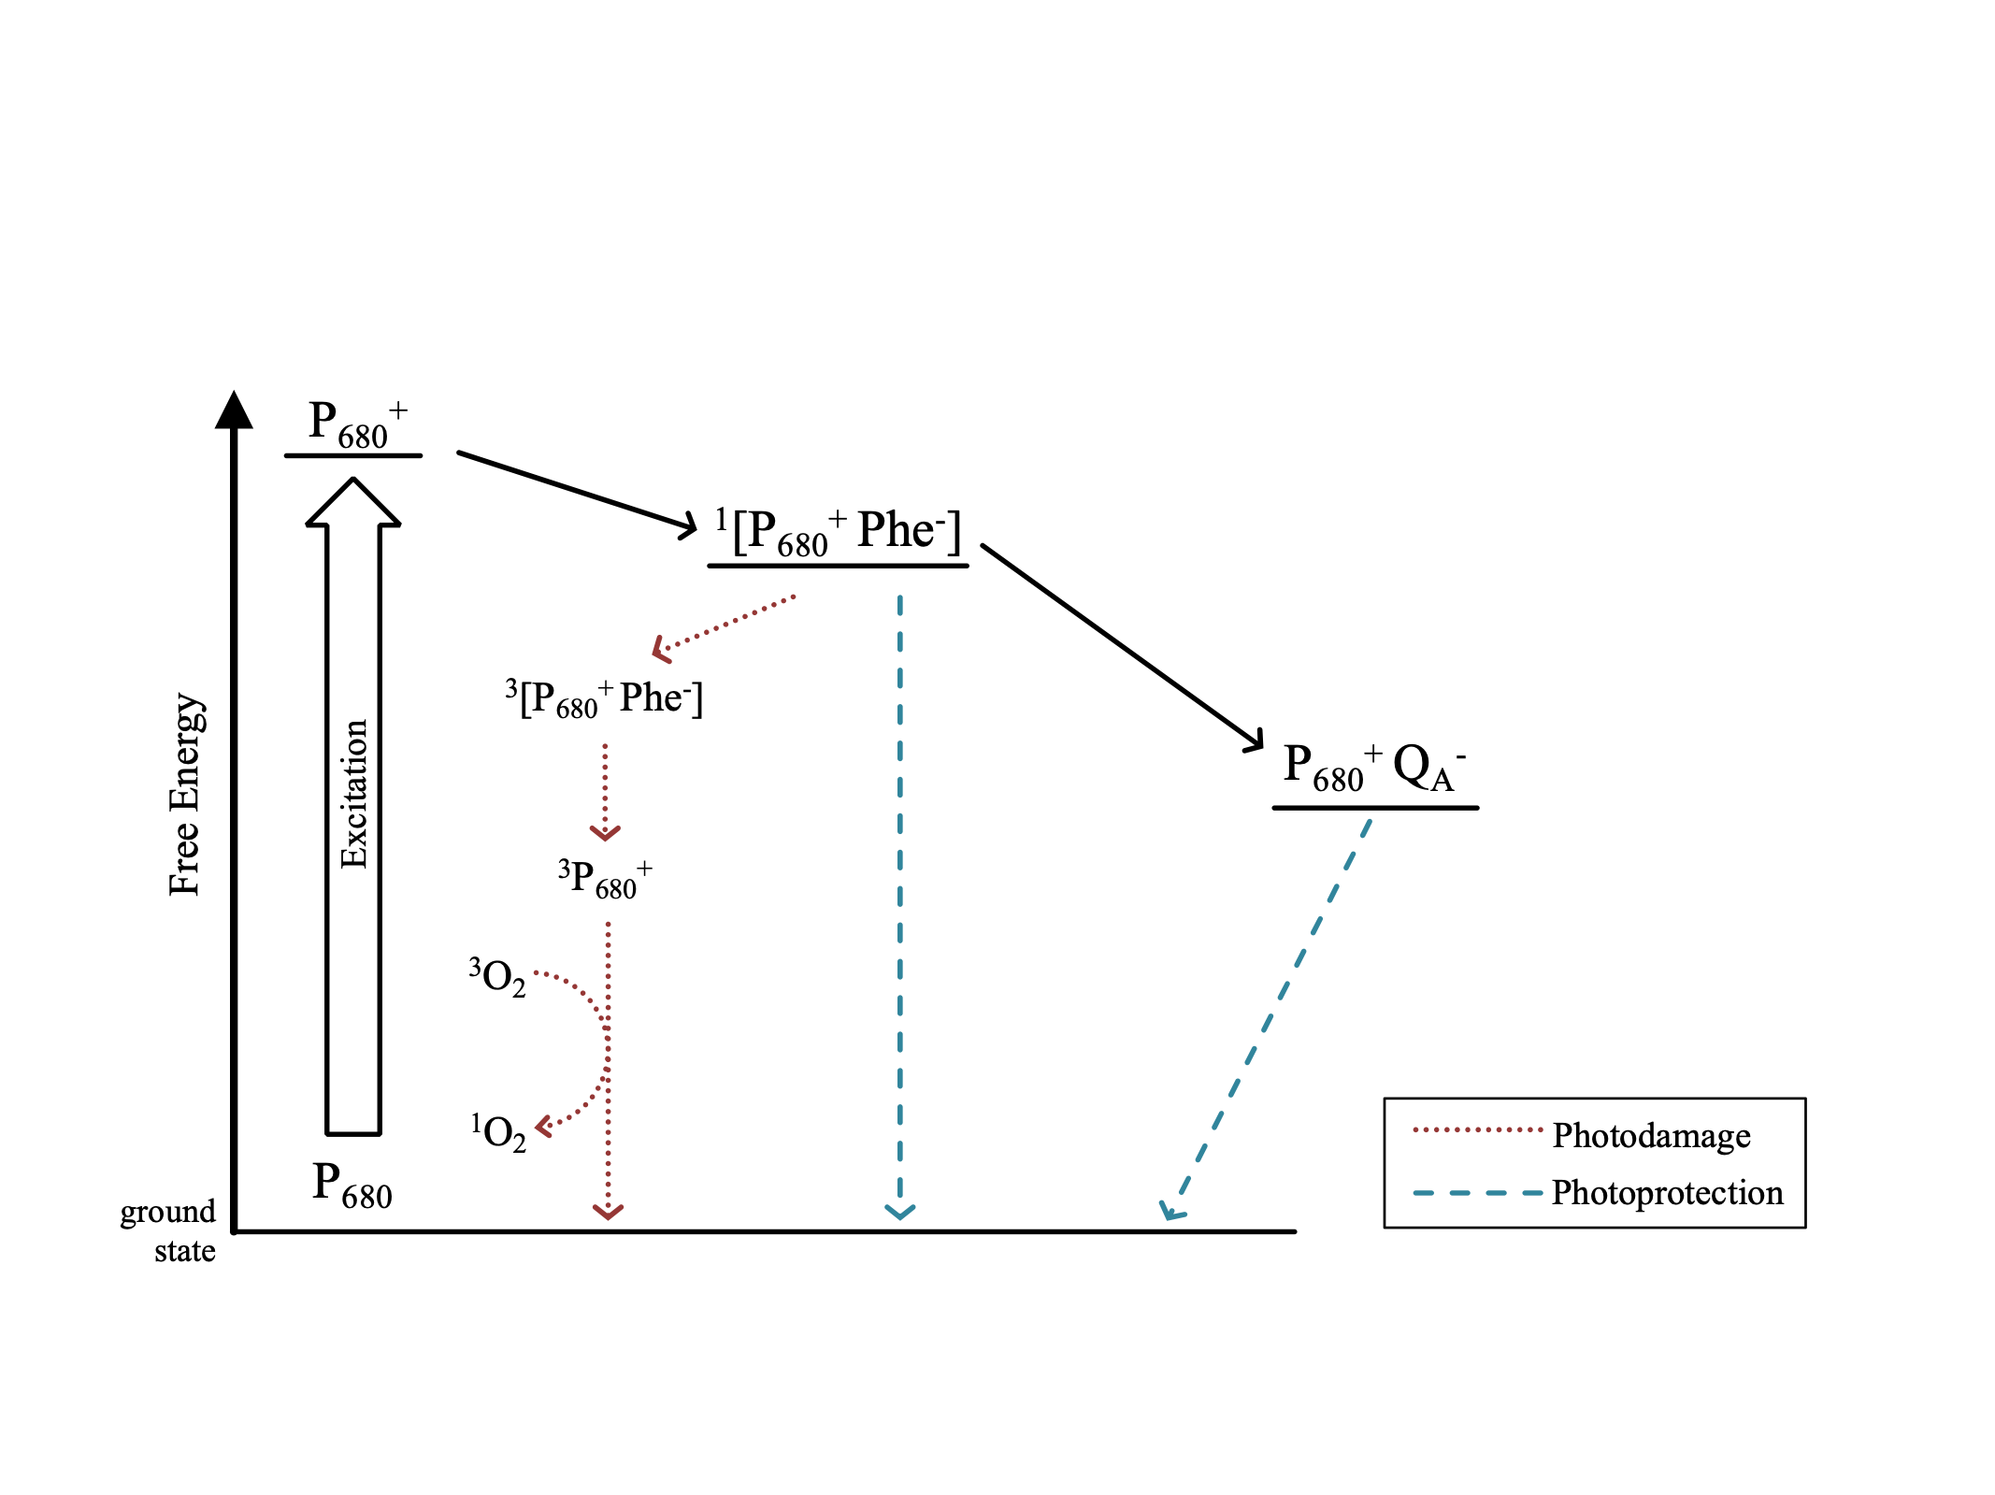

**Figure 2:** Photodamaging and photoprotective charge recombination pathways in photosystem II.

Beyond their roles in photodamage and photoprotection, charge recombination reactions may also occur as a wasteful process that lowers photosynthetic energy conversion efficiency [22]. Altering reduction potentials of downstream electron acceptors, leading to changes in energy gaps, may represent evolutionary adaptations aimed at maximizing photoprotection and minimizing inefficient back-reactions under light-limited conditions [25].

### S-State Cycling

The oxygen-evolving complex (OEC) of PSII is the active site where water is converted to oxygen and protons [26]. It consists of a metal-oxo cluster with the formula Mn4CaO5. As P680 absorbs successive photons, they induce charge separations, which cause electrons to be extracted from the Mn cluster. Each electron removed from the WOC replaces one lost by the reaction center when an electron is transferred downstream to metabolism. Consecutive charge separations induce four increasingly oxidized states, known as S-States [27], denoted as S0, S1,S2,andS3, followed by a transient S4 state, which rapidly decays to S0 (Figure 3). Once four photons have been absorbed and the Mn cluster has lost four electrons, it replaces them by oxidizing two water molecules to one molecule of molecular oxygen. Therefore, a complete water oxidation cycle during oxygenic photosynthesis requires the absorption of four photons and the successive accumulation of four oxidizing equivalents [26–28].

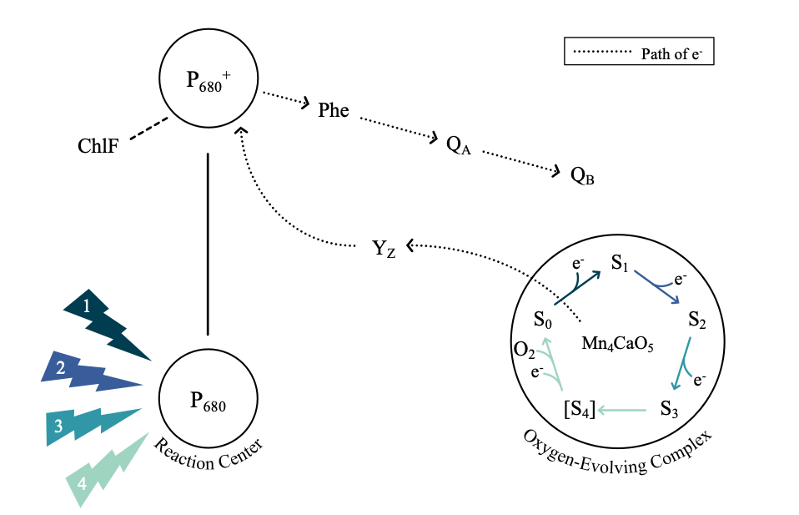

**Figure 3:** Pathway of S-State cycling and the electron transfer in PSII. Successive PSII charge separations extract successive electrons from the Mn cluster, inducing four increasingly oxidized states. After accumulating four oxidizing equivalents, 2 H2O molecules are oxidized to 1 O2 and four protons released to the lumenal side of the thylakoid.

Stable S-State cycling allows cells to maintain productive photosynthesis under light limitation, characterized by widely spaced photon arrivals. With low PSII excitation rates, there is reduced pressure driving downstream electron flow [29]. Under these conditions, there is an elevated probability of energetically wasteful recombination reactions, representing a step backward in the S-State cycle [29,30]. However, stable S-State cycling under low light ensures continued electron flow through the ETC, sustaining ATP and NADPH production, and minimizing the risk of photodamage to the photosynthetic machinery [22,29].

## Study Aims

This study evaluates if psychrophilic diatoms and green algae have evolved to increase photosynthetic energy conversion efficiency by minimizing inefficient back reactions.

The stability of S-State cycling in a phytoplankton sample may be evaluated by the applications of sequences of short, very bright, single-turnover light flashes. As sequential light flashes are applied, the population of PSII is driven synchronously through the S-State cycle [28]. In an idealized sample, the four S-States will be reflected by an ongoing periodic oscillation in ChlF. However, recombination reactions represent a loss of charge separation and wasteful slippage in the S-State cycling of individual PSII. As more recombination events occur, desynchronization of S-State cycling among the PSII of the population will scramble the periodic changes in ChlF, dampening the observed oscillation [30]. An organism exhibiting S-State cycling over more flash cycles indicates fewer inefficient back reactions and potentially more efficient photosynthetic energy conversion.

By comparing the S-State cycling over flash cycles, of psychrophilic and temperate taxa, we can determine if psychrophilic diatoms and green algae have evolved increased photosynthetic efficiency and under what conditions they may have a significant advantage in stable extraction of electrons from water.

# Materials & Methods

## Study Strains

Seven phytoplankton species were studied, including polar and temperate strains of diatoms and green algae. *F. cylindrus*, a psychrophilic pennate diatom measuring 15-55 µm, thrives in the high salinity and subzero temperatures of Arctic and Antarctic sea-ice systems [31,32]. Forming large blooms in the bottom layer of sea ice and across the wider sea ice zone, *F. cylindrus* acts as a keystone and indicator species for polar ecosystems [31,33]. Conversely, *T. pseudonana* is a small (2.5-15 μm) centric diatom found worldwide in diverse freshwater, coastal, brackish, and marine habitats [34]. *T. pseudonana* can tolerate a wide range of salinities (0.5%–37%) and temperatures (4–25°C), contributing to its frequent use as a model diatom species [34].

*Chlamydomonas ICEMDV* and *Chlamydomonas priscuii* are halotolerant algae isolated from the perennially ice-covered hypersaline Lake Bonney, in McMurdo Dry Valleys, Antarctica [35,36]. With large (15 to 20 μm) biflagellate cells, *C. ICEMDV* dominates the shallow photic zone, where it experiences higher irradiance, extreme nutrient limitation, and lower salinity [35,37]. The smaller *C. priscuii* dominates the deep photic zone, characterized by permanent low temperatures, low irradiance, and high salinity [12,38]. The final psychrophile species is *Chlamydomonas malina,* amarine microalga isolated from the Arctic Ocean's Beaufort Sea, measuring around 10 μm in length and 5 μm in width, and growing optimally at 4°C [39,40]. *C. reinhardtii* is a model green alga approximately 10 μm in size and found in soil and aquatic environments with an optimal temperature range of 20-32°C [41,42]. *C. vulgaris*, ranging from 2 μm to 10 μm in size, is primarily found in freshwater environments and grows optimally at 27°C [43,44].

### Culturing Protocols

The seven species and their respective culturing conditions are summarized in Table 1. Cultures of *T. pseudonana* and *C. vulgaris* were prepared by Naaman Omar (Mount Allison University); *Chlamydomonas* cultures were prepared by MacKenzie Poirier (Cvetskova Lab, University of Ottawa); and *F. cylindrus* cultures were prepared by Sébastien Guérin (Takuvik International Research Laboratory, Université Laval).

**Table 1:** Culturing conditions for experimental phytoplankton strains

|  |  |  |  |  |  |
| --- | --- | --- | --- | --- | --- |
| Genus | Species | Growth  Temp (°C) | Par (µmol photons m-2s-1) | Photoperiod | Media |
| *Thalassiosira* | *pseudonana* | 22 | 50 | 12 | F2 |
| *Chlorella* | *vulgaris* | 22 | 50 | 12 | F2 |
| *Chlorella* | *vulgaris* | 22 | 50 | 12 | BG11 |
| *Chlorella* | *vulgaris* | 22 | 70 | 12 | BG11 |
| *Thalassiosira* | *pseudonana* | 22 | 70 | 12 | F2 |
| *Fragilariopsis* | *cylindrus* | 0 | 10 | 24 | F2 |
| *Fragilariopsis* | *cylindrus* | 6 | 10 | 24 | F2 |
| *Chlamydomonas* | *priscuii* | 4 | 10 | 24 | BBM |
| *Chlamydomonas* | *ICEMDV* | 4 | 10 | 24 | BBM |
| *Chlamydomonas* | *malina* | 4 | 10 | 24 | BBM |
| *Chlamydomonas* | *reinhardtii* | 24 | 10 | 24 | BBM |

## Single Turnover Variable Chlorophyll Fluorescence

A single turnover variable chlorophyll fluorescence (St-ChlF) approach was employed to evaluate the progressive desynchronization of the S-State cycle across the range of phytoplankton species and growth temperatures.

A 100 µL sample of each culture was taken for a chlorophyll assay. Chlorophyll was extracted using a solution of acetone and DMSO, and concentrations were measured using a Trilogy Laboratory Fluorometer (Turner Designs).

Then, 3 mL samples of culture were loaded into a temperature-controlled cuvette (PolyScience) placed within the measurement chamber of a Soliense LIFT-REM fluorometer (Version LIFT-REM 1.0, Soliense Inc). The apparatus was covered to block out incident light and cells were acclimated to the dark for a minimum of 30 seconds. In a dark regulated state, non-photochemical quenching processes are relaxed, and electrons have been passed downstream from all PSII centres, leaving all PSII reaction centres open for photochemistry upon receipt of an incident photon. Therefore, when if PSII receives a photon, the maximum proportion of energy will be partitioned to photochemistry, corresponding to minimum ChlF (Fo) [18].

The sample is then exposed to a series of 32 short, high-intensity, evenly spaced flashes of 445 nm light. Depending upon the spacing between sequential flashes, each series occupied 62 to 542 seconds. Flash series were applied with different spacings, and at different temperatures, with the culture sample replaced for each new measurement temperature.

Each flash consists of a rapid series of 50-70 sub-saturating flashlets delivered every ZZ microsecond, over ~ AA µs [18]. These flashlets induce the absorption of light by PSII, which then extracts electrons from H2O, and passes the electrons downstream to QA-, transiently reducing the pool of electron acceptors and effectively closing PSII for photochemistry over a period of ~1000 µs [28]. Closing the photochemistry pathway redirects a greater proportion of additional incoming light energy to ChlF, resulting in maximum ChlF (Fm). This induction is known as the saturation phase (Figure 4), where the fluorescence yield increases from a minimum (Fo) to a maximum (Fm) [45]. For each flash, the ChlF minima and maxima are extracted using a fitting model (LIFT software version 22.11.11, Soliense Inc) [46]. Fo and Fm can then be used to derive the maximum quantum yield of photochemistry in PSII, a secondary ChlF parameter calculated as follows [18]:

**(Equation 1)**

The maximum quantum yield represents the efficiency with which an open PSII can convert absorbed light energy into chemical energy.

**Figure 4:** Sample chlorophyll fluorescence induction curve

The brightness of the flashes and the number of sub-saturating flashlets required for full saturation varies between cultures. These experimental parameters depend on the effective absorption cross-section of photosystem II (σPSII), estimated from the ChlF induction curve during the saturation phase [46]. σPSII represents the probability of light capture by the PSII antenna bed associated with the dark-adapted PSII [18,47]. When σPSII is larger, dimmer or fewer flashes are required to saturate the population of PSII while preventing the stress or double hits associated with excess light [47]. Conversely, a small σPSII requires brighter or more numerous flashlets to ensure that the proportion of closed reaction centres increases progressively to saturation. If the brightness and number of sub-saturating flashlets are appropriate for the culture, the fluorescence will reach a plateau after approximately 70-80% of the flashlets, as depicted in Figure 4 [46].

Each flash is short and bright enough to deliver, on average, one photon to each PSII, initiating a transition between S-States for each PSII. Thus, as sequential flashes are applied to the culture, each individual PSII is driven through the four S-States (Figure 5) [28]. As the oxygen-evolving complex of PSII moves between S-States, it alters the system's kinetics and free energy [25]. Since the energy allocated to ChlF is modulated by the energy allotted to photochemistry and thermalization, the yield of ChlF varies between S-States [18,26].

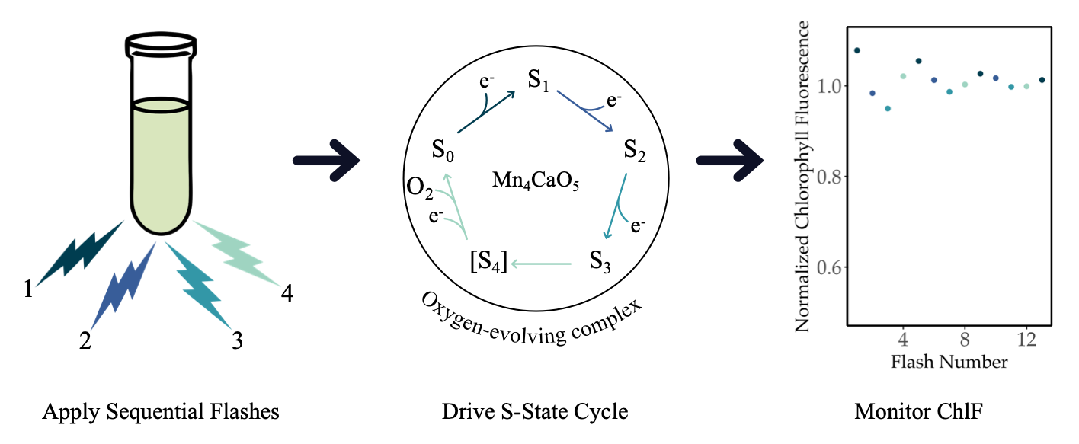

**Figure 5:** Repeated single-turnover excitation of variable chlorophyll fluorescence for monitoring the S-State cycling in PSII during photosynthesis. Sequential flashes drive S-State transitions from S0 to S1, S1 to S2, S2 toS3, and S3 to the transient S4 state, which rapidly decays to S0.

In an idealized culture, the population of PSII will cycle synchronously, reflected by an ongoing oscillation in chlorophyll fluorescence with a period of four (Figure 5) [30]. However, a recombination reaction, representing the loss of charge separation, will cause a missed step in the S-State cycling of an individual PSII. As more recombination events occur, desynchronization of S-State cycling among the population of PSII will scramble the periodic changes in ChlF, dampening the observed oscillation of the population-level fluorescence [30]. Prolonged synchronous cycling thus reflects fewer wasteful recombination reactions at the level of each PSII and thus, more efficient photosynthetic energy conversion.

### Measurement Conditions

By evaluating the S-State cycling of polar and temperate taxa of diatoms and green algae under a range of effective light levels and measurement temperatures (Table 2), we can determine if polar taxa have evolved to increase photosynthetic energy conversion efficiency by minimizing inefficient recombination reactions.

Measurement temperatures ranged from 0 to 28°C, depending on the taxa (Table 2). While light absorption and energy transfer in PSII are not temperature-sensitive, the redox reactions associated with downstream electron transport can be highly temperature-dependent [38]. Notably, the incidence of charge recombination typically decreases with temperature due to the thermal sensitivity of recombination enzymes [48]. However, this effect may be minimized in strains possessing adaptive mechanisms to regulate photosynthetic electron flow, S-State transitions, and energy partitioning [38]. Thus, comparing S-State cycling across measurement temperatures helps unravel the properties of the photosynthetic apparatus.

Altering the spacing between sequential flashes can simulate varying effective light conditions. At higher light levels, more photons arrive per unit of time, corresponding to shorter spacing between saturating flashes in our measurement protocol (Figure 5). Cultures were evaluated at flash spacings of 1, 2, 4, 8, and 16 seconds. Corresponding to the effective light levels calculated using the σPSII for each unique measurement condition as follows:

**(Equation 2)**

The conversion of flash spacing to light levels yielded similar ranges of effective measurement light levels for each strain (Table 2). For comparison, full sunlight at the sea surface is ~ 2000 µmol photons m-2s-1, so our measurement light ranges ~ 5 orders of magnitude lower than full sunlight, and ~ 3 orders of magnitude below the ~ 20 µmol photons m-2s-1 threshold, used to define the conventional bottom of the photic zone supporting photosynthetic productivity in the oceans [2].

**Table 2:** Measurement conditions by strain

|  |  |  |  |
| --- | --- | --- | --- |
| Strain | Flash Spacings (s) | Steady Light Levels (µmol photons m-2s-1) | Measurement Temperatures (°C) |
| *F. cylindrus* | 1, 2, 4, 8, 16 | 0.02981 - 0.65678 | 0, 2, 6, 10 |
| *T. pseudonana* | 1, 2, 4, 8, 16 | 0.02428 - 0.53428 | 10, 14, 18, 20, 22, 24, 28 |
| *C. ICEMDV* | 1, 2, 4, 8, 16 | 0.04252 - 0.73733 | 4, 8, 12 |
| *C. priscuii* | 1, 2, 4, 8, 16 | 0.04289 - 0.77084 | 4, 8, 12 |
| *C. malina* | 1, 2, 4, 8, 16 | 0.03705 - 0.65817 | 4, 8, 12 |
| *C. reinhardtii* | 1, 2, 4, 8, 16 | 0.04670 - 0.84377 | 12, 16, 20, 24 |
| *C. vulgaris* | 1, 2, 4, 8, 16 | 0.05102 - 0.89781 | 10, 14, 18, 22, 26 |

## Analytical Methods

Data was processed using R version 4.3.2 and RStudio version 2023.12.0+369 on the x86_64-apple-darwin20 (64-bit) platform and running under macOS Sonoma 14.3.1. Fluorescence data files generated by LIFT software were imported and tidied using the tidyverse [49], lubridate [50], and googlesheets4 [51] packages. The tidyverse, doBy [52], and WaveletComp [53] packages were used for wavelet analyses. Lastly, the mgcv [54] and mgcViz [55] packages were used for generalized additive modelling, while the ggplot2 [56] and metR [57] packages were used for data visualization.

### Wavelet Transformations

The fluorescence data yields a time series of Fv/Fm over 32 flashes for each flash spacing and each measurement temperature. The fluorescence time series were analyzed for each combination of strain, growth conditions, measurement temperature, and flash spacing, using wavelet transformations [58], as exemplified in Figure 6. Unlike traditional methods, wavelet analysis does not assume that the statistical properties of a time series are constant. Instead, wavelet transformations locally decompose the signal across different time scales and estimate spectral characteristics as a function of time [59]. By examining the frequency and wavelet power spectra, we can uncover the dominant patterns in the data [58].

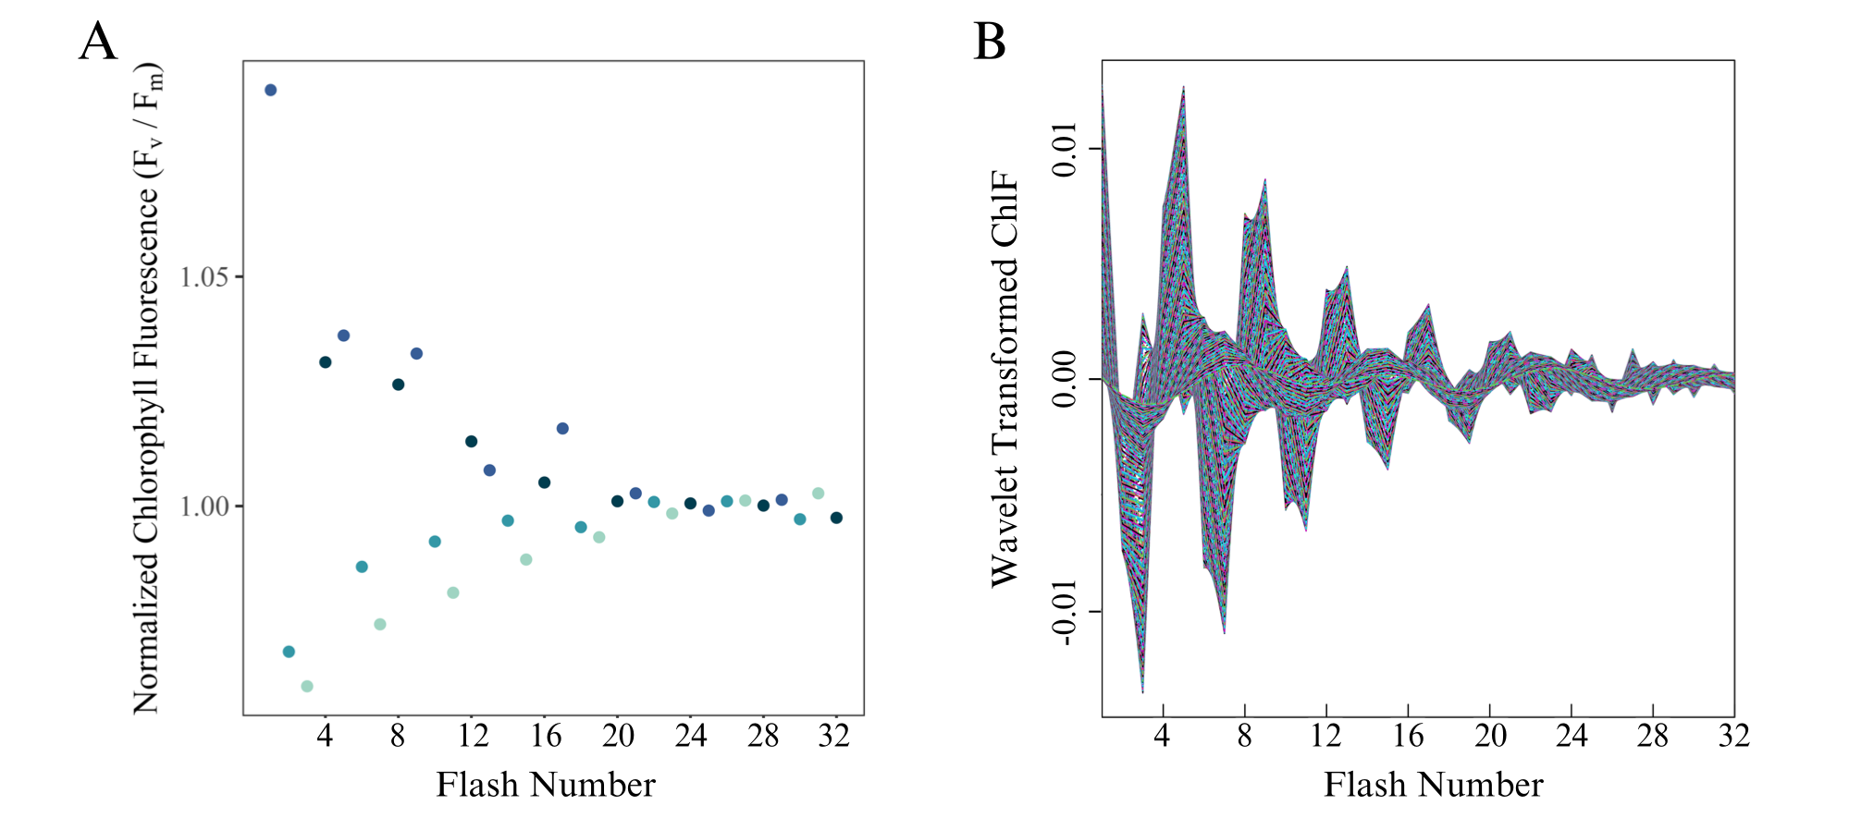

**Figure 6:** Representative wavelet transformation of *Chlamydomonas priscuii* fluorescence over 32 consecutive flashes, measured at 4°C and 1-second flash spacing, equivalent to a photon delivery rate to PSII achieved under approximately steady-state light level of 0.708 µmol photons m-2 s-1.

The core of the wavelet transformation involves computing the wavelet power spectrum of the standardized time series using the Morlet wavelet [58]. Further, the statistical significance of the periodic components in the time series was calculated using a simulation algorithm. Surrogate time series are generated based on a white noise model, consisting of uncorrelated random values with constant mean and variance. Comparing the wavelet of the original data with the white noise model, p-values are calculated to determine whether the observed periodic components are statistically significant [58].

The statistical significance of the wavelet power at a periodicity of four indicates whether the culture is exhibiting the periodic oscillations in chlorophyll fluorescence that indicate synchronous S-State cycling across the PSII population. For wavelets exhibiting S-State cycling, we generated a reconstruction limited to areas with a statistically significant signal, as depicted in Figure 7. Damping of the reconstructed wavelet represents the significance of the signal dropping below the threshold of p=0.05. The damping index then represents the number of flashes applied before this damping occurs, indicating how many successive photons are received by the PSII population before recombination reactions desynchronize the S-State cycle towards randomness across the population.

**Figure 7:** Sample plot illustrating the wavelet reconstructions at ⍺ = 0.05 of *Chlamydomonas priscuii* fluorescence over 32 consecutive single turnover flashes across a range of measurement temperatures and flash spacings, with their equivalent effective light levels.

### Generalized Additive Modelling

The observed patterns in S-State cycling across conditions within taxa were then modelled using the nonparametric method of generalized additive modelling (GAM). GAMs fit a model to predict the damping index based on a tensor product smooth of the two predictors, temperature, and light level. The response variable is linked to the independent variables using a smoothing function, where many localized polynomials are joined to form a piecewise function called a spline [60]. For each strain, two separate GAM models were fit to the data using the restricted maximum likelihood method. The first examines the response of S-State damping to light level and deviation from growth temperature according to the following equation, where n is the number of distinct levels of temperature deviation evaluated for that strain:

**(Equation 3)**

The second examines the response of S-State damping to light level and measurement temperature according to the following equation, where n is the number of distinct levels of temperature measured for that strain:

**(Equation 4)**

Models were validated by verifying the choice of basis dimensions (k) and evaluating the residual plots [61]. Based on the fitted models, the damping index can then be predicted for other combinations of temperature and light [62]. These predictions were then visually represented with a contour plot.

# Results

## Single Turnover Variable Chlorophyll Fluorescence

Exposing phytoplankton cultures to a series of 32 successive flashes produced oscillations in the maximum quantum yield of photochemistry in PSII, as estimated through the secondary chlorophyll fluorescence parameter FV/FM. Initially, the majority of the dark-adapted population of PSII is at S1, with a smaller fraction at S0 [26,30]. As shown in Figure 8 for the polar alga *C. priscuii,* the time series of FV/FM over successive flashes reveals consistent variations in fluorescence yield as the predominant s-states follow each other across the PSII within the population. However, the amplitude of the ChlF oscillations declines progressively over time, and with wider spacing of sequential flashes, equivalent to decreasing light levels.

**Figure 8:** Oscillations in the maximum quantum yield of the photochemistry in *Chlamydomonas priscuii* cultures over a series of 32 flashes, as measured through the secondary chlorophyll fluorescence parameter FV/FM. Representative conditions include cultures measured at 4 or 12 °C, with flash spacings of 8 – 1 seconds, equivalent to effective light levels of 0.088 – 0.708 µmol photons m-2s-1.

## Wavelet Analysis

Wavelet transformations were computed for the fluorescence time series of each unique combination of measurement temperature, flash spacing, equivalent to effective light level, growth temperature, and species or strain. Assessing the wavelet power of a 4-step periodicity across conditions, key trends emerge. As exemplified by the polar alga *C. priscuii* (Figure 9A), the average wavelet power declines with increasing flash spacings, equivalent to decreasing effective light levels, and with increasing measurement temperatures. While this trend remains in the temperate taxa *C. reinhardtii* (Figure 9B), the wavelet power is consistently lower, suggesting a weaker 4-step periodicity of ChlF in temperate taxa, which is only significant at the shorter flash spacings, with higher equivalent light levels.

**B**

**Figure 9:** Sample plot of wavelet power by period of oscillations in the maximum quantum yield of photochemistry in A. Polar *Chlamydomonas priscuii* and B. Temperate *Chlamydomonas reinhardtii* cultures across a range of measurement temperatures and flash spacings, with the equivalent effective light levels.

**A**

Polar taxa maintained significant 4-step oscillations in Fv/Fm,and thus stronger synchronization of PSII S-State cycling across a broader range of measurement conditions, than did their temperate counterparts (Figure 10). The temperate diatom *T. pseudonana* showed significant 4-step ChlF oscillations across 20.57 % of measured conditions, compared to 85% of measured conditions in its polar counterpart, *F. cylindrus*. Similarly, significant 4-step ChlF oscillations occurred across 32% and 40 % of measurement conditions for the temperate green algae *C. vulgaris* and *C. reinhardtii,* and60, 73, and 80% of measurement conditions for the polar algae *C. ICEMDV*, *C. malina*, and *C. priscuii*.

**Figure 10:** Statistical significance of 4-step oscillations in the maximum quantum yield of PSII photochemistry across polar and temperate phytoplankton taxa, as measured through variable chlorophyll fluorescence.

## Generalized Additive Modelling by Deviation from Growth Temperature

Predictions from generalized additive modelling were generated for the damping of S-State-induced chlorophyll fluorescence oscillations, as predicted by the tensor product smooth of the deviation from growth temperature during measurements (°C) and the effective light level (µmol photons m-2s-1; Table 3) for each strain.

**Table 3:** Summary statistics by phytoplankton strain of GAM models using the restricted maximum likelihood method to model the response of the damping of S-State-induced chlorophyll fluorescence oscillations to the predictors of deviation from growth temperature (°C) and the effective light level (µmol photons m-2s-1).

|  |  |  |  |  |  |
| --- | --- | --- | --- | --- | --- |
| Strain | Significance of smooth term | | | Adjusted R2 | Deviance Explained |
| EDF | F-ratio | P-value |
| *F. cylindrus* | 7.23 | 6.82 | 2.8e-05 | 0.584 | 66.1% |
| *T. pseudonana* | 6.08 | 9.01 | 5.38e-06 | 0.674 | 73.2% |
| *C. ICEMDV* | 4.51 | 6.59 | 0.00687 | 0.687 | 78.8% |
| *C. priscuii* | 4.31 | 2.17 | 0.115 | 0.389 | 57.7% |
| *C. malina* | 4.34 | 2.56 | 0.0843 | 0.423 | 60.2% |
| *C. reinhardtii* | 6.05 | 9.49 | 0.000274 | 0.786 | 85.4% |
| *C. vulgaris* | 5.39 | 13.83 | 4.08e-06 | 0.772 | 82.3% |

The smoothing term was significant for the polar diatom *F. cylindrus* (F = 6.835, p = 2.8e-05), explaining 66.1% (adjusted R2 = 0.584) of the deviance in the damping index. Similarly, the model of the temperate diatom, *T. pseudonana*, produced a significant smoothing term (F = 9.01, p = 5.38e-06), which accounted for 73.2% of the deviance in the damping index (adjusted R2 = 0.674). These models were used to predict the number of consecutive flashes before the damping of ChlF oscillations below significance, for each strain at each combination of deviation from growth temperature during measurements (°C) and effective light level (µmol photons m-2s-1; Figure 11).

Both diatom taxa exhibited the longest predicted periodic oscillations in ChlF at higher effective light levels and lower temperatures. Notably, the polar *F. cylindrus* sustained cycling longer than its temperate counterpart, *T. pseudonana*, under comparable conditions. This disparity was particularly prevalent for measurements above the growth temperature and when longer spacing between flashes produced lower effective light levels (Figure 11). Under these conditions, *T. pseudonana* cultures did not retain the significant 4-step oscillation in ChlF indicative of synchronized S-State cycling, while *F. cylindrus* did.

**Figure 11**: GAM model predictions of the consecutive flashes before the damping of S-State-induced chlorophyll fluorescence oscillations as predicted by the deviation from growth temperature (°C) during measurements and the effective light level (µmol photons m-2s-1, with equivalent flash spacings in seconds) experienced by polar and temperate diatoms. White dashed lines represent the growth temperatures for the cultures.

The GAM outputs varied more among green algal strains (Table 3). The smoothing term was significant for the temperate strains *C. reinhardtii* (F = 9.49, p = 0.000274) and *C. vulgaris* (F = 13.83, p = 4.08e-06), predicting 85.4% (adjusted R2 = 0.786) and 82.3% (adjusted R2 = 0.772) of the deviance in the damping index, respectively. However, while the smoothing term was significant (F = 6.59, p = 0.00687), predicting 78.8% (adjusted R2 = 0.687) of the deviance for the polar *C. ICEMDV*, it was not significant for the other two polar green algal taxa. For *C. priscuii*, the statistical evaluation of the smoothing term produced an F value of 2.17 and a corresponding p-value of 0.115, explaining only 57.7% (adjusted R2 = 0.389) of the deviance in the response variable. Similarly, the non-significant smoothing term for *C. malina* (F = 2.56, p = 0.0843) only explained 60.2% of the deviance in the damping index (adjusted R2 = 0.423).

Overall, model predictions for green algal strains exhibited a similar pattern to the diatoms, with the longest predicted oscillations in ChlF at measurement conditions with higher effective light levels (shorter spacing between flashes) and lower measurement temperatures relative to growth temperature (Figure 12). The trends shown by the three strains of polar algae are remarkably consistent, displaying virtually identical patterns and differing by only 1-2 flashes before signal damping, under identical conditions (Figure 12). Further, much like the temperate diatoms, the temperate algae *C. reinhardtii* and *C. vulgaris* did not exhibit significant periodic oscillations in ChlF at measurement temperatures near or above their growth temperature and under the low light conditions produced by longer flash spacings (Figure 12).

**Figure 12**: GAM model predictions of the consecutive flashes before the damping of S-State-induced chlorophyll fluorescence oscillations below significance, as predicted by the deviation from growth temperature (°C) during measurements and the effective light level (µmol photons m-2s-1, with equivalent flash spacings in seconds) experienced by polar and temperate green algae. Dashed lines represent the growth temperatures.

## Generalized Additive Modelling By Measurement Temperature

To facilitate comparison across actual measurement temperatures, additional generalized additive models were fit to the data. For *T. pseudonana, C. ICEMDV, C. priscuii, C. malina, C. reinhardtii,* and *C. vulgaris,* replicate cultures of the strain were grown at the same temperatures. Therefore, the GAMs generated for these strains encompass a different temperature range but are represented by the same summary statistics (Table 4). Conversely, the polar diatom *F. cylindrus* was cultured at both 0 and 6°C. Thus, separate models were fit for each *F. cylindrus* culture to account for possible physiological differences resulting from the distinct growth conditions.

The smoothing term was significant for both *F. cylindrus* cultures (0°C F = 4.46, p = 0.00827; 6°C F = 3.42, p = 0.0279). However, while the GAM model accounted for 73.4% of the deviance in the damping response of *F. cylindrus* grown at 0°C (adjusted R2 = 0.609), it only accounted for 65.1% (adjusted R2 = 0.509) in *F. cylindrus* grown at 6°C (Table 4).

**Table 4:** Summary statistics by phytoplankton strain of GAM models using the restricted maximum likelihood method to model the response of the damping of S-State-induced chlorophyll fluorescence oscillations to the predictors of measurement temperature (°C) and the effective light level (µmol photons m-2s-1).

|  |  |  |  |  |  |
| --- | --- | --- | --- | --- | --- |
| Strain | Significance of smooth term | | | Adjusted R2 | Deviance Explained |
| EDF | F-ratio | P-value |
| *F. cylindrus* (grown at 0°C) | 6.06 | 4.46 | 0.00827 | 0.609 | 73.4% |
| *F. cylindrus* (grown at 6°C) | 5.49 | 3.42 | 0.0279 | 0.509 | 65.1% |
| *T. pseudonana* | 6.08 | 9.01 | 5.38e-06 | 0.674 | 73.2% |
| *C. ICEMDV* | 4.51 | 6.59 | 0.00687 | 0.687 | 78.8% |
| *C. priscuii* | 4.31 | 2.17 | 0.115 | 0.389 | 57.7% |
| *C. malina* | 4.34 | 2.56 | 0.0843 | 0.423 | 60.2% |
| *C. reinhardtii* | 6.05 | 9.49 | 0.000274 | 0.786 | 85.4% |
| *C. vulgaris* | 5.39 | 13.83 | 4.08e-06 | 0.772 | 82.3% |

Although measured at the same range of temperatures, the two *F. cylindrus* cultures from different growth temperatures exhibited different trends in ChlF oscillations. First, the culture grown at 0°C exhibited the significant 4-step oscillation in ChlF indicative of synchronized S-State cycling across only 75% of the measured conditions, compared to 95% of the measurement conditions for the culture grown at 6°C (Figure 13). Further, at comparable measurement temperatures under wide flash spacing, equivalent to low light, the culture grown at 6°C maintained significant cycling for longer (Figure 14). At flash spacings equivalent to light levels above 0.2 µmol photons m-2s-1, cultures from both 0 and 6°C growth temperatures exhibited similar, stable damping indices (Figure 14).

**Figure 13:** Statistical significance of 4-step oscillations in the maximum quantum yield of PSII photochemistry across measurement conditions in the polar diatom *F. cylindrus*, as measured through variable chlorophyll fluorescence.

**Figure 14**: GAM model predictions of the consecutive flashes before the damping of S-State-induced chlorophyll fluorescence oscillations as predicted by the measurement temperature (°C) and effective light level (µmol photons m-2s-1; with equivalent flash spacings in seconds) experienced by polar and temperate diatoms. White dashed lines represent the growth temperatures of the individual cultures.

At a measurement temperature of 10°C, the model predicts that the duration of ChlF oscillations (Damping Index) for *F. cylindrus* will sharply increase with effective light before plateauing at approximately 0.2 µmol photons m-2s-1, the light level produced by a 4-second interval between flashes (Figure 15). At light levels below 0.5 µmol photons m-2 s-1, this corresponds to *F. cylindrus* exhibiting more sustained ChlF oscillations than does *T. pseudonana* also measured at 10°C. However, at this common measurement temperature and the higher effective light levels produced by shorter flash spacings, *T. pseudonana* sustains ChlF oscillations for durations comparable to its polar counterpart *F. cylindrus* (Figure 15).

**Figure 15:** GAM model predictions of the consecutive flashes before the damping of S-State-induced chlorophyll fluorescence oscillations in polar and temperate diatom cultures over a range of effective light levels (µmol photons m-2s-1) at a common measurement temperature of 10°C. The effective light levels for the model training data were calculated based on the spacing (seconds) between sequential flashes delivered to the culture.

For the green algae, the models using measurement temperature as a predictor depicted the same trends between and within strains as the models using the deviation from growth temperature as a predictor (Figure 16).

**Figure 16**: GAM model predictions of the consecutive flashes before the damping of S-State-induced chlorophyll fluorescence oscillations as predicted by the measurement temperature (°C) and the effective light level (µmol photons m-2s-1; with equivalent flash spacings in seconds) experienced by polar and temperate green algae. White dashed lines represent the growth temperatures of the individual strains.

However, the model predictions at a shared measurement temperature of 12°C demonstrate limited variation among green algal taxa (Figure 17). For all green algal taxa, the duration of significant ChlF oscillations increased with the higher effective light levels corresponding to shorter intervals between sequential flashes. Two polar strains, *C. priscuii* and *C. malina*, and the temperate *C. reinhardtii* showed near-identical trajectories. While the temperate *C. vulgaris* exhibits less sustained ChlF oscillations at low effective light levels, it achieves similar durations to the *Chlamydomonas* strains by flash spacings of 2 seconds, equivalent to an effective light level of approximately 0.3 µmol photons m-2s-1. Unexpectedly, at 12°C the polar alga *C. ICEMDV* consistently exhibits the shortest duration of ChlF oscillations, indicative of the least sustained S-State cycling across all measurement conditions (Figure 17).

**Figure 17:** GAM model predictions of the consecutive flashes before the damping of S-State-induced chlorophyll fluorescence oscillations in polar and temperate green algae strains over a range of effective light levels (µmol photons m-2s-1) at a common measurement temperature of 12°C. The effective light levels for the model training data were calculated based on the spacing (seconds) between sequential flashes delivered to the culture.

# Discussion

## Modelling and Operational Limitations

Two generalized additive models were fit for each phytoplankton strain, predicting the number of consecutive flashes before the damping of ChlF oscillations based on the effective light level (µmol photons m-2s-1) and either the measurement temperature or the deviation from the growth temperature during measurement (°C; Tables 3 & 4). All models explained over 50% of the deviance in the response variable. Additionally, the tensor product smooth of the predictors was statistically significant in both models for *F. cylindrus*, *T. pseudonana, C. ICEMDV*, *C. reinhardtii,* and *C. vulgaris*. However, for two strains of polar algae, *C. priscuii* and *C. malina*, the tensor product smooths of the predictors were not statistically significant.

The insignificance of the smooth for *C. malina* can be attributed to a significant outlier in the model training data (see model training dataset at [GitHub: S-State Damping](https://github.com/FundyPhytoPhys/LowLightPhotosynth/blob/1570b794dc8957bafcf4645adc2a4cb9fa9b727b/Data/ProcessedData/LOW_SState_Damping.Rds)). Evaluating the cook’s distances [63], an outlier occurs at a measurement temperature of 12 °C and a 2-second interval between flashes (corresponding to an effective light level of 0.073 µmol photons m-2s-1). Under these conditions, significant ChlF oscillations were detected over nine flashes, a sharp contrast to the closest other conditions, which exhibited no significant 4-step oscillations in ChlF (damping index of 0). Removing this outlier point increases the deviation explained by the model from 60.2 to 75.2 % and produces a significant smooth term (F = 4.544, p = 0.0255).

Conversely, the insignificance of the smooth term in *C. priscuii* is attributable to the limited number of measurement temperatures. With only three measurement temperatures, the number of basis dimensions used to create the smooth function (k) was limited to 3 [61]. However, model validation demonstrates that three basis dimensions cannot capture the underlying relationship between the predictors and the response variable (Table A2). Therefore, three measurement temperatures were insufficient for modelling the response of ChlF damping for this strain.

Beyond the modelling limitations, ignoring the limited range of effective light levels evaluated in this study would be remiss. Our overall measurement range of 0.024 to 0.898 µmol photons m-2s-1 (Table 2) is approximately five orders of magnitude lower than full sunlight and approximately three orders of magnitude below the traditional threshold for the bottom of the photic zone in the ocean [2].

The operational capacity of the Soliense LIFT-REM fluorometer bound the upper limit of the measurable light range. In an analysis comprising 425 runs, the set flash spacing was compared to the actual spacing recorded between flashes down to the millisecond. In runs with the flash spacing set to 0.5, 0.25, or 0.1 seconds, the average measured flash spacings were 1.06, 1.00, and 1.00, respectively (see Appendix Table 1). Thus, a 1-second interval was the lowest reliable flash spacing, corresponding to maximum effective light levels of 0.534 to 0.898 µmol photons m-2s-1, depending on the effective absorption cross-section of photosystem II (σPSII) of each culture (Table 2).

## Consistent Responses to Measurement Conditions

Across all study strains, the observed ChlF oscillations indicate less efficient photosynthetic energy conversion under higher temperatures and lower light levels. The wavelet power at a period of four declines with decreasing light and increasing temperatures, illustrating that the periodic oscillations in ChlF are weaker under these conditions (Figure 9). Further, the decrease in the consecutive flashes before the ChlF oscillations damp out suggests that cultures are maintaining synchronicity in their S-State cycling for shorter durations (Figure 14, 16) [30]. The desynchronization of S-State cycling between the PSII in a population indicates that a sufficient number of charge recombinations have taken place to create a PSII population with a random distribution of S-States. Thus, if this desynchronization occurs after fewer consecutive flashes, it signifies an increased proportion of PSIIs undergoing charge recombinations after each flash. By inference, PSII populations with increased incidence of energetically wasteful charge recombinations, such as those under high temperatures and low light levels, are less efficient in their photosynthetic energy conversion [22].

These results are consistent with previous literature evaluating the response of recombination reactions to light conditions. As light levels decline, there are longer intervals between successive PSII excitations, pushing fewer electrons through the electron transport chain [29]. Consequently, the probability of energetically wasteful charge recombinations is higher, corresponding to weaker maintenance of S-State cycling [29,30]. Similarly, these findings are consistent with known relationships between charge recombination and temperature, as recombination reactions typically decrease with temperature due to the thermal sensitivity of the associated enzymes [48]. However, these results are in direct contrast with previous literature regarding the temperature dependence of S-State transitions. In 2022, Han *et al.* demonstrated that between isolated PSII membranes at 10, 1, 10, and 20 °C, the average miss probability of S-State transitions was highest at -10 °C and lowest at 10 °C [64]. Therefore, we would expect to have seen more sustained S-State transitions at moderate temperatures.

## Comparisons Among Strains

Polar strains of diatoms and green algae consistently demonstrated a stronger periodicity in ChlF emissions (Figure 9). Further, they exhibited significant 4-step ChlF oscillations under a broader range of measurement conditions (Figure 10) than did their temperate counterparts. These findings illustrate that polar phytoplankton strains have a higher capacity to maintain S-State cycling than do temperate strains. Nevertheless, comparing the number of consecutive flashes before the ChlF oscillations damp out between strains under comparable conditions reveals variable patterns.

The first comparison was between the polar diatom *F. cylindrus* and the temperate diatom *T. pseudonana*. When measured at the same temperature under low light, *F. cylindrus* sustained ChlF oscillations for longer than *T. pseudonana*. However, as light levels increased, the duration of cycling in *T. pseudonana* increased to near that of *F. cylindrus* (Figure 15). This behaviour is consistent with the trends observed below the growth temperature when comparing these two diatom strains by the deviation from growth temperature during measurement (Figure 11). Yet, when temperatures increase the same amount above the growth temperature, *F. cylindrus* maintains cycling for much longer than *T. pseudonana*, regardless of the light level. These trends indicate that *F. cylindrus* maintains S-State cycling for longer than *T. pseudonana* under low photon delivery and low temperatures. However, in less stressful conditions, *T. pseudonana* can match the photosynthetic performance of *F. cylindrus*. Theoretically, the rate of charge recombinations would increase under low light and high temperatures [29,48]. Thus, the stability of S-State cycling in the PSII of *F. cylindrus* under these conditions reflects the suppression of energetically wasteful charge recombinations by this strain compared to a temperate diatom.

The second comparison comprises three polar, *C. priscuii,* *C. malina, and C. ICEMDV*, and two temperate, *C. reinhardtii,* and *C. vulgaris,* strains of green algae. When evaluated at their growth temperature, the polar strains exhibited longer significant ChlF oscillations than their temperate counterparts across all light conditions (Figure 12). Yet, when compared at the same measurement temperature, these strains showed little variation in the duration of significant ChlF oscillations (Figure 17), suggesting little difference in the incidence of energetically wasteful charge recombinations. This shared measurement temperature represents a departure from the growth temperature of +8 °C for polar strains and -10 to -12 °C for temperate strains. Recombination reactions are expected to increase with temperature [48]. Thus, the capacity for polar strains to exhibit the same durations of S-State cycling when warmed as temperate strains do when cooled suggests some suppression of energetically wasteful charge recombinations in the PSII of polar strains. This finding is underscored by the disparity in recombination reactions observed under comparable conditions.

Through analyzing ChlF oscillations, we extrapolated the duration of significant S-State cycling and therefore, the incidence of energetically wasteful charge recombinations. Overall, our findings indicate that polar phytoplankton exhibit more stable S-State cycling than do temperate strains under photic stress and high temperatures. These findings suggest that polar phytoplankton strains increase their photosynthetic energy conversion efficiency under low light and low temperatures by minimizing energetically wasteful charge recombinations. Stable S-State cycling and minimal energy loss through charge recombination ensure continued electron flow through the ETC, sustaining ATP and NADPH production, and minimizing the risk of photodamage to the photosynthetic machinery [22,29]. Thus, this ability may be integral for the productivity of polar phytoplankton under the ice during the polar night.

## Ecological Implications & Future Directions

Unravelling the mechanisms enabling polar phytoplankton to sustain slow, but significant productivity under the ice in the winter is crucial for predicting the changing dynamics of spring phytoplankton blooms. This is particularly critical in the Arctic, where the pace of warming is rapidly accelerating [7]. Beyond temperature changes, polar aquatic ecosystems are experiencing reductions in sea ice extent and thickness, escalating freshwater inputs, acidification, and increased winds and storms [7,12]. These pressures are causing alterations in the productivity and seasonal peaks of phytoplankton blooms [7,11]. Understanding the nature of maintaining an intact photosystem under the ice in the winter allows us to better predict under what conditions these blooms will initiate, and which phytoplankton strains will be involved [4].

The ability to maintain efficient photosynthetic energy conversion over winter is crucial for the timing and speed of spring bloom initiation [4]. Strains with this ability may possess a competitive advantage in quickly initiating spring growth, giving them first access to the nutrients required to form an extensive bloom. Thus, the proportions of these strains may increase in polar regions. Altering the phytoplankton community composition may, in turn, exert bottom-up effects on polar ecosystems [7].

Future directions for this research include more extensive comparative analyses to further our understanding. Incorporating more strains of diatoms and green algae, as well as other phytoplankton groups will enable us to uncover whether certain groups have a higher capacity to suppress energetically wasteful charge recombinations. A difference between these groups may affect their contribution to the phytoplankton community, leading to differences in the ecosystem services offered by spring phytoplankton blooms. Moreover, since there were differences observed between *F. cylindrus* strains grown at 0 and 6 °C, further comparison between ecotypes may yield information on the conditions that lead to the evolution of this ability.

# References

1. Pierella Karlusich JJ, Ibarbalz FM, Bowler C. Phytoplankton in the Tara Ocean. Annual Review of Marine Science. 2020;12: 233–265. doi:10.1146/annurev-marine-010419-010706

2. Raven JA, Kübler JE, Beardall J. Put out the light, and then put out the light. Journal of the Marine Biological Association of the United Kingdom. 2000;80: 1–25. doi:10.1017/S0025315499001526

3. Kirk JTO. Light and photosynthesis in aquatic ecosystems. 2nd ed. Cambridge [England] ; New York, NY, USA: Cambridge University Press; 1994.

4. Randelhoff A, Lacour L, Marec C, Leymarie E, Lagunas J, Xing X, et al. Arctic mid-winter phytoplankton growth revealed by autonomous profilers. Science Advances. 2020;6: eabc2678. doi:10.1126/sciadv.abc2678

5. Hancke K, Lund-Hansen LC, Lamare ML, Højlund Pedersen S, King MD, Andersen P, et al. Extreme Low Light Requirement for Algae Growth Underneath Sea Ice: A Case Study From Station Nord, NE Greenland. Journal of Geophysical Research: Oceans. 2018;123: 985–1000. doi:10.1002/2017JC013263

6. Leu E, Mundy CJ, Assmy P, Campbell K, Gabrielsen TM, Gosselin M, et al. Arctic spring awakening – Steering principles behind the phenology of vernal ice algal blooms. Progress in Oceanography. 2015;139: 151–170. doi:10.1016/j.pocean.2015.07.012

7. Ardyna M, Arrigo KR. Phytoplankton dynamics in a changing Arctic Ocean. Nat Clim Chang. 2020;10: 892–903. doi:10.1038/s41558-020-0905-y

8. Robinson DH, Arrigo KR, Iturriaga R, Sullivan CW. Microalgal Light-Harvesting in Extreme Low-Light Environments in Mcmurdo Sound, Antarctica1. Journal of Phycology. 1995;31: 508–520. doi:10.1111/j.1529-8817.1995.tb02544.x

9. Bax N, Sands CJ, Gogarty B, Downey RV, Moreau CVE, Moreno B, et al. Perspective: Increasing blue carbon around Antarctica is an ecosystem service of considerable societal and economic value worth protecting. Glob Chang Biol. 2021;27: 5–12. doi:10.1111/gcb.15392

10. Lyon BR, Mock T. Polar Microalgae: New Approaches towards Understanding Adaptations to an Extreme and Changing Environment. Biology. 2014;3: 56–80. doi:10.3390/biology3010056

11. Croteau D, Guérin S, Bruyant F, Ferland J, Campbell DA, Babin M, et al. Contrasting nonphotochemical quenching patterns under high light and darkness aligns with light niche occupancy in Arctic diatoms. Limnology and Oceanography. 2021;66: S231–S245. doi:https://doi.org/10.1002/lno.11587

12. Cvetkovska M, Vakulenko G, Smith DR, Zhang X, Hüner NPA. Temperature stress in psychrophilic green microalgae: Minireview. Physiologia Plantarum. 2022;174: e13811. doi:10.1111/ppl.13811

13. Mock T, Otillar RP, Strauss J, McMullan M, Paajanen P, Schmutz J, et al. Evolutionary genomics of the cold-adapted diatom Fragilariopsis cylindrus. Nature. 2017;541: 536–540. doi:10.1038/nature20803

14. Bayer-Giraldi M, Weikusat I, Besir H, Dieckmann G. Characterization of an antifreeze protein from the polar diatom Fragilariopsis cylindrus and its relevance in sea ice. Cryobiology. 2011;63: 210–219. doi:10.1016/j.cryobiol.2011.08.006

15. Kennedy F, Martin A, Bowman JP, Wilson R, McMinn A. Dark metabolism: a molecular insight into how the Antarctic sea-ice diatom Fragilariopsis cylindrus survives long-term darkness. New Phytologist. 2019;223: 675–691. doi:10.1111/nph.15843

16. Kawakami K, Shen J-R. Purification of fully active and crystallizable photosystem II from thermophilic cyanobacteria. Methods in Enzymology. Elsevier; 2018. pp. 1–16. doi:10.1016/bs.mie.2018.10.002

17. Vass I. Role of charge recombination processes in photodamage and photoprotection of the photosystem II complex. Physiologia Plantarum. 2011;142: 6–16. doi:10.1111/j.1399-3054.2011.01454.x

18. Schuback N, Tortell PD, Berman-Frank I, Campbell DA, Ciotti A, Courtecuisse E, et al. Single-Turnover Variable Chlorophyll Fluorescence as a Tool for Assessing Phytoplankton Photosynthesis and Primary Productivity: Opportunities, Caveats and Recommendations. Frontiers in Marine Science. 2021;8. doi:10.3389/fmars.2021.690607

19. Shen J-R. Photosynthesis | Photosystem II: Protein Components, Structure and Electron Transfer. In: Jez J, editor. Encyclopedia of Biological Chemistry III (Third Edition). Oxford: Elsevier; 2021. pp. 215–228. doi:10.1016/B978-0-12-819460-7.00012-8

20. Mukhopadhyay S, Mandal SK, Bhaduri S, Armstrong WH. Manganese Clusters with Relevance to Photosystem II. Chem Rev. 2004;104: 3981–4026. doi:10.1021/cr0206014

21. Vass I, Cser K. Janus-faced charge recombinations in photosystem II photoinhibition. Trends in Plant Science. 2009;14: 200–205. doi:10.1016/j.tplants.2009.01.009

22. Rappaport F, Cuni A, Xiong L, Sayre R, Lavergne J. Charge Recombination and Thermoluminescence in Photosystem II. Biophysical Journal. 2005;88: 1948–1958. doi:10.1529/biophysj.104.050237

23. Laloi C, Przybyla D, Apel K. A genetic approach towards elucidating the biological activity of different reactive oxygen species in Arabidopsis thaliana. Journal of Experimental Botany. 2006;57: 1719–1724. doi:10.1093/jxb/erj183

24. Rutherford AW, Osyczka A, Rappaport F. Back-reactions, short-circuits, leaks and other energy wasteful reactions in biological electron transfer: Redox tuning to survive life in O2. FEBS Letters. 2012;586: 603–616. doi:10.1016/j.febslet.2011.12.039

25. Vinyard DJ, Ananyev GM, Charles Dismukes G. Photosystem II: The Reaction Center of Oxygenic Photosynthesis. Annual Review of Biochemistry. 2013;82: 577–606. doi:10.1146/annurev-biochem-070511-100425

26. Gates C, Ananyev G, Dismukes GC. Realtime kinetics of the light driven steps of photosynthetic water oxidation in living organisms by “stroboscopic” fluorometry. Biochimica et Biophysica Acta (BBA) - Bioenergetics. 2020;1861: 148212. doi:10.1016/j.bbabio.2020.148212

27. Zaharieva I, Dau H. Energetics and Kinetics of S-State Transitions Monitored by Delayed Chlorophyll Fluorescence. Frontiers in Plant Science. 2019;10. Available: https://www.frontiersin.org/articles/10.3389/fpls.2019.00386

28. Dau H, Haumann M. Time-resolved X-ray spectroscopy leads to an extension of the classical S-state cycle model of photosynthetic oxygen evolution. Photosynth Res. 2007;92: 327–343. doi:10.1007/s11120-007-9141-9

29. Keren N, Berg A, van Kan PJM, Levanon H, Ohad I. Mechanism of photosystem II photoinactivation and D1 protein degradation at low light: The role of back electron flow. Proceedings of the National Academy of Sciences. 1997;94: 1579–1584. doi:10.1073/pnas.94.4.1579

30. de Wijn R, van Gorkom HJ. S-state dependence of the miss probability in Photosystem II. Photosynthesis Research. 2002;72: 217–222. doi:10.1023/A:1016128632704

31. Otte A, Winder JC, Deng L, Schmutz J, Jenkins J, Grigoriev IV, et al. The diatom Fragilariopsis cylindrus: A model alga to understand cold-adapted life. Journal of Phycology. 2023;59: 301–306. doi:10.1111/jpy.13325

32. Cefarelli AO, Ferrario ME, Almandoz GO, Atencio AG, Akselman R, Vernet M. Diversity of the diatom genus Fragilariopsis in the Argentine Sea and Antarctic waters: morphology, distribution and abundance. Polar Biology. 2010;33. doi:10.1007/s00300-010-0794-z

33. Kang S-H, Fryxell GA. Fragilariopsis cylindrus (Grunow) Krieger: The most abundant diatom in water column assemblages of Antarctic marginal ice-edge zones. Polar Biol. 1992;12: 609–627. doi:10.1007/BF00236984

34. Poulsen N, Kröger N. Thalassiosira pseudonana (Cyclotella nana) (Hustedt) Hasle et Heimdal (Bacillariophyceae): A genetically tractable model organism for studying diatom biology, including biological silica formation. Journal of Phycology. 2023;59: 809–817. doi:10.1111/jpy.13362

35. Cook G, Teufel A, Kalra I, Li W, Wang X, Priscu J, et al. The Antarctic psychrophiles Chlamydomonas spp. UWO241 and ICE-MDV exhibit differential restructuring of photosystem I in response to iron. Photosynth Res. 2019;141: 209–228. doi:10.1007/s11120-019-00621-0

36. Stahl-Rommel S, Kalra I, D’Silva S, Hahn MM, Popson D, Cvetkovska M, et al. Cyclic electron flow (CEF) and ascorbate pathway activity provide constitutive photoprotection for the photopsychrophile, Chlamydomonas sp. UWO 241 (renamed Chlamydomonas priscuii). Photosynth Res. 2022;151: 235–250. doi:10.1007/s11120-021-00877-5

37. Li W, Podar M, Morgan-Kiss RM. Ultrastructural and Single-Cell-Level Characterization Reveals Metabolic Versatility in a Microbial Eukaryote Community from an Ice-Covered Antarctic Lake. Applied and Environmental Microbiology. 2016;82: 3659–3670. doi:10.1128/AEM.00478-16

38. Hüner NPA, Szyszka-Mroz B, Ivanov AG, Kata V, Lye H, Smith DR. Photosynthetic adaptation and multicellularity in the Antarctic psychrophile, Chlamydomonas priscuii. Algal Research. 2023;74: 103220. doi:10.1016/j.algal.2023.103220

39. Balzano S, Gourvil P, Siano R, Chanoine M, Marie D, Lessard S, et al. Diversity of cultured photosynthetic flagellates in the northeast Pacific and Arctic Oceans in summer. Biogeosciences. 2012;9: 4553–4571. doi:10.5194/bg-9-4553-2012

40. Morales-Sánchez D, Schulze PSC, Kiron V, Wijffels RH. Temperature-Dependent Lipid Accumulation in the Polar Marine Microalga Chlamydomonas malina RCC2488. Frontiers in Plant Science. 2020;11. doi:10.3389/fpls.2020.619064

41. Sasso S, Stibor H, Mittag M, Grossman AR. From molecular manipulation of domesticated Chlamydomonas reinhardtii to survival in nature. King SR, Rodgers PA, editors. eLife. 2018;7: e39233. doi:10.7554/eLife.39233

42. Xie B, Bishop S, Stessman D, Wright D, Spalding MH, Halverson LJ. Chlamydomonas reinhardtii thermal tolerance enhancement mediated by a mutualistic interaction with vitamin B12-producing bacteria. The ISME Journal. 2013;7: 1544–1555. doi:10.1038/ismej.2013.43

43. Wiel JBV, D. Mikulicz J, R. Boysen M, Hashemi N, Kalgren P, M. Nauman L, et al. Characterization of Chlorella vulgaris and Chlorella protothecoides using multi-pixel photon counters in a 3D focusing optofluidic system. RSC Advances. 2017;7: 4402–4408. doi:10.1039/C6RA25837A

44. Leyva LA, Bashan Y, Mendoza A, de-Bashan LE. Accumulation fatty acids of in Chlorella vulgaris under heterotrophic conditions in relation to activity of acetyl-CoA carboxylase, temperature, and co-immobilization with Azospirillum brasilense. Naturwissenschaften. 2014;101: 819–830. doi:10.1007/s00114-014-1223-x

45. Berman-Frank I, Campbell D, Ciotti A, Erickson Z, Fujiki T, Halsey K, et al. Application of Single Turnover Active Chlorophyll Fluorescence for Phytoplankton Productivity Measurements. Version 2.0. Scientific Committee on Oceanic Research (SCOR) Working Group 156; 2023 Jun. doi:10.25607/OBP-1084

46. Kolber ZS. Measurements of variable chlorophyll £uorescence using fast repetition rate techniques: de¢ning methodology and experimental protocols. Biochimica et Biophysica Acta. : 19.

47. Xu K, Lavaud J, Perkins R, Austen E, Bonnanfant M, Campbell DA. Phytoplankton σPSII and Excitation Dissipation; Implications for Estimates of Primary Productivity. Front Mar Sci. 2018;5. doi:10.3389/fmars.2018.00281

48. Ivanov AG, Sane PV, Krol M, Gray GR, Balseris A, Savitch LV, et al. Acclimation to temperature and irradiance modulates PSII charge recombination. FEBS Letters. 2006;580: 2797–2802. doi:10.1016/j.febslet.2006.04.018

49. Wickham H, Averick M, Bryan J, Chang W, McGowan LD, François R, et al. Welcome to the tidyverse. Journal of Open Source Software. 2019;4: 1686. doi:10.21105/joss.01686

50. Grolemund G, Wickham H. Dates and times made easy with lubridate. Journal of Statistical Software. 2011;40: 1–25. Available: https://www.jstatsoft.org/v40/i03/

51. Bryan J. googlesheets4: Access google sheets using the sheets API V4. 2023. Available: https://CRAN.R-project.org/package=googlesheets4

52. Højsgaard S, Halekoh U. doBy: Groupwise statistics, LSmeans, linear estimates, utilities. 2023. Available: https://CRAN.R-project.org/package=doBy

53. Roesch A, Schmidbauer H. WaveletComp: Computational wavelet analysis. 2018. Available: https://CRAN.R-project.org/package=WaveletComp

54. Wood SN. Fast stable restricted maximum likelihood and marginal likelihood estimation of semiparametric generalized linear models. Journal of the Royal Statistical Society: Series B (Statistical Methodology). 2011;73: 3–36. doi:10.1111/j.1467-9868.2010.00749.x

55. Fasiolo, Matteo, Nedellec, Rapha"el, Goude, Yannig, et al. Scalable visualisation methods for modern generalized additive models. Journal of the Royal Statistical Society (B). 2020;29: 78–86.

56. Wickham H. ggplot2: Elegant graphics for data analysis. Springer-Verlag New York; 2016. Available: https://ggplot2.tidyverse.org

57. Campitelli E. metR: Tools for easier analysis of meteorological fields. 2021. doi:10.5281/zenodo.2593516

58. Theis FJ, Meyer-Bäse A. Spectral Transformations. 1st ed. Biomedical Signal Analysis : Contemporary Methods and Applications. 1st ed. MIT Press; 2010. p. 42.

59. Cazelles B, Chavez M, Berteaux D, Ménard F, Vik JO, Jenouvrier S, et al. Wavelet analysis of ecological time series. Oecologia. 2008;156: 287–304. doi:10.1007/s00442-008-0993-2

60. Pinilla J, Negrín M. Non-Parametric Generalized Additive Models as a Tool for Evaluating Policy Interventions. Mathematics. 2021;9: 299. doi:10.3390/math9040299

61. Schoenig D, Maynard L, Brice M-H, Cazelles K, Braga PHP, Gongora E, et al. Workshop 8: Generalized additive models in R. Québec Centre for Biodiversity Science; 2023. Available: https://r.qcbs.ca/workshop08/pres-en/workshop08-pres-en.html#36

62. Wood SN. Generalized Additive Models: an introduction with R. 2nd ed. New York: Chapman and Hall/CRC; 2017.

63. Yager RM. Detecting influential observations in nonlinear regression modeling of groundwater flow. Water Resources Research. 1998;34: 1623–1633. doi:10.1029/98WR01010

64. Han G, Chernev P, Styring S, Messinger J, Mamedov F. Molecular basis for turnover inefficiencies (misses) during water oxidation in photosystem II. Chem Sci. 2022;13: 8667–8678. doi:10.1039/D2SC00854H

# Appendix

**Table A1:** Flash delivery capacity of the Soliense LIFT-REM fluorometer

|  |  |  |
| --- | --- | --- |
| Set Flash Spacing (s) | Mean Actual Flash Spacing (s) | Variance of Actual Flash Spacing (s) |
| 0.1 | 1.00 | 3.86e-06 |
| 0.25 | 1.00 | 3.26-06 |
| 0.5 | 1.06 | 8.84e-03 |
| 1 | 1.53 | 2.79e-03 |
| 2 | 2.54 | 2.74e-03 |
| 4 | 4.53 | 2.68-03 |
| 8 | 8.54 | 2.90-03 |
| 16 | 16.53 | 1.86-03 |

**Table A2:** Basis dimension (k) checking results by phytoplankton strain of GAM models of the response of the damping of S-State-induced chlorophyll fluorescence oscillations to the predictors of measurement temperature (°C) and the effective light level (µmol photons m-2s-1). A low p-value (<0.05) indicates that K is too low.

|  |  |  |  |  |
| --- | --- | --- | --- | --- |
| Strain | K’ | EDF | K-Index | P-Value |
| *C. ICEMDV* | 8.00 | 4.51 | 1.27 | 0.91 |
| *C. malina* | 8.00 | 4.34 | 1.07 | 0.46 |
| *C. priscuii* | 8.00 | 4.31 | 0.67 | 0.02 |
| *C. vulgaris* | 24.00 | 5.39 | 1.29 | 0.99 |
| *C. reinhardtii* | 15.00 | 6.05 | 1.21 | 0.82 |
| *T. pseudonana* | 48.00 | 6.08 | 1.23 | 0.94 |
| *F. cylindrus*  (grown at 0 °C) | 15.00 | 6.06 | 0.87 | 0.12 |
| *F. cylindrus*  (grown at 6 °C) | 15.00 | 5.49 | 1.1 | 0.65 |