Introduction

Polar Phytoplankton
Phytoplankton are photosynthetic microorganisms with diverse evolutionary histories and ecologies [1]. Inhabiting aquatic environments, phytoplankton can be found in oceans, lakes, rivers, streams, estuaries, and wetlands across the biosphere.
Photolithotrophic growth, a defining characteristic of phytoplankton, fuels the production of biomass by harnessing light energy to oxidize inorganic compounds containing carbon, nitrogen, phosphorus, sulfur, and other essential micronutrients [2]. With photons as the sole energy input, phytoplankton growth is constrained to the photic zone, the region of water receiving sufficient light for photosynthesis. Photosynthetically active radiation (PAR) decreases with depth as the light passing through the water column is scattered and absorbed [3]. Eventually, light attenuates to a level defined as the bottom limit of the photic zone, operationally established at 1% of surface irradiance, equivalent to 2-20 µmol photons m-² s⁻¹ [2].
Light availability is further constrained in polar regions, presenting unique challenges for phytoplankton growth [4,5]. The radiation that penetrates through the ice is influenced by solar angle, sea ice thickness, and snow depth [6]. The solar elevation angle changes because of the obliquity, or tilt, of the Earth as it orbits the sun, resulting in the polar night and midnight sun, depending upon latitude and season. The thickness of the ice and snowpack further constrains light, with reflective and relatively opaque ice and snow cover limiting the light that penetrates these environments [4]. Snow, in particular, shows high light attenuation properties, further lowering the already limited light energy [5].
Despite these constraints, certain psychrophile phytoplankton demonstrate remarkable adaptability, exhibiting net growth under the ice through photosynthesis at extremely low light levels [4,5]. Across the Arctic, phytoplankton have been reported beneath the sea ice from Resolute Bay to the North of Svalbard, Baffin Bay, and the Greenland, Barents, Laptev, and Chukchi Seas [7]. In 1995, the lower limit of the photic zone was reconsidered as benthic microalgae in the Antarctic were reported photosynthetically active at light levels less than 1 µmol photons m-² s⁻¹ [8]. Moreover, more recent studies have documented winter phytoplankton growth below >1 m of snow and 1 m of sea ice, corresponding to PAR below 0.15 µmol photons m⁻² s⁻¹ [5]. This represents photosynthesis occurring at light levels 1-2 orders of magnitude below the historical lower limit for the photic zone.
Slow but significant growth during winter under the ice underscores the ability of psychrophilic phytoplankton to maintain intact photosystems throughout the polar night [4]. Further, it offers support for a theoretical minimum light level for phytoplankton growth of 0.01 µmol photons m-² s⁻¹[2]. Such low-light phytoplankton photosynthesis and growth may serve to mitigate cell mortality in the extended darkness of winter, establishing a seeding population for the spring bloom [4].

Arctic Blooms
As the ice begins to retreat in the spring, phytoplankton blooms start to appear in the Arctic Ocean. Spring blooms are a major source of annual net primary production in this region, representing the most significant event for carbon export to higher trophic levels or biological sequestration in the deep ocean [7]. However, the ice-free period is also characterized by the stratification of surface water, which limits the inorganic nutrient supply [6]. Nutrient limitation imposes an upper limit on the size and duration of polar spring blooms, resulting in a short productive period [6]. Regardless, spring phytoplankton blooms in the Arctic play key global biogeochemical roles in primary production and carbon cycling.
Polar regions play a pivotal role in carbon cycling, representing almost half of the global CO₂ sequestration through microbial photosynthesis [9]. As part of this carbon cycle, phytoplankton form the biological carbon pump, mediating the drawdown of atmospheric carbon to the ocean's interior [1]. The increased solubility of CO₂ at low water temperatures leads to substantial carbon sequestration through deep water formation at the poles, establishing a crucial carbon export pathway from surface waters to the deep ocean [5,7]. Further, substantial CO₂ sequestration arises from high river inputs and the resistance of the terrestrially derived dissolved organic matter entering the Arctic basin to degradation [10].
Phytoplankton are highly productive relative to their biomass, owing to their rapid proliferation and photosynthetic activity in all cells, which distinguishes them from terrestrial plants [1]. This productivity supports rapid consumption by higher trophic levels, creating a prolific food source for ice-associated zooplankton and amphipods. Therefore, the timing of spring blooms is crucial in shaping food availability and the hatching success of associated zooplankton [5]. As the base of polar food webs, changing phytoplankton dynamics can have repercussions across all trophic levels.
The dynamics of polar phytoplankton blooms are currently undergoing substantial changes in both total annual productivity and seasonal peaks, primarily driven by climate change [7,11]. In the Arctic, the pace of warming is accelerating, resulting in multifaceted alterations within the marine ecosystem. The warming-induced reduction in sea ice extent and thickness has increased light availability, extending the potential phytoplankton growing season and expanding their potential open-water habitats [7]. Simultaneously, escalating freshwater inputs from melting contribute to an increase in vertical stratification, influencing nutrient availability. However, these effects are counterbalanced by heightened storm frequency and increased wind speeds, fostering vertical nutrient mixing [7]. Further, ocean acidification results in reduced calcification, while increased water temperatures boost metabolic activity for some species while posing challenges for obligate cold extremophiles [7,12].
These climate-driven modifications extend across the atmosphere, cryosphere, and ocean and greatly alter marine ecological dynamics, including productivity, interspecific interactions, population mixing, and pathogen and disease transmission [7]. Comprehending the adaptations and ecophysiology of psychrophilic phytoplankton becomes imperative in anticipating the consequences of these rapid global changes.

Cold Adaptations
Numerous adaptations enable some psychrophile phytoplankton to survive in extreme polar environments. Microbes inhabiting sea ice must contend with solar, osmotic, oxidative and nutrient stress [10]. Further, as poikilotherms, they must overcome the severe inhibiting effects of a cold, low-energy environment. Cold temperatures place severe physiochemical constraints on the cellular functions of psychrophile phytoplankton, exerting a negative influence on water viscosity, solute diffusion rates, membrane fluidity, enzyme kinetics and macromolecule interactions [10].
As a result of their extreme environments, some psychrophilic phytoplankton exhibit high genetic divergence from closely related temperate species. A study of the polar diatom F. cylindrus found that approximately 25% of its genome consists of loci with highly divergent alleles from their mesophilic relatives [13]. Genes related to catalytic activity, transport, metabolic processes and those integral to membranes were shown to be significantly enriched compared to temperate species, consistent with known microbial adaptations to cold temperatures [13].
To combat the harsh cold, some psychrophiles produce new compounds or alter existing ones. Cryospheric enzyme flexibility is promoted by changes in protein structure, including amino acid substitutions, H-bonds, and salt bridges [10]. Further, synthesizing cold shock proteins minimizes cold protein denaturation while promoting replication, transcription, and translation under low-temperature conditions [10]. Psychrophile phytoplankton also possess anti-freeze proteins (AFPs), encoded by numerous genes identified through metagenomic analyses [14]. AFPs are released into the extracellular space, where they act on ice through an adsorption-inhibition mechanism, effectively inhibiting ice recrystallization. As temperatures dip below freezing, AFPs attach to the ice crystal, forcing the ice front to grow between them. This induces a surface curvature of the crystal that shifts the equilibrium vapour pressure, lowering the local freezing point and limiting local ice growth [14].
Beyond novel compounds, polar microbes alter their cell membranes and solutes. First, they utilize cellular-compatible solutes, including sugars, polyols, amino acids, betaine, and DMSP, which reduce intracellular freezing points and maintain enzyme hydration spheres, stabilizing catalytic activity [10]. Additionally, they exhibit high levels of polyunsaturated fatty acids (PUFAs) in their lipid membranes, including cell membrane phospholipids and chloroplast membrane galactolipids [10,12]. The unsaturated bonds contribute to a looser packing of lipids, maintaining membrane fluidity at cold temperatures.
Moreover, many psychrophilic species coordinate multiple metabolic routes to achieve photostasis, a delicate balance between energy input and utilization [12]. During dark periods, they employ the Entner-Doudoroff pathway (EDP). While the EDP provides less energy per molecule of glucose than glycolytic metabolism, it requires fewer resources for enzyme synthesis, representing a strategic trade-off [15]. Using this alternate metabolism may help the phytoplankton to retain the functionality of their photosynthetic apparatus during prolonged dark periods, allowing them to quickly recover upon re-illumination [12].
Much is known about these diverse physiochemical adaptations for surviving cold temperatures and low light. However, possible bioenergetic adaptations in the photosynthetic apparatus of psychrophilic phytoplankton remain understudied.

Energetic Principles of Photosynthesis
Oxygenic photosynthesis is the metabolic process by which light energy, water, and carbon dioxide are converted to oxygen and carbohydrates. Photosynthesis in eukaryotic phytoplankton occurs in specialized organelles called chloroplasts, which, depending upon taxa, are bounded by a two-to-four-membrane envelope and filled with a granular matrix called the stroma [3]. The stroma comprises a concentrated solution of proteins, including the enzymes used in carbon dioxide fixation. Within the stroma are thylakoids, membranes containing pigments and electron carriers. The thylakoid membrane is composed of a polar lipid bilayer, and embedded in it is photosystem II (PSII), a multi-subunit protein complex (Figure 1) [3].
Figure 1:

PSII consists of 17 transmembrane protein subunits, three membrane-extrinsic protein subunits, and more than 40 cofactors, including the Mn cluster, chlorophylls, carotenoids, plastoquinones, and Fe²⁺. Ca²⁺, and Cl⁻ ions [16,17]. During photosynthesis, PSII catalyzes light-induced charge separation and water oxidation, transferring electrons from a donor to acceptor molecules and producing molecular oxygen [16].
In PSII, photons are captured by light-harvesting chlorophyll molecules, composed of a central magnesium atom surrounded by cyclic tetrapyrrole [3]. Absorption of a photon by a chlorophyll molecule initiates a transition from the ground state to an electrically excited state. The excitation energy is distributed variably among three pathways: photochemistry, dissipation as heat (non-photochemical quenching, NPQ), and re-emission as fluorescence (ChlF) [18]. Energy directed towards photochemistry by antenna pigments first undergoes rounds of inductive resonance transfer among multiple pigments before eventually reaching the reaction center of PSII, where actual photochemistry occurs [3]. The reaction center, P₆₈₀, is composed of a Chl a heterodimer P_{D1} and P_{D2} [17,19].
When P₆₈₀ is raised to its excited state, P₆₈₀⁺, it transfers an electron to an initial acceptor molecule and then withdraws an electron from a donor molecule [3]. On the acceptor side, P₆₈₀⁺ first passes an electron to pheophytin (Phe). The electron from reduced Phe is transferred to plastoquinone A (Q_{A}), followed by transfer to plastoquinone B (Q_{B}) [17]. Once Q_{B} is fully reduced by receiving two electrons, the reduced Q_{B} is released, carrying the electrons into the mobile plastoquinone pool in the lipid phase of the thylakoid membrane [3]. On the donor side, P₆₈₀⁺ returns to its ground state P₆₈₀ by taking an electron from a tyrosine residue D1-Tyr-161 (Y_{z}). Y_{z}, in turn, extracts an electron from the manganese cluster in PSII [20].

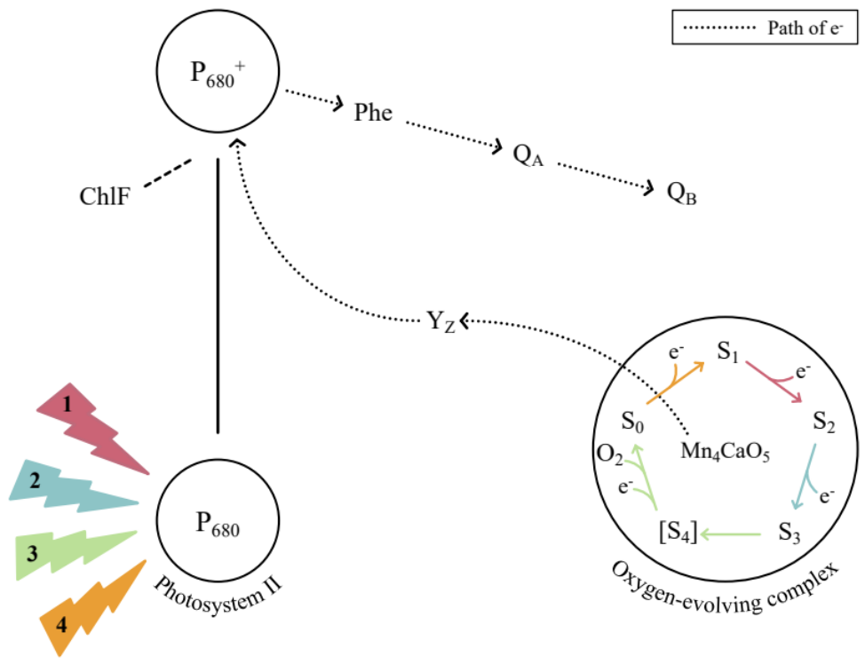
Figure 2: Pathway of S-state cycling and the electron transfer in PSII. Successive PSII charge separations extract successive electrons from the Mn cluster, inducing four increasingly oxidized states. After accumulating four oxidizing equivalents, 2 H₂O molecules are oxidized to 1 O₂ and four protons released to the lumenal side of the thylakoid.

S-State Cycling
The oxygen-evolving complex (OEC) of PSII is the active site where water is converted to oxygen and protons [21]. It consists of a metal-oxo cluster with the formula Mn₄CaO₅. As P680 absorbs successive photons, they induce charge separations, which cause electrons to be extracted from the Mn cluster. Each electron removed from the WOC replaces one lost by the reaction center when an electron is transferred downstream to metabolism. Consecutive charge separationsinduce four increasingly oxidized states, known as S-states [22], denoted as S₀ , S₁ , S₂ , S₃, followed by a transient S₄ state which rapidly decays to S₀ (Figure 2). Once four photons have been absorbed and the Mn cluster has lost four electrons, it replaces them by oxidizing two water molecules to one molecule of molecular oxygen. Therefore, a complete water oxidation cycle during oxygenic photosynthesis requires the absorption of four photons and the successive accumulation of four oxidizing equivalents [21–23].
As the OEC moves between S-states, it alters the kinetics and free energy of the system [24]. In turn, this changes the partitioning of excitation energy between photochemistry, dissipation as heat, and chlorophyll fluorescence (ChlF). As the energy allocated to ChlF is modulated by the energy allotted to photochemistry and thermalization, the quantum yield of ChlF varies between S-states [18,21]. Therefore, the four S-states are reflected by an oscillation in chlorophyll fluorescence with a period of four [25].

Recombination
During photosynthesis, electron transfers occur at both the donor and acceptor sides of Photosystem II (PSII), stabilizing separated charges [17]. However, these reactions remain reversible, occasionally resulting in the backflow of electrons through the pathway, referred to as recombination reactions [26]. Recombination plays a pivotal role in photodamage and photoprotection, harming PSII but proving essential for survival under excess light conditions [27].
At elevated light levels, the prior reduction of downstream electron acceptors blocks electron transfer from P₆₈₀⁺. Under such conditions, the primary radical pair [P₆₈₀⁺Phe⁻] will recombine, generating the excited triplet chlorophyll ³P₆₈₀⁺ (Figure 3) [28]. Chlorophyll triplets react with ground-state molecular oxygen to produce singlet oxygen (¹O₂), a highly damaging, photoinhibitory reactive oxygen species [27].
Conversely, non-radiative charge recombination acts as a mechanism of photoprotection [17]. These pathways enable direct recombination from the singlet P₆₈₀⁺Phe⁻ or P₆₈₀⁺Q_{A}⁻ state and are governed by the redox potential of the Q_{A} and Phe electron acceptors [29]. Direct recombination helps prevent the accumulation of excess energy and competes with triplet chlorophyll formation in the PSII reaction center, thereby reducing the formation of harmful ROS [26].
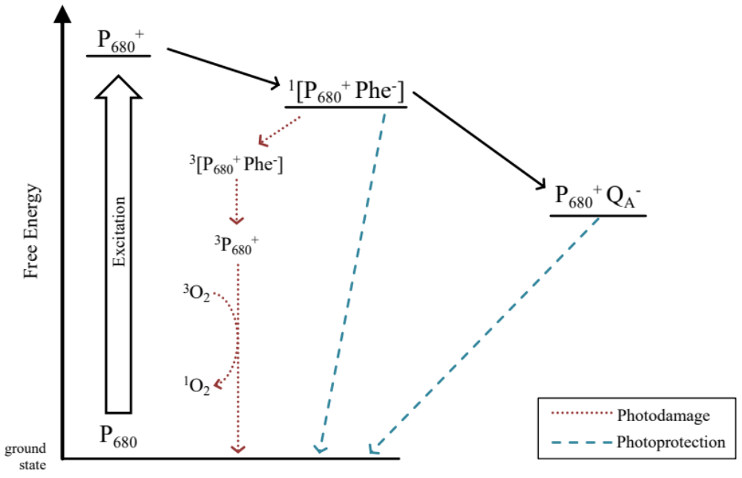
Figure 3:

Beyond their roles in photodamage and photoprotection, charge recombination reactions may also occur as a wasteful process that lowers photosynthetic energy conversion efficiency [27]. Altering reduction potentials of downstream electron acceptors, leading to changes in energy gaps, may represent evolutionary adaptations aimed at maximizing photoprotection and minimizing inefficient back recombinations under light-limited conditions [24].

Study Aims
This study evaluates if psychrophilic diatoms and green algae have evolved to increase photosynthetic energy conversion efficiency by minimizing inefficient back reactions.
The stability of S-state cycling in a phytoplankton sample may be evaluated by the applications of sequences of short, very bright, single-turnover light flashes. As sequential light flashes are applied, the population of PSII is driven synchronously through the S-state cycle [23]. In an idealized sample, the four S-states will be reflected by an ongoing periodic oscillation in ChlF. However, recombination reactions represent a loss of charge separation and wasteful slippage in the S-state cycling of individual PSII. As more recombination events occur, desynchronization of S-state cycling among the PSII of the population will scramble the periodic changes in ChlF, dampening the observed oscillation [25]. An organism exhibiting S-state cycling over more flash cycles indicates fewer inefficient back reactions and potentially more efficient photosynthetic energy conversion.
By comparing the S-state cycling over flash cycles, of psychrophilic and temperate taxa, we can determine if psychrophilic diatoms and green algae have evolved increased photosynthetic efficiency and under what conditions they may have a significant advantage in stable extraction of electrons from water.

References
1. Pierella Karlusich JJ, Ibarbalz FM, Bowler C. Phytoplankton in the Tara Ocean. Annual Review of Marine Science. 2020;12: 233–265. doi:10.1146/annurev-marine-010419-010706
2. Raven JA, Kübler JE, Beardall J. Put out the light, and then put out the light. Journal of the Marine Biological Association of the United Kingdom. 2000;80: 1–25. doi:10.1017/S0025315499001526
3. Kirk JTO. Light and Photosynthesis in Aquatic Ecosystems. 3rd ed. Cambridge, UK ; Cambridge University Press; 2011.
4. Randelhoff A, Lacour L, Marec C, Leymarie E, Lagunas J, Xing X, et al. Arctic mid-winter phytoplankton growth revealed by autonomous profilers. Science Advances. 2020;6: eabc2678. doi:10.1126/sciadv.abc2678
5. Hancke K, Lund-Hansen LC, Lamare ML, Højlund Pedersen S, King MD, Andersen P, et al. Extreme Low Light Requirement for Algae Growth Underneath Sea Ice: A Case Study From Station Nord, NE Greenland. Journal of Geophysical Research: Oceans. 2018;123: 985–1000. doi:10.1002/2017JC013263
6. Leu E, Mundy CJ, Assmy P, Campbell K, Gabrielsen TM, Gosselin M, et al. Arctic spring awakening – Steering principles behind the phenology of vernal ice algal blooms. Progress in Oceanography. 2015;139: 151–170. doi:10.1016/j.pocean.2015.07.012
7. Ardyna M, Arrigo KR. Phytoplankton dynamics in a changing Arctic Ocean. Nat Clim Chang. 2020;10: 892–903. doi:10.1038/s41558-020-0905-y
8. Robinson DH, Arrigo KR, Iturriaga R, Sullivan CW. Microalgal Light-Harvesting in Extreme Low-Light Environments in Mcmurdo Sound, Antarctica1. Journal of Phycology. 1995;31: 508–520. doi:10.1111/j.1529-8817.1995.tb02544.x
9. Bax N, Sands CJ, Gogarty B, Downey RV, Moreau CVE, Moreno B, et al. Perspective: Increasing blue carbon around Antarctica is an ecosystem service of considerable societal and economic value worth protecting. Glob Chang Biol. 2021;27: 5–12. doi:10.1111/gcb.15392
10. Lyon BR, Mock T. Polar Microalgae: New Approaches towards Understanding Adaptations to an Extreme and Changing Environment. Biology. 2014;3: 56–80. doi:10.3390/biology3010056
11. Croteau D, Guérin S, Bruyant F, Ferland J, Campbell DA, Babin M, et al. Contrasting nonphotochemical quenching patterns under high light and darkness aligns with light niche occupancy in Arctic diatoms. Limnology and Oceanography. 2021;66: S231–S245. doi:https://doi.org/10.1002/lno.11587
12. Cvetkovska M, Vakulenko G, Smith DR, Zhang X, Hüner NPA. Temperature stress in psychrophilic green microalgae: Minireview. Physiologia Plantarum. 2022;174: e13811. doi:10.1111/ppl.13811
13. Mock T, Otillar RP, Strauss J, McMullan M, Paajanen P, Schmutz J, et al. Evolutionary genomics of the cold-adapted diatom Fragilariopsis cylindrus. Nature. 2017;541: 536–540. doi:10.1038/nature20803
14. Bayer-Giraldi M, Weikusat I, Besir H, Dieckmann G. Characterization of an antifreeze protein from the polar diatom Fragilariopsis cylindrus and its relevance in sea ice. Cryobiology. 2011;63: 210–219. doi:10.1016/j.cryobiol.2011.08.006
15. Kennedy F, Martin A, Bowman JP, Wilson R, McMinn A. Dark metabolism: a molecular insight into how the Antarctic sea-ice diatom Fragilariopsis cylindrus survives long-term darkness. New Phytologist. 2019;223: 675–691. doi:10.1111/nph.15843
16. Kawakami K, Shen J-R. Purification of fully active and crystallizable photosystem II from thermophilic cyanobacteria. Methods in Enzymology. Elsevier; 2018. pp. 1–16. doi:10.1016/bs.mie.2018.10.002
17. Vass I. Role of charge recombination processes in photodamage and photoprotection of the photosystem II complex. Physiologia Plantarum. 2011;142: 6–16. doi:10.1111/j.1399-3054.2011.01454.x
18. Schuback N, Tortell PD, Berman-Frank I, Campbell DA, Ciotti A, Courtecuisse E, et al. Single-Turnover Variable Chlorophyll Fluorescence as a Tool for Assessing Phytoplankton Photosynthesis and Primary Productivity: Opportunities, Caveats and Recommendations. Frontiers in Marine Science. 2021;8. Available: https://www.frontiersin.org/articles/10.3389/fmars.2021.690607
19. Shen J-R. Photosynthesis | Photosystem II: Protein Components, Structure and Electron Transfer☆. In: Jez J, editor. Encyclopedia of Biological Chemistry III (Third Edition). Oxford: Elsevier; 2021. pp. 215–228. doi:10.1016/B978-0-12-819460-7.00012-8
20. Mukhopadhyay S, Mandal SK, Bhaduri S, Armstrong WH. Manganese Clusters with Relevance to Photosystem II. Chem Rev. 2004;104: 3981–4026. doi:10.1021/cr0206014
21. Gates C, Ananyev G, Dismukes GC. Realtime kinetics of the light driven steps of photosynthetic water oxidation in living organisms by “stroboscopic” fluorometry. Biochimica et Biophysica Acta (BBA) - Bioenergetics. 2020;1861: 148212. doi:10.1016/j.bbabio.2020.148212
22. Zaharieva I, Dau H. Energetics and Kinetics of S-State Transitions Monitored by Delayed Chlorophyll Fluorescence. Frontiers in Plant Science. 2019;10. Available: https://www.frontiersin.org/articles/10.3389/fpls.2019.00386
23. Dau H, Haumann M. Time-resolved X-ray spectroscopy leads to an extension of the classical S-state cycle model of photosynthetic oxygen evolution. Photosynth Res. 2007;92: 327–343. doi:10.1007/s11120-007-9141-9
24. Vinyard DJ, Ananyev GM, Charles Dismukes G. Photosystem II: The Reaction Center of Oxygenic Photosynthesis. Annual Review of Biochemistry. 2013;82: 577–606. doi:10.1146/annurev-biochem-070511-100425
25. de Wijn R, van Gorkom HJ. S-state dependence of the miss probability in Photosystem II. Photosynthesis Research. 2002;72: 217–222. doi:10.1023/A:1016128632704
26. Vass I, Cser K. Janus-faced charge recombinations in photosystem II photoinhibition. Trends in Plant Science. 2009;14: 200–205. doi:10.1016/j.tplants.2009.01.009
27. Rappaport F, Cuni A, Xiong L, Sayre R, Lavergne J. Charge Recombination and Thermoluminescence in Photosystem II. Biophysical Journal. 2005;88: 1948–1958. doi:10.1529/biophysj.104.050237
28. Laloi C, Przybyla D, Apel K. A genetic approach towards elucidating the biological activity of different reactive oxygen species in Arabidopsis thaliana. Journal of Experimental Botany. 2006;57: 1719–1724. doi:10.1093/jxb/erj183
29. Rutherford AW, Osyczka A, Rappaport F. Back-reactions, short-circuits, leaks and other energy wasteful reactions in biological electron transfer: Redox tuning to survive life in O2. FEBS Letters. 2012;586: 603–616. doi:10.1016/j.febslet.2011.12.039

