Photosystem II Function under Extreme Low Light and Low Temperatures; Polar vs. Temperate Phytoplankton
Mackenzie Poirier³, Natasha M. Ryan¹, Pomona Osmers³, Arthur Plassart^{2;4}, Sébastien Guérin², Marcel Babin², Maximilian Berthold¹, Mireille Savoie¹, Marina Cvetkovska³, and Douglas A. Campbell¹
2026-01-05
Abstract
Polar phytoplankton achieve slow, but ecologically significant, productivity under exceptionally low light, where the sequential arrivals of photons at Photosystem II complexes are widely spaced in time. We hypothesized that maintaining photosynthesis under such low light involves suppression of energetically wasteful photochemical ‘misses’ in Photosystem II. Under full darkness Photosystem II relaxes predominantly to the S1 oxidation state of the oxygen evolving complex. After such dark relaxation we applied series of single turnover, saturating, flashes to advance Photosystem II through sequential photochemical charge separations, progressively oxidizing the oxygen evolving complex through sequential increments through the S-States, resulting in four-step changes in Photosystem II chlorophyll fluorescence yield. We tracked these oscillations in chlorophyll fluorescence to measure the persistence of synchronized S-States across the Photosystem II populations in diatoms and green algae, in response to changing measurement temperatures and a range of extremely low light, which we emulated by increasing the spacing between photon deliveries. Prolonged synchronous S-State cycling indicates fewer desynchronizations from wasteful photochemical misses and, thus, potentially more efficient photosynthetic energy conversion under low light. We observed that colder temperatures result in more sustained cycling at longer photon spacings, within taxa. Further, polar taxa maintained synchronized cycles for longer than did temperate taxa, even under comparable measurement conditions. Our findings support our hypothesis that diverse lineages of polar phytoplankton can suppress energetically wasteful photochemical misses under low temperature, to help sustain photosynthesis even under extremely low light. Therefore ambient temperature interacts with the lower-light limitation on photosynthesis.
¹ Department of Biology, Mount Allison University, Sackville NB, Canada, E4L1G7
² Takuvik Joint International Laboratory, Université Laval (Canada) - CNRS (France)
³ Department of Biology, University of Ottawa, Ottawa, ON, Canada
4 Institut de Biologie de l’ ́Ecole Normale Sup ́erieure (IBENS), ́Ecole Normale Sup ́erieure, CNRS, INSERM, PSL Universit ́e Paris, 75005, Paris, France;

- Differences in pigment composition and implications for light absorption in vivo : The green lineage has antenna complexes (LHCs) composed mainly of chlorophyll a and b, while diatoms have FCPs (fucoxanthin-chlorophyll a/c-binding proteins) composed of chlorophyll a and fucoxanthin (Fx). This difference in composition gives diatoms much more efficient blue-green light absorption in the 500-560 nm region (see Oka et al., 2020 for Phaeodactylum, https://doi.org/10.1007/s11120-018-0523-y), compared to the green lineage, where absorption drops dramatically in this region of the spectrum (see Ueno et al., 2019 for Chlamydomonas, https://doi.org/10.1007/s11120-018-0523-y). As you now. Here, excitation occurs only at 445 nm, which mainly excites chlorophyll a and b in green algae organisms, and also the beginning of the fucoxanthin absorption spectrum in diatoms. However, this does not cover the entire possible absorption spectrum of accessory pigments in vivo. We saw that, for Fragilariopsis acclimatized to low light, chlorophyll a represents only 50% of the total pigment pool, and we observe a slight increase in the fucoxanthin pool compared to chlorophyll a (see figure). Do you think that exciting all pigments (across the entire absorption spectrum of the species) would have an impact on the “dumping index”? In other words, could using excitation at 445 nm alone bias our assessment, particularly in diatoms where accessory pigments (such as fucoxanthin) play a major role in light capture in vivo, or is there actually greater photon capture capacity for diatoms? Perhaps the evaluators could be asked to discuss this.

- Question of curiosity/opinion: The putative role of cyclic electron flux : we know that there are cyclic electron flows around the PSI mediated by the PGR5/PGRL1 pair and type I NADH dehydrogenase (NDH) in the green lineage, mainly active under stress conditions for photoprotection and balancing the ATP/NADPH ratio (Croteau et al., 2024; see also Chapter 1, Section 1.4.1). These mechanisms involve the plastoquinone (PQ) pool and remain putative in diatoms, although the PGR5/PGRL1 genes are present in these organisms, and NDH is specifically found in F. cylindrus (absent in Phaeodactylum and Thalassiosira). Furthermore, it is now established that in the green lineage, a cyclic electron flow may also exist around PSII (Zourmas et al., 2023, https://doi.org/10.1007/s11120-023-00997-0 ; Ananyev et al., 2017, https://doi.org/10.1016/j.bbabio.2017.07.001). In their study on Chlorella ohadii, Ananyev et al. (2017) associate the loss of Fv/Fm oscillations following more widely spaced flashes with the establishment of a cyclic electron flow around PSII (see their Figure 7 and paragraph 4.3). In their section 4.5 entitled “The mechanism(s) of PSII-CEF,” the authors seem to directly link the loss of the fluorescence oscillation signal with the induction of the cyclic flow of PSII. They write: "It is likely that CEF is an energy-conservative pathway generating proton motive force (pmf) from electrons in the reduced PQH₂ pool that equilibrate with QB. This mechanism for CEF would achieve two goals: 1) lower the redox poise, PQH₂/PQ, of the pool, thus lowering potentially dangerous levels of upstream redox-active molecules, preventing generation of reactive oxygen species or singlet oxygen (Scheme 1), and 2) conserve photonic energy by generating pmf" (I recommend reading the rest of this section as it raises some excellent questions). This mechanism is described for cells in response to high light (HL), but could it also play a role in explaining the faster loss of oscillations observed in temperate taxa (phenotype usually cultivated in HL)? Do you think that cyclic flows around PSI or those of PSII could play a role in QB equilibration?

To Do

0.1 Substantial:
convert damping index to relative probability of desynchronization?
do math or cite literature to estimate probability of double hits contributing to desynchronization and whether that probability varies with flash spacing or temperature?
process & plot tau data to track how long PSII is closed after flash

0.2 Manu Prep:
Fix figure & table citation issue
Scan recent literature; Gates?

Introduction
Phytoplankton are a functional grouping of photosynthetic microorganisms, of diverse lineages and ecologies (Pierella Karlusich et al., 2020). Phytoplankters share photolithotrophic growth, using a set of highly conserved protein complexes (Falkowski et al., 2008) to harness energy from Photosynthetically Active Radiation (PAR), to drive reduction and assimilation of inorganic carbon, nitrogen, phosphorus, sulphur, and other essential micronutrients (Raven et al., 2000). PAR, however, decreases with depth, as light passing through the water column is scattered and absorbed (Kirk, 2011). Therefore, with photons as an energy input, phytoplankton growth is constrained to the photic zone, the region of water receiving sufficient light for photosynthesis, operationally defined in past as extending down to a limit receiving 1% of surface irradiance, thus 2-20 µmol photons m⁻² s⁻¹ (Raven et al., 2000).
Light availability is further constrained in polar aquatic habitats, with light penetration of the water limited by seasonally low solar angles, ice cover, and snow cover (Cohen et al., 2020; Leu et al., 2015; Hancke et al., 2018), thereby presenting challenges for phytoplankton growth (Hancke et al., 2018; Randelhoff et al., 2020; Hoppe et al., 2024). Indeed the lower limit of the photic zone was reconsidered when benthic microalgae in the Antarctic were reported as photosynthetically active at light levels less than 1 µmol photons m⁻² s⁻¹ (Robinson et al., 1995; McMinn et al., 2003). Some polar psychrophile phytoplankton further demonstrate slow, but ecologically significant, photosynthetic productivity in the winter at PAR below 0.17 µmol photons m⁻² s⁻¹ [Randelhoff et al. (2020); Hancke et al. (2018); Morgan-Kiss et al. (2016); Hoppe et al. (2024)], with implications for the responses of polar phytoplankton communities to climate change (Ardyna and Arrigo, 2020).
This slow, but potentially significant, phytoplankton photosynthesis during polar winters underscores the ability of psychrophilic phytoplankton to maintain functional photosystems throughout the polar night (Morgan-Kiss et al., 2016; Randelhoff et al., 2020; Hoppe et al., 2024), and supports a theoretical minimum light level for phytoplankton photosynthesis of 0.01 µmol photons m⁻² s⁻¹ (Raven et al., 2000). Such low-light phytoplankton photosynthesis could mitigate cell mortality in the extended darkness of winter, maintaining seeding populations for the spring bloom (Randelhoff et al., 2020), the major source of annual net primary production in polar regions (Ardyna and Arrigo, 2020).
In parallel with seasonally low light, psychrophile phytoplankton contend with cold temperature constraints on water viscosity, solute diffusion rates, membrane fluidity, enzyme kinetics and macromolecule interactions (Lyon and Mock, 2014). In parallel, salinities vary across polar habitats [REFERENCES MACKENZIE ET AL], along with shorter-tem local salinity fluctuations driven by freezing and thawing of ice [REFERENCES MACKENZIE ET AL]. XXXPOMONA ARTICLE(S) on SALINITY RESPONSES?XXX.
Such extreme abiotic constraints probably act as powerful ecological filters, by imposing niche-driven speciation processes among phytoplankton lineages adapted to polar environments (Ibarbalz et al., 2023). Some psychrophilic phytoplankton indeed exhibit high genetic divergence from related temperate species. The polar diatom Fragilariopsis cylindrus shows divergent alleles compared to their mesophilic relatives (Mock et al., 2017), with changes in protein structure, including amino acid substitutions, H-bonds, and salt bridges (Lyon and Mock, 2014), cold shock proteins (Lyon and Mock, 2014) and anti-freeze proteins (Bayer-Giraldi et al., 2011). Similarly, the polar green algae Chlamydomonas priscui and Chlamydomonas sp. ICE-L harbour large genomes enriched in genes families encoding for ice-binding proteins, molecular chaperones, light harvesting proteins and core histones (Zhang et al. (2021)). Polar microbes use cellular-compatible solutes, including sugars, polyols, amino acids, betaine, and DMSP, which lower intracellular freezing points and maintain enzyme hydration spheres, stabilizing catalytic activity (Lyon and Mock, 2014; Zhang et al., 2020). Additionally, they exhibit high levels of polyunsaturated fatty acids (PUFAs) in their lipid membranes (Lyon and Mock, 2014; Cvetkovska et al., 2022) contributing to maintenance of membrane fluidity at cold temperatures.
Oxygenic photosynthesis in eukaryotic phytoplankton occurs in chloroplasts, bounded by a two- to four-membrane envelope, depending upon taxa (Kirk, 2011). Thylakoid membranes, containing pigments and electron carriers, traverse the chloroplast stroma. Photosystem II (PSII), a multi-subunit protein complex embedded in the thylakoid membranes (Shevela et al., 2023), catalyzes the photooxidation of water, releasing O₂ and H⁺, and passing reductant into the photosynthetic electron transport chain.
Photons are captured by light-harvesting chlorophyll molecules (Kirk, 2011), initiating a transition from the ground state to an electronically excited state. Energy absorbed by light harvesting complexes undergoes rounds of inductive resonance transfer among multiple pigments before eventually reaching the photochemical reaction center of PSII, P₆₈₀ (Kirk, 2011), composed of a Chl a heterodimer (Shen, 2021; Vass, 2011). The excitation energy is then distributed, in variable proportions, to i) photochemistry; ii) dissipation as heat; or iii) re-emission as fluorescence (ChlF) (Schuback et al., 2021). When P₆₈₀ is raised to its excited state, P₆₈₀*, it shifts to a lower reduction potential, allowing photooxidation to P₆₈₀+ through transfer of an electron to a phaeophytin (Phe) initial acceptor molecule (Vass, 2011; Shevela et al., 2023). In productive electron transport the electron from reduced Phe- is transferred to plastoquinone A (Q_{A}), followed by transfer to plastoquinone B (Q_{B}) (Shen, 2021). Q_{B}, once fully reduced after receiving two electrons, is released, carrying the electrons into the mobile plastoquinone pool in the lipid phase of the thylakoid membrane (Kirk, 2011). P₆₈₀+ is reduced back to P₆₈₀ by taking an electron from a tyrosine residue D1-Tyr-161 (Yz). Yz, in turn, extracts an electron from a manganese cluster on the thylakoid lumenal side of PSII (Shen, 2021; Mukhopadhyay et al., 2004).
During photosynthesis, electron transfers thus sequentially stabilize the photochemical charge separations (Vass, 2011). These charge separations are, however, reversible through recombination reactions (Vass and Cser, 2009; Han et al., 2012), which are futile cycles of photochemistry (Rappaport et al., 2002; Rappaport et al., 2005; Laloi et al., 2006) forming one category of photochemical ‘miss’ (Han et al., 2012, 2022). Recombinations can generate chlorophyll triplets which react with ground-state molecular oxygen to produce singlet oxygen (¹O₂), a highly damaging, photoinhibitory reactive oxygen species (ROS) (Rappaport et al., 2005). Conversely, these non-radiative charge recombinations act as a mechanism of photoprotection under excess excitation (Vass, 2011), enabling direct recombination from the singlet P₆₈₀+Phe- or P₆₈₀+Q_{A}- states (Rutherford et al., 2012), to help suppress the formation of harmful ROS (Vass and Cser, 2009). Since these recombinations have characteristic activation energies (Rappaport et al., 2002), the probabilities of recombinations vary with temperature, (Ivanov et al., 2006; Han et al., 2008; Han et al., 2012, 2022). Both plants and cyanobacteria furthermore show acclimatory modulations (Quigg et al., 2003) of the reduction potentials of electron transfer intermediates, thereby changing the probabilities and temperature dependencies of recombinations (Ivanov et al., 2006; Sane et al., 2003; Sane et al., 2002; Ivanov et al., 2003).
Beyond their roles in photodamage and photoprotection, charge recombination reactions are wasteful ‘miss’ processes that lower photosynthetic energy conversion efficiency (Rappaport et al., 2005; Han et al., 2012) by competing with linear electron transport. Shifting reduction potentials of downstream electron acceptors, leading to changes in energy gaps for recombinations, may represent evolutionary adaptations aimed at maximizing photoprotection and minimizing losses through back-reactions under light-limited conditions (Vinyard et al., 2013).
The oxygen-evolving complex (OEC) of PSII consists of a manganese-oxo cluster (Mn₄CaO₅) where water is oxidized, releasing oxygen and protons (Gates et al., 2020). Four consecutive charge separations at P₆₈₀ induce four increasingly oxidized states of the Mn cluster, known as S-States (Zaharieva and Dau, 2019), denoted, from most reduced to most oxidized, as S0, S1, S2, and S3, followed by a transient S4 state, which rapidly decays to S0. Once the Mn cluster has progressively lost four electrons, it oxidizes two water molecules, releasing one molecule of O₂. Therefore, a complete water oxidation cycle during oxygenic photosynthesis requires four sequential photon excitations of a single PSII, with the progressive accumulation of four oxidizing equivalents in the OEC (Dau and Haumann, 2007; Gates et al., 2020; Zaharieva and Dau, 2019), and the reduction of two Q_{B}.
Under light limitation, the excitations of P₆₈₀ in each PSII are widely spaced in time. Thus in order to maintain productive electron transport, the electron transfer intermediates must persist for long periods of time, elevating the probabilities of energetically wasteful recombination reactions, which represent a step backward in the S-State cycle (Keren et al., 1997; de Wijn and van Gorkom, 2002; Han et al., 2008). Stable and progressive S-State cycling under low light, in contrast, sustains electron flow for ATP and NADPH production, while minimizing risks of low-light photodamage to PSII (Rappaport et al., 2005; Keren et al., 1997).
S-State cycling in a phytoplankton sample can be tracked by applications of sequences of short, single-turnover saturating light flashes, bright enough to deliver a photon to each PSII. In darkness the PSII population relaxes primarily to S1 (Han et al., 2008). As sequential light flashes are applied, the population of PSII complexes is driven through the S-State cycle (Dau and Haumann, 2007). The S-States have different intrinsic PSII fluorescence yields (Gates et al., 2020; Zaharieva and Dau, 2019), so in an idealized sample, the four sequential S-States will be reflected by an ongoing periodic oscillation in ChlF. Recombination reactions, however, contribute to wasteful misses in the S-State cycling of individual PSII (Han et al., 2012). As misses occur, they progressively desynchronize S-State cycling across the PSII population, dampening the observed ChlF oscillation (de Wijn and van Gorkom, 2002) towards an averaged ChlF for the PSII population distributed across the S-States. An organism exhibiting synchronized S-State cycling sustained over more flash cycles indicates fewer photochemical misses, and thus higher conversion of sequentially spaced excitations to photosynthetic electron transport. By comparing the S-State cycling over flash cycles, of psychrophilic and temperate phytoplankton taxa, we sought to determine if psychrophilic diatoms and green algae show higher maintenance of progressive PSII function under extreme low light, thereby supporting stable extraction of electrons from water to support productive photosynthesis.

Materials and methods

Study Strains and Culturing Conditions
The nine study taxa, including polar and temperate strains of diatoms and green algae, and their respective culturing conditions are summarized in Table 1.
Table 1: Study taxa and culture growth conditions.
Taxa | Lineage | Origin | Growth °C | NaCl (mM) | NaCl (opt) | PAR (µE) | Photoperiod (h) | Media
Fragilariopsis cylindrus | Diatom | Polar | 0 | 500.00 | 500.00 | 10 | 24 | F2
Fragilariopsis cylindrus | Diatom | Polar | 0 | 500.00 | 500.00 | 1 | 24 | F2
Fragilariopsis cylindrus | Diatom | Polar | 6 | 500.00 | 500.00 | 10 | 24 | F2
Fragilariopsis cylindrus | Diatom | Polar | 6 | 500.00 | 500.00 | 1 | 24 | F2
Thalassiosira pseudonana | Diatom | Temperate | 22 | 500.00 | 500.00 | 50 | 12 | F2
Chlamydomonas ICEMDV | Green | Polar | 4 | 70.00 | 500.00 | 10 | 24 | BBM
Chlamydomonas klinobasis | Green | Polar | 4 | 0.43 | 0.43 | 10 | 24 | BBM
Chlamydomonas klinobasis | Green | Polar | 4 | 10.00 | 0.43 | 10 | 24 | BBM
Chlamydomonas klinobasis | Green | Polar | 4 | 30.00 | 0.43 | 10 | 24 | BBM
Chlamydomonas malina | Green | Polar | 4 | 30.00 | 500.00 | 10 | 24 | BBM
Chlamydomonas malina | Green | Polar | 4 | 70.00 | 500.00 | 10 | 24 | BBM
Chlamydomonas malina | Green | Polar | 4 | 500.00 | 500.00 | 10 | 24 | BBM
Chlamydomonas priscui | Green | Polar | 4 | 30.00 | 500.00 | 10 | 24 | BBM
Chlamydomonas priscui | Green | Polar | 4 | 70.00 | 500.00 | 10 | 24 | BBM
Chlamydomonas priscui | Green | Polar | 4 | 500.00 | 500.00 | 10 | 24 | BBM
Chlamydomonas priscui | Green | Polar | 4 | 700.00 | 500.00 | 10 | 24 | BBM
Chlamydomonas euryale | Green | Temperate | 24 | 30.00 | 500.00 | 10 | 24 | BBM_NH4
Chlamydomonas euryale | Green | Temperate | 24 | 70.00 | 500.00 | 10 | 24 | BBM_NH4
Chlamydomonas euryale | Green | Temperate | 24 | 500.00 | 500.00 | 10 | 24 | BBM_NH4
Chlamydomonas reinhardtii | Green | Temperate | 24 | 0.43 | 0.43 | 10 | 24 | BBM
Chlamydomonas reinhardtii | Green | Temperate | 24 | 10.00 | 0.43 | 10 | 24 | BBM
Chlamydomonas reinhardtii | Green | Temperate | 24 | 30.00 | 0.43 | 10 | 24 | BBM
Chlorella vulgaris | Green | Temperate | 22 | 500.00 | 500.00 | 50 | 12 | F2
Chlorella vulgaris | Green | Temperate | 22 | 500.00 | 500.00 | 50 | 12 | BG11
Fragilariopsis cylindrus is a psychrophilic (Fiala and Oriol, 1990) pennate diatom measuring 15-55 µm which forms large blooms in the high salinity and subzero temperatures of Arctic and Antarctic sea-ice systems (Otte et al., 2023; Cefarelli et al., 2010), and is a keystone species for polar ecosystems (von Quillfeldt, 2004; Otte et al., 2023; Kang and Fryxell, 1992). Sequenced in 2017, Fragilariopsis cylindrus has since become the model psychrophilic diatom species for investigating molecular and physiological mechanisms of cold adaptation (Mock et al., 2017). Conversely, Thalassiosira pseudonana (Cyclotella nana) is a centric diatom (2.5-15 μm) found in diverse freshwater, coastal, brackish, and marine habitats (Poulsen and Kröger, 2023), across a range of salinities and temperatures (4–25°C) (Poulsen and Kröger, 2023). Chlamydomonas sp. ICE-MDV and Chlamydomonas priscui are halotolerant algae isolated from the perennially ice-covered hypersaline Lake Bonney, in McMurdo Dry Valleys, Antarctica (Cook et al., 2019; Stahl-Rommel et al., 2022). With 15 to 20 μm biflagellate cells, Chlamydomonas sp. ICE-MDV dominates the shallow photic zone, where it experiences relatively higher irradiance, extreme nutrient limitation, and lower salinity (Cook et al., 2019; Li et al., 2016). The smaller Chlamydomonas priscui dominates the deep photic zone, characterized by permanent low temperatures, low irradiance, and high salinity (Cvetkovska et al., 2022; Hüner et al., 2023). Chlamydomonas malina is a marine microalga isolated from the Arctic Beaufort Sea, around 10 μm in length and 5 μm in width, growing optimally at 4°C (Balzano et al., 2012; Morales-Sánchez et al., 2020). Chlamydomonas klinobasis is a freshwater microalga isolated from XXXX, around XX μm in length and YY μm in width, growing optimally at 4°C [CITATIONS MACKENZIE?]. The temperate Chlamydomonas reinhardtii is a model green alga approximately 10 μm in diamter, found in freshwater soil and aquatic environments with an optimal temperature range of 20-32°C (Sasso et al., 2018; Xie et al., 2013). The temperate Chlamydomonas euryale is approximately 10 μm in diameter, isolated from ZZZZ[MacKenzieCITATION], with an optimal temperature of ~24°C [CITATIONSXXX]. Chlorella vulgaris, ranging from 2 μm to 10 μm in size, is primarily found in freshwater environments and grows optimally at 27°C (Wiel et al., 2017; Leyva et al., 2014).
XXXXMacKenzie add origins & citations for C. euryale, C.klinobasis?
Thalassiosira pseudonana and Chlorella vulgaris were cultured by Naaman Omar (Mount Allison University); Chlamydomonas strains were cultured by Mackenzie Poirier (Cvetkovska Lab, University of Ottawa) as reported previously (Poirier et al. (2025)); while Fragilariopsis cylindrus was cultured by Sébastien Guérin (Takuvik International Research Laboratory, Université Laval).

Single Turnover Variable Chlorophyll Fluorescence
We used series of single turnover, saturating, flashes to induce variable chlorophyll fluorescence (ChlF) (Kolber, 1998), and evaluate progressive desynchronization of the S-State cycle in several polar and temperate phytoplankton species acclimated to a range of growth temperatures. We loaded a 3 mL sample of culture into a temperature-controlled water-jacketed quartz cuvette (Cafferty’s Scientific Glassblowing, Anola, Manitoba, Canada), placed within the measurement chamber of a Soliense fluorometer (Version LIFT-REM 1.0, Soliense Inc., Shoreham NY, USA). The apparatus was covered to block out incident light, for a minimum of 30 seconds prior to measurements. In the dark PSII reaction centres relax to ground state, and are open for photochemistry upon receipt of an absorbed photon, with a low fluorescence yield (Schuback et al., 2021). In parallel the OEC relaxes primarily to S1 (Han et al., 2008), so the S-States of the population of PSII largely synchronize. The sample was then exposed to a series of 32 short, high irradiance evenly spaced flashes centred at 445 nm. Each flash comprised a rapid series of 50-70 sub-saturating flashlets of 1.6 µs and ~ 30000 µmol photons m⁻² s⁻¹, , delivered every 4.1 µs, over a total 205 - 287 µs per flash (Schuback et al., 2021). These flashlets cumulatively deliver a photon to each PSII in the population, with each PSII ideally undergoing a single round of photochemistry and passing an electron downstream to Q_{A}-, closing PSII for photochemistry for ~1000 µs, the lifetime (𝛕) for re-opening by downstream electron transport (Dau and Haumann, 2007; Schuback et al., 2021). Closing the photochemistry pathway transiently redirects a greater proportion of additional incoming excitation to ChlF, driving ChlF progressively from minimum (F_{O}) towards a maximum (F_{M}) as the PSII centres close (Schuback et al., 2021). For each flash-induced fluorescence rise, F_{O} and F_{M} were extracted using a fitting model (LIFT software version 22.11.11, Solisense Inc) (Kolber, 1998). F_{O} and F_{M} were then used to derive the maximum quantum yield of photochemistry for open PSII (Schuback et al., 2021), a secondary ChlF parameter calculated as:
$$\frac{F_{V}}{F_{M}}=\frac{F_{M}-F_{O}}{F_{M}} \left(1\right)$$
For each culture sample we adjusted the number and excitation power of flashlets per flash to achieve closure of ~ 0.95 of PSII complexes, as estimated by the fitting of the chlorophyll fluorescence induction (Kolber, 1998; Schuback et al., 2021). Ideally the saturating flash would achieve complete closure of the PSII population, but concomitant re-opening of PSII centres by downstream electron transport results in a steady state ratio of mainly closed PSII to a fraction of open PSII, even at F_{M}. The flash power required to drive the PSII population to closure depends largely upon the effective absorption cross-section of photosystem II (σ_{PSII}), itself estimated from the ChlF induction curve during the saturation phase (Kolber, 1998). σ_{PSII} represents the probability of light capture by the PSII antenna bed associated with the dark-adapted PSII (Schuback et al., 2021; Xu et al., 2018). When σ_{PSII} for a sample is large, the higher probability of excitation delivery to PSII means fewer, or weaker, flashlets are required to sequentially saturate the population of PSII, while limiting excitation stress or double turnovers of PSII associated with excess light (Xu et al., 2018). Conversely, a sample with a smaller σ_{PSII} requires more numerous, or brighter, flashlets, to drive the proportion of closed reaction centres progressively towards saturation. If the brightness and number of sub-saturating flashlets are appropriate for the culture, the fluorescence will reach a plateau after approximately 70% of the flashlets are applied (Kolber, 1998).
We kept the single turnover excitation flash train as short as feasible, to avoid excessive excitation, and to limit the probability of ‘double hits’ (Han et al., 2012, 2022); re-openings of PSII, followed by re-closures of PSII complexes by a second round of photochemistry, which contribute to desynchronization of the progression of the PSII complexes through S-States. Thus, as sequential flashes are applied to the culture, each individual PSII is ideally driven through the four S-States (Fig 1) (Dau and Haumann, 2007). As the oxygen-evolving complex of PSII moves between S-States, it alters the system kinetics and free energy (Vinyard et al., 2013), so the yield of ChlF varies between S-States (Gates et al., 2020), and we can use ChlF to monitor S-State progression, until the PSII population desynchronizes to a distribution of S-States with an averaged ChlF.
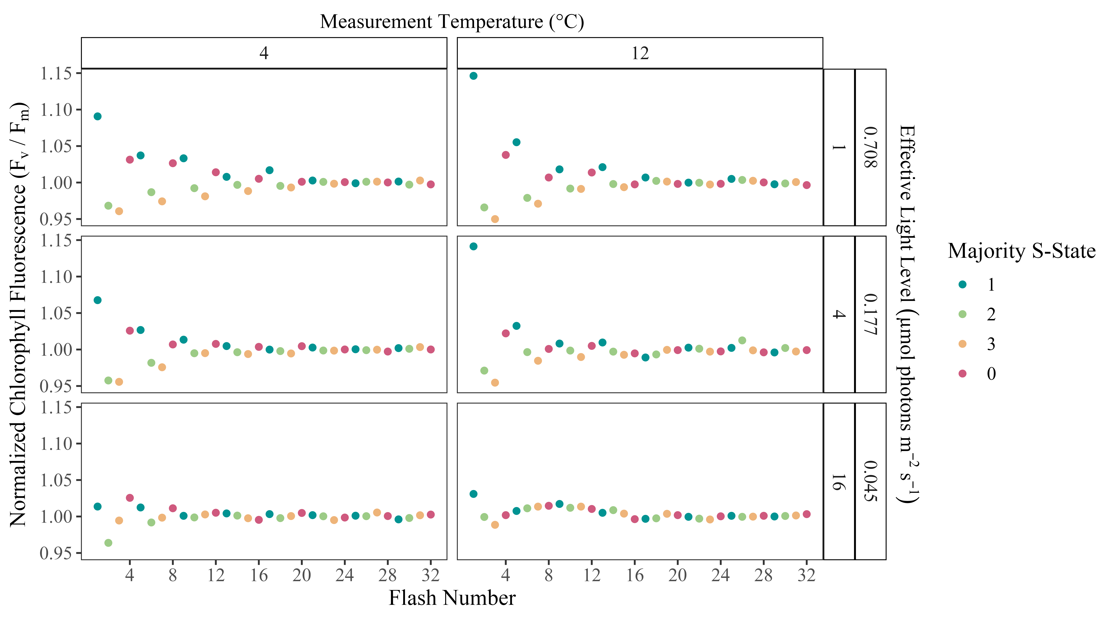
Fig 1: Representative oscillations of the maximum quantum yield of PSII photochemistry over a Series of Single Turnover Saturating Flashes applied to Chlamydomonas priscui. F_{V}/F_{M} was normalized to the average value over the series, measured at 4 or 12 °C, with spacing of 1, 4, or 16 s between sequential flashes, excitation rates equivalent to irradiance with 0.708, 0.177 or 0.044 µmol photons m⁻² s⁻¹. Symbol colour indicates inferred majority S-State, based upon relaxation to S1 during the dark incubation preceding the flash sequence.

Measurements
By evaluating the oscillations in ChlF (Fig 1), we tracked S-State cycling of polar and temperate taxa of diatoms and green algae under a range of measurement temperatures and effective light levels (2), to determine if polar taxa maintain synchronized PSII function, as an index of their capacity for electron transport under low light, by suppressing wasteful photochemical misses. Measurement temperatures ranged from 0 to 28°C, depending on the taxa (2).
Increasing the spacing between sequential flashes decreases the repeat rate for excitations arriving at PSII, thereby approximating a decrease in excitations delivered to PSII per second under a decrease in continuous irradiance (Fig 1). Our instrument control limited our minimum flash spacing to 1 s, so cultures were evaluated at flash spacings of 1, 2, 4, 8, and 16 seconds (2). The equivalent effective light levels were then estimated using the σ_{PSII} determined for each culture as follows:
$$Light\left({photons m}^{-2}{ s}^{-1}\right)=\frac{1}{flash spacing \left(s\right)}×\frac{1}{σ_{PSII} \left(m^{2} {photons}^{-1}\right)} \left(2\right)$$
1/σ_{PSII} is multiplied by flash spacing (s) to convert the probability that an individual incident photon is absorbed by PSII, into an equivalent photon flux density, i.e. to estimate effective light availability serving PSII photochemistry.
Since the population of PSII starts predominantly from S1 in the dark acclimated state, the population of PSII will initially cycle synchronously through S States, reflected by an oscillation in chlorophyll fluorescence with a period of four (Fig 1)(de Wijn and van Gorkom, 2002). Photochemical misses, including wasteful recombination reactions causing loss of a charge separation in a PSII, will cause a missed step in the S-State cycling of an individual PSII. As more photochemical misses occur, desynchronization of S-State cycling among the population of PSII will scramble the periodic changes in ChlF, dampening the observed oscillation of the population-level fluorescence (de Wijn and van Gorkom, 2002; Han et al., 2022). Prolonged four-step synchronous cycling of PSII fluorescence thus reflects a lower probability of desynchronization at each excitation, and thus a lower probability of losses through photochemical misses. Photochemical double hits also contribute to desynchronization (Han et al., 2022; Han et al., 2008), but should not vary strongly across changes in flash spacing nor measurement temperature within a sample.

Analytical Methods
Data was processed using R version 4.3.2 (R Core Team, 2023) and RStudio version 2023.12.0+369 (Posit team, 2025) on the x86_64-apple-darwin20 (64-bit) platform and running under macOS Sonoma 14.3.1. Fluorescence data files generated by LIFT software were imported, tidied and combined with metadata on each culture using the tidyverse (Wickham, 2023), lubridate (Spinu et al., 2024), and googlesheets4 (Bryan, 2023) packages. The doBy (Halekoh and Højsgaard, 2025), and WaveletComp (Roesch and Schmidbauer, 2018) packages were used for wavelet analyses. The mgcv (Wood, 2011) and mgcViz (Fasiolo et al., 2020) packages were used for generalized additive modelling, while the ggplot2 (Wickham, 2016), ggh4x (van den Brand, 2025), and metR (Campitelli, 2021) packages were used for data visualization. Statistical results tables were done using the packages ‘broom’ (Robinson et al., 2025), ‘knitr’ (Xie, 2025), and ‘kableExtra’ (Zhu, 2024).

Wavelet Transformations
The fluorescence data yields a time series of F_{V}/F_{M} over 32 sequentially applied flashes, for each flash spacing, and each measurement temperature, for each culture sample. The F_{V}/F_{M} time series were analyzed for each combination of strain, growth conditions, measurement temperature, and flash spacing, using wavelet transformations (Theis and Meyer-Bäse, 2010), as exemplified in (Fig 2). Unlike traditional methods, wavelet analysis does not assume that the statistical properties of a time series are constant. Instead, wavelet transformations locally decompose the signal across different time scales and estimate spectral characteristics as a function of time (Cazelles et al., 2008). By examining the frequency and wavelet power spectra, we can uncover the dominant patterns in the data (Theis and Meyer-Bäse, 2010).

Fig 2: Representative wavelet transformations of Antarctic Chlamydomonas priscui variable chlorophyll fluorescence (F_{V}/F_{M}) measured at 4, 8 or 12°C, over 32 consecutive single turnover saturating flashes, applied at spacings of 1, 2, 4, 8, 16 s, equivalent to photon delivery rates to PSII achieved under light levels from 0.708 down to 0.045 µmol photons m⁻² s⁻¹.
The wavelet transformation involves computing the wavelet power spectrum of the standardized time series using the Morlet wavelet (Theis and Meyer-Bäse, 2010). The statistical significance of the periodic components in the time series was then calculated using a simulation algorithm. Surrogate time series are generated based on a white noise model, consisting of uncorrelated random values with constant mean and variance. The wavelet transform of the data is compared with the white noise model, to estimate p-values for whether the observed periodic components are statistically significant (Theis and Meyer-Bäse, 2010). Statistical significance of the wavelet power at a periodicity of four indicates the culture is exhibiting periodic oscillations in chlorophyll fluorescence, reflecting synchronous S-State cycling across the PSII population. For wavelets exhibiting detectable S-State cycling, we generated a reconstruction, limited to the sub-set of flashes showing a signal that was statistically different from the average value of F_{V}/F_{M}. We then extracted a Damping Index as the number of flashes applied before desynchronization results in the reconstructed wavelet dropping below a detection threshold significance of p=0.05 above random noise. This Damping Index indicates how many successive photochemical charge separations occur in the PSII population before recombinations, other photochemical misses, or photochemical double hits, desynchronize the S-State cycle to a randomized distribution of S-States across the population.

Generalized Additive Modelling
The patterns in the persistence of S-State cycling within taxa were then modeled using the nonparametric method of generalized additive modelling (GAM). GAMs fit a model to predict the damping index based on a tensor product smooth of the two predictors, measurement temperature, and equivalent effective light level. The response variable is linked to the independent variables using a smoothing function, where many localized polynomials are joined to form a piecewise function called a spline (Pinilla and Negrín, 2021). For each strain, GAM models were fit to the data using the restricted maximum likelihood method (REML).
The GAM model examines the response of S-State damping to the measurement temperature (°C) and the equivalent effective light level (µmol photons m⁻² s⁻¹) for the measurement flash spacing. The generalized additive models were fitted using the R-package mgcv (Wood, 2025). Only S-State damping estimates for which the amplitude of standard error was smaller than 320% of the fitted S-State damping were included in the GAM. Models were validated by verifying the choice of basis dimensions (k) and evaluating the residual plots (Schoenig et al., 2023) using gam.check from the R-package mgcv (Wood, 2025) (Table ??). Based on the fitted models, the damping index can then be predicted for other combinations of temperature and light (Wood, 2017), represented with a contour plot.

Analyses of Variance
Analyses of Variance (ANOVA) were run using the aov function (R Core Team, 2023) to detect effects of taxa , measurement equivalent effective light levels (derived from flash spacing), measurement temperature, and growth salinity, upon the Damping Index.

Results

Single Turnover Variable Chlorophyll Fluorescence
Exposing phytoplankton cultures to a series of 20-32 successive single turnover, saturating flashes produced oscillations in the maximum quantum yield of photochemistry of PSII, as estimated through the secondary chlorophyll fluorescence parameter F_{V}/F_{M}. Initially, the majority of the dark-adapted population of PSII is at S1, with a smaller fraction at S0 (Gates et al., 2020; de Wijn and van Gorkom, 2002). As shown in representative data from polar Chlamydomonas priscui Fig 1 and temperate Chlamydomonas rheinhardtii Fig 2, each grown at respective optimal salinities, the time series of F_{V}/F_{M} over successive flashes reveals consistent variations in fluorescence yield as the predominant S-States, with different yields for ChlF, follow each other across the PSII within the population. The amplitudes of the ChlF oscillations, however, decline progressively over successive flashes. The persistence of oscillations decreases with wider spacing between sequential flashes, equivalent to decreasing effective light levels, and at higher measurement temperatures. The full set of S-State time courses captured across taxa and growth salinities are in Supplemental Data. XXX
Photochemical misses, including recombination reactions causing loss of charge separation in a PSII, will cause a missed step in the S-State cycling of an individual PSII. As more photochemical misses occur, desynchronization of S-State cycling among the population of PSII will scramble the periodic changes in ChlF, dampening the observed oscillation of the population-level fluorescence (de Wijn and van Gorkom, 2002; Han et al., 2022). Prolonged synchronous cycling thus reflects a lower probability of desynchronization at each excitation, and thus a lower probability of losses through photochemical misses. Photochemical double hits also contribute to desynchronization (Han et al., 2022; Han et al., 2008), but should not vary strongly across changes in flash spacing nor temperature within a sample.
The conversions of flash spacing to equivalent effective light levels gave similar ranges of light levels applied to each strain (Table 2). For comparison, full sunlight at the sea surface is ~ 2000 µmol photons m⁻²s⁻¹, while the threshold for the bottom of the photic zone supporting photosynthetic productivity in the oceans is conventionally defined as ~ 20 µmol photons m⁻²s⁻¹ (Raven et al., 2000). Therefore our measurement light ranges are ~ 5 orders of magnitude lower than full sunlight, and ~ 2-3 orders of magnitude below the minimum photic zone threshold, but nevertheless span light ranges found to support phytoplankton productivity in field studies (Hancke et al., 2018; Randelhoff et al., 2020; Hoppe et al., 2024).

Wavelet Analysis
Wavelet transformations were computed for the fluorescence time series of each unique combination of measurement temperature, flash spacing, growth temperature, and species or strain. Assessing the wavelet power of a 4-step periodicity across conditions, key trends emerge. As exemplified by the Antarctic green alga Chlamydomonas priscui (Figure 3), the average wavelet power declines with increasing flash spacings, equivalent to decreasing effective light levels, and also declines with increasing measurement temperatures.
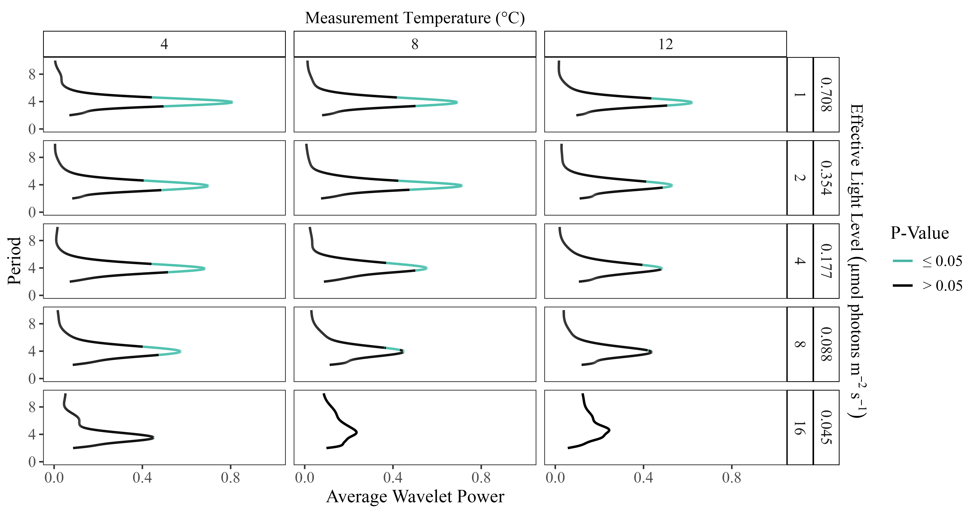
Fig 3: Sample plot of wavelet powers by period of oscillations in the maximum quantum yield of photochemistry Antarctic green algae Chlamydomonas priscui, grown at 4°C and 500 mM NaCl, and measured across a range of measurement temperatures and flash spacings, with the equivalent effective light levels. Regions where wavelet power reached statistical significance (p < 0.05) are shaded in blue.
In contrast, in the temperate green algae Chlamydomonas reinhardtii (Figure 4), the wavelet power is consistently lower, showing a weaker 4-step periodicity of ChlF in the temperate taxa, which only reaches statistical significance at shorter flash spacings, with higher equivalent effective light levels.
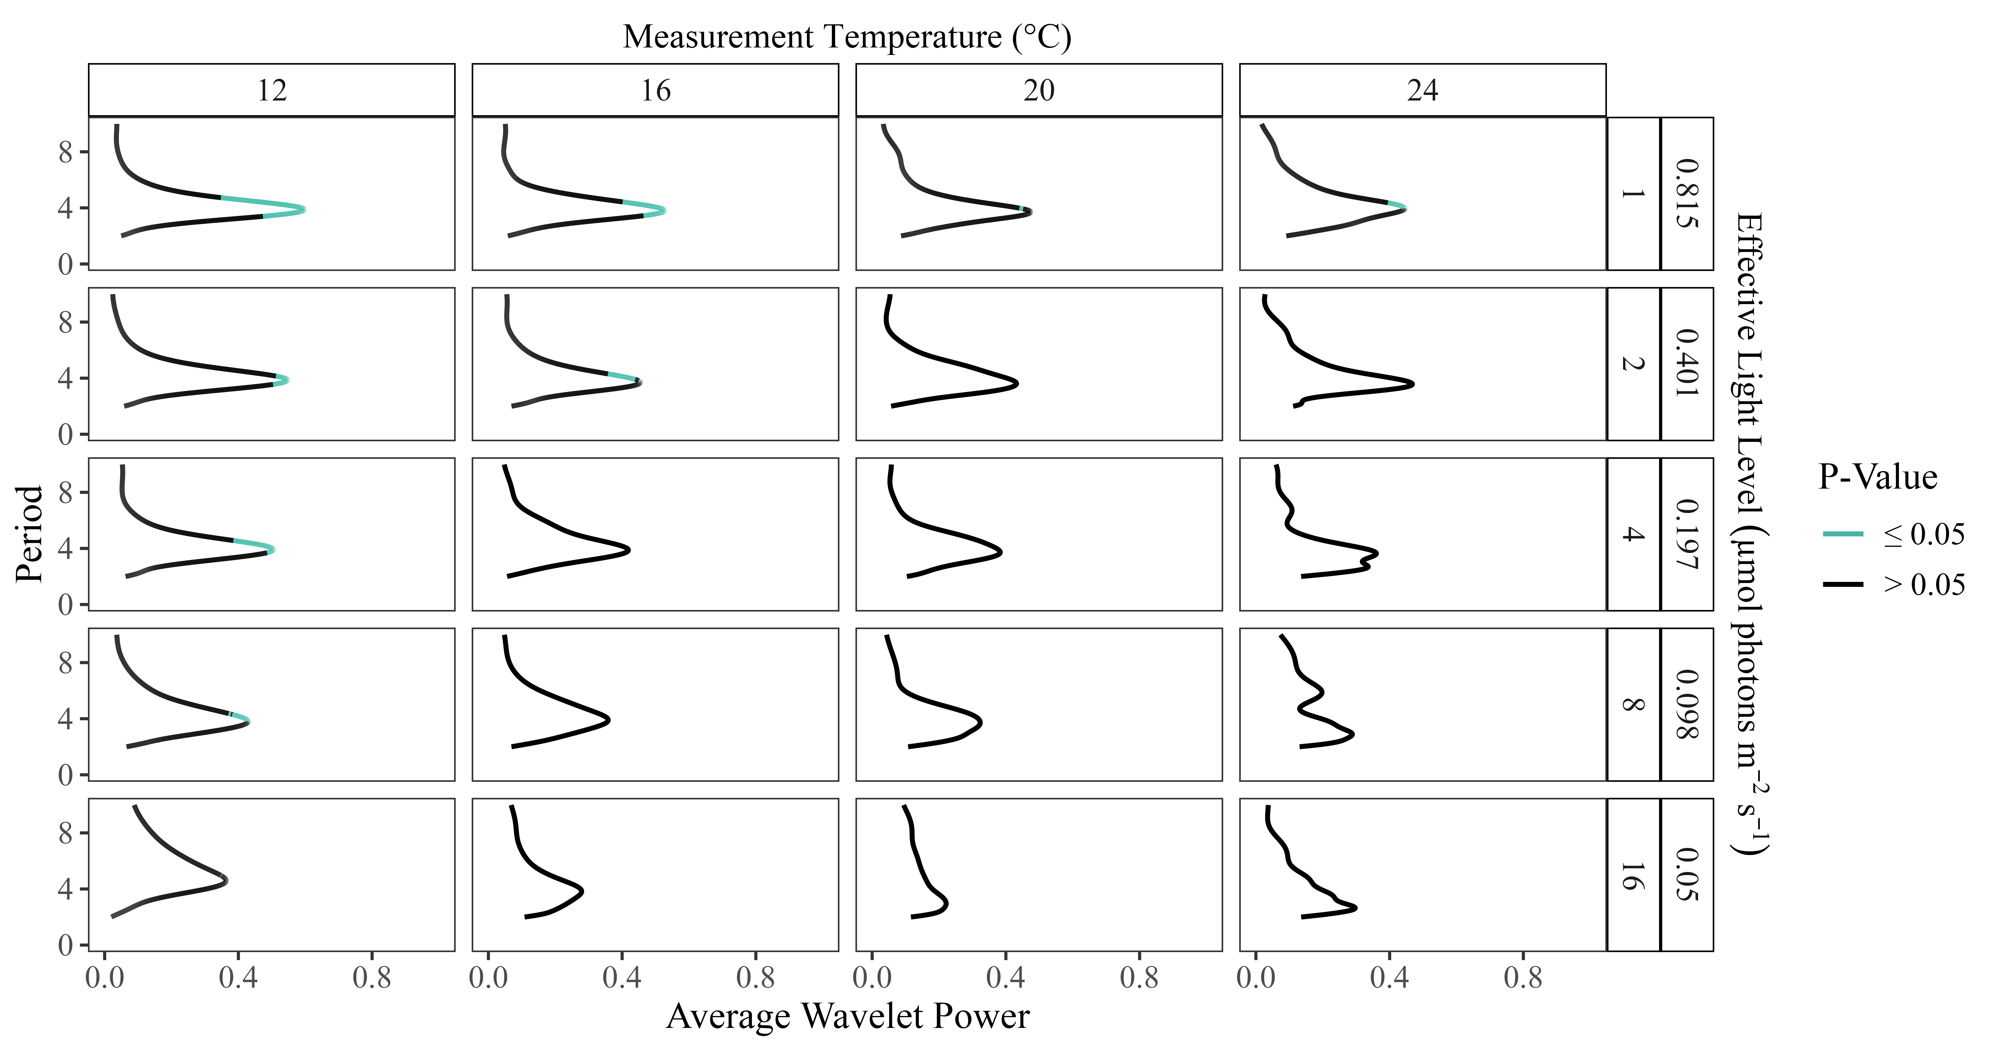
Fig 4: Sample plot of wavelet powers by period of oscillations in the maximum quantum yield of photochemistry in the temperate green algae Chlamydomonas reinhardtii, grown at 24°C and 0.43 mM NaCl, and measured across a range of measurement temperatures and flash spacings, with the equivalent effective light levels. Regions where wavelet power reached statistical significance (p < 0.05) shaded in blue.

Generalized Additive Modelling of Damping of 4-step oscillations By Measurement Temperature
Predictions from generalized additive modelling were generated for the damping of S-State-induced chlorophyll fluorescence oscillations, as predicted by the tensor product smooth of the temperature during measurements (°C) and the equivalent effective light level (µmol photons m⁻² s⁻¹) set by flash spacing, for each strain; Table 2; Table ??. All of the model fits explained over 50% of the variation in the response variable, damping index, except the GAM fits for C. euryale, which failed to fit. Both diatom taxa exhibited the longest predicted periodic oscillations in ChlF at higher effective light levels and lower temperatures. Notably, the polar Fragilariopsis cylindrus sustained cycling longer than its temperate counterpart, Thalassiosira pseudonana, under comparable conditions. This disparity was particularly prevalent at measurements taken above the growth temperature and when longer spacing between flashes produced lower effective light levels (Fig 5), where Thalassiosira pseudonana cultures did not retain the significant 4-step oscillation in ChlF indicative of synchronized S-State cycling.
Similarly the GAM outputs varied among the green algae tested (Table ??). The polar, saline strains Chlamydomonas ICEMDV, Chlamydomonas malina and Chlamydomonas priscui showed GAM model predictions of maximum damping indices of ~ 10-11 flashes, centred at lower temperatures but extending over a wide range of effective light levels (Fig 6). The polar freshwater **Chlamydomonas klinobasis* also showed maximum damping indices at lower temperatures, across a range of effective light levels. Further, much like the temperate diatoms, the freshwater temperate algae Chlamydomonas reinhardtii and Chlorella vulgaris did not exhibit significant periodic oscillations in ChlF at measurement temperatures near or above their growth temperature, under longer flash spacings equivalent to lower light. The marine temperate Chlamydomonas klinobasis did not generate a statistically significant GAM model, consistent with limited evidence for periodic oscillations from Chlamydomonas klinobasis.
Strain
term
edf
ref.df
statistic
p.value
Fragilariopsis_cylindrus
s(LightLevel_ue)
1.829
1.971
4.714
0.032
Fragilariopsis_cylindrus
s(Temp_C)
1.000
1.000
0.056
0.817
Fragilariopsis_cylindrus
ti(Temp_C,LightLevel_ue)
1.000
1.000
0.032
0.860
Fragilariopsis_cylindrus
s(LightLevel_ue)
1.105
1.196
3.267
0.069
Fragilariopsis_cylindrus
s(Temp_C)
1.000
1.000
2.355
0.146
Fragilariopsis_cylindrus
ti(Temp_C,LightLevel_ue)
1.457
1.702
2.817
0.178
Chlorella_vulgaris
s(LightLevel_ue)
1.943
1.997
8.412
0.002
Chlorella_vulgaris
s(Temp_C)
1.893
1.989
4.706
0.022
Chlorella_vulgaris
ti(Temp_C,LightLevel_ue)
1.000
1.000
0.710
0.410
Thalassiosira_pseudonana
s(LightLevel_ue)
1.955
1.993
10.252
0.000
Thalassiosira_pseudonana
s(Temp_C)
1.000
1.001
2.834
0.103
Thalassiosira_pseudonana
ti(Temp_C,LightLevel_ue)
2.174
2.631
3.957
0.038
Chlamydomonas_euryale
s(LightLevel_ue)
1.000
1.000
188.809
0.000
Chlamydomonas_euryale
s(Temp_C)
1.963
1.000
537.239
0.000
Chlamydomonas_euryale
ti(Temp_C,LightLevel_ue)
1.000
1.000
42.557
0.000
Chlamydomonas_ICEMDV
s(LightLevel_ue)
1.736
1.930
3.331
0.067
Chlamydomonas_ICEMDV
s(Temp_C)
1.000
1.000
0.305
0.593
Chlamydomonas_ICEMDV
ti(Temp_C,LightLevel_ue)
1.000
1.000
0.029
0.868
Chlamydomonas_klinobasis
s(LightLevel_ue)
1.849
1.977
5.809
0.013
Chlamydomonas_klinobasis
s(Temp_C)
1.253
1.442
2.066
0.148
Chlamydomonas_klinobasis
ti(Temp_C,LightLevel_ue)
1.000
1.000
2.758
0.119
Chlamydomonas_malina
s(LightLevel_ue)
1.839
1.974
3.735
0.057
Chlamydomonas_malina
s(Temp_C)
1.000
1.000
0.537
0.477
Chlamydomonas_malina
ti(Temp_C,LightLevel_ue)
1.000
1.000
0.989
0.338
Chlamydomonas_priscui
s(LightLevel_ue)
1.904
1.991
11.072
0.000
Chlamydomonas_priscui
s(Temp_C)
1.767
1.946
7.211
0.002
Chlamydomonas_priscui
ti(Temp_C,LightLevel_ue)
1.000
1.000
7.782
0.008
Chlamydomonas_reinhardtii
s(LightLevel_ue)
1.866
1.934
2.549
0.107
Chlamydomonas_reinhardtii
s(Temp_C)
1.000
1.000
6.538
0.015
Chlamydomonas_reinhardtii
ti(Temp_C,LightLevel_ue)
2.194
2.649
1.076
0.485
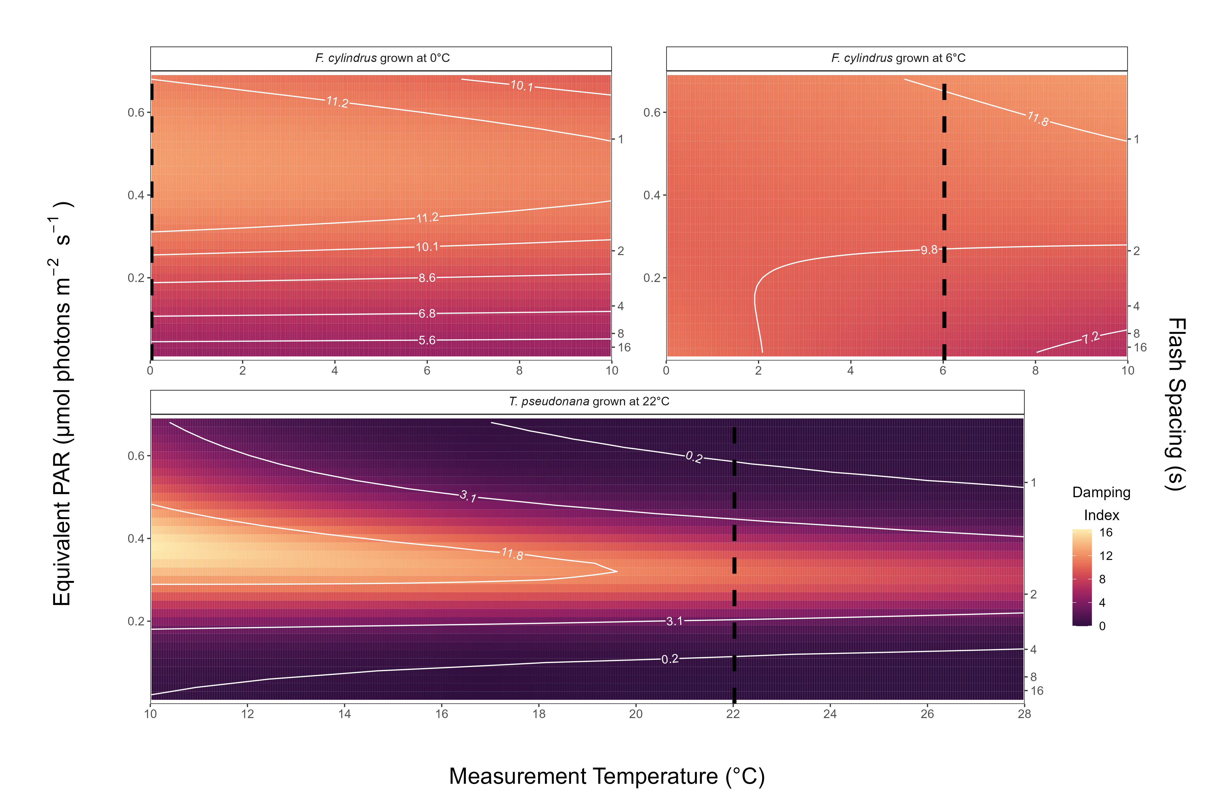
Fig 5: GAM models for polar and temperate diatoms, of consecutive flashes before damping of S-State induced chlorophyll fluorescence oscillations. GAM model predicted by the temperature (°C) imposed during measurements and the effective light level (µmol photons m⁻² s⁻¹, estimated from flash spacings in seconds). Dashed vertical lines represent the growth temperatures. Measurement temperatures varied across taxa but the temperature scaling ranges are comparable across plots.
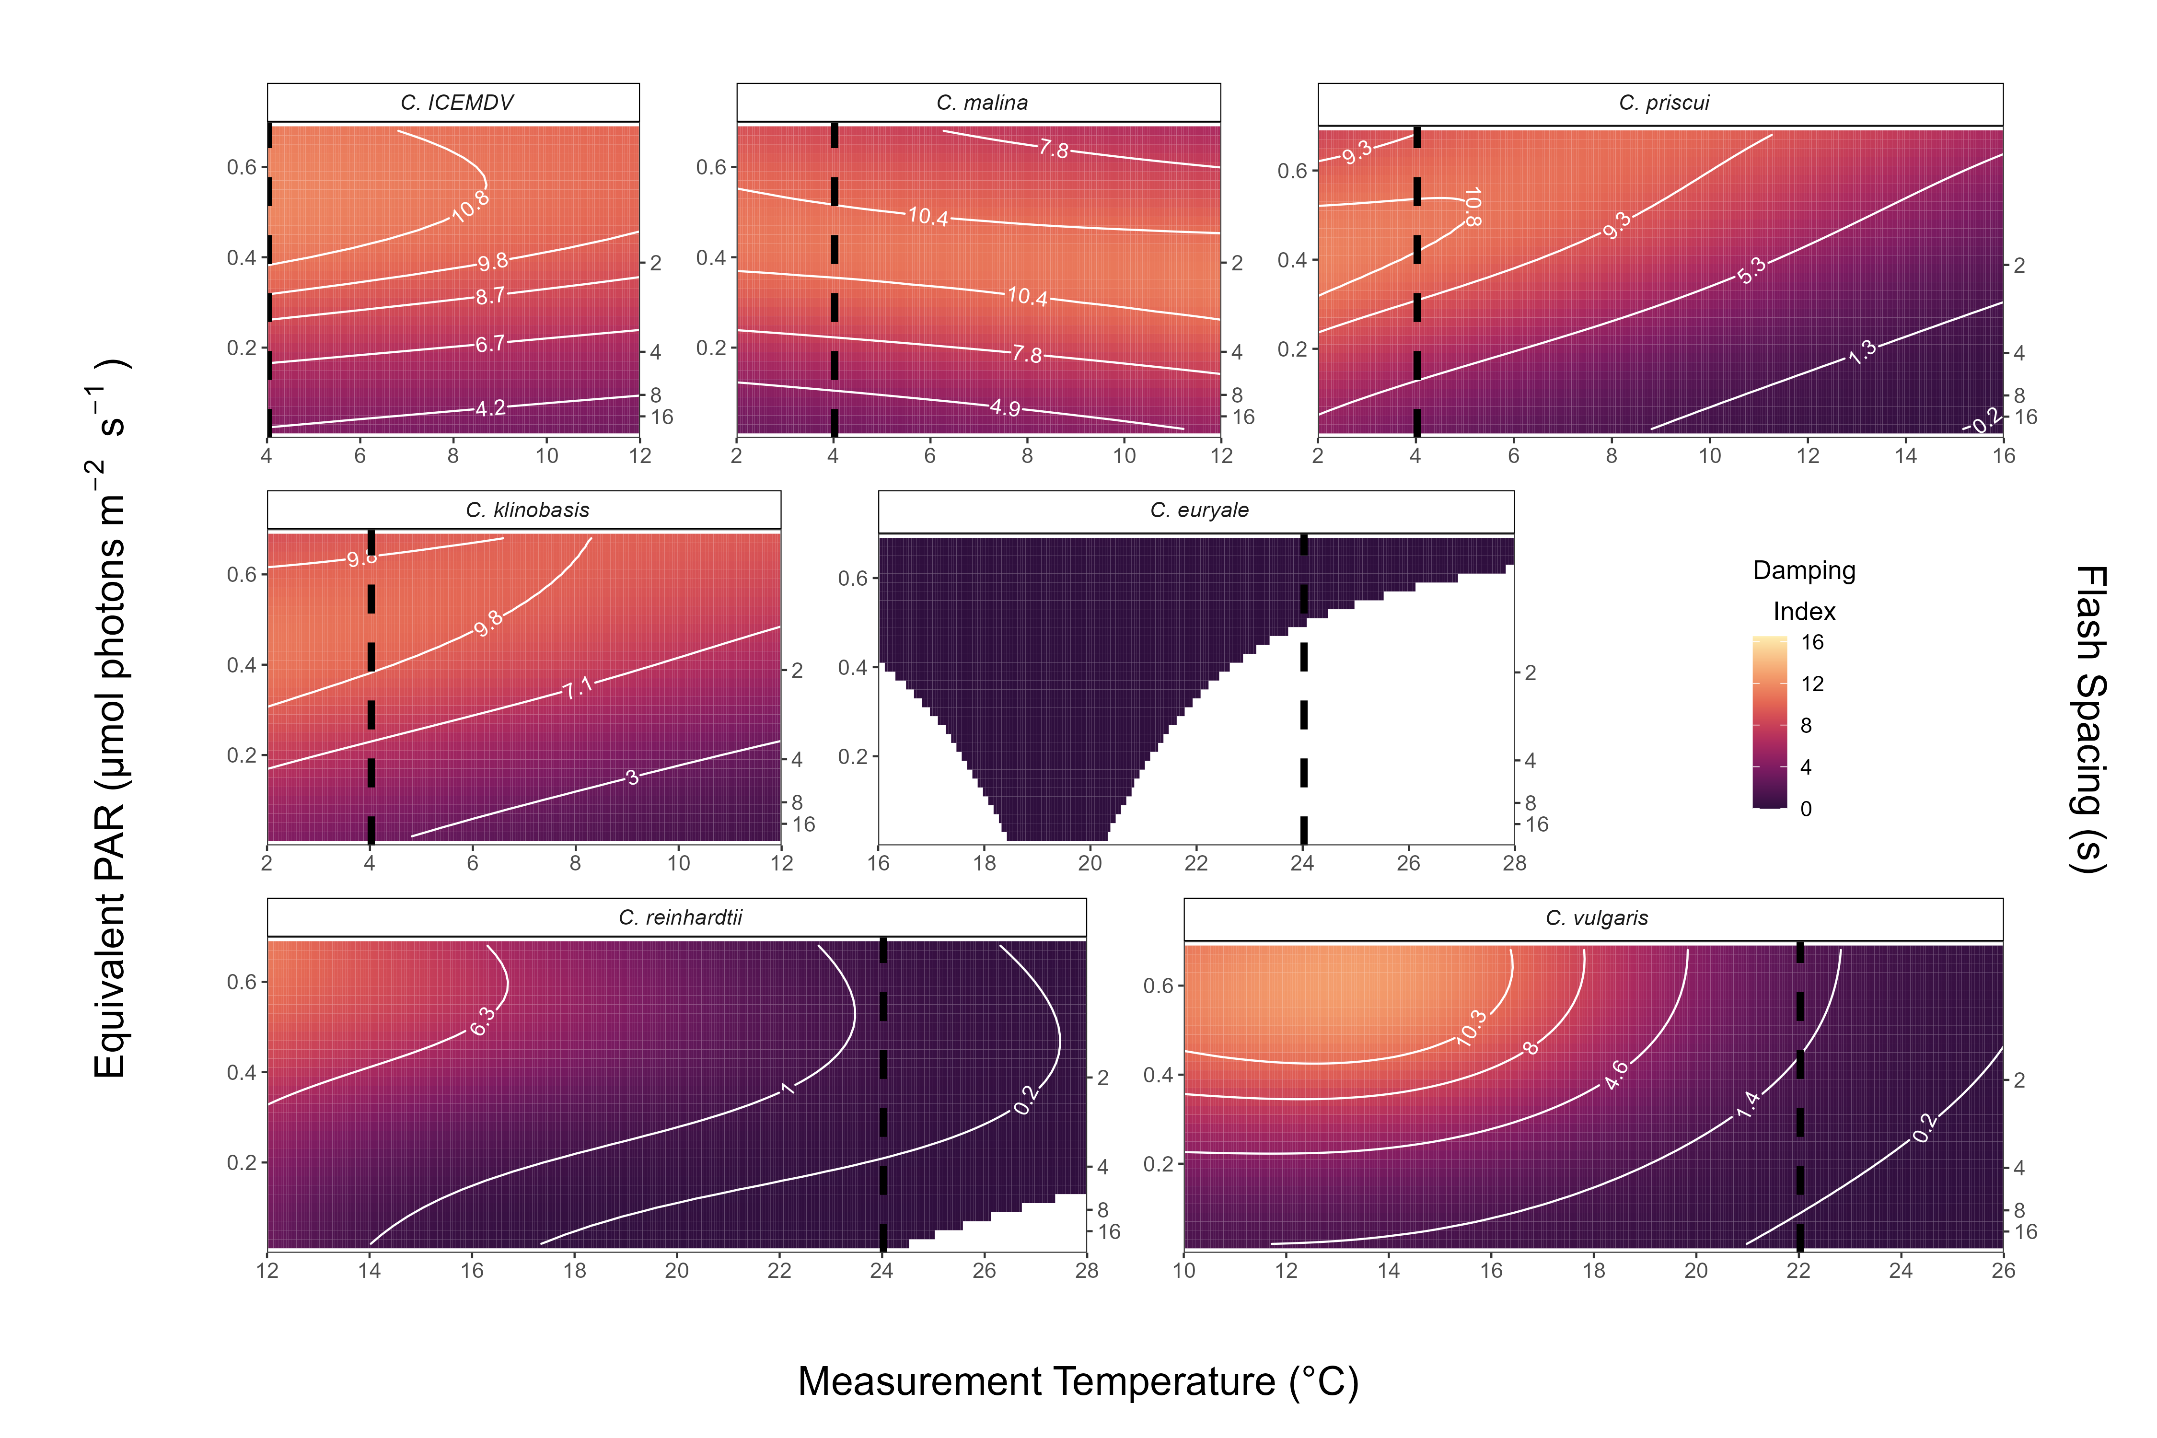
Fig 6: GAM models for polar and temperate green algae, of consecutive flashes before damping of SState induced chlorophyll fluorescence oscillations. GAM model predicted by the temperature (Δ°C) imposed during measurements and the effective light level (µmol photons m⁻²s⁻¹, estimated from flash spacings in seconds). Dashed vertical lines represent the growth temperatures. Measurement temperatures varied across taxa but the temperature scaling ranges are comparable across plots.
Within, and across, species of Chlamydomonas XXXXCITE Pomona PaperXXXX growth under higher salinities increases maintenance of F_{V}/F_{M} and photosynthetic capacity during stress. We therefore grew each Chlamydomonas strain across three growth-permissive salinities 1 and performed saturating flash trains over a range of flash spacings, and at measurement temperatures flanking the growth temperature for each taxa. We ran an ANOVA for damping indices testing effects of taxa, effective equivalent light level (derived from the saturating flash spacing and 𝛔_{PSII}), measurement temperature, and the growth concentration of NaCl, with interactions among all factors ??. As expected, taxa, effective equivalent light level and measurement temperature all showed strongly significant influences on damping indices. NaCl concentration also showed a significant influence on damping indices across strains, with a significant interaction with effective equivalent light level.
## Df Sum Sq Mean Sq F value Pr(>F)
## Strain 4 2128.0 532.0 78.485 < 2e-16 ***
## LightLevel_ue 1 576.5 576.5 85.051 < 2e-16 ***
## Temp_C 1 488.2 488.2 72.015 1.18e-15 ***
## NaCl_mM 1 35.2 35.2 5.198 0.0233 *
## Strain:LightLevel_ue 4 368.9 92.2 13.606 3.65e-10 ***
## Strain:Temp_C 4 203.3 50.8 7.498 9.36e-06 ***
## LightLevel_ue:Temp_C 1 1.4 1.4 0.211 0.6463
## Strain:NaCl_mM 4 39.2 9.8 1.445 0.2193
## LightLevel_ue:NaCl_mM 1 26.9 26.9 3.967 0.0474 *
## Temp_C:NaCl_mM 1 10.9 10.9 1.604 0.2064
## Strain:LightLevel_ue:Temp_C 4 74.0 18.5 2.729 0.0295 *
## Strain:LightLevel_ue:NaCl_mM 4 8.2 2.0 0.302 0.8767
## Strain:Temp_C:NaCl_mM 4 46.7 11.7 1.721 0.1454
## LightLevel_ue:Temp_C:NaCl_mM 1 5.4 5.4 0.797 0.3727
## Strain:LightLevel_ue:Temp_C:NaCl_mM 4 37.8 9.5 1.396 0.2355
## Residuals 285 1931.9 6.8
## ---
## Signif. codes: 0 '***' 0.001 '**' 0.01 '*' 0.05 '.' 0.1 ' ' 1
We then ran the ANOVA for each taxa separately ??. Within a taxa only Chlamydomonas priscui showed a significant effect of NaCl on damping indices, suggesting the statistical influence of NaCl detected across taxa derives from different taxa growing at different salinites and showing different responses of damping indices, rather than a direct effect of NaCl on damping indices in most strains.
Strain | Strains_aovinteract_Param_term | Strains_aovinteract_Param_df | Strains_aovinteract_Param_sumsq | Strains_aovinteract_Param_meansq | Strains_aovinteract_Param_statistic | Strains_aovinteract_Param_p.value
Chlamydomonas_euryale | LightLevel_ue | 1 | 30.46160 | 30.46160 | 5.136345 | 0.0277899
Chlamydomonas_klinobasis | LightLevel_ue | 1 | 550.11063 | 550.11063 | 77.519111 | 0.0000000
Chlamydomonas_klinobasis | Temp_C | 1 | 136.58520 | 136.58520 | 19.246971 | 0.0000550
Chlamydomonas_malina | LightLevel_ue | 1 | 140.11121 | 140.11121 | 14.462098 | 0.0004041
Chlamydomonas_priscui | LightLevel_ue | 1 | 254.82592 | 254.82592 | 31.347386 | 0.0000004
Chlamydomonas_priscui | Temp_C | 1 | 475.80733 | 475.80733 | 58.531394 | 0.0000000
Chlamydomonas_priscui | NaCl_mM | 1 | 39.56866 | 39.56866 | 4.867535 | 0.0306984
Chlamydomonas_reinhardtii | Temp_C | 1 | 18.49120 | 18.49120 | 5.152300 | 0.0265393

Discussion
Across all study strains ChlF oscillations, provoked by a series of single turnover saturating flashes, showed wavelet power at a period of four, that declined with increasing measurement temperatures and increasing spacing of flashes, equivalent to decreasing light. Thus sustained synchronized S-State cycling of PSII decayed faster under higher temperatures and lower equivalent light (Figure 3) (de Wijn and van Gorkom, 2002). While light absorption and excitation energy transfer within PSII are not temperature-sensitive, the redox reactions associated with downstream electron transport are highly temperature-dependent (Hüner et al., 2023). Furthermore, the probabilities of charge recombinations decrease as temperature drops below the activation energies for recombination paths, 21 - 29 °C for recombination to S2 from Q_{A}⁻, or 35 - 41 for recombination to S2 from Q_{B}⁻ (Ivanov et al., 2006). This temperature dependence may interact with acclimatory mechanisms to regulate photosynthetic electron flow, S-State transitions, and energy partitioning (Hüner et al., 2023).
The desynchronization of S-State cycling among the PSII in a population indicates that sufficient photochemical misses, including charge recombinations, have taken place to create a PSII population with a randomized distribution of S-States. Thus, if this desynchronization occurs after fewer consecutive flashes, it signifies an increased proportion of PSII undergoing photochemical misses for each flash. By inference, PSII populations with increased incidence of energetically wasteful misses, including charge recombinations, such as those under high temperatures and low light levels, are less efficient in their photosynthetic energy conversion (Rappaport et al., 2005), which becomes a critical factor for maintaining photosynthesis under low light, with wide spacings between sequential excitations of each PSII. While light absorption and excitation energy transfer within PSII are not temperature-sensitive, the redox reactions associated with downstream electron transport are highly temperature-dependent (Hüner et al., 2023). Furthermore, the probability of charge recombinations decrease below room temperature (Ivanov et al., 2006; Han et al., 2008), as temperature drops below the activation energies for recombination paths. This temperature dependence may interact with acclimatory mechanisms to regulate photosynthetic electron flow, S-State transitions, and energy partitioning (Hüner et al., 2023).
These results are consistent with previous literature evaluating the responses of photochemical misses to light conditions. As light levels decline, there are longer intervals between successive PSII excitations, pushing fewer electrons through the electron transport chain (Keren et al., 1997). Consequently, the probability of energetically wasteful charge recombinations is higher over the longer intervals between excitations, leading to weaker maintenance of S-State cycling (Keren et al., 1997; de Wijn and van Gorkom, 2002). These findings are consistent with recombination reactions decreasing with temperature (Ivanov et al., 2006) as ambient temperature falls below the activation temperatures of the recombinations. In contrast, in PSII-enriched membrane fractions isolated from spinach, the average miss probability of S-State transitions was highest at -10 °C and lowest at 10 °C (Han et al., 2022).
Chlamydomonas sp. ICE-MDV, Chlamydomonas malina and Chlamydomonas priscui originate from Lake Bonney in Antarctica, but previous work found differential responses to light among the strains. Unlike the obligately shade-adapted Chlamydomonas priscui that is only present in the deep photic zone, Chlamydomonas sp. ICE-MDV has been isolated from various depths within the lake (Li and Morgan-Kiss (2019)) including shallow and seasonally open waters (Sherwell et al. (2022)) where it encounters a wider range of light conditions. Thus, in contrast with Chlamydomonas priscui that has a “locked” physiology, Chlamydomonas sp. ICE-MDV has retained the ability to balance excitation pressure through state transitions (Kalra et al. (2023)), can modify its photosynthetic apparatus due to nutrient availability (Cook et al. (2019)), exhibits phototactic motility in response to light signals (Poirier et al.) and can successfully acclimate to a range of wavelengths and light intensities (Poirier et al. (2025)). It is evident that physiological differences exist among polar species, likely as a result of life in comparably cold, but otherwise differing environments.
Nevertheless, strong, sustained periodicity of ChlF emissions is a common trait across the diverse polar strains of diatoms and green algae (Figures 3; 4; 5; 6. Further, the polar exhibited significant 4-step ChlF oscillations under a broader range of measurement conditions around their growth temperatures than did their temperate counterparts. These findings illustrate that polar phytoplankton species, at and around their lower growth temperatures, show higher capacity to maintain synchronized S-State cycling than do temperate strains around their higher growth temperatures. The rates of photochemical misses, notably through charge recombinations, relative to productive photochemistry, increase under lower light and higher temperatures (Keren et al., 1997; Ivanov et al., 2006). Thus, sustained synchronized S-State cycling reflects suppression of energetically wasteful photochemical misses in the polar strains, measured at the lower growth temperatures possible for polar strains. Stable S-State cycling and minimizing energy losses through charge recombination support electron flow to the linear photosynthetic chain, sustaining ATP and NADPH production, and minimizing the risk of photodamage to the photosynthetic machinery (Rappaport et al., 2005; Keren et al., 1997). Thus, sustaining PSII function even under widely spaced excitations appears as an emergent property for the productivity of polar phytoplankton under the ice during the polar night.
Salinities vary widely across the habitats of the tested strains, and fluctuate within some habitats during ice formation and melting XXXMACKENZIE CITATIONSXXXX. Higher salinity stabilizes PSII function under stress across strains of Chlamydomonas XXXXPOMONA CITATIONXXX. NaCl concentration showed an influence on dampening indices when analyzed across all tested Chlamydomonas taxa, but when tested within taxa, NaCl only showed an influence within Chlamydomonas priscui. It is important to note that faster desynchronization of S-State cycling does not indicate a loss nor instability of PSII function per se. Instad, desynchronization reflects randomization of the S-States of the PSII population. Prolonged synchronization under low effective light levels is thus an indicator of the capacity of PSII to exploit widely spaced photons under low light, not the stability of PSII function.
Understanding and detecting mechanisms enabling polar phytoplankton to sustain slow, but significant, productivity under the ice in the winter can help predict the changing dynamics of spring phytoplankton blooms, in the face of rapid warming (Ardyna and Arrigo, 2020). Beyond direct temperature changes, polar aquatic ecosystems are experiencing declines in sea ice extent and thickness, escalating freshwater inputs, acidification, and increased winds and storms (Ardyna and Arrigo, 2020; Cvetkovska et al., 2022). These pressures are altering the productivity and seasonal peaks of phytoplankton blooms (Ardyna and Arrigo, 2020). Maintaining photosynthetic energy conversion over winter is crucial for the timing and speed of spring bloom initiation (Hancke et al., 2018). Our findings indicate that low growth temperature is a factor enabling phytoplankton to exploit extreme low light. Taxa with this capacity then possess a competitive advantage in quickly initiating spring growth, giving them first access to the nutrients required to form an extensive bloom and in turn, exert bottom-up effects on changing polar ecosystems (Ardyna and Arrigo, 2020).

Acknowledgements

Supporting information
Table 2: Study taxa and single turnover saturating flash measurement conditions, with equivalent effective light levels (µmol photons m⁻²s⁻¹).
Taxa | Flash Spacings (s) | Measurement Temperatures (°C) | Equivalent Light (µE) | Growth Temperatures (°C) | NaCl (mM)
Chlamydomonas_euryale | 1 | 16 | 0.70619 | 24 | 30.00
Chlamydomonas_euryale | 1 | 16 | 0.73733 | 24 | 70.00
Chlamydomonas_euryale | 1 | 16 | 0.76025 | 24 | 500.00
Chlamydomonas_euryale | 1 | 20 | 0.70195 | 24 | 30.00
Chlamydomonas_euryale | 1 | 20 | 0.71115 | 24 | 70.00
Chlamydomonas_euryale | 1 | 20 | 0.74576 | 24 | 500.00
Chlamydomonas_euryale | 1 | 24 | 0.71579 | 24 | 30.00
Chlamydomonas_euryale | 1 | 24 | 0.74750 | 24 | 70.00
Chlamydomonas_euryale | 1 | 24 | 0.75646 | 24 | 500.00
Chlamydomonas_euryale | 1 | 28 | 0.69095 | 24 | 30.00
Chlamydomonas_euryale | 1 | 28 | 0.71163 | 24 | 70.00
Chlamydomonas_euryale | 1 | 28 | 0.71551 | 24 | 500.00
Chlamydomonas_euryale | 2 | 16 | 0.35324 | 24 | 30.00
Chlamydomonas_euryale | 2 | 16 | 0.37070 | 24 | 500.00
Chlamydomonas_euryale | 2 | 20 | 0.34453 | 24 | 30.00
Chlamydomonas_euryale | 2 | 20 | 0.34781 | 24 | 70.00
Chlamydomonas_euryale | 2 | 20 | 0.35646 | 24 | 500.00
Chlamydomonas_euryale | 2 | 24 | 0.36837 | 24 | 70.00
Chlamydomonas_euryale | 2 | 24 | 0.36973 | 24 | 500.00
Chlamydomonas_euryale | 2 | 24 | 0.37018 | 24 | 30.00
Chlamydomonas_euryale | 2 | 28 | 0.31991 | 24 | 30.00
Chlamydomonas_euryale | 2 | 28 | 0.35392 | 24 | 70.00
Chlamydomonas_euryale | 2 | 28 | 0.35483 | 24 | 500.00
Chlamydomonas_euryale | 4 | 16 | 0.17211 | 24 | 30.00
Chlamydomonas_euryale | 4 | 16 | 0.18028 | 24 | 70.00
Chlamydomonas_euryale | 4 | 16 | 0.18390 | 24 | 500.00
Chlamydomonas_euryale | 4 | 20 | 0.16972 | 24 | 30.00
Chlamydomonas_euryale | 4 | 20 | 0.17013 | 24 | 70.00
Chlamydomonas_euryale | 4 | 20 | 0.17835 | 24 | 500.00
Chlamydomonas_euryale | 4 | 24 | 0.17743 | 24 | 30.00
Chlamydomonas_euryale | 4 | 24 | 0.17970 | 24 | 70.00
Chlamydomonas_euryale | 4 | 24 | 0.18311 | 24 | 500.00
Chlamydomonas_euryale | 4 | 28 | 0.17541 | 24 | 70.00
Chlamydomonas_euryale | 4 | 28 | 0.17756 | 24 | 500.00
Chlamydomonas_euryale | 8 | 16 | 0.08293 | 24 | 30.00
Chlamydomonas_euryale | 8 | 16 | 0.08883 | 24 | 70.00
Chlamydomonas_euryale | 8 | 16 | 0.09005 | 24 | 500.00
Chlamydomonas_euryale | 8 | 20 | 0.08460 | 24 | 70.00
Chlamydomonas_euryale | 8 | 20 | 0.08532 | 24 | 30.00
Chlamydomonas_euryale | 8 | 20 | 0.08600 | 24 | 500.00
Chlamydomonas_euryale | 8 | 24 | 0.08677 | 24 | 70.00
Chlamydomonas_euryale | 8 | 24 | 0.09158 | 24 | 500.00
Chlamydomonas_euryale | 8 | 24 | 0.09232 | 24 | 30.00
Chlamydomonas_euryale | 8 | 28 | 0.08155 | 24 | 30.00
Chlamydomonas_euryale | 8 | 28 | 0.08850 | 24 | 70.00
Chlamydomonas_euryale | 8 | 28 | 0.08943 | 24 | 500.00
Chlamydomonas_euryale | 16 | 16 | 0.04380 | 24 | 30.00
Chlamydomonas_euryale | 16 | 16 | 0.04410 | 24 | 70.00
Chlamydomonas_euryale | 16 | 16 | 0.04515 | 24 | 500.00
Chlamydomonas_euryale | 16 | 20 | 0.04265 | 24 | 70.00
Chlamydomonas_euryale | 16 | 20 | 0.04311 | 24 | 500.00
Chlamydomonas_euryale | 16 | 20 | 0.04359 | 24 | 30.00
Chlamydomonas_euryale | 16 | 24 | 0.04598 | 24 | 70.00
Chlamydomonas_euryale | 16 | 24 | 0.04651 | 24 | 500.00
Chlamydomonas_euryale | 16 | 24 | 0.04738 | 24 | 30.00
Chlamydomonas_euryale | 16 | 28 | 0.04323 | 24 | 30.00
Chlamydomonas_euryale | 16 | 28 | 0.04505 | 24 | 500.00
Chlamydomonas_euryale | 16 | 28 | 0.04612 | 24 | 70.00
Chlamydomonas_ICEMDV | 1 | 4 | 0.73733 | 4 | 70.00
Chlamydomonas_ICEMDV | 1 | 8 | 0.71644 | 4 | 70.00
Chlamydomonas_ICEMDV | 1 | 12 | 0.67904 | 4 | 70.00
Chlamydomonas_ICEMDV | 2 | 4 | 0.36369 | 4 | 70.00
Chlamydomonas_ICEMDV | 2 | 8 | 0.35457 | 4 | 70.00
Chlamydomonas_ICEMDV | 2 | 12 | 0.33588 | 4 | 70.00
Chlamydomonas_ICEMDV | 4 | 4 | 0.17929 | 4 | 70.00
Chlamydomonas_ICEMDV | 4 | 8 | 0.17562 | 4 | 70.00
Chlamydomonas_ICEMDV | 4 | 12 | 0.16533 | 4 | 70.00
Chlamydomonas_ICEMDV | 8 | 4 | 0.08936 | 4 | 70.00
Chlamydomonas_ICEMDV | 8 | 8 | 0.08720 | 4 | 70.00
Chlamydomonas_ICEMDV | 8 | 12 | 0.08271 | 4 | 70.00
Chlamydomonas_ICEMDV | 16 | 4 | 0.04471 | 4 | 70.00
Chlamydomonas_ICEMDV | 16 | 8 | 0.04432 | 4 | 70.00
Chlamydomonas_ICEMDV | 16 | 12 | 0.04252 | 4 | 70.00
Chlamydomonas_klinobasis | 1 | 2 | 0.74547 | 4 | 10.00
Chlamydomonas_klinobasis | 1 | 2 | 0.75323 | 4 | 0.43
Chlamydomonas_klinobasis | 1 | 2 | 0.80500 | 4 | 30.00
Chlamydomonas_klinobasis | 1 | 4 | 0.74450 | 4 | 0.43
Chlamydomonas_klinobasis | 1 | 4 | 0.75012 | 4 | 10.00
Chlamydomonas_klinobasis | 1 | 4 | 0.80484 | 4 | 30.00
Chlamydomonas_klinobasis | 1 | 8 | 0.71713 | 4 | 0.43
Chlamydomonas_klinobasis | 1 | 8 | 0.73108 | 4 | 10.00
Chlamydomonas_klinobasis | 1 | 8 | 0.77089 | 4 | 30.00
Chlamydomonas_klinobasis | 1 | 12 | 0.70120 | 4 | 0.43
Chlamydomonas_klinobasis | 1 | 12 | 0.70328 | 4 | 10.00
Chlamydomonas_klinobasis | 1 | 12 | 0.74429 | 4 | 30.00
Chlamydomonas_klinobasis | 1 | 16 | 0.79330 | 4 | 30.00
Chlamydomonas_klinobasis | 2 | 2 | 0.37796 | 4 | 10.00
Chlamydomonas_klinobasis | 2 | 2 | 0.37948 | 4 | 0.43
Chlamydomonas_klinobasis | 2 | 2 | 0.40574 | 4 | 30.00
Chlamydomonas_klinobasis | 2 | 4 | 0.37628 | 4 | 0.43
Chlamydomonas_klinobasis | 2 | 4 | 0.37973 | 4 | 10.00
Chlamydomonas_klinobasis | 2 | 4 | 0.40446 | 4 | 30.00
Chlamydomonas_klinobasis | 2 | 8 | 0.36172 | 4 | 0.43
Chlamydomonas_klinobasis | 2 | 8 | 0.36810 | 4 | 10.00
Chlamydomonas_klinobasis | 2 | 8 | 0.38681 | 4 | 30.00
Chlamydomonas_klinobasis | 4 | 2 | 0.19017 | 4 | 0.43
Chlamydomonas_klinobasis | 4 | 2 | 0.19031 | 4 | 10.00
Chlamydomonas_klinobasis | 4 | 2 | 0.20088 | 4 | 30.00
Chlamydomonas_klinobasis | 4 | 4 | 0.18882 | 4 | 0.43
Chlamydomonas_klinobasis | 4 | 4 | 0.18927 | 4 | 10.00
Chlamydomonas_klinobasis | 4 | 4 | 0.20074 | 4 | 30.00
Chlamydomonas_klinobasis | 4 | 8 | 0.18045 | 4 | 0.43
Chlamydomonas_klinobasis | 4 | 8 | 0.18250 | 4 | 10.00
Chlamydomonas_klinobasis | 4 | 8 | 0.19023 | 4 | 30.00
Chlamydomonas_klinobasis | 4 | 12 | 0.17588 | 4 | 10.00
Chlamydomonas_klinobasis | 4 | 12 | 0.17686 | 4 | 0.43
Chlamydomonas_klinobasis | 4 | 12 | 0.18326 | 4 | 30.00
Chlamydomonas_klinobasis | 4 | 16 | 0.19167 | 4 | 30.00
Chlamydomonas_klinobasis | 8 | 2 | 0.09451 | 4 | 10.00
Chlamydomonas_klinobasis | 8 | 2 | 0.09547 | 4 | 0.43
Chlamydomonas_klinobasis | 8 | 2 | 0.09934 | 4 | 30.00
Chlamydomonas_klinobasis | 8 | 4 | 0.09364 | 4 | 10.00
Chlamydomonas_klinobasis | 8 | 4 | 0.09368 | 4 | 0.43
Chlamydomonas_klinobasis | 8 | 4 | 0.09829 | 4 | 30.00
Chlamydomonas_klinobasis | 8 | 8 | 0.08929 | 4 | 0.43
Chlamydomonas_klinobasis | 8 | 8 | 0.08956 | 4 | 10.00
Chlamydomonas_klinobasis | 8 | 8 | 0.09322 | 4 | 30.00
Chlamydomonas_klinobasis | 8 | 12 | 0.08648 | 4 | 10.00
Chlamydomonas_klinobasis | 8 | 12 | 0.08807 | 4 | 0.43
Chlamydomonas_klinobasis | 8 | 12 | 0.08920 | 4 | 30.00
Chlamydomonas_klinobasis | 8 | 16 | 0.09427 | 4 | 30.00
Chlamydomonas_klinobasis | 16 | 2 | 0.04650 | 4 | 10.00
Chlamydomonas_klinobasis | 16 | 2 | 0.04726 | 4 | 0.43
Chlamydomonas_klinobasis | 16 | 2 | 0.04878 | 4 | 30.00
Chlamydomonas_klinobasis | 16 | 4 | 0.04608 | 4 | 10.00
Chlamydomonas_klinobasis | 16 | 4 | 0.04620 | 4 | 0.43
Chlamydomonas_klinobasis | 16 | 4 | 0.04790 | 4 | 30.00
Chlamydomonas_klinobasis | 16 | 8 | 0.04400 | 4 | 10.00
Chlamydomonas_klinobasis | 16 | 8 | 0.04469 | 4 | 0.43
Chlamydomonas_klinobasis | 16 | 8 | 0.04594 | 4 | 30.00
Chlamydomonas_klinobasis | 16 | 12 | 0.04382 | 4 | 10.00
Chlamydomonas_klinobasis | 16 | 12 | 0.04441 | 4 | 30.00
Chlamydomonas_klinobasis | 16 | 12 | 0.04442 | 4 | 0.43
Chlamydomonas_klinobasis | 16 | 16 | 0.04734 | 4 | 30.00
Chlamydomonas_malina | 1 | 2 | 0.64326 | 4 | 500.00
Chlamydomonas_malina | 1 | 2 | 0.74445 | 4 | 70.00
Chlamydomonas_malina | 1 | 2 | 0.78258 | 4 | 30.00
Chlamydomonas_malina | 1 | 4 | 0.64944 | 4 | 70.00
Chlamydomonas_malina | 1 | 4 | 0.65549 | 4 | 500.00
Chlamydomonas_malina | 1 | 4 | 0.72400 | 4 | 30.00
Chlamydomonas_malina | 1 | 4 | 0.73611 | 4 | 70.00
Chlamydomonas_malina | 1 | 8 | 0.59352 | 4 | 500.00
Chlamydomonas_malina | 1 | 8 | 0.65817 | 4 | 70.00
Chlamydomonas_malina | 1 | 8 | 0.69658 | 4 | 30.00
Chlamydomonas_malina | 1 | 8 | 0.70403 | 4 | 70.00
Chlamydomonas_malina | 1 | 12 | 0.57065 | 4 | 500.00
Chlamydomonas_malina | 1 | 12 | 0.60195 | 4 | 70.00
Chlamydomonas_malina | 1 | 12 | 0.69271 | 4 | 30.00
Chlamydomonas_malina | 1 | 12 | 0.69536 | 4 | 70.00
Chlamydomonas_malina | 2 | 2 | 0.32434 | 4 | 500.00
Chlamydomonas_malina | 2 | 2 | 0.37749 | 4 | 70.00
Chlamydomonas_malina | 2 | 2 | 0.39601 | 4 | 30.00
Chlamydomonas_malina | 2 | 4 | 0.31635 | 4 | 500.00
Chlamydomonas_malina | 2 | 4 | 0.32365 | 4 | 70.00
Chlamydomonas_malina | 2 | 4 | 0.36867 | 4 | 30.00
Chlamydomonas_malina | 2 | 4 | 0.37276 | 4 | 70.00
Chlamydomonas_malina | 2 | 8 | 0.30068 | 4 | 500.00
Chlamydomonas_malina | 2 | 8 | 0.32339 | 4 | 70.00
Chlamydomonas_malina | 2 | 8 | 0.35373 | 4 | 30.00
Chlamydomonas_malina | 2 | 8 | 0.35643 | 4 | 70.00
Chlamydomonas_malina | 2 | 12 | 0.29669 | 4 | 70.00
Chlamydomonas_malina | 4 | 2 | 0.16420 | 4 | 500.00
Chlamydomonas_malina | 4 | 2 | 0.19367 | 4 | 70.00
Chlamydomonas_malina | 4 | 2 | 0.19903 | 4 | 30.00
Chlamydomonas_malina | 4 | 4 | 0.16128 | 4 | 70.00
Chlamydomonas_malina | 4 | 4 | 0.16230 | 4 | 500.00
Chlamydomonas_malina | 4 | 4 | 0.18699 | 4 | 30.00
Chlamydomonas_malina | 4 | 4 | 0.18764 | 4 | 70.00
Chlamydomonas_malina | 4 | 8 | 0.15032 | 4 | 500.00
Chlamydomonas_malina | 4 | 8 | 0.16084 | 4 | 70.00
Chlamydomonas_malina | 4 | 8 | 0.17698 | 4 | 70.00
Chlamydomonas_malina | 4 | 8 | 0.17820 | 4 | 30.00
Chlamydomonas_malina | 4 | 12 | 0.14637 | 4 | 500.00
Chlamydomonas_malina | 4 | 12 | 0.14752 | 4 | 70.00
Chlamydomonas_malina | 4 | 12 | 0.17194 | 4 | 70.00
Chlamydomonas_malina | 4 | 12 | 0.17375 | 4 | 30.00
Chlamydomonas_malina | 8 | 2 | 0.08173 | 4 | 500.00
Chlamydomonas_malina | 8 | 2 | 0.09981 | 4 | 30.00
Chlamydomonas_malina | 8 | 2 | 0.10038 | 4 | 70.00
Chlamydomonas_malina | 8 | 4 | 0.08023 | 4 | 70.00
Chlamydomonas_malina | 8 | 4 | 0.08260 | 4 | 500.00
Chlamydomonas_malina | 8 | 4 | 0.09246 | 4 | 30.00
Chlamydomonas_malina | 8 | 4 | 0.09298 | 4 | 70.00
Chlamydomonas_malina | 8 | 8 | 0.07425 | 4 | 500.00
Chlamydomonas_malina | 8 | 8 | 0.07944 | 4 | 70.00
Chlamydomonas_malina | 8 | 8 | 0.08759 | 4 | 30.00
Chlamydomonas_malina | 8 | 8 | 0.08763 | 4 | 70.00
Chlamydomonas_malina | 8 | 12 | 0.07154 | 4 | 500.00
Chlamydomonas_malina | 8 | 12 | 0.07333 | 4 | 70.00
Chlamydomonas_malina | 8 | 12 | 0.08287 | 4 | 30.00
Chlamydomonas_malina | 8 | 12 | 0.08548 | 4 | 70.00
Chlamydomonas_malina | 16 | 2 | 0.04966 | 4 | 30.00
Chlamydomonas_malina | 16 | 2 | 0.04969 | 4 | 70.00
Chlamydomonas_malina | 16 | 4 | 0.03987 | 4 | 70.00
Chlamydomonas_malina | 16 | 4 | 0.04002 | 4 | 500.00
Chlamydomonas_malina | 16 | 4 | 0.04499 | 4 | 30.00
Chlamydomonas_malina | 16 | 4 | 0.04549 | 4 | 70.00
Chlamydomonas_malina | 16 | 8 | 0.03654 | 4 | 500.00
Chlamydomonas_malina | 16 | 8 | 0.04035 | 4 | 70.00
Chlamydomonas_malina | 16 | 8 | 0.04251 | 4 | 30.00
Chlamydomonas_malina | 16 | 8 | 0.04258 | 4 | 70.00
Chlamydomonas_malina | 16 | 12 | 0.03488 | 4 | 500.00
Chlamydomonas_malina | 16 | 12 | 0.03705 | 4 | 70.00
Chlamydomonas_malina | 16 | 12 | 0.04046 | 4 | 30.00
Chlamydomonas_malina | 16 | 12 | 0.04219 | 4 | 70.00
Chlamydomonas_priscui | 1 | 2 | 0.68203 | 4 | 500.00
Chlamydomonas_priscui | 1 | 2 | 0.78891 | 4 | 70.00
Chlamydomonas_priscui | 1 | 2 | 0.82135 | 4 | 30.00
Chlamydomonas_priscui | 1 | 4 | 0.70549 | 4 | 500.00
Chlamydomonas_priscui | 1 | 4 | 0.77084 | 4 | 70.00
Chlamydomonas_priscui | 1 | 4 | 0.77084 | 4 | 700.00
Chlamydomonas_priscui | 1 | 4 | 0.78265 | 4 | 70.00
Chlamydomonas_priscui | 1 | 4 | 0.81319 | 4 | 30.00
Chlamydomonas_priscui | 1 | 8 | 0.65205 | 4 | 500.00
Chlamydomonas_priscui | 1 | 8 | 0.69822 | 4 | 70.00
Chlamydomonas_priscui | 1 | 8 | 0.69822 | 4 | 700.00
Chlamydomonas_priscui | 1 | 8 | 0.76142 | 4 | 70.00
Chlamydomonas_priscui | 1 | 8 | 0.76268 | 4 | 30.00
Chlamydomonas_priscui | 1 | 12 | 0.65410 | 4 | 70.00
Chlamydomonas_priscui | 1 | 12 | 0.65410 | 4 | 700.00
Chlamydomonas_priscui | 1 | 12 | 0.66985 | 4 | 500.00
Chlamydomonas_priscui | 1 | 12 | 0.78727 | 4 | 30.00
Chlamydomonas_priscui | 1 | 12 | 0.80266 | 4 | 70.00
Chlamydomonas_priscui | 1 | 16 | 0.65046 | 4 | 500.00
Chlamydomonas_priscui | 1 | 16 | 0.67108 | 4 | 70.00
Chlamydomonas_priscui | 1 | 16 | 0.79219 | 4 | 30.00
Chlamydomonas_priscui | 2 | 2 | 0.34937 | 4 | 500.00
Chlamydomonas_priscui | 2 | 2 | 0.40357 | 4 | 70.00
Chlamydomonas_priscui | 2 | 2 | 0.41525 | 4 | 30.00
Chlamydomonas_priscui | 2 | 4 | 0.33507 | 4 | 500.00
Chlamydomonas_priscui | 2 | 4 | 0.38457 | 4 | 70.00
Chlamydomonas_priscui | 2 | 4 | 0.38457 | 4 | 700.00
Chlamydomonas_priscui | 2 | 4 | 0.39734 | 4 | 70.00
Chlamydomonas_priscui | 2 | 4 | 0.40813 | 4 | 30.00
Chlamydomonas_priscui | 2 | 8 | 0.32823 | 4 | 500.00
Chlamydomonas_priscui | 2 | 8 | 0.35141 | 4 | 70.00
Chlamydomonas_priscui | 2 | 8 | 0.35141 | 4 | 700.00
Chlamydomonas_priscui | 2 | 8 | 0.37875 | 4 | 30.00
Chlamydomonas_priscui | 2 | 8 | 0.38475 | 4 | 70.00
Chlamydomonas_priscui | 2 | 12 | 0.32278 | 4 | 70.00
Chlamydomonas_priscui | 2 | 12 | 0.32662 | 4 | 70.00
Chlamydomonas_priscui | 2 | 12 | 0.32662 | 4 | 700.00
Chlamydomonas_priscui | 2 | 12 | 0.34593 | 4 | 30.00
Chlamydomonas_priscui | 2 | 12 | 0.36895 | 4 | 500.00
Chlamydomonas_priscui | 2 | 16 | 0.30769 | 4 | 500.00
Chlamydomonas_priscui | 2 | 16 | 0.35922 | 4 | 70.00
Chlamydomonas_priscui | 2 | 16 | 0.39011 | 4 | 70.00
Chlamydomonas_priscui | 2 | 16 | 0.39025 | 4 | 30.00
Chlamydomonas_priscui | 2 | 16 | 0.51235 | 4 | 500.00
Chlamydomonas_priscui | 4 | 2 | 0.17514 | 4 | 500.00
Chlamydomonas_priscui | 4 | 2 | 0.20122 | 4 | 70.00
Chlamydomonas_priscui | 4 | 2 | 0.20896 | 4 | 30.00
Chlamydomonas_priscui | 4 | 4 | 0.17948 | 4 | 500.00
Chlamydomonas_priscui | 4 | 4 | 0.19277 | 4 | 70.00
Chlamydomonas_priscui | 4 | 4 | 0.19277 | 4 | 700.00
Chlamydomonas_priscui | 4 | 4 | 0.19802 | 4 | 70.00
Chlamydomonas_priscui | 4 | 4 | 0.20141 | 4 | 30.00
Chlamydomonas_priscui | 4 | 8 | 0.16319 | 4 | 500.00
Chlamydomonas_priscui | 4 | 8 | 0.17520 | 4 | 70.00
Chlamydomonas_priscui | 4 | 8 | 0.17520 | 4 | 700.00
Chlamydomonas_priscui | 4 | 8 | 0.18819 | 4 | 30.00
Chlamydomonas_priscui | 4 | 8 | 0.19212 | 4 | 70.00
Chlamydomonas_priscui | 4 | 12 | 0.16321 | 4 | 70.00
Chlamydomonas_priscui | 4 | 12 | 0.16321 | 4 | 700.00
Chlamydomonas_priscui | 4 | 12 | 0.16723 | 4 | 500.00
Chlamydomonas_priscui | 4 | 12 | 0.19074 | 4 | 30.00
Chlamydomonas_priscui | 4 | 12 | 0.19644 | 4 | 70.00
Chlamydomonas_priscui | 4 | 16 | 0.16327 | 4 | 500.00
Chlamydomonas_priscui | 4 | 16 | 0.16513 | 4 | 70.00
Chlamydomonas_priscui | 4 | 16 | 0.19307 | 4 | 30.00
Chlamydomonas_priscui | 8 | 2 | 0.08950 | 4 | 500.00
Chlamydomonas_priscui | 8 | 2 | 0.10132 | 4 | 70.00
Chlamydomonas_priscui | 8 | 2 | 0.10249 | 4 | 30.00
Chlamydomonas_priscui | 8 | 4 | 0.09120 | 4 | 500.00
Chlamydomonas_priscui | 8 | 4 | 0.09560 | 4 | 70.00
Chlamydomonas_priscui | 8 | 4 | 0.09560 | 4 | 700.00
Chlamydomonas_priscui | 8 | 4 | 0.09934 | 4 | 30.00
Chlamydomonas_priscui | 8 | 4 | 0.10002 | 4 | 70.00
Chlamydomonas_priscui | 8 | 8 | 0.08298 | 4 | 500.00
Chlamydomonas_priscui | 8 | 8 | 0.08747 | 4 | 70.00
Chlamydomonas_priscui | 8 | 8 | 0.08747 | 4 | 700.00
Chlamydomonas_priscui | 8 | 8 | 0.09134 | 4 | 30.00
Chlamydomonas_priscui | 8 | 8 | 0.09536 | 4 | 70.00
Chlamydomonas_priscui | 8 | 12 | 0.08198 | 4 | 70.00
Chlamydomonas_priscui | 8 | 12 | 0.08198 | 4 | 700.00
Chlamydomonas_priscui | 8 | 12 | 0.08317 | 4 | 500.00
Chlamydomonas_priscui | 8 | 12 | 0.09279 | 4 | 30.00
Chlamydomonas_priscui | 8 | 12 | 0.09544 | 4 | 70.00
Chlamydomonas_priscui | 8 | 16 | 0.08186 | 4 | 500.00
Chlamydomonas_priscui | 8 | 16 | 0.08318 | 4 | 70.00
Chlamydomonas_priscui | 8 | 16 | 0.09356 | 4 | 30.00
Chlamydomonas_priscui | 16 | 2 | 0.04628 | 4 | 500.00
Chlamydomonas_priscui | 16 | 2 | 0.05054 | 4 | 70.00
Chlamydomonas_priscui | 16 | 2 | 0.05055 | 4 | 30.00
Chlamydomonas_priscui | 16 | 4 | 0.04565 | 4 | 70.00
Chlamydomonas_priscui | 16 | 4 | 0.04565 | 4 | 700.00
Chlamydomonas_priscui | 16 | 4 | 0.04648 | 4 | 500.00
Chlamydomonas_priscui | 16 | 4 | 0.04860 | 4 | 30.00
Chlamydomonas_priscui | 16 | 4 | 0.04907 | 4 | 70.00
Chlamydomonas_priscui | 16 | 8 | 0.04163 | 4 | 500.00
Chlamydomonas_priscui | 16 | 8 | 0.04418 | 4 | 70.00
Chlamydomonas_priscui | 16 | 8 | 0.04418 | 4 | 700.00
Chlamydomonas_priscui | 16 | 8 | 0.04454 | 4 | 30.00
Chlamydomonas_priscui | 16 | 8 | 0.04495 | 4 | 70.00
Chlamydomonas_priscui | 16 | 12 | 0.04169 | 4 | 500.00
Chlamydomonas_priscui | 16 | 12 | 0.04281 | 4 | 70.00
Chlamydomonas_priscui | 16 | 12 | 0.04281 | 4 | 700.00
Chlamydomonas_priscui | 16 | 12 | 0.04585 | 4 | 70.00
Chlamydomonas_priscui | 16 | 12 | 0.04617 | 4 | 30.00
Chlamydomonas_priscui | 16 | 16 | 0.04225 | 4 | 500.00
Chlamydomonas_priscui | 16 | 16 | 0.04312 | 4 | 70.00
Chlamydomonas_priscui | 16 | 16 | 0.04671 | 4 | 30.00
Chlamydomonas_priscui | NA | 4 | NA | 4 | 70.00
Chlamydomonas_reinhardtii | 1 | 12 | 0.83039 | 24 | 0.43
Chlamydomonas_reinhardtii | 1 | 12 | 1.00406 | 24 | 10.00
Chlamydomonas_reinhardtii | 1 | 12 | 1.00963 | 24 | 30.00
Chlamydomonas_reinhardtii | 1 | 12 | 1.02789 | 24 | 0.43
Chlamydomonas_reinhardtii | 1 | 16 | 0.77838 | 24 | 0.43
Chlamydomonas_reinhardtii | 1 | 16 | 0.96127 | 24 | 0.43
Chlamydomonas_reinhardtii | 1 | 16 | 1.06233 | 24 | 10.00
Chlamydomonas_reinhardtii | 1 | 16 | 1.07464 | 24 | 30.00
Chlamydomonas_reinhardtii | 1 | 20 | 0.80831 | 24 | 0.43
Chlamydomonas_reinhardtii | 1 | 20 | 1.03039 | 24 | 0.43
Chlamydomonas_reinhardtii | 1 | 20 | 1.03987 | 24 | 10.00
Chlamydomonas_reinhardtii | 1 | 20 | 1.05276 | 24 | 30.00
Chlamydomonas_reinhardtii | 1 | 24 | 0.84377 | 24 | 0.43
Chlamydomonas_reinhardtii | 1 | 24 | 0.92300 | 24 | 10.00
Chlamydomonas_reinhardtii | 1 | 24 | 1.02344 | 24 | 30.00
Chlamydomonas_reinhardtii | 1 | 24 | 1.03318 | 24 | 0.43
Chlamydomonas_reinhardtii | 1 | 28 | 0.95515 | 24 | 30.00
Chlamydomonas_reinhardtii | 1 | 28 | 1.00251 | 24 | 0.43
Chlamydomonas_reinhardtii | 1 | 28 | 1.01890 | 24 | 10.00
Chlamydomonas_reinhardtii | 1 | 28 | 1.01954 | 24 | 30.00
Chlamydomonas_reinhardtii | 2 | 12 | 0.41022 | 24 | 0.43
Chlamydomonas_reinhardtii | 2 | 16 | 0.38094 | 24 | 0.43
Chlamydomonas_reinhardtii | 2 | 16 | 0.45294 | 24 | 30.00
Chlamydomonas_reinhardtii | 2 | 16 | 0.46377 | 24 | 10.00
Chlamydomonas_reinhardtii | 2 | 16 | 0.51372 | 24 | 0.43
Chlamydomonas_reinhardtii | 2 | 20 | 0.40132 | 24 | 0.43
Chlamydomonas_reinhardtii | 2 | 20 | 0.48682 | 24 | 30.00
Chlamydomonas_reinhardtii | 2 | 20 | 0.49294 | 24 | 10.00
Chlamydomonas_reinhardtii | 2 | 20 | 0.51033 | 24 | 0.43
Chlamydomonas_reinhardtii | 2 | 24 | 0.41131 | 24 | 0.43
Chlamydomonas_reinhardtii | 2 | 24 | 0.49102 | 24 | 10.00
Chlamydomonas_reinhardtii | 2 | 24 | 0.49625 | 24 | 30.00
Chlamydomonas_reinhardtii | 2 | 24 | 0.50351 | 24 | 0.43
Chlamydomonas_reinhardtii | 2 | 28 | 0.47645 | 24 | 30.00
Chlamydomonas_reinhardtii | 2 | 28 | 0.49136 | 24 | 10.00
Chlamydomonas_reinhardtii | 2 | 28 | 0.49669 | 24 | 0.43
Chlamydomonas_reinhardtii | 4 | 12 | 0.19990 | 24 | 0.43
Chlamydomonas_reinhardtii | 4 | 12 | 0.24874 | 24 | 10.00
Chlamydomonas_reinhardtii | 4 | 12 | 0.25258 | 24 | 30.00
Chlamydomonas_reinhardtii | 4 | 12 | 0.25726 | 24 | 0.43
Chlamydomonas_reinhardtii | 4 | 16 | 0.18599 | 24 | 0.43
Chlamydomonas_reinhardtii | 4 | 16 | 0.25751 | 24 | 0.43
Chlamydomonas_reinhardtii | 4 | 16 | 0.26563 | 24 | 10.00
Chlamydomonas_reinhardtii | 4 | 16 | 0.26832 | 24 | 30.00
Chlamydomonas_reinhardtii | 4 | 20 | 0.19950 | 24 | 0.43
Chlamydomonas_reinhardtii | 4 | 20 | 0.23712 | 24 | 0.43
Chlamydomonas_reinhardtii | 4 | 20 | 0.25153 | 24 | 10.00
Chlamydomonas_reinhardtii | 4 | 20 | 0.26341 | 24 | 30.00
Chlamydomonas_reinhardtii | 4 | 24 | 0.20414 | 24 | 0.43
Chlamydomonas_reinhardtii | 4 | 24 | 0.23129 | 24 | 0.43
Chlamydomonas_reinhardtii | 4 | 24 | 0.23658 | 24 | 10.00
Chlamydomonas_reinhardtii | 4 | 24 | 0.25271 | 24 | 30.00
Chlamydomonas_reinhardtii | 4 | 28 | 0.24729 | 24 | 10.00
Chlamydomonas_reinhardtii | 4 | 28 | 0.24866 | 24 | 30.00
Chlamydomonas_reinhardtii | 4 | 28 | 0.25143 | 24 | 0.43
Chlamydomonas_reinhardtii | 8 | 12 | 0.09797 | 24 | 0.43
Chlamydomonas_reinhardtii | 8 | 12 | 0.12240 | 24 | 10.00
Chlamydomonas_reinhardtii | 8 | 12 | 0.12285 | 24 | 30.00
Chlamydomonas_reinhardtii | 8 | 12 | 0.12664 | 24 | 0.43
Chlamydomonas_reinhardtii | 8 | 16 | 0.09155 | 24 | 0.43
Chlamydomonas_reinhardtii | 8 | 16 | 0.12455 | 24 | 0.43
Chlamydomonas_reinhardtii | 8 | 16 | 0.12737 | 24 | 10.00
Chlamydomonas_reinhardtii | 8 | 16 | 0.13254 | 24 | 30.00
Chlamydomonas_reinhardtii | 8 | 20 | 0.09960 | 24 | 0.43
Chlamydomonas_reinhardtii | 8 | 20 | 0.11621 | 24 | 10.00
Chlamydomonas_reinhardtii | 8 | 20 | 0.12256 | 24 | 0.43
Chlamydomonas_reinhardtii | 8 | 20 | 0.12955 | 24 | 30.00
Chlamydomonas_reinhardtii | 8 | 24 | 0.10466 | 24 | 0.43
Chlamydomonas_reinhardtii | 8 | 24 | 0.12228 | 24 | 10.00
Chlamydomonas_reinhardtii | 8 | 24 | 0.12647 | 24 | 30.00
Chlamydomonas_reinhardtii | 8 | 24 | 0.12666 | 24 | 0.43
Chlamydomonas_reinhardtii | 8 | 28 | 0.12037 | 24 | 10.00
Chlamydomonas_reinhardtii | 8 | 28 | 0.12442 | 24 | 30.00
Chlamydomonas_reinhardtii | 8 | 28 | 0.12687 | 24 | 0.43
Chlamydomonas_reinhardtii | 16 | 12 | 0.04879 | 24 | 0.43
Chlamydomonas_reinhardtii | 16 | 12 | 0.05928 | 24 | 0.43
Chlamydomonas_reinhardtii | 16 | 12 | 0.06074 | 24 | 30.00
Chlamydomonas_reinhardtii | 16 | 12 | 0.06362 | 24 | 10.00
Chlamydomonas_reinhardtii | 16 | 16 | 0.04670 | 24 | 0.43
Chlamydomonas_reinhardtii | 16 | 16 | 0.05707 | 24 | 10.00
Chlamydomonas_reinhardtii | 16 | 16 | 0.06164 | 24 | 0.43
Chlamydomonas_reinhardtii | 16 | 16 | 0.06606 | 24 | 30.00
Chlamydomonas_reinhardtii | 16 | 20 | 0.05152 | 24 | 0.43
Chlamydomonas_reinhardtii | 16 | 20 | 0.06090 | 24 | 0.43
Chlamydomonas_reinhardtii | 16 | 20 | 0.06183 | 24 | 10.00
Chlamydomonas_reinhardtii | 16 | 20 | 0.06414 | 24 | 30.00
Chlamydomonas_reinhardtii | 16 | 24 | 0.05254 | 24 | 0.43
Chlamydomonas_reinhardtii | 16 | 24 | 0.06109 | 24 | 0.43
Chlamydomonas_reinhardtii | 16 | 24 | 0.06243 | 24 | 10.00
Chlamydomonas_reinhardtii | 16 | 24 | 0.06319 | 24 | 30.00
Chlamydomonas_reinhardtii | 16 | 28 | 0.06066 | 24 | 10.00
Chlamydomonas_reinhardtii | 16 | 28 | 0.06091 | 24 | 0.43
Chlamydomonas_reinhardtii | 16 | 28 | 0.06236 | 24 | 30.00
Fragilariopsis_cylindrus | 1 | 0 | 0.60264 | 0 | 500.00
Fragilariopsis_cylindrus | 1 | 0 | 0.65678 | 6 | 500.00
Fragilariopsis_cylindrus | 1 | 10 | 0.48962 | 6 | 500.00
Fragilariopsis_cylindrus | 1 | 10 | 0.54545 | 0 | 500.00
Fragilariopsis_cylindrus | 1 | 2 | 0.61098 | 0 | 500.00
Fragilariopsis_cylindrus | 1 | 2 | 0.64889 | 6 | 500.00
Fragilariopsis_cylindrus | 1 | 6 | 0.60264 | 6 | 500.00
Fragilariopsis_cylindrus | 1 | 6 | 0.77226 | 0 | 500.00
Fragilariopsis_cylindrus | 16 | 0 | 0.03644 | 0 | 500.00
Fragilariopsis_cylindrus | 16 | 0 | 0.03965 | 6 | 500.00
Fragilariopsis_cylindrus | 16 | 10 | 0.02981 | 6 | 500.00
Fragilariopsis_cylindrus | 16 | 10 | 0.03384 | 0 | 500.00
Fragilariopsis_cylindrus | 16 | 2 | 0.03476 | 0 | 500.00
Fragilariopsis_cylindrus | 16 | 2 | 0.03863 | 6 | 500.00
Fragilariopsis_cylindrus | 16 | 6 | 0.03644 | 6 | 500.00
Fragilariopsis_cylindrus | 16 | 6 | 0.04774 | 0 | 500.00
Fragilariopsis_cylindrus | 2 | 0 | 0.30029 | 0 | 500.00
Fragilariopsis_cylindrus | 2 | 0 | 0.32826 | 6 | 500.00
Fragilariopsis_cylindrus | 2 | 10 | 0.24346 | 6 | 500.00
Fragilariopsis_cylindrus | 2 | 10 | 0.27117 | 0 | 500.00
Fragilariopsis_cylindrus | 2 | 2 | 0.30507 | 0 | 500.00
Fragilariopsis_cylindrus | 2 | 2 | 0.32415 | 6 | 500.00
Fragilariopsis_cylindrus | 2 | 6 | 0.30029 | 6 | 500.00
Fragilariopsis_cylindrus | 2 | 6 | 0.38422 | 0 | 500.00
Fragilariopsis_cylindrus | 4 | 0 | 0.14881 | 0 | 500.00
Fragilariopsis_cylindrus | 4 | 0 | 0.16276 | 6 | 500.00
Fragilariopsis_cylindrus | 4 | 10 | 0.12075 | 6 | 500.00
Fragilariopsis_cylindrus | 4 | 10 | 0.13375 | 0 | 500.00
Fragilariopsis_cylindrus | 4 | 2 | 0.15186 | 0 | 500.00
Fragilariopsis_cylindrus | 4 | 2 | 0.16169 | 6 | 500.00
Fragilariopsis_cylindrus | 4 | 6 | 0.14881 | 6 | 500.00
Fragilariopsis_cylindrus | 4 | 6 | 0.19033 | 0 | 500.00
Fragilariopsis_cylindrus | 8 | 0 | 0.07329 | 0 | 500.00
Fragilariopsis_cylindrus | 8 | 0 | 0.08049 | 6 | 500.00
Fragilariopsis_cylindrus | 8 | 10 | 0.05961 | 6 | 500.00
Fragilariopsis_cylindrus | 8 | 10 | 0.06600 | 0 | 500.00
Fragilariopsis_cylindrus | 8 | 2 | 0.07493 | 0 | 500.00
Fragilariopsis_cylindrus | 8 | 2 | 0.07912 | 6 | 500.00
Fragilariopsis_cylindrus | 8 | 6 | 0.07329 | 6 | 500.00
Fragilariopsis_cylindrus | 8 | 6 | 0.09308 | 0 | 500.00
Chlorella_vulgaris | 1 | 10 | 0.89642 | 22 | 0.43
Chlorella_vulgaris | 1 | 14 | 0.84830 | 22 | 0.43
Chlorella_vulgaris | 1 | 18 | 0.89781 | 22 | 0.43
Chlorella_vulgaris | 1 | 22 | 0.85379 | 22 | 0.43
Chlorella_vulgaris | 1 | 26 | 0.81455 | 22 | 0.43
Chlorella_vulgaris | 16 | 10 | 0.05256 | 22 | 0.43
Chlorella_vulgaris | 16 | 14 | 0.05102 | 22 | 0.43
Chlorella_vulgaris | 16 | 18 | 0.05271 | 22 | 0.43
Chlorella_vulgaris | 16 | 22 | 0.05257 | 22 | 0.43
Chlorella_vulgaris | 16 | 26 | 0.05206 | 22 | 0.43
Chlorella_vulgaris | 2 | 10 | 0.44111 | 22 | 0.43
Chlorella_vulgaris | 2 | 14 | 0.41880 | 22 | 0.43
Chlorella_vulgaris | 2 | 18 | 0.43990 | 22 | 0.43
Chlorella_vulgaris | 2 | 22 | 0.41676 | 22 | 0.43
Chlorella_vulgaris | 2 | 26 | 0.41394 | 22 | 0.43
Chlorella_vulgaris | 4 | 10 | 0.21780 | 22 | 0.43
Chlorella_vulgaris | 4 | 14 | 0.20730 | 22 | 0.43
Chlorella_vulgaris | 4 | 18 | 0.21460 | 22 | 0.43
Chlorella_vulgaris | 4 | 22 | 0.20720 | 22 | 0.43
Chlorella_vulgaris | 4 | 26 | 0.20306 | 22 | 0.43
Chlorella_vulgaris | 8 | 10 | 0.10689 | 22 | 0.43
Chlorella_vulgaris | 8 | 14 | 0.10240 | 22 | 0.43
Chlorella_vulgaris | 8 | 18 | 0.10540 | 22 | 0.43
Chlorella_vulgaris | 8 | 22 | 0.10241 | 22 | 0.43
Chlorella_vulgaris | 8 | 26 | 0.10200 | 22 | 0.43
Thalassiosira_pseudonana | 1 | 10 | 0.53428 | 22 | 0.43
Thalassiosira_pseudonana | 1 | 14 | 0.43574 | 22 | 0.43
Thalassiosira_pseudonana | 1 | 18 | 0.41504 | 22 | 0.43
Thalassiosira_pseudonana | 1 | 20 | 0.38983 | 22 | 0.43
Thalassiosira_pseudonana | 1 | 22 | 0.52157 | 22 | 0.43
Thalassiosira_pseudonana | 1 | 24 | 0.38402 | 22 | 0.43
Thalassiosira_pseudonana | 1 | 28 | 0.42081 | 22 | 0.43
Thalassiosira_pseudonana | 16 | 10 | 0.03180 | 22 | 0.43
Thalassiosira_pseudonana | 16 | 14 | 0.02518 | 22 | 0.43
Thalassiosira_pseudonana | 16 | 18 | 0.02568 | 22 | 0.43
Thalassiosira_pseudonana | 16 | 20 | 0.02449 | 22 | 0.43
Thalassiosira_pseudonana | 16 | 22 | 0.03021 | 22 | 0.43
Thalassiosira_pseudonana | 16 | 24 | 0.02588 | 22 | 0.43
Thalassiosira_pseudonana | 16 | 28 | 0.02428 | 22 | 0.43
Thalassiosira_pseudonana | 2 | 10 | 0.26530 | 22 | 0.43
Thalassiosira_pseudonana | 2 | 14 | 0.21333 | 22 | 0.43
Thalassiosira_pseudonana | 2 | 18 | 0.20783 | 22 | 0.43
Thalassiosira_pseudonana | 2 | 20 | 0.19361 | 22 | 0.43
Thalassiosira_pseudonana | 2 | 22 | 0.26359 | 22 | 0.43
Thalassiosira_pseudonana | 2 | 24 | 0.19054 | 22 | 0.43
Thalassiosira_pseudonana | 2 | 28 | 0.18820 | 22 | 0.43
Thalassiosira_pseudonana | 4 | 10 | 0.13432 | 22 | 0.43
Thalassiosira_pseudonana | 4 | 14 | 0.10699 | 22 | 0.43
Thalassiosira_pseudonana | 4 | 18 | 0.10402 | 22 | 0.43
Thalassiosira_pseudonana | 4 | 20 | 0.09670 | 22 | 0.43
Thalassiosira_pseudonana | 4 | 22 | 0.12684 | 22 | 0.43
Thalassiosira_pseudonana | 4 | 24 | 0.09699 | 22 | 0.43
Thalassiosira_pseudonana | 4 | 28 | 0.09461 | 22 | 0.43
Thalassiosira_pseudonana | 8 | 10 | 0.06603 | 22 | 0.43
Thalassiosira_pseudonana | 8 | 14 | 0.05358 | 22 | 0.43
Thalassiosira_pseudonana | 8 | 18 | 0.05231 | 22 | 0.43
Thalassiosira_pseudonana | 8 | 20 | 0.04852 | 22 | 0.43
Thalassiosira_pseudonana | 8 | 22 | 0.06450 | 22 | 0.43
Thalassiosira_pseudonana | 8 | 24 | 0.04928 | 22 | 0.43
Thalassiosira_pseudonana | 8 | 28 | 0.04766 | 22 | 0.43
##
##
## ### GAM diagnostics: 1
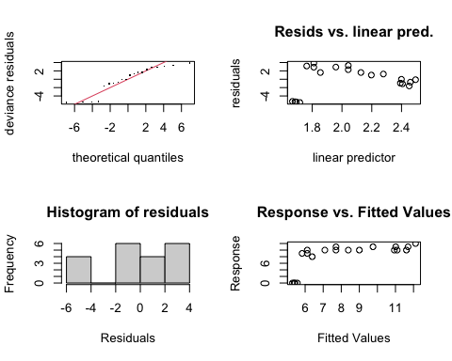
Fig 7: GAM model diagnostic summary for polar and temperate diatoms, of consecutive flashes before damping of SState induced chlorophyll fluorescence oscillations. GAM model predicted by the temperature (°C) imposed during measurements and the effective light level (µmol photons m⁻²s⁻¹, estimated from flash spacings in seconds and 𝛔_{PSII}).
##
## Method: REML Optimizer: outer newton
## full convergence after 12 iterations.
## Gradient range [-1.148855e-05,2.458705e-06]
## (score 56.65425 & scale 12.43105).
## Hessian positive definite, eigenvalue range [4.616448e-06,8.015894].
## Model rank = 9 / 9
##
## Basis dimension (k) checking results. Low p-value (k-index<1) may
## indicate that k is too low, especially if edf is close to k'.
##
## k' edf k-index p-value
## s(LightLevel_ue) 2.00 1.83 0.26 <2e-16 ***
## s(Temp_C) 2.00 1.00 0.81 0.125
## ti(Temp_C,LightLevel_ue) 4.00 1.00 0.55 0.005 **
## ---
## Signif. codes: 0 '***' 0.001 '**' 0.01 '*' 0.05 '.' 0.1 ' ' 1
##
##
## ### GAM diagnostics: 2
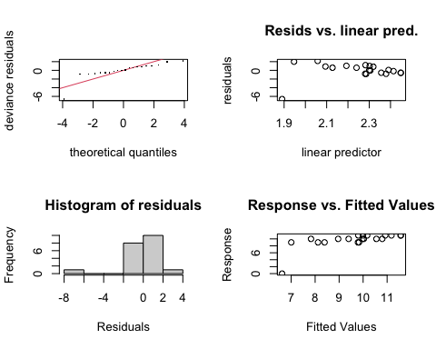
Fig 8: GAM model diagnostic summary for polar and temperate diatoms, of consecutive flashes before damping of SState induced chlorophyll fluorescence oscillations. GAM model predicted by the temperature (°C) imposed during measurements and the effective light level (µmol photons m⁻²s⁻¹, estimated from flash spacings in seconds and 𝛔_{PSII}).
##
## Method: REML Optimizer: outer newton
## full convergence after 12 iterations.
## Gradient range [-1.045605e-05,1.128619e-05]
## (score 47.79832 & scale 3.965611).
## Hessian positive definite, eigenvalue range [6.856764e-06,8.007953].
## Model rank = 9 / 9
##
## Basis dimension (k) checking results. Low p-value (k-index<1) may
## indicate that k is too low, especially if edf is close to k'.
##
## k' edf k-index p-value
## s(LightLevel_ue) 2.00 1.10 0.76 0.08 .
## s(Temp_C) 2.00 1.00 0.93 0.27
## ti(Temp_C,LightLevel_ue) 4.00 1.46 0.89 0.11
## ---
## Signif. codes: 0 '***' 0.001 '**' 0.01 '*' 0.05 '.' 0.1 ' ' 1
##
##
## ### GAM diagnostics: 3
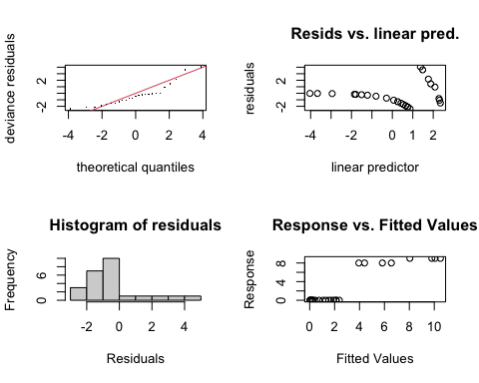
Fig 9: GAM model diagnostic summary for polar and temperate diatoms, of consecutive flashes before damping of SState induced chlorophyll fluorescence oscillations. GAM model predicted by the temperature (°C) imposed during measurements and the effective light level (µmol photons m⁻²s⁻¹, estimated from flash spacings in seconds and 𝛔_{PSII}).
##
## Method: REML Optimizer: outer newton
## full convergence after 12 iterations.
## Gradient range [-1.964407e-05,6.40554e-06]
## (score 55.32928 & scale 3.571869).
## Hessian positive definite, eigenvalue range [1.200439e-05,10.5307].
## Model rank = 9 / 9
##
## Basis dimension (k) checking results. Low p-value (k-index<1) may
## indicate that k is too low, especially if edf is close to k'.
##
## k' edf k-index p-value
## s(LightLevel_ue) 2.00 1.94 1.23 0.86
## s(Temp_C) 2.00 1.89 1.37 0.98
## ti(Temp_C,LightLevel_ue) 4.00 1.00 0.97 0.40
##
##
## ### GAM diagnostics: 4
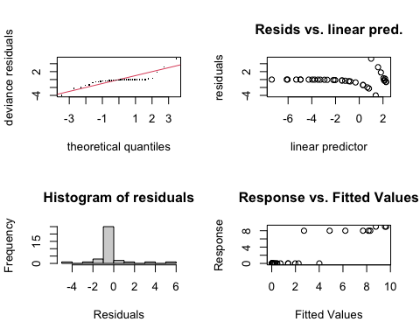
Fig 10: GAM model diagnostic summary for polar and temperate diatoms, of consecutive flashes before damping of SState induced chlorophyll fluorescence oscillations. GAM model predicted by the temperature (°C) imposed during measurements and the effective light level (µmol photons m⁻²s⁻¹, estimated from flash spacings in seconds and 𝛔_{PSII}).
##
## Method: REML Optimizer: outer newton
## full convergence after 11 iterations.
## Gradient range [-6.831923e-05,0.0001971058]
## (score 71.16439 & scale 2.490609).
## Hessian positive definite, eigenvalue range [5.281984e-06,15.52403].
## Model rank = 9 / 9
##
## Basis dimension (k) checking results. Low p-value (k-index<1) may
## indicate that k is too low, especially if edf is close to k'.
##
## k' edf k-index p-value
## s(LightLevel_ue) 2.00 1.96 1.60 1.00
## s(Temp_C) 2.00 1.00 1.02 0.49
## ti(Temp_C,LightLevel_ue) 4.00 2.17 1.48 0.99
##
##
## ### GAM diagnostics: 5
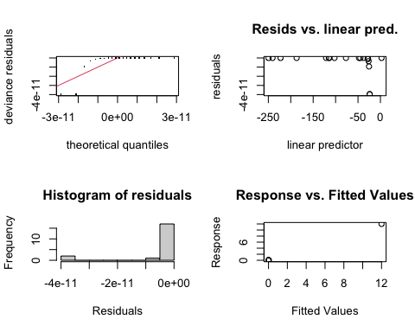
Fig 11: GAM model diagnostic summary for polar and temperate diatoms, of consecutive flashes before damping of SState induced chlorophyll fluorescence oscillations. GAM model predicted by the temperature (°C) imposed during measurements and the effective light level (µmol photons m⁻²s⁻¹, estimated from flash spacings in seconds and 𝛔_{PSII}).
##
## Method: REML Optimizer: outer newton
## step failed after 1 iteration.
## Gradient range [-1.61541e-06,9.174523]
## (score -420.8737 & scale 2.151999e-22).
## eigenvalue range [-9224757,7.998127].
## Model rank = 9 / 9
##
## Basis dimension (k) checking results. Low p-value (k-index<1) may
## indicate that k is too low, especially if edf is close to k'.
##
## k' edf k-index p-value
## s(LightLevel_ue) 2.00 1.00 0.29 0.010 **
## s(Temp_C) 2.00 1.96 0.75 0.165
## ti(Temp_C,LightLevel_ue) 4.00 1.00 0.67 0.085 .
## ---
## Signif. codes: 0 '***' 0.001 '**' 0.01 '*' 0.05 '.' 0.1 ' ' 1
##
##
## ### GAM diagnostics: 6
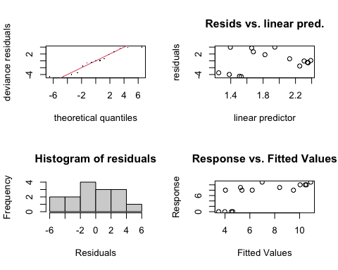
Fig 12: GAM model diagnostic summary for polar and temperate diatoms, of consecutive flashes before damping of SState induced chlorophyll fluorescence oscillations. GAM model predicted by the temperature (°C) imposed during measurements and the effective light level (µmol photons m⁻²s⁻¹, estimated from flash spacings in seconds and 𝛔_{PSII}).
##
## Method: REML Optimizer: outer newton
## full convergence after 13 iterations.
## Gradient range [-4.513978e-06,3.114671e-06]
## (score 42.28655 & scale 12.57865).
## Hessian positive definite, eigenvalue range [1.968747e-06,5.520196].
## Model rank = 9 / 9
##
## Basis dimension (k) checking results. Low p-value (k-index<1) may
## indicate that k is too low, especially if edf is close to k'.
##
## k' edf k-index p-value
## s(LightLevel_ue) 2.00 1.74 1.00 0.41
## s(Temp_C) 2.00 1.00 0.99 0.41
## ti(Temp_C,LightLevel_ue) 4.00 1.00 1.02 0.29
##
##
## ### GAM diagnostics: 7
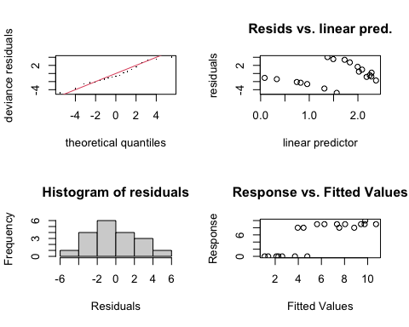
Fig 13: GAM model diagnostic summary for polar and temperate diatoms, of consecutive flashes before damping of SState induced chlorophyll fluorescence oscillations. GAM model predicted by the temperature (°C) imposed during measurements and the effective light level (µmol photons m⁻²s⁻¹, estimated from flash spacings in seconds and 𝛔_{PSII}).
##
## Method: REML Optimizer: outer newton
## full convergence after 10 iterations.
## Gradient range [-1.145248e-05,7.291372e-06]
## (score 49.70235 & scale 8.081872).
## Hessian positive definite, eigenvalue range [3.948816e-06,7.521732].
## Model rank = 9 / 9
##
## Basis dimension (k) checking results. Low p-value (k-index<1) may
## indicate that k is too low, especially if edf is close to k'.
##
## k' edf k-index p-value
## s(LightLevel_ue) 2.00 1.85 0.70 0.06 .
## s(Temp_C) 2.00 1.25 1.14 0.64
## ti(Temp_C,LightLevel_ue) 4.00 1.00 0.77 0.07 .
## ---
## Signif. codes: 0 '***' 0.001 '**' 0.01 '*' 0.05 '.' 0.1 ' ' 1
##
##
## ### GAM diagnostics: 8
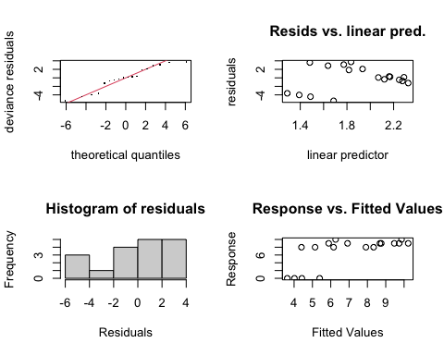
Fig 14: GAM model diagnostic summary for polar and temperate diatoms, of consecutive flashes before damping of SState induced chlorophyll fluorescence oscillations. GAM model predicted by the temperature (°C) imposed during measurements and the effective light level (µmol photons m⁻²s⁻¹, estimated from flash spacings in seconds and 𝛔_{PSII}).
##
## Method: REML Optimizer: outer newton
## full convergence after 8 iterations.
## Gradient range [-2.055142e-05,1.125567e-05]
## (score 49.36194 & scale 10.11107).
## Hessian positive definite, eigenvalue range [9.922912e-07,7.021343].
## Model rank = 9 / 9
##
## Basis dimension (k) checking results. Low p-value (k-index<1) may
## indicate that k is too low, especially if edf is close to k'.
##
## k' edf k-index p-value
## s(LightLevel_ue) 2.00 1.84 1.04 0.46
## s(Temp_C) 2.00 1.00 1.06 0.45
## ti(Temp_C,LightLevel_ue) 4.00 1.00 1.04 0.46
##
##
## ### GAM diagnostics: 9
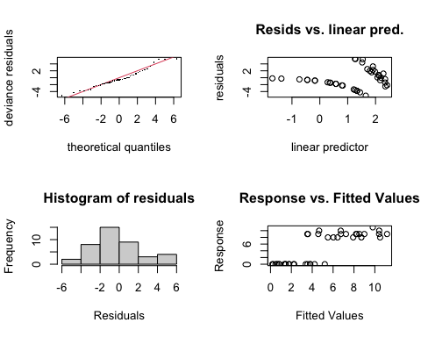
Fig 15: GAM model diagnostic summary for polar and temperate diatoms, of consecutive flashes before damping of SState induced chlorophyll fluorescence oscillations. GAM model predicted by the temperature (°C) imposed during measurements and the effective light level (µmol photons m⁻²s⁻¹, estimated from flash spacings in seconds and 𝛔_{PSII}).
##
## Method: REML Optimizer: outer newton
## full convergence after 12 iterations.
## Gradient range [-3.720374e-05,8.668272e-05]
## (score 104.6995 & scale 7.872017).
## Hessian positive definite, eigenvalue range [2.611616e-05,18.51441].
## Model rank = 9 / 9
##
## Basis dimension (k) checking results. Low p-value (k-index<1) may
## indicate that k is too low, especially if edf is close to k'.
##
## k' edf k-index p-value
## s(LightLevel_ue) 2.00 1.90 0.72 0.04 *
## s(Temp_C) 2.00 1.77 1.06 0.68
## ti(Temp_C,LightLevel_ue) 4.00 1.00 0.62 <2e-16 ***
## ---
## Signif. codes: 0 '***' 0.001 '**' 0.01 '*' 0.05 '.' 0.1 ' ' 1
##
##
## ### GAM diagnostics: 10
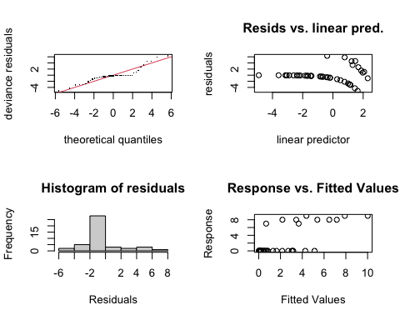
Fig 16: GAM model diagnostic summary for polar and temperate diatoms, of consecutive flashes before damping of SState induced chlorophyll fluorescence oscillations. GAM model predicted by the temperature (°C) imposed during measurements and the effective light level (µmol photons m⁻²s⁻¹, estimated from flash spacings in seconds and 𝛔_{PSII}).
##
## Method: REML Optimizer: outer newton
## full convergence after 9 iterations.
## Gradient range [-6.765617e-05,3.899604e-05]
## (score 103.853 & scale 6.13007).
## Hessian positive definite, eigenvalue range [5.51875e-05,20.0096].
## Model rank = 9 / 9
##
## Basis dimension (k) checking results. Low p-value (k-index<1) may
## indicate that k is too low, especially if edf is close to k'.
##
## k' edf k-index p-value
## s(LightLevel_ue) 2.00 1.87 1.01 0.45
## s(Temp_C) 2.00 1.00 1.27 0.94
## ti(Temp_C,LightLevel_ue) 4.00 2.19 0.85 0.09 .
## ---
## Signif. codes: 0 '***' 0.001 '**' 0.01 '*' 0.05 '.' 0.1 ' ' 1

References
Ardyna, M., and Arrigo, K. R. (2020). Phytoplankton dynamics in a changing Arctic Ocean. Nature Climate Change 10, 892–903. doi:10.1038/s41558-020-0905-y.
Balzano, S., Gourvil, P., Siano, R., Chanoine, M., Marie, D., Lessard, S., Sarno, D., and Vaulot, D. (2012). Diversity of cultured photosynthetic flagellates in the northeast Pacific and Arctic Oceans in summer. Biogeosciences 9, 4553–4571. doi:10.5194/bg-9-4553-2012.
Bayer-Giraldi, M., Weikusat, I., Besir, H., and Dieckmann, G. (2011). Characterization of an antifreeze protein from the polar diatom Fragilariopsis cylindrus and its relevance in sea ice. Cryobiology 63, 210–219. doi:10.1016/j.cryobiol.2011.08.006.
Bryan, J. (2023). googlesheets4: Access google sheets using the sheets API V4. Available at: https://googlesheets4.tidyverse.org.
Campitelli, E. (2021). metR: Tools for easier analysis of meteorological fields. doi:10.5281/zenodo.2593516.
Cazelles, B., Chavez, M., Berteaux, D., Ménard, F., Vik, J. O., Jenouvrier, S., and Stenseth, N. C. (2008). Wavelet analysis of ecological time series. Oecologia 156, 287–304. doi:10.1007/s00442-008-0993-2.
Cefarelli, A. O., Ferrario, M. E., Almandoz, G. O., Atencio, A. G., Akselman, R., and Vernet, M. (2010). Diversity of the diatom genus Fragilariopsis in the Argentine Sea and Antarctic waters: Morphology, distribution and abundance. Polar Biology 33. doi:10.1007/s00300-010-0794-z.
Cohen, J. H., Berge, J., Moline, M. A., Johnsen, G., and Zolich, A. P. (2020). “Light in the Polar Night,” in POLAR NIGHT Marine Ecology, eds. J. Berge, G. Johnsen, and J. H. Cohen (Cham: Springer International Publishing), 37–66. doi:10.1007/978-3-030-33208-2_3.
Cook, G., Teufel, A., Kalra, I., Li, W., Wang, X., Priscu, J., and Morgan-Kiss, R. (2019). The Antarctic psychrophiles Chlamydomonas spp. UWO241 and ICEMDV exhibit differential restructuring of photosystem I in response to iron. Photosynthesis Research 141, 209–228. doi:10.1007/s11120-019-00621-0.
Cvetkovska, M., Vakulenko, G., Smith, D. R., Zhang, X., and Hüner, N. P. A. (2022). Temperature stress in psychrophilic green microalgae: Minireview. Physiologia Plantarum 174, e13811. doi:10.1111/ppl.13811.
Dau, H., and Haumann, M. (2007). Time-resolved X-ray spectroscopy leads to an extension of the classical S-state cycle model of photosynthetic oxygen evolution. Photosynthesis Research 92, 327–343. doi:10.1007/s11120-007-9141-9.
de Wijn, R., and van Gorkom, H. J. (2002). S-state dependence of the miss probability in Photosystem II. Photosynthesis Research 72, 217–222. doi:10.1023/A:1016128632704.
Falkowski, P., Fenchel, T., and Delong, E. (2008). The Microbial Engines That Drive Earth’s Biogeochemical Cycles. Science 320, 1034–1039. doi:10.1126/science.1153213.
Fasiolo, M., Nedellec, R., Goude, Y., and Wood, S. N. (2020). Scalable Visualization Methods for Modern Generalized Additive Models. Journal of Computational and Graphical Statistics 29, 78–86. doi:10.1080/10618600.2019.1629942.
Fiala, M., and Oriol, L. (1990). Light-temperature interactions on the growth of Antarctic diatoms. Polar Biology 10, 629–636. doi:10.1007/BF00239374.
Gates, C., Ananyev, G., and Dismukes, G. C. (2020). Realtime kinetics of the light driven steps of photosynthetic water oxidation in living organisms by “stroboscopic” fluorometry. Biochimica et Biophysica Acta (BBA) - Bioenergetics 1861, 148212. doi:10.1016/j.bbabio.2020.148212.
Halekoh, U., and Højsgaard, S. (2025). doBy: Groupwise statistics, LSmeans, linear estimates, utilities. Available at: https://github.com/hojsgaard/doBy.
Han, G., Chernev, P., Styring, S., Messinger, J., and Mamedov, F. (2022). Molecular basis for turnover inefficiencies (misses) during water oxidation in photosystem II. Chemical Science 13, 8667–8678. doi:10.1039/D2SC00854H.
Han, G., Ho, F. M., Havelius, K. G. V., Morvaridi, S. F., Mamedov, F., and Styring, S. (2008). Direct quantification of the four individual S states in Photosystem II using EPR spectroscopy. Biochimica et Biophysica Acta (BBA) - Bioenergetics 1777, 496–503. doi:10.1016/j.bbabio.2008.03.007.
Han, G., Mamedov, F., and Styring, S. (2012). Misses during water oxidation in photosystem II are S state-dependent. The Journal of Biological Chemistry 287, 13422–13429. doi:10.1074/jbc.M112.342543.
Hancke, K., Lund-Hansen, L. C., Lamare, M. L., Højlund Pedersen, S., King, M. D., Andersen, P., and Sorrell, B. K. (2018). Extreme Low Light Requirement for Algae Growth Underneath Sea Ice: A Case Study From Station Nord, NE Greenland. Journal of Geophysical Research: Oceans 123, 985–1000. doi:10.1002/2017JC013263.
Hoppe, C. J. M., Fuchs, N., Notz, D., Anderson, P., Assmy, P., Berge, J., Bratbak, G., Guillou, G., Kraberg, A., Larsen, A., et al. (2024). Photosynthetic light requirement near the theoretical minimum detected in Arctic microalgae. Nature Communications 15, 7385. doi:10.1038/s41467-024-51636-8.
Hüner, N. P. A., Szyszka-Mroz, B., Ivanov, A. G., Kata, V., Lye, H., and Smith, D. R. (2023). Photosynthetic adaptation and multicellularity in the Antarctic psychrophile, Chlamydomonas priscuii. Algal Research 74, 103220. doi:10.1016/j.algal.2023.103220.
Ibarbalz, F. M., Henry, N., Mahé, F., Ardyna, M., Zingone, A., Scalco, E., Lovejoy, C., Lombard, F., Jaillon, O., Iudicone, D., et al. (2023). Pan-Arctic plankton community structure and its global connectivity. Elementa: Science of the Anthropocene 11, 00060. doi:10.1525/elementa.2022.00060.
Ivanov, A. G., Sane, P. V., Krol, M., Gray, G. R., Balseris, A., Savitch, L. V., Öquist, G., and Hüner, N. P. A. (2006). Acclimation to temperature and irradiance modulates PSII charge recombination. FEBS Letters 580, 2797–2802. doi:10.1016/j.febslet.2006.04.018.
Ivanov, A. G., Sane, P., Hurry, V., Król, M., Sveshnikov, D., Huner, N. P. A., and Öquist, G. (2003). Low-temperature modulation of the redox properties of the acceptor side of photosystem II: Photoprotection through reaction centre quenching of excess energy. Physiologia Plantarum 119, 376–383. doi:10.1034/j.1399-3054.2003.00225.x.
Kalra, I., Wang, X., Zhang, R., and Morgan-Kiss, R. (2023). High salt-induced PSI-supercomplex is associated with high CEF and attenuation of state transitions. Photosynthesis Research 157, 65–84. doi:10.1007/s11120-023-01032-y.
Kang, S.-H., and Fryxell, G. A. (1992). Fragilariopsis cylindrus (Grunow) Krieger: The most abundant diatom in water column assemblages of Antarctic marginal ice-edge zones. Polar Biology 12, 609–627. doi:10.1007/BF00236984.
Keren, N., Berg, A., van Kan, P. J. M., Levanon, H., and Ohad, I. (1997). Mechanism of photosystem II photoinactivation and D1 protein degradation at low light: The role of back electron flow. Proceedings of the National Academy of Sciences 94, 1579–1584. doi:10.1073/pnas.94.4.1579.
Kirk, J. T. O. (2011). Light and Photosynthesis in Aquatic Ecosystems. 3rd ed. Cambridge, UK: Cambridge University Press.
Kolber, Z. S. (1998). Measurements of variable chlorophyll fluorescence using fast repetition rate techniques: Defining methodology and experimental protocols. Biochimica et Biophysica Acta 1367, 19. doi:10.1016/S0005-2728(98)00135-2.
Laloi, C., Przybyla, D., and Apel, K. (2006). A genetic approach towards elucidating the biological activity of different reactive oxygen species in Arabidopsis thaliana. Journal of Experimental Botany 57, 1719–1724. doi:10.1093/jxb/erj183.
Leu, E., Mundy, C. J., Assmy, P., Campbell, K., Gabrielsen, T. M., Gosselin, M., Juul-Pedersen, T., and Gradinger, R. (2015). Arctic spring awakening – Steering principles behind the phenology of vernal ice algal blooms. Progress in Oceanography 139, 151–170. doi:10.1016/j.pocean.2015.07.012.
Leyva, L. A., Bashan, Y., Mendoza, A., and de-Bashan, L. E. (2014). Accumulation fatty acids of in Chlorella vulgaris under heterotrophic conditions in relation to activity of acetyl-CoA carboxylase, temperature, and co-immobilization with Azospirillum brasilense. Naturwissenschaften 101, 819–830. doi:10.1007/s00114-014-1223-x.
Li, W., and Morgan-Kiss, R. M. (2019). Influence of Environmental Drivers and Potential Interactions on the Distribution of Microbial Communities From Three Permanently Stratified Antarctic Lakes. Frontiers in Microbiology 10. doi:10.3389/fmicb.2019.01067.
Li, W., Podar, M., and Morgan-Kiss, R. M. (2016). Ultrastructural and Single-Cell-Level Characterization Reveals Metabolic Versatility in a Microbial Eukaryote Community from an Ice-Covered Antarctic Lake. Applied and Environmental Microbiology 82, 3659–3670. doi:10.1128/AEM.00478-16.
Lyon, B. R., and Mock, T. (2014). Polar Microalgae: New Approaches towards Understanding Adaptations to an Extreme and Changing Environment. Biology 3, 56–80. doi:10.3390/biology3010056.
McMinn, A., Ryan, K., and Gademann, R. (2003). Diurnal changes in photosynthesis of Antarctic fast ice algal communities determined by pulse amplitude modulation fluorometry. Marine Biology 143, 359–367. doi:10.1007/s00227-003-1052-5.
Mock, T., Otillar, R. P., Strauss, J., McMullan, M., Paajanen, P., Schmutz, J., Salamov, A., Sanges, R., Toseland, A., Ward, B. J., et al. (2017). Evolutionary genomics of the cold-adapted diatom Fragilariopsis cylindrus. Nature 541, 536–540. doi:10.1038/nature20803.
Morales-Sánchez, D., Schulze, P. S. C., Kiron, V., and Wijffels, R. H. (2020). Temperature-Dependent Lipid Accumulation in the Polar Marine Microalga Chlamydomonas malina RCC2488. Frontiers in Plant Science 11. doi:10.3389/fpls.2020.619064.
Morgan-Kiss, R. M., Lizotte, M. P., Kong, W., and Priscu, J. C. (2016). Photoadaptation to the polar night by phytoplankton in a permanently ice-covered Antarctic lake. Limnology and Oceanography 61, 3–13. doi:10.1002/lno.10107.
Mukhopadhyay, S., Mandal, S. K., Bhaduri, S., and Armstrong, W. H. (2004). Manganese Clusters with Relevance to Photosystem II. Chemical Reviews 104, 3981–4026. doi:10.1021/cr0206014.
Otte, A., Winder, J. C., Deng, L., Schmutz, J., Jenkins, J., Grigoriev, I. V., Hopes, A., and Mock, T. (2023). The diatom Fragilariopsis cylindrus: A model alga to understand cold-adapted life. Journal of Phycology 59, 301–306. doi:10.1111/jpy.13325.
Pierella Karlusich, J. J., Ibarbalz, F. M., and Bowler, C. (2020). Phytoplankton in the Tara Ocean. Annual Review of Marine Science 12, 233–265. doi:10.1146/annurev-marine-010419-010706.
Pinilla, J., and Negrín, M. (2021). Non-Parametric Generalized Additive Models as a Tool for Evaluating Policy Interventions. Mathematics 9, 299. doi:10.3390/math9040299.
Poirier, M. C., Fugard, K., and Cvetkovska, M. (2025). Light quality affects chlorophyll biosynthesis and photosynthetic performance in Antarctic Chlamydomonas. Photosynthesis Research 163, 9. doi:10.1007/s11120-024-01127-0.
Poirier, M., Osmers, P., Wilkins, K., Morgan-Kiss, R. M., and Cvetkovska, M. Aberrant light sensing and motility in the green alga Chlamydomonas priscuii from the ice-covered Antarctic Lake Bonney. Plant Signaling & Behavior 18, 2184588. doi:10.1080/15592324.2023.2184588.
Posit team (2025). RStudio: Integrated development environment for R. Boston, MA: Posit Software, PBC.
Poulsen, N., and Kröger, N. (2023). Thalassiosira pseudonana (Cyclotella nana) (Hustedt) Hasle et Heimdal (Bacillariophyceae): A genetically tractable model organism for studying diatom biology, including biological silica formation. Journal of Phycology 59, 809–817. doi:10.1111/jpy.13362.
Quigg, A., Beardall, J., and Wydrzynski, T. (2003). Photoacclimation involves modulation of the photosynthetic oxygen-evolving reactions in Dunaliella tertiolecta and Phaeodactylum tricornutum. Functional Plant Biology 30, 301. doi:10.1071/FP02140.
R Core Team (2023). R: A language and environment for statistical computing. Vienna, Austria: R Foundation for Statistical Computing.
Randelhoff, A., Lacour, L., Marec, C., Leymarie, E., Lagunas, J., Xing, X., Darnis, G., Penkerc’h, C., Sampei, M., Fortier, L., et al. (2020). Arctic mid-winter phytoplankton growth revealed by autonomous profilers. Science Advances 6, eabc2678. doi:10.1126/sciadv.abc2678.
Rappaport, F., Cuni, A., Xiong, L., Sayre, R., and Lavergne, J. (2005). Charge Recombination and Thermoluminescence in Photosystem II. Biophysical Journal 88, 1948–1958. doi:10.1529/biophysj.104.050237.
Rappaport, F., Guergova-Kuras, M., Nixon, P. J., Diner, B. A., and Lavergne, J. (2002). Kinetics and Pathways of Charge Recombination in Photosystem II. Biochemistry 41, 8518–8527. doi:10.1021/bi025725p.
Raven, J. A., Kübler, J. E., and Beardall, J. (2000). Put out the light, and then put out the light. Journal of the Marine Biological Association of the United Kingdom 80, 1–25. doi:10.1017/S0025315499001526.
Robinson, D. H., Arrigo, K. R., Iturriaga, R., and Sullivan, C. W. (1995). Microalgal Light-Harvesting in Extreme Low-Light Environments in Mcmurdo Sound, Antarctica. Journal of Phycology 31, 508–520. doi:10.1111/j.1529-8817.1995.tb02544.x.
Robinson, D., Hayes, A., and Couch, S. (2025). Broom: Convert statistical objects into tidy tibbles. Available at: https://broom.tidymodels.org/.
Roesch, A., and Schmidbauer, H. (2018). WaveletComp: Computational wavelet analysis.
Rutherford, A. W., Osyczka, A., and Rappaport, F. (2012). Back-reactions, short-circuits, leaks and other energy wasteful reactions in biological electron transfer: Redox tuning to survive life in O2. FEBS Letters 586, 603–616. doi:10.1016/j.febslet.2011.12.039.
Sane, P. V., Ivanov, A. G., Hurry, V., Huner, N. P. A., and Öquist, G. (2003). Changes in the Redox Potential of Primary and Secondary Electron-Accepting Quinones in Photosystem II Confer Increased Resistance to Photoinhibition in Low-Temperature-Acclimated Arabidopsis. Plant Physiology 132, 2144–2151. doi:10.1104/pp.103.022939.
Sane, P. V., Ivanov, A. G., Sveshnikov, D., Huner, N. P. A., and Oquist, G. (2002). A Transient Exchange of the Photosystem II Reaction Center Protein D1:1 with D1:2 during Low Temperature Stress ofSynechococcus sp. PCC 7942 in the Light Lowers the Redox Potential of QB*. Journal of Biological Chemistry 277, 32739–32745. doi:10.1074/jbc.M200444200.
Sasso, S., Stibor, H., Mittag, M., and Grossman, A. R. (2018). From molecular manipulation of domesticated Chlamydomonas reinhardtii to survival in nature. eLife 7, e39233. doi:10.7554/eLife.39233.
Schoenig, D., Maynard, L., Brice, M.-H., Cazelles, K., Braga, P. H. P., Gongora, E., Sherin, L., Pedersen, E., Taranu, Z., Dussault, C. F., et al. (2023). Workshop 8: Generalized additive models in R. Québec Centre for Biodiversity Science.
Schuback, N., Tortell, P. D., Berman-Frank, I., Campbell, D. A., Ciotti, A., Courtecuisse, E., Erickson, Z. K., Fujiki, T., Halsey, K., Hickman, A. E., et al. (2021). Single-Turnover Variable Chlorophyll Fluorescence as a Tool for Assessing Phytoplankton Photosynthesis and Primary Productivity: Opportunities, Caveats and Recommendations. Frontiers in Marine Science 8. doi:10.3389/fmars.2021.690607.
Shen, J.-R. (2021). “Photosynthesis Photosystem II: Protein Components, Structure and Electron Transfer,” in Encyclopedia of Biological Chemistry III (Third Edition), ed. J. Jez (Oxford: Elsevier), 215–228. doi:10.1016/B978-0-12-819460-7.00012-8.
Sherwell, S., Kalra, I., Li, W., McKnight, D. M., Priscu, J. C., and Morgan-Kiss, R. M. (2022). Antarctic lake phytoplankton and bacteria from near-surface waters exhibit high sensitivity to climate-driven disturbance. Environmental Microbiology 24, 6017–6032. doi:10.1111/1462-2920.16113.
Shevela, D., Kern, J. F., Govindjee, G., and Messinger, J. (2023). Solar energy conversion by photosystem II: Principles and structures. Photosynthesis Research 156, 279–307. doi:10.1007/s11120-022-00991-y.
Spinu, V., Grolemund, G., and Wickham, H. (2024). Lubridate: Make dealing with dates a little easier. Available at: https://lubridate.tidyverse.org.
Stahl-Rommel, S., Kalra, I., D’Silva, S., Hahn, M. M., Popson, D., Cvetkovska, M., and Morgan-Kiss, R. M. (2022). Cyclic electron flow (CEF) and ascorbate pathway activity provide constitutive photoprotection for the photopsychrophile, Chlamydomonas sp. UWO 241 (renamed Chlamydomonas priscuii). Photosynthesis Research 151, 235–250. doi:10.1007/s11120-021-00877-5.
Theis, F. J., and Meyer-Bäse, A. (2010). “Spectral Transformations,” in Biomedical Signal Analysis : Contemporary Methods and Applications The MIT Press Series. (MIT Press), 42.
van den Brand, T. (2025). Ggh4x: Hacks for ’Ggplot2’.
Vass, I. (2011). Role of charge recombination processes in photodamage and photoprotection of the photosystem II complex. Physiologia Plantarum 142, 6–16. doi:10.1111/j.1399-3054.2011.01454.x.
Vass, I., and Cser, K. (2009). Janus-faced charge recombinations in photosystem II photoinhibition. Trends in Plant Science 14, 200–205. doi:10.1016/j.tplants.2009.01.009.
Vinyard, D. J., Ananyev, G. M., and Charles Dismukes, G. (2013). Photosystem II: The Reaction Center of Oxygenic Photosynthesis. Annual Review of Biochemistry 82, 577–606. doi:10.1146/annurev-biochem-070511-100425.
von Quillfeldt, C. H. (2004). The diatom fragilariopsis cylindrus and its potential as an indicator species for cold water rather than for sea ice. Vie et Milieu / Life & Environment, 137–143.
Wickham, H. (2016). Ggplot2: Elegant graphics for data analysis. Springer-Verlag New York.
Wickham, H. (2023). Tidyverse: Easily install and load the tidyverse. Available at: https://tidyverse.tidyverse.org.
Wiel, J. B. V., D. Mikulicz, J., R. Boysen, M., Hashemi, N., Kalgren, P., M. Nauman, L., J. Baetzold, S., G. Powell, G., He, Q., and Nastaran Hashemi, N. (2017). Characterization of Chlorella vulgaris and Chlorella protothecoides using multi-pixel photon counters in a 3D focusing optofluidic system. RSC Advances 7, 4402–4408. doi:10.1039/C6RA25837A.
Wood, S. (2025). Mgcv: Mixed GAM computation vehicle with automatic smoothness estimation. Available at: https://CRAN.R-project.org/package=mgcv.
Wood, S. N. (2011). Fast stable restricted maximum likelihood and marginal likelihood estimation of semiparametric generalized linear models. Journal of the Royal Statistical Society: Series B (Statistical Methodology) 73, 3–36. doi:10.1111/j.1467-9868.2010.00749.x.
Wood, S. N. (2017). Generalized Additive Models: An introduction with R. 2nd ed. New York: Chapman and Hall/CRC.
Xie, B., Bishop, S., Stessman, D., Wright, D., Spalding, M. H., and Halverson, L. J. (2013). Chlamydomonas reinhardtii thermal tolerance enhancement mediated by a mutualistic interaction with vitamin B12-producing bacteria. The ISME Journal 7, 1544–1555. doi:10.1038/ismej.2013.43.
Xie, Y. (2025). Knitr: A general-purpose package for dynamic report generation in r. Available at: https://yihui.org/knitr/.
Xu, K., Lavaud, J., Perkins, R., Austen, E., Bonnanfant, M., and Campbell, D. A. (2018). Phytoplankton $σ$PSII and Excitation Dissipation; Implications for Estimates of Primary Productivity. Frontiers in Marine Science 5. doi:10.3389/fmars.2018.00281.
Zaharieva, I., and Dau, H. (2019). Energetics and Kinetics of S-State Transitions Monitored by Delayed Chlorophyll Fluorescence. Frontiers in Plant Science 10.
Zhang, X., Cvetkovska, M., Morgan-Kiss, R., Hüner, N. P. A., and Smith, D. R. (2021). Draft genome sequence of the Antarctic green alga Chlamydomonas sp. UWO241. iScience 24, 102084. doi:10.1016/j.isci.2021.102084.
Zhang, Z., Qu, C., Zhang, K., He, Y., Zhao, X., Yang, L., Zheng, Z., Ma, X., Wang, X., Wang, W., et al. (2020). Adaptation to Extreme Antarctic Environments Revealed by the Genome of a Sea Ice Green Alga. Current Biology 30, 3330–3341.e7. doi:10.1016/j.cub.2020.06.029.
Zhu, H. (2024). kableExtra: Construct complex table with kable and pipe syntax. Available at: http://haozhu233.github.io/kableExtra/.

