2. Materials & Methods
2.1. Study Organisms & Culturing
Seven phytoplankton species were studied, including polar and temperate strains of diatoms and green algae. Diatoms are represented by two taxa, Fragilariopsis cylindrus and Thalassiosira pseudonana. F. cylindrus, a psychrophilic pennate diatom measuring 15-55 µm, thrives in the high salinity and subzero temperatures of Arctic and Antarctic sea-ice systems[1,2]. Forming large blooms in the bottom layer of sea ice and across the wider sea ice zone, F. cylindrus acts as a keystone and indicator species for polar ecosystems[1,3]. Conversely, T. pseudonana is a small (2.5-15 μm) centric diatom found worldwide in diverse freshwater, coastal, brackish, and marine habitats[4]. T. pseudonana can tolerate a wide range of salinities (0.5%–37%) and temperatures (4–25°C), contributing to its frequent use as a model diatom species[4].
The remaining five taxa comprise three polar and two temperate species of green algae. Chlamydomonas ICEMDV and Chlamydomonas priscuii are marine algae isolated from the perennially ice-covered hypersaline Lake Bonney in McMurdo Dry Valleys, Antarctica[5,6]. With large (15 to 20 μm) biflagellate cells, C. ICEMDV dominates the shallow photic zone, where it experiences higher irradiance, extreme nutrient limitation, and low salinity[5,7]. The smaller C. priscuii dominates the deep photic zone, characterized by permanent low temperatures and high salinity[8,9]. The final psychrophile species is Chlamydomonas malina, a marine microalga isolated from the Arctic Ocean's Beaufort Sea, measuring around 10 μm in length and 5 μm in width, and growing optimally at 4°C[10,11]. The temperate green algae is comprised of Chlamydomonas reinhardtii and Chlorella vulgaris. C. reinhardtii is a model alga approximately 10 μm in size and found in soil and aquatic environments with an optimal temperature range of 20-32°C[12,13]. Meanwhile, C. vulgaris, ranging from 2 μm to 10 μm in size, is primarily found in freshwater environments and grows optimally at 27°C[14,15].

Culturing Protocols
Twelve cultures comprising seven species were used, as summarized in Table 1. Cultures of T. pseudonana and C. vulgaris were prepared by Naaman Omar (Mount Allison University), Chlamydomonas cultures were prepared by MacKenzie Poirier (Cvetskova Lab, University of Ottawa), and F. cylindrus cultures were prepared by Sébastien Guérin (Takuvik International Research Laboratory, Université Laval).

Table 1: Culturing conditions for experimental phytoplankton strains
Culture ID | Strain | Dilution | Par (µmol photons m⁻²s⁻¹) | Photoperiod | Growth  Temp (°C) | Media
NaOm1305 | T. pseudonana | 1 | 50 | 12 | 22 | F2
NaOm1663 | T. pseudonana | 1 | 50 | 12 | 22 | F2
NaOm1671 | C. vulgaris | 1 | 50 | 12 | 22 | F2
NaOm2987 | C. vulgaris | 1 | 50 | 12 | 22 | BG11
NaOm2988 | T. pseudonana | 1 | 50 | 12 | 22 | F2
NaOm2990 | C. vulgaris | 1 | 70 | 12 | 22 | BG11
NaOm2991 | T. pseudonana | 1 | 70 | 12 | 22 | F2
NaOm2992 | T. pseudonana | 1 | 70 | 12 | 22 | F2
SeGu1001 | F. cylindrus | 1 | 10 | 24 | 0 | F2
SeGu1006 | F. cylindrus | 1 | 10 | 24 | 6 | F2
MaPo1001 | C. priscuii | 0.2 | 10 | 24 | 4 | BBM
MaPo1002 | C. ICEMDV | 0.2 | 10 | 24 | 4 | BBM
MaPo1003 | C. malina | 0.2 | 10 | 24 | 4 | BBM
MaPo1004 | C. priscuii | 1 | 10 | 24 | 4 | BBM
MaPo1005 | C. reinhardtii | 1 | 10 | 24 | 24 | BBM
MaPo1006 | C. reinhardtii | 1 | 10 | 24 | 24 | BBM

2.2. Single Turnover Variable Chlorophyll Fluorescence
A single turnover variable chlorophyll fluorescence (St-ChlF) approach was employed to evaluate the desynchronization of the s-state cycle across a range of phytoplankton species, temperatures, and light levels.
Cultures were loaded into a temperature-controlled cuvette (PolyScience) within a Soliense LIFT-REM fluorometer (Version LIFT-REM 1.0, Soliense Inc). The apparatus was covered to block out incident light and cells were acclimated to the dark for a minimum of 30 seconds. In a dark regulated state, non-photochemical quenching processes have been fully reversed, and electrons have been passed downstream, leaving all reaction centres open for photochemistry. Therefore, when the photosystem receives a photon, the maximum proportion of energy will be partitioned to photochemistry, corresponding to minimum ChlF (F_{o}) [16].
The sample is then exposed to a series of short, high-intensity, evenly-spaced flashes of 445 nm light. Each flash consists of a rapid series of sub-saturating flashlets occurring on microsecond timescales [16]. These flashlets induce the absorption of light by PSII, which then passes electrons downstream to Q_{A}⁻, transiently reducing the pool of electron acceptors and effectively closing PSII for photochemistry[18]. Closing the photochemistry pathway redirects a greater proportion of energy to ChlF, resulting in maximum ChlF (F_{m}). This induction is known as the saturation phase (Figure 1), where the fluorescence yield increases from a minimum (F_{o}) to a maximum (F_{m}) [17]. For each flash, the ChlF minima and maxima can be used to derive the maximum quantum yield of photochemistry in PSII, a secondary ChlF parameter calculated as follows [16]:
$${{\text{F}}_{\text{v}}}/{{\text{F}}_{\text{m}}}\text{=}\frac{{\text{F}}_{\text{m}}\text{-}{\text{F}}_{\text{o}}}{{\text{F}}_{\text{m}}}$$
The maximum quantum yield represents the efficiency with which PSII can convert absorbed light energy into chemical energy. Chlorophyll fluorescence parameters were fitted using LIFT software version 22.11.11 (Soliense Inc).

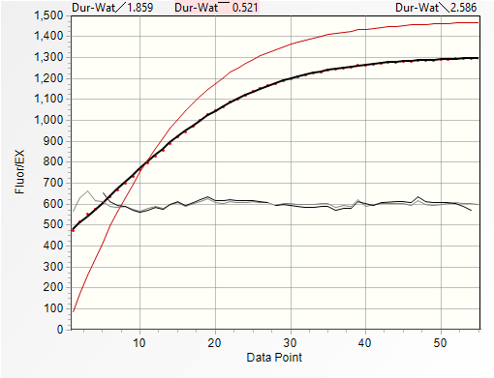
Figure 1: Sample chlorophyll fluorescence induction curve

Each flash delivers one photon to a PSII, initiating a transition between S-states. Thus, as sequential flashes are applied to the culture, each individual PSII is driven through the four S-states [18]. In an idealized culture, the population of PSII cycles synchronously, reflected by an ongoing oscillation in chlorophyll fluorescence with a period of four (Figure 3) [19]. However, recombination reactions, represent a loss of charge separation, causing a backward slip in the S-state cycling of an individual PSII. As more recombination events occur, desynchronization of S-state cycling among the PSII of the population will scramble the periodic changes in ChlF, dampening the observed oscillation [19]. Prolonged synchronous cycling indicates fewer wasteful recombination reactions and, thus, more efficient photosynthetic energy conversion.

Figure 3: Repeated single-turnover excitation of variable chlorophyll fluorescence for monitoring the S-state cycling in PSII during photosynthesis

Measurement Conditions
By evaluating the cycling of polar and temperate taxa of diatoms and green algae under a range of light and temperature conditions (Table 2), we can determine if polar taxa have evolved to increase photosynthetic energy conversion efficiency by minimizing inefficient recombination reactions. Measurement temperatures ranged from 0 to 28°C, depending on the taxa (Table 2).
Altering the spacing between flashes can simulate varying light conditions. At higher light intensities, more photons are emitted per unit of time, corresponding to shorter spacing between flashes. Cultures were evaluated at flash spacings of 1, 2, 4, 8, and 16 seconds. Corresponding steady-state light levels were calculated for each unique measurement condition as follows:
$$\text{Light} \left(\text{μmol γ} {\text{m}}^{\text{-2}}{\text{s}}^{\text{-1}}\right) \text{=} \frac{\text{1}}{\text{flash spacing (s)}}\text{×}\frac{\text{1}}{{\text{σ}}_{\text{PSII}}\text{(}{\text{Å}}^{\text{2}}{\text{γ}}^{\text{-1}}\text{)}}\text{×}\frac{\text{1} {\text{m}}^{\text{2}}}{\text{1E20} {\text{Å}}^{\text{2}}}\text{×}\frac{\text{1 }\text{μmol}}{\text{6.02 2E17 γ}}$$
This calculation requires the effective absorption cross-section of photosystem II (σ_{PSII}), a parameter estimated from the ChlF induction curve during the saturation phase. This parameter represents the probability of light capture by the PSII antenna bed associated with the dark-adapted PSII [16,20]. The conversion of flash spacing to light levels yielded similar but unique measurement ranges of light level for each strain (Table 2).

Table 2: Measurement conditions by strain
Strain | Flash Spacings (s) | Steady Light Level Range  (µmol photons m⁻²s⁻¹) | Measurement Temperatures (°C)
F. cylindrus | 1, 2, 4, 8, 16 | 0.02981 - 0.65678 | 0, 2, 6, 10
T. pseudonana | 1, 2, 4, 8, 16 | 0.02428 - 0.53428 | 10, 14, 18, 20, 22, 24, 28
C. ICEMDV | 1, 2, 4, 8, 16 | 0.04252 - 0.73733 | 4, 8, 12
C. priscuii | 1, 2, 4, 8, 16 | 0.04289 - 0.77084 | 4, 8, 12
C. malina | 1, 2, 4, 8, 16 | 0.03705 - 0.65817 | 4, 8, 12
C. reinhardtii | 1, 2, 4, 8, 16 | 0.04670 - 0.84377 | 12, 16, 20, 24
C. vulgaris | 1, 2, 4, 8, 16 | 0.05102 - 0.89781 | 10, 14, 18, 22, 26

2.3. Analytical Methods
Data was processed using R version 4.3.2 along with RStudio version 2023.12.0+369 using the x86_64-apple-darwin20 (64-bit) platform and running under macOS Sonoma 14.3.1. Fluorescence data generated by LIFT software was imported and tidied using the tidyverse, lubridate, and googlesheets4 packages. The tidyverse, doBy, and WaveletComp packages were used for wavelet analyses. Lastly, ggplot2, metR, stats, and viridis packages were used for data visualization.

Wavelet Transformations
Raw fluorescence data yields a time series of F_{v}/F_{m} over 32 flashes, which was analyzed for each combination of strain, temperature, and flash spacing using wavelet transformations, as exemplified in Figure 4. Unlike traditional methods, wavelet analysis does not assume that the statistical properties of a time series are constant. Instead, wavelet transformations locally decompose the signal across different time scales and estimate spectral characteristics as a function of time [21]. By examining the frequency and wavelet power spectra, we can uncover the dominant patterns in the data [22].
Figure 4: Representative wavelet transformation of Chlamydomonas priscuii fluorescence over 32 consecutive flashes at 4°C and 1-second flash spacing, analogous to an approximate steady-state light level of 0.708 µmol photons m⁻²s⁻¹.

The core of the wavelet transformation involves computing the wavelet power spectrum of the standardized time series using the Morlet wavelet [23]. Further, the significance of the periodic components in the time series was calculated using a simulation algorithm. Surrogate time series are generated based on a white noise model, consisting of uncorrelated random values with constant mean and variance. Comparing the wavelet of the original data with the white noise model, p-values are calculated to determine whether the observed periodic components are statistically significant [23].
The statistical significance of the wavelet power at a periodicity of four indicates whether the culture is exhibiting the periodic oscillations in chlorophyll fluorescence that indicate synchronous S-state cycling across the PSII population. For wavelets exhibiting S-state cycling, we generated a reconstruction limited to areas with a statistically significant signal, as depicted in Figure 5. Damping of the reconstructed wavelet represents the significance of the signal dropping below the threshold of p=0.05. The damping index represents the number of flashes applied before this damping occurs, indicating how many successive photons are received before sufficient recombination reactions fully desynchronize the S-state cycle.
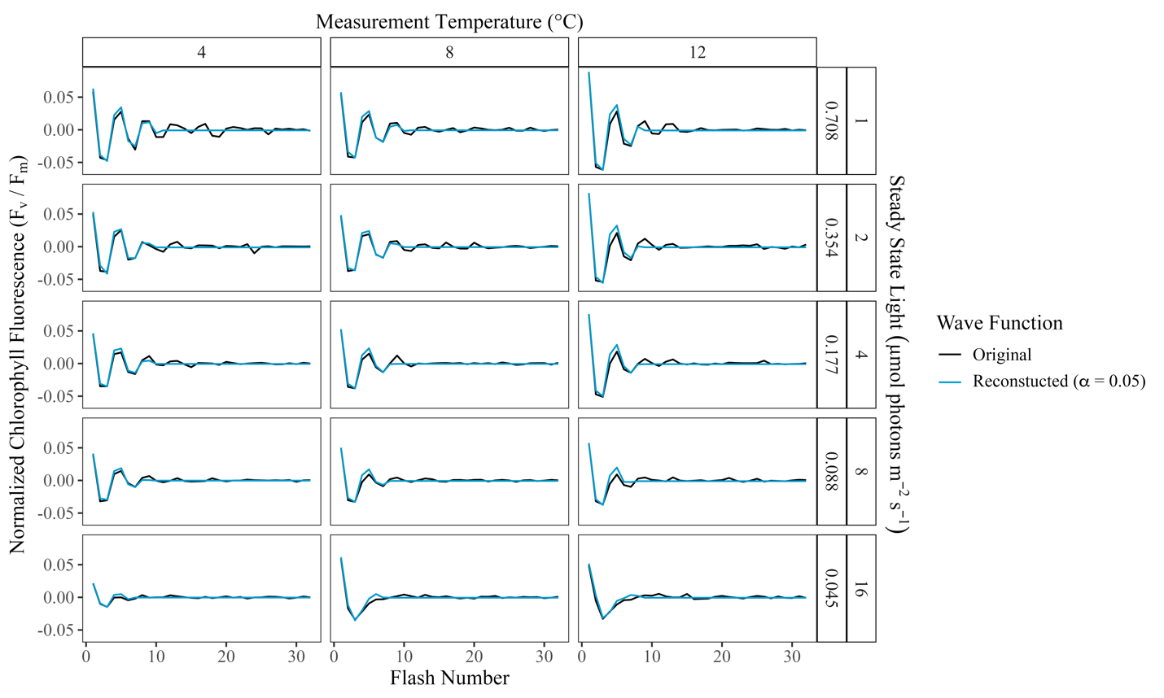
Figure 5: Sample plot illustrating the wavelet reconstructions at ⍺ = 0.05 of Chlamydomonas priscuii fluorescence over 32 consecutive single turnover flashes across a range of measurement temperatures and steady-state light levels, with their equivalent flash spacings.

Local Polynomial Regression
The observed patterns in S-state cycling across conditions within taxa were then modelled using the non-parametric Loess method of local polynomial regression. Loess fits a smooth curve by generating local regression models at each data point, estimating the response variable by calculating a weighted average of nearby data points based on their distance from the point of interest [24]. These local regression models are then combined to produce a smooth curve representing the overall relationship between the damping index and the predictors of temperature and light level. Based on the fitted model, the damping index can then be predicted for other combinations of temperature and light [25]. These predictions were then visually represented with a contour plot.
Two separate loess models were fit to the data, the first examining the response of S-state damping to light level and measurement temperature and the other to light level and the deviation from growth temperature.

References
1. Otte A, Winder JC, Deng L, Schmutz J, Jenkins J, Grigoriev IV, et al. The diatom Fragilariopsis cylindrus: A model alga to understand cold-adapted life. Journal of Phycology. 2023;59: 301–306. doi:10.1111/jpy.13325
2. Cefarelli AO, Ferrario ME, Almandoz GO, Atencio AG, Akselman R, Vernet M. Diversity of the diatom genus Fragilariopsis in the Argentine Sea and Antarctic waters: morphology, distribution and abundance. Polar Biology. 2010;33. doi:10.1007/s00300-010-0794-z
3. Kang S-H, Fryxell GA. Fragilariopsis cylindrus (Grunow) Krieger: The most abundant diatom in water column assemblages of Antarctic marginal ice-edge zones. Polar Biol. 1992;12: 609–627. doi:10.1007/BF00236984
4. Poulsen N, Kröger N. Thalassiosira pseudonana (Cyclotella nana) (Hustedt) Hasle et Heimdal (Bacillariophyceae): A genetically tractable model organism for studying diatom biology, including biological silica formation. Journal of Phycology. 2023;59: 809–817. doi:10.1111/jpy.13362
5. Cook G, Teufel A, Kalra I, Li W, Wang X, Priscu J, et al. The Antarctic psychrophiles Chlamydomonas spp. UWO241 and ICE-MDV exhibit differential restructuring of photosystem I in response to iron. Photosynth Res. 2019;141: 209–228. doi:10.1007/s11120-019-00621-0
6. Stahl-Rommel S, Kalra I, D’Silva S, Hahn MM, Popson D, Cvetkovska M, et al. Cyclic electron flow (CEF) and ascorbate pathway activity provide constitutive photoprotection for the photopsychrophile, Chlamydomonas sp. UWO 241 (renamed Chlamydomonas priscuii). Photosynth Res. 2022;151: 235–250. doi:10.1007/s11120-021-00877-5
7. Li W, Podar M, Morgan-Kiss RM. Ultrastructural and Single-Cell-Level Characterization Reveals Metabolic Versatility in a Microbial Eukaryote Community from an Ice-Covered Antarctic Lake. Applied and Environmental Microbiology. 2016;82: 3659–3670. doi:10.1128/AEM.00478-16
8. Cvetkovska M, Vakulenko G, Smith DR, Zhang X, Hüner NPA. Temperature stress in psychrophilic green microalgae: Minireview. Physiologia Plantarum. 2022;174: e13811. doi:10.1111/ppl.13811
9. Hüner NPA, Szyszka-Mroz B, Ivanov AG, Kata V, Lye H, Smith DR. Photosynthetic adaptation and multicellularity in the Antarctic psychrophile, Chlamydomonas priscuii. Algal Research. 2023;74: 103220. doi:10.1016/j.algal.2023.103220
10. Balzano S, Gourvil P, Siano R, Chanoine M, Marie D, Lessard S, et al. Diversity of cultured photosynthetic flagellates in the northeast Pacific and Arctic Oceans in summer. Biogeosciences. 2012;9: 4553–4571. doi:10.5194/bg-9-4553-2012
11. Morales-Sánchez D, Schulze PSC, Kiron V, Wijffels RH. Temperature-Dependent Lipid Accumulation in the Polar Marine Microalga Chlamydomonas malina RCC2488. Frontiers in Plant Science. 2020;11. doi:10.3389/fpls.2020.619064
12. Sasso S, Stibor H, Mittag M, Grossman AR. From molecular manipulation of domesticated Chlamydomonas reinhardtii to survival in nature. King SR, Rodgers PA, editors. eLife. 2018;7: e39233. doi:10.7554/eLife.39233
13. Xie B, Bishop S, Stessman D, Wright D, Spalding MH, Halverson LJ. Chlamydomonas reinhardtii thermal tolerance enhancement mediated by a mutualistic interaction with vitamin B12-producing bacteria. The ISME Journal. 2013;7: 1544–1555. doi:10.1038/ismej.2013.43
14. Wiel JBV, D. Mikulicz J, R. Boysen M, Hashemi N, Kalgren P, M. Nauman L, et al. Characterization of Chlorella vulgaris and Chlorella protothecoides using multi-pixel photon counters in a 3D focusing optofluidic system. RSC Advances. 2017;7: 4402–4408. doi:10.1039/C6RA25837A
15. Leyva LA, Bashan Y, Mendoza A, de-Bashan LE. Accumulation fatty acids of in Chlorella vulgaris under heterotrophic conditions in relation to activity of acetyl-CoA carboxylase, temperature, and co-immobilization with Azospirillum brasilense. Naturwissenschaften. 2014;101: 819–830. doi:10.1007/s00114-014-1223-x
16. Schuback N, Tortell PD, Berman-Frank I, Campbell DA, Ciotti A, Courtecuisse E, et al. Single-Turnover Variable Chlorophyll Fluorescence as a Tool for Assessing Phytoplankton Photosynthesis and Primary Productivity: Opportunities, Caveats and Recommendations. Frontiers in Marine Science. 2021;8. doi:10.3389/fmars.2021.690607
17. Berman-Frank I, Campbell D, Ciotti A, Erickson Z, Fujiki T, Halsey K, et al. Application of Single Turnover Active Chlorophyll Fluorescence for Phytoplankton Productivity Measurements. Version 2.0. Scientific Committee on Oceanic Research (SCOR) Working Group 156; 2023 Jun. doi:10.25607/OBP-1084
18. Dau H, Haumann M. Time-resolved X-ray spectroscopy leads to an extension of the classical S-state cycle model of photosynthetic oxygen evolution. Photosynth Res. 2007;92: 327–343. doi:10.1007/s11120-007-9141-9
19. de Wijn R, van Gorkom HJ. S-state dependence of the miss probability in Photosystem II. Photosynthesis Research. 2002;72: 217–222. doi:10.1023/A:1016128632704
20. Xu K, Jiang H, Juneau P, Qiu B. Comparative studies on the photosynthetic responses of three freshwater phytoplankton species to temperature and light regimes. J Appl Phycol. 2012;24: 1113–1122. doi:10.1007/s10811-011-9741-9
21. Cazelles B, Chavez M, Berteaux D, Ménard F, Vik JO, Jenouvrier S, et al. Wavelet analysis of ecological time series. Oecologia. 2008;156: 287–304. doi:10.1007/s00442-008-0993-2
22. Theis FJ, Meyer-Bäse A. Spectral Transformations. 1st ed. Biomedical Signal Analysis : Contemporary Methods and Applications. 1st ed. MIT Press; 2010. p. 42.
23. Roesch A, Schmidbauer H. WaveletComp: Computational wavelet analysis. 2018. Available: https://CRAN.R-project.org/package=WaveletComp
24. Loader C. Local regression and likelihood. New York: Springer; 1999.
25. Breiman L, Friedman JH. Predicting Multivariate Responses in Multiple Linear Regression. Journal of the Royal Statistical Society: Series B (Methodological). 1997;59: 3–54. doi:10.1111/1467-9868.00054

