Functional Analyses of Distinct Oxygen Concentrations and Light Niches of *Prochlorococcus marinus*

**Mireille Savoie**, Julie Nadeau, Laurel Genge, Sylwia Śliwińska-Wilczewska, Maximilian Berthold, Naaman Omar, and Douglas A. Campbell

2024-01-30

Table of Contents

1 Department of Biology, Mount Allison University, 53 York St., Sackville NB, Canada, E4L 1C9.

# Abstract

# Introduction

# Materials and methods

## Culturing

%%%%%% Taken from my thesis word for word, need to reword and shorten %%%%

Three xenic *P. marinus* cultures, obtained from Bigelow Labs, NCMA Maine, US: MED4 (CCMP1986) from a High Light-adapted (HLI) clade, SS120 (CCMP1375) from a Low Light-adapted (LLIII) clade and MIT9313 (CCMP2773) also from a Low Light-adapted (LLIV) clade. These cultures were then maintained in two separate incubators. The temperature for both incubators was set to 22°C and a light/dark cycle of 12 h. The PAR level of the incubator was chosen to reflect the light level of the natural niche of the ecotype during culturation. The PAR level of the incubator containing the HLI clade, MED4, was set at 160 µmol photons m-2 s-1, whereas the incubator containing the LLIII and LLIV clades, SS120 and MIT9313 respectively, was set at 30 µmol photons m-2 s-1. To ensure cultures remained in exponential growth phase, all strains were transferred weekly in Pro99 media prepared according to [1] in autoclaved artificial seawater. Artificial seawater was prepared according to the National Center for Marine Algae and Microbiota (NCMA) protocol by combining salt solution I and salt solution II using the enriched artificial seawater (ESAW) recipe.

## Experimental design

%%%%%% Taken from my thesis word for word, need to reword and shorten %%%%

For each of three ecotypes, we imposed [O2] (three levels: 2.5 µM, 25µM, 250 µM), photoperiod (four levels: 4 h, 8 h, 12 h, 16 h), spectral waveband (four bands: full spectrum white LED, 660 nm, 530 nm, 450 nm), and light level (three levels: 30, 90, 180 µmol photons m-2 s-1) treatments in a factorial design. Each factor is explained below. The full crossing of all factors would yield 3 x 4 x 4 x 3 = 144 treatments per ecotype (432 total), but due to time constraints and total absence of growth of some ecotypes under some conditions, not all treatments were carried out. In total, we completed 291 treatments.

All growth experiments were conducted at 22°C.

## Experimental light conditions

%%%%%% Taken from my thesis word for word, need to reword and shorten %%%%

Three growth Photosynthetically Active Radiation (PAR) levels (180, 90, and 30 µmol photons m-2 s-1) and four spectral wavebands (white LED full spectrum, 660 nm, 530 nm, and 450 nm) were chosen to simulate light levels and spectral color spanning the vertical ocean water column, from near-surface to the lower euphotic zone depths. For simplicity, actinic light used for growth under specific wavebands will be referred by the respective spectral color; white LED for LED full spectrum, red for 660 nm, green for 530 nm and blue for 450 nm. Four different photoperiods were chosen to simulate various diel cycles characteristic of current and hypothetical future niches of *P. marinus*. A photoperiod of 16 h was chosen to represent temperate (45°N) summer at the ocean surface, 12 h for equatorial (0°N) ocean surface or temperate (45°N) spring and fall ocean surface or temperate (45°N) summer at deep ocean depths, 8 h for temperate (45°N) winter at the surface or at temperate (45°N) spring and fall at depth and equatorial (0°N) deep ocean depths and 4 h for temperate (45°N) winter or deep ocean depths during temperate (45°N) spring and fall.

## Experimental oxygen conditions

%%%%%% Taken from my thesis word for word, need to reword and shorten %%%%

Three target dissolved oxygen concentrations [O2] were delivered to tubes of the Multicultivator by mixing varying ratios of air and Nitrogen (N2) gases while delivering 0.05% of Carbon Dioxide (CO2) gas through a 0.2 μm sterile microfilter via a G400 gas mixing system. To confirm and monitor the [O2], 4 FireSting optodes (PyroScience, Germany) were inserted into select tubes of each modified [O2] run for real-time measurements. A compensation temperature probe was placed in the aquarium of the bioreactor to correct [O2] for temperature fluctuations. In addition, the software corrected [O2] based on the salinity of the media (32 ppt). For the low O2 environment experiments, 0.5 to 1.0 µM of O2 was delivered to each Multicultivator tube by sparging with a gas mixture containing 99.95% N2 and 0.05% CO2 to purge dissolved O2 out of the culture. The intermediate O2 environment experiments were sparged to deliver 10 to 25 µM of O2 using a gas mixture containing 98.95% N2, 0.05% CO2 and 1% O2. The high O2 environment experiments were sparged with lab air (78% N2, 21% O2, 1% Ar and 0.05% CO2) to deliver 230 µM of O2. While the flow rate of the gas mixture was controlled, variations in bubbling speed affected the [O2] delivered to each tube; therefore, a range of [O2] was defined for each experimental O2 level; 0.5 µM - 5 µM for low, 5 µM - 50 µM for intermediate and 200 µM - 280 µM for high O2 experiments. To simplify the representation of experimental [O2] conditions in graphs and discussions, the approximate median [O2] of each experimental range: 2.5 µM, 25 µM, and 250 µM, will be used for low, intermediate, and high conditions, respectively.

## Bioreactors

%%%%%% Taken from my thesis word for word, need to reword and shorten %%%%

Growth experiments under different spectral wavebands were performed using a PSI MCMIX-OD Multicultivator (Figure 1) or a PSI MC1000-OD Multicultivator for white LED experiments. Each Multicultivator has the capacity to individually control 8 tubes with specific PAR levels and photoperiods and the MCMIX-OD has options for individually controlled spectral wavebands. 10 mL of exponential growth culture was added to 70 mL of Pro99 media and all 8 tubes were situated in a common temperature-controlled water bath to ensure the temperature remained constant at 22°C over the duration of the experiment. Real time absorbance measurements of Optical Density (OD) 680 nm (a proxy for cell suspension density, cell scatter and cell chlorophyll content) and OD 720 nm (a proxy for cell suspension density and cell scatter) were recorded every 5 minutes for at least 8 to 14 days depending on the duration of the lag phase, if any. Real time OD measurements eliminate intrusive subsampling of sterile cultures and provide high resolution chlorophyll and cell scatter proxies over the duration of the experiment. All data from the Multicultivator were saved as a comma separated values file and processed in R-Studio for calculations of growth rate estimates and graphical plotting.

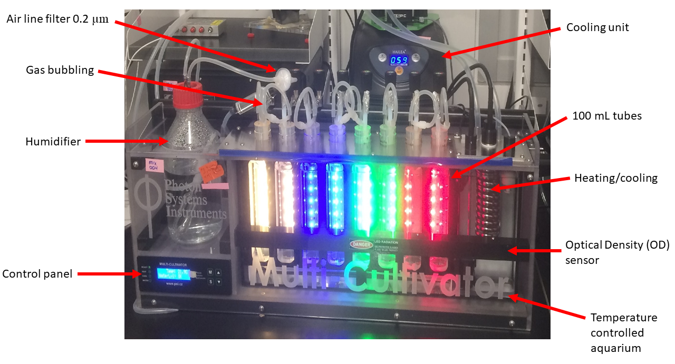

Figure 1: **PSI MCMIX-OD Multicultivator.** Spectral wavebands and light levels are individually controlled for each culture tube. Real time Optical Density (OD) measurements eliminate intrusive subsampling of sterile cultures. The temperature of culture tubes are controlled via heating or cooling of the aquarium water. Gas with specific oxygen concentrations are bubbled through a humidifier and passed through a 0.2 um filter.

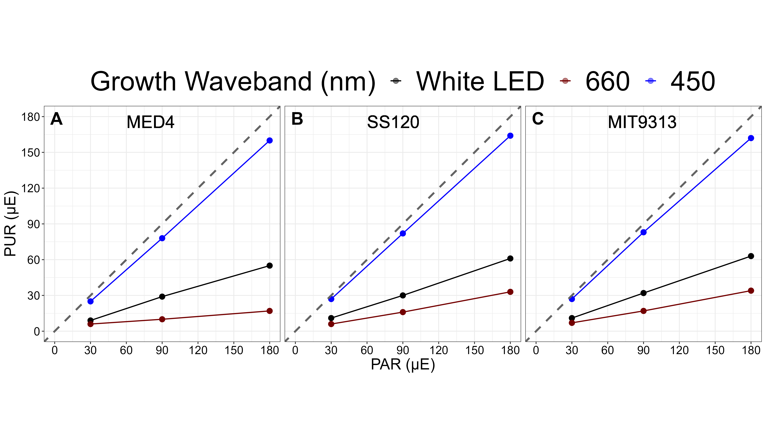

Figure 2: **The absorbed Photosynthetically Usable Radiation (PUR) (µmol photons m-2 s-1) vs. the Photosynthetically Active Radiation (PAR) (µmol photons m-2 s-1).** The correlation between PAR, plotted on the x-axis and absorbed PUR, plotted on the y-axis, are colored for each spectral waveband; blue for 450 nm, red for 660 nm and black for white LED full spectrum light. The grey dashed line represents a hypothetical one to one correlation. **A.** is *Prochlorococcus marinus* MED4. **B.** is *Prochlorococcus marinus* SS120. **C.** is *Prochlorococcus marinus* MIT9313.

## Data management and analysis

%%%%%% Taken from my thesis word for word, need to reword and shorten %%%%

Data from the Multicultivators were imported into R-Studio for data management, growth rate calculations, statistics, and generation of figures with the ggplot2 package [2]. The chlorophyll proxy optical density (OD680 - OD720) or ΔOD was used to determine the growth rate for each condition. We used a rolling mean from the RStudio zoo package [3] to calculate the average ΔOD data over a 1-hour window. This was done to prevent extraneous data points from affecting the growth rate estimates. A Levenberg-Marquardt algorithm [4] modification of the non-linear least squares fit equation using the R package minpack.lm [5] was used to calculate growth rate (µ) using the logistic equation (1):

where ΔODmax is maximum ΔOD, ΔODmin is minimum ΔOD, t is time duration over the growth trajectory.

## Generalized additive model

%%%%%% Taken from my thesis word for word, need to reword and shorten %%%%

A Generalized Additive Model (GAM) was applied to examine the relationship between the chlorophyll proxy (ΔOD) growth rate across the blue spectral waveband, photoperiod and PAR levels for each *P.marinus* ecotype in this study. The gam function from the R package mgcv [6] was used to model the growth rate with smoothing terms to indicate the 90, 50 and 10% quantiles. Only data below a standard error tolerance of 30% of the fit was used in the model. Because of time limitations, we were unable to conduct sufficient growth response experiments for all the other spectral wavebands, except for the blue, to fulfill the input requirements for the GAM. Therefore, our priority was on studying the effect of blue light on growth trends, considering that blue light is the most ecologically relevant spectral waveband for deep ocean niches.

# Results

%%%% Insert OceanDepthO2ProteinPhotosynth figure from OceanPortal repository %%%

%%%% Insert GAM figures %%%

%%%% Insert PURFits figures %%%

%%% TO DO Fits and ANOVA %% 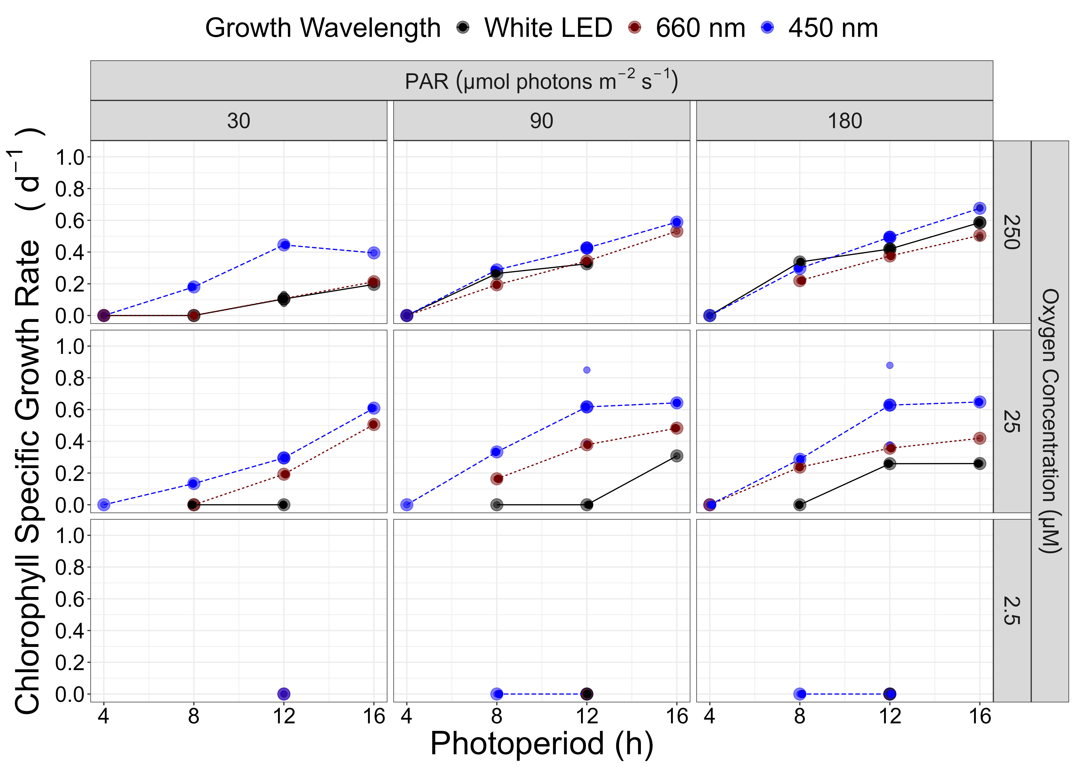

%%% TO DO Fits and ANOVA %% 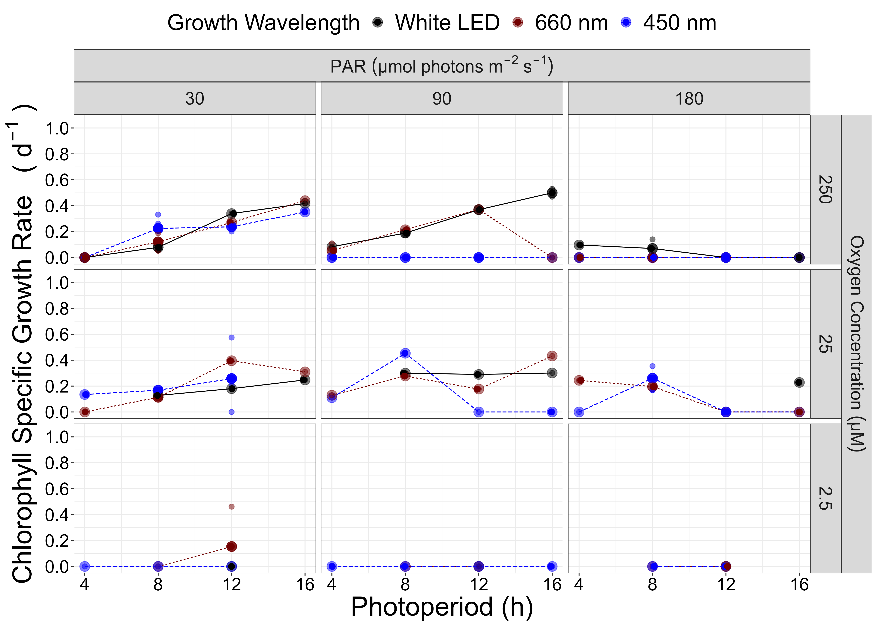

%%% TO DO Fits and ANOVA %% 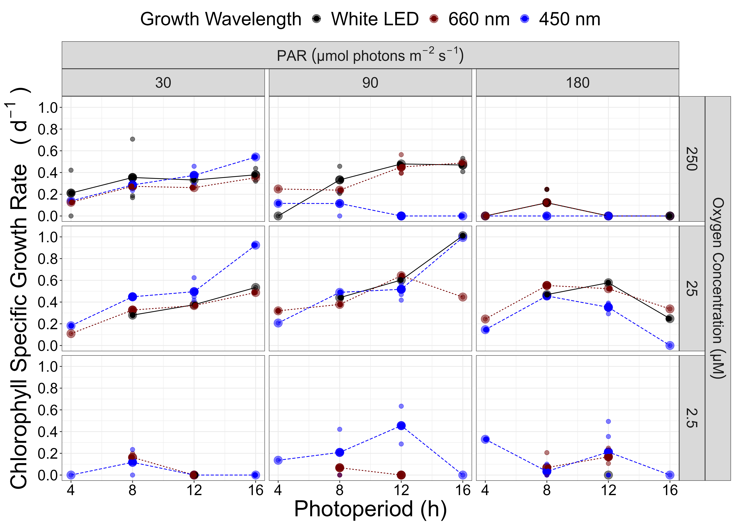

%%%% Insert OceanFtsHRibosomeProteins figure from OceanPortal repository %%%

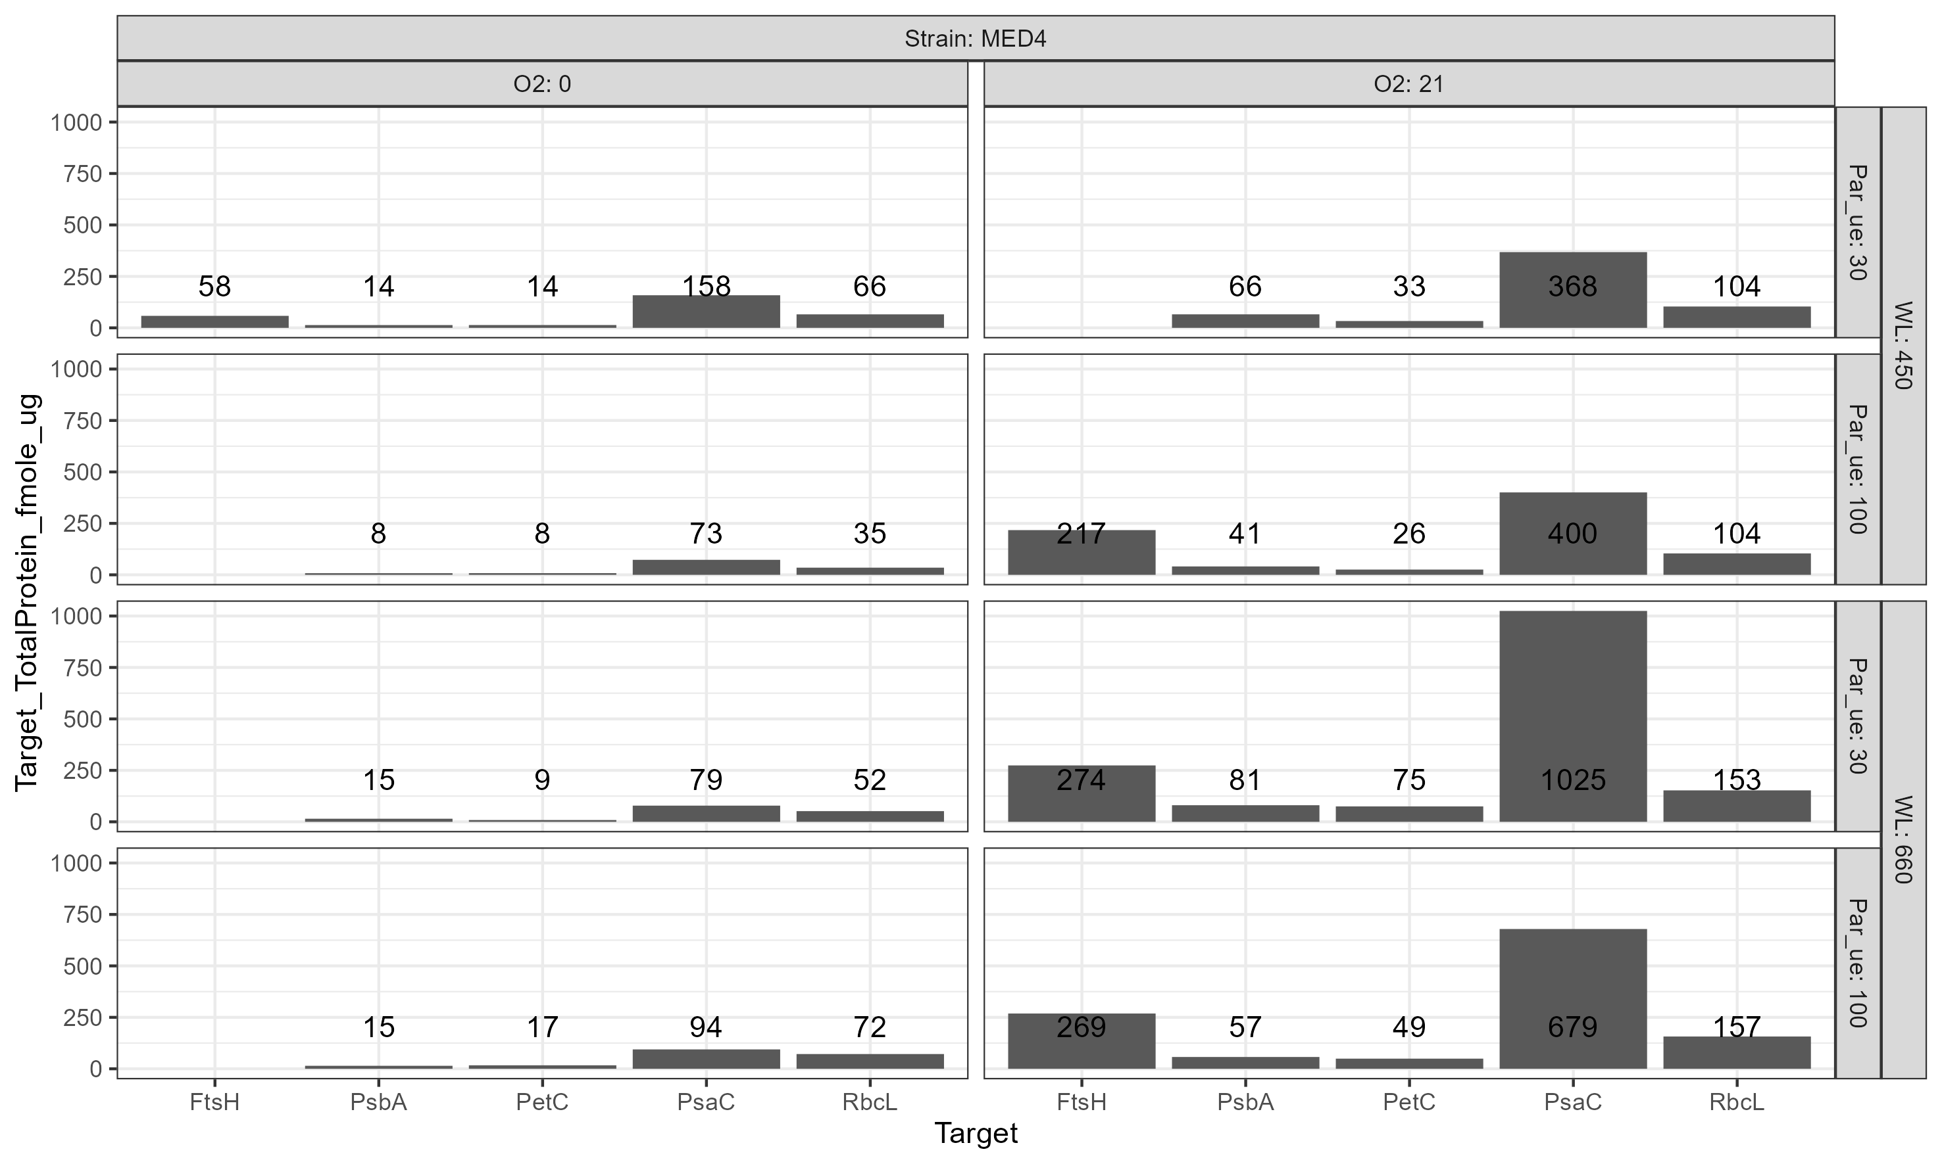

Figure 6: **fmole target protein per ug total protein for *Prochlorococcus marinus* MED4 (High Light (HLI) near surface clade).**  Growth Photosynthetically Active Radiation (PAR) (µmol photons m-2 s-1) and spectral wavelength are in rows; 2 levels of imposed growth dissolved O2 concentrations (µM) are in columns. Numbers over each bar are fmole/ug

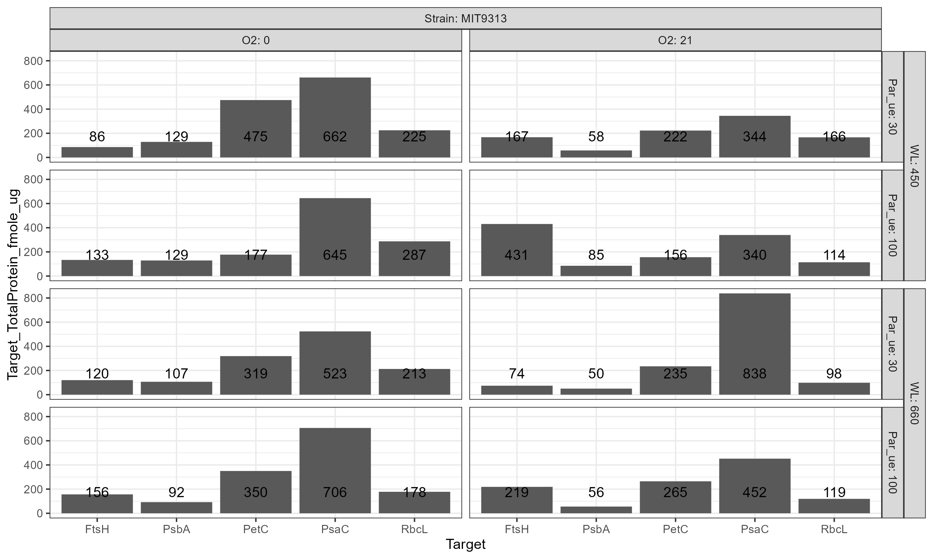

Figure 7: **fmole target protein per ug total protein for *Prochlorococcus marinus* MIT9313 (Low Light (LLIV) deep ocean clade).**  Growth Photosynthetically Active Radiation (PAR) (µmol photons m-2 s-1) and spectral wavelength are in rows; 2 levels of imposed growth dissolved O2 concentrations (µM) are in columns. Numbers over each bar are fmole/ug

# Supplemental

# References

1. Moore LR, Coe A, Zinser ER, Saito MA, Sullivan MB, Lindell D, et al. Culturing the marine cyanobacterium Prochlorococcus: Prochlorococcus culturing. Limnology and Oceanography: Methods. 2007;5: 353–362. doi:[10.4319/lom.2007.5.353](https://doi.org/10.4319/lom.2007.5.353)

2. Wickham H. Tidyverse: Easily install and load the tidyverse. 2023. Available: <https://CRAN.R-project.org/package=tidyverse>

3. Zeileis A, Grothendieck G, Ryan JA. Zoo: S3 infrastructure for regular and irregular time series (z’s ordered observations). 2021. Available: <https://zoo.R-Forge.R-project.org/>

4. Bellavia S, Gratton S, Riccietti E. A LevenbergMarquardt method for large nonlinear least-squares problems with dynamic accuracy in functions and gradients. Numerische Mathematik. 2018;140: 791–825. doi:[10.1007/s00211-018-0977-z](https://doi.org/10.1007/s00211-018-0977-z)

5. Elzhov TV, Mullen KM, Spiess A-N, Bolker B. Minpack.lm: R interface to the levenberg-marquardt nonlinear least-squares algorithm found in MINPACK, plus support for bounds. 2016. Available: <https://CRAN.R-project.org/package=minpack.lm>

6. Wood S. Mgcv: Mixed GAM computation vehicle with automatic smoothness estimation. 2022. Available: <https://CRAN.R-project.org/package=mgcv>