A 200-Day Trend Filter for 3× Leveraged U.S. Equity ETFs
Reviewer-Response Revision: Financing, Exposure-Matched Controls, Risk Inference, and Reproducibility
Independent quantitative research | Methodological revision v2
12 November 2026

Abstract
This revision reassesses a fixed, long-only rule in which the close of SPY (or QQQ) relative to its 200-session simple moving average (SMA) controls staged next-open investments in the daily-reset 3× product SPXL (or TQQQ). The original observational backtest recorded higher drawdown-adjusted absolute losses avoided than unfiltered leveraged buy-and-hold but weaker return and Sharpe performance in the common real-ETF period, 11 February 2010–12 November 2026. We accept the referee’s central identification objection: reduced drawdown by itself does not demonstrate timing skill because cash exposure is variable. Accordingly, the v2 engine adds unleveraged ETF buy-and-hold, an average-capital-weighted leveraged/cash benchmark, and a lagged-realized-volatility allocator; reconstructs pre-inception leveraged returns with bank-bill funding and consistent adjusted source prices; measures average portfolio weight rather than counting every positive-weight day as a full exposure; and generates regime, rolling-start and trade-ledger diagnostics.
Evidence boundary. The present accompanying historical performance figures are the uncorrected v1 audit, not results from the corrected financing and dividend model. Its licensed four-instrument daily source archives cannot be fetched inside the current authoring environment. The corrected model and unit tests are provided, but new v2 benchmark CAGRs, risk-adjusted comparisons, regime tables, and rolling-start distributions are not asserted as validated empirical findings until a complete source refresh and reproduction run succeeds. A separate, executable paired circular-block bootstrap operates on the available 201 archived month-end observations and is labeled explicitly as a coarse-frequency sensitivity audit, not a journal-grade daily-risk inference.

1. Prior art, research design, and falsifiable hypotheses
The 200-day leverage-switching idea is not novel. Gayed and Bilello (2016), Leverage for the Long Run, explicitly connect long-term trend, realized volatility, and the decision to employ leverage or move to Treasury bills. Faber (2007) studies moving-average tactical asset allocation. Avellaneda and Zhang (2010) establish the path dependence of leveraged ETF returns, and Moreira and Muir (2017) provide a competing volatility-management mechanism. The contribution here is therefore best characterized as an implementation-level replication and adversarial benchmark of an existing hypothesis, not the discovery of SMA-based leverage rotation.
We prestate three distinct hypotheses, none presumed established: (H1) next-open SMA exit reduces severe realized drawdowns relative to 3× buy-and-hold; (H2) it improves a relevant risk-adjusted metric versus equal average leveraged exposure and versus a volatility-managed alternative; (H3) findings transport across an S&P 500-linked and a Nasdaq-100-linked product without asset-specific threshold fitting. H1 is descriptive until inference is performed. H2 is the critical test of market-timing value. SPY and QQQ are correlated U.S. equity exposures; agreement between them is limited transport evidence, not a broad multi-asset replication.

2. The unchanged trading rule
For signal ETF closing adjusted price $P_{t}$, define
$$M_{t}=\frac{1}{200}\sum_{j=0}^{199}{P_{t−j}}.$$
After close $t$, a new entry or one additional staged purchase is scheduled if $P_{t}≥1.04M_{t}$, until targeted weights 20%, 40%, 60%, 80%, and 100% are reached. The target is based on total portfolio equity at execution; no automatic sales rebalance an appreciating partial position. Existing shares are retained if $0.97M_{t}≤P_{t}<1.04M_{t}$. If invested and $P_{t}<0.97M_{t}$, every leveraged-ETF share is sold. All scheduled orders fill at open $t+1$. A uniform assumed $0.10\%$ one-way friction applies per executed notional; taxes and market-impact tails are outside scope. Full stock/ETF purchases permit fractional units.
The 3% filter is a price-vs-average threshold, not a fixed 3% stop on ETF equity. A stretched trend can be far above its own SMA; therefore the rule can still suffer large and rapid leveraged drawdowns before exiting.

3. Correcting cash, financing, and distributions

3.1 Historical T-bill proxy and safe information timing
The revision uses monthly last available daily quotations from the Federal Reserve’s DTB3 3-month Treasury bill bank-discount series. Only the previous calendar month’s last available quote is used during month $m$: the current month’s final observation is never used prospectively inside that month. As DTB3 quotes on a bank-discount, 360-day convention, a 91-day investment-equivalent annual rate is approximated by
$${\tilde{r}}_{f,t}=\frac{\left(365/360\right)d_{m−1}}{1−\left(91/360\right)d_{m−1}},$$
where $d_{m−1}$ is the prior-month-end quoted annual discount yield in decimal form. This is a stylized bill reinvestment proxy, not an exact tradeable return series; actual cash accounts may receive less and may have account-specific restrictions. Idle portfolio cash compounds at approximately $1+{\tilde{r}}_{f,t}/252$ per trading day. The machine-readable derivative contains 335 monthly observations spanning December 1998–October 2026; October’s latest sourced quote was 26 October. The isolated negative September 2015 quote (−0.01% annual bank discount) is explicitly preserved in the rate decoder rather than silently rounded to zero.

3.2 Pre-inception leveraged return, using consistent total-return underlying
Let $r_{t}^{TR}$ be the unleveraged ETF daily adjusted total-return proxy. The pre-inception synthetic 3× closing series follows
$$L_{t}=L_{t−1}\left(1+3r_{t}^{TR}−2\frac{{\tilde{r}}_{f,t}+s}{252}−\frac{f}{252}\right),$$
where $s≥0$ is an explicit additional annual financing spread per borrowed unit and $f=0.0095$ is an illustrative annual operating fee. Two funded units are charged at the short-rate proxy, unlike the prior v1 code, which omitted the borrowing term. The financing and fee are not charged a second time for actual SPXL/TQQQ prices, which already reflect the funds’ realized economics. Synthetic openings model 3× the overnight underlying move and an illustrative half-day carry; they remain not executable historical quotes. Exact swap costs, futures basis, ETF tracking and historical distribution implementation are not observed and hence cannot be recovered from a price file alone.
SPY and SPXL source files have Adj Close; the adjusted Open is reconstructed as Open × Adj Close / Close on each date. The already-auto-adjusted QQQ/TQQQ inputs remain adjusted. The recent tail must use matching adjustment conventions. Source stitching fails rather than rescales if the archive and the independent overlap close differ by more than one basis point. The IBKR-only snapshot is retained solely as a dated, partly price-return, legacy comparison; any new corrected total-return analysis uses vendor-consistent input or stops with an error.

3.3 Economic intuition and its limitations
For ideal continuous-time constant daily-reset leverage $ℓ$, arithmetic underlying drift $μ$, variance $σ^{2}$, and a funding rate $r_{f}$, the approximate leveraged log growth is
$$g_{ℓ}≃ℓμ−\frac{ℓ^{2}σ^{2}}{2}−\left(ℓ−1\right)r_{f}−f.$$
At $ℓ=3$, the variance penalty is $4.5σ^{2}$, approximately 55.1% annually for $σ=35\%$, versus 6.48% for $σ=12\%$, holding all else fixed. This illustrates why high-volatility regimes can damage compounded leveraged growth. It is not evidence that an SMA filter actually predicts future volatility or return. The v2 regime_nextday.csv generator therefore sorts observations by the close-of-day signal regime, then computes the following session’s underlying mean return, volatility, and illustrative leveraged growth, avoiding same-bar contemporaneous circular reasoning.

4. Independent controls that determine timing value
The experiment explicitly compares five investment rules on common timestamps and identical data:
Method | Target weight in 3× ETF | Cash treatment | Timing information
SMA200 / +4% / −3% | Original five-stage state machine | Prior-month T-bill yield | Close $t$, open $t+1$
Leveraged ETF buy/hold | 100% after first open | None except residual | None
Unleveraged SPY or QQQ buy/hold | 100% in 1× ETF | None except residual | None
Exposure-matched | Constant leveraged allocation equal to realized mean SMA weight, remainder cash; rebalance every 21 trading sessions | Prior-month T-bill yield | Retrospective diagnostic only
Volatility-managed | Weight $min\left(1,0.30/{\hat{σ}}_{63,t}\right)$, 63-day lagged-realized ETF volatility; rebalance every 5 sessions | Prior-month T-bill yield | Trailing through close $t$
The average weight is w=T−1t​wt where $w_{t}={shares}_{t} {price}_{t}/{NAV}_{t}$; a 20%-weight day is therefore only one-fifth of a full-risk day, not 100% exposed. The exposure-matched control calibrates to a full-sample realized mean SMA weight and thus is ex-post only, not a prospective investment rule; it isolates how much lower average exposure explains. The 30% volatility target is a fixed, plainly stated diagnostic choice, not fit on these two funds. Any claim of superior SMA timing demands a relevant advantage versus these alternatives with appropriately calibrated risk and statistical uncertainty, not just superiority to 100%-exposed leveraged ETF drawdown.

5. Results audit and Calmar correction
The following v1 figures are preserved to show what was criticized. They are not asserted as corrected total-return, financing-inclusive v2 results. The common actual-ETF dates were 11 February 2010–12 November 2026, with 10 bp execution cost and zero yield on uninvested cash.
Original 2010–2026 audit | SMA CAGR | 3× hold CAGR | SMA max DD | Hold max DD | SMA Calmar | Hold Calmar
SPXL | 21.14% | 28.94% | −52.88% | −76.86% | 0.400 | 0.377
TQQQ | 26.93% | 40.91% | −62.09% | −81.66% | 0.434 | 0.501
The TQQQ SMA rule underperformed unfiltered leveraged buy/hold on CAGR, Sharpe, and Calmar, and only offered a smaller absolute observed maximum drawdown. Even SPXL’s Calmar advantage is narrow. Thus the original draft’s blanket risk-management framing was too strong. Since lower exposure plausibly accounts for some downside improvement, the independent value of the SMA filter remains unproven until the v2 control runs finish.
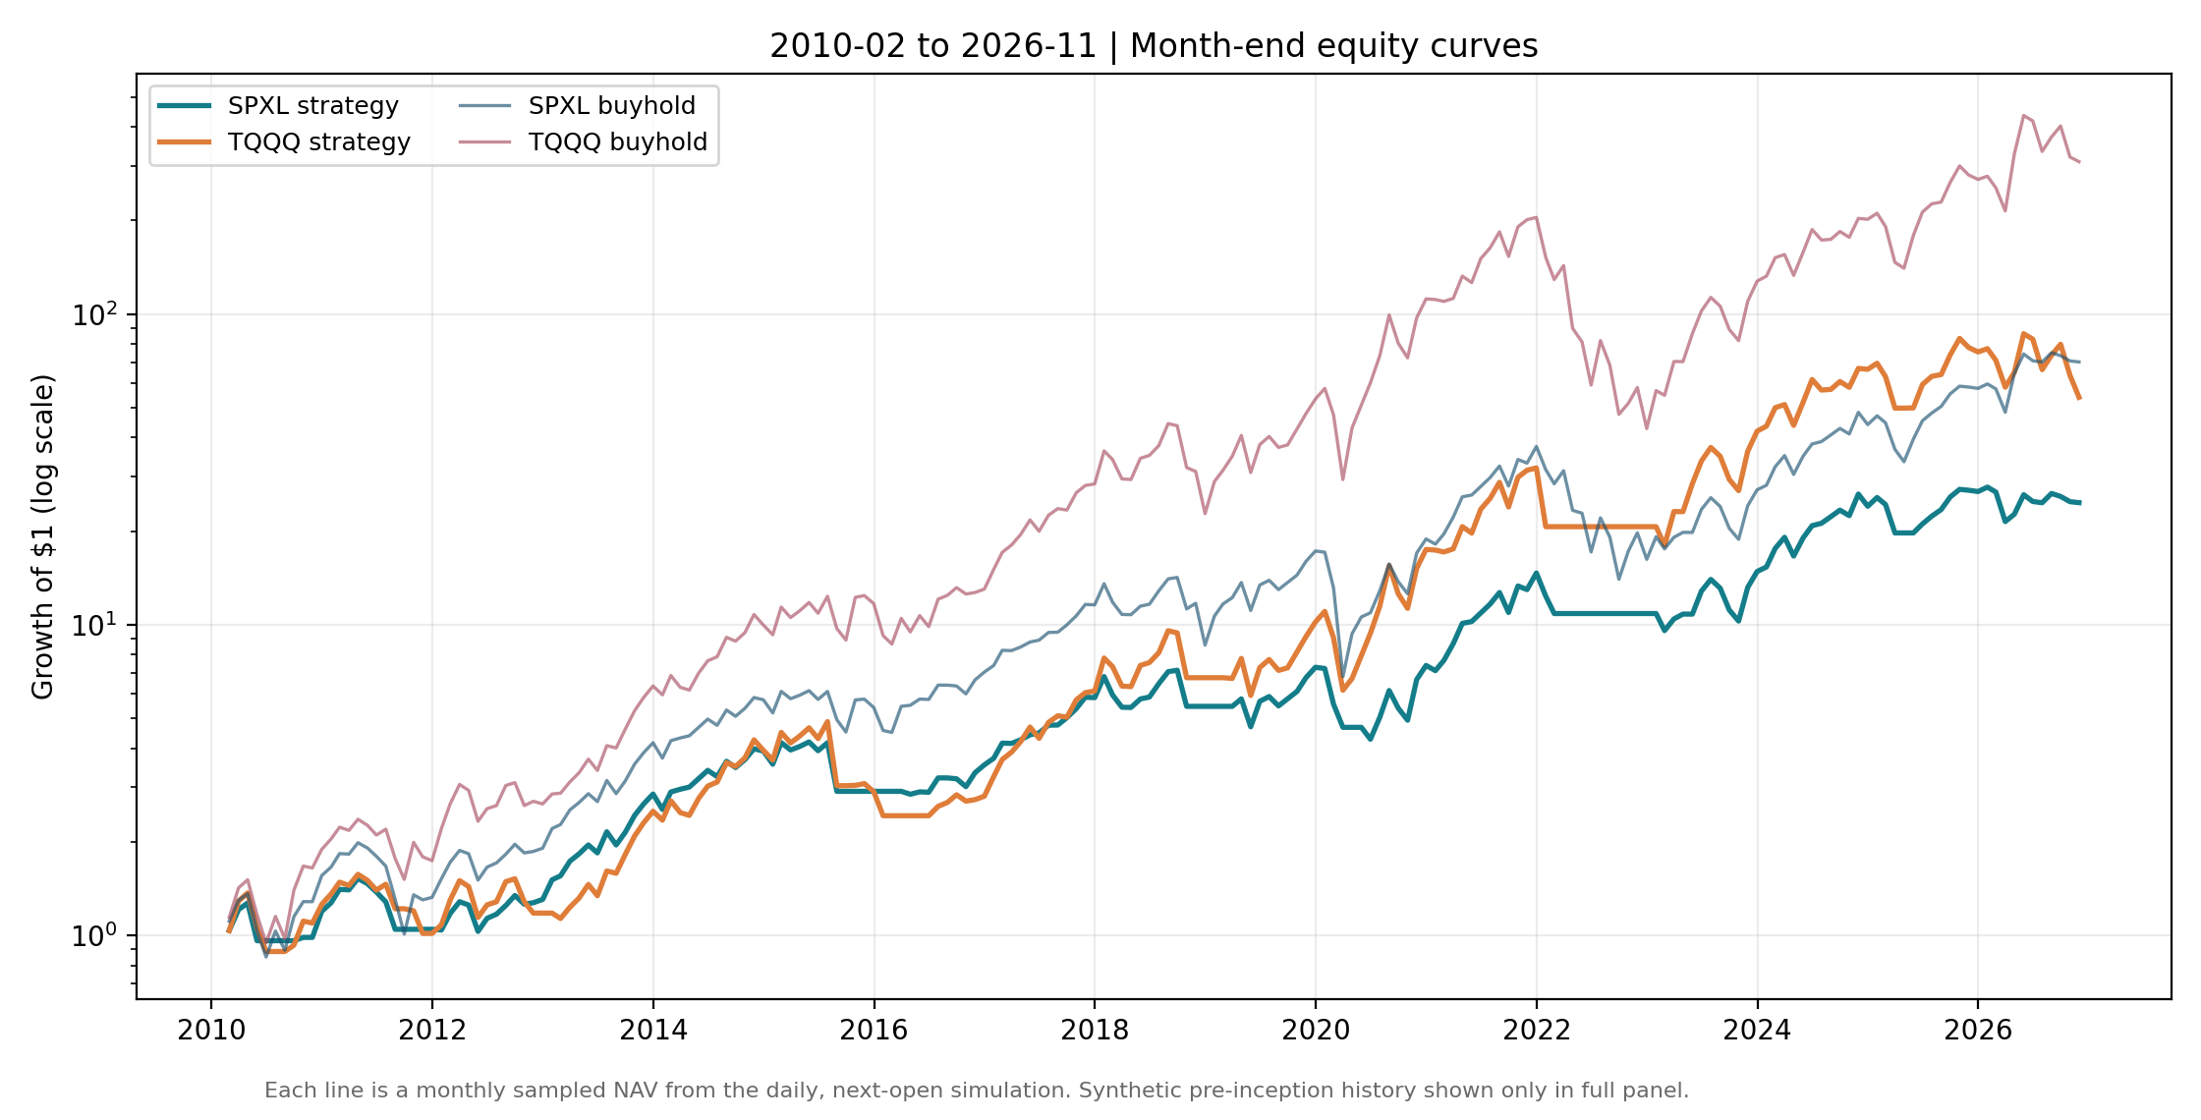
Figure 1. Legacy real-ETF 2010–2026 audited equity curves, before funding, dividend and benchmark revisions. Do not read as v2 performance.

6. Paired risk uncertainty: newly computed, frequency-limited evidence
A paired fixed-length circular block bootstrap reuses the archived 201 monthly close-to-close observations of both strategies and their leveraged buy/hold controls (5,000 draws, 12-month blocks, seed 20261112). Each bootstrap draw uses the same sampled month indices for the strategy and its control, preserving contemporaneous co-movement. These are percentile intervals from an explicitly retrospective sample; the method is not the Politis–Romano stationary bootstrap, does not use Ledoit–Wolf’s complete studentized Sharpe procedure, and does not correct for earlier parameter search.
Asset | Risk difference (strategy minus 3× hold) | Observed | Paired 95% percentile interval
SPXL | Monthly-return Sharpe (rf = 0) | −0.047 | [−0.276, +0.184]
TQQQ | Monthly-return Sharpe (rf = 0) | −0.121 | [−0.375, +0.182]
SPXL | Max drawdown, sampled monthly NAV | +0.213 | [−0.066, +0.338]
TQQQ | Max drawdown, sampled monthly NAV | +0.289 | [−0.215, +0.351]
SPXL | Worst 5% monthly CVaR | +0.052 | [−0.009, +0.109]
TQQQ | Worst 5% monthly CVaR | +0.025 | [−0.029, +0.075]
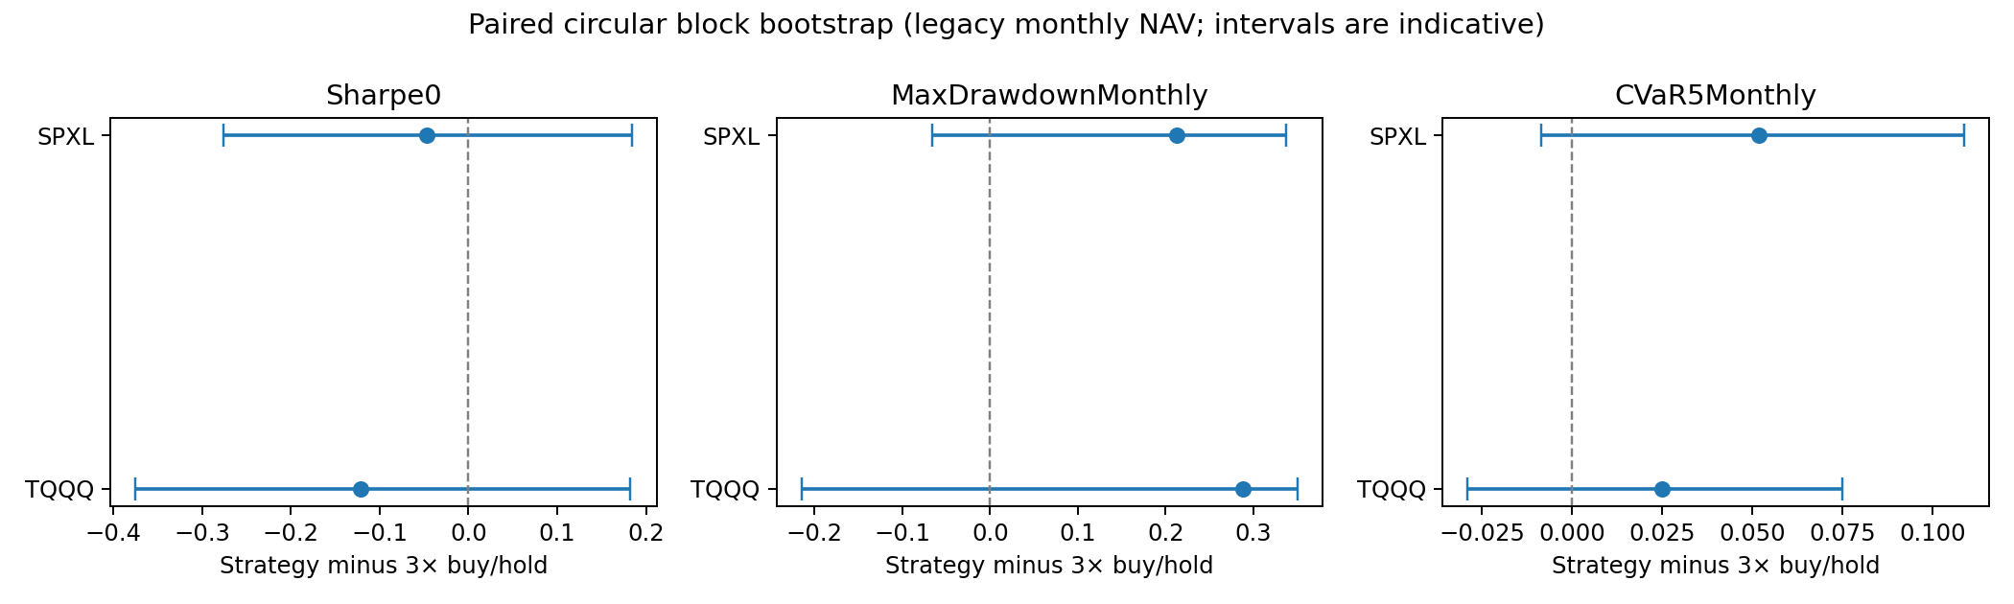
Figure 2. Legacy monthly paired bootstrap intervals. Every shown interval intersects zero; these do not estimate daily policy-resampling uncertainty.
The sign of drawdown/CVaR differences is written so a positive value indicates a smaller absolute loss under SMA. All six exploratory intervals cross zero. This does not demonstrate risk-indicator superiority. Month-end sampling misses adverse daily peaks and therefore these figures cannot be substituted for daily-sampled drawdown inferential results. A valid future analysis should bootstrap the joint daily asset-return and cash-rate process, re-run the trading policy within every resampled path, and respect estimation and parameter-selection uncertainty; merely shuffling precomputed strategy returns does not retrain the policy on counterfactual prices.

7. Stress and sensitivity diagnostics, disclosure of multiple testing
The baseline remains SMA200/+4%/−3%, selected before this revision. The previously inspected 27-cell grid per ETF uses SMA lengths 150, 200, 250; entry buffers +2%, +4%, +6%; and exit buffers −1%, −3%, −5%. All 54 variants produced positive historical CAGR in the original 2010 sample, but not one exceeded its fund’s corresponding 3× buy-and-hold CAGR (SPXL grid maximum 22.54% versus leveraged hold 28.94%; TQQQ grid maximum 31.12% versus leveraged hold 40.91%). This comparison matters more than the visual positivity of the heatmap. The grid does not establish a broad optimal plateau; repeated inspection creates data snooping. White (2000) and Hansen (2005) motivate formal correction, but the set of previously tried unpublished rules is unknown, so a defensible comprehensive multiple-testing adjustment cannot be claimed.
The program additionally writes full-sample daily risk summaries (mean/conditional mean drawdown, CDaR10, CVaR5, Ulcer Index, underwater fraction, longest underwater spell), a trade ledger mapping each full exit to the subsequent first-stage reentry, and a monthly-start distribution of strategy CAGR and maximum drawdown. The ledger records the leveraged ETF return forgone between exit and reentry. A positive foregone return is a reentry opportunity cost; a negative one reflects avoiding part of a decline. It is not counterfactual causal identification, and the trade count is small. These features are implemented but do not have populated corrected-run tables in this release because the four raw price streams are unavailable locally.
Mechanical weakness to test next: as price rises far above a trailing average, the absolute exit distance expands; during violent crashes a next-open execution can suffer a material gap. Alternative volatility-scaled buffers or trade-level drawdown stops can be prospectively preregistered as new experiments, not silently substituted into this baseline.

8. Code validation, data requirements, and pending publication gates
The revised code includes offline unit tests verifying next-open timing, staged orders, proper liquidation, average capital weight, interest accrual on uninvested cash, last-month-only Treasury quotations, failure on an unaligned vendor splice, and that higher financing costs worsen the synthetic invested return. A separate paired monthly-risk file is generated directly from shipped derived NAV snapshots and runs entirely offline. The entire corrected cross-asset backtest requires four locally retrieved adjusted OHLC archives plus a tail that passes the 1 bp overlap audit.
The following must be satisfied before the paper can honestly be treated as a revised empirical replication rather than an executable research protocol:
- Acquire licensed, consistent total-return OHLC for all four instruments, with dividend/split reconciliation and independent checks of official fund NAV total returns.
- Rerun scripts/review_revision.py; publish the new v2 results rather than reusing v1 metrics; record the source file hashes and merge-status report.
- Evaluate 1×, cash-weight-matched, and volatility-managed benchmarks on identical windows, with both matched-weight and volatility-target opportunity costs explicitly discussed.
- Run a daily dependent risk bootstrap that recalculates strategy decisions on resampled price paths, and a truly future frozen-parameter paper-trading sample.
- Release any additional parameter trials together with their outcomes. Do not describe the 2018–2026 split as an untouched holdout given the historical experimentation.
The record remains exploratory until these conditions are met. This is a deliberately stronger and more falsifiable characterization than “risk management validated.”

References
- Gayed, M. A. and Bilello, C. V. (2016). Leverage for the Long Run: A Systematic Approach to Managing Risk and Magnifying Returns in Stocks. Charles H. Dow Award. https://cmtassociation.org/wp-content/uploads/2025/08/2016-gayed-bilello.pdf.
- Faber, M. T. (2007). A Quantitative Approach to Tactical Asset Allocation. Journal of Wealth Management. https://papers.ssrn.com/sol3/papers.cfm?abstract_id=962461.
- Avellaneda, M. and Zhang, S. (2010). Path-Dependence of Leveraged ETF Returns. SIAM Journal on Financial Mathematics, 1, 586–603. https://math.nyu.edu/inmemoriam/avellaneda/SIAMLETFS.pdf.pdf.
- Cheng, M. and Madhavan, A. (2009). The Dynamics of Leveraged and Inverse Exchange-Traded Funds. Journal of Investment Management, 7(4).
- Moreira, A. and Muir, T. (2017). Volatility-Managed Portfolios. Journal of Finance, 72, 1611–1644. https://doi.org/10.1111/jofi.12513.
- Ledoit, O. and Wolf, M. (2008). Robust Performance Hypothesis Testing with the Sharpe Ratio. Journal of Empirical Finance, 15, 850–859. https://doi.org/10.1016/j.jempfin.2008.03.002.
- Politis, D. N. and Romano, J. P. (1994). The Stationary Bootstrap. JASA, 89(428), 1303–1313. https://doi.org/10.1080/01621459.1994.10476870.
- White, H. (2000). A Reality Check for Data Snooping. Econometrica, 68(5), 1097–1126. https://doi.org/10.1111/1468-0262.00152.
- Hansen, P. R. (2005). A Test for Superior Predictive Ability. Journal of Business & Economic Statistics, 23(4), 365–380. https://doi.org/10.1198/073500105000000063.
- Board of Governors of the Federal Reserve System (U.S.). DTB3, 3-Month Treasury Bill Secondary Market Rate, Bank-Discount Basis. Federal Reserve Bank of St. Louis (FRED). https://fred.stlouisfed.org/series/DTB3.
- Direxion. SPXL fund profile and daily target. https://www.direxion.com/product/daily-sp-500-bull-bear-3x-etfs.
- ProShares. TQQQ fund profile and daily target. https://www.proshares.com/our-etfs/leveraged-and-inverse/tqqq.

