Fenglei Gu

fg1121@nyu.edu

CS 060 – Database Design and Implementation

Oct 8, 2019

Assignment 3 Summary

These data are Zhejiang Gaokao (College Entrance Exam) Admission Score Lines[1] in the First Enrollment Round of Year 2019. The URL of these data is https://www.zjzs.net/moban/index/402848536bab8311016bfe0466c600a8.html.

Through these queries, we find that most universities would admit students with Gaokao score lower than 640. This could release some pressure for high school students, and encouraging them to spend more time outside of standardized exams.

I do believe that the dataset is reliable, and the actual results reflect what I have anticipated to find. On the one hand, the data source comes from a governmental authority that administrates Gaokao in Zhejiang Province. On the other hand, the results are within common expectation. For example, our queries show that Tsinghua University and Peking University, which are the two Chinese universities ranked highest according to QS World University Rankings, also have the highest requirement on students’ least Gaokao score.

For further researches, I would like to use MATLAB software or Python libraries such as pandas or seaborn, to visualize the data, so that readers will feel more comfortable. Also, it is preferable to obtain more data, such as the actual distribution of Gaokao scores of admitted students for each major at each university.

Appendix: Terminal Snapshot (on Ubuntu)

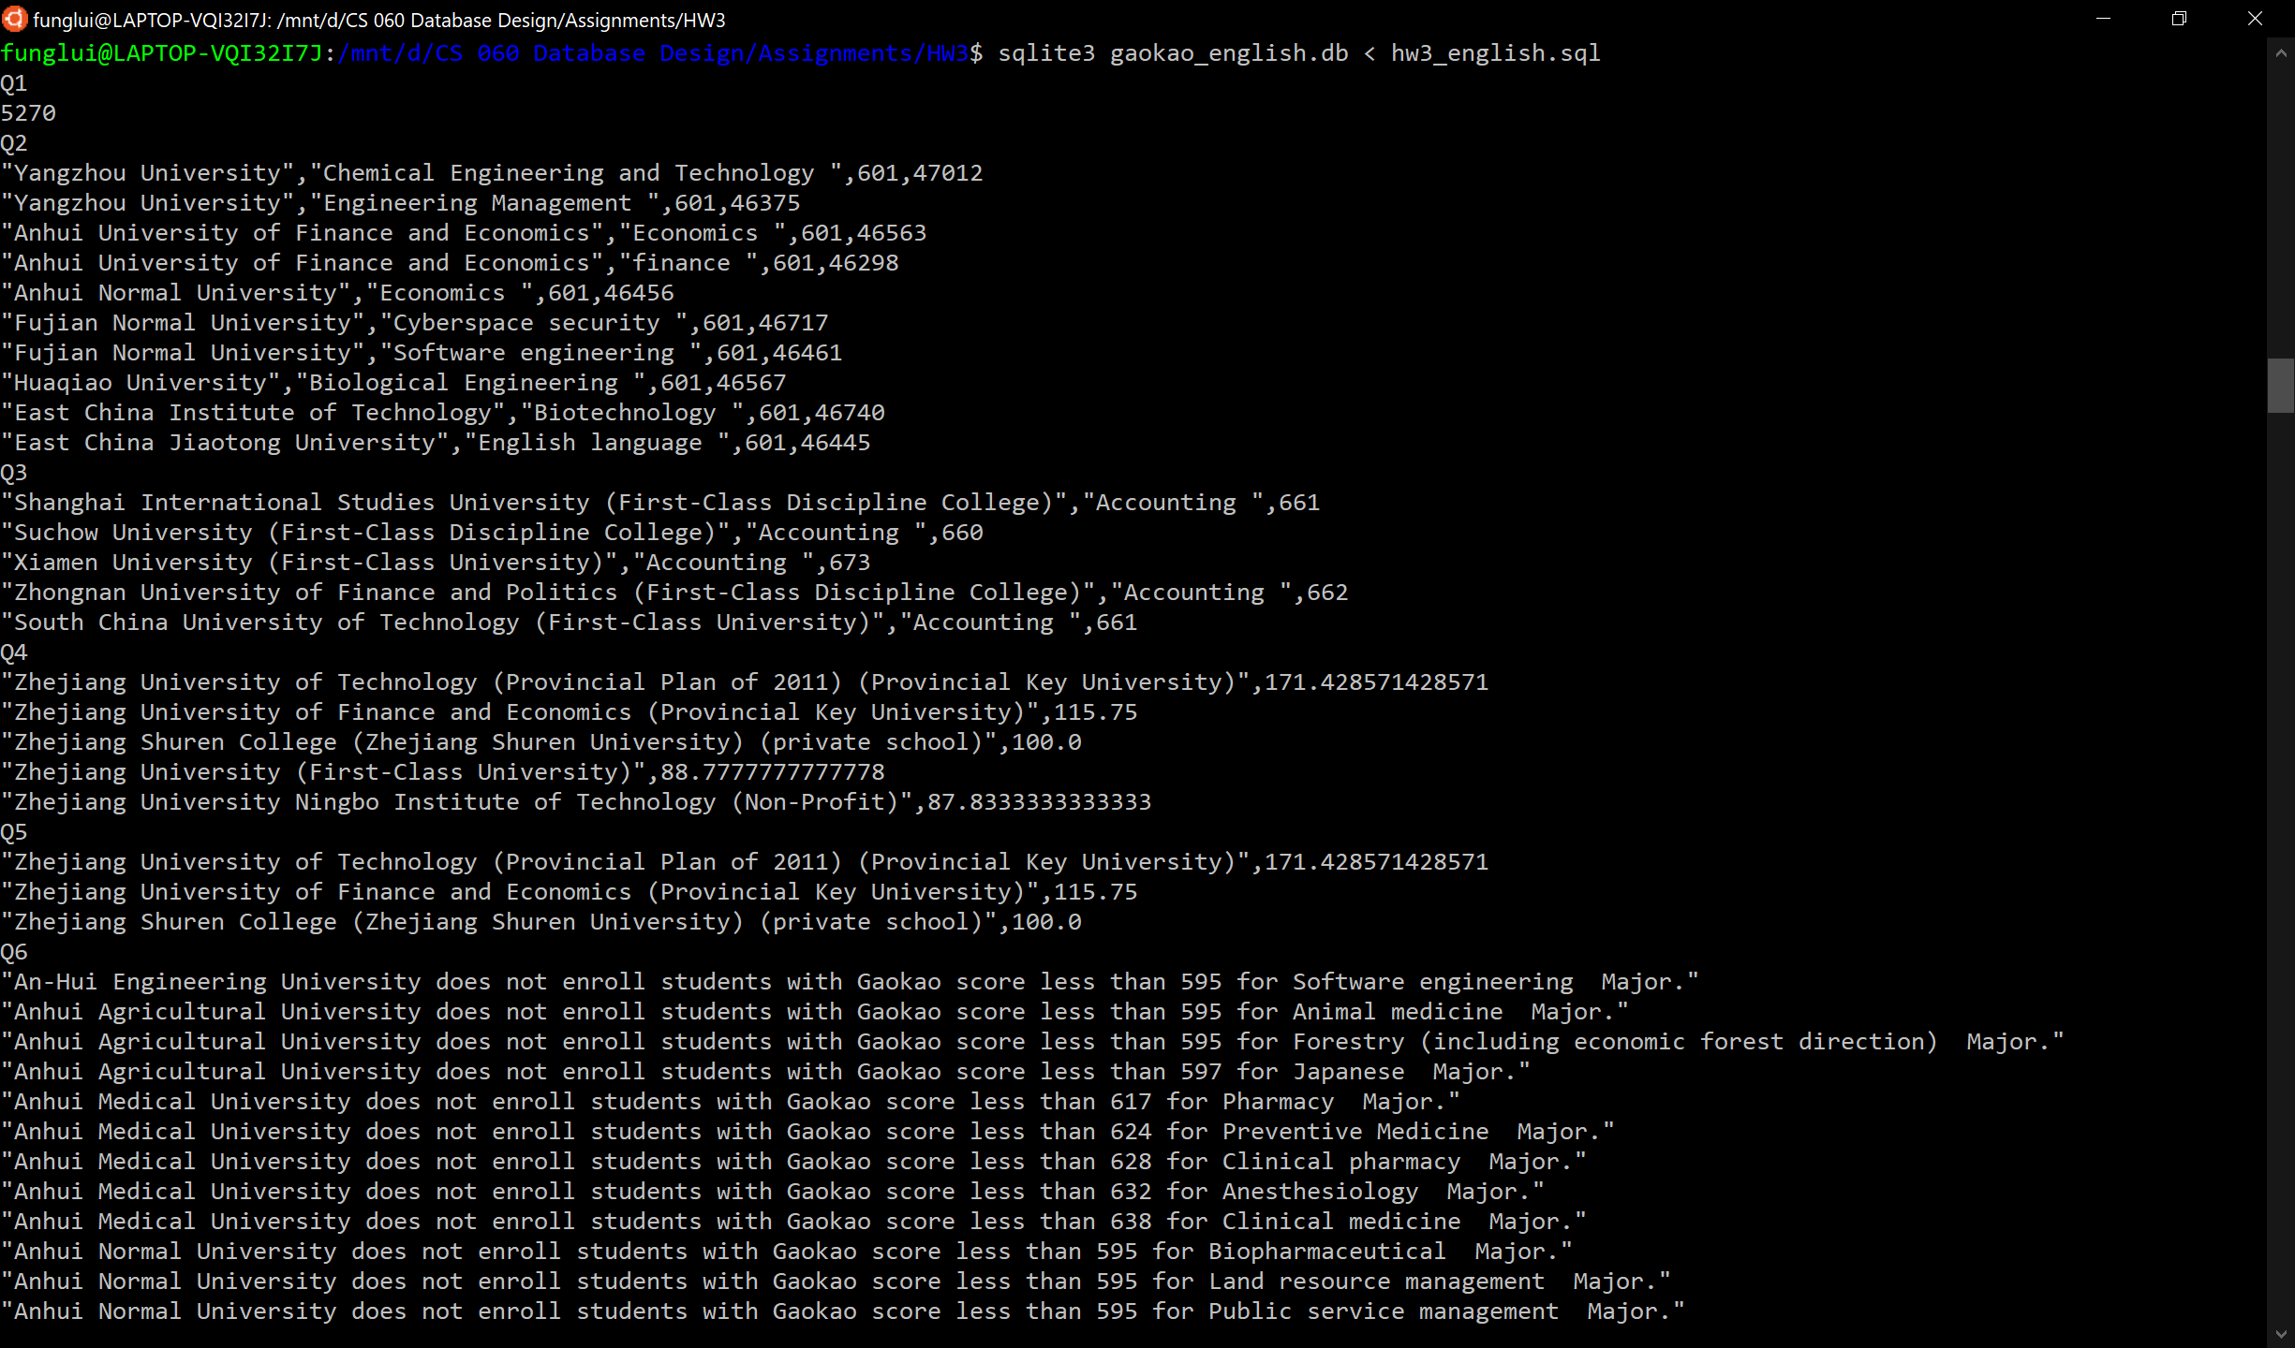

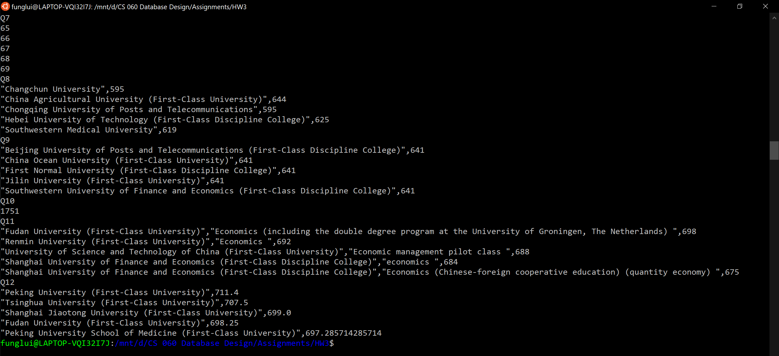

1. The admission to college in China is (with few exceptions) based only on the scores in Gaokao (College Entrance Exam), and every year, the authority will publish the lowest Gaokao score with which one student may be admitted to any given major/division of a particular college/university.