User Guide for ‘A Novel Secondary Poisoning Model for Pharmaceutical Bioaccumulation in Aquatic, Terrestrial, and Subterranean Food Webs’
Charlie J. E. Davey, Una Milovanović, Jiaqi Wang, A. Jan Hendriks, Ad M. J. Ragas

Introduction 2
User Input Blocks 3
Block 1: Chemical Input Data 3
Block 2: Environmental Input Data 4
Block 3: Species & Food Chain Data 4
Block 4: Model Options 4
Results Blocks 5
Main Results 5
Rate Constants 5
Graph 5
Time Course Constants (Used to make Graph) 6
Calculation Blocks 7
Block 5: Speciation, soil partitioning and pp-LFERs 7
Block 6: Chemical Input Data 7
Block 7: Chemical Input Data 7
Block 8: Chemical Input Data 8
Block 9: Chemical Input Data 8
Model Lookup Tables 9

Introduction
This document provides a brief user guide for the model developed by the authors in the publication titled "A Novel Secondary Poisoning Model for Pharmaceutical Bioaccumulation in Aquatic, Terrestrial, and Subterranean Food Webs”, otherwise referred to as the SPM. The excel version of the model can be downloaded from either the GITHUB page, from the PREMIER website, or along with the supplementary information of the study.








The SPM was designed to estimate the whole-body steady-state concentrations of pharmaceuticals in an array of food chains. The food chains can involve any animal in the subterranean, terrestrial, and aquatic environments provided the relevant species information are provided to the model (Figure 1). The model can also estimate any combination of animals in a food chain, even if that food chain is unrealistic. While the SPM was designed for, and validated against, pharmaceuticals, any chemical can be used as an input into the SPM, provided the correct data are entered.
The SPM works by calculating kinetic parameters from basic input data about the chemical, environment, and species in the scenario. These kinetic parameters are compared to concentrations in either the environment (e.g. water), food, or inside the organism at each timestep to calculate the new concentration inside the organism (Figure 2). Since one organism might be another’s’ food, the food concentration will also change. These dynamics are what create the kinetic model, which might take some time to come to an equilibrium, or steady state.
Figure 1: Examples of subterranean/terrestrial (right panel) and aquatic (left panel) foodwebs

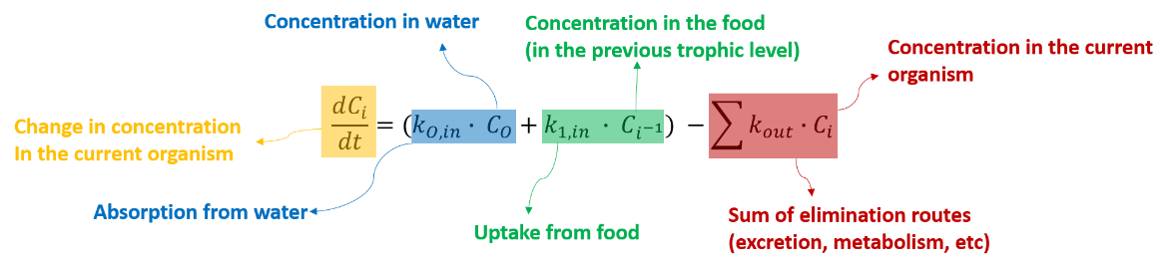

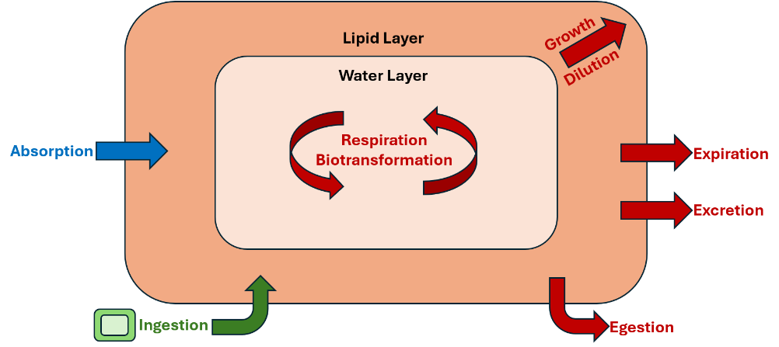
Figure 2: The overall model equation (Top) showing the three uptake and elimination routes, and a representation of an organism within the SPM (Bottom) with the corresponding uptake and elimination routes in the same colour.

User Input Blocks
The model is divided into a number of ‘blocks’ that are mostly used for calculating the kinetic rate constants. These blocks are spread across the model sheet in the excel file, and all the equations for these blocks can be found in either the main text or the SI of the publication.
In these blocks, indicate where a user can input data. These can either be a dropdown list or somewhere you can type. Only blocks 1-4 have allow the user to input data. The others are simply calculations for the models (See Calculation Blocks).

Block 1: Chemical Input Data
This block has two modes: Manual Input and Lookup. In the manual input mode, the user can enter the name, logKow, ionic LogKow, LogKoa, and pKa, ionisation type and ionising functional group of the chemical.
Two experimental features are also included, Biotransformation and pp-LFER estimations. In the publication, these did not improve the predictive accuracy of the model, so it is recommended to leave these turned off (See Block 4). However, their input data are also in this block.
The data for this can be found in databases or calculated via online tools. Good sources include PubChem, CompTox, RDKit, UFZ, and EPISuite.
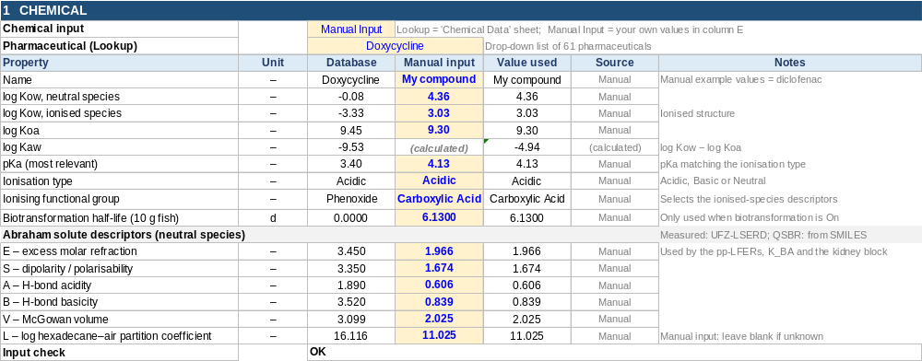
In the lookup mode, you can select the lookup pharmaceutical at the top to fetch the data from 61 pharmaceuticals that were used in the validation for the study. This will remove the yellow highlight and cross out the manual input data, letting you know that you don’t need to edit these in lookup mode.
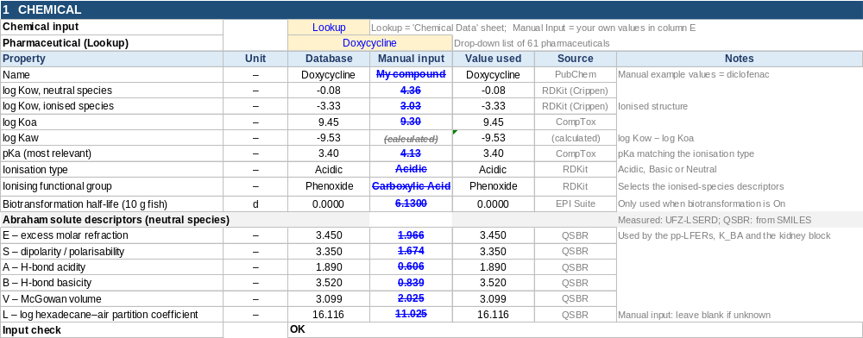

Block 2: Environmental Input Data
Here, the user can enter the aquatic concentration, aquatic temperature, and aquatic pH, soil concentration, soil pH, soil organic carbon fraction, soil density, and soil moisture content. Water data are used in the aquatic environments, while soil data are used for the subterranean environments (See Block 3). You will need to input data for one or the other depending on what environments your species live in. Terrestrial species do not need environmental data, but the model will simulate soil:air partitioning and inhalation for those species if soil data are available.
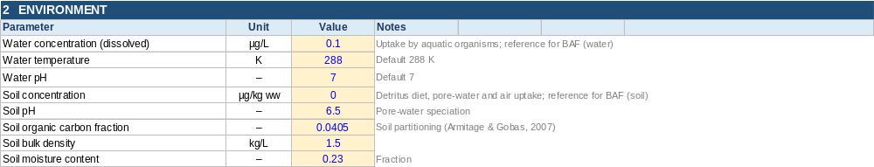

Block 3: Species & Food Chain Data
The species data sub-block is an important block. The user can enter data for up to four trophic levels. The organism line contains the species types in drop-down menus that are compatible with the model (Algae, Plants, Worms, Molluscs, Worms, Arthropods, Crustaceans, Insects, Fish, Amphibians, Cnidaria, Birds, Mammals, or None). The environment line contains a drop-down menu to select the model variant (aquatic, terrestrial, or subterranean). The diet line is a drop-down menu for the different diet types (Photosynthesis, Detritus, Herbivore, Carnivore, or None). The blood type line contains a drop-down menu for blood type (cold or warm). The body mass and internal pH lines allow the user to input those data manually. Blood pH of the organism can be used as a proxy for whole body pH here. See the screenshot for some default values.
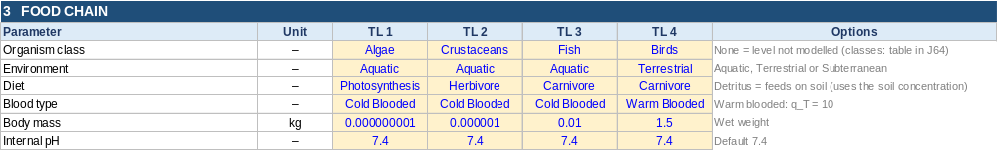

Block 4: Model Options
The final user-input block allows the user to select the experimental sub-models, as well as change the time-course length of the chart.
The first line allows the user to determine if the pp-LFER partitioning sub-model is active (by selecting K_iW II), and if selected, if the model should use estimated pp-LFER values if no measured values are available (second line). Due to the lower performance of the pp-LFER partitioning, it is recommended to leave K_iW as I.
Biotransformation can also be turned on or off here. This uses the best performing sub-model from the paper (allometrically scaled fish half-lives from EPISuite), but due to the lower performance compared to the base model, it is recommended to leave this off.

Results Blocks
The following blocks provide the outputs of the model, as well as other useful information.

Main Results
For each trophic level, this shows the steady-state internal concentration (µg/kg wet weight), the BAF relative to water and to soil, the BMF relative to the level below, the TMF of the whole food chain, and the time to reach 95 % of steady state. A status message flags levels that cannot be calculated: invalid inputs, an unmodelled level, or a missing food source.
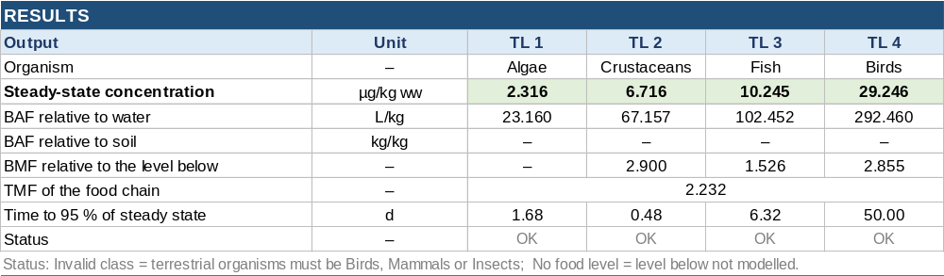

Rate Constants
For each trophic level, this lists the uptake rate constants (from water, air, pore water and food) and the elimination rate constants (excretion to water, air, pore water and urine, egestion with faeces, growth dilution and biotransformation), together with their sum, which together give the steady-state concentration. These constants are the same as those in equation 1 of the publication.
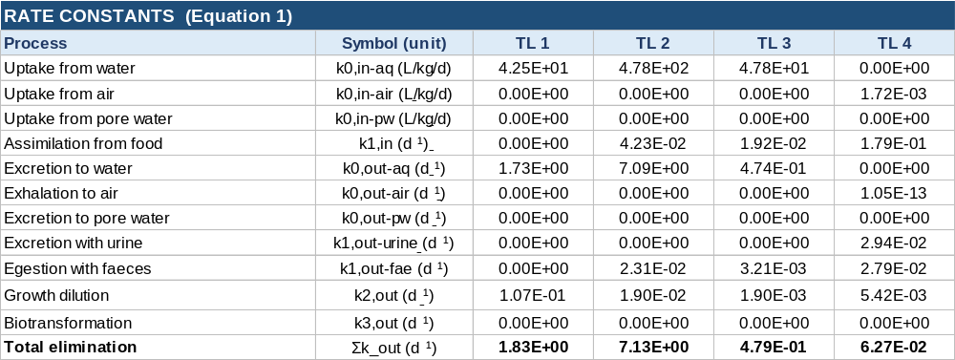

Graph
This chart shows how the internal concentration of each trophic level rises towards its steady-state value over time, starting from an uncontaminated food chain with constant environmental concentrations. It is for illustration only and does not affect the steady-state results, since those are calculated separately. In other words, it does not matter to the steady state concentrations if some of the trophic levels do not appear steady state, such as in the case of birds in this example.
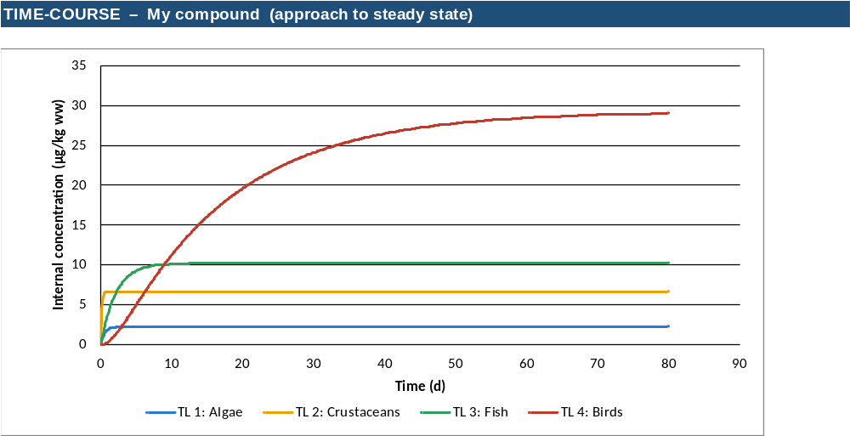

Time Course Constants (Used to make Graph)
This helper block solves Equation 1 numerically over 1,000 time steps. The simulation length is set automatically to about four times the summed 1/Σk_out of the modelled levels, or to the number of days entered in the model options.
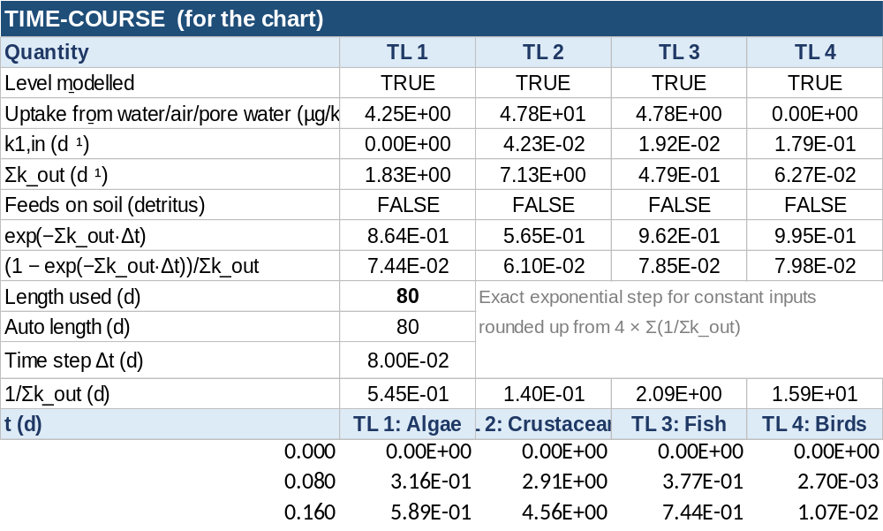

Calculation Blocks
The following blocks do not need any user input, but will be briefly explained below.

Block 5: Speciation, soil partitioning and pp-LFERs
This block calculates the chemical properties shared by all trophic levels: the neutral fractions and D_OW at water and soil pH, partitioning into soil, pore water and air, the blood–air partition coefficient (K_BA), and the pp-LFER membrane, BSA and muscle-protein distribution coefficients (Eqs. 3–5).
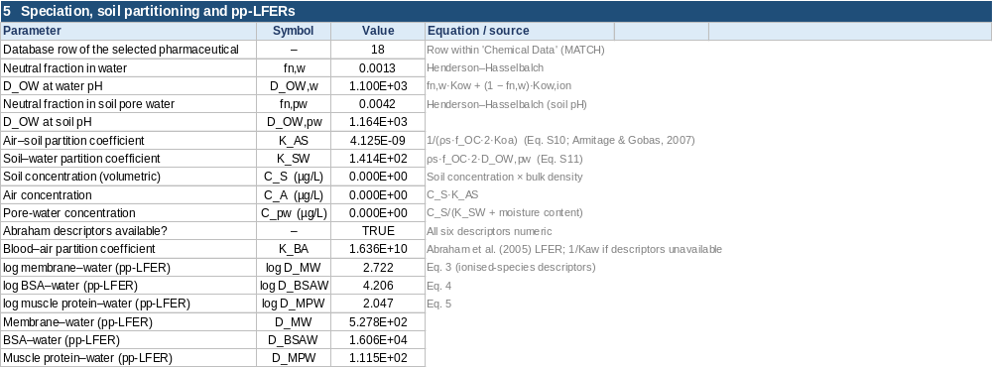

Block 6: Chemical Input Data
For each trophic level, this block gives the physiological and dietary parameters, the body composition, D_OW at internal pH, and the organism–water partition coefficient from both Estimation I and Estimation II (Eqs. 2 and 6), along with the terms that feed the uptake and elimination rate constants.
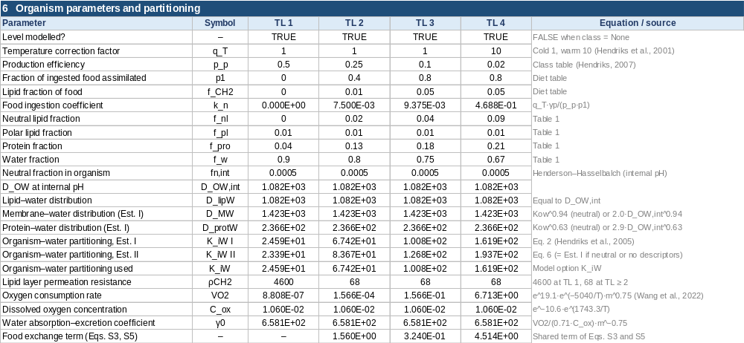

Block 7: Chemical Input Data
For terrestrial organisms (birds, mammals and insects), this block calculates ventilation, cardiac output, inhalation efficiency and the ventilation–perfusion coefficient used for uptake from and exhalation to air.
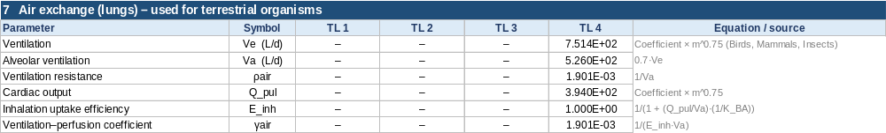

Block 8: Chemical Input Data
For terrestrial and subterranean organisms, this block calculates the glomerular filtration rate, blood composition, unbound fraction, body–blood partition coefficient, urine speciation and passive reabsorption that make up the urinary excretion rate constant.
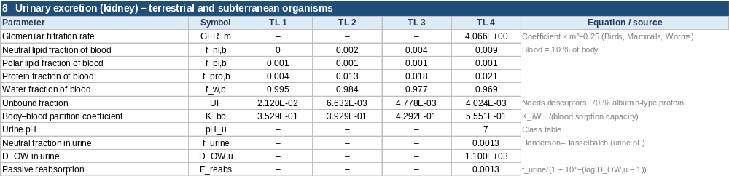

Block 9: Chemical Input Data
This block lists the trophic level and log₁₀ steady-state concentration of each modelled level, which are used to calculate the TMF shown in the Results.

Model Lookup Tables
These are the parameters behind all the calculations: organism composition and production efficiency by class (Table 1), the air-exchange and kidney coefficients by class, the diet parameters, the model constants with their sources, and the equations for the ionised-species Abraham descriptors (SI Section S2). These can be edited by the user if you would like to experiment with different parameters, but this is not recommended.
