I'm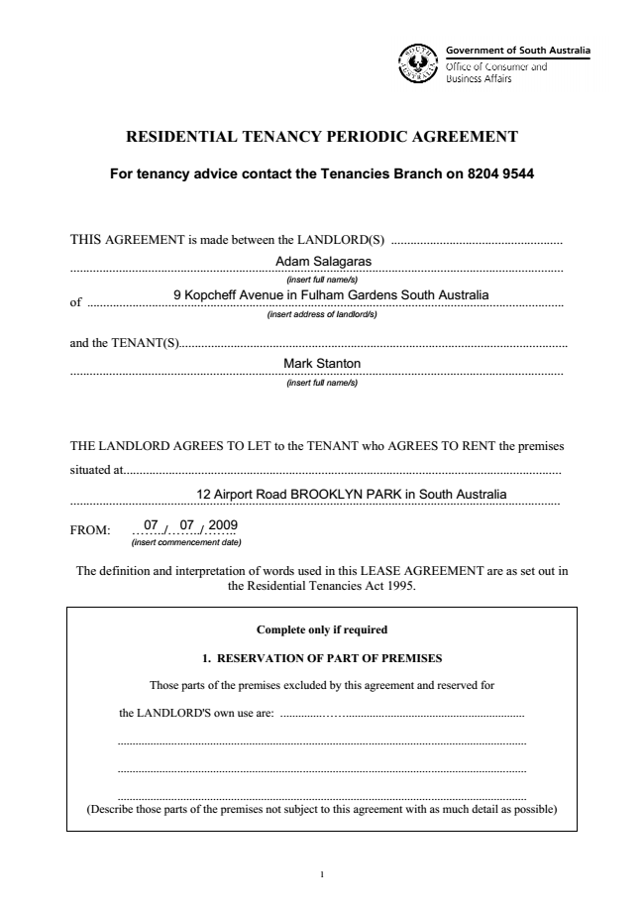

**RESIDENTIAL TENANCY PERIODIC AGREEMENT**

**For tenancy advice contact the Tenancies Branch on 8204 9544**

THIS AGREEMENT is made between the *Dr Nick Pourgezis*

*& Dr Kerry Salagaras*

*(insert full name/s)*

of *31 Main Street, HENLEY BEACH 5022*..........

*(insert address of landlord/s)*

and the TENANT(S)..................................................Ayiesha Rose Myree Connelly-Black......

*(insert full name/s)*

THE LANDLORD AGREES TO LET to the TENANT who AGREES TO RENT the premises

situated at........

12 Airport Road BROOKLYN PARK in South Australia

FROM: ...05...../...03...../...2021.....

*(insert commencement date)*

The definition and interpretation of words used in this LEASE AGREEMENT are as set out in the Residential Tenancies Act 1995.

**Complete only if required**

**1. RESERVATION OF PART OF PREMISES**

Those parts of the premises excluded by this agreement and reserved for

the LmNDLORD'S own use are: ...................................................................................

.........................................................................................................................................

.........................................................................................................................................

.........................................................................................................................................

(Describe those parts of the premises not subject to this agreement with as much detail as possible)

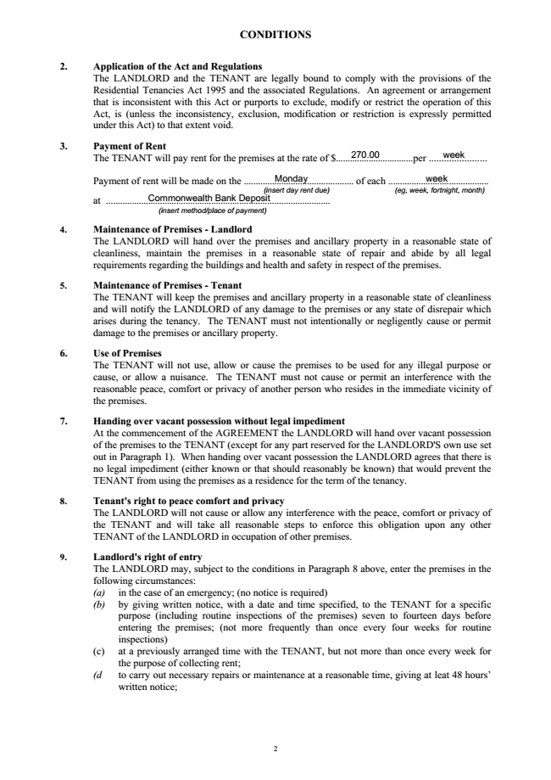

**CONDITIONS**

**2. Application of the Act and Regulations**

The LANDLORD and the TENANT are legally bound to comply with the provisions of the Residential Tenancies Act 1995 and the associated Regulations. An agreement or arrangement that is inconsistent with this Act or purports to exclude, modify or restrict the operation of this Act, is (unless the inconsistency, exclusion, modification or restriction is expressly permitted under this Act) to that extent void.

**3. Payment of Rent**

The TENANT will pay rent for the premises at the rate of $300...per ...WEEK

Payment of rent will be made on Friday of each Week

Into the nominated bank account through eft or direct deposit

**4. Maintenance of Premises - Landlord**

The LANDLORD will hand over the premises and ancillary property in a reasonable state of cleanliness, maintain the premises in a reasonable state of repair and abide by all legal requirements regarding the buildings and health and safety in respect of the premises.

**5. Maintenance of Premises - Tenant**

The TENANT will keep the premises and ancillary property in a reasonable state of cleanliness and will notify the LANDLORD of any damage to the premises or any state of disrepair which arises during the tenancy. The TENANT must not intentionally or negligently cause or permit damage to the premises or ancillary property.

**6. Use of Premises**

The TENANT will not use, allow or cause the premises to be used for any illegal purpose or cause, or allow a nuisance. The TENANT must not cause or permit an interference with the reasonable peace, comfort or privacy of another person who resides in the immediate vicinity of the premises.

**7. Handing over vacant possession without legal impediment**

At the commencement of the AGREEMENT the LANDLORD will hand over vacant possession of the premises to the TENANT (except for any part reserved for the LANDLORD'S own use set out in Paragraph 1). When handing over vacant possession the LANDLORD agrees that there is no legal impediment (either known or that should reasonably be known) that would prevent the TENANT from using the premises as a residence for the term of the tenancy.

**8. Tenant's right to peace comfort and privacy**

The LANDLORD will not cause or allow any interference with the peace, comfort or privacy of the TENANT and will take all reasonable steps to enforce this obligation upon any other TENANT of the LANDLORD in occupation of other premises.

**9. Landlord's right of entry**

The LANDLORD may, subject to the conditions in Paragraph 8 above, enter the premises in the following circumstances: (a) in the case of an emergency; (no notice is required) (b) by giving written notice, with a date and time specified, to the TENANT for a specific purpose (including routine inspections of the premises) seven to fourteen days before entering the premises; (not more frequently than once every four weeks for routine inspections) (c) at a previously arranged time with the TENANT, but not more than once every week for

the purpose of collecting rent; (d to carry out necessary repairs or maintenance at a reasonable time, giving at leat 48 hours‘

written notice;

270.00 week

Monday week

Commonwealth Bank Deposit

2

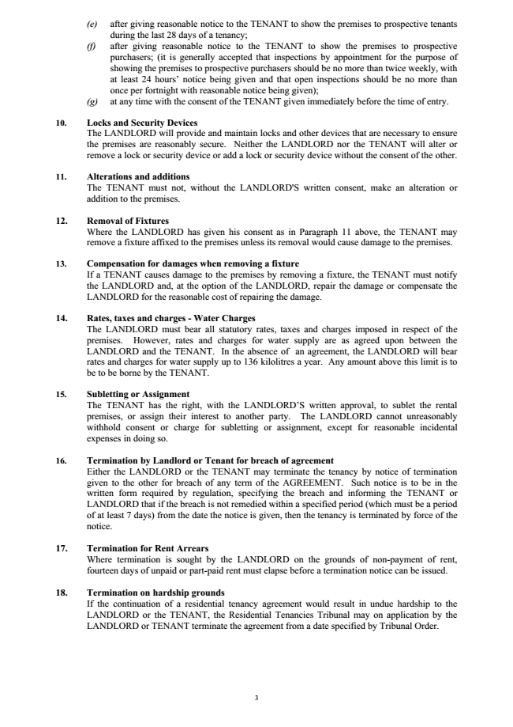

(e) after giving reasonable notice to the TENANT to show the premises to prospective tenants

during the last 28 days of a tenancy; (f) after giving reasonable notice to the TENANT to show the premises to prospective purchasers; (it is generally accepted that inspections by appointment for the purpose of showing the premises to prospective purchasers should be no more than twice weekly, with at least 24 hours‘ notice being given and that open inspections should be no more than once per fortnight with reasonable notice being given); (g) at any time with the consent of the TENANT given immediately before the time of entry.

**10. Locks and Security Devices**

The LANDLORD will provide and maintain locks and other devices that are necessary to ensure the premises are reasonably secure. Neither the LANDLORD nor the TENANT will alter or remove a lock or security device or add a lock or security device without the consent of the other.

**11. Alterations and additions**

The TENANT must not, without the LANDLORD'S written consent, make an alteration or addition to the premises.

**12. Removal of Fixtures**

Where the LANDLORD has given his consent as in Paragraph 11 above, the TENANT may remove a fixture affixed to the premises unless its removal would cause damage to the premises.

**13. Compensation for damages when removing a fixture**

If a TENANT causes damage to the premises by removing a fixture, the TENANT must notify the LANDLORD and, at the option of the LANDLORD, repair the damage or compensate the LANDLORD for the reasonable cost of repairing the damage.

**14. Rates, taxes and charges - Water Charges**

The LANDLORD must bear all statutory rates, taxes and charges imposed in respect of the premises. However, rates and charges for water supply are as agreed upon between the LANDLORD and the TENANT. In the absence of an agreement, the LANDLORD will bear rates and charges for water supply up to 136 kilolitres a year. Any amount above this limit is to be to be borne by the TENANT.

**15. Subletting or Assignment**

The TENANT has the right, with the LANDLORD‘S written approval, to sublet the rental premises, or assign their interest to another party. The LANDLORD cannot unreasonably withhold consent or charge for subletting or assignment, except for reasonable incidental expenses in doing so.

**16. Termination by Landlord or Tenant for breach of agreement**

Either the LANDLORD or the TENANT may terminate the tenancy by notice of termination given to the other for breach of any term of the AGREEMENT. Such notice is to be in the written form required by regulation, specifying the breach and informing the TENANT or LANDLORD that if the breach is not remedied within a specified period (which must be a period of at least 7 days) from the date the notice is given, then the tenancy is terminated by force of the notice.

**17. Termination for Rent Arrears**

Where termination is sought by the LANDLORD on the grounds of non-payment of rent, fourteen days of unpaid or part-paid rent must elapse before a termination notice can be issued.

**18. Termination on hardship grounds**

If the continuation of a residential tenancy agreement would result in undue hardship to the LANDLORD or the TENANT, the Residential Tenancies Tribunal may on application by the LANDLORD or TENANT terminate the agreement from a date specified by Tribunal Order.

3

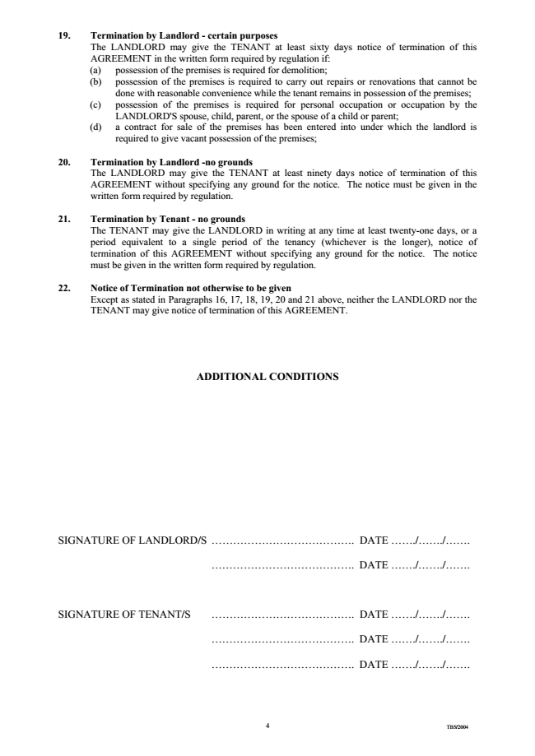

**19. Termination by Landlord - certain purposes**

The LANDLORD may give the TENANT at least sixty days notice of termination of this AGREEMENT in the written form required by regulation if: (a) possession of the premises is required for demolition; (b) possession of the premises is required to carry out repairs or renovations that cannot be

done with reasonable convenience while the tenant remains in possession of the premises; (c) possession of the premises is required for personal occupation or occupation by the

LANDLORD'S spouse, child, parent, or the spouse of a child or parent; (d) a contract for sale of the premises has been entered into under which the landlord is

required to give vacant possession of the premises;

**20. Termination by Landlord -no grounds**

The LANDLORD may give the TENANT at least ninety days notice of termination of this AGREEMENT without specifying any ground for the notice. The notice must be given in the written form required by regulation.

**21. Termination by Tenant - no grounds**

The TENANT may give the LANDLORD in writing at any time at least twenty-one days, or a period equivalent to a single period of the tenancy (whichever is the longer), notice of termination of this AGREEMENT without specifying any ground for the notice. The notice must be given in the written form required by regulation.

**22. Notice of Termination not otherwise to be given**

Except as stated in Paragraphs 16, 17, 18, 19, 20 and 21 above, neither the LANDLORD nor the TENANT may give notice of termination of this AGREEMENT.

**ADDITIONAL CONDITIONS**

SIGNATURE OF LANDLORD/S ......................................

. DATE ..06/05/.2021

........................................

DATE :...6/05/.2021

SIGNATURE OF TENANT/S ........................................

DATE: 06/05/.2021

4

TB5/2004