ME4640 S26 Robot Homework C: Forward Kinematics

Learning Objectives
In this assignment, you will:
- Derive and implement forward kinematics (FK) for the ME arm v3.0 using the Product of Exponentials method
- Validate your ME arm FK against physical measurements at three distinct set points

Part 1: Derive and Implement Forward Kinematics for the ME Arm

1. Derive the forward-kinematic equations of your robot arm.
Assume your robot is a serial chain with 4 rotation axes, $ω_{A}$ through $ω_{D}$, where $ω_{A}$ aligns with the first servomotor axis such that $ω_{A}$ = [$0,0,1$]ᵀ. The other axes are shown in Figure 1, which illustrates the robot in the home position.
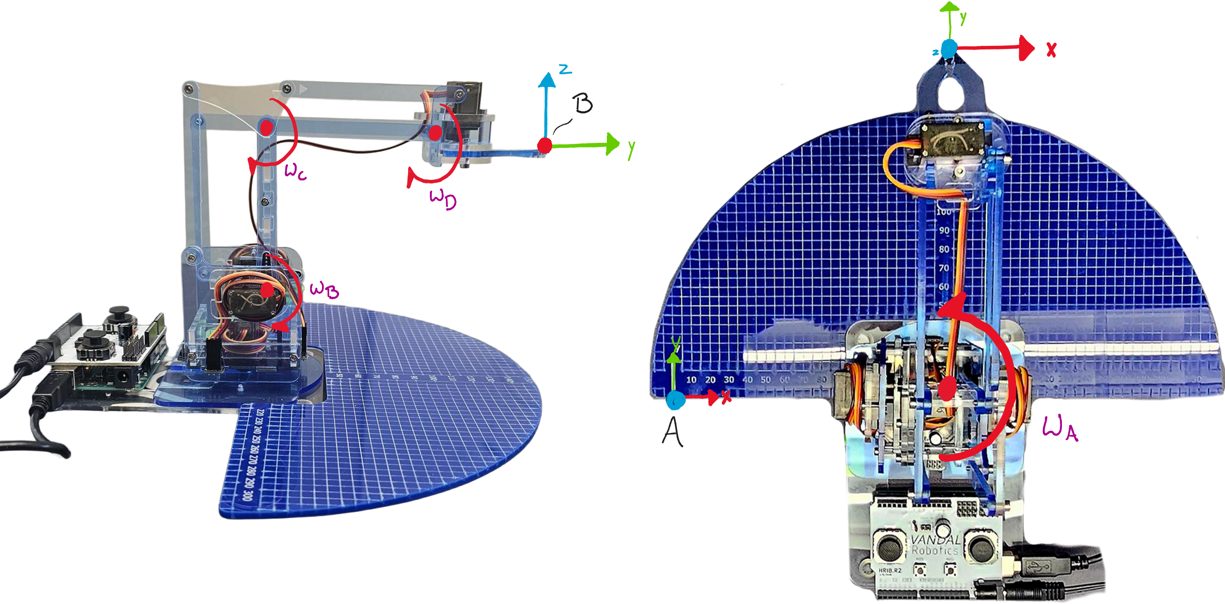
a. Find the home position, $g_{st}(0)$, of the tool frame. Assume the origin is at the top edge of the gripper tip, with the same orientation as the spatial frame.
b. Find each joint axis, $ω_{A}$ through $ω_{D}$, matching those shown in Figure 1.
c. Find a point on each joint axis, $q_{A}$ through $q_{D}$ (in mm). You will need to measure the dimensions of your robot links. You can use posted CAD files and measurements on your own robot. The provided base includes the origin of the spatial frame and a 5×5 mm grid.
d. In MATLAB or Python, use the results above to find the forward kinematics homogeneous transformation $g_{st}(θ_{A},θ_{B},θ_{C},θ_{D})$.

e. Find the relationship between the serial chain kinematic angles $θ_{A}-θ_{D}$ and the servomotor angles $θ_{1}-θ_{3}$ for each motor, the positive direction is determined using the right-hand rule, assuming an axis extending out from the servomotor axis. The joint angles have the following directions when the robot is in the home position, defined in Figure 1.
- Note: $θ_{1}$ = base, $θ_{2}$ = left, $θ_{3}$ = right.
$$ω_{1}=\left[\begin{matrix}0 \\ 0 \\ -1\end{matrix}\right], ω_{2}=\left[\begin{matrix}1 \\ 0 \\ 0\end{matrix}\right], ω_{3}=\left[\begin{matrix}-1 \\ 0 \\ 0\end{matrix}\right]$$
f. Define each of $θ_{A}-θ_{D}$ in terms of $θ_{1}-θ_{3}$.
- For example, $θ_{A}=θ_{1}$ and $θ_{B}=θ_{2}$. What are $θ_{C}$ and $θ_{D}$?
- Once defined, substitute $θ_{A}-θ_{D}$ with $θ_{1}-θ_{3}$ in your serial-chain forward kinematics to create $g_{st}(θ_{1},θ_{2},θ_{3})$.
- Create a numerical function for $g_{st}(θ_{1},θ_{2},θ_{3})$ using matlabFunction or lambdify.
g. Add the kinematic solution to your Arduino code from HW B (i.e., add 3 equations for x, y, and z in the spatial frame to your existing joystick/trajectory control code). Ensure your Arduino outputs the following to the Serial Monitor each loop:
- $θ_{1}-θ_{3}$ in degrees
- x, y, z in mm (from FK)

Part 2: Validate ME Arm FK at Commanded Set Points

1. Command Your Robot to Three Set Points
Select three clearly distinct joint configurations for validation. Use your joysticks (or joint-trajectory mode) to move your robot to each configuration while your Arduino outputs the FK-predicted position in real time in the Serial Monitor.
For your submission, fill in a table like the one below with the three validation configurations before distributing this assignment. Choose positions that are physically distinct, safely within range of motion, and where the gripper tip is accessible for measurement.
 | $$θ_{A}$$ | $$θ_{B}$$ | $$θ_{C}$$ | $$θ_{D}$$ | $$θ_{1}$$ | $$θ_{2}$$ | $$θ_{3}$$ | Expected x (mm) | Expected y (mm) | Expected z (mm) | Measured x (mm) | Measured y (mm) | Measured z (mm)
A
B
C

2. Measure and Compare
At each of the three set points:
a. Record the FK-predicted (x, y, z) values printed to the Serial Monitor.
b. Physically measure x, y, z using a ruler and the 5×5 mm grid on the robot base. (You may 3D print a measurement aid or use a plumb line to measure the z coordinate accurately.)
c. Take and annotate a photo of the robot at each position. Each photo must show:
- Predicted: x, y, z from Serial Monitor
- Measured: x, y, z from physical measurement

3. Record a Validation Video
Record a short video (30–60 seconds) of your robot being moved to each of the three set points, pausing at each position while the Serial Monitor output is visible.

What to Submit
Submit the following files on Canvas (do not zip). Name each file using the convention shown.
File | Contents
RobotC_Lastname_Kinematics.pdf | MATLAB or Python FK code from Part 1. Include your full name commented at the top.
RobotC_Lastname_Verification.pdf | Three annotated comparison photos from Part 2 + filled table.
RobotC_Lastname_Arduino.pdf | Arduino code with FK included (from Part 1g). Include your full name commented at the top.
RobotC_Lastname_video.mp4 | Short video (30–60 sec) of ME arm moving to each of the three set points with Serial Monitor visible

