**Utsav Jitendrabhai Patel**

**PART:A**

**Register:**

**Login:**

If I am trying to put wrong username:

If I am trying to put wrong password:

**Get:**

**Part:B**

**Register:**

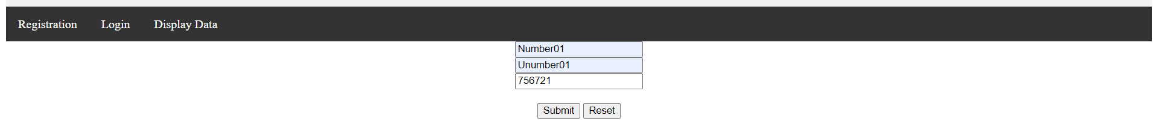

For reset:



**Login:**

If I am trying to put wrong username:



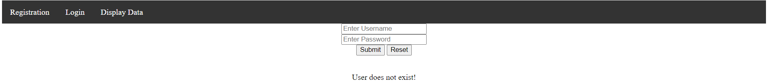

If I am trying to put wrong password:



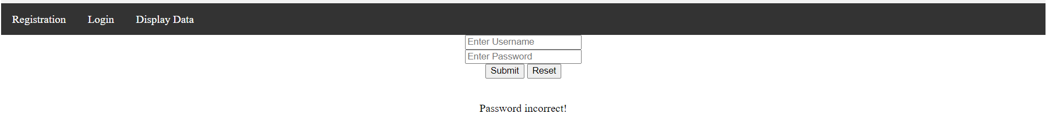

If Username and password both are correct:



**Display Data:**

